OceanStor
6.1.8.SPH20
 | Patch Installation Guide
 | Issue | 01
 | Date | 2025-04-29

 | HUAWEI TECHNOLOGIES CO., LTD. |  | 

Copyright © Huawei Technologies Co., Ltd. 2025. All rights reserved.
No part of this document may be reproduced or transmitted in any form or by any means without prior written consent of Huawei Technologies Co., Ltd.

Trademarks and Permissions
and other Huawei trademarks are trademarks of Huawei Technologies Co., Ltd.
All other trademarks and trade names mentioned in this document are the property of their respective holders.

Notice
The purchased products, services and features are stipulated by the contract made between Huawei and the customer. All or part of the products, services and features described in this document may not be within the purchase scope or the usage scope. Unless otherwise specified in the contract, all statements, information, and recommendations in this document are provided "AS IS" without warranties, guarantees or representations of any kind, either express or implied.
The information in this document is subject to change without notice. Every effort has been made in the preparation of this document to ensure accuracy of the contents, but all statements, information, and recommendations in this document do not constitute a warranty of any kind, express or implied.

Huawei Technologies Co., Ltd.
Address: | Huawei Industrial Base  Bantian, Longgang  Shenzhen 518129  People's Republic of China
Website: | https://e.huawei.com

Security Declaration
Product Lifecycle
Huawei's regulations on product lifecycle are subject to the Product End of Life Policy. For details about this policy, visit the following web page:
https://support.huawei.com/ecolumnsweb/en/warranty-policy

Vulnerability
Huawei's regulations on product vulnerability management are subject to the Vul. Response Process. For details about this process, visit the following web page:
https://www.huawei.com/en/psirt/vul-response-process
For vulnerability information, enterprise customers can visit the following web page:
https://securitybulletin.huawei.com/enterprise/en/security-advisory

Initial Digital Certificate
The Initial digital certificates on Huawei devices are subject to the Rights and Responsibilities of Initial Digital Certificates on Huawei Devices. For details about this document, visit the following web page:
https://support.huawei.com/enterprise/en/bulletins-service/ENEWS2000015789

Huawei Enterprise End User License Agreement
This agreement is the end user license agreement between you (an individual, company, or any other entity) and Huawei for the use of the Huawei Software. Your use of the Huawei Software will be deemed as your acceptance of the terms mentioned in this agreement. For details about this agreement, visit the following web page:
https://e.huawei.com/en/about/eula

Lifecycle of Product Documentation
Huawei after-sales user documentation is subject to the Product Documentation Lifecycle Policy. For details about this policy, visit the following web page:
https://support.huawei.com/enterprise/en/bulletins-website/ENEWS2000017761

Contents
1 Change History 1
2 Installation Process and Precautions 2
3 Preparing to Install 4
3.1 Preinstallation To-Do List 4
3.2 Obtaining Patch Files and Reference Documents 4
3.3 Preparing Tools 5
3.3.1 Downloading and Installing SmartKit 6
3.3.2 (Optional) Upgrading SmartKit Online 7
3.3.3 (Optional) Importing the SmartKit Function Package Offline 8
3.4 Checking Patch Integrity 13
4 Installing Procedure 14
4.1 Installing the Patch on the Storage System 14
5 Verifying Patch Installation 23
5.1 Verifying the Patch Version 23
6 Rolling Back the Patch Installation 24
7 Verifying Patch Consistency After Rollback 25
8 Deleting the Patch 26
9 FAQs 27
9.1 Inconsistent Base Versions 27
9.2 Repeated Patch Installation 28
9.3 Solution to Hot Patch Installation Failure 29
9.4 Solution to Hot Patch Deletion Failure 29
9.5 Solution to the "Cannot perform the upgrade because the disk usage is high." or "System resources (CPU or memory) are insufficient" Message Displayed During the Patch Installation Check 30
9.6 Solution to the "Handle the Hot Patch Evaluation Failure Displayed on the DeviceManager" 30
9.7 How Do I Evaluate the Patch 31
9.8 OTA Patch Installation Procedure 36
9.8.1 Before You Start 36
9.8.2 Connecting a Device to DME IQ 36
9.8.3 Querying the Version Update 37
9.8.4 Performing Pre-upgrade Evaluation 38
9.8.5 Downloading the Patch Package 41
9.8.6 Setting Off-Peak Download 42
9.8.7 Installing a Device Patch 44
9.9 Conducting an Inspection 52
9.10 Checking Whether the Antivirus Service Is Used 55
9.11 Overwrite Installation of the Antivirus Agent Plug-in 56

Change History
Issue | Date | Description
01 | 2025-04-28 | This issue is the first official release.

Installation Process and Precautions
Step | Suggested Start Time | Time Required | Remarks
Preparations | One week before the installation | 30 min | See 3 Preparing to Install.
Pre-installation Evaluation | One week before the installation | 15 min | Optional. See 9.7 How Do I Evaluate the Patch.
Performing the installation | During the installation | 15 min to 30 min | See 4 Installing Procedure.
Verifying the installation | After the installation | 5 min | See 5 Verifying Patch Installation.
Conducting an inspection | After the installation | 15 min | Optional. See 9.9 Conducting an Inspection.

- If you want to install the patch through OTA on DeviceManager, see 9.8 OTA Patch Installation Procedure. Otherwise, see the following installation precautions.
- Before installing the patch, read the Patch Notes of the corresponding version to understand the basic information about the patch, impact of the patch installation, and version mapping changes. If a third-party software security patch, such as an operating system or database security patch, is available, obtain the required security patch package by referring to the version mapping information in the Patch Notes of the corresponding version.
- Before the installation, close the opened DeviceManager and CLI windows to prevent login failures due to excessive login links.
- (Optional) For more pre-installation checks, see 9.7 How Do I Evaluate the Patch.
- To resolve known NFS service issues, restart NFS service processes during patch installation. NFSv3/NFSv4 services may be paused for seconds.
- If an NDMP backup or restoration task is in progress during patch installation, the NDMP backup or restoration task will fail.
- During the patch installation, an alarm indicating that a suspicious process exists in the system may be displayed on the DeviceManager page. This is because the binary file is replaced during the patch installation. This is a normal phenomenon.
- Check whether the antivirus service is enabled on the storage system by referring to 9.10 Checking Whether the Antivirus Service Is Used. If the antivirus service is enabled and the antivirus agent plug-in is not reinstalled or installed in overwrite mode after the SPH16 or a later patch is installed, refer to 9.11 Overwrite Installation of the Antivirus Agent Plug-in.

Preparing to Install
3.1 Preinstallation To-Do List
3.2 Obtaining Patch Files and Reference Documents
3.3 Preparing Tools
3.4 Checking Patch Integrity

Preinstallation To-Do List
This section describes the items that need to be checked before an installation.
Table 3-1 lists the items to be accomplished before starting patch installation.
                - Preinstallation to-do list
No. | Item | Start Time | Time Required
1 | Obtaining patch files and reference documents | Three days before patch installation | 60 minutes
2 | Preparing tools | Three days before patch installation | 30 minutes

Obtaining Patch Files and Reference Documents
This section describes how to obtain patch files and reference documents for the installation.
Obtain the patch software and required reference documents three days before the installation. To obtain the required software and documents, perform the following steps:
- For carriers, log in to https://support.huawei.com/carrier/navi?coltype=software#col=software&path=PBI1-21430725/PBI1-21430757/PBI1-250389226, select "OceanStor Series" and then choose the patch. For enterprise users, log in to https://support.huawei.com/enterprise/en/category/enterprise-storage-pid-1482606575525?submodel=software. Select the corresponding product and then choose the patch.

In the download process, enter the user name and password as prompted.
            - Download the release documents:
- OceanStor 6.1.8.SPH20 Patch Notes
Please check whether the patch package is compatible with the current patch according to the Patch Notes. If not, contact technical support engineers to delete the current patch and then install the new patch.
- OceanStor 6.1.8.SPH20 Version Mapping Table
Please use the SmartKit tool supported in the Version Mapping Table.
            - Download patch files and their digital signature:
- OceanStor_6.1.8.SPH20_Software.tgz (patch software package)
- OceanStor_6.1.8.SPH20_Software.tgz.asc (digital signature)
- OceanStor_6.1.8.SPH20_Software.tgz.p7s (digital signature)
----End

Preparing Tools
Prepare the tools required for patch installation three days in advance. This section helps you prepare the tools in the following situations:
- If SmartKit is not installed, download and install SmartKit by following instructions in 3.3.1 Downloading and Installing SmartKit.
- If SmartKit has been installed and can access the Huawei support website, and identity authentication has been completed, upgrade SmartKit online by following instructions in 3.3.2 (Optional) Upgrading SmartKit Online.
- If SmartKit has been installed but cannot access the Huawei support website, and identity authentication cannot be performed, import the SmartKit function package offline by following instructions in 3.3.3 (Optional) Importing the SmartKit Function Package Offline.

Downloading and Installing SmartKit
Downloading the Upgrade Tool
- For carriers, access https://support.huawei.com/carrierindex/en/hwe/index.html. For enterprise users, access https://support.huawei.com/enterprise/en/index.html. Click Login and enter your username and password.
            - For carriers, choose Support > Product Support > Carrier IT > Data Storage > Storage Common > SmartKit > Software. For enterprise users, choose Tools > SmartKit. Then select a later version.
            - Download the latest SmartKit installation package SmartKit_x.x.x.zip.
            - Decompress the SmartKit installation package, for example: SmartKit_x.x.x.zip, double-click SmartKit_x.x.x.exe, and install the SmartKit as prompted.
            - If identity authentication is required, perform the corresponding steps.
              - Identity Authentication
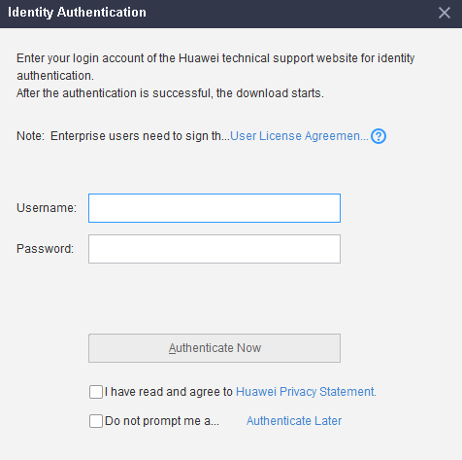

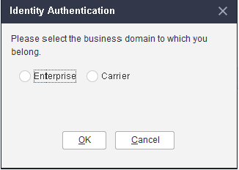
            - After SmartKit has been installed, you can start to install the patch if the Hot Patch Installation option turns black.
              - Hot patch installation
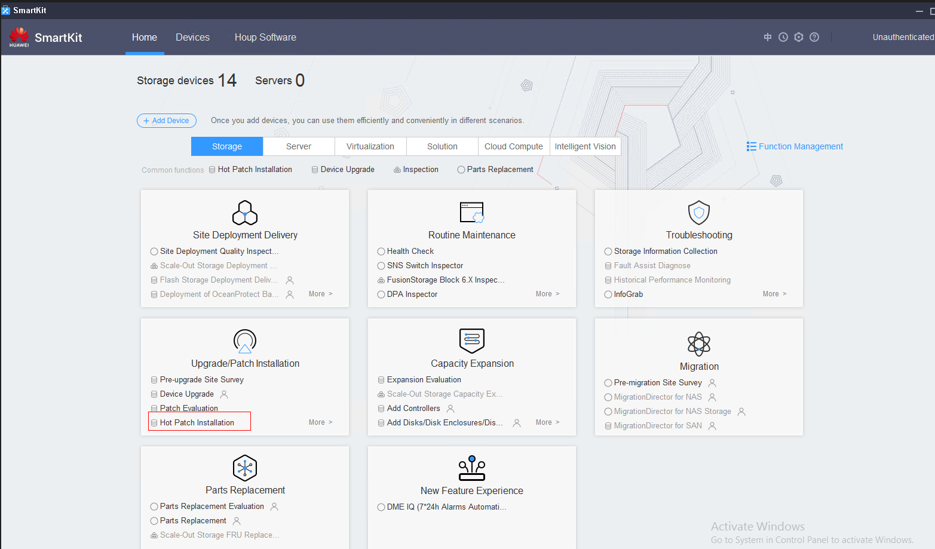
----End

(Optional) Upgrading SmartKit Online
Application Scenario
SmartKit has been installed and identity authentication has been completed. In addition, the host or laptop used to install the hot patch can access the Huawei website.
This section can be performed only after the procedure in section 3.3.1 Downloading and Installing SmartKit is complete.
Procedure
- On the SmartKit home page, click in the upper right corner. On the tool management page, click Upgrade to upgrade SmartKit to a later version.
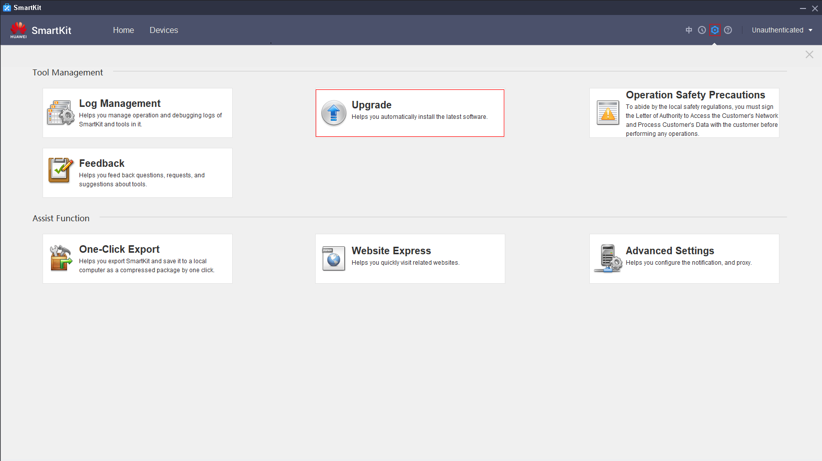
            - After the upgrade is complete, you can start to install the patch if the Hot Patch Installation option turns black.
----End

(Optional) Importing the SmartKit Function Package Offline
Application Scenario
When the host or laptop that performs the pre-upgrade site survey or upgrade fails to connect to Huawei website.
This section can be performed only after the procedure in section 3.3.1 Downloading and Installing SmartKit is complete.
Procedure
- Choose Home > Function Management, and click Export, as shown in Figure 3-3. Select the functions to be exported and click Export, as shown in Figure 3-4.
              - Clicking Export
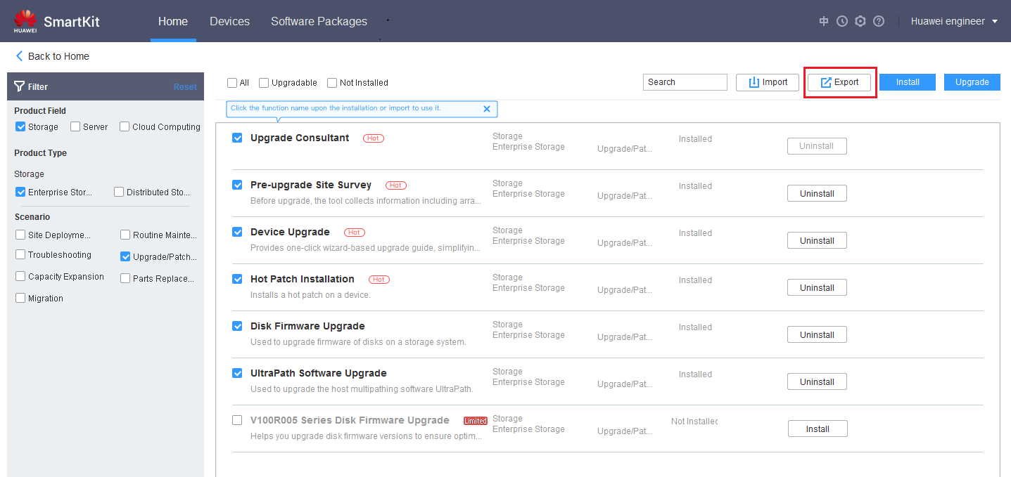

              - Export
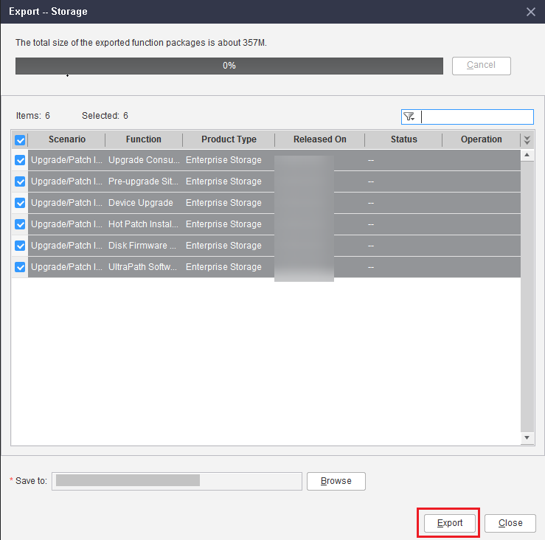

            - After the export is complete, click View to open the exported function package, as shown in Figure 3-5.
              - Clicking View
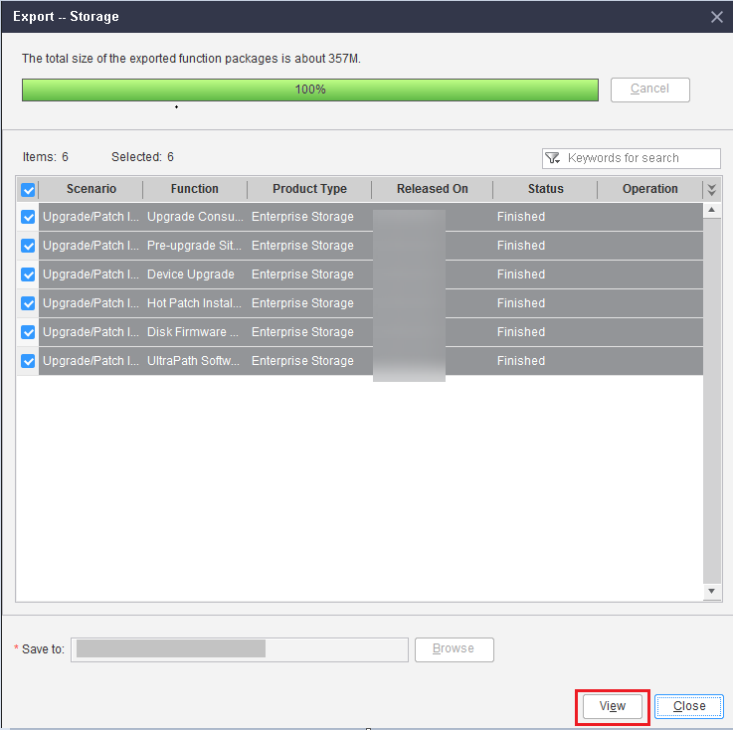

            - Copy the function package exported in Step 1 and the latest SmartKit installation later package downloaded in 3.3.1 Downloading and Installing SmartKit to the host or laptop where the pre-upgrade site survey or upgrade is to be performed.
            - Decompress the SmartKit installation package and install the latest SmartKit. On the Function Management page, click Import, as shown in Figure 3-6. Select the function package copied in Step 3 and click OK, as shown in Figure 3-7.
              - Clicking Import
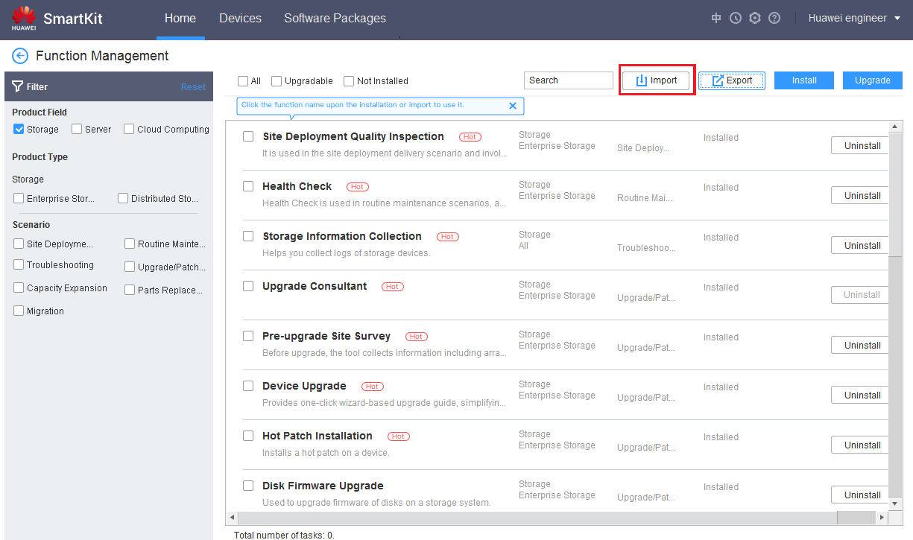

              - Clicking OK
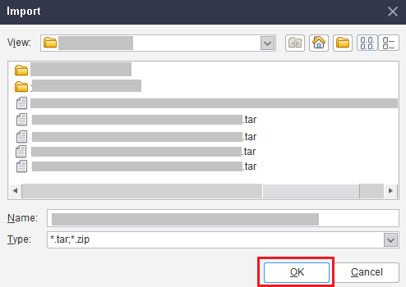

            - After the import is successful, corresponding functions are available on the Home page.
----End

Checking Patch Integrity
- To prevent a software package from being maliciously tampered with during transmission or storage, download the corresponding digital signature file for integrity verification when downloading the software package.
- After the software package is downloaded, verify its PGP digital signature according to OpenPGP Signature Verification Guide. If the software package fails the verification, do not use the software package, and contact Huawei technical support engineers.
- Before a software package is used in installation or upgrade, its digital signature also needs to be verified according to the OpenPGP Signature Verification Guide to ensure that the software package is not tampered with. Visit either of the following websites to obtain the OpenPGP Signature Verification Guide:
Carrier customers: https://support.huawei.com/carrier/docview?nid=DOC1100840125&path=PBI1-253383977/PBI1-23710112/PBI1-21431666/PBI1-253386759/PBI1-22562161&detailId=PBI1-253374093.
Enterprise customers: https://support.huawei.com/enterprise/zh/doc/EDOC1100209376?idPath=22658044|22662728|250950571|22562161.

Installing Procedure


- Before installing a hot patch, ensure that the storage system is in the normal state. Otherwise, the hot patch may fail to be installed.
- If you want to upgrade a controller before installing the hot patch, wait 20 minutes after the controller upgrade is complete, and then install the hot patch. Otherwise, the hot patch may fail to be installed.
4.1 Installing the Patch on the Storage System

Installing the Patch on the Storage System
This section describes how to install the patch on the storage system.
- On the SmartKit page, choose Upgrade/Patch Installation > Hot Patch Installation, as shown in Figure 4-1.
              - Selecting hot patch installation
            - Click Hot Patch Installation.
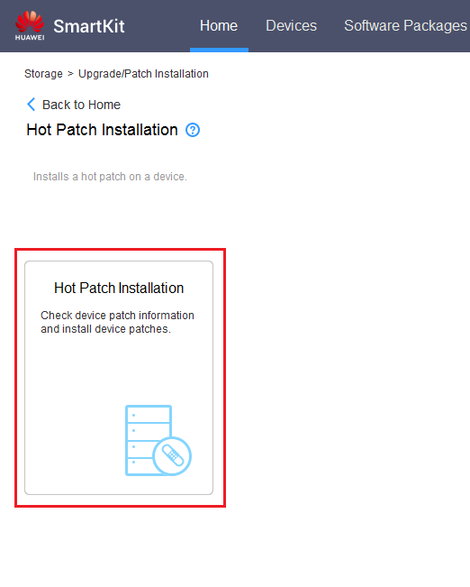
            - On the Patch Tool page, click Add Device.
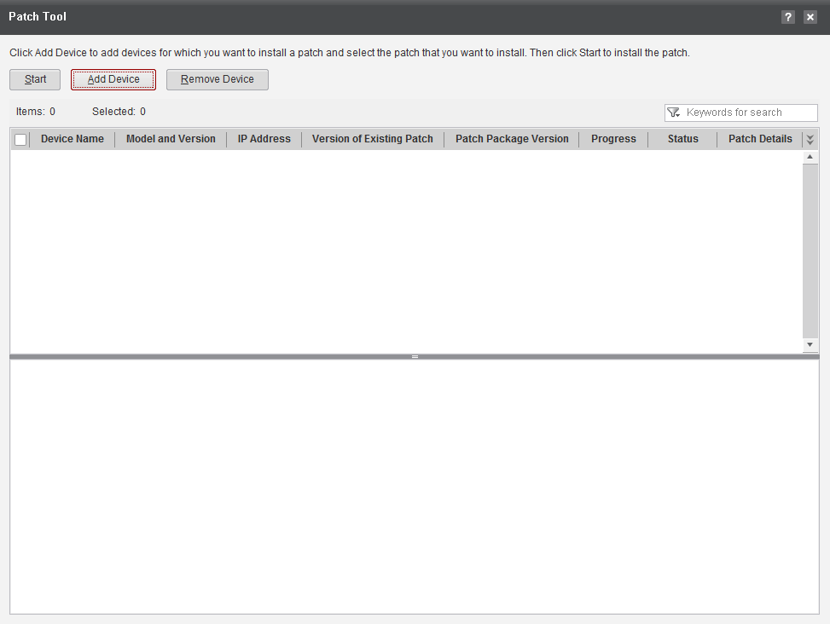
            - On the Select Device page, click Add Devices, as shown in Figure 4-2.
              - Add Devices
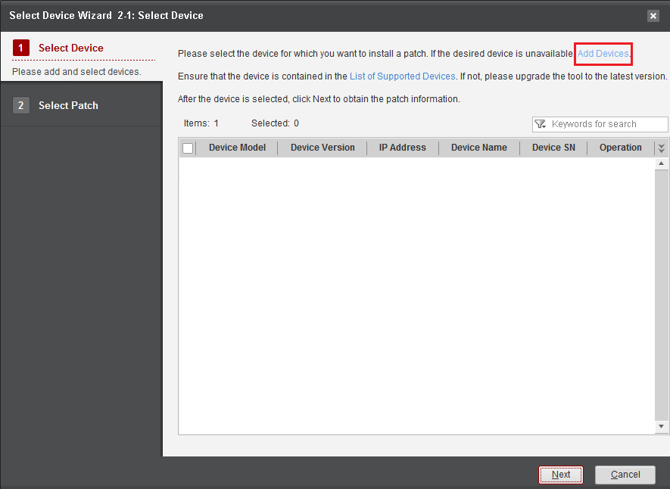

            - In IP Address, enter the IP address of the device and click Next, as shown in Figure 4-3.
              - Entering the device IP address
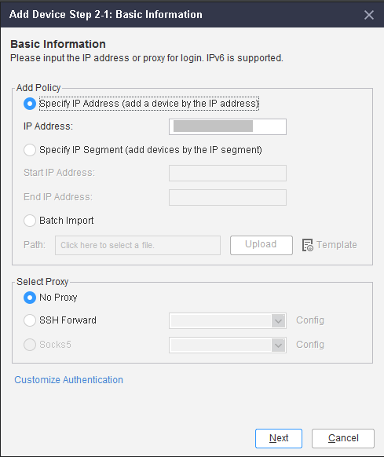

            - Enter required device information in Username and Password and click Finish, as shown in Figure 4-4.
The default value of the port is 22. Do not select Need Debugging Password.
              - Entering the username and password
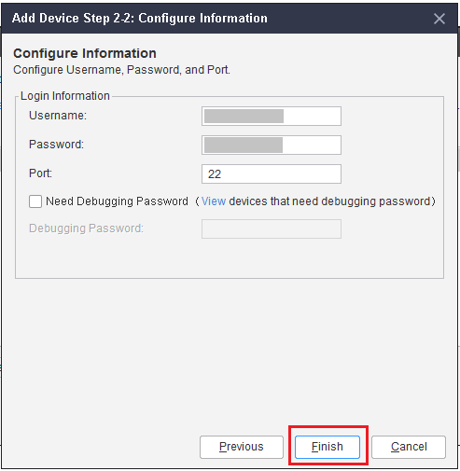

- Select the desired device and click Next.
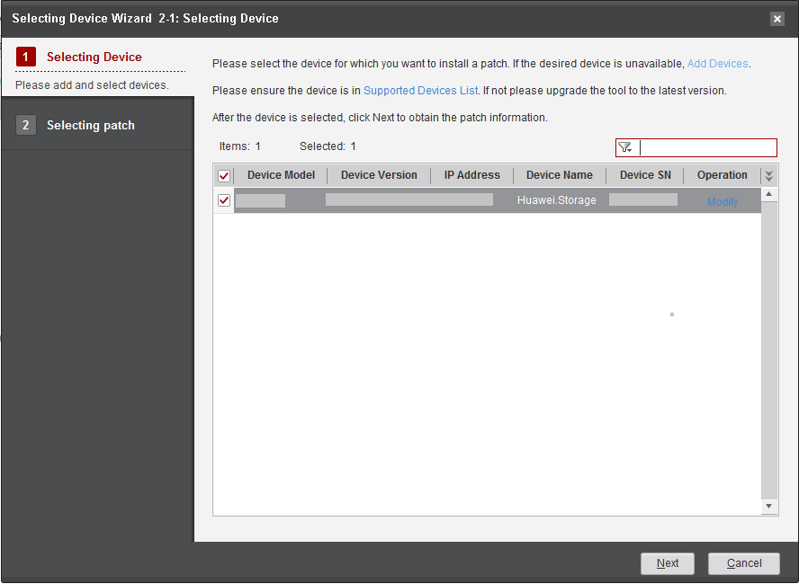
            - Select the desired device and select Manual. Click Next.
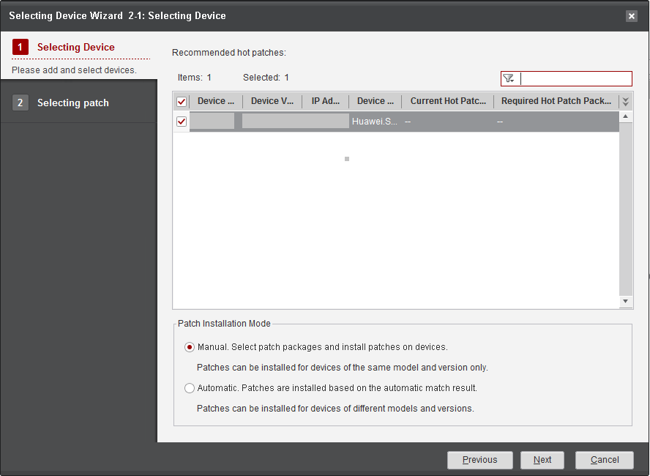
            - Select the patch package to be installed and click Finish.
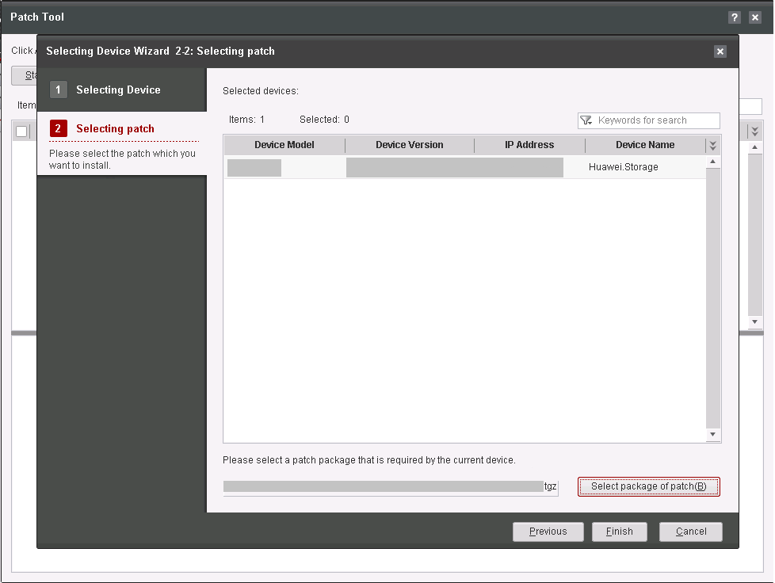
            - Select the desired device and click Start to start patch installation.
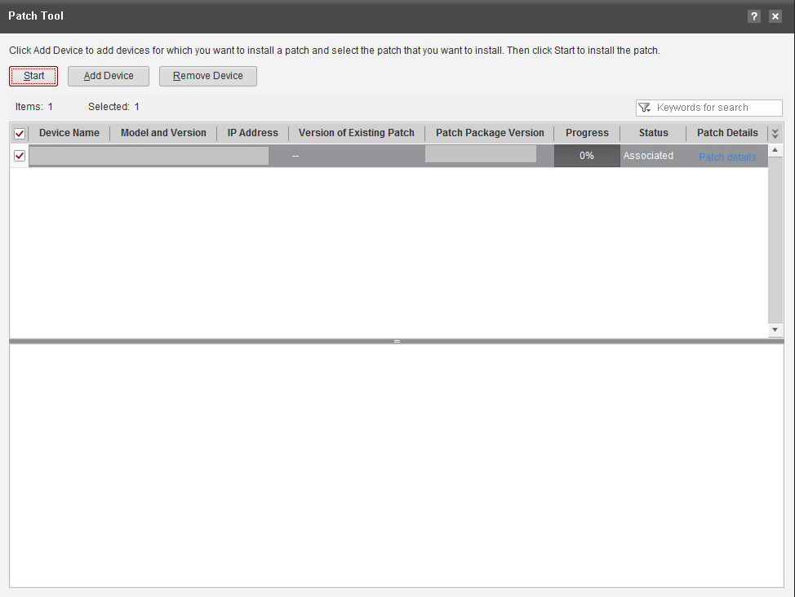
            - The system automatically installs the patch for the device.
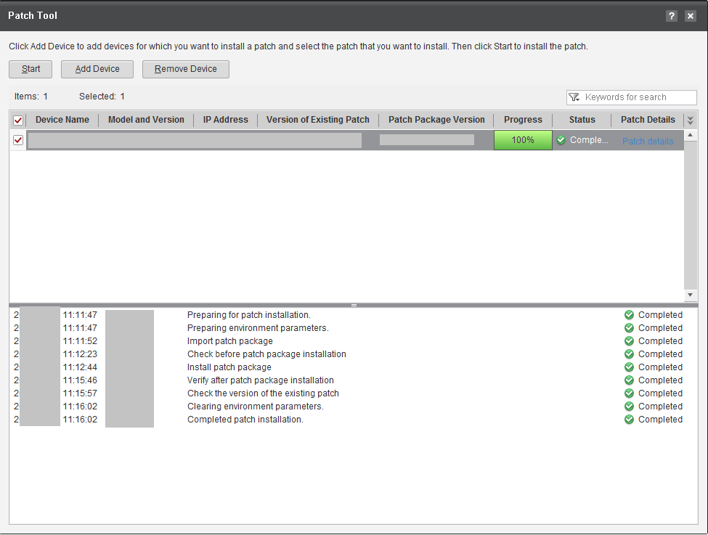
----End

Verifying Patch Installation
5.1 Verifying the Patch Version

Verifying the Patch Version
In the CLI of a controller, run show upgrade package to query the patch versions of all controllers. Verify that the patch versions are consistent with the target patch version, as shown in the following figure (a dual-controller system is used as an example).
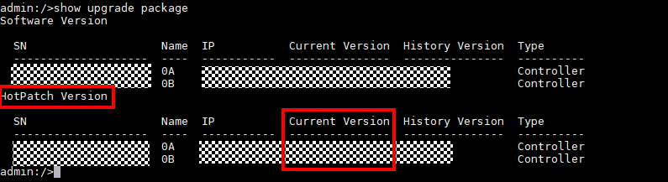

Rolling Back the Patch Installation


If you need to roll back the patch, contact technical support.
Prerequisites
The system becomes abnormal after the hot patch is installed or the hot patch conflicts with a current patch running on the device. In these cases, the current patch must be rolled back before the new patch is installed.
Check whether the storage system has historical patches. If no, see 8 Deleting the Patch . If yes, perform the following steps to roll back the patch:
Rolling Back the Hot Patch Through CLI
- Log in to the CLI and type change user_mode current_mode user_mode=developer to enter the developer mode. To roll back the patch, run the restore hotpatch command and enter y to confirm the operation.
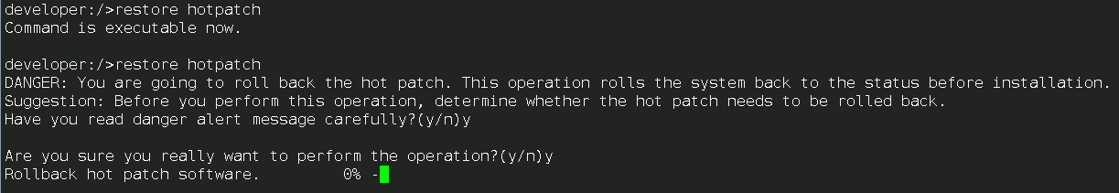
- Wait 5 to 10 minutes. The command result display shows that the rollback is successful.
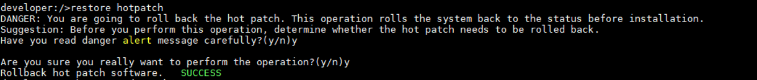
- After the patch rollback is successful, close all CLIs and log in again. Otherwise, operations relevant to the patch may be performed incorrectly.
If the rollback fails, refer to 8 Deleting the Patch If patches were installed before, download and re-install the patches after you delete them.

Verifying Patch Consistency After Rollback
- In the CLI, run show upgrade package to query the patch versions of all controllers. Verify if the patch versions are consistent with the patch version before patch installation, as shown in the following figure (a dual-controller is taken as an example).
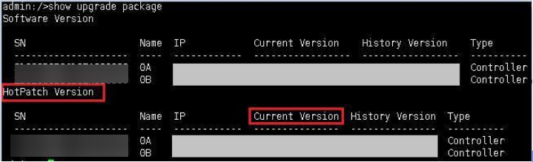

Deleting the Patch
Deleting the Hot Patch Through the CLI
- On the CLI, run the change user_mode current_mode user_mode=developer command to enter the developer mode. Then run the delete hotpatch command to delete the hot patch and enter y to confirm the operation.
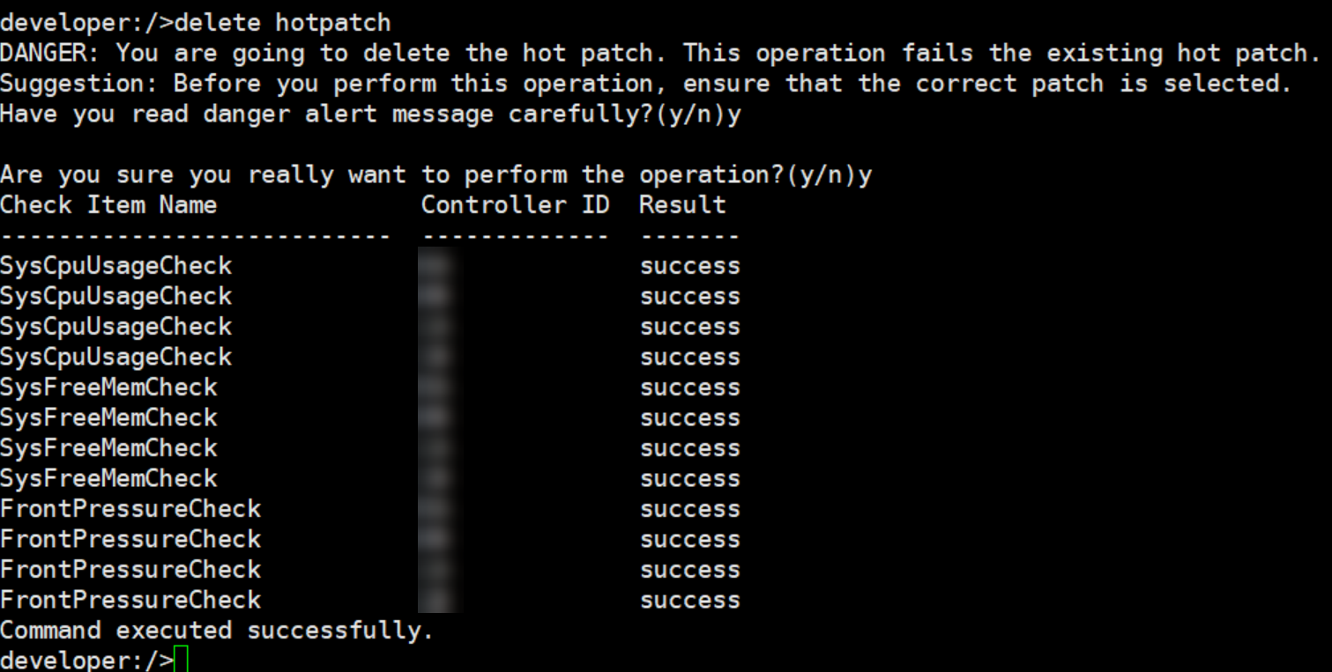

FAQs
9.1 Inconsistent Base Versions
9.2 Repeated Patch Installation
9.3 Solution to Hot Patch Installation Failure
9.4 Solution to Hot Patch Deletion Failure
9.5 Solution to the "Cannot perform the upgrade because the disk usage is high." or "System resources (CPU or memory) are insufficient" Message Displayed During the Patch Installation Check
9.6 Solution to the "Handle the Hot Patch Evaluation Failure Displayed on the DeviceManager"
9.7 How Do I Evaluate the Patch
9.8 OTA Patch Installation Procedure
9.9 Conducting an Inspection
9.10 Checking Whether the Antivirus Service Is Used
9.11 Overwrite Installation of the Antivirus Agent Plug-in

Inconsistent Base Versions
Question: During the installation, a message is displayed indicating that Handling after package distribution fails to be executed. The installation is interrupted.
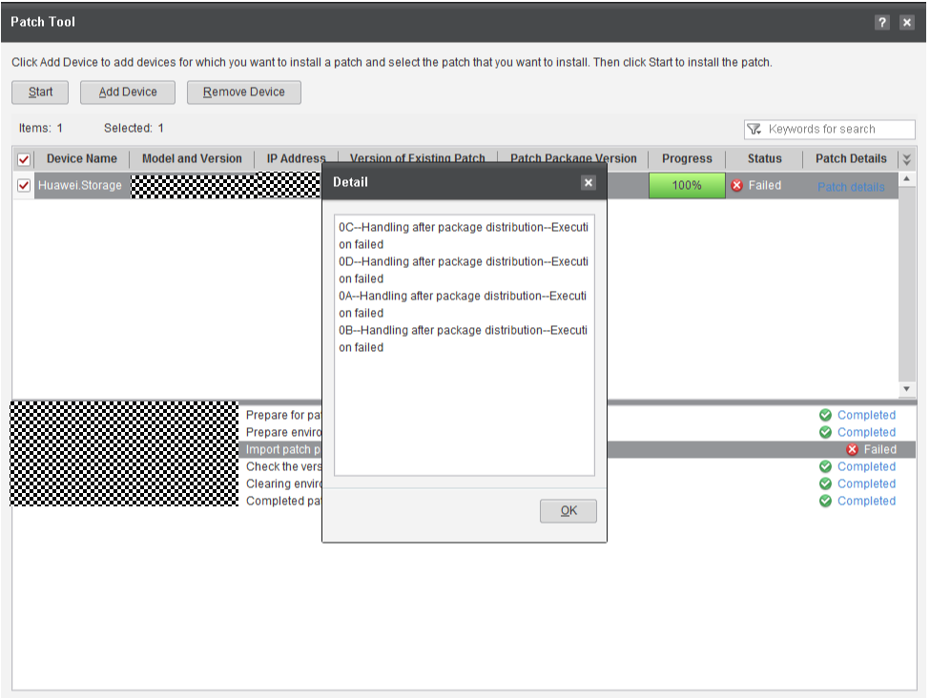
Answer: This fault occurs because the base version of the hot patch package is inconsistent with the current device version. View the Version Mapping and down the correct hot patch package from the website and install the patch.

Repeated Patch Installation
Question: During the installation, a message is displayed indicating that Checking the Patch Status fails to be checked. The installation is interrupted.
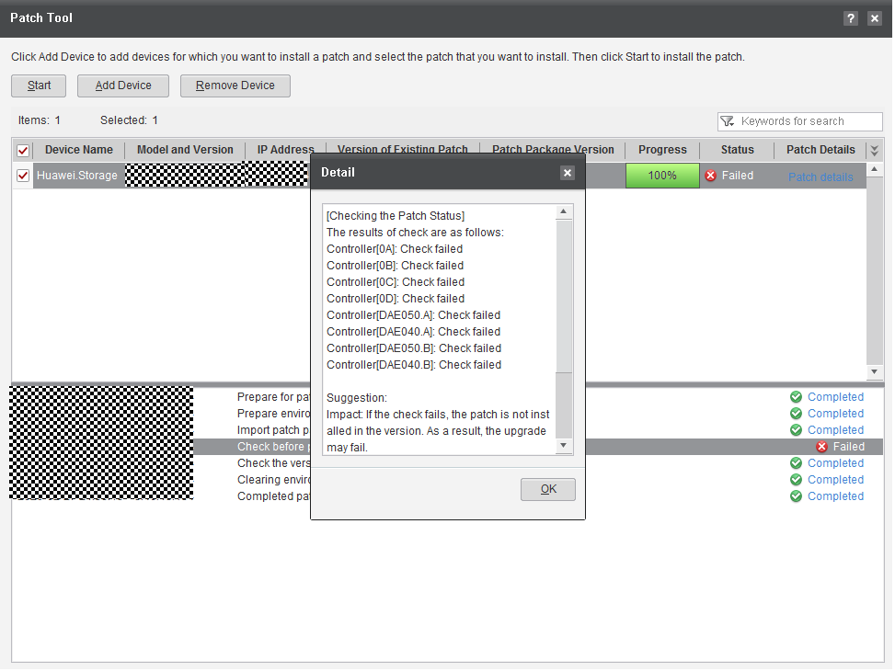
Answer: This fault occurs because the hot patch has been installed successfully. View the Version of Existing Patch in the figure and check whether the hot patch package has been installed or the correct hot patch package has been imported.

Solution to Hot Patch Installation Failure
Question: How to handle hot patch installation failure.
Answer: A hot patch installation fails and the storage array is automatically rolled back.
After the rollback is complete, please reinstall it. If fail, collect logs and contact technical support engineers.

Solution to Hot Patch Deletion Failure
Question: How to handle hot patch deletion failure?
Answer: If a message reporting that the hot patch fails to be deleted is displayed, log in to the CLI and run the show upgrade package command. If the command output indicates no patch, the patch is successfully deleted, as shown in the following figure (a dual-controller system is used as an example). If the command output indicates that there are still patches left, collect the logs and contact Huawei technical support.
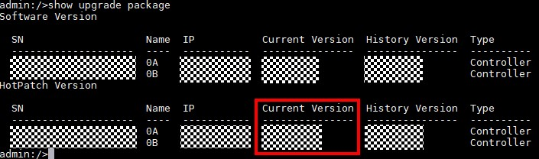

Solution to the "Cannot perform the upgrade because the disk usage is high." or "System resources (CPU or memory) are insufficient" Message Displayed During the Patch Installation Check
Question: What can I do if the "Cannot perform the upgrade because the disk usage is high." or "System resources (CPU or memory) are insufficient" message is displayed during the patch installation check?
Answer: If the host workload is light, post-process deduplication increases the CPU usage, causing the CPU usage check to fail. You must temporarily disable post-process deduplication and install the patch again.
- Log in to CLI and run the show disk_domain general command to query the domain ID, as shown in the following figure.
            - Run the change user_mode current_mode user_mode=developer command to enter the developer mode. Run the change ddp pdr_switch switch=off disk_domain_id=[disk_domain_id] pause_duration=15 command to temporarily disable post-process deduplication for the specified disk domain. The value of disk_domain_id is the disk domain ID queried in step 1.
----End

Solution to the "Handle the Hot Patch Evaluation Failure Displayed on the DeviceManager"
Question: How do I handle the message indicating a pre-check failure is displayed on the DeviceManager GUI during the pre-patching check using SmartKit?
Answer: Ignore the failure information displayed on the DeviceManager page.

How Do I Evaluate the Patch
- After SmartKit and upgrade-related plug-ins are installed, go to the Home page and choose Upgrade/Patch Installation > Patch Evaluation.
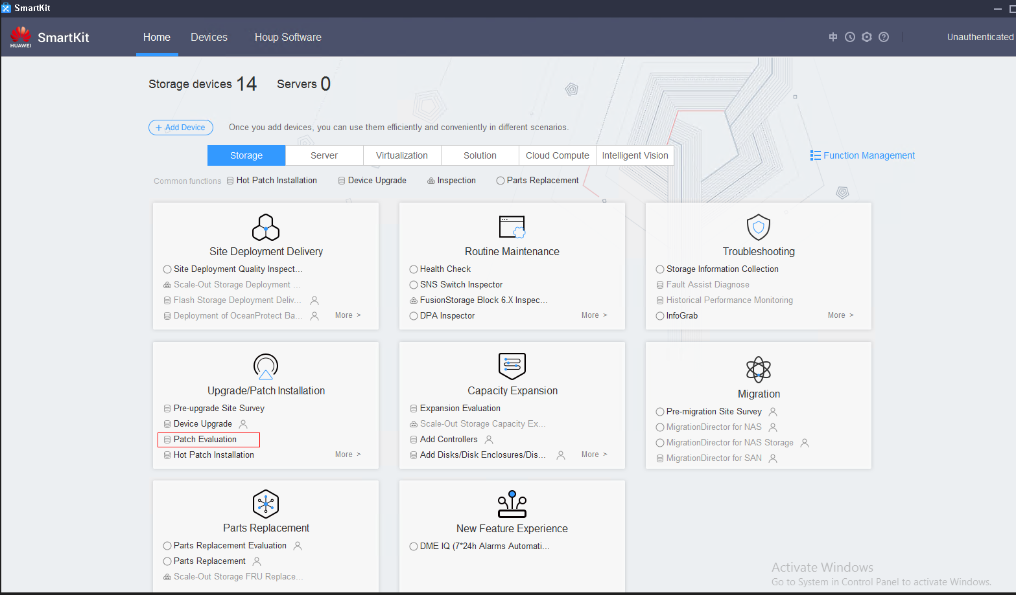
            - On the Patch Evaluation page, click Add Device.
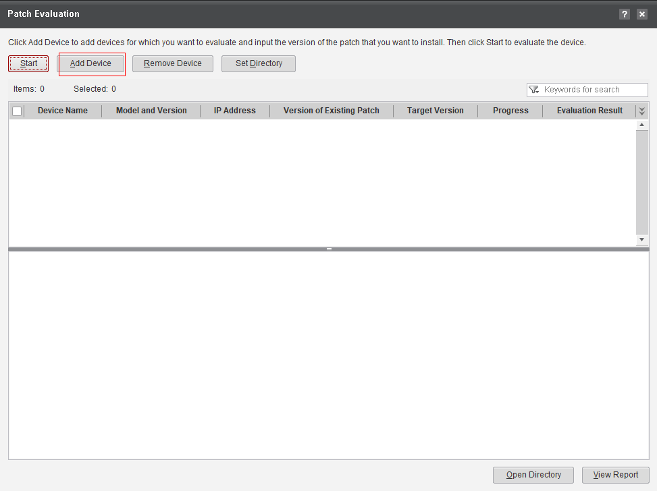
            - Click Add Devices, enter the management IP address of the device, and click Next.
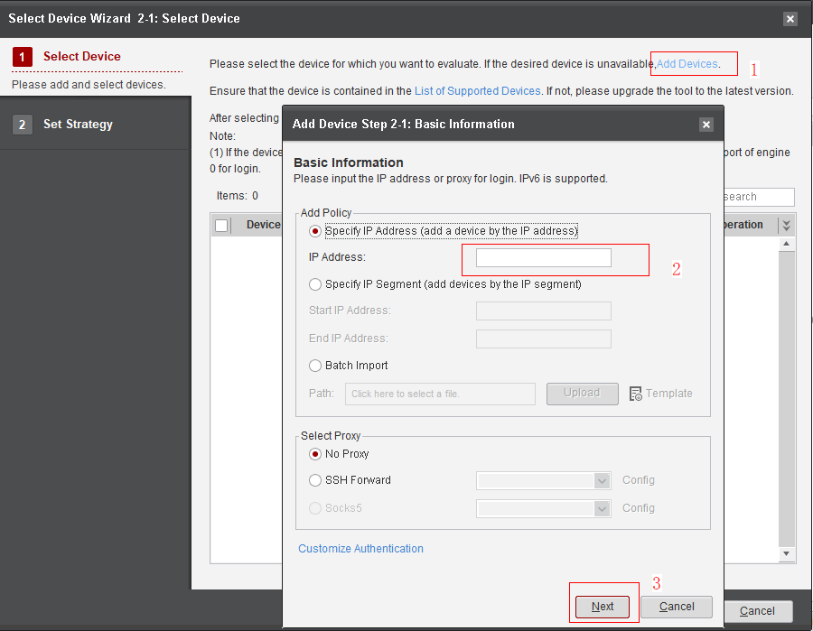
            - Enter the username and password of the device and then click Finish.
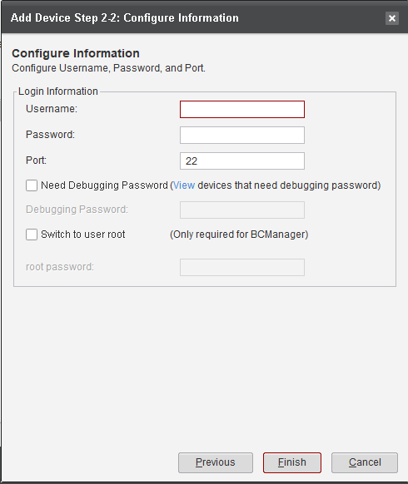
- Select the device to be added and click Next.
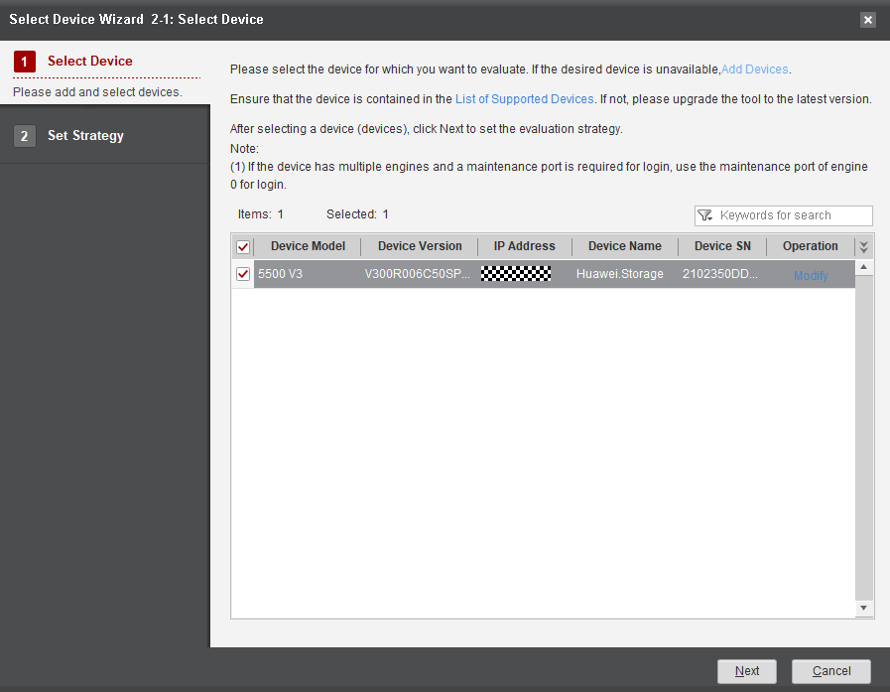
            - On the Set Strategy page, enter the target version and click Finish.
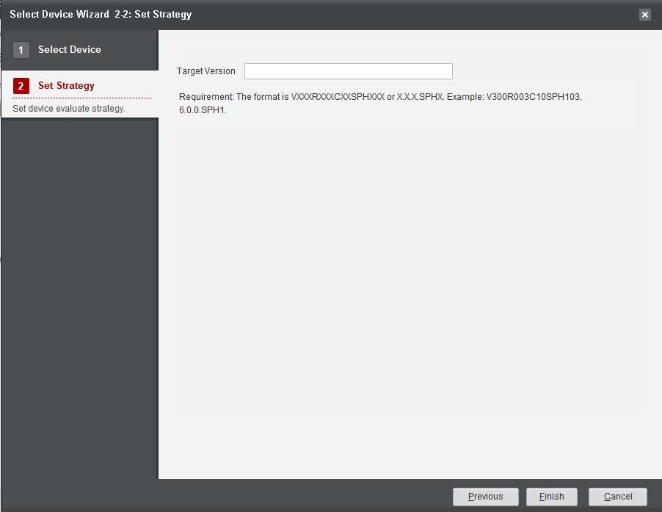
            - Select the device and click Start.
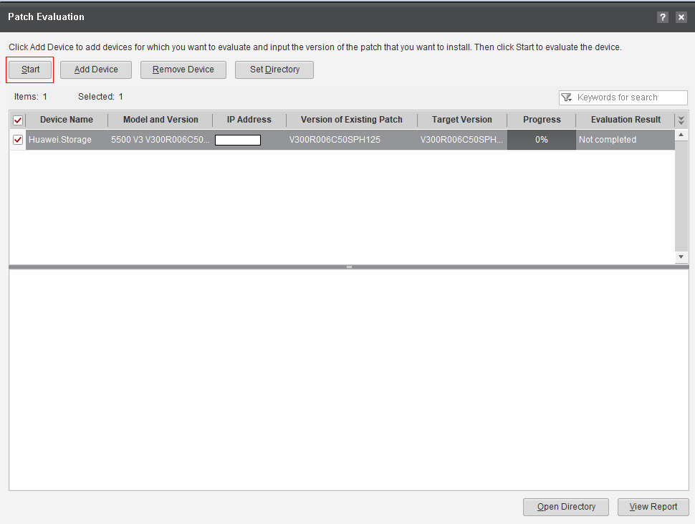
            - After the upgrade evaluation is complete, if the result of any check item is Failed, click the check item and rectify the fault by referring to the specific check method. Then perform an evaluation again till the result of each check item is Passed.
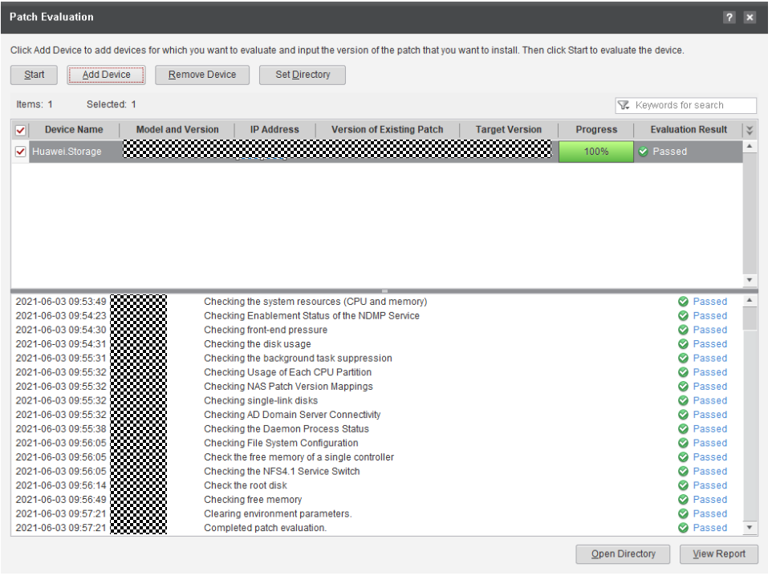
----End

OTA Patch Installation Procedure
This section describes how to install the device patch in Over The Air (OTA) mode.

- The OTA patch installation uses the same entry as the OTA upgrade function. Therefore, the upgrade information described in this section is about patch installation.
- If a patch is limited, it cannot be obtained and installed through the OTA.

Before You Start
In OceanStor 6.1.3RC2 and later, you can upgrade a device in OTA mode after connecting it to DME IQ. Compared with the SmartKit-based upgrade, the OTA upgrade does not require complex operations, such as formulating upgrade policies, downloading software packages, and installing SmartKit. The version update is immediately pushed after new release and you only need to log in to DeviceManager to upgrade devices.

1. The current version must be 6.1.3RC2 or later.
2. Only mid-range and low-end models support this upgrade mode.

Connecting a Device to DME IQ
This section describes how to connect a device to DME IQ and enable the OTA upgrade function.
- Log in to DeviceManager and choose Settings > DME IQ Settings. If you have connected the device to DME IQ as shown in Figure 9-1, click Test Network to ensure that the network connectivity is normal. Otherwise, go to the next step.
              - DME IQ Settings
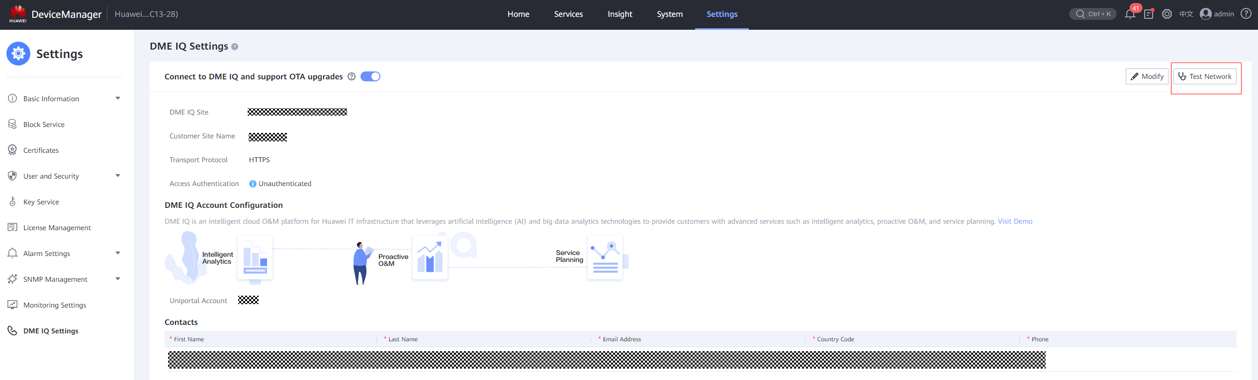
            - Click the online help icon in the upper right corner of DeviceManager to go to the Online Help page. Search for Setting DME IQ and refer to the procedure to connect the device to DME IQ.
----End

Querying the Version Update
This section describes how to check whether a device can be upgraded to another version after it has been connected to DME IQ.
- Log in to DeviceManager after connecting a device to DME IQ. If a new version is detected, the system prompts a message, as shown in Figure 9-2.
              - New version prompt
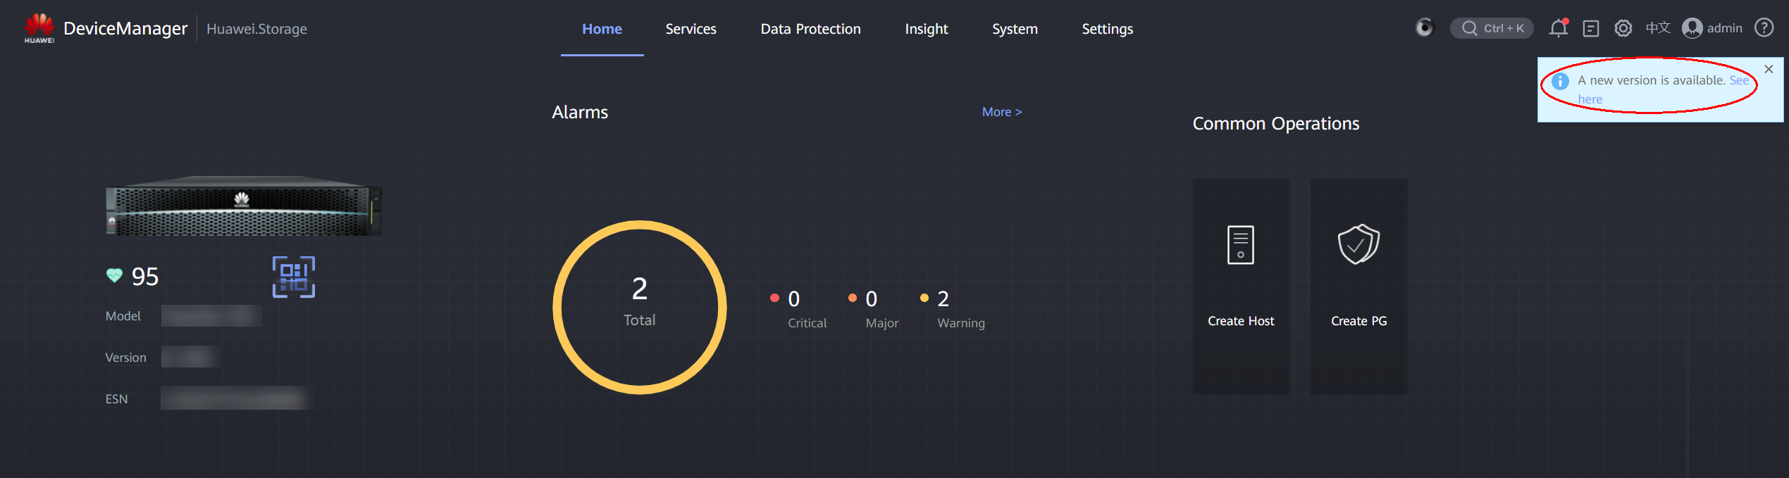
You can also click in the upper right corner of DeviceManager to go to the Upgrade page and view the version update information.
            - Click View Now. The version details page is displayed, as shown in Figure 9-3.
              - Version details page
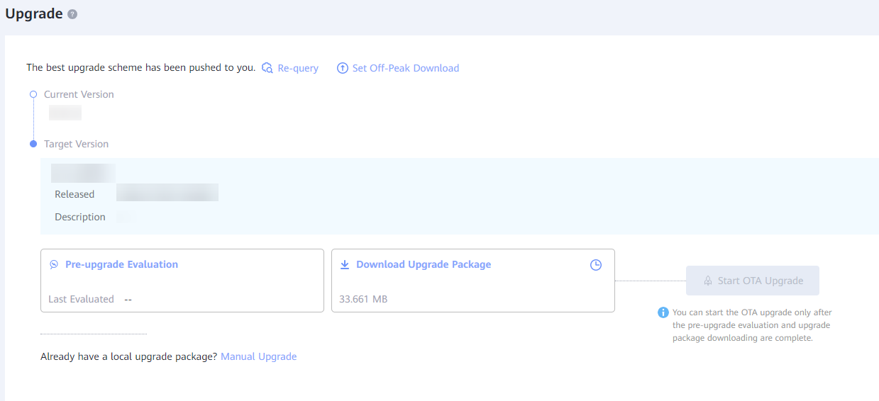
- As shown in the preceding figure, you can view the current version and available target version of the device. Specifically, you can view the version number, release time, and description of the target version.
- You can perform all subsequent OTA patch installation operations on this page, including pre-patch installation evaluation, patch package download, and patch installation startup.
----End

Performing Pre-upgrade Evaluation
This section describes how to perform pre-upgrade evaluation. The device pre-upgrade check is automatically performed before the upgrade starts.

- Pre-upgrade Evaluation is used. The evaluation and check are performed based on the actual change operations. For example, the pre-patch installation evaluation is performed during patch installation.
- The pre-upgrade evaluation aims to identify problems that may fail the upgrade before downloading the software package and starting the upgrade. You must ensure that all check items pass the check before performing subsequent steps.
- On the version details page, click Pre-upgrade Evaluation. The system automatically performs the pre-upgrade evaluation.
              - Starting upgrade evaluation
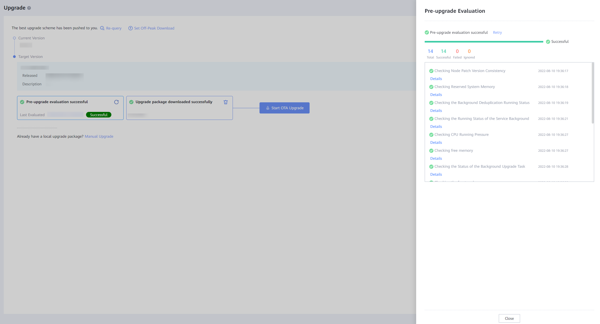
            - If all evaluation items are passed, click Close to exit the evaluation page.
            - If any item fails to pass the evaluation, click Failure Details to view the failure cause and rectification suggestions. Rectify the fault based on the suggestions and redo the evaluation until all evaluation items are passed.
              - Viewing failed item details
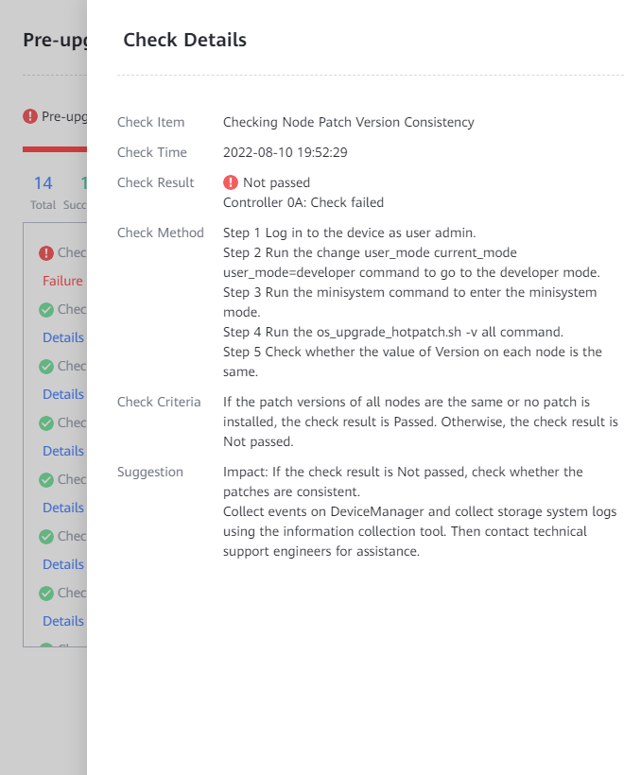
            - After the fault is rectified, click the retry button to redo the evaluation.
              - Redoing evaluation
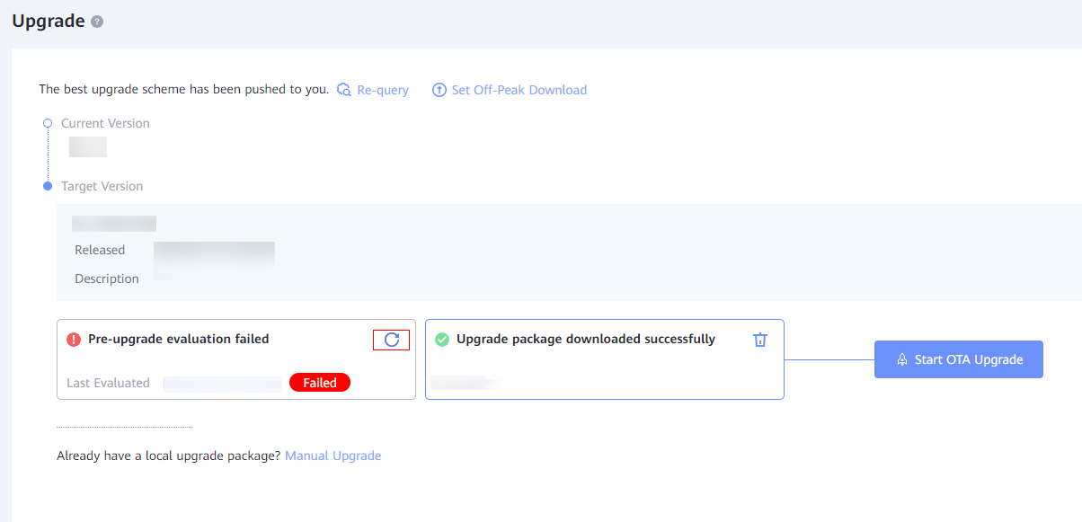
- You can click the last evaluation record to view its details.
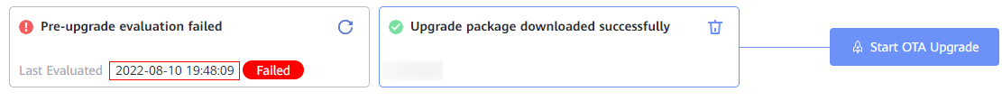
- You can click Retry to redo the evaluation on the last evaluation details page.
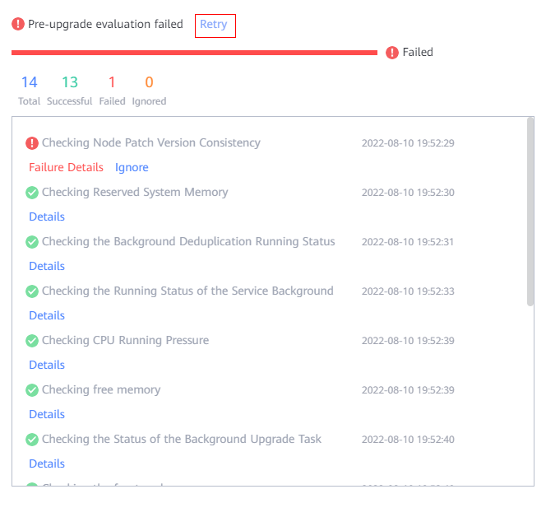
----End

Downloading the Patch Package
This section describes how to download the patch software package.
- The software package download may take a long time due to network problems. You are advised to arrange the download before the patch installation time window according to the software package size and current download speed.
- You are advised to download the software package only after the patch installation evaluation is passed. Otherwise, the device may not meet patch installation requirements, wasting download time.
- Click Download Upgrade Package. The system automatically downloads the upgrade software package.
              - Starting download
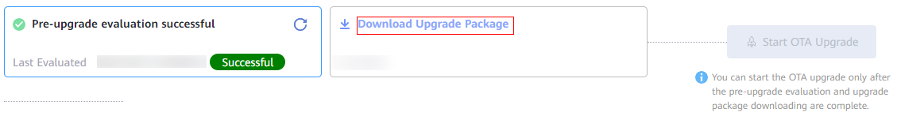
              - Displaying the current progress
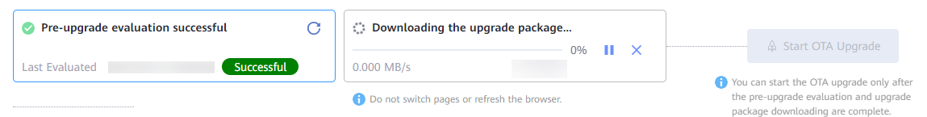
- You can click to pause the download and then resume it at any time since the downloaded part is stored on the device.
- You can click to cancel the download. The cancellation will delete the downloaded package and terminate the download task. You need to restart the download task for another download.
- If a network exception interrupts the download, the download task is automatically suspended and is resumed after the network is recovered.
- After the download is complete, you can click to delete the downloaded package.
----End

Setting Off-Peak Download
This section describes how to set the off-peak download function.
- You can configure the start time, end time, and maximum download speed for off-peak download. In this way, the software package can be automatically downloaded when a new version is detected.
- After a device is connected to DME IQ, off-peak download is enabled by default.
- On the version details page, click Set Off-Peak Download and set the start time, end time, and maximum speed, as shown in Figure 9-9
              - Setting off-peak download parameters
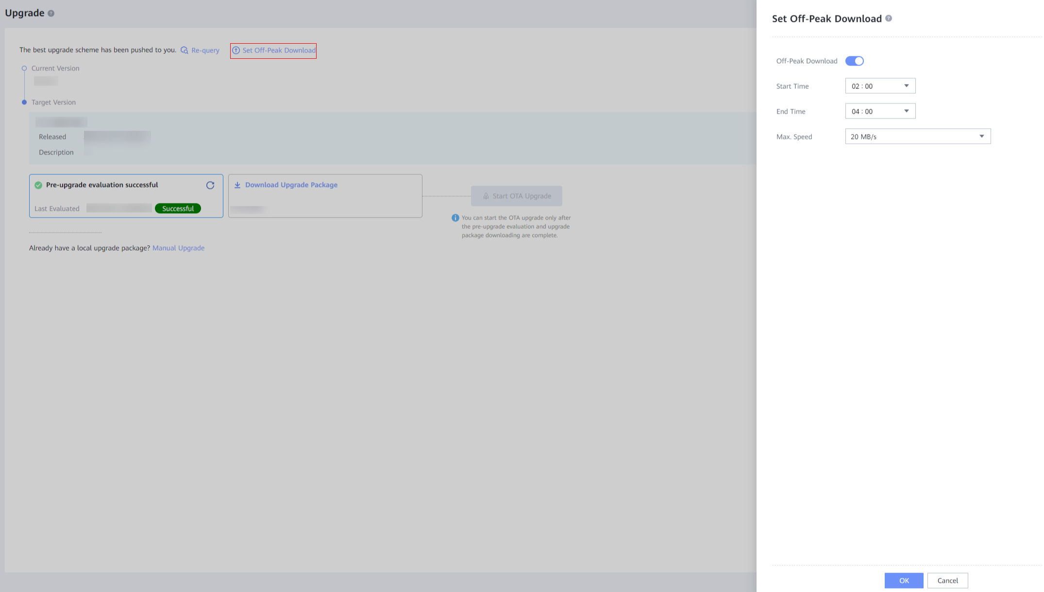
If off-peak download is not required, you can turn off the switch, as shown in Figure 9-10.
              - Disabling off-peak download
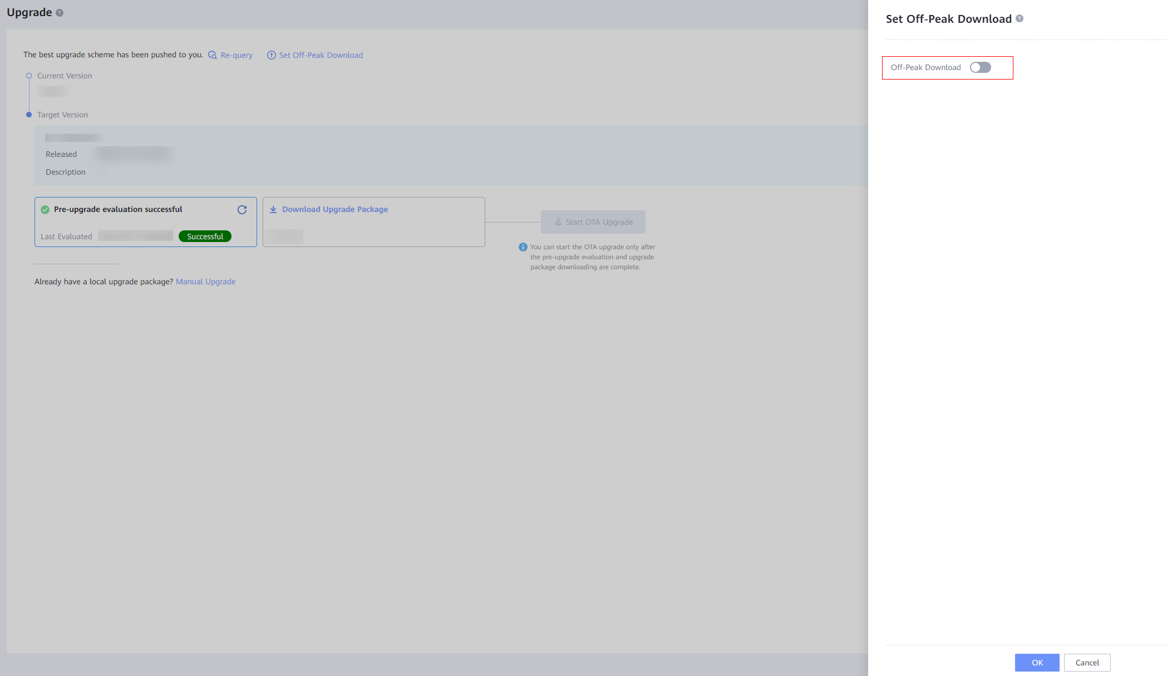
            - The system automatically starts to download the upgrade software package after entering the time interval set in off-peak download.
              - Off-peak download in progress
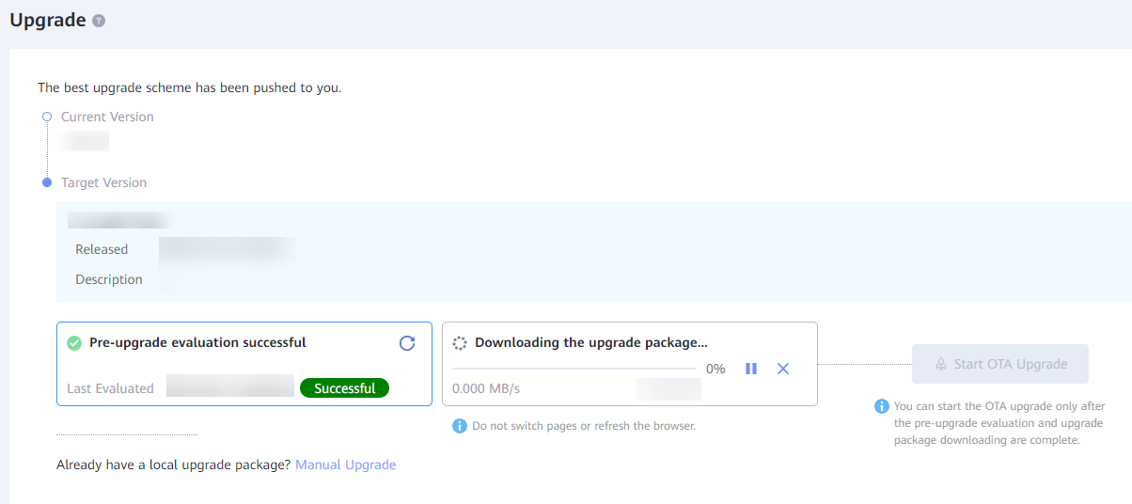
----End

Installing a Device Patch
This section describes how to install a device patch after the patch package is downloaded.
- Click Start OTA Upgrade. The window for confirming the target patch version is displayed. Click the Upgrade button.
              - Confirming the target patch version
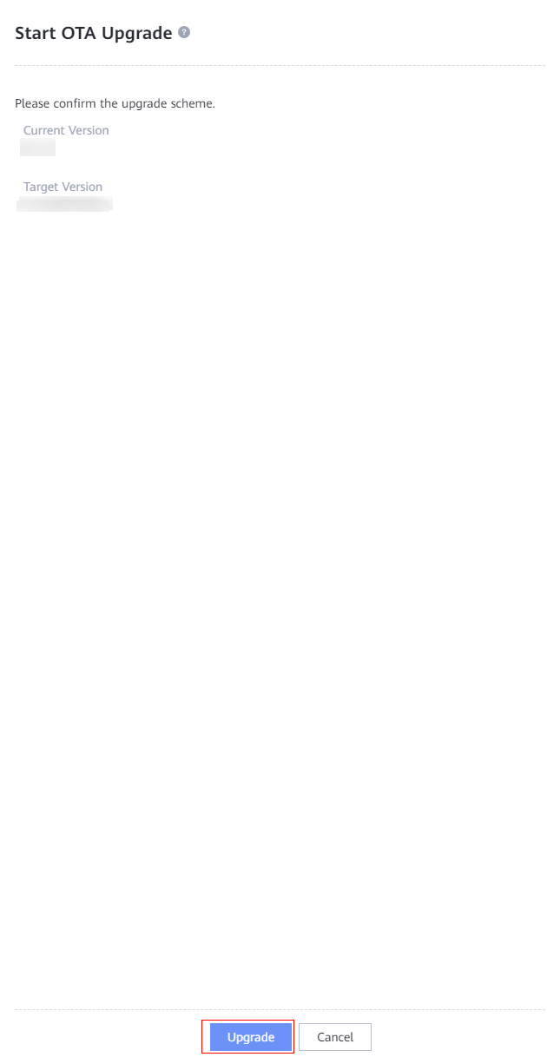
            - Confirm the risk as prompted and click OK.
              - Risk confirmation
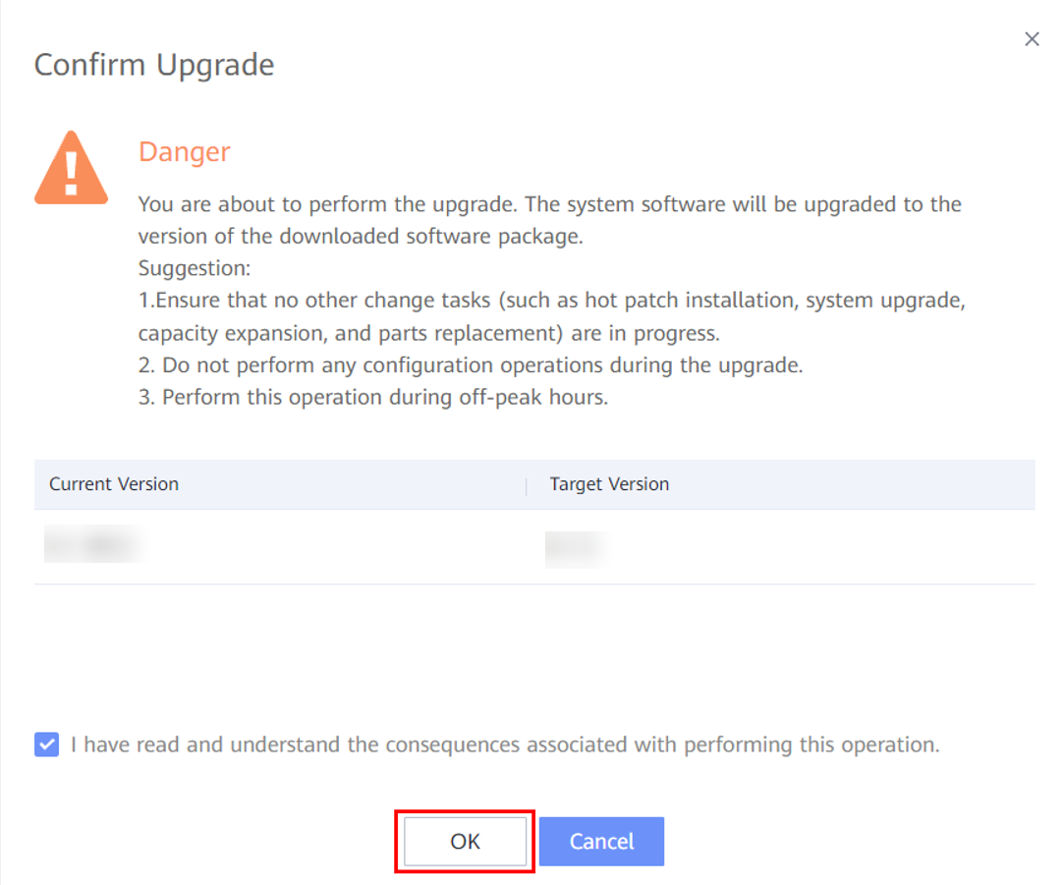
- If you do not want to continue the patch installation, click Cancel.
- After you click OK, the system automatically starts the patch installation process, and completes all steps if no exception occurs. You cannot stop or cancel the patch installation during the process.
            - The system automatically distributes the patch package to all device nodes, as shown in Figure 9-14.
              - Package distribution
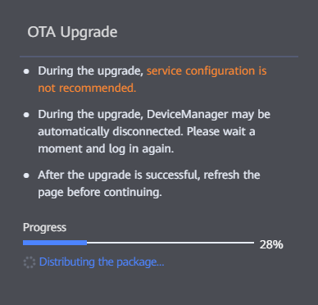
This step will fail if the patch package is incomplete or a download error occurs. The failure cause will be displayed on this page. You can manually query the version on the version details page, download the patch package again, and redo the installation.
            - After distributing the patch package, the system automatically redoes a pre-patch installation check to ensure a normal system status and correct software package.
              - Performing a pre-patch installation check
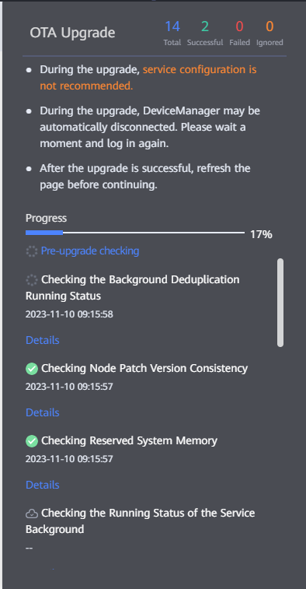
You can ignore the check result of some failed check items and continue the upgrade.
            - After the pre-patch installation check is passed, the system automatically enters the patch installation execution phase. In normal cases, the process cannot be terminated or exited until the patch installation is complete.
              - Performing the patch installation
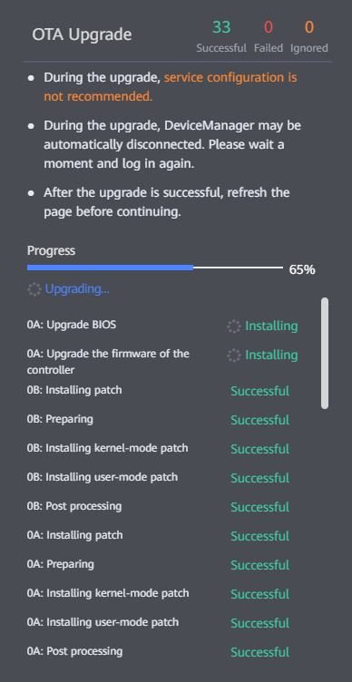
If the patch installation fails due to an exception, the system automatically rolls back to the source version. If an exception also occurs during the rollback, the process stops at the failure point and manual intervention is required. In this case, contact Huawei technical support engineers.
            - After the patch installation is complete, the system automatically performs a post-patch installation check to ensure a normal system status.
              - Performing the post-patch installation check
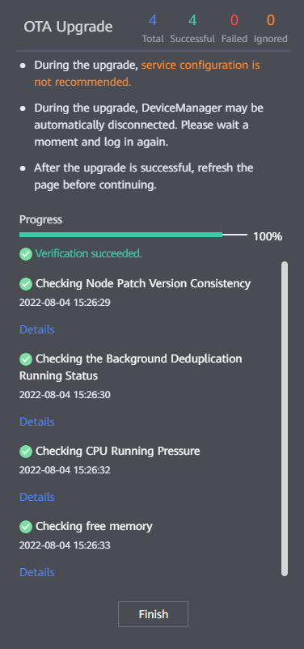
- The patch installation process enters the post-patch installation check phase, in which the patch is installed successfully.
- If the post-patch installation check fails, rectify the fault by clicking Details.
----End

Conducting an Inspection

The inspection is to check the system health status after the installation. The system status is normal only when all inspection items pass the check. Otherwise, rectify the failed items as prompted.
Procedure
- After the fast upgrade is complete, Click Health Check in the Routine Maintenance window, as shown in Figure 9-18. Select the check items. By default, all items are selected, as shown in Figure 9-19.
              - Starting the health check
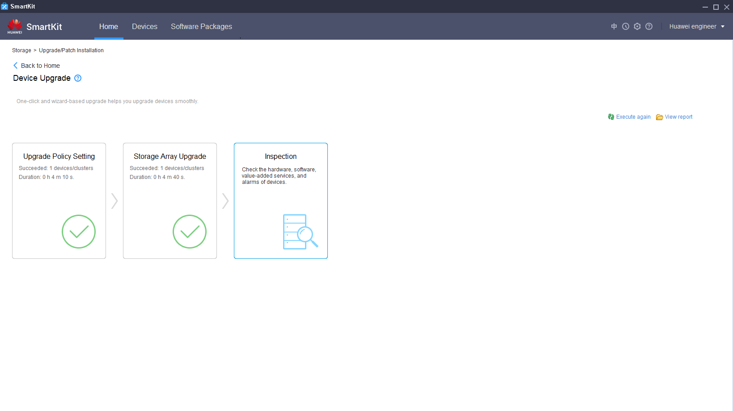

              - Selecting check items
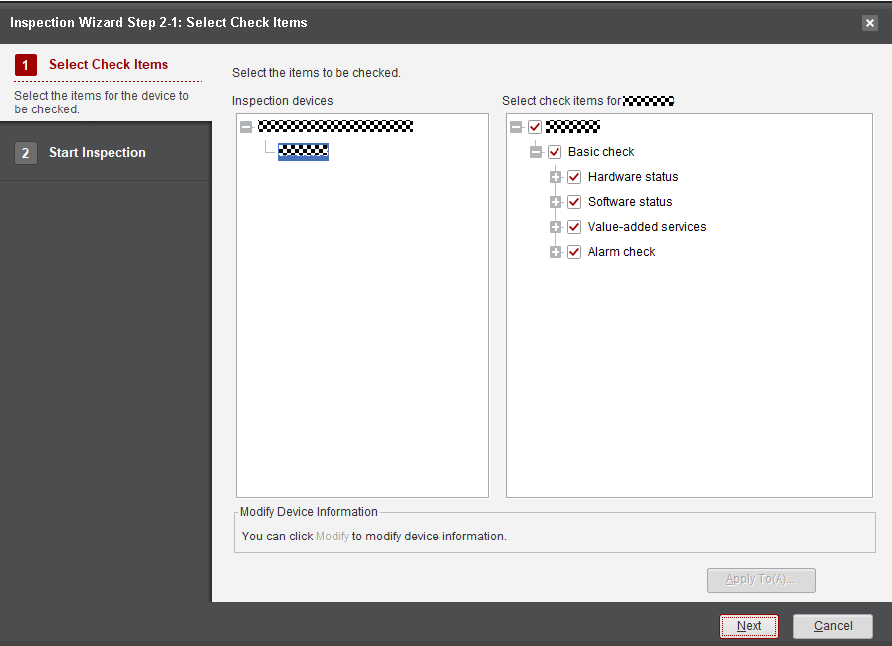

            - Click Next. The inspection starts and takes about 5 minutes, as shown in Figure 9-20.
              - Inspection completed
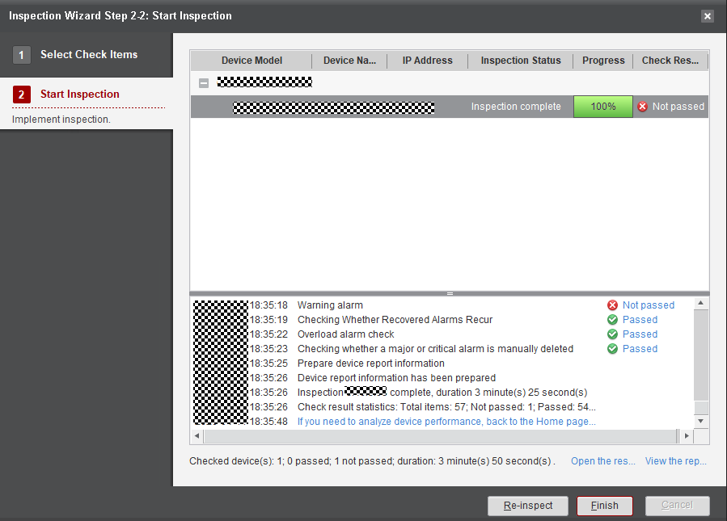

            - After the inspection is complete, click Passed or Not passed to view the inspection details, as shown in Figure 9-21.
              - Viewing the inspection details
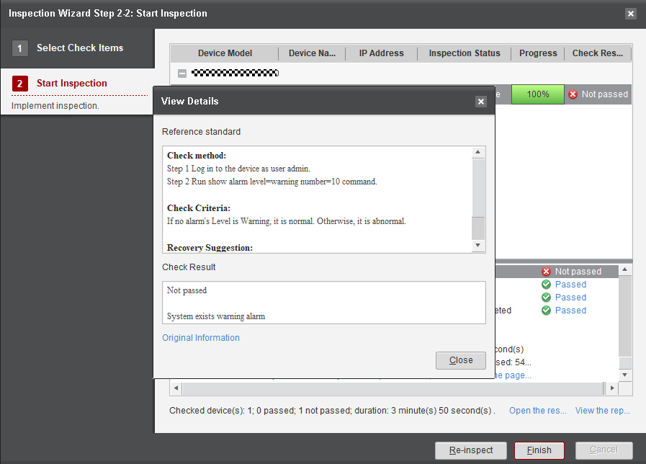

            - Click Original Information to view error details, as shown in Figure 9-22.
              - Original information
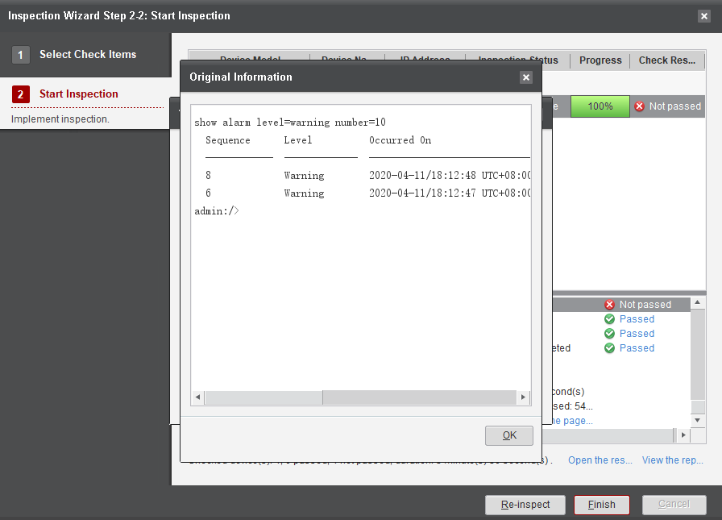

            - Click View the report, as shown in Figure 9-23.
              - Viewing the report
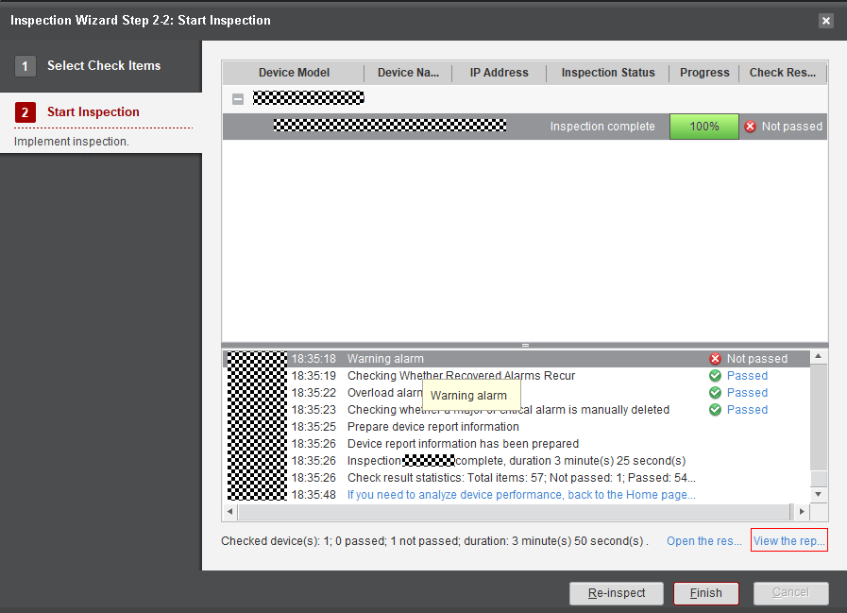

            - Click the navigation tree on the left for detailed information, as shown in Figure 9-24.
              - Detailed storage device inspection report
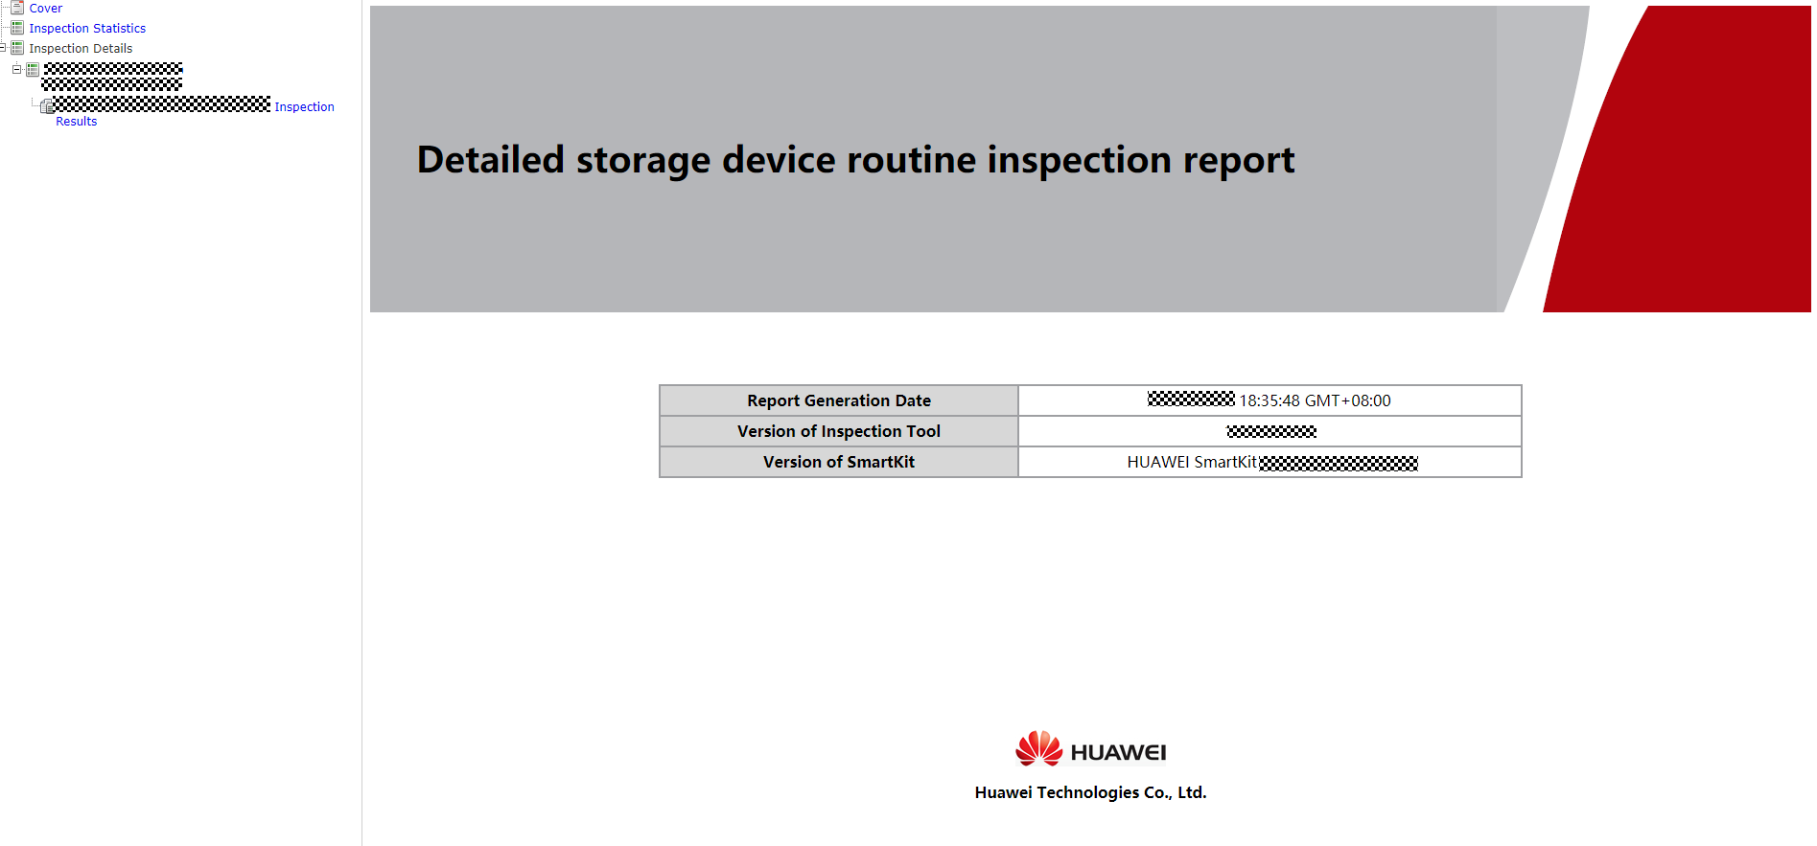

----End

Checking Whether the Antivirus Service Is Used
On DeviceManager, choose Settings > File Service > Antivirus Service to check whether the antivirus service is enabled, that is, select vStores one by one to check whether the antivirus service is enabled for any vStore.
If the antivirus service is enabled for any vStore and the antivirus agent plug-in is not downloaded from DeviceManager to overwrite the previous version after SPH16 or a later patch is installed, refer to 9.11 Overwrite Installation of the Antivirus Agent Plug-in .
              - Antivirus service page
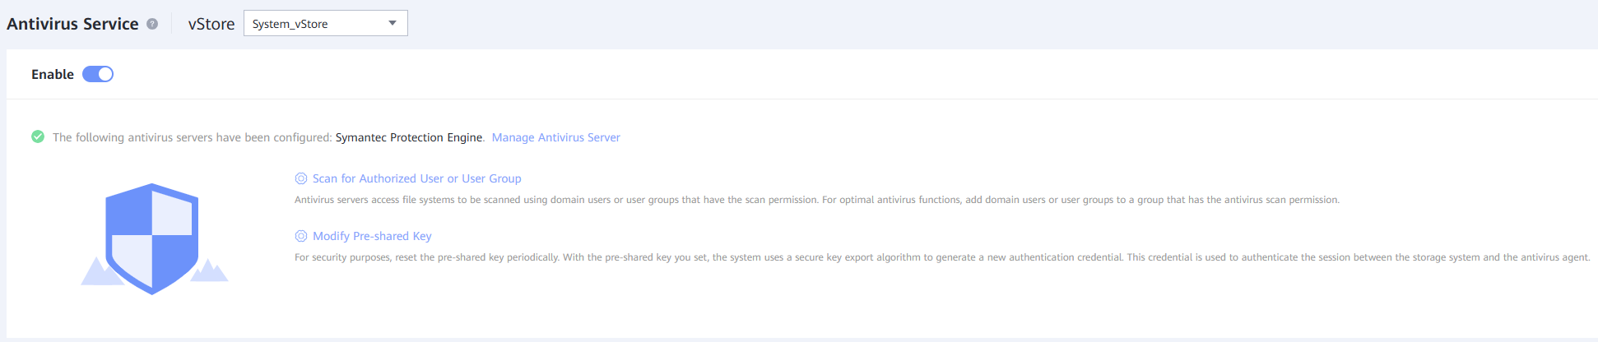

Overwrite Installation of the Antivirus Agent Plug-in
- After the patch installation, download the antivirus agent plug-in on the Antivirus Service page of DeviceManager.
              - Downloading the antivirus agent plug-in
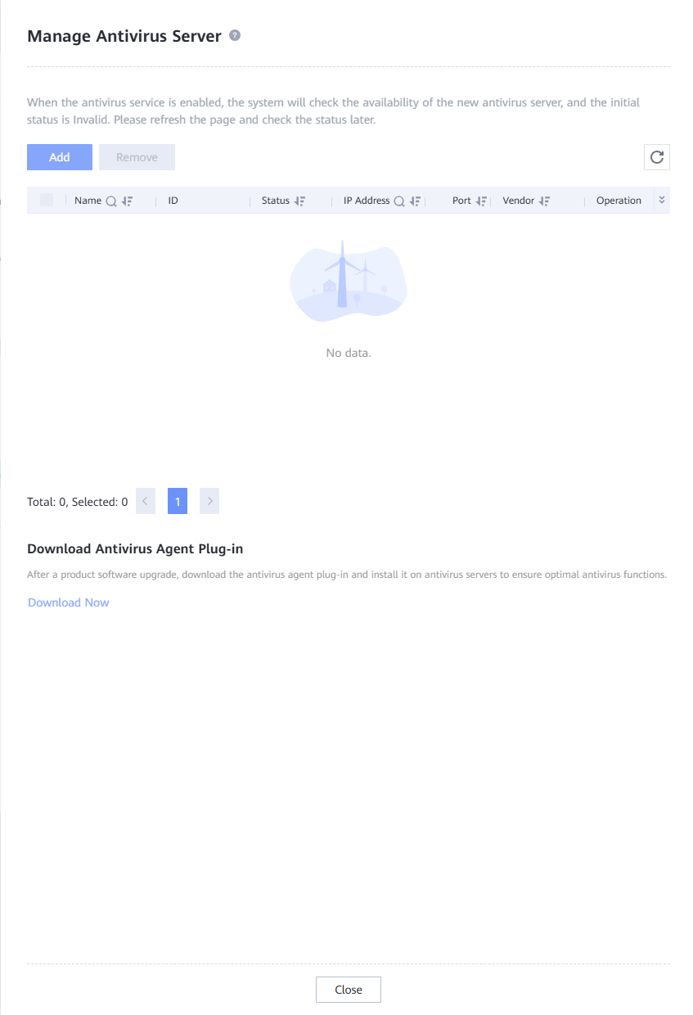

            - Copy the antivirus agent plug-in to the antivirus servers in use.
            - Run the antivirus agent plug-in to overwrite the previous version.
              - Performing overwrite installation
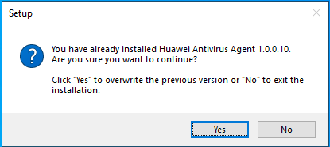

            - On the Services page, log in to the Antivirus Agent Watchdog again as an antivirus privileged user and restart the service.
              - Re-logging in as an antivirus privileged user
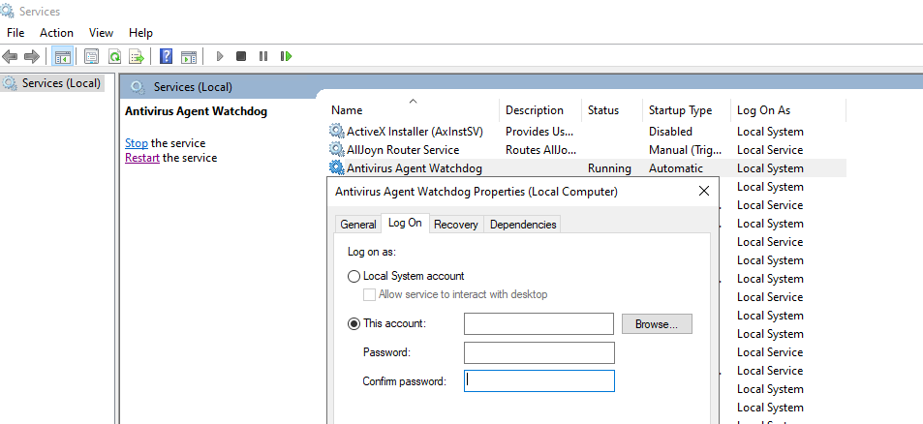

After overwrite installation of the antivirus agent plug-in, the previous antivirus user is automatically logged out. Log in to the Antivirus Agent Watchdog again. Otherwise, the antivirus service cannot run properly.
----End

