OceanStor Dorado
6.1.6
 | Upgrade Guide
 | Issue | 01
 | Date | 2023-07-31

 | HUAWEI TECHNOLOGIES CO., LTD. |  | 

Copyright © Huawei Technologies Co., Ltd. 2023. All rights reserved.
No part of this document may be reproduced or transmitted in any form or by any means without prior written consent of Huawei Technologies Co., Ltd.

Trademarks and Permissions
and other Huawei trademarks are trademarks of Huawei Technologies Co., Ltd.
All other trademarks and trade names mentioned in this document are the property of their respective holders.

Notice
The purchased products, services and features are stipulated by the contract made between Huawei and the customer. All or part of the products, services and features described in this document may not be within the purchase scope or the usage scope. Unless otherwise specified in the contract, all statements, information, and recommendations in this document are provided "AS IS" without warranties, guarantees or representations of any kind, either express or implied.
The information in this document is subject to change without notice. Every effort has been made in the preparation of this document to ensure accuracy of the contents, but all statements, information, and recommendations in this document do not constitute a warranty of any kind, express or implied.

Huawei Technologies Co., Ltd.
Address: | Huawei Industrial Base  Bantian, Longgang  Shenzhen 518129  People's Republic of China
Website: | https://e.huawei.com

About This Document
Overview
This guide describes how to perform an upgrade on the OceanStor storage systems and provides solutions to common problems.
Intended Audience
This document is intended for storage upgrade personnel. The upgrade personnel must:
- Be familiar with the networking and version information about the related network elements.
- Have experience in device O&M.
Symbol Conventions
The symbols that may be found in this document are defined as follows.
Symbol | Description
 | Indicates a hazard with a high level of risk which, if not avoided, will result in death or serious injury.
 | Indicates a hazard with a medium level of risk which, if not avoided, could result in death or serious injury.
 | Indicates a hazard with a low level of risk which, if not avoided, could result in minor or moderate injury.
 | Indicates a potentially hazardous situation which, if not avoided, could result in equipment damage, data loss, performance deterioration, or unanticipated results.  NOTICE is used to address practices not related to personal injury.
Supplements the important information in the main text.
NOTE is used to address information not related to personal injury, equipment damage, and environment deterioration.

Contents
About This Document ii
1 Before You Start 1
1.1 Upgrade Tool 1
1.2 Upgrade Methods 2
1.3 Requirements on the Source Version 5
1.4 Impact of Fast Upgrade 6
1.5 Precautions 6
2 Upgrade Process 8
3 Preparations 9
3.1 Obtaining Upgrade Reference Documents 9
3.2 Confirming the Patch Version Before the Upgrade 9
3.3 Obtaining Tools and Upgrade Packages 10
3.3.1 Confirming Tools and Upgrade Packages 10
3.3.2 Downloading Tools and Upgrade Packages 11
3.3.3 (Optional) Verifying Upgrade Package Integrity 12
4 Pre-upgrade Site Survey 14
4.1 Installing the Upgrade Tool 15
4.1.1 Installing SmartKit Online 15
4.1.2 (Optional) Importing the SmartKit Function Package Offline 16
4.2 (Optional) Importing Devices in a Batch 21
4.3 Setting the Upgrade Policy 23
4.4 Evaluating Array Upgrade 30
4.5 Collecting Array Information 32
5 Performing the Upgrade 35
5.1 Setting the Upgrade Policy 35
5.2 Prerequisites for Upgrading Controller Software 39
5.3 Upgrading Controller Software 40
6 Conducting an Inspection 45
7 Verifying the Upgrade 49
7.1 Verifying User Configuration Data 49
7.2 Verifying Host Services 50
8 Retrying the Upgrade 51
9 Rolling Back the Upgrade 52
10 OTA Upgrade Procedure 53
10.1 Before You Start 53
10.2 OTA Upgrade Process 53
10.3 Connecting a Device to DME IQ 54
10.4 Querying the Version Update 55
10.5 Performing Pre-upgrade Evaluation 56
10.6 Downloading the Upgrade Package 60
10.7 Setting Off-Peak Download and Auto Upgrade 60
10.8 Upgrading a Device 63
11 Rolling and Parallel Upgrade Procedure 70
11.1 Before You Start 70
11.1.1 Upgrade Impact 70
11.1.1.1 Impact on the System During the Upgrade 70
11.1.1.2 Impact on the System After the Upgrade 71
11.1.2 Precautions 71
11.2 Upgrade Process 72
11.3 Preparations 73
11.4 Pre-upgrade Site Survey 73
11.4.1 Installing the Upgrade Tool 74
11.4.2 Setting the Upgrade Policy 74
11.4.3 Collecting Array Information 74
11.4.4 Conducting an Inspection 74
11.4.5 Evaluating Array Upgrade 75
11.4.6 Evaluating Compatibility 77
11.4.7 Analyzing Logs 82
11.5 Performing the Upgrade 86
11.5.1 Setting the Upgrade Policy 86
11.5.2 Evaluating Array Upgrade 86
11.5.3 Upgrading Controller Software 93
11.5.3.1 Prerequisites 93
11.5.3.2 Upgrading Controller Software 94
11.5.4 Conducting an Inspection 99
11.6 Verifying the Upgrade 99
12 Kernel and Firmware Upgrade Procedure 100
12.1 Before You Start 100
12.1.1 Upgrade Impact 100
12.1.1.1 Impact on the System During the Upgrade 100
12.1.1.2 Impact on the System After the Upgrade 101
12.1.2 Precautions 101
12.2 Upgrade Process 102
12.3 Preparations 103
12.4 Pre-upgrade Site Survey 103
12.4.1 Installing the Upgrade Tool 104
12.4.2 Setting the Upgrade Policy 104
12.4.3 Collecting Array Information 104
12.4.4 Conducting an Inspection 105
12.4.5 Evaluating Array Upgrade 105
12.4.6 Evaluating Compatibility 105
12.4.7 Analyzing Logs 105
12.5 Performing the Upgrade 105
12.5.1 Setting the Upgrade Policy 105
12.5.2 Evaluating Array Upgrade 112
12.5.3 Performing the Kernel and Firmware Upgrade 119
12.5.3.1 Prerequisites 119
12.5.3.2 Performing the Kernel and Firmware Upgrade 119
12.6 Conducting an Inspection 124
12.7 Verifying the Upgrade 124
13 Upgrading Storage Systems in a HyperMetro Deployment 125
13.1 Upgrading Storage Systems in a SAN HyperMetro Deployment 126
13.1.1 Upgrade Schemes 126
13.1.2 Upgrade Flowchart 126
13.1.3 Pre-upgrade Check 127
13.1.4 Performing the Upgrade 129
13.1.5 Verifying the Upgrade 131
13.2 Upgrading Storage Systems in a NAS HyperMetro Deployment 132
13.2.1 Upgrade Schemes 132
13.2.2 Upgrade Flowchart 133
13.2.3 Pre-upgrade Check 133
13.2.4 Performing the Upgrade 134
13.2.5 Verifying the Upgrade 137
14 Troubleshooting 139
14.1 Common Troubleshooting Methods for an Upgrade Failure 139
14.2 Failed to Notify the System of Starting Upgrade 142
14.3 A Controller Hardware Fault Occurred During an Upgrade, Causing an Upgrade Failure 143
14.4 The Upgrade Is Interrupted Due to a Version Verification Failure Occurred After the Local Storage Array Restarts During an Upgrade on a Non-standard Heterogeneous Network 145
14.5 After an Array Is Upgraded, Status of the Physical Path and Logical Path Displayed on UltraPath Is Inconsistent 146
14.6 Upgrade Progress on the Upgrade Tool Is Not Refreshed Within 30 Minutes But No Upgrade Failure Is Displayed 150
14.7 Upgrade Failure Due to Abnormal NAS HyperMetro Domain Disconnection 150
15 FAQs 153
15.1 What Are the Common Methods for Logging In to a Storage System? 154
15.2 How Can I Upgrade a Non-Commercial Version to a Commercial One? 156
15.3 How Can I Query and Modify the SSH Port Number of a Controller? 160
15.4 How Can I Collect Storage System Information If the System Is Abnormal? 161
15.5 How Can I Ignore the Failed Step During the Upgrade and Proceed with the Subsequent Procedure? 161
15.6 How Can I Forcibly Upgrade the Storage System? 164
15.7 What Can I Do If Multiple Check Items Fail During a Pre-upgrade Check? 165
15.8 How Do I Query Major or Critical Alarms That Have Been Deleted Manually? 166
15.9 What Can I Do If the Front-End Link Redundancy Check Fails During the Upgrade? 166
15.10 How Can I Check the Compatibility of Hosts Running Non-mainstream Operating Systems? 168
15.11 How Can I Ignore the Pre-Upgrade Check Items and Continue the Upgrade? 169
15.12 What Can I Do When the Host HBA or iSCSI Timeout Parameter Does Not Pass the Check and Cannot be Modified? 172
15.13 How Do I Run CLI Commands to Perform the Kernel and Firmware Upgrade? 172
15.14 How Do I Perform a Fast Upgrade Using DeviceManager? 176
15.15 Why Is the Performance Data Displayed During the Upgrade Inaccurate? 183
15.16 How Can I Configure Upgrade Batches? 184
15.17 How Do I Obtain and Manually Import the CA Certificate for Disk Authentication to the Storage Array? 185
15.18 How Can I Upgrade the Storage System If the Interface Modules Are Incompatible? 188
16 Appendix 189
16.1 Checking Host Status 189
16.1.1 Testing Host Connectivity 189
16.1.2 Checking Host Multipathing Link Status 189
16.1.2.1 VMware ESX 190
16.1.2.1.1 Link Redundancy Check with Huawei UltraPath 190
16.1.2.1.2 Link Redundancy Check with VMware Multipathing Software 191
16.1.2.2 Windows 193
16.1.2.2.1 Link Redundancy Check with Huawei UltraPath 193
16.1.2.3 Linux 194
16.1.2.3.1 Link Redundancy Check with Huawei UltraPath 194
16.1.2.3.2 Link Redundancy Check with Linux Multipathing Software 196
16.1.2.4 Solaris 197
16.1.2.4.1 Link Redundancy Check with Huawei UltraPath 197
16.1.2.4.2 Link Redundancy Check with Solaris Multipathing Software 199
16.1.2.5 HP-UX 201
16.1.2.5.1 Link Redundancy Check with HP-UX 11i v1/v2 PVlinks 201
16.1.2.5.2 Link Redundancy Check with HP-UX 11i v3 NMP 203
16.1.2.6 AIX 207
16.1.3 Checking Risky Emulex HBA Driver Versions in a Fibre Channel Network 209
16.1.4 Checking the Oracle Heartbeat Parameter 211
16.1.5 Checking the HBA Timeout Parameter in a Fibre Channel Network 217
16.1.5.1 VMware ESX 218
16.1.5.2 Windows 219
16.1.5.3 Linux 223
16.1.5.3.1 SUSE 10 223
16.1.5.3.2 SUSE 11 and SUSE 12 232
16.1.5.3.3 CentOS 5.11 233
16.1.5.3.4 CentOS 6.5 and CentOS 7.2 241
16.1.5.3.5 Red Hat 5.10 and Red Hat 5.6 242
16.1.5.3.6 Red Hat 6.8 and Red Hat 7.1 242
16.1.5.3.7 Red Hat 7.3 242
16.1.5.3.8 OEL 5.11 and OEL 6.1 242
16.1.5.3.9 OEL 7.2 242
16.1.5.3.10 Ubuntu 12.04, Ubuntu 14.10, and Ubuntu 16.04 242
16.1.5.4 Solaris 242
16.1.5.5 HP-UX 249
16.1.5.5.1 HP-UX 11i v1 and v2 249
16.1.5.5.2 HP-UX 11i v3 251
16.1.5.6 AIX 252
16.1.6 Checking the Initiator Timeout Parameter in an iSCSI Network 255
16.1.6.1 VMware ESX 255
16.1.6.2 Windows 257
16.1.6.3 Linux 258
16.2 Default Batch Upgrade Policies 259
16.3 Obtaining the License File for the Target Version 260

Before You Start
1.1 Upgrade Tool
1.2 Upgrade Methods
1.3 Requirements on the Source Version
1.4 Impact of Fast Upgrade
1.5 Precautions

Upgrade Tool
This section describes the available upgrade tools.

Tool | Application Scenario | Advantage | Procedure
SmartKit | This tool is recommended by default. | Various upgrade function entries, such as upgrade site survey, device upgrade, inspection, and log collection. This tool is used as an example in the subsequent sections. | See this document.
DeviceManager | Use a browser to log in to DeviceManager and upgrade the device.  Constraints:  1. Only OceanStor 2000/3000/5000/5300/5500/5600/5600K/6000 support this function.  2. Only the fast upgrade is supported.  3. This method is applicable when SmartKit cannot be installed.  4. The current version must be 6.1.0 or later. | No additional tools are required. | For details, see 15.14 How Do I Perform a Fast Upgrade Using DeviceManager?
OTA | Use a browser to log in to DeviceManager to start the Over The Air (OTA) upgrade.  Constraints:  1. The current version must be 6.1.3 or later.  2. Only OceanStor Dorado 2000/3000/5000/5300/5500/5600/5600K/6000 support this function.  3. Only the fast upgrade is supported. | No additional tools are required. This simplifies complex operations, such as formulating upgrade policies, downloading software packages, and installing SmartKit. In addition, the version update can be pushed immediately after new release and you only need to log in to DeviceManager to upgrade devices. | For details, see 10 OTA Upgrade Procedure.

Upgrade Methods
This section describes the upgrade methods supported by OceanStor Dorado V6.
                - Upgrade methods and application scenarios
Upgrade Method | Application Scenario | Advantage | Procedure
Fast upgrade | This upgrade method is recommended by default.  Constraint:  - NVMe over RoCE is unavailable after a fast upgrade from 6.0.x to 6.1.2 or later. If NVMe over RoCE is needed, you must perform another kernel and firmware upgrade.  - The replication link encryption feature cannot be used after a fast upgrade from 6.1.3 or earlier to 6.1.6. If this feature is needed, you must perform another kernel and firmware upgrade. | Host compatibility evaluation is not required. The upgrade process is transparent to hosts. The upgrade takes the shortest duration (15 to 30 minutes) and can be performed in OTA mode. | If the device version is Dorado 6.1.3 or later:  - When the device is connected to eService, refer to 10 OTA Upgrade Procedure.  - When the device is not connected to eService, connect it to eService by referring to 10.3 Connecting a Device to DME IQ and then perform an OTA upgrade.  If the device version is Dorado 6.1.2 or earlier:  - Perform the manual upgrade by referring to sections 2 Upgrade Process to 7 Verifying the Upgrade.  - When the device is connected eService before the upgrade, the OTA upgrade function is enabled by default after the upgrade and upgrade version information is automatically pushed.
Rolling upgrade | - This upgrade method is recommended when host services have been stopped.  - If the current version is 6.0.x or you have performed a fast upgrade from 6.0.x to 6.1.0, you can use this method to upgrade the system to 6.1.2 or later to use NVMe over RoCE.  Constraint: Because controllers will be reset during the rolling upgrade, you must evaluate the host compatibility in advance. | All features of the new version can be used. | 11 Rolling and Parallel Upgrade Procedure
Parallel upgrade | This method is recommended only when no service is configured. | All features of the new version can be used. The upgrade duration is half of that in rolling upgrade. | 11 Rolling and Parallel Upgrade Procedure
Kernel and firmware upgrade | - This method is used when you have performed a fast upgrade from 6.0.x to 6.1.2 or later and want to use NVMe over RoCE.  - If you have performed a fast upgrade from 6.0.x to 6.1.0 and then another fast upgrade from 6.1.0 to 6.1.2 or later, you can use this method if you want to use NVMe over RoCE.  Constraint: Because controllers will be reset during the kernel and firmware upgrade, you must evaluate the host compatibility in advance. | All features of the new version can be used. | 12 Kernel and Firmware Upgrade Procedure

- Fast upgrade (recommended)
Fast upgrade is implemented by replacing processes and without resetting controllers. During the upgrade, host links are not interrupted and hosts are unaware of the upgrade. This upgrade method is recommended.
- Rolling upgrade (alternative)
In a rolling upgrade, controllers are upgraded in several batches and reset for the upgrade to take effect. By working with the host's multipathing software, the storage system switches over services between controllers during the upgrade to prevent interruption.

- During a rolling upgrade, controllers are restarted in several batches, and front-end links are switched over between controllers. This may cause host compatibility issues. Before the upgrade, evaluate host compatibility by following the instructions in 11.4.6 Evaluating Compatibility. If host services have been stopped before the upgrade, compatibility evaluation is not needed.
- OceanStor Dorado 8000 V6 and 18000 V6 use an active-active front-end architecture. Resetting a single controller does not interrupt front-end links or trigger a switchover. If you do not need to upgrade front-end interface modules or the front-end interface modules support hot upgrade, the rolling upgrade does not trigger host compatibility issues, and compatibility evaluation will be automatically skipped during the pre-upgrade site survey.
- For the default batch upgrade policy, see 16.2 Default Batch Upgrade Policies.
- For details about customized upgrade batches, see 15.16 How Can I Configure Upgrade Batches?.
- If NFSv3 or NFSv4 is used, a rolling upgrade can be performed without interrupting services. If SMB 2.0 or SMB 3.0 is used, you must manually enable failover. If you have any questions, contact Huawei technical support engineers.
- Parallel upgrade (recommended only when no service is configured)
Parallel upgrade is recommended when a storage system is not associated with any host. In a parallel upgrade, all controllers are upgraded at the same time, which takes only half of time required by a rolling upgrade.


- If disks have been mapped to hosts, some hosts may encounter drive letter changes. In this case, you need to rectify these faults manually.
- If disks have been mapped to hosts or file system services have been associated, stop related services before performing a parallel upgrade.
- Kernel & firmware upgrade
When NVMe over RoCE needs to be configured after a fast upgrade from OceanStor Dorado V6 6.0.x to 6.1.2 or a fast upgrade from 6.0.x to 6.1.0 and then another fast upgrade to 6.1.2. SmartKit uses the rolling upgrade mode by default. Controllers are upgraded in several batches and reset for the upgrade to take effect. By working with the host's multipathing software, the storage system switches over services between controllers during the upgrade to prevent interruption.
If the kernel upgrade uses the rolling upgrade mode, the upgrade batch is as follows:
- For details about the default one, see 16.2 Default Batch Upgrade Policies.
- For details about the customized one, see 15.16 How Can I Configure Upgrade Batches?.

Requirements on the Source Version
Table 1-3 lists the requirements on the source version before an upgrade.
                - Requirements on the source version
Source Version | Upgrade Method
OceanStor Dorado 6.0.0 (including 6.0.0 with SPH hot patches) | Fast, rolling, or parallel upgrade
OceanStor Dorado 6.0.1 (including 6.0.1 with SPH hot patches) | Fast, rolling, or parallel upgrade
OceanStor Dorado 6.1.0 (including 6.1.0 with SPH hot patches) | Fast, rolling, or parallel upgrade
OceanStor Dorado 6.1.2 (including 6.1.2 with SPH hot patches) | Fast, rolling, or parallel upgrade
OceanStor Dorado 6.1.3 (including 6.1.3 with SPH hot patches) | Fast, rolling or parallel upgrade
OceanStor Dorado 6.1.5 (including 6.1.5 with SPH hot patches) | Fast, rolling or parallel upgrade
OceanStor Dorado 6.1.6RC1 (including 6.1.6RC with SPH hot patches) | Fast, rolling or parallel upgrade

The following sections use fast upgrade as an example.
For the rolling and parallel upgrade procedure, see 11 Rolling and Parallel Upgrade Procedure.
For the kernel and firmware upgrade procedure, see 12 Kernel and Firmware Upgrade Procedure.
To query the storage system version:
Log in to the CLI as user admin and run the show upgrade package command, as shown in Figure 1-1.
              - Checking the storage system version
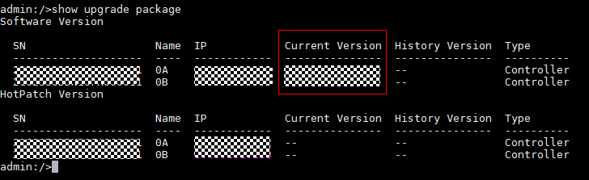

Impact of Fast Upgrade
Impact on Services
During the fast upgrade of controller software, the controllers do not restart. However, because service processes and interface modules respond slowly during the upgrade, I/Os may be suspended for two to four times. This does not interrupt host services, but you are still advised to perform the upgrade during off-peak hours.
The reference values of the I/O suspension time in typical configurations are as follows:
- For SAN services, the suspension is 1 to 2 seconds each time and the performance returns to 100% in 2 to 5 seconds after suspension.
- For NAS services using the NFSv3 protocol, the suspension is less than 8 seconds each time and the performance returns to 100% in 30 seconds after suspension.
- For NAS services using the SMB protocol, the suspension is less than 90 seconds each time and the performance returns to 100% in 30 seconds after suspension.
- For NAS services using the NFSv4.1 protocol, the suspension is 90 to 135 seconds each time and the performance returns to 100% in 30 seconds after suspension.
- If both NFSv3 and NFSv4 services exist, the suspension time and recovery time of NFSv3 is the same as those of NFSv4.

Precautions
This section describes the precautions for an upgrade.
Before the Upgrade
- If the HyperMetro deployment is used, see 13 Upgrading Storage Systems in a HyperMetro Deployment.
- If a local storage system has replication links to a remote system and only the local storage system is upgraded successfully, you cannot configure the remote device (such as creating or deleting the remote device, or adding or removing replication links). The existing configuration is not affected and services can run normally.
- Before the upgrade, ensure that the service load of the controllers is normal to avoid adverse impact on the upgrade. To be specific:
- The CPU usage must be lower than 80%.
- The free memory of the controllers must be greater than 500 MB.
During the Upgrade
- Do not perform configurations on DeviceManager or deliver configuration commands on the CLI.
- Do not perform any operation on the hardware, such as removing or inserting interface modules, power modules, or disks.
- Ensure that the power supply and network connection are normal and all faults have been handled.
After the Upgrade
- If original version alarms not applicable to the target version are generated during the upgrade, manually clear the alarms after the upgrade is complete.
- If certain alarm IDs cannot be found in the document of the target version, query the alarm IDs in the document of the original version.
- After the upgrade is complete, clear the cache data of the browser on the maintenance terminal. For example, if you use Internet Explorer, choose Tools > Internet Options. On the General tab, click Delete under Browsing history. In the dialog box that is displayed, clear the browser's caches as prompted. Then you can visit OceanStor DeviceManager.
- If the digital certificate or private key imported to OceanStor DeviceManager before the upgrade does not work, the backup digital certificate and private key will be used after the upgrade to ensure that background services can be started properly.

Upgrade Process
This chapter describes the upgrade process.
Table 2-1 provides the estimated upgrade schedule for each procedure.
                - Upgrade schedule
Step | Start Time | Time Required | Remarks
Preparations | One week before the upgrade | 30 minutes | See 3 Preparations.
Pre-upgrade Site Survey | One week before the upgrade | 30 minutes | See 4 Pre-upgrade Site Survey.
Performing the Upgrade | During the upgrade | 15-30 minutes | This step involves package import, pre-upgrade check, data backup, software upgrade, and post-upgrade check.  See 5.3 Upgrading Controller Software.
Conducting an Inspection | After the upgrade | 30 minutes | See 6 Conducting an Inspection
Verifying the Upgrade | After the upgrade | 15 minutes | See 7 Verifying the Upgrade

The time listed for each operation is for reference only. The time actually required depends on onsite conditions.

Preparations
3.1 Obtaining Upgrade Reference Documents
3.2 Confirming the Patch Version Before the Upgrade
3.3 Obtaining Tools and Upgrade Packages

Obtaining Upgrade Reference Documents
Procedure
            - For carriers, log in to https://support.huawei.com/carrier/navi?coltype=software#col=software&path=PBI1-21430725/PBI1-21430757/PBI1-250389226.
For enterprise users, log in to https://support.huawei.com/enterprise/en/category/enterprise-storage-pid-1482606575525?submodel=software.
            - Find and download the desired documents under the product catalog.
If you are using this website for the first time, register with the website.
----End

Confirming the Patch Version Before the Upgrade
Current Version | Patch Version
OceanStor Dorado 6.0.0 | OceanStor Dorado 6.0.0 latest patch
OceanStor Dorado 6.0.1 | OceanStor Dorado 6.0.1 latest patch
OceanStor Dorado 6.1.0 | OceanStor Dorado 6.1.0 latest patch
OceanStor Dorado 6.1.2 | OceanStor Dorado 6.1.2 latest patch
OceanStor Dorado 6.1.3 | OceanStor Dorado 6.1.3 latest patch
OceanStor Dorado 6.1.5 | OceanStor Dorado 6.1.5 latest patch
OceanStor Dorado 6.1.6RC1 | OceanStor Dorado 6.1.6RC1 latest patch

After the patch version is confirmed, download the patch package and related patch installation guide from the download path listed in the preceding table.

Obtaining Tools and Upgrade Packages

Confirming Tools and Upgrade Packages
                - Checklist of the upgrade packages
Software | Version
Storage system upgrade package | OceanStor Dorado 6.1.6
Patch package to be installed after the upgrade | 6.1.6 latest patch

                - Checklist of tools
Tool | Remarks
SmartKit | See 3.3.2 Downloading Tools and Upgrade Packages.
OpenPGP digital signature tool | See 3.3.2 Downloading Tools and Upgrade Packages.

If third-party SSH and SFTP tools are required, PuTTY and Core FTP are recommended, which can be downloaded from their respective official website.
Other tools and materials required include:
Serial cables (with RJ45 serial connectors), network cables, ESD gloves, labels, laptops (connected to RJ45 serial ports), and network adapters.

Downloading Tools and Upgrade Packages
Downloading the Upgrade Tool
            - For carriers, access https://support.huawei.com/carrierindex/en/hwe/index.html. For enterprise users, access https://support.huawei.com/enterprise/en/index.html. Click Login and enter your username and password.
            - For carriers, choose Product Support > Data Storage and Intelligent Vision > Storage Common > SmartKit > Software. For enterprise users, choose Tools > SmartKit.
            - Find and download the latest SmartKit installation package SmartKit_x.x.x.zip.
            - After the SmartKit installation package has been downloaded, download the relevant upgrade packages of SmartKit:
- SmartKit_x.x.x_Tool_ArrayUpgrade.zip
- SmartKit_x.x.x_Tool_UpgradeEvaluation.zip


Use SmartKit_23.0.0.0 or later.
----End
Downloading the Upgrade Package
            - For carriers, log in to https://support.huawei.com/carrier/navi?coltype=software#col=software&path=PBI1-21430725/PBI1-21430757/PBI1-250389226.
For enterprise users, log in to https://support.huawei.com/enterprise/en/category/enterprise-storage-pid-1482606575525?submodel=software.
            - On the page that is displayed, select your product model. Then download the controller upgrade package and digital certificate, as shown in Figure 3-1
              - Downloading the software package and digital certificate
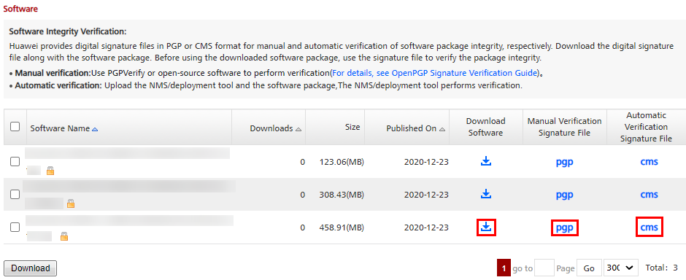

----End
(Optional) Downloading the Upgrade Package Verification Tool
The integrity of the upgrade package will be verified when it is imported. If no exception occurs during the download and transmission of the upgrade package, skip this step.
Use an OpenPGP signature verification tool to check patch file integrity. It is recommended that you use "PGPVerify.exe", an easy-to-use PGP verification tool developed by Huawei. For details on how to use the tool, see the OpenPGP Signature Verification Guide. For carriers, download the guide from https://support.huawei.com/carrier/digitalSignatureAction. For enterprise users, download the guide from https://support.huawei.com/enterprise/en/tool/pgp-verify-TL1000000054/TV1000000016.

(Optional) Verifying Upgrade Package Integrity
The integrity of the upgrade package will be verified when it is imported. If no exception occurs during the download and transmission of the upgrade package, skip this step.
Procedure
            - Double-click PGPVerify.exe to open the OpenPGP signature verification tool. Click Select Public Key, as shown in Figure 3-2.
              - Clicking Select Public Key
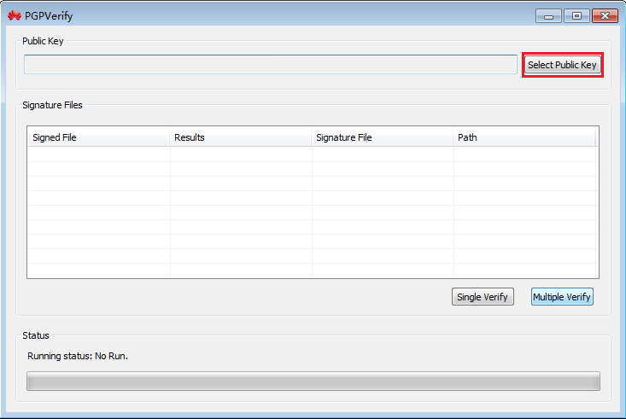

            - Select the KEYS file and click Single Verify, as shown in Figure 3-3.
              - Clicking Single Verify
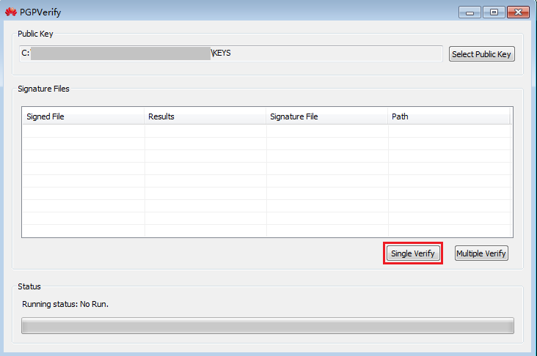

            - Select the digital certificate used with the upgrade package and check upgrade package integrity. If PASS is displayed in the Results column and the entry is green, the upgrade package integrity check is passed, as shown in Figure 3-4. Otherwise, the check fails and you must check whether the downloaded upgrade package and digital certificate are correct.
For details on how to obtain the digital certificate of the upgrade package, see 3.3.2 Downloading Tools and Upgrade Packages. The digital certificate and upgrade package must be in the same directory.
              - Upgrade package integrity check passed
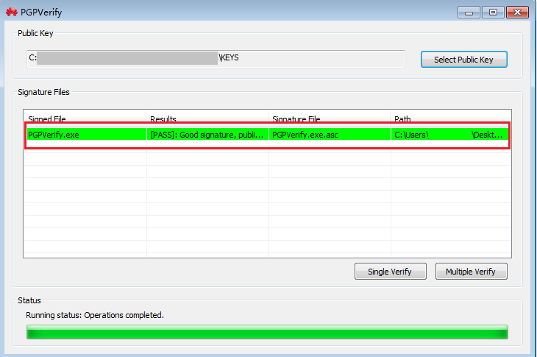
----End

Pre-upgrade Site Survey

The site survey is to check the health status of the storage system to ensure a successful upgrade. Perform the operations by following instructions in this chapter.
The site survey involves installing the upgrade tool, evaluating array upgrade.
Step | Description | Duration
Install the upgrade tool. | Install SmartKit. | 10 minutes
Set the upgrade policy. | Select the device to be upgraded and set the upgrade policy. | 3 minutes
Evaluate array upgrade. | Check the health status of the storage system. This operation is automatically performed by the upgrade evaluation tool. | 5 minutes for dual controllers

4.1 Installing the Upgrade Tool
4.2 (Optional) Importing Devices in a Batch
4.3 Setting the Upgrade Policy
4.4 Evaluating Array Upgrade
4.5 Collecting Array Information

Installing the Upgrade Tool

Installing SmartKit Online
Procedure
            - Copy the SmartKit installation package obtained in 3.3.2 Downloading Tools and Upgrade Packages to the PC used for the site survey or upgrade, and then decompress the package.
            - Double-click SmartKit_x.x.x.exe to start installation.
            - After the installation is complete, start SmartKit.
            - Authenticate your identity (if needed), as shown in Figure 4-1.
              - Identity authentication
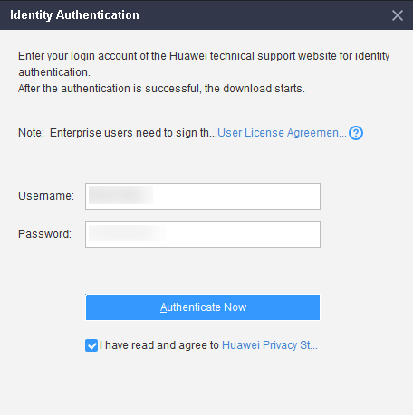
            - Click Function Management, as shown in Figure 4-2. In the Filter area on the left, select Storage in Product Field. Then select Pre-upgrade Site Survey and Device Upgrade and click Install, as shown in Figure 4-3.
              - Function Management
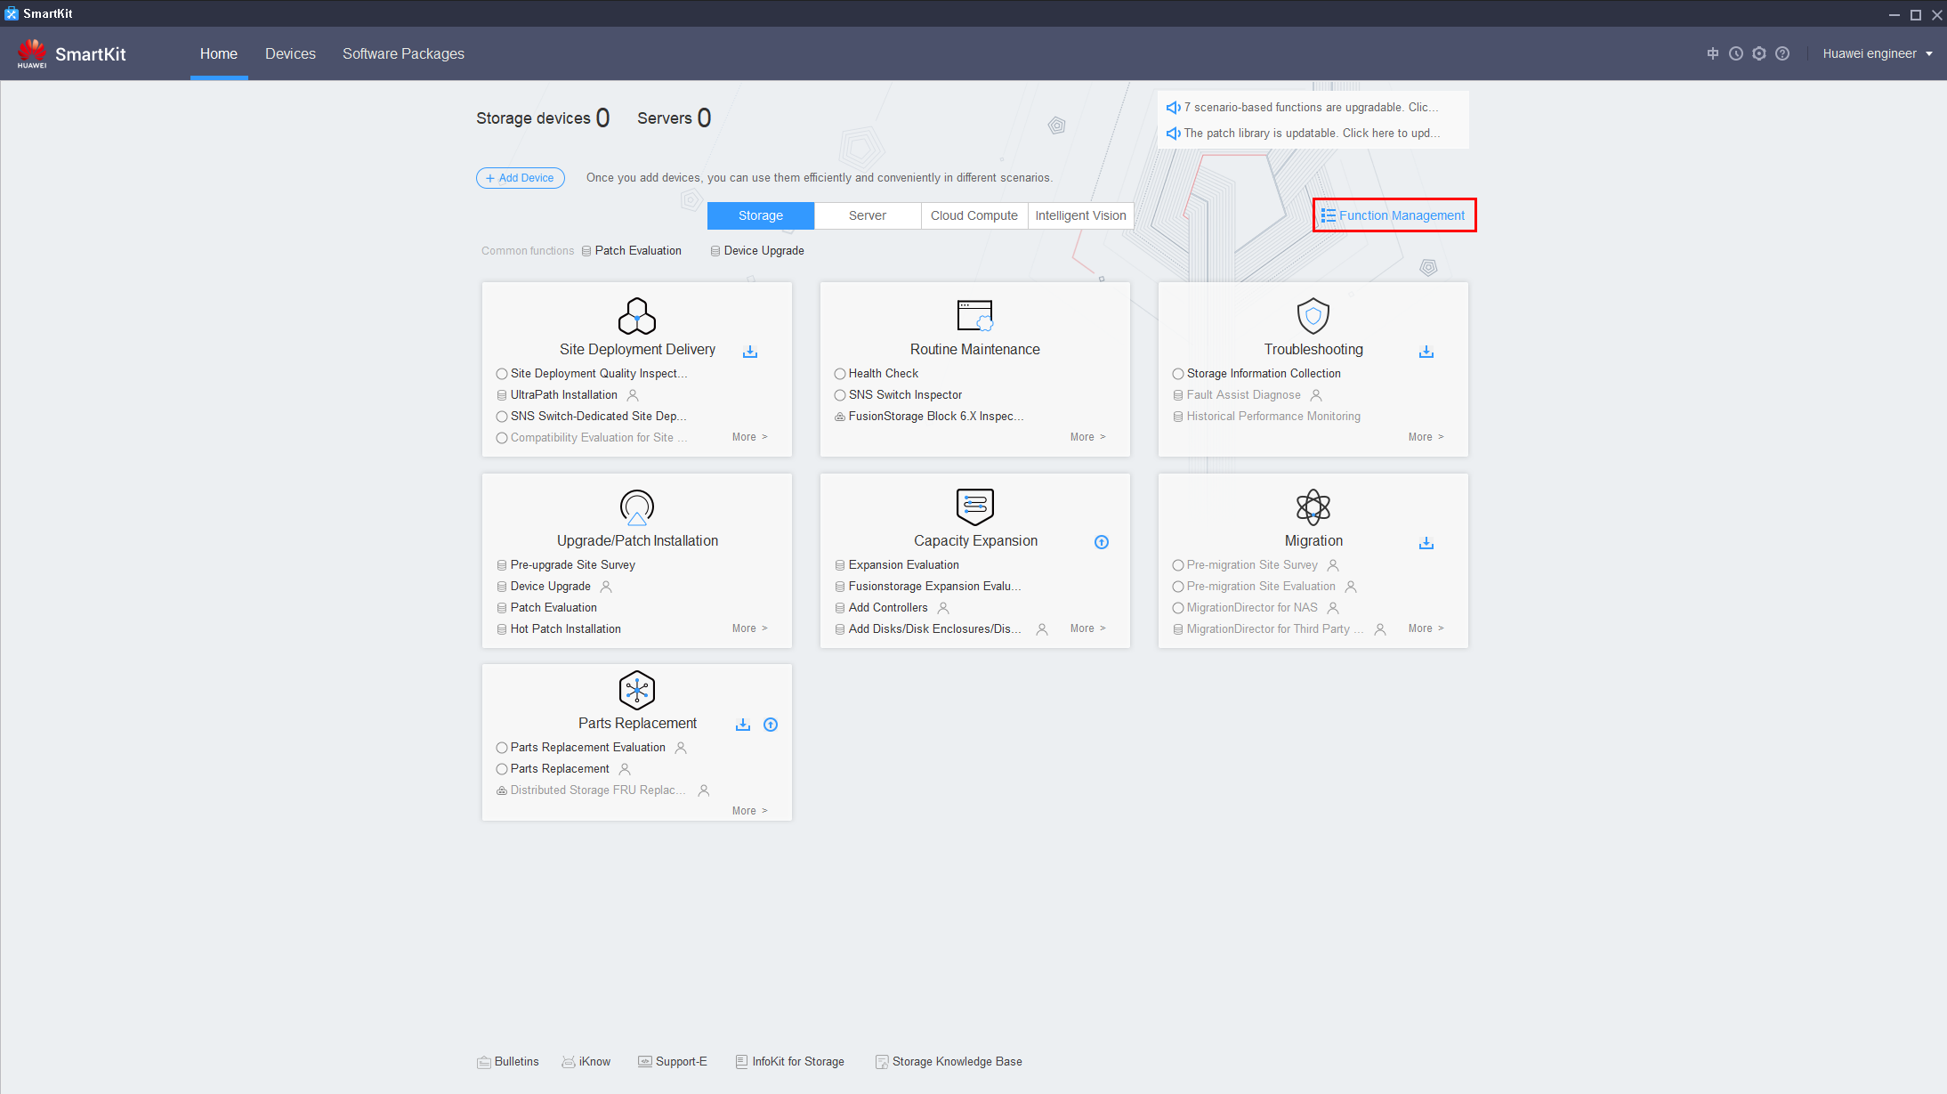
              - Install
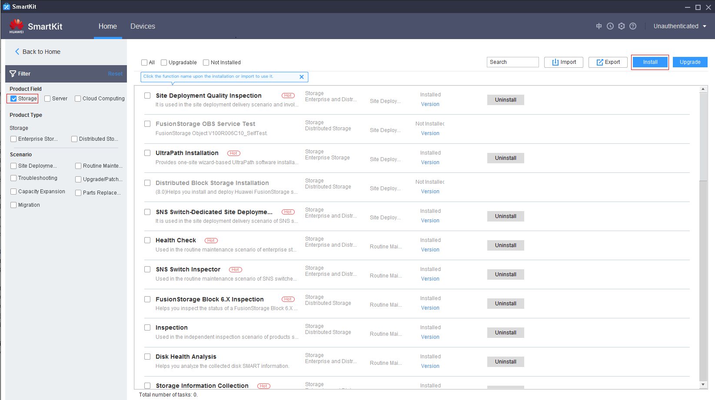

            - After the installation is complete, return to the home page and select Pre-upgrade Site Survey or Device Upgrade in Upgrade/Patch Installation to perform the site survey or upgrade.
----End

(Optional) Importing the SmartKit Function Package Offline
Application Scenario
Use this method when the host or laptop, which is used to perform the pre-upgrade site survey or upgrade, fails to connect to Huawei website.
This section can be performed only after the procedure in 4.1.1 Installing SmartKit Online is complete.
Procedure
            - On the SmartKit home page, click Function Management and then click Export. In the dialog box that is displayed, select the desired functions and click Export. Figure 4-4 and Figure 4-5 show an example.
              - Function management
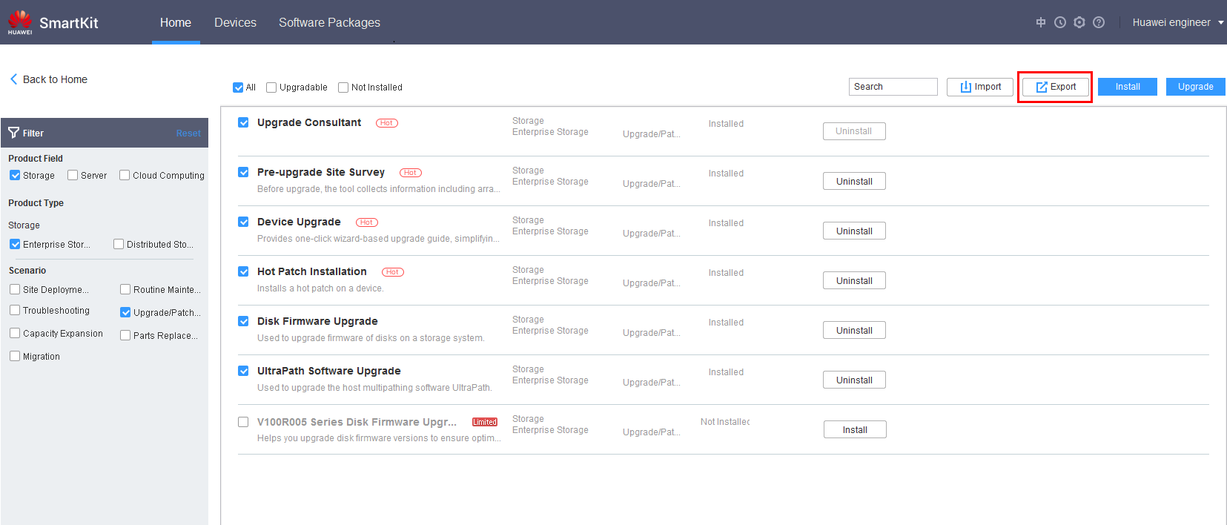

              - Exporting functions
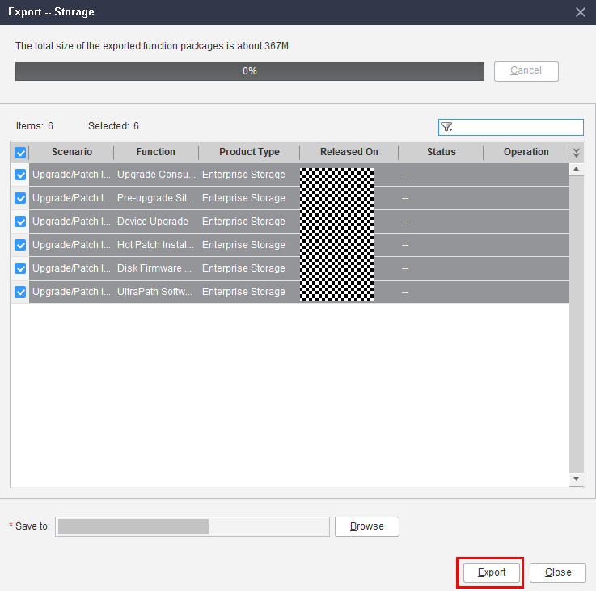

            - After the export is complete, click View to open the save path of the function package.
              - Opening the save path
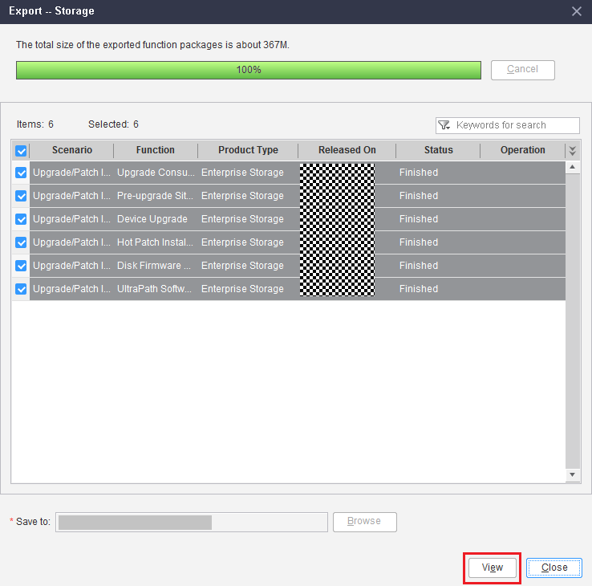

            - Copy the function package exported in Step 1 and the latest SmartKit installation package to the host or laptop that is used to perform the pre-upgrade site survey or upgrade.
            - Decompress the SmartKit installation package and install the latest SmartKit. On the Function Management page, click Import, select the function package copied in Step 3 and click OK, as shown in Figure 4-7 and Figure 4-8.
              - Importing the function package
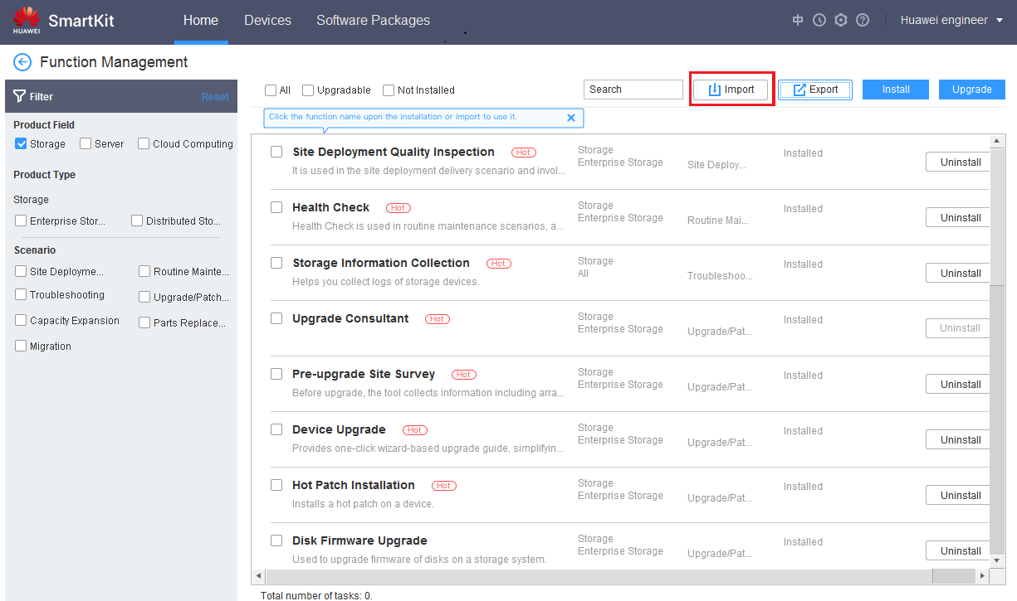

              - Selecting the package to be imported
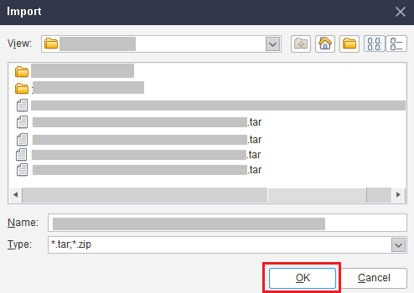

            - After the import is complete, click Install to install the imported function package.
              - Install
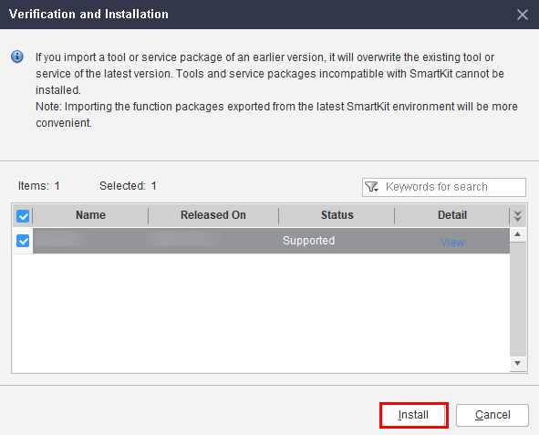
            - After the import is complete, you can use the functions on the SmartKit home page.
----End

(Optional) Importing Devices in a Batch
Application Scenario
When there are a large number of devices, adding them one by one is time-consuming. In this case, you can import devices in a batch. After adding the devices successfully, you can directly select them in different scenarios, which is more efficient and convenient.
Procedure
            - On the main menu, click Add Device to go to the device list page as shown in Figure 4-10.
              - Adding devices
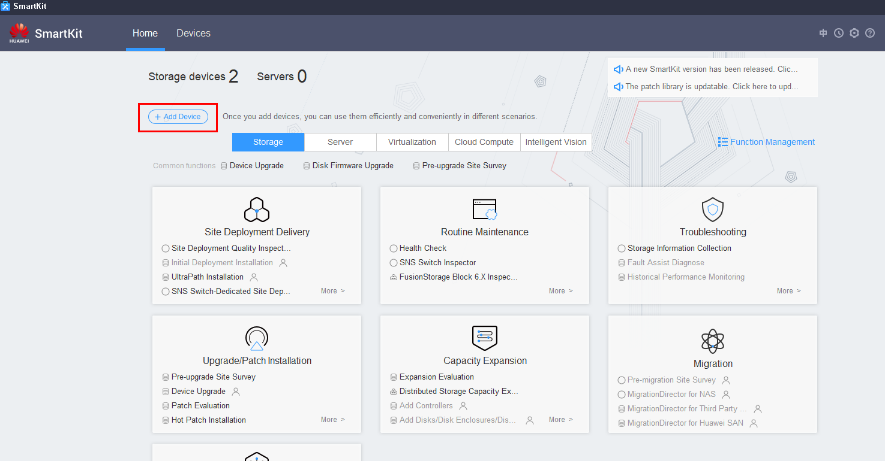
            - On the device list page, click Get Template File to download the template file to a specified local directory as shown in Figure 4-11.
              - Obtaining the template for importing devices
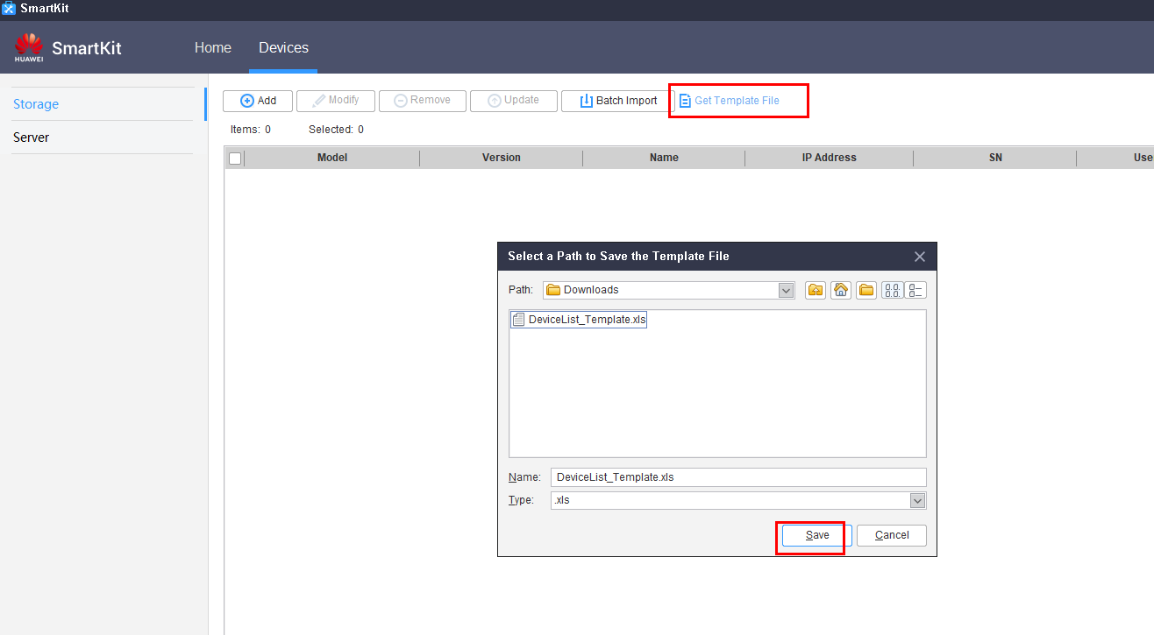
            - Open the downloaded template file and fill in the information about the devices to be added according to the requirements described in the template as shown in Figure 4-12. (Each row represents one device. You can add multiple rows).
              - Filling in the device information
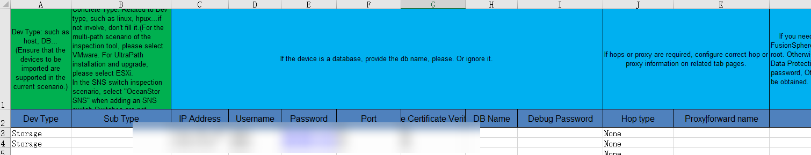
            - Click Batch Import, select the DeviceList_Template.xls file, and import it as shown in Figure 4-13.
              - Importing device information
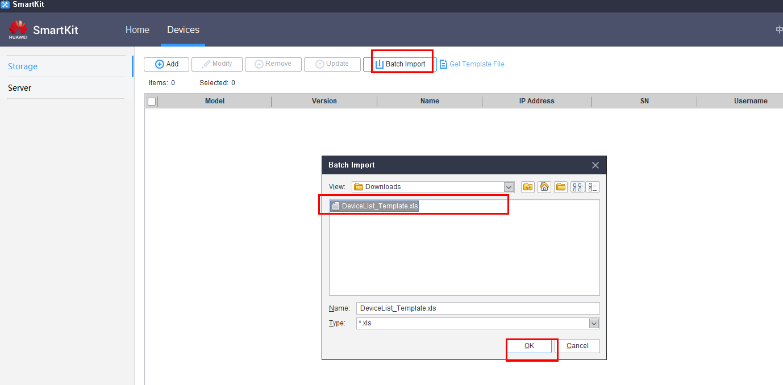
            - The devices are successfully added in a batch as shown in Figure 4-14.
              - Successfully adding the devices in a batch
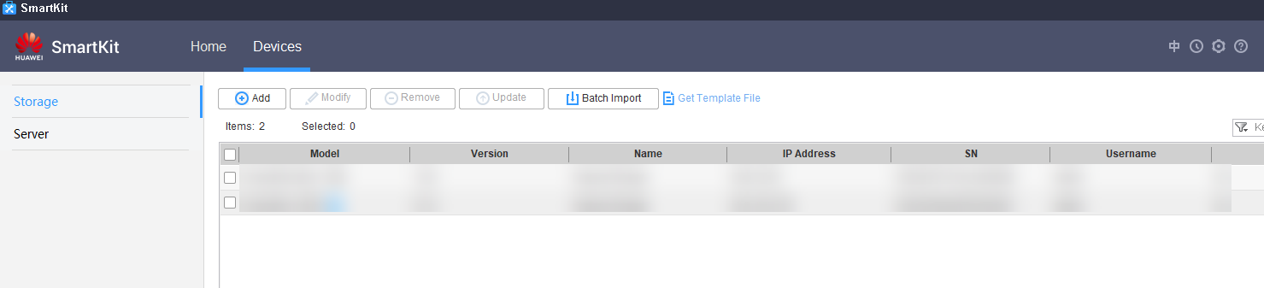
----End

Setting the Upgrade Policy
Procedure
            - After SmartKit and the upgrade plug-ins have been installed, click Pre-upgrade Site Survey in Upgrade/Patch Installation, as shown in Figure 4-15.
              - Pre-upgrade site survey
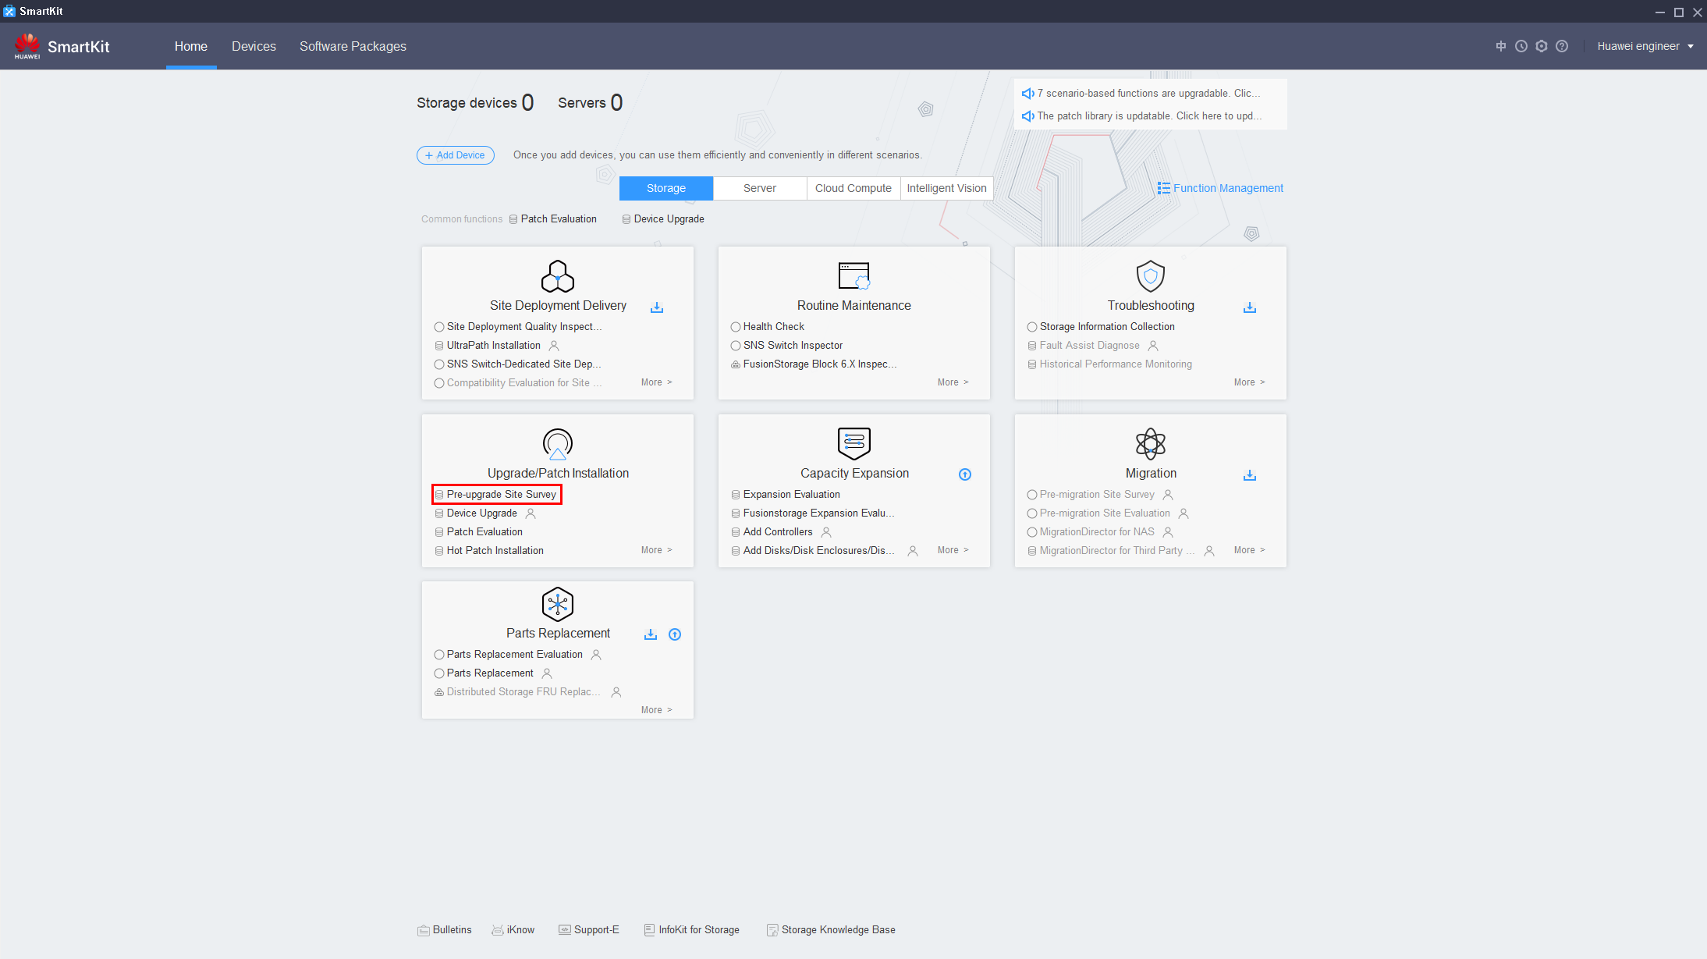

            - On the page that is displayed, click Upgrade Policy Setting, as shown in Figure 4-16.
              - Setting the upgrade policy
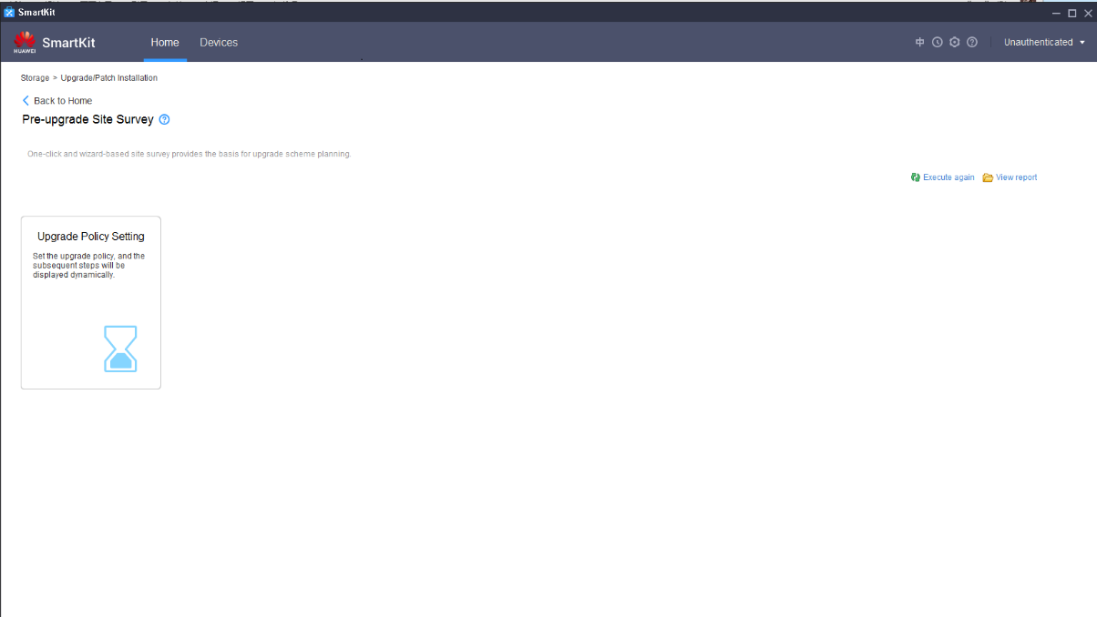

            - On the displayed Set Upgrade Policy page, click Add Device, as shown in Figure 4-17 and Figure 4-18.
This step describes how to add a single device. For details about how to add devices in a batch, see 4.2 (Optional) Importing Devices in a Batch.
              - Adding a device (1)
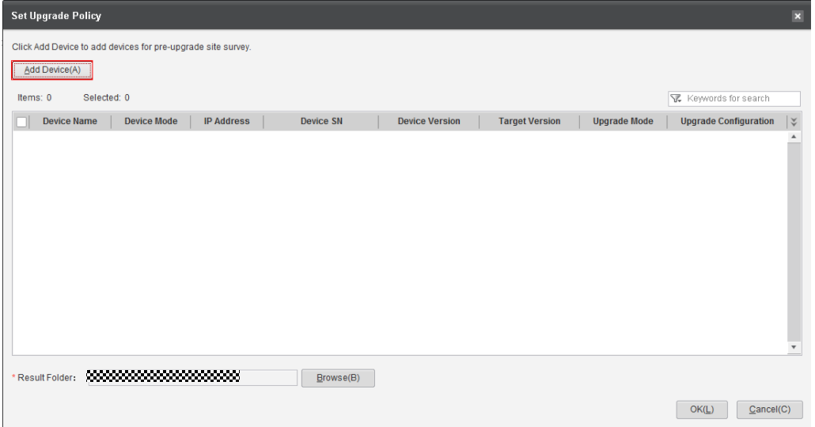

              - Adding a device (2)
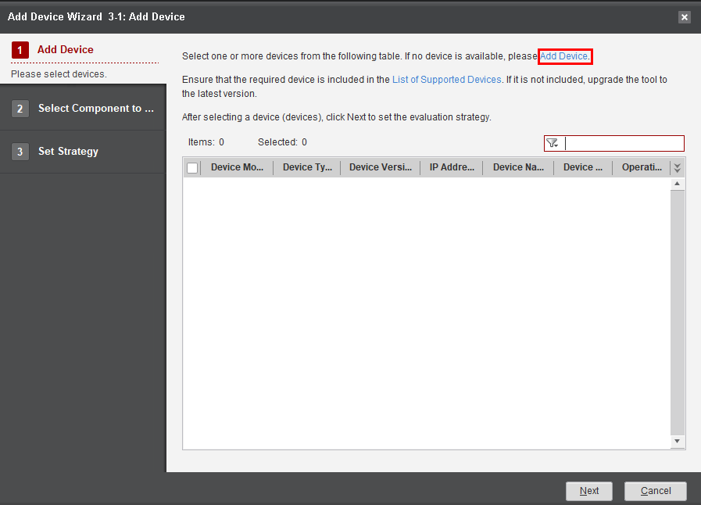

            - Enter the management IP address of the device and click Next, as shown in Figure 4-19.
              - Entering the management IP address of the device
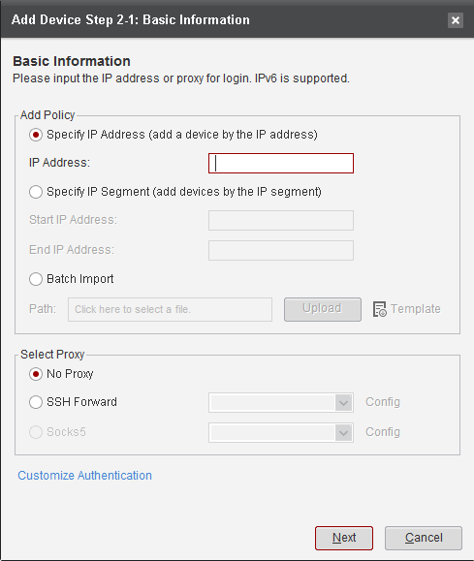

            - Enter Username and Password of the device and click Finish, as shown in Figure 4-20.
The default port number is 22. Require Certificate Verification is set to No by default. Leave Need Debugging Password and Switch to user root empty.
              - Entering the username and password
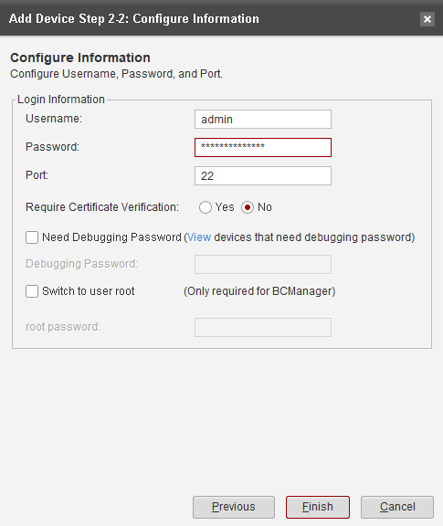

            - A dialog box is displayed indicating that the device fingerprint is not registered. Click OK to register it, as shown in Figure 4-21.
              - Registering the fingerprint
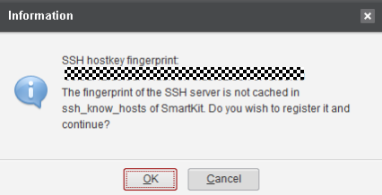

If a message is displayed indicating that the security certificate of this device is untrusted, click OK to continue.
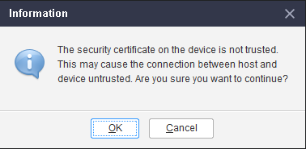
            - Select the added device and click Next, as shown in Figure 4-22.
              - Selecting devices
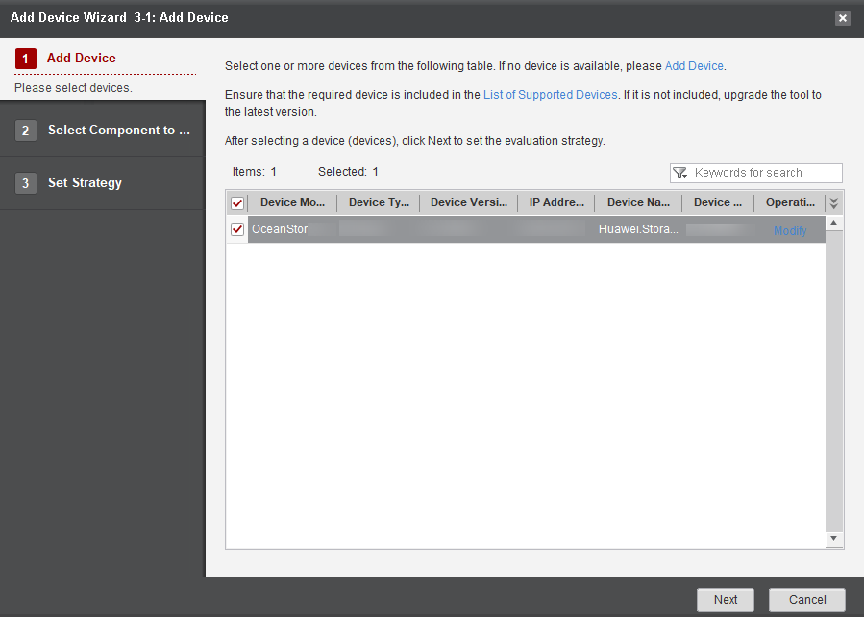

            - Select the component to be upgraded and click Next, as shown in Figure 4-23.
              - Selecting component to be upgraded
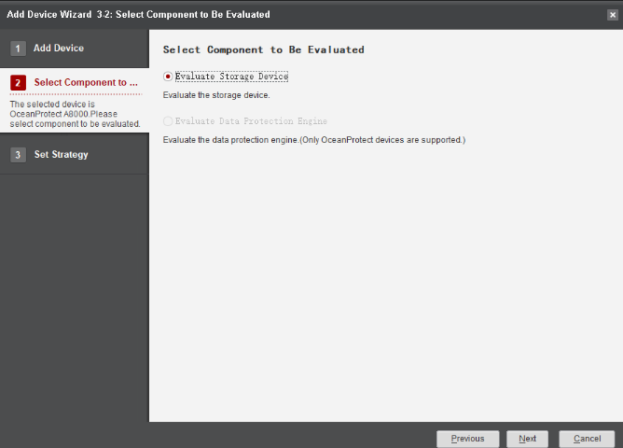
            - On the Set Strategy page, specify the Upgrade Mode and Target Version, and click Finish, as shown in Figure 4-24.
              - Setting the strategy
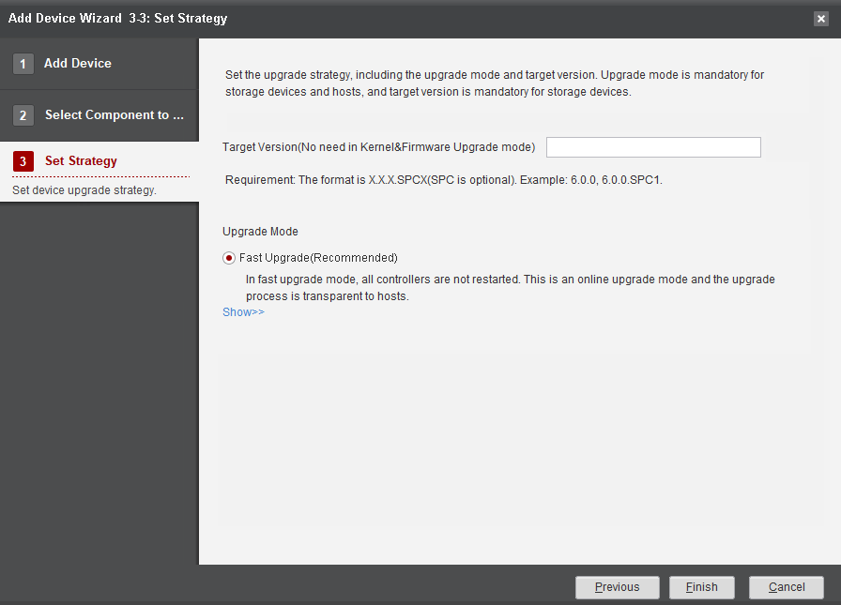

            - On the Set Upgrade Policy page, select the added device and click OK to complete the upgrade policy setting, as shown in Figure 4-25.
              - Upgrade policy set successfully
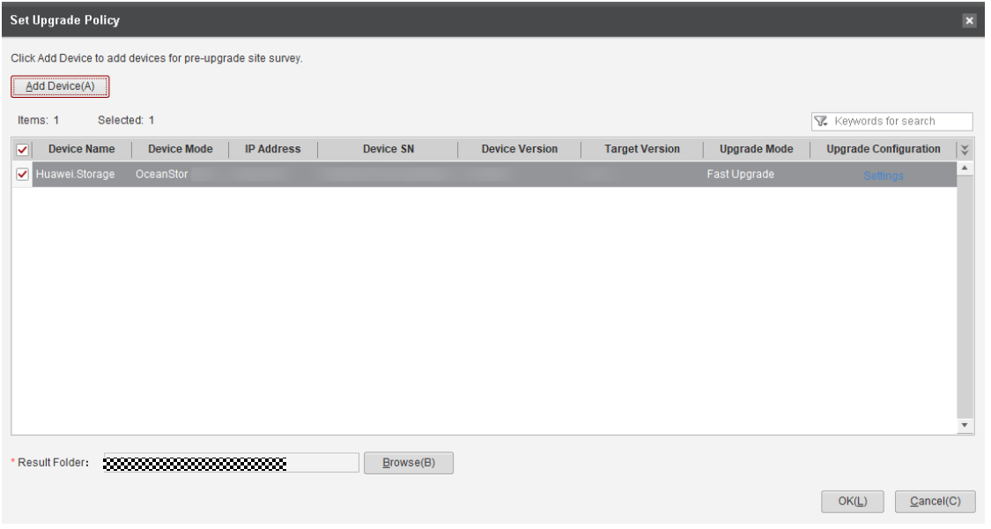

----End

Evaluating Array Upgrade

This evaluation is to check the health status of the storage system to prevent any adverse impact on the upgrade. Ensure that all items pass the evaluation before performing subsequent operations. If you decide to ignore the failed items (if any) and forcibly upgrade the system, make sure you are aware of the risks and accept the consequences thereof. The array upgrade evaluation takes about 5 to 10 minutes.
Procedure
            - On the Pre-upgrade Site Survey page, select Array Upgrade Evaluation, as shown in Figure 4-26.
              - Starting storage system evaluation
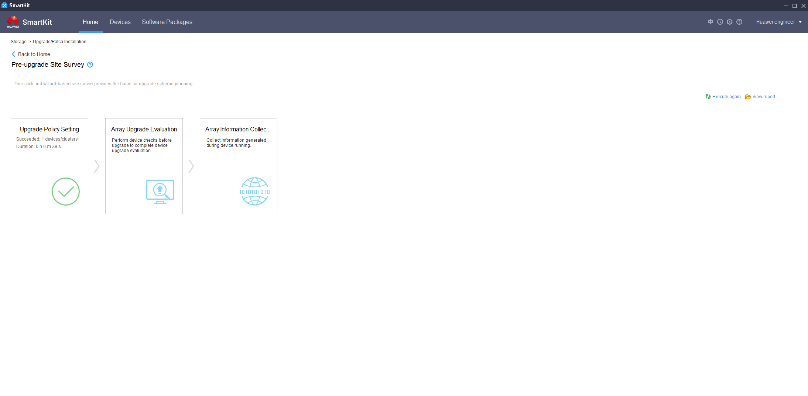

            - On the Upgrade Evaluation Tool page, select the desired device and click Execute, as shown in Figure 4-27.
              - Upgrade evaluation tool
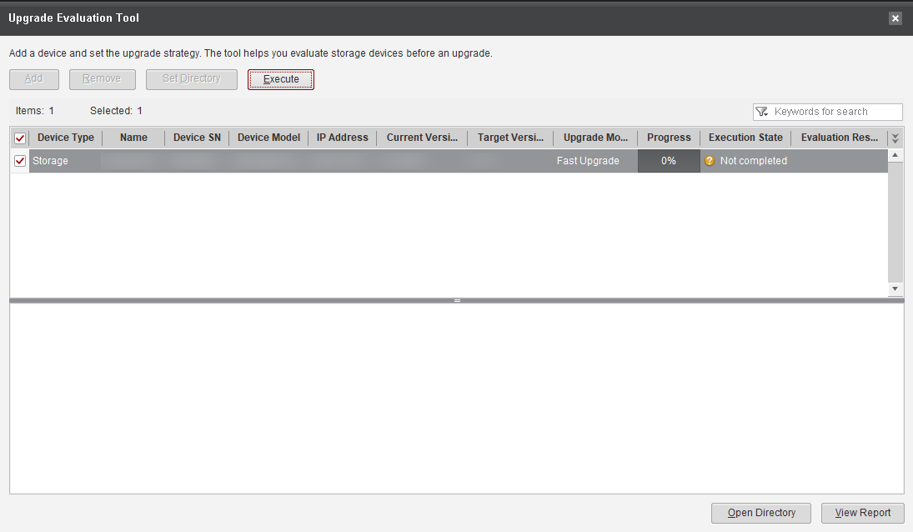

            - After the evaluation is complete, click the failed items (if any) and follow the instructions in Reference in the Details dialog box to rectify them. Then perform the evaluation again until all items are passed, as shown in Figure 4-28.
              - Detailed check information
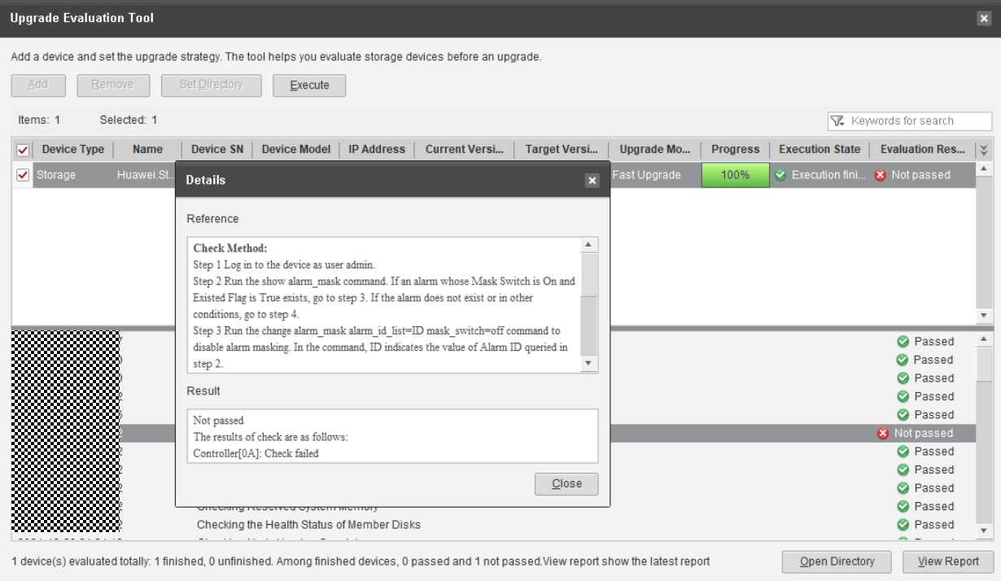

If certain failed items cannot be rectified, contact the technical support engineers to evaluate the risks and proceed with the upgrade only when the risks are acceptable.
----End

Collecting Array Information
Procedure
            - On the Pre-upgrade Site Survey page, click Array Information Collection, as shown in Figure 4-29.
              - Collecting array information
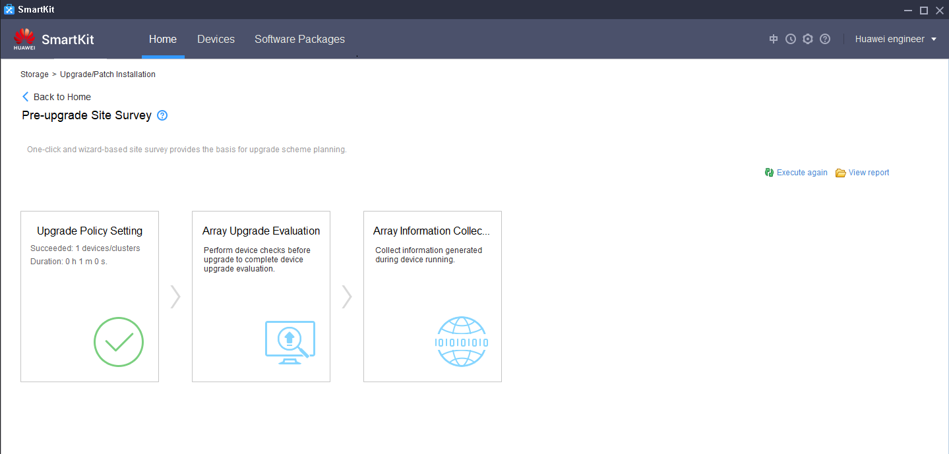

            - On the Information Collection page, select the desired device from the list and click Collect, as shown in Figure 4-30.
              - Start collecting
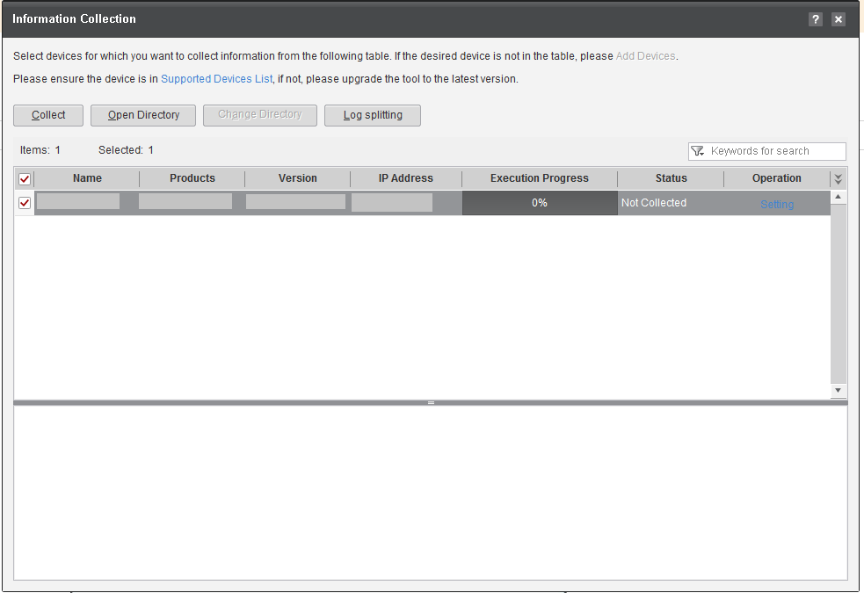

            - After information has been collected, click Open Directory to view the collected information, as shown in Figure 4-31.
              - Opening the directory of the collected information
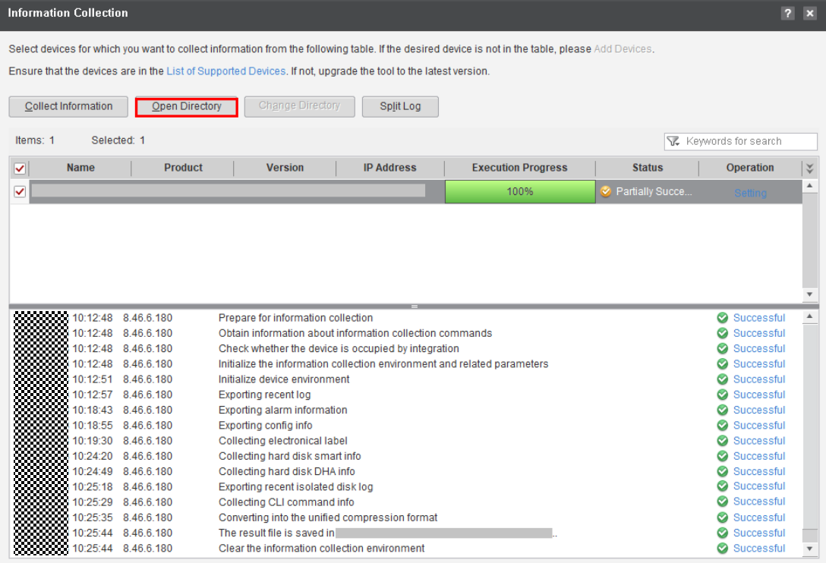

----End

Performing the Upgrade
5.1 Setting the Upgrade Policy
5.2 Prerequisites for Upgrading Controller Software
5.3 Upgrading Controller Software

Setting the Upgrade Policy
            - On the SmartKit home page, click Device Upgrade in Upgrade/Patch Installation and then click Upgrade Policy Setting, as shown in Figure 5-1.
              - Setting the upgrade policy
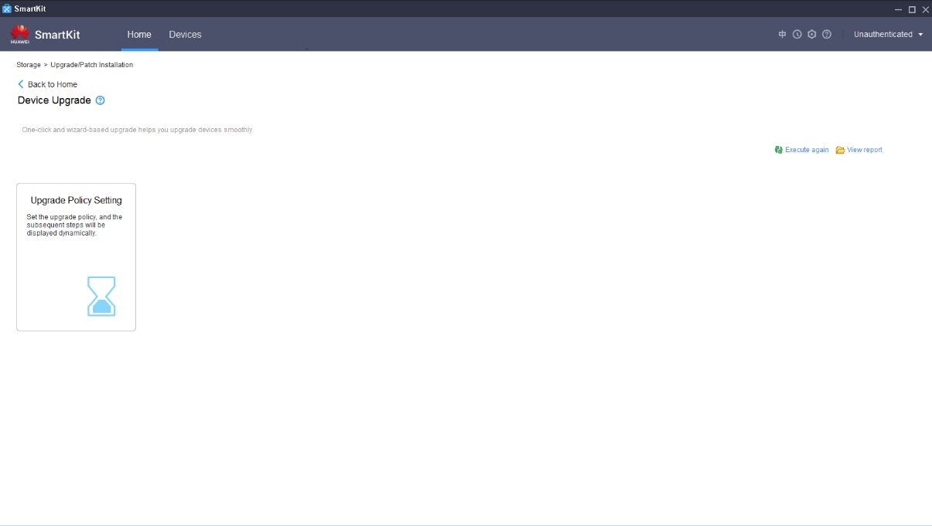

            - Click Add Device, as shown in Figure 5-2.
              - Adding a device
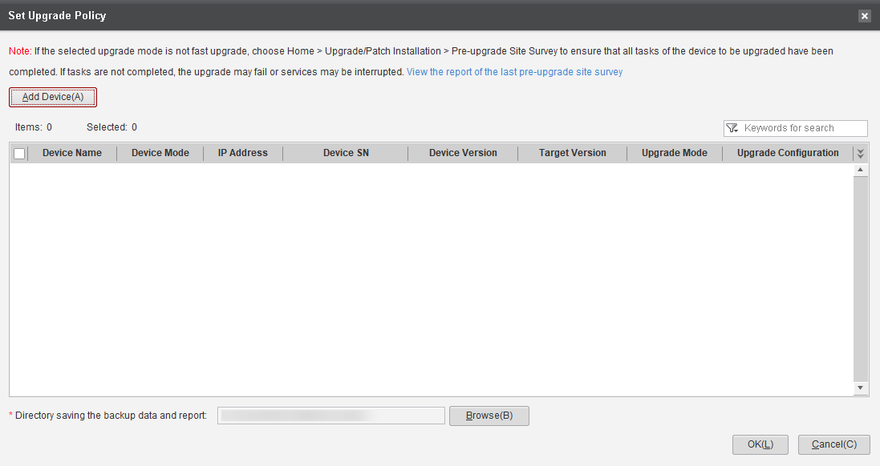
            - On the Select Device page, select the device that has been added in 4.3 Setting the Upgrade Policy and click Next, as shown in Figure 5-3. (If no device has been added, add one by following the instructions in 4.3 Setting the Upgrade Policy.)
              - Selecting a device
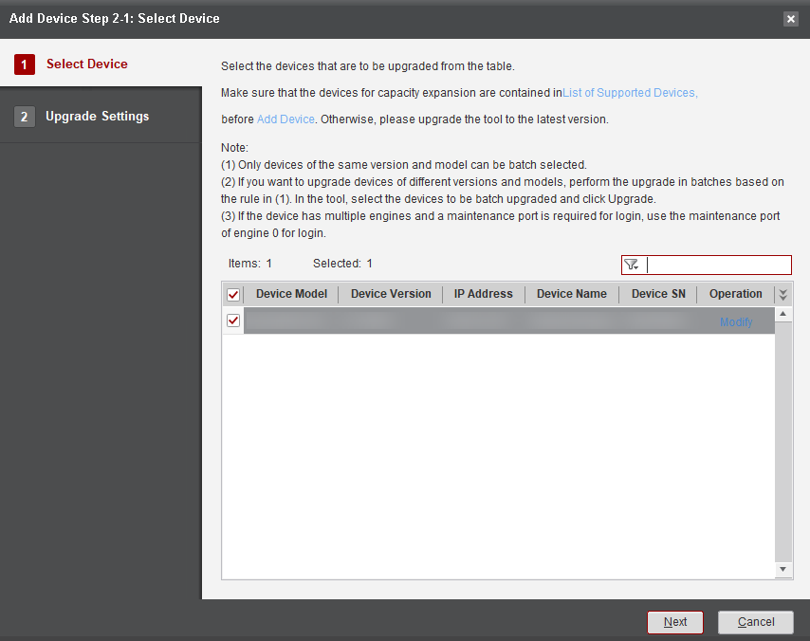
            - Select the component to be upgraded and click Next, as shown in Figure 5-4.
              - Selecting component to be upgraded
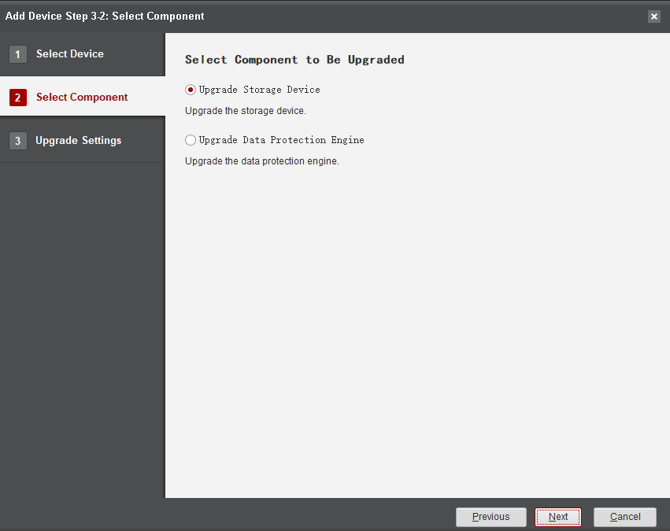
            - On the Upgrade Settings page, click Browse, select the upgrade package, and click OK, as shown in Figure 5-5.
              - Selecting the upgrade package
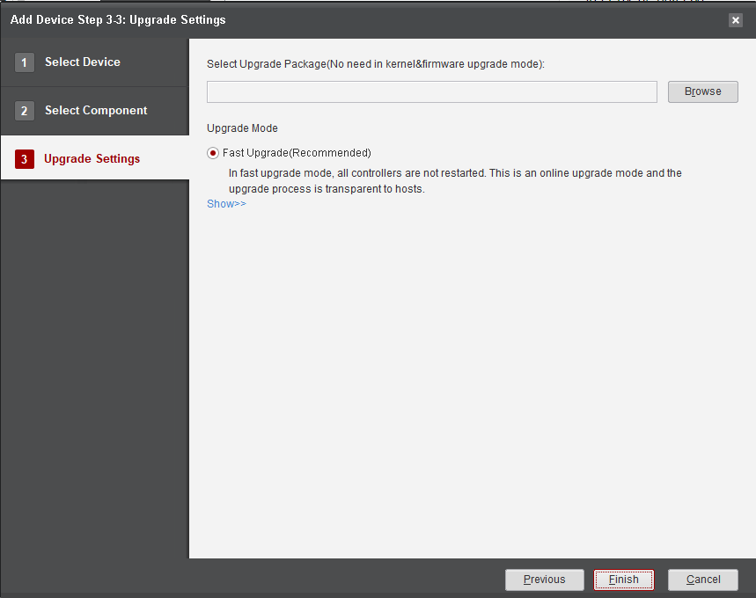
            - Click Modify. Select the patch package to be installed after the upgrade, as shown in Figure 5-6.
              - Selecting the patch package
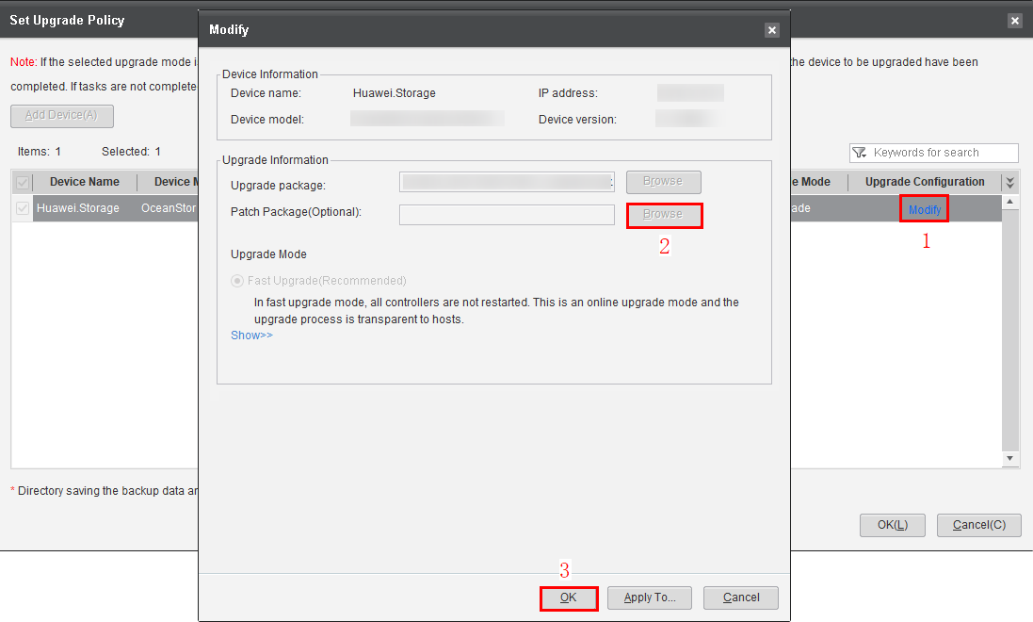
            - Click Browse on the right of Directory saving the backup data and report to select a backup path and click Save, as shown in Figure 5-7.
              - Selecting a backup path
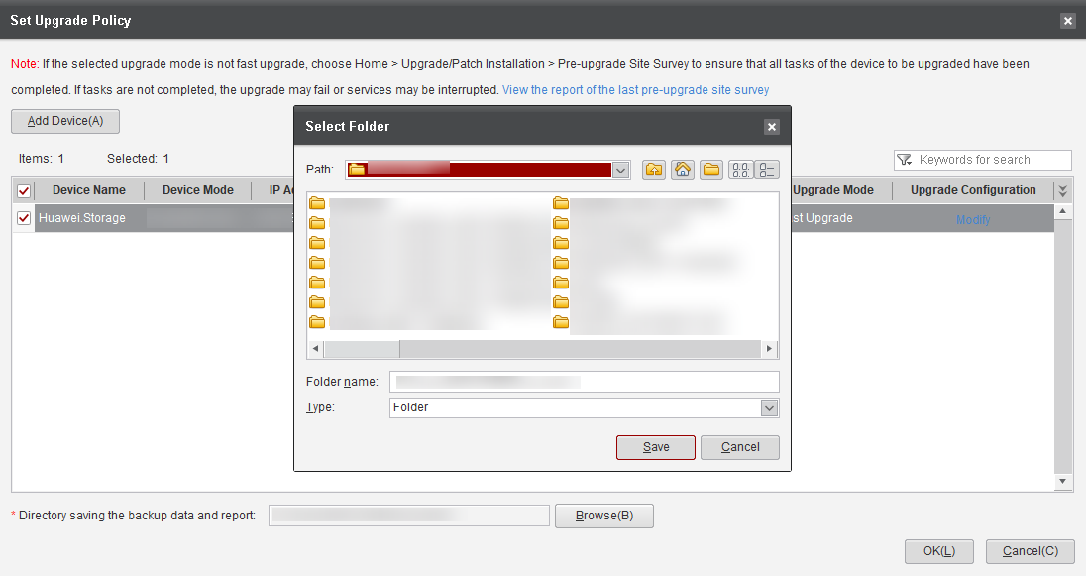
            - Return to the Set Upgrade Policy page. Select the added device, select the confirmation item, and click OK to complete the upgrade policy setting, as shown in Figure 5-8.
              - Upgrade policy set successfully
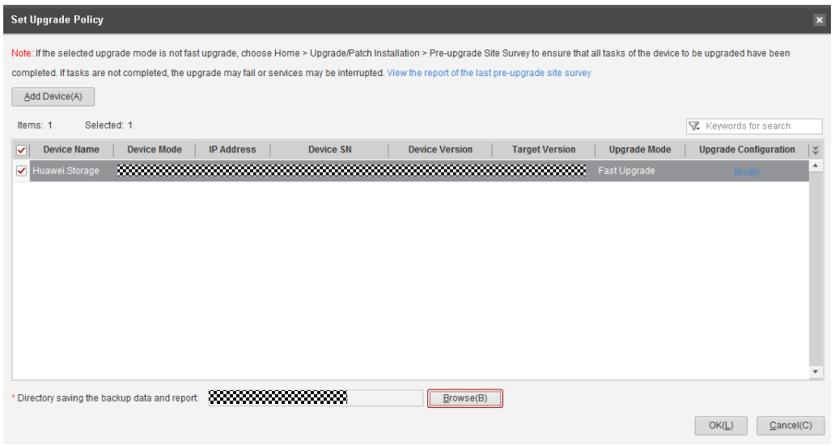

----End

Prerequisites for Upgrading Controller Software
Prerequisites
- Preparations have been made according to 3 Preparations.
- The pre-upgrade site survey has been conducted according to 4 Pre-upgrade Site Survey. If the upgrade is performed more than one day after the last pre-upgrade site survey, you are advised to perform the site survey again before upgrading the controller software.
- On DeviceManager, Max. Sessions per User has been set to 0. To check the value, choose Settings > User and Security > Security Policies and find the value in Login Policy. If it is not 0, change it to 0 and restore the original value after the upgrade is complete.
              - Login policy
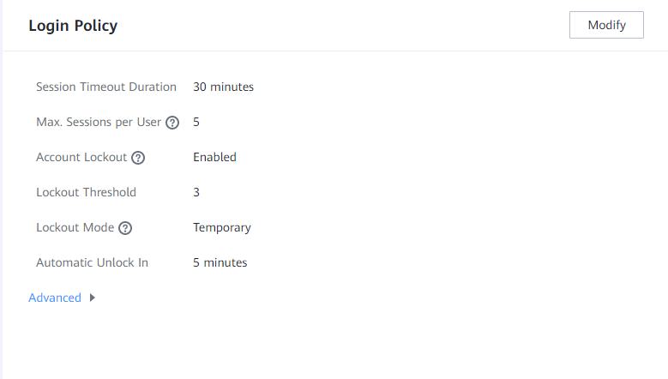

- All DeviceManager and CLI pages have been closed. In addition, login to DeviceManager or the CLI is prohibited during the upgrade.

Upgrading Controller Software
Procedure
            - On the Device Upgrade page, click Storage Array Upgrade, as shown in Figure 5-10.
              - Starting storage upgrade
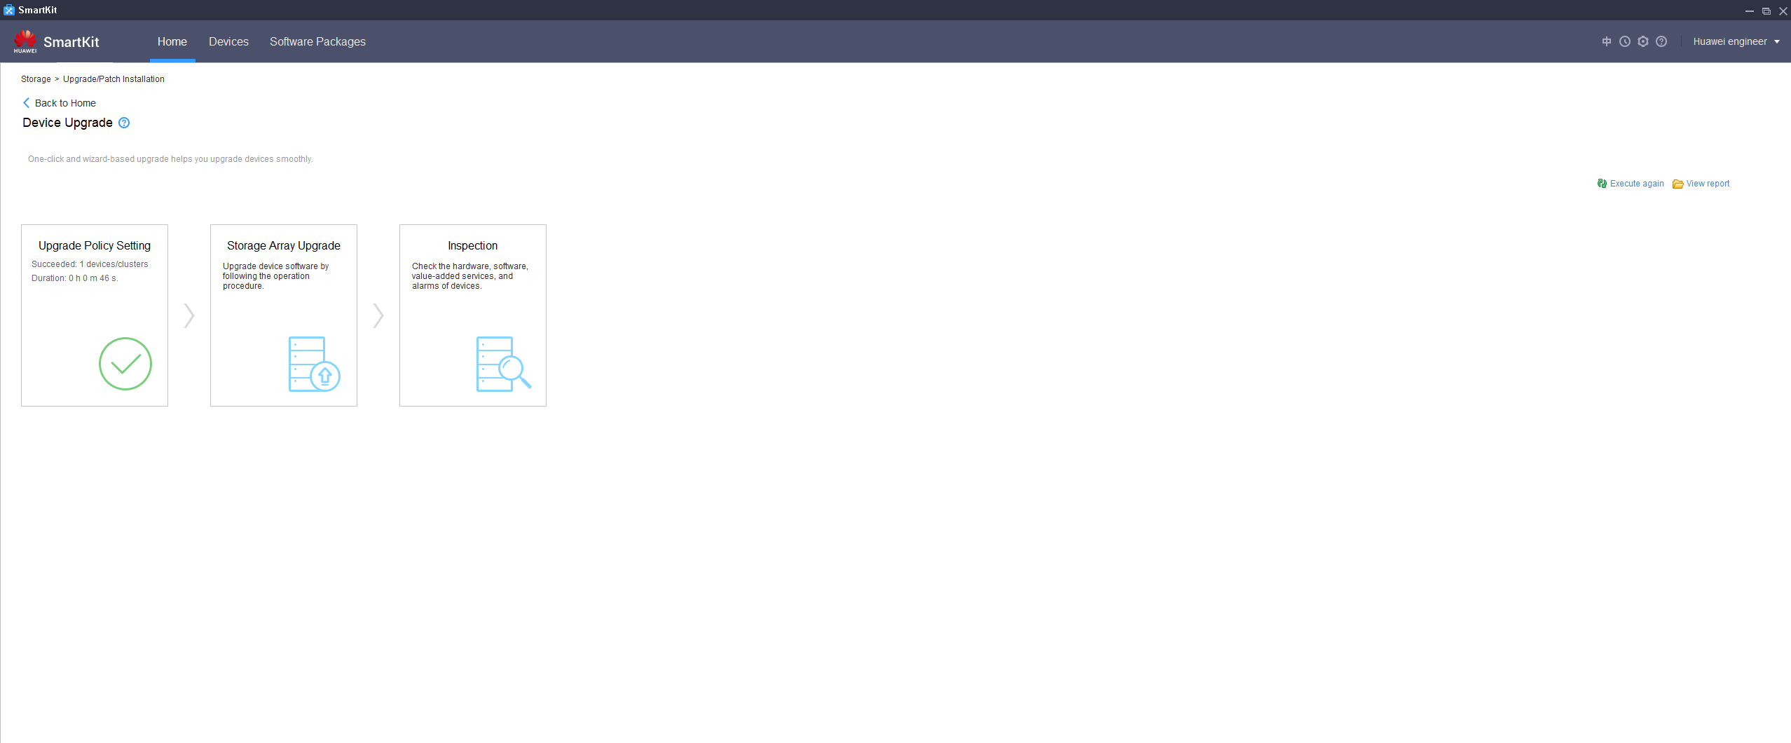
            - Click Perform Upgrade to start the upgrade, as shown in Figure 5-11.
              - Performing the upgrade
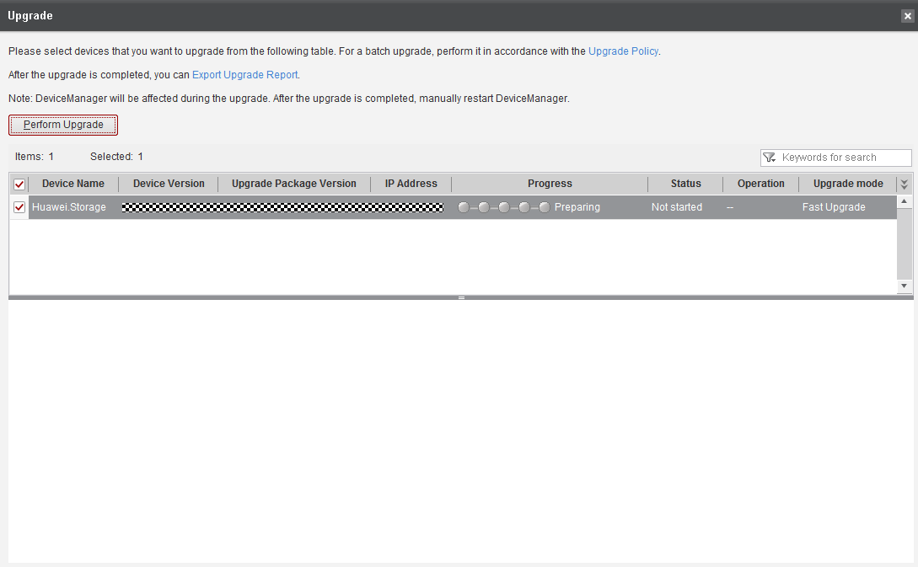

            - In the Confirm Upgrade dialog box, confirm the information, enter Yes, and click OK to start the upgrade, as shown in Figure 5-12.
              - Confirming the upgrade
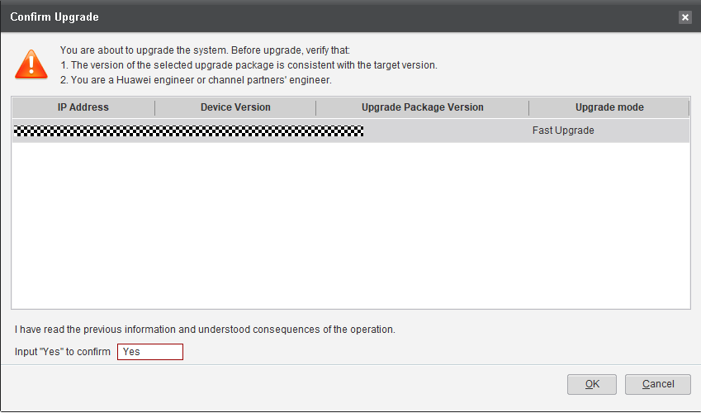

            - The system automatically imports the upgrade package, as shown in Figure 5-13.
              - Importing the upgrade package
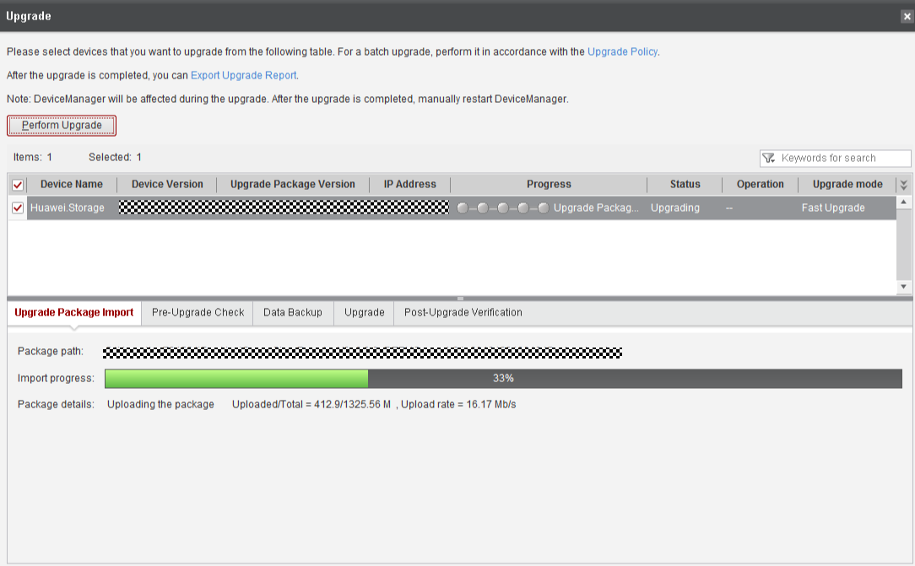

            - After the upgrade package is imported, the system automatically starts a pre-upgrade check, as shown in Figure 5-14.
              - Pre-upgrade check
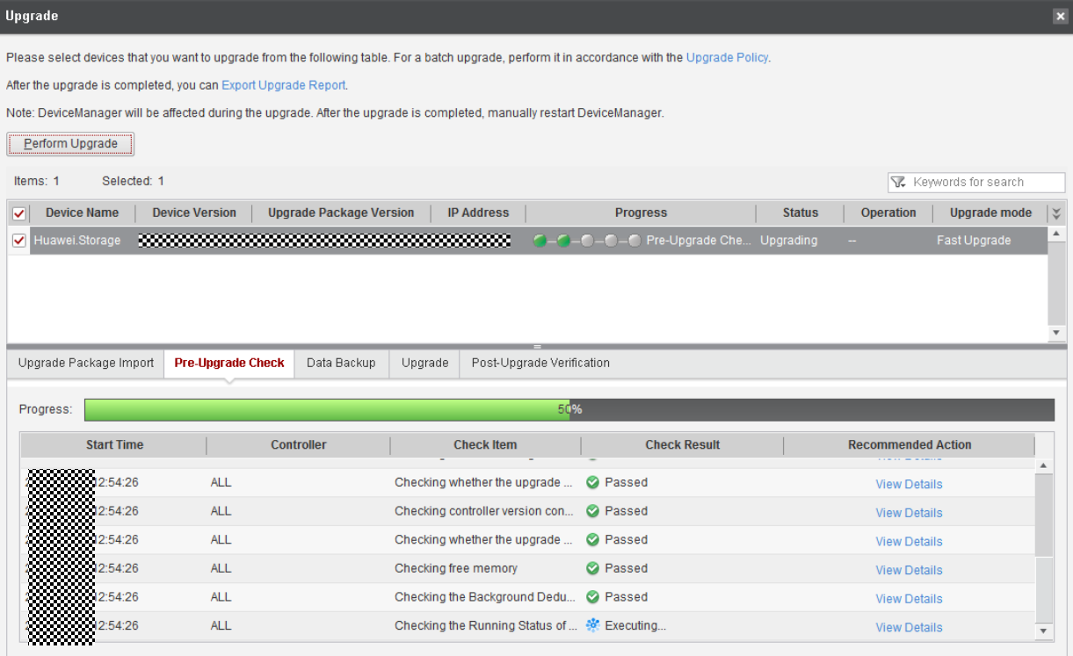

The pre-upgrade check mainly carries out inspections directly related to the device and its health status, such as the upgrade package compatibility, device service load, redundant links of hosts, and device alarms. Some check items have been covered by the array upgrade evaluation, while other items must be checked after the upgrade package is imported.
            - After the pre-upgrade check is complete, the system automatically backs up data, as shown in Figure 5-15.
              - Data backup
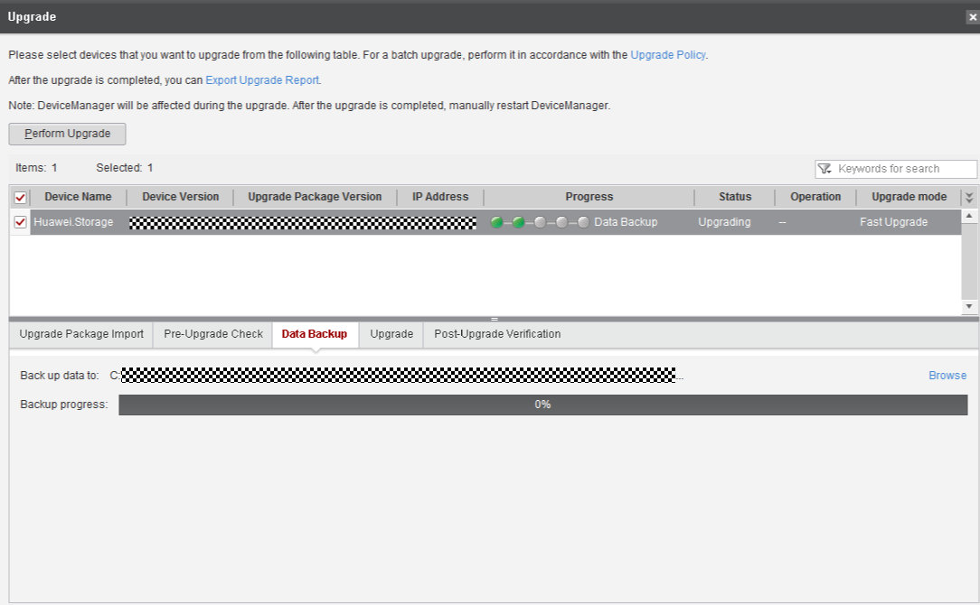
            - After data backup, the system automatically performs the upgrade, as shown in Figure 5-16.
              - Performing the upgrade
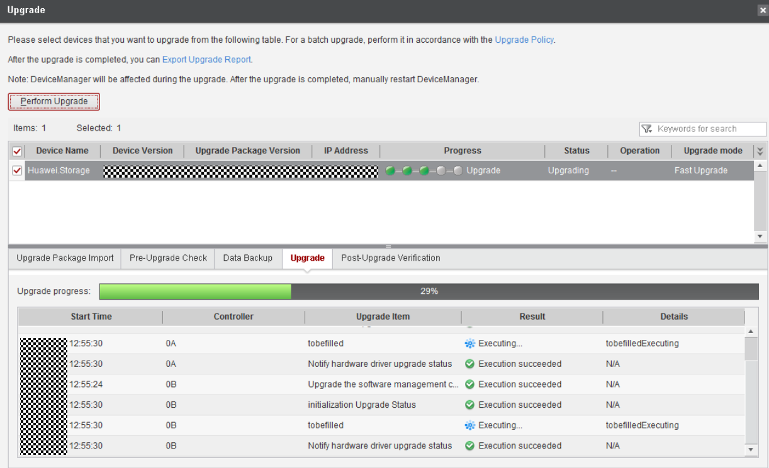

            - After the upgrade is complete, the system automatically performs a post-upgrade verification, as shown in Figure 5-17.
              - Post-upgrade verification
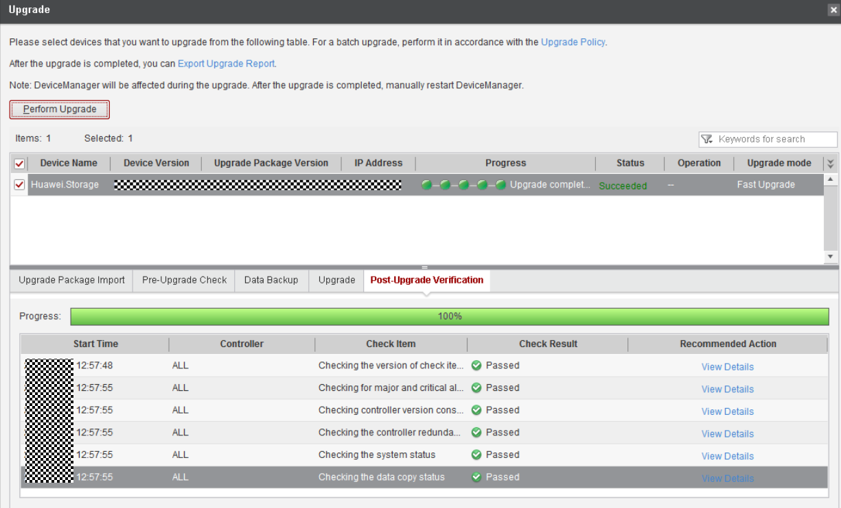

Check the post-upgrade verification result carefully to ensure no exception occurred during the upgrade.
            - After the upgrade, verify that the system version is consistent with the upgrade package version. The upgrade process is completed, as shown in Figure 5-18.
              - Confirming completion of the upgrade
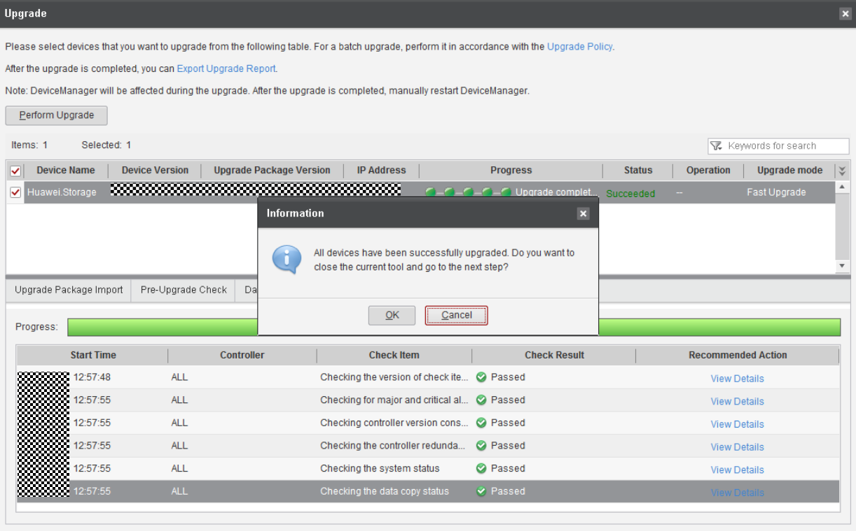

----End

Conducting an Inspection

The inspection is to check the system health status after the upgrade. The system status is normal only when all inspection items pass the check. Otherwise, rectify the failed items as prompted.
Procedure
            - After the fast upgrade is complete, click Inspection, as shown in Figure 6-1. Select the check items. By default, all items are selected, as shown in Figure 6-2.
              - Starting the inspection
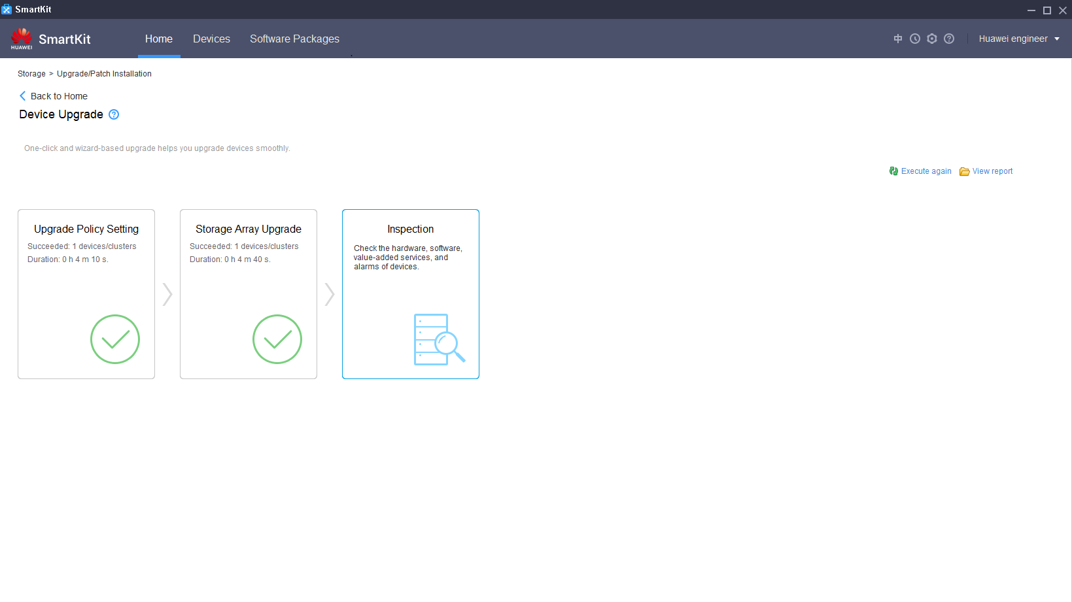

              - Selecting check items
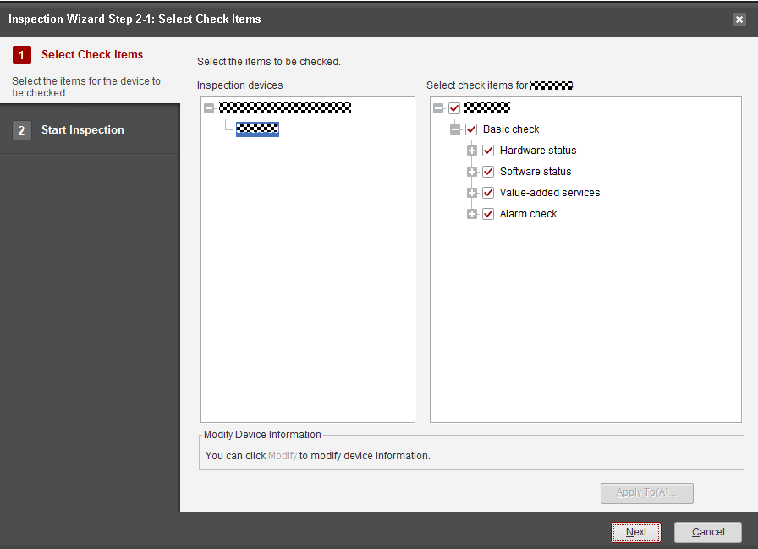

            - Click Next. The inspection starts and takes about 5 minutes, as shown in Figure 6-3.
              - Inspection completed
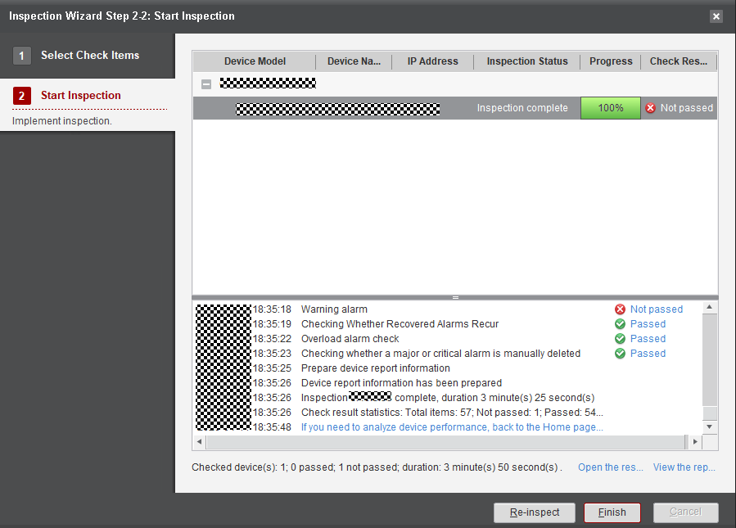

            - After the inspection is complete, click Passed or Not passed to view the inspection details, as shown in Figure 6-4.
              - Viewing the inspection details
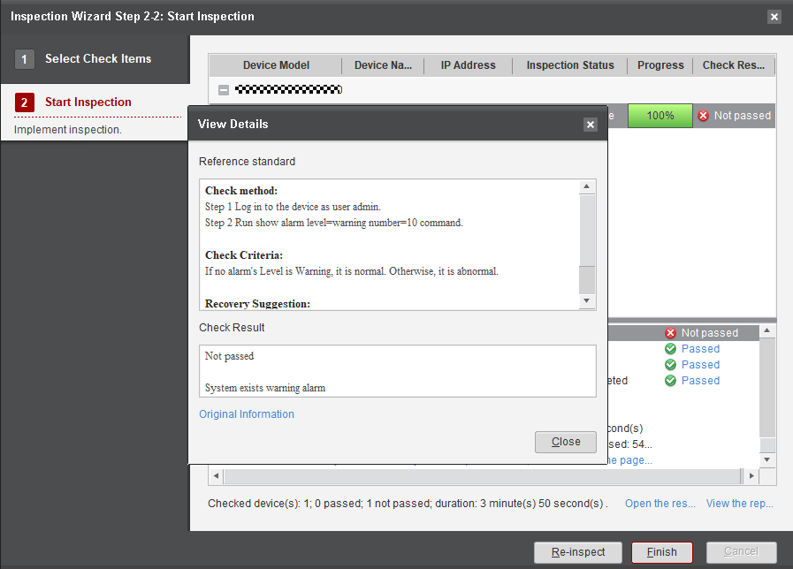

            - Click Original Information to view error details, as shown in Figure 6-5.
              - Original information
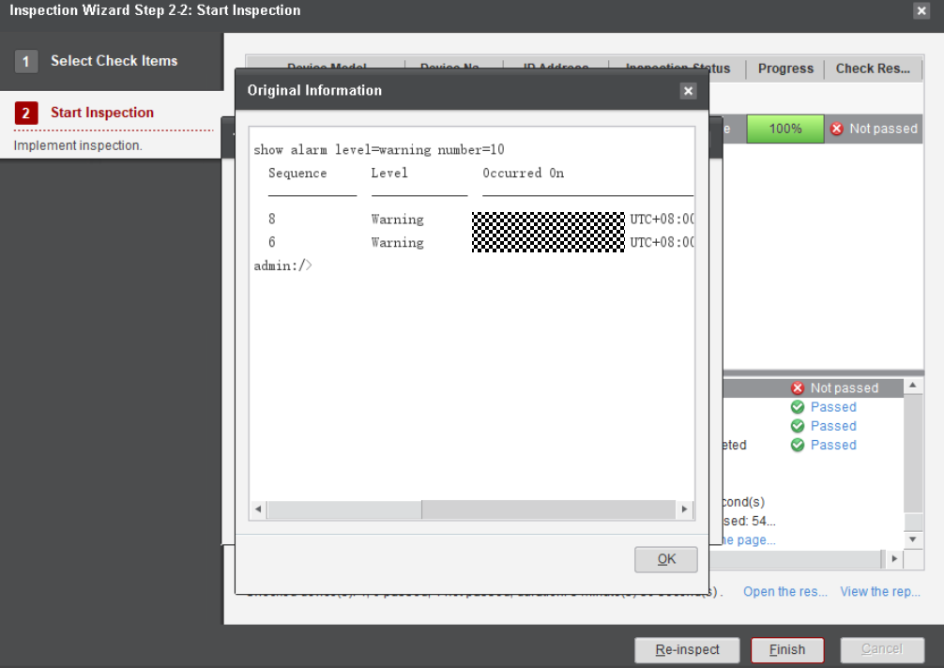

            - Click View the report, as shown in Figure 6-6.
              - Viewing the report
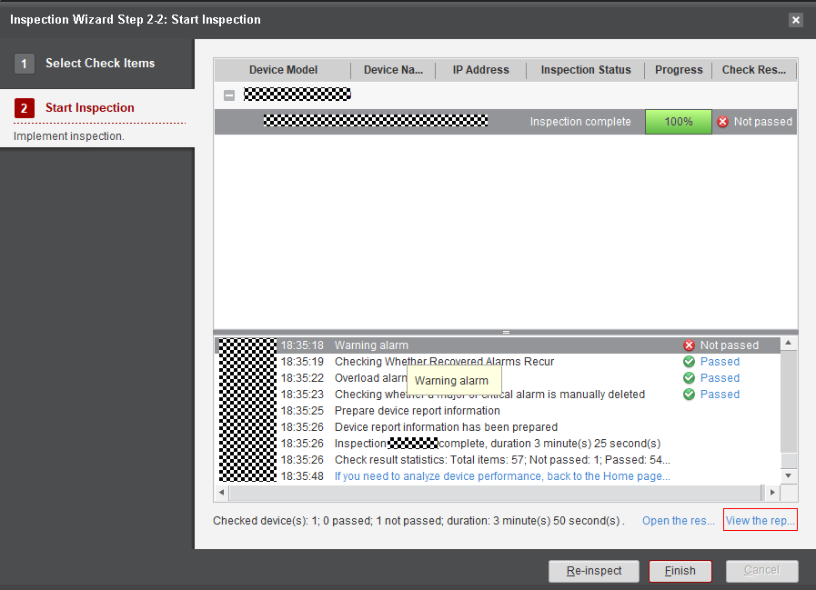

            - Click the navigation tree on the left for detailed information, as shown in Figure 6-7.
              - Detailed storage device inspection report
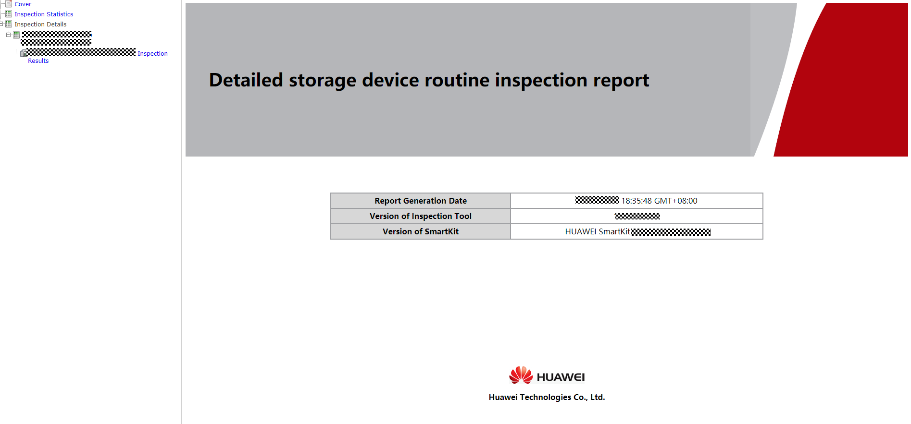

----End

Verifying the Upgrade
7.1 Verifying User Configuration Data
7.2 Verifying Host Services
This section describes how to verify that host services are running properly.

Verifying User Configuration Data
Expected Results
- The user configuration data is consistent with that before the upgrade.
- The license is available after the upgrade.
Procedure
            - Verify that the user configuration data is consistent with that before the upgrade.
            - Verify that the license is available after the upgrade.
----End
Troubleshooting
            - If user configuration data is lost, import the configuration data backed up before the upgrade for restoration. If the restoration fails, manually restore the configuration using exported running data.
            - If the license is unavailable after the upgrade, import the license file backed up during the upgrade.
The license file is automatically backed up along with data backup during the system upgrade.
----End

Verifying Host Services
This section describes how to verify that host services are running properly.
Contact the customer's device administrator or IT department administrator to assist in verifying that host services are running properly.

Retrying the Upgrade
If the upgrade fails, see 14.1 Common Troubleshooting Methods for an Upgrade Failure. Click Retry as shown in step 2 of the troubleshooting procedure.

Rolling Back the Upgrade
If the upgrade fails, see 14.1 Common Troubleshooting Methods for an Upgrade Failure. If the retry fails, click Roll Back as shown in step 2 of the troubleshooting procedure.

OTA Upgrade Procedure
This chapter describes how to upgrade the device in Over The Air (OTA) mode.
10.1 Before You Start
10.2 OTA Upgrade Process
10.3 Connecting a Device to DME IQ
10.4 Querying the Version Update
10.5 Performing Pre-upgrade Evaluation
10.6 Downloading the Upgrade Package
10.7 Setting Off-Peak Download and Auto Upgrade
10.8 Upgrading a Device

Before You Start
In OceanStor Dorado 6.1.3 and later, you can upgrade a device in OTA mode after connecting it to eService. Compared with the SmartKit-based upgrade, the OTA upgrade does not require complex operations, such as formulating upgrade policies, downloading software packages, and installing SmartKit. The version update is immediately pushed after new release and you only need to log in to DeviceManager to upgrade devices.

1. The current version must be 6.1.3 or later.
2. Only OceanStor Dorado 2000, 3000, 5000, 5300, 5500, 5600, 5600K, and 6000 support this upgrade mode.
3. Only fast upgrade supports this upgrade mode.

OTA Upgrade Process
This section describes the main steps for the OTA upgrade and their required time.
Table 10-1 lists necessary steps and their required time in the OTA upgrade.
                - OTA upgrade procedure
Step | Time Required | Remarks
Connecting a device to DME IQ | 1 to 5 minutes | See 10.3 Connecting a Device to DME IQ.
Querying the version update | 5 seconds | See 10.4 Querying the Version Update.
Performing pre-upgrade evaluation | 3 to 5 minutes | See 10.5 Performing Pre-upgrade Evaluation.
Downloading the software package | It depends on the software package size and network download speed. If the download speed is 5 Mbit/s, it takes about 3 to 5 minutes. | See 10.6 Downloading the Upgrade Package.
Upgrading a device | 20 to 30 minutes | See 10.8 Upgrading a Device.

Connecting a Device to DME IQ
This section describes how to connect a device to DME IQ and enable the OTA upgrade function.
            - Log in to DeviceManager and choose Settings > DME IQ Settings. If you have connected the device to DME IQ as shown in Figure 10-1, click Test Network to ensure that the network connectivity is normal. Otherwise, go to the next step.
              - DME IQ Settings
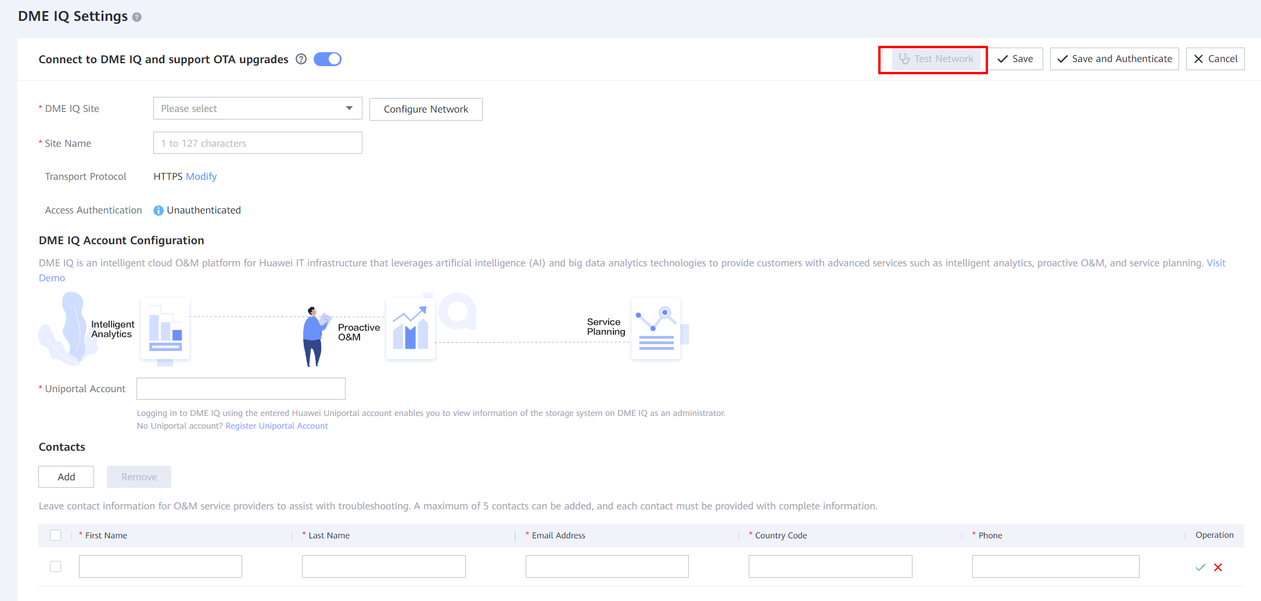
            - Click the online help icon in the upper right corner of DeviceManager to go to the Online Help page. Search for Managing DME IQ and refer to the procedure to connect the device to DME IQ.
----End

1. The current version is 6.1.5 or earlier. You need to access eService settings to enable OTA upgrade.
            - Log in to DeviceManager and choose Settings > eService Settings. If you have connected the device to eService as shown in Figure 10-2, click Test Network to ensure that the network connectivity is normal. Otherwise, go to the next step.
              - eService Settings
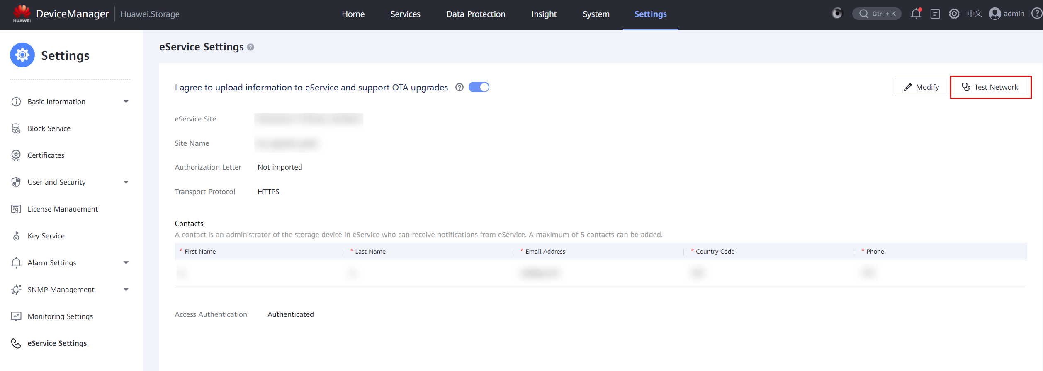
            - Click the online help icon in the upper right corner of DeviceManager to go to the Online Help page. Search for Managing eService and refer to the procedure to connect the device to eService.
----End

Querying the Version Update
This section describes how to check whether a device can be upgraded to another version after it has been connected to DME IQ.
            - Log in to DeviceManager after connecting a device to DME IQ. If a new version is detected, the system prompts a message, as shown in Figure 10-3.
              - New version prompt
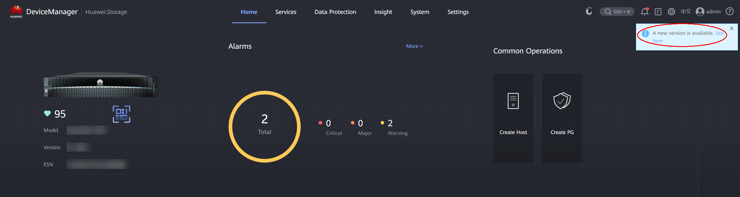
You can also click in the upper right corner of DeviceManager to go to the Upgrade page and view the version update information.
            - Click View Now. The version details page is displayed, as shown in Figure 10-4.
              - Version details page
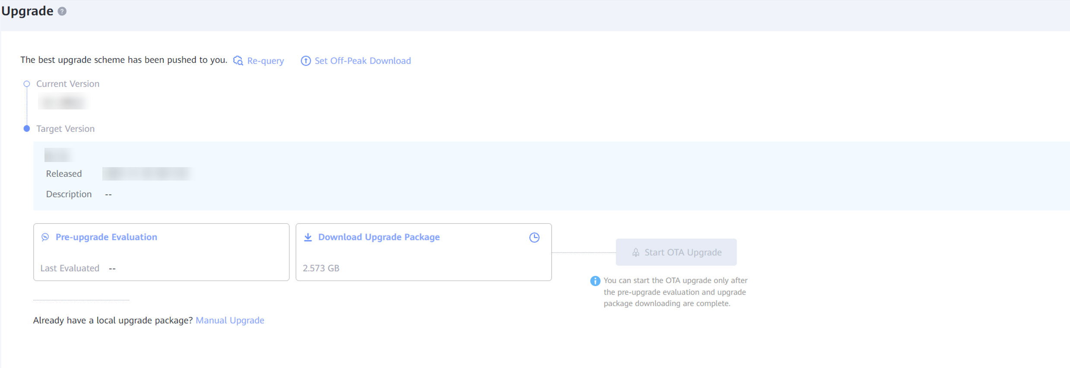
- As shown in the preceding figure, you can view the current version and available target version of the device. Specifically, you can view the version number, release time, and description of the target version.
- You can perform all subsequent OTA upgrade operations on this page, including pre-upgrade evaluation, upgrade package download, and upgrade startup.
----End

Performing Pre-upgrade Evaluation
This section describes how to perform pre-upgrade evaluation. The device pre-upgrade check is automatically performed before the upgrade starts.

The pre-upgrade evaluation aims to identify problems that may fail the upgrade before downloading the software package and starting the upgrade. You must ensure that all check items pass the check before performing subsequent steps.
            - On the version details page, click Pre-upgrade Evaluation. The system automatically performs the pre-upgrade evaluation.
              - Starting upgrade evaluation
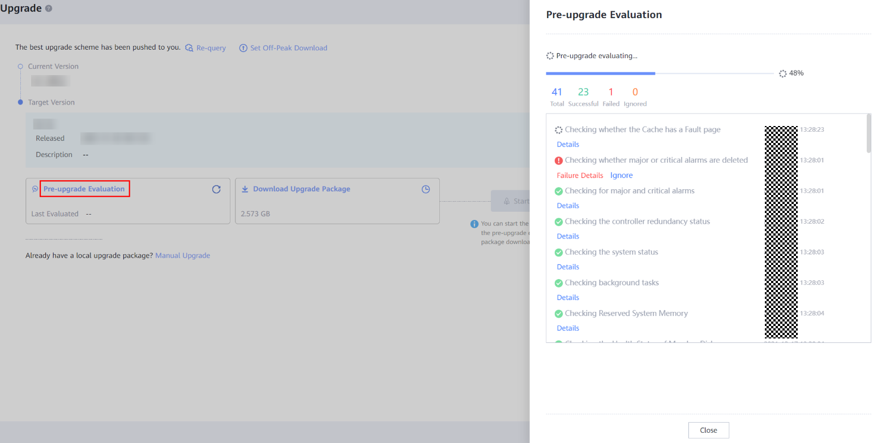
            - If all evaluation items are passed, click Close to exit the evaluation page.
            - If any item fails to pass the evaluation, click Failure Details to view the failure cause and rectification suggestions. Rectify the fault based on the suggestions and redo the evaluation until all evaluation items are passed.
              - Viewing failed item details
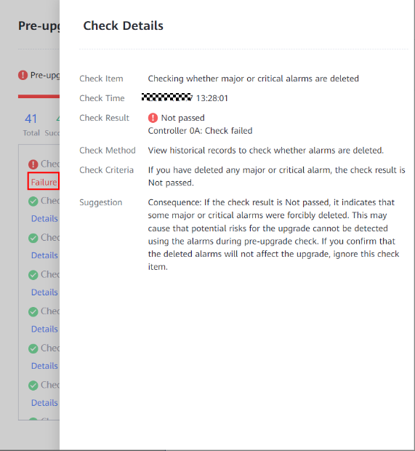
            - After the fault is rectified, click the retry button to redo the evaluation.
              - Redoing evaluation
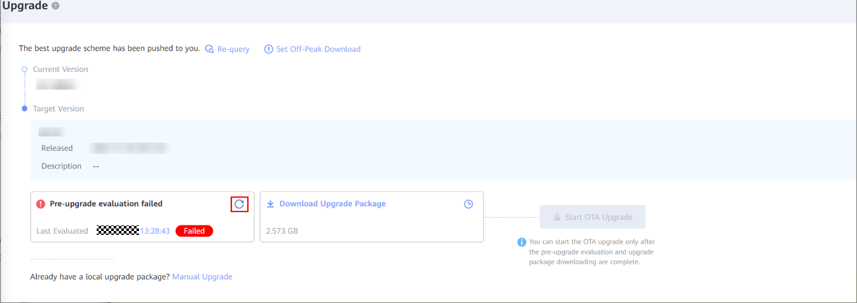
- You can click the last evaluation record to view its details.
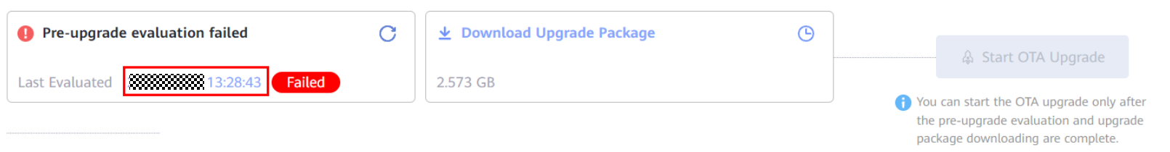
- You can click Retry to redo the evaluation on the last evaluation details page.
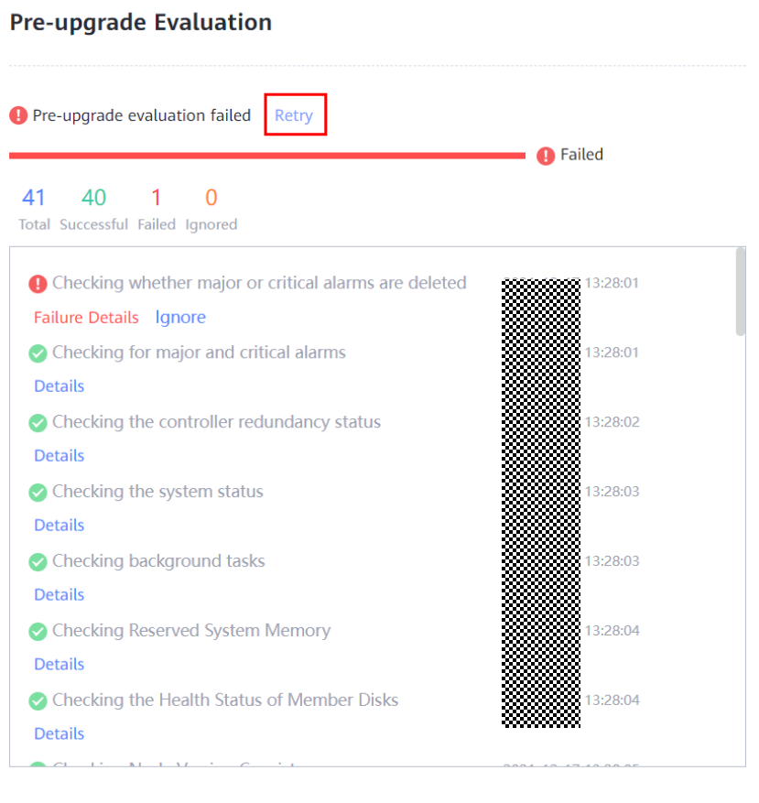
- If the pre-upgrade evaluation fails but the upgrade package is successfully downloaded, you can confirm the risk and start the OTA upgrade.
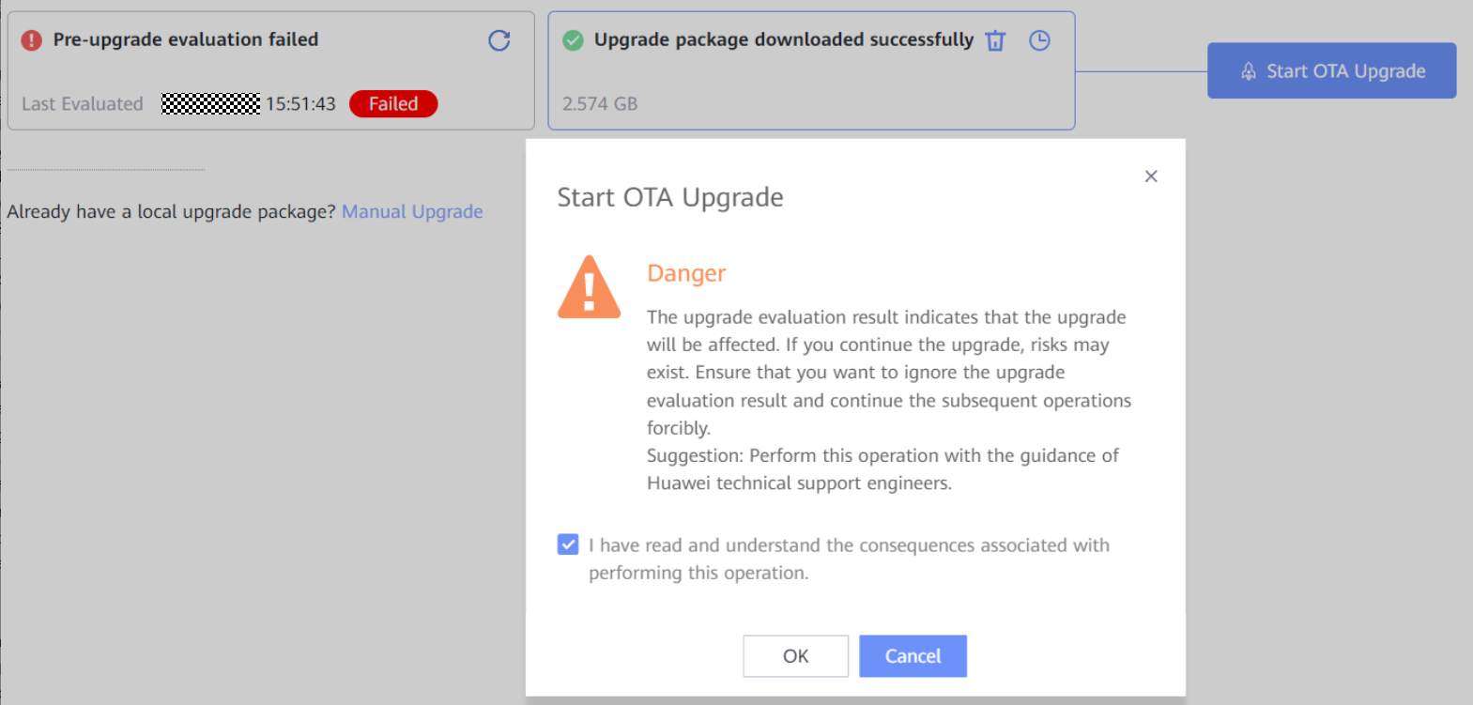
----End

Downloading the Upgrade Package
This section describes how to download the upgrade software package.
- The software package download may take a long time due to network problems. You are advised to arrange the download before the upgrade time window according to the software package size and current download speed.
- You are advised to download the software package only after the upgrade evaluation is passed. Otherwise, the device may not meet upgrade requirements, wasting download time.
            - Click Download Upgrade Package. The system automatically downloads the upgrade software package.
              - Starting download
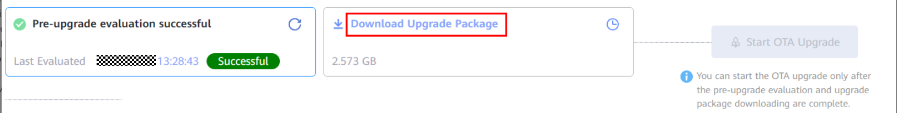
              - Displaying the current progress
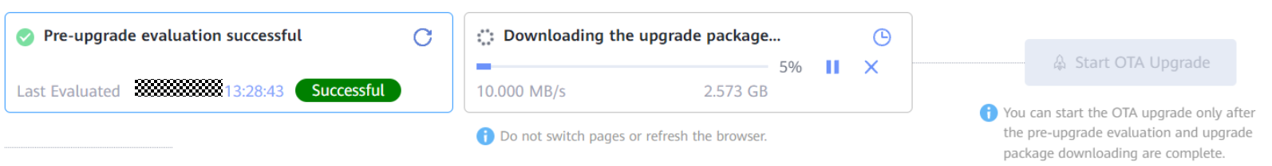
- You can click to pause the download and then resume it at any time since the downloaded part is stored on the device.
- You can click to cancel the download. The cancellation will delete the downloaded package and terminate the download task. You need to restart the download task for another download.
- If a network exception interrupts the download, the download task is automatically suspended and is resumed after the network is recovered.
- After the download is complete, you can click to delete the downloaded package.
----End

Setting Off-Peak Download and Auto Upgrade
This section describes how to set the off-peak download function.
- You can configure the start time, end time, and maximum download speed for off-peak download. In this way, the software package can be automatically downloaded when a new version is detected.
- After a device is connected to eService, off-peak download is enabled by default.
            - On the version details page, click Set Off-Peak Download and set the start time, end time, and maximum speed, as shown in Figure 10-10
              - Setting off-peak download parameters
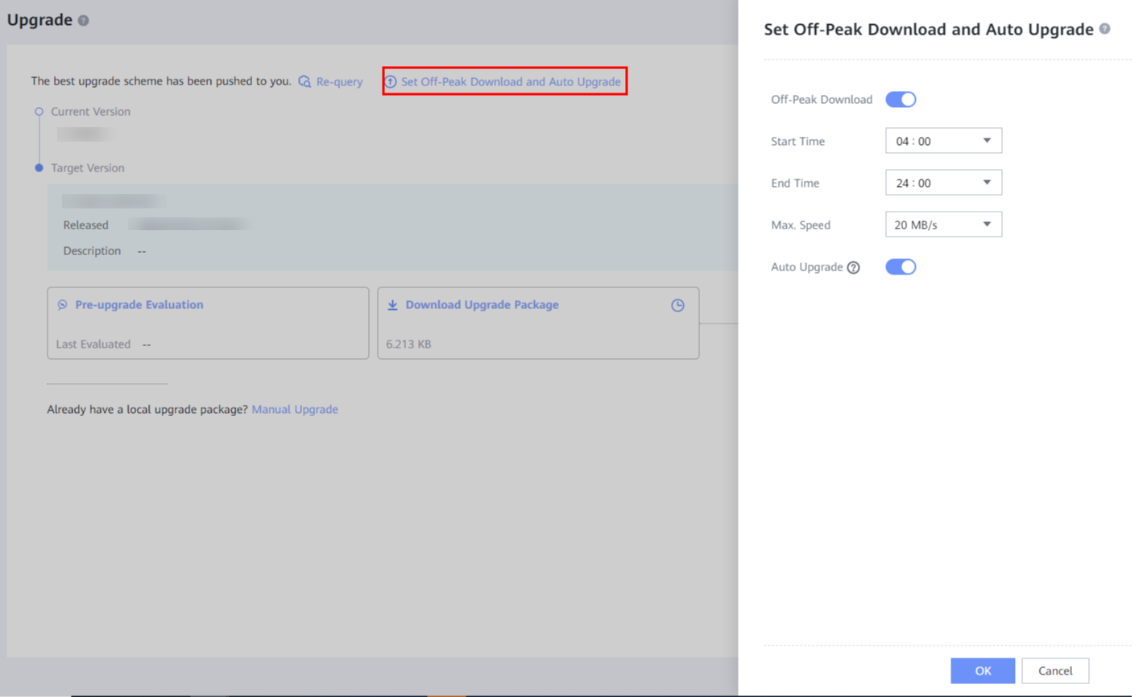

Figure 10-11 shows how to enable auto upgrade.
              - Enabling auto upgrade
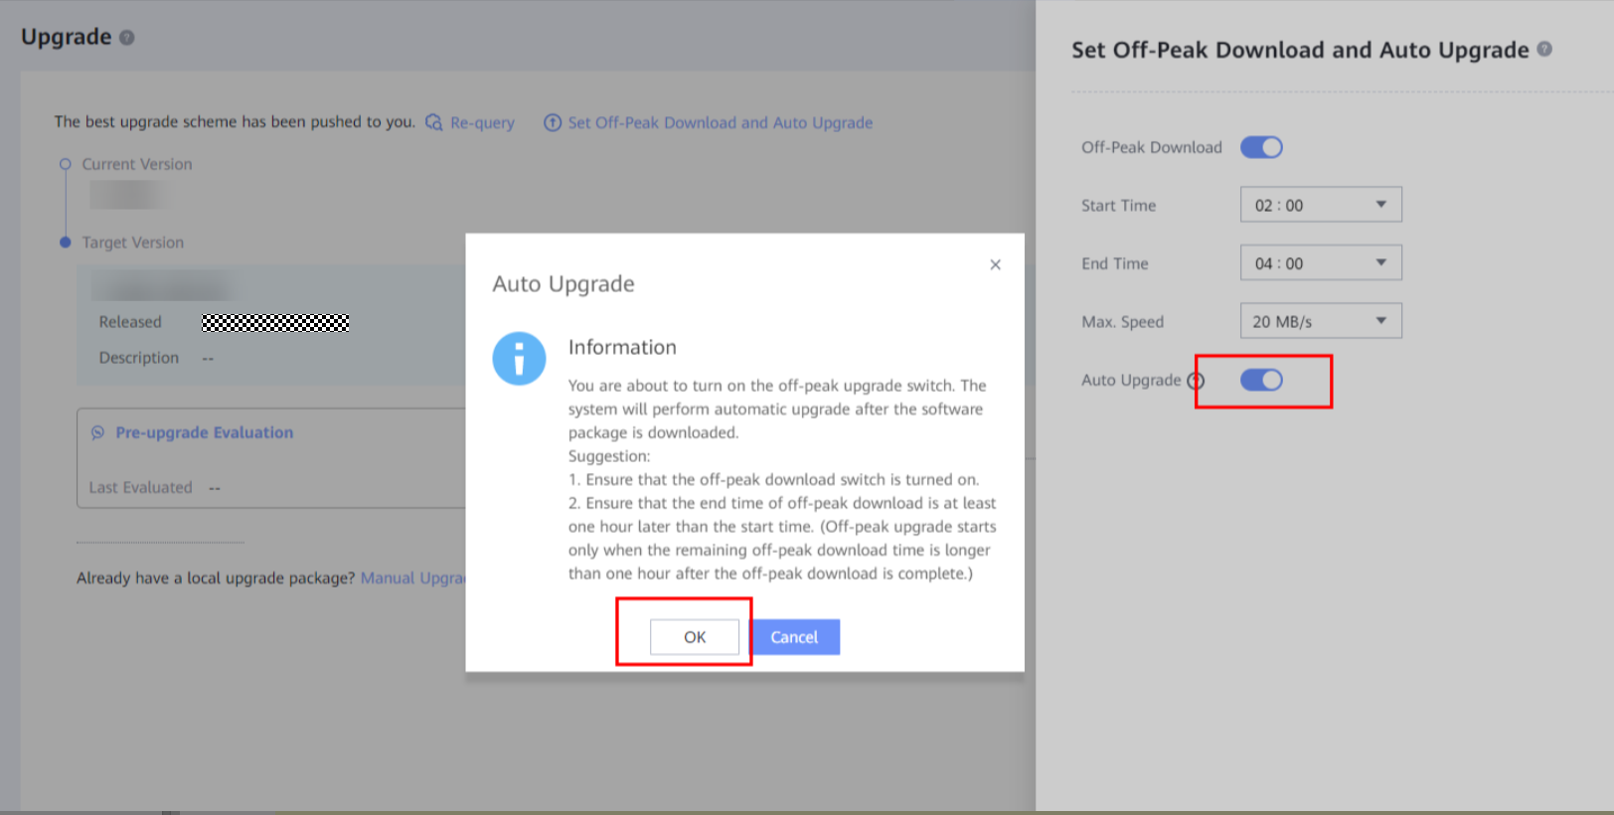

If auto upgrade is not required, you can turn off the switch, as shown in Figure 10-12.
              - Turning off the auto upgrade switch
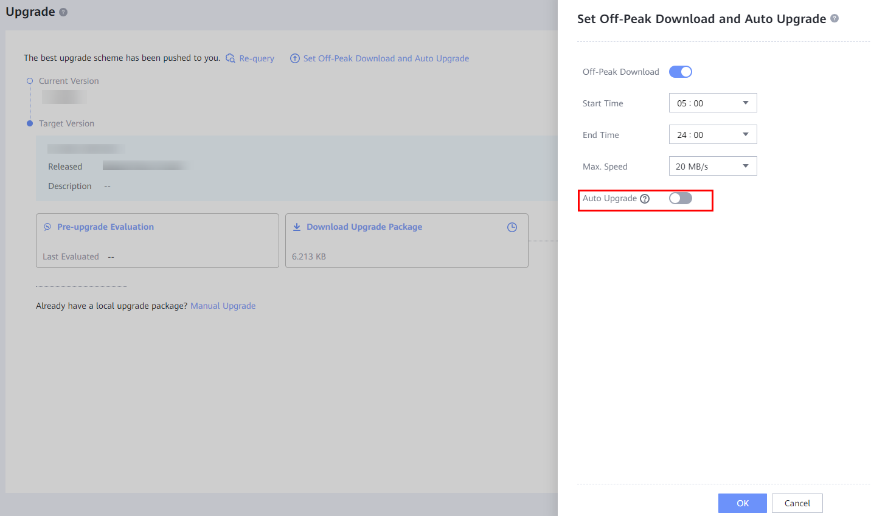

If off-peak download is not required, you can turn off the switch, as shown in Figure 10-13.
              - Disabling off-peak download
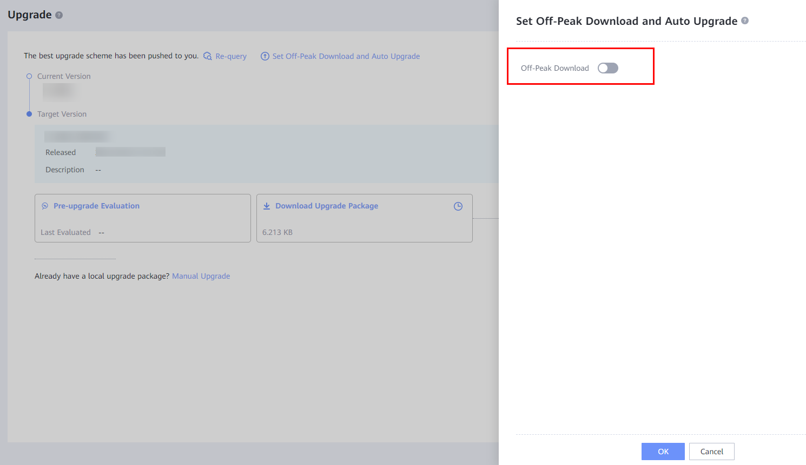

            - The system automatically starts to download the upgrade software package after entering the time interval set in off-peak download.
              - Off-peak download in progress
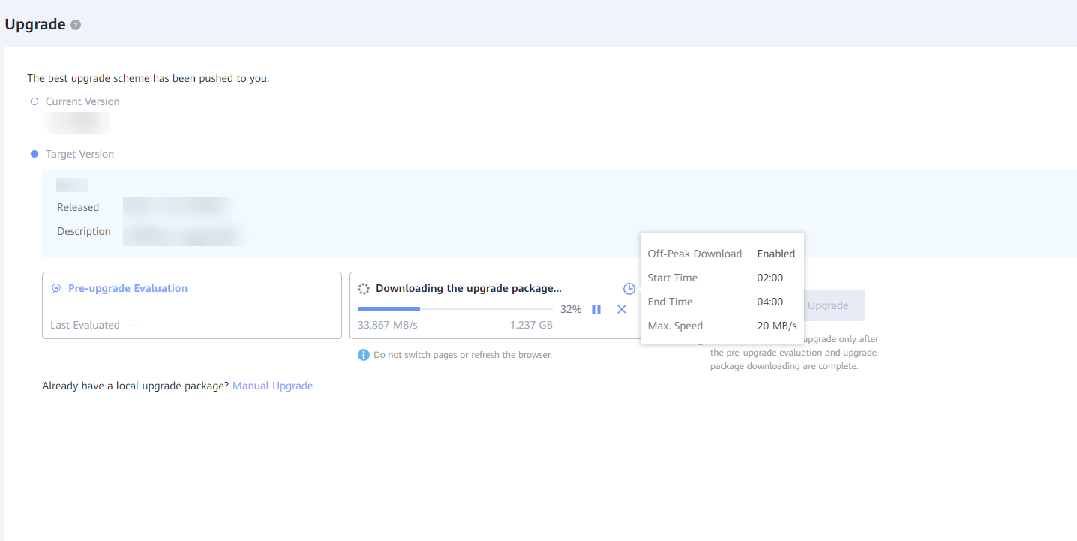
            - After off-peak download is complete, auto upgrade is performed.
              - Auto upgrade completed
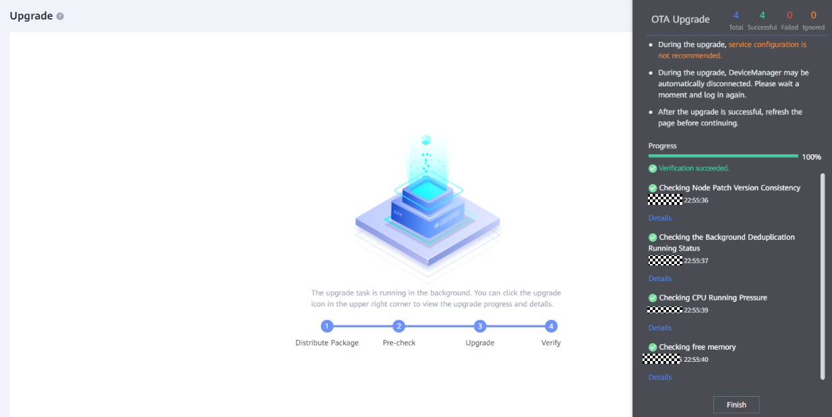
----End

Upgrading a Device
This section describes how to upgrade a device after the upgrade package is downloaded.
The OTA upgrade uses the fast upgrade mode by default. There is no device restart and host service impact during the upgrade. However, the I/O impact lasts for 1 to 2 seconds during the upgrade. Therefore, you are advised to start the OTA upgrade during off-peak hours.
            - Click Start OTA Upgrade. The window for confirming the target version and backing up data is displayed.
              - Confirming the target version and backing up data
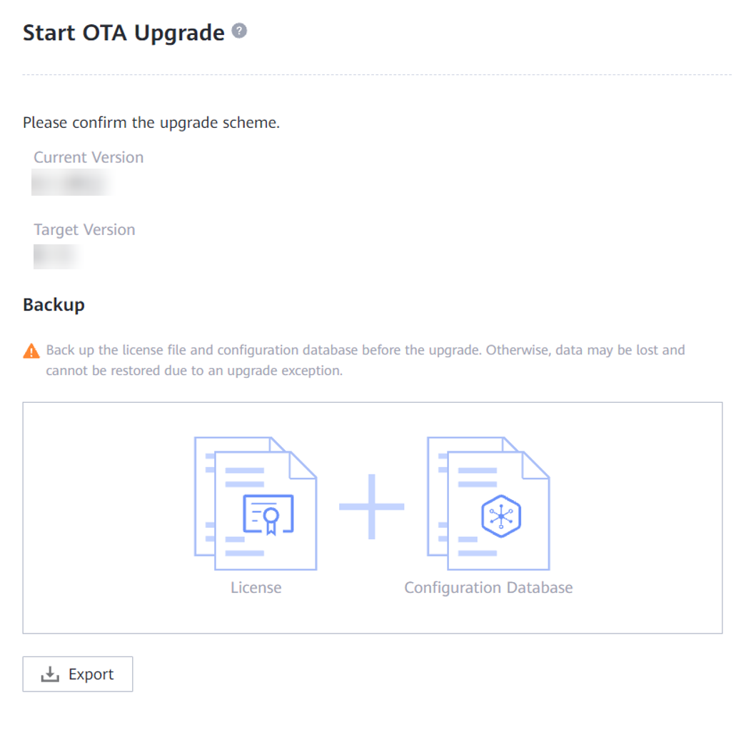
            - Click Export. The license file and configuration data are automatically backed up. Save the backup file properly.
            - After the configuration data is backed up, click Upgrade.
              - Starting the upgrade
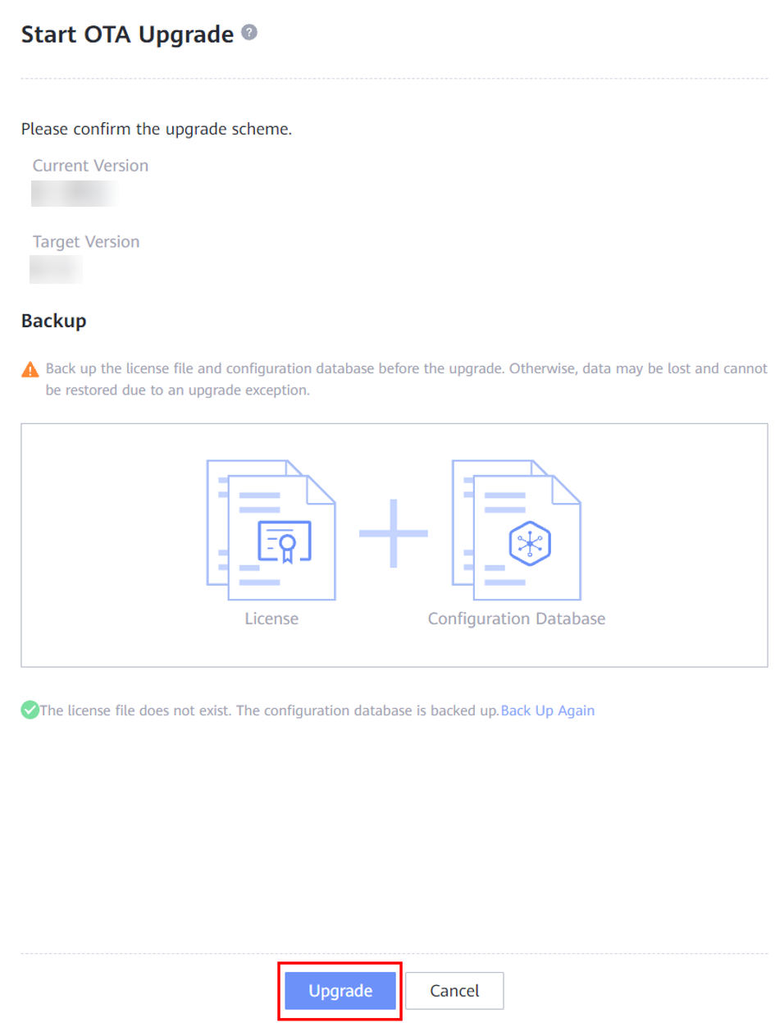
            - Confirm the risk as prompted and click OK.
              - Risk confirmation
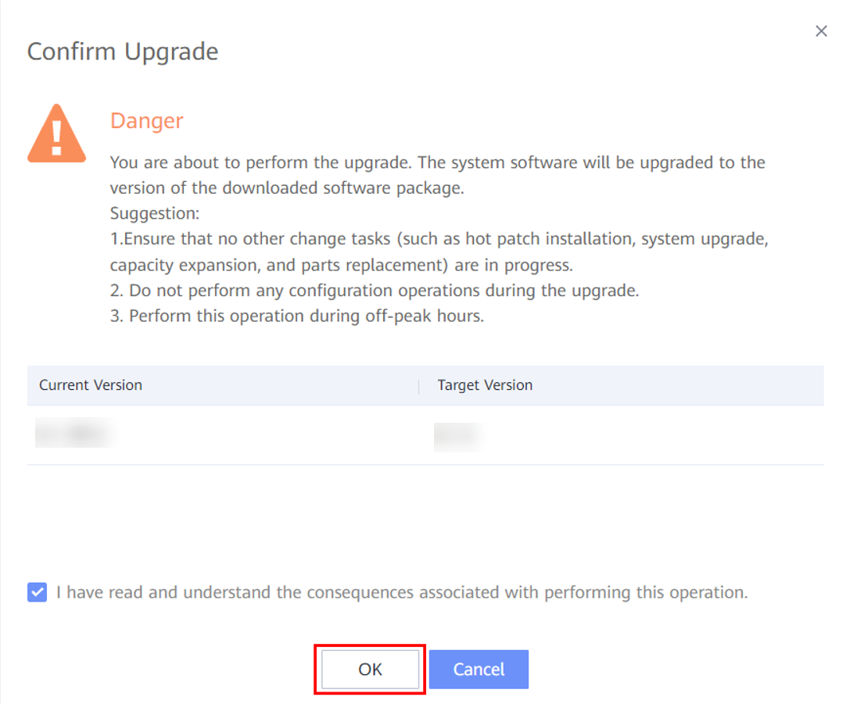
- If you do not want to continue the upgrade, click Cancel.
- After you click OK, the system automatically starts the upgrade process, and completes all steps if no exception occurs. You cannot stop or cancel the upgrade during the upgrade process.
            - The system automatically distributes the upgrade package to all device nodes, as shown in Figure 10-19.
              - Package distribution
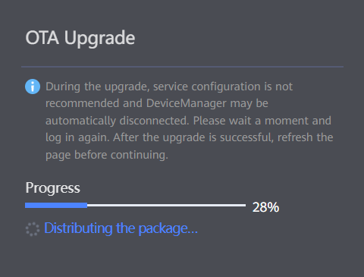
This step will fail if the upgrade package is incomplete or a download error occurs. The failure cause will be displayed on this page. You can manually query the version on the version details page, download the software package again, and redo the upgrade.
            - After distributing the upgrade package, the system automatically redoes a pre-upgrade check to ensure a normal system status and correct software package.
              - Performing a pre-upgrade check
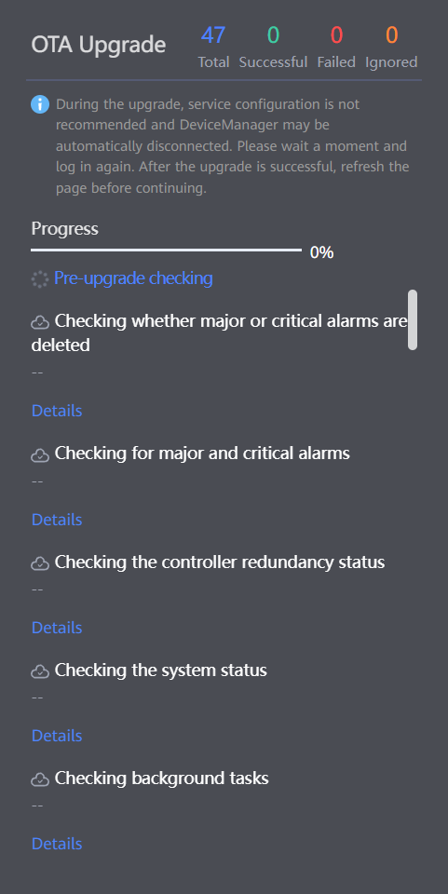
You can ignore the check result of some failed pre-upgrade check items and continue the upgrade.
            - After the pre-upgrade check is passed, the system automatically enters the upgrade execution phase. In normal cases, the upgrade process cannot be terminated or exited until the upgrade is complete.
              - Performing the upgrade
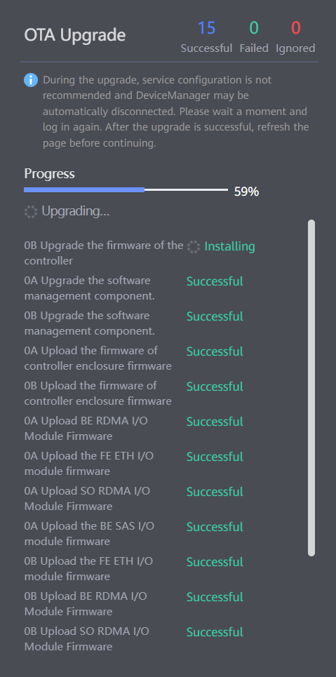
If the upgrade fails due to an exception, the system automatically rolls back to the source version. If an exception also occurs during the rollback, the upgrade process stops at the failure point and manual intervention is required. In this case, contact Huawei technical support engineers.
            - After the upgrade is complete, the system automatically performs a post-upgrade check to ensure a normal system status.
              - Performing the post-upgrade check
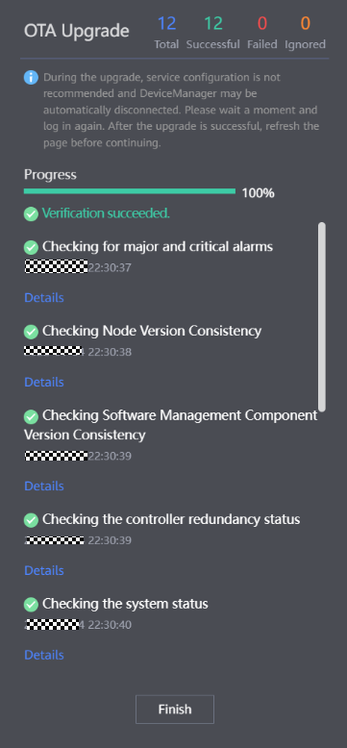
- The upgrade process enters the post-upgrade check phase, in which the system version has been upgraded to the target version.
- If the post-upgrade check fails, rectify the fault by clicking Details.
----End

Rolling and Parallel Upgrade Procedure
11.1 Before You Start
11.2 Upgrade Process
11.3 Preparations
11.4 Pre-upgrade Site Survey
11.5 Performing the Upgrade
11.6 Verifying the Upgrade

Before You Start

Upgrade Impact
This section describes the possible impact of the upgrade on the storage system.
Before the upgrade, read this section carefully to understand the possible impact on the system.

Impact on the System During the Upgrade
This section describes the possible impact on the system during the upgrade.
Impact on Services
- During a rolling upgrade, some controllers restart and their services are taken over by other functioning controllers. The read and write performance may decrease by 10% to 20%. It is recommended that you perform the upgrade in off-peak hours.
- A parallel upgrade requires that no services are carried. Stop all host services before a parallel upgrade.
Impact on Network Communication
When a controller is being restarted, its management network is temporarily inaccessible. After the controller starts up, the management network restores.

Impact on the System After the Upgrade
There is no negative impact on the storage system after the upgrade.

Precautions
This section describes the precautions for an upgrade.
Before the Upgrade
- Before performing a rolling upgrade on an OceanStor Dorado 2000, 3000, 5000, 6000, ensure that the hosts, heterogeneous devices, and remote devices have redundant links to each controller of the storage system. To be specific:
- Each host, heterogeneous device, and remote device have available links to controller A of each controller enclosure.
- Each host, heterogeneous device, and remote device have available links to controller B of each controller enclosure.
- Before performing a rolling upgrade on an OceanStor Dorado 8000 or 18000, ensure that the hosts, heterogeneous devices, and remote devices have redundant links to interface modules of the storage system. To be specific:
- Each host, heterogeneous device, and remote device have available links to at least one interface module on the upper plane of each controller enclosure.
- Each host, heterogeneous device, and remote device have available links to at least one interface module on the lower plane of each controller enclosure.
- To check the path redundancy, refer to 15.9 What Can I Do If the Front-End Link Redundancy Check Fails During the Upgrade?
- Before the upgrade, ensure that the service load of the controllers is normal to avoid adverse impact on the upgrade. To be specific:
- The CPU usage must be lower than 50%.
- The free memory of the controllers must be greater than 500 MB.
- The maximum disk usage must be lower than 80%, and the average disk usage must be lower than 60%.
- The front-end bandwidth usage must be lower than 80%.
- Ensure that the target storage version is compatible with the customer's management software, such as OceanStor BCManager.
- For storage systems in a DR Star trio, you are advised to first upgrade the third site (secondary end of the two asynchronous remote replication pairs or consistency groups).
- Do not upgrade both the primary and secondary storage systems of remote replication at the same time. Do not perform any of the following operations when a member storage system of remote replication is being upgraded:
- Add a member to the remote replication consistency group.
- Remove a member from the remote replication consistency group.
- Delete the SAN remote replication pair.
- Switch over the primary and secondary storage systems.
- Synchronize the remote replication pair or consistency group.
During the Upgrade
- Do not access the system using non-upgrade users.
- Do not perform any operation on the hardware, such as removing or inserting interface modules, power modules, or disks.
- Ensure persistent power supply.
- Ensure normal network connections.
- Do not manually scan for disks on the host.
After the Upgrade
- If an alarm ID cannot be found in the document of the target version, find it in the document of the source version. Such an alarm does not exist in the target version and must be manually cleared.
- After the upgrade is complete, clear the cache data of the browser on the maintenance terminal. For example, if you use Internet Explorer, choose Tools > Internet Options. On the General tab, click Delete under Browsing history. In the dialog box that is displayed, clear the browser's caches as prompted. Then you can visit OceanStor DeviceManager.
- If the digital certificate or private key imported to OceanStor DeviceManager before the upgrade does not work, the backup digital certificate and private key will be used after the upgrade to ensure that background services can be started properly.

Upgrade Process
Table 11-1 provides the estimated upgrade schedule for each procedure.
                - Upgrade schedule
Step | Start Time | Time Required | Remarks
Preparations | One week before the upgrade | 30 minutes | See 11.3 Preparations.
Pre-upgrade Site Survey | One week before the upgrade | 40 minutes | See 11.4 Pre-upgrade Site Survey.
Performing the Upgrade | During the upgrade | 60 to 90 minutes | The upgrade duration depends on the number of disk enclosures, interface modules, and service load.  See 11.5 Performing the Upgrade.
Conducting an Inspection | After the upgrade | 30 minutes | See 11.5.4 Conducting an Inspection.
Verifying the Upgrade | After the upgrade | 15 minutes | See 11.6 Verifying the Upgrade.

The time listed for each operation is for reference only. The time actually required depends on onsite conditions.

Preparations
Download related tools and software packages. For details, see 3 Preparations.

Pre-upgrade Site Survey

- The site survey is to check the storage systems and host services to ensure a successful upgrade. Perform the operations by following instructions in this section.
- OceanStor Dorado 8000 and 18000 use an active-active front-end architecture. Resetting a single controller does not interrupt front-end links or trigger a switchover. If you do not need to upgrade front-end interface modules or the front-end interface modules support hot upgrade, the rolling upgrade does not trigger host compatibility issues, and compatibility evaluation will be automatically skipped during the pre-upgrade site survey.
The site survey involves installing the upgrade tool, setting the upgrade policy, collecting storage information, conducting an inspection,evaluating the array upgrade, evaluating the compatibility, and analyzing logs.
Step | Description | Duration
Installing the upgrade tool | Install SmartKit that is used to perform the pre-upgrade site survey and upgrade operations. | 10 minutes
Setting the upgrade policy | Select the device you want to upgrade and set the upgrade policy. | 5 minutes
Collecting array information | Use the information collection tool to collect the storage system's run logs for health status evaluation. | 5 minutes for dual controllers
Conducting an inspection | Check the software and hardware status, value-added services, and alarms on the storage system. | 10 minutes
Evaluating array upgrade | Use the upgrade evaluation tool to automatically check the storage system status to ensure a smooth upgrade. | 5 minutes for dual controllers
Evaluating the compatibility | For OceanStor Dorado 8000 and 18000 storage systems, if the hosts connect to the storage systems through Fibre Channel networks and the front-end interface modules support hot upgrade, skip this step. Otherwise, evaluate the host network compatibility. Parallel upgrades do not require compatibility evaluation. | 5 minutes for 100 devices
Analyzing logs | Use the fault diagnosis tool of eService to analyze logs (skip this step if it is not included in the pre-upgrade site survey on SmartKit). | 10 minutes

Installing the Upgrade Tool
For details, see 4.1 Installing the Upgrade Tool.

Setting the Upgrade Policy
On the Set Strategy page, select Rolling Upgrade. For details, see 4.3 Setting the Upgrade Policy.
To select rolling upgrade, click Show>>.
              - Setting the strategy
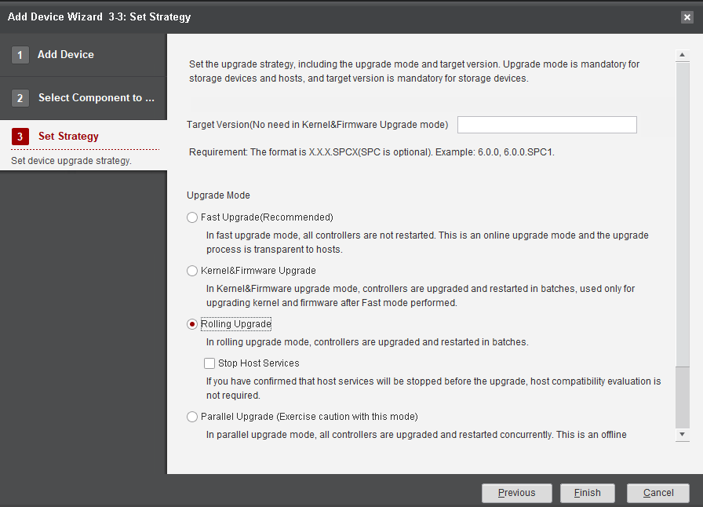

Collecting Array Information
For details, see 4.5 Collecting Array Information.

Conducting an Inspection

The verification is successful only when all items pass the inspection.
For details, see 6 Conducting an Inspection.

Evaluating Array Upgrade
This section describes how to evaluate the system upgrade during pre-upgrade site survey.

- This evaluation is to check the health status of the storage system to prevent any adverse impact on the upgrade. Ensure that all items pass the evaluation before performing subsequent operations. If you decide to ignore the failed items (if any) and forcibly upgrade the system, make sure you are aware of the risks and accept the consequences thereof.
- If compatibility evaluation becomes unavailable after the array upgrade evaluation, you do not need to evaluate compatibility separately.
Procedure
            - On the Pre-upgrade Site Survey page, select Array Upgrade Evaluation, as shown in Figure 11-2.
              - Starting storage system evaluation
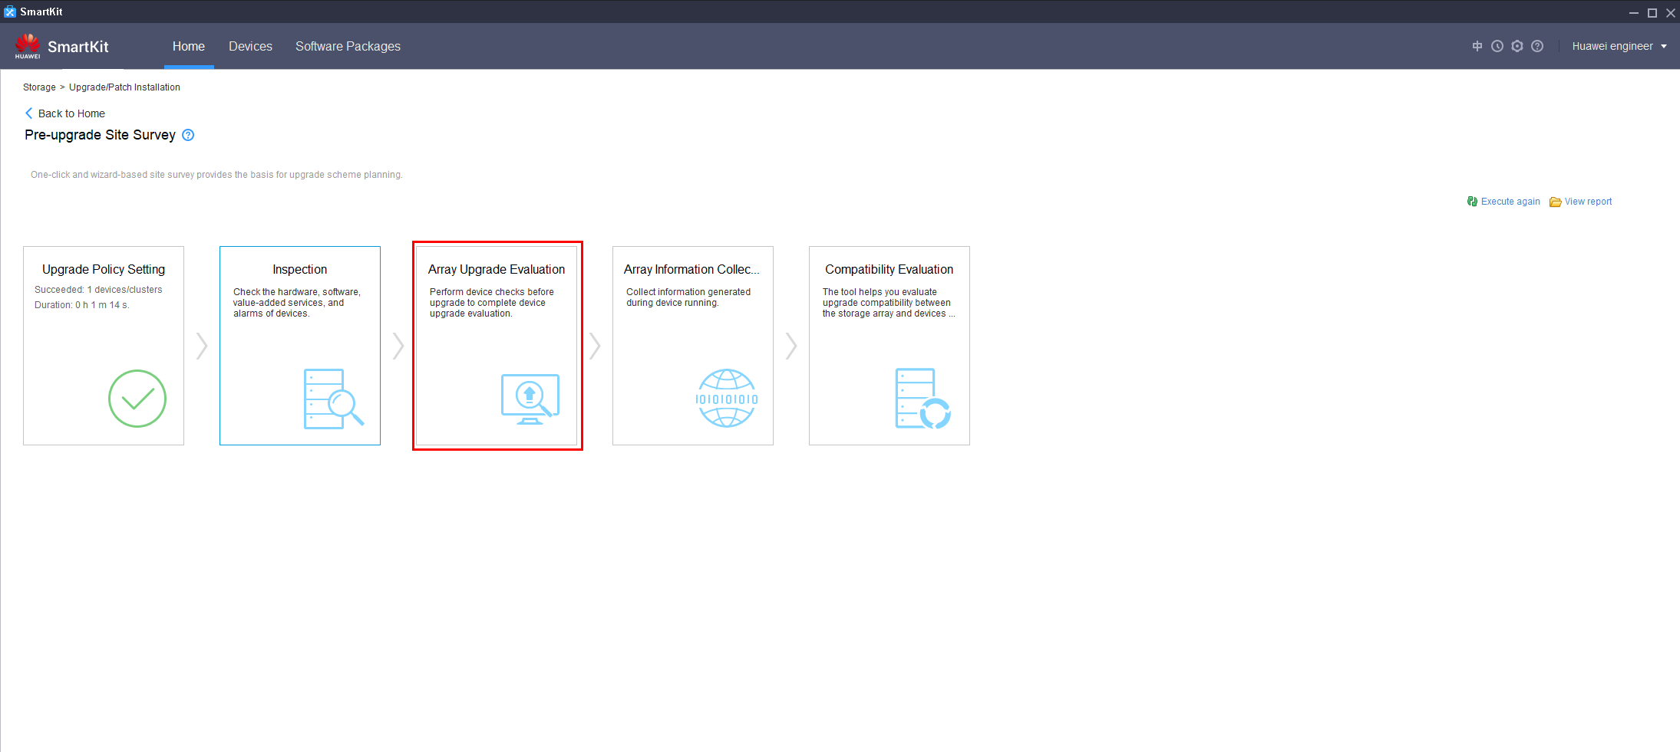
            - On the Upgrade Evaluation Tool page, select the desired device and click Execute, as shown in Figure 11-3.
              - Upgrade evaluation tool
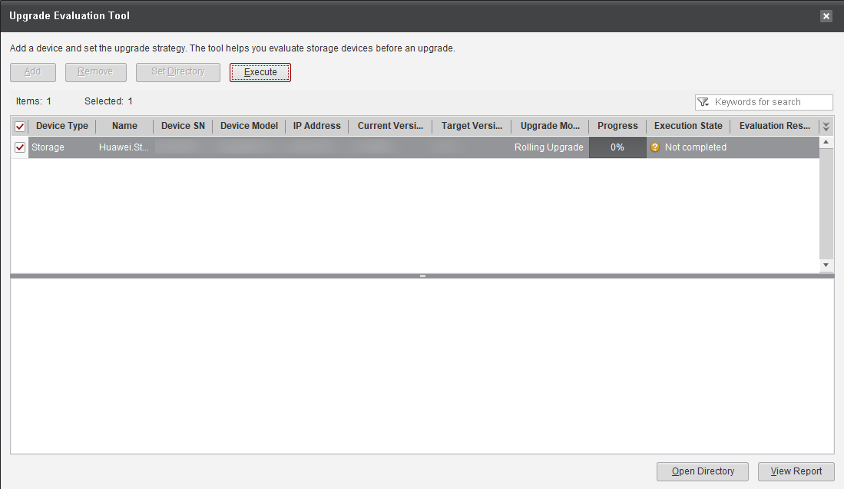
            - After the evaluation is complete, click the failed items (if any) and follow the instructions in Reference in the Details dialog box to rectify them. Then perform the evaluation again until all items are passed.
              - Detailed check information
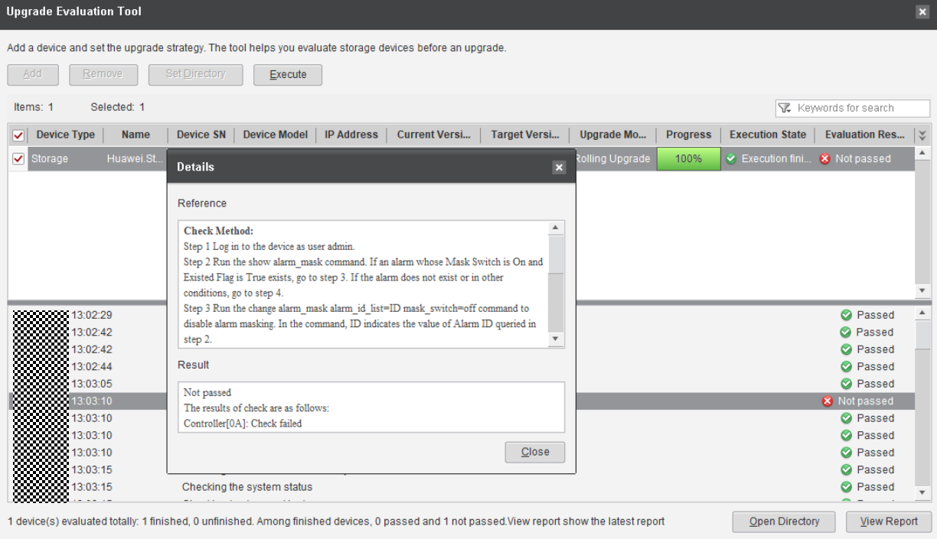

If certain failed items cannot be rectified, contact Huawei technical support engineers to evaluate the risks and proceed with the upgrade only when the risks are acceptable.
----End

Evaluating Compatibility
This section describes how to evaluate the compatibility of devices such as hosts, switches, and databases to check the host network status and third-party compatibility issues.
- If all items in 11.4.5 Evaluating Array Upgrade have passed the evaluation, Compatibility Evaluation becomes unavailable on SmartKit. This means that compatibility evaluation is not required, and you can skip this section.
- If host services have been stopped before the upgrade, compatibility evaluation is not needed.
- If the compatibility evaluation tool provided in this section cannot be used, log in to each host and check compatibility manually by following instructions in 16.1 Checking Host Status.
Procedure
            - On the Pre-upgrade Site Survey page, click Compatibility Evaluation, as shown in Figure 11-5.
              - Entering compatibility evaluation
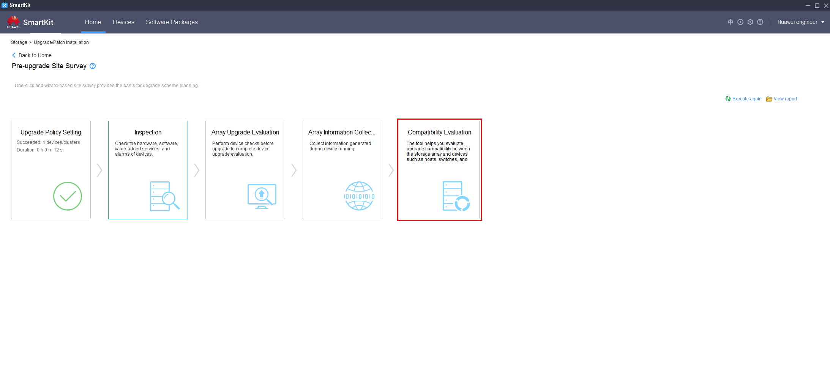
            - The system automatically queries the host information of the current device, as shown in Figure 11-6.
              - Querying host information
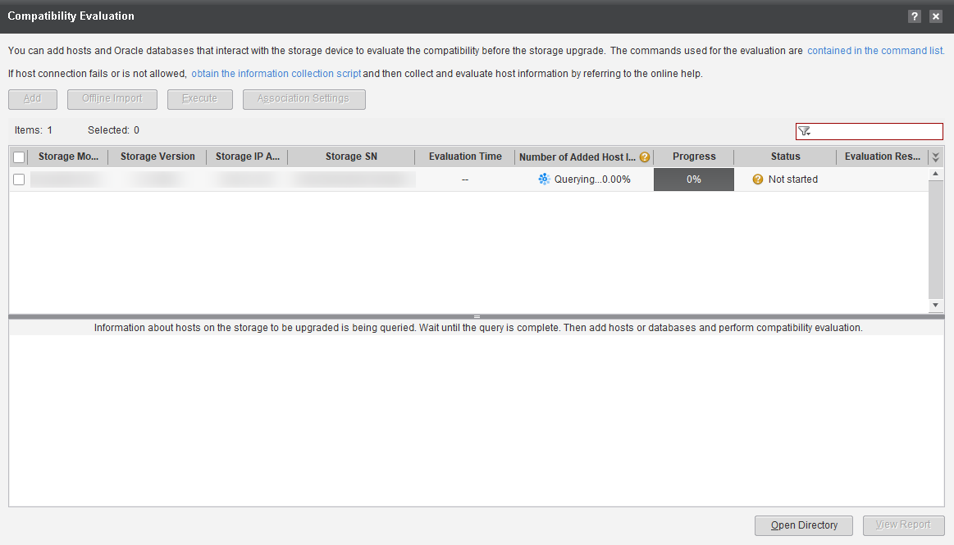
            - After the query is complete, click Add. In the displayed dialog box, enter the IP address of the device and click Next, as shown in Figure 11-7.
              - Entering the device IP address
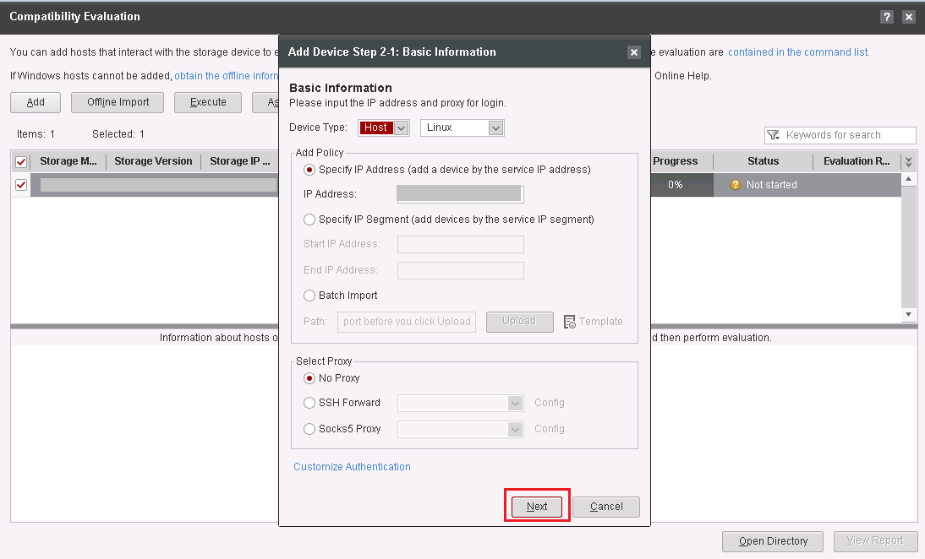

            - Enter the user name and password of the host and click Finish, as shown in Figure 11-8.
              - Entering the user name and password
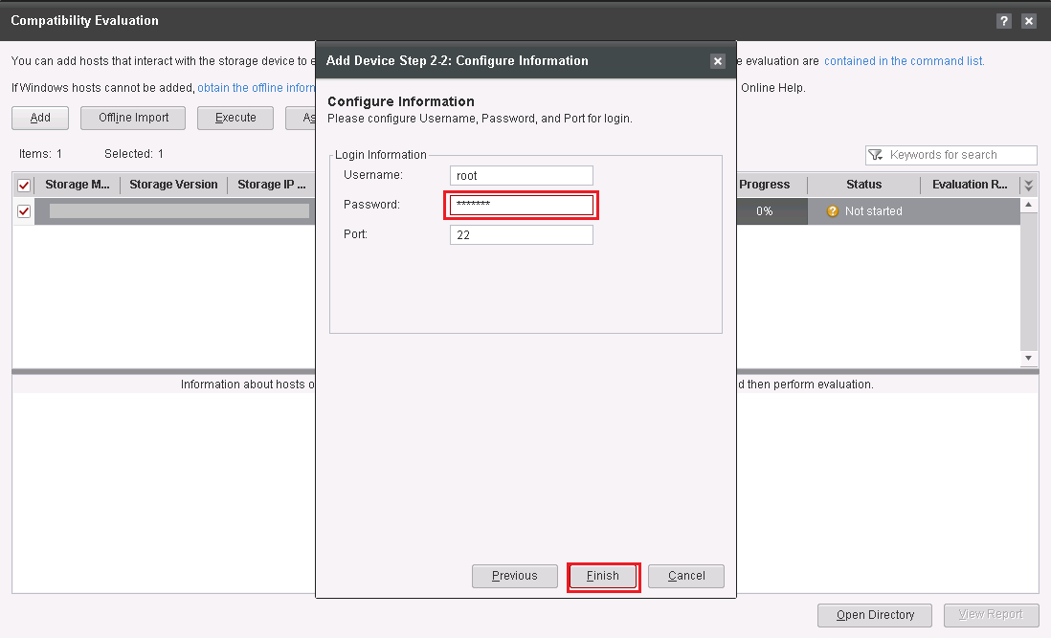

            - Select the device to be evaluated and click Execute, as shown in Figure 11-9.
              - Executing compatibility evaluation
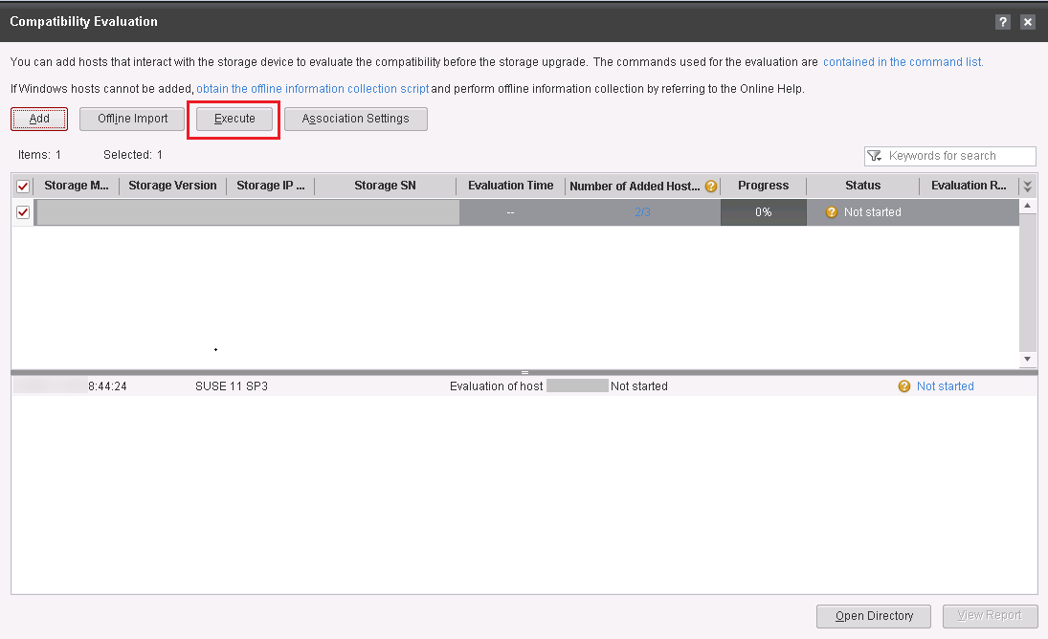

              - Confirming the warning
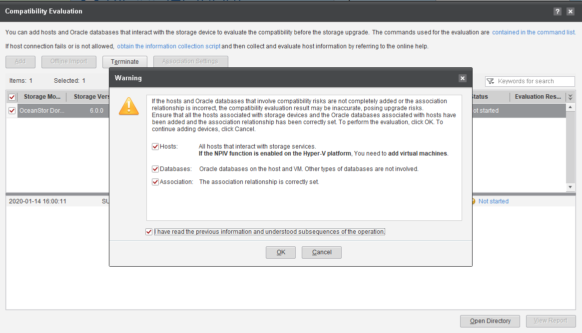

            - SmartKit automatically evaluates compatibility, as shown in Figure 11-11.
              - Evaluation completed
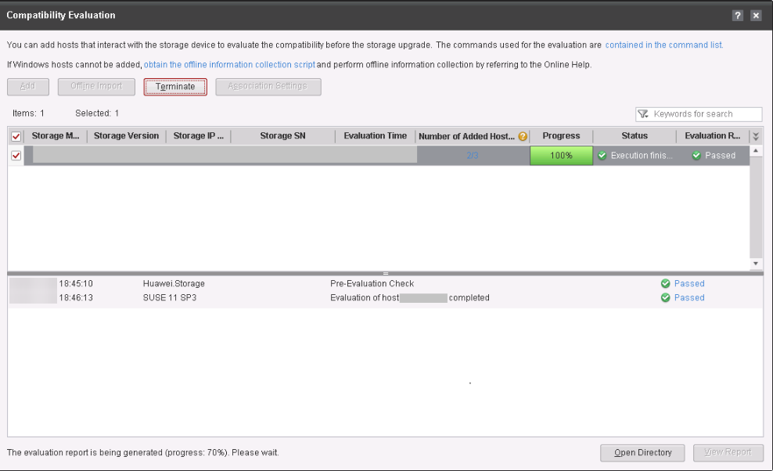

            - Click View Report, as shown in Figure 11-12.
              - Viewing the report
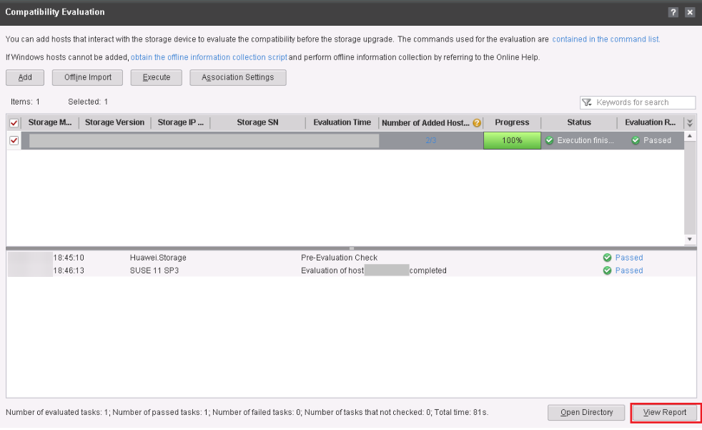

            - Click the navigation tree on the left for detailed information, as shown in Figure 11-13.
              - Compatibility evaluation report
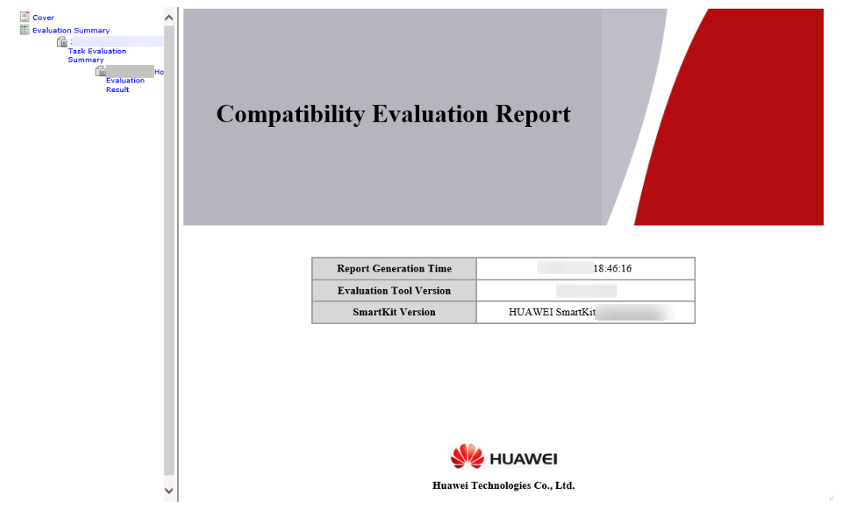

- The host compatibility evaluation tool can be used only when the host OS is VMware, Windows, Linux, Solaris, HP_UX, or AIX. For details on how to check compatibility of hosts running non-mainstream OSs, see 15.10 How Can I Check the Compatibility of Hosts Running Non-mainstream Operating Systems?
- If the timeout period of the HBA or iSCSI initiator fails to pass the check but the problem cannot be rectified according to the handling suggestion, refer to 15.12 What Can I Do When the Host HBA or iSCSI Timeout Parameter Does Not Pass the Check and Cannot be Modified?
----End

Analyzing Logs
This section describes how to use the fault diagnosis tool of eService and storage array logs to analyze potential faults.
Procedure
            - Access the eService home page at http://support.eservice.huawei.com/#/Welcome.
Obtain the login account and password from Huawei technical support engineers.
            - Click Storage Fault Diagnosis under Troubleshooting to open the fault diagnosis tool, as shown in Figure 11-14.
              - Opening the storage fault diagnosis tool
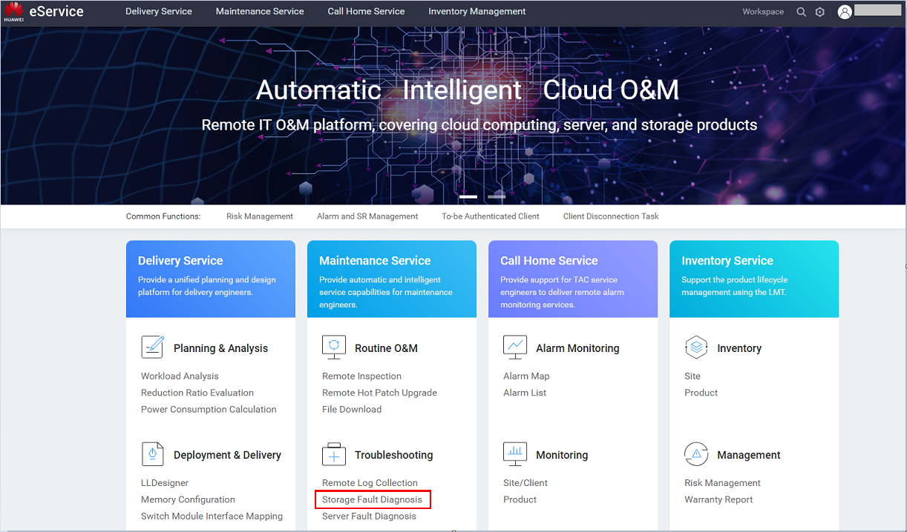

            - Click Create Fault Analysis Task, as shown in Figure 11-15.
              - Starting fault diagnosis
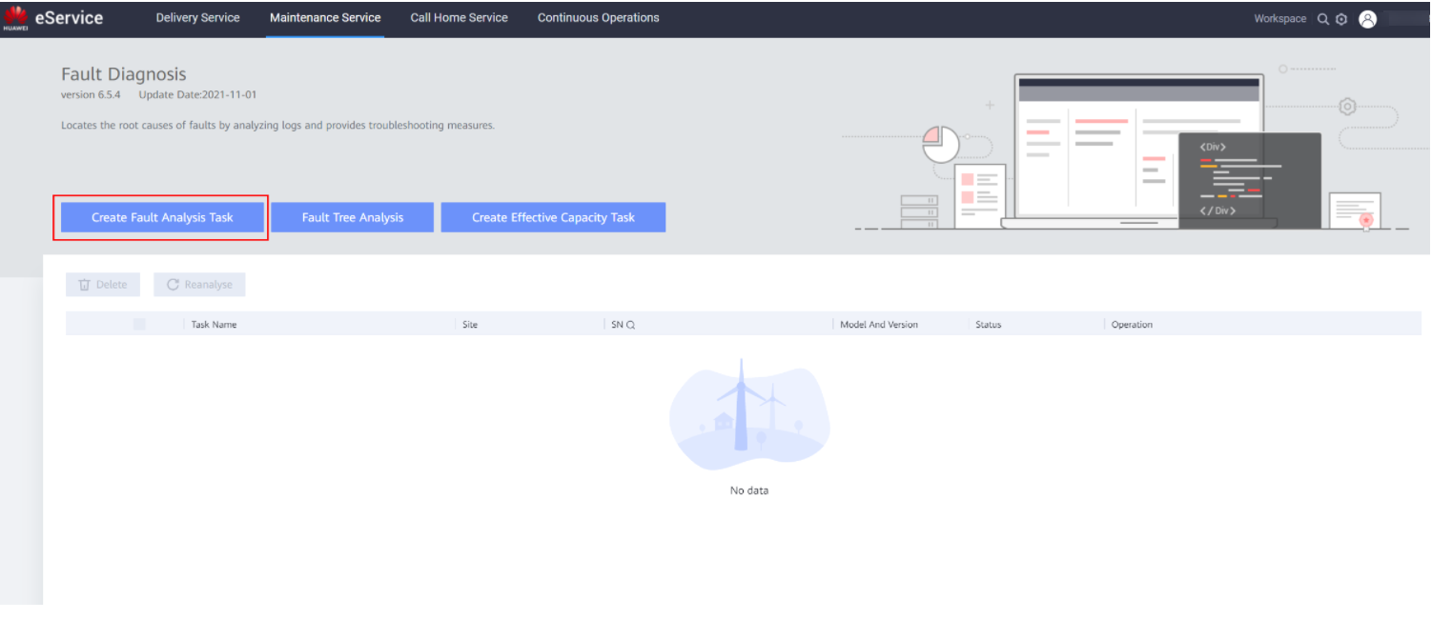
            - On the New Analysis page, add the log file, as shown in Figure 11-16.
              - Adding the log file
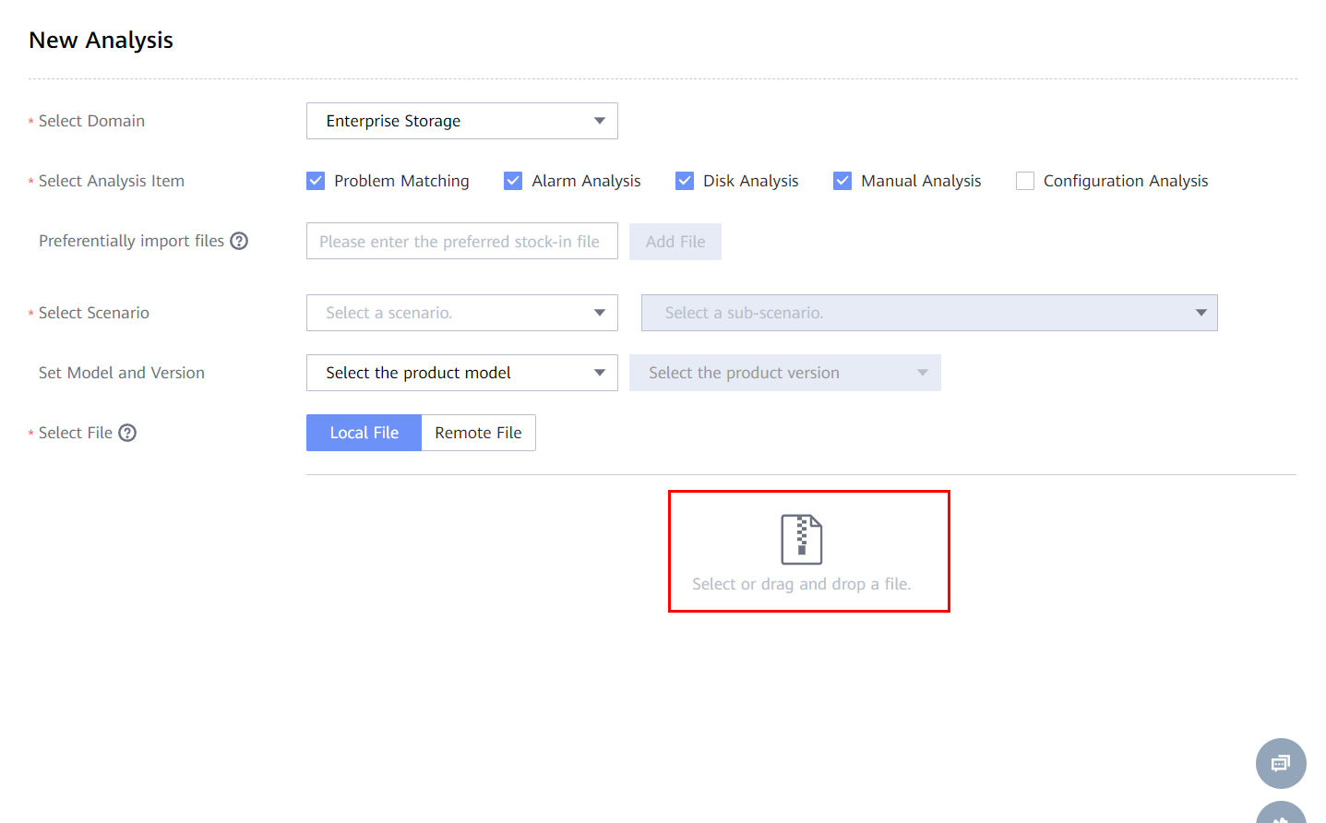
            - Select the log file package to be uploaded, as shown in Figure 11-17.
              - Uploading the local log package
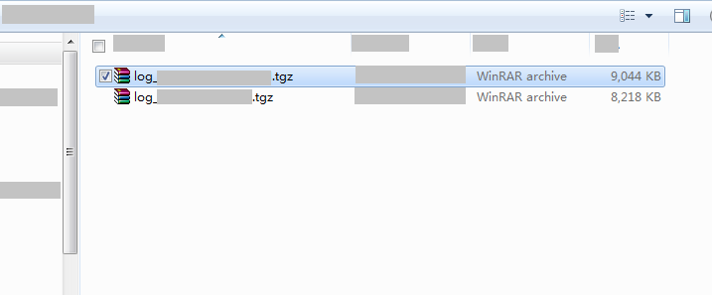

The uploaded log package is obtained in 11.4.4 Conducting an Inspection.
            - After selecting the log file package and a scenario, click OK, as shown in Figure 11-18. Wait until the logs are uploaded and analyzed, as shown in Figure 11-19.
              - Clicking OK
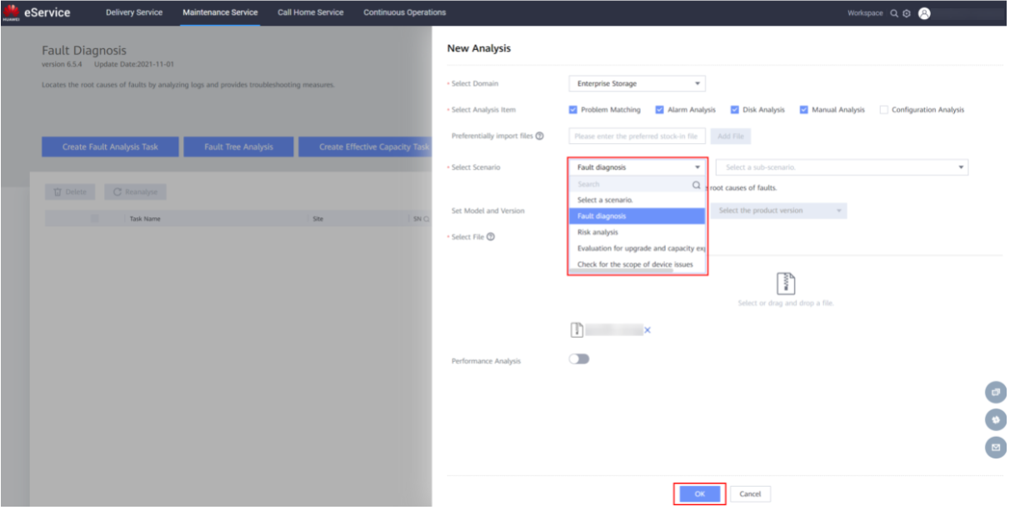
              - Waiting for analysis
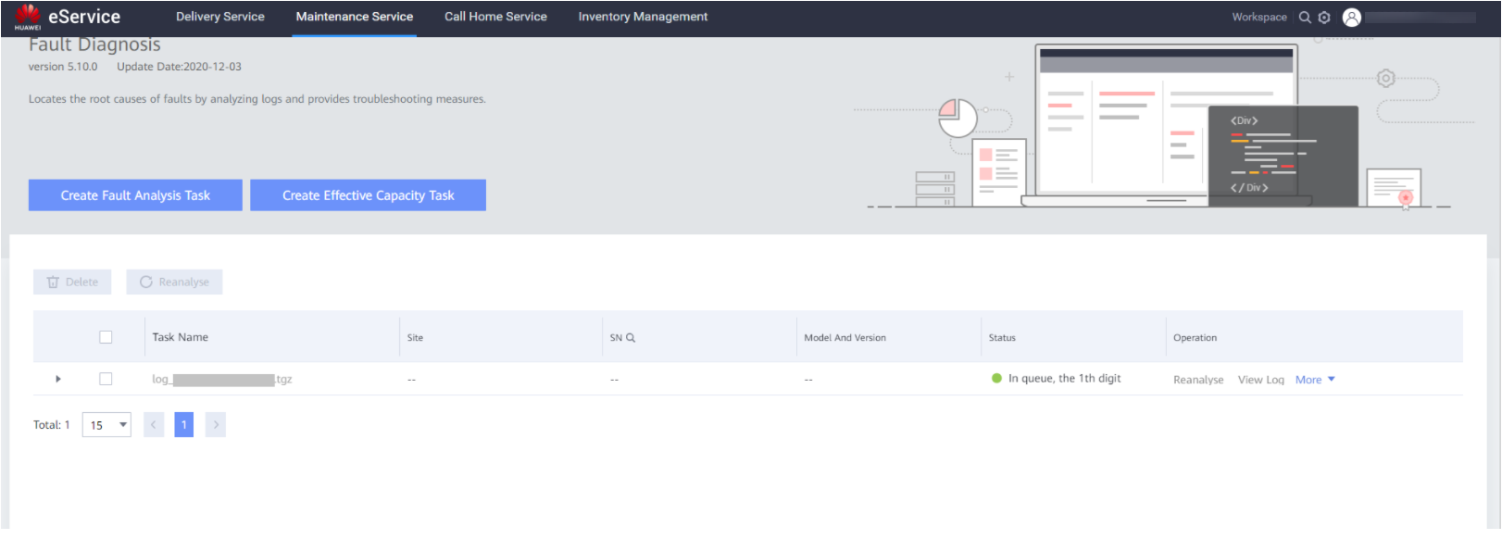

For the first upload, specify the product model and version information as prompted.
            - After the analysis is complete, click View to view the log analysis result, as shown in Figure 11-20.
              - Viewing the log analysis result
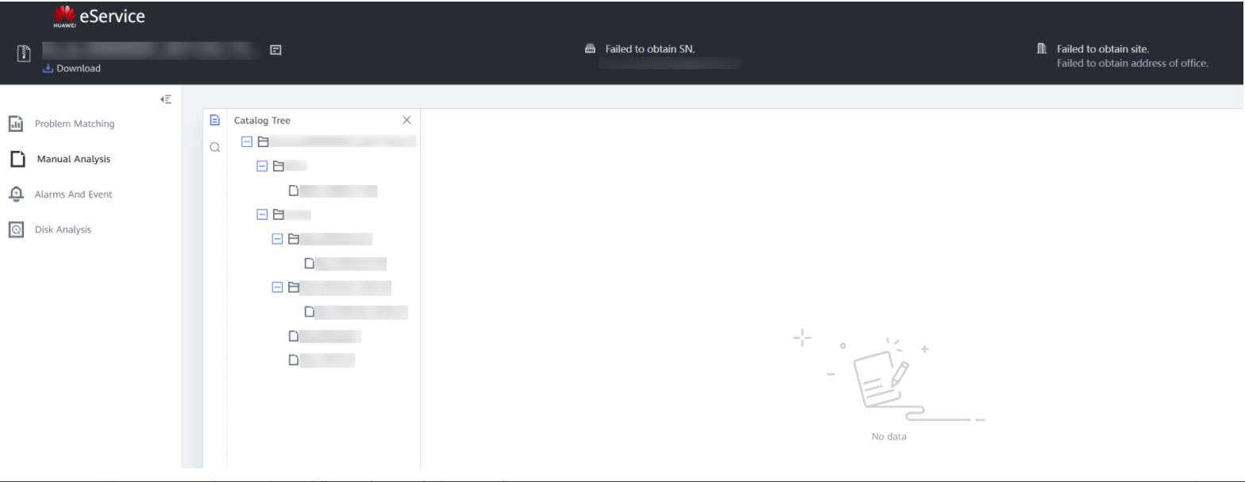
In the log analysis result, you only need to focus on the faults and risks in the last two months.
            - If any fault or risk exists, rectify it as prompted. If the fault or risk persists, contact Huawei technical support for assistance.

If any fault or risk is found, do not perform the subsequent upgrade operations before the fault is rectified or Huawei technical support engineers suggest. Otherwise, the upgrade may fail or services may be interrupted.
----End

Performing the Upgrade

Setting the Upgrade Policy
On the Upgrade Settings page, select Rolling Upgrade. For details, see 5.1 Setting the Upgrade Policy.
To select rolling upgrade, click Show>>.
              - Selecting an upgrade mode

Evaluating Array Upgrade
This section describes how to evaluate the system upgrade.
            - If the upgrade is to be performed more than one day after the site survey is complete, you must perform the array upgrade evaluation again to ensure a smooth upgrade.
            - You can skip this section if either of the following conditions is met:
- The pre-upgrade site survey has been conducted on the day when the upgrade is performed and all check items of array upgrade evaluation are passed.
- All failed check items have been rectified, and the storage settings, host service configurations, and host networking are not changed after the evaluation.
Procedure
            - Click Array Upgrade Evaluation, as shown in Figure 11-22.
              - Starting storage system evaluation
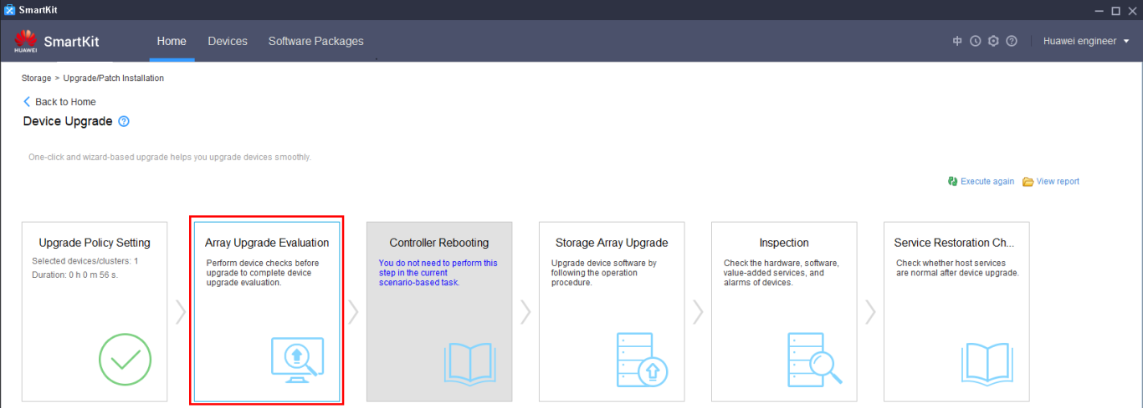

            - On the Upgrade Evaluation Tool page, select the desired device and click Execute, as shown in Figure 11-23.
              - Selecting a device

            - After the evaluation is complete, click the failed items (if any) and follow the instructions in Reference in the Details dialog box to rectify them. Then perform the evaluation again until all items are passed.
              - Detailed check information

If the hot patch check fails, as shown in Figure 11-25, perform Step 4 to Step 10.
              - Upgrade evaluation tool

            - Click Install Patch, as shown in Figure 11-26.
              - Installing the patch

            - On the Patch Tool page, click Select patch, as shown in Figure 11-27.
              - Selecting a patch package

            - Download the required patch package according to the information in the Patch Details dialog box and save it to a local directory.
              - Patch details
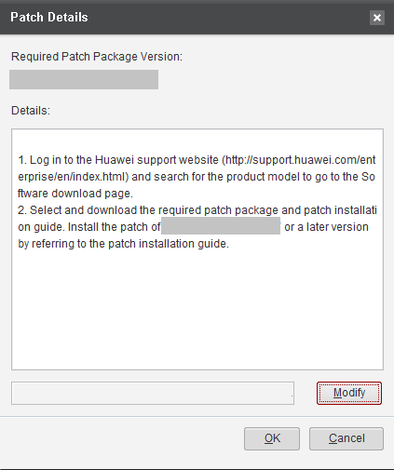

            - Click Modify, select the desired patch package, and click OK, as shown in Figure 11-29.
              - Selecting a patch package

            - In the Information dialog box that is displayed, click OK.
              - Information dialog box
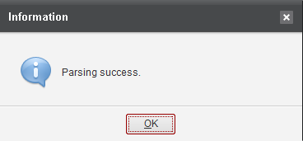

            - On the Patch Tool page, click Start to install the patch, as shown in Figure 11-31.
              - Installing the patch

            - Verify that the patch is installed successfully.
              - Patch installed successfully

----End

Upgrading Controller Software
This section describes how to upgrade the controller software.

Prerequisites
This section provides the prerequisites for performing a rolling or parallel upgrade of controller software using SmartKit.
Prerequisites
- The pre-upgrade site survey has been performed according to 11.4 Pre-upgrade Site Survey and all check items and evaluations are passed.
- If the site survey and controller upgrade are performed on different days, a recheck has been performed according to 11.5.2 Evaluating Array Upgrade and all check items are passed.

If you want to ignore failed items and continue with the upgrade, ensure that you fully understand the risks and proceed only when the risks are acceptable.
- On DeviceManager, Max. Sessions per User has been set to 0. To check the value, choose Settings > User and Security > Security Policies and find the value in Login Policy. If it is not 0, change it to 0 and restore the original value after the upgrade is complete.
              - Login policy

- All DeviceManager pages and CLI windows have been closed. Login to DeviceManager or the CLI is prohibited during the upgrade.

Upgrading Controller Software
This section describes how to perform a rolling upgrade of controller software on SmartKit.
Procedure
The following procedure uses rolling upgrade as an example and the screenshots are for reference only. The GUI of SmartKit may vary with the version.
            - On the Device Upgrade page, click Storage Array Upgrade, as shown in Figure 11-34.
              - Starting storage upgrade

            - Click Perform Upgrade to start the upgrade, as shown in Figure 11-35.
              - Performing the upgrade

            - In the Confirm Upgrade dialog box, confirm the information, enter Yes, and click OK to start the upgrade, as shown in Figure 11-36.
              - Confirming the upgrade
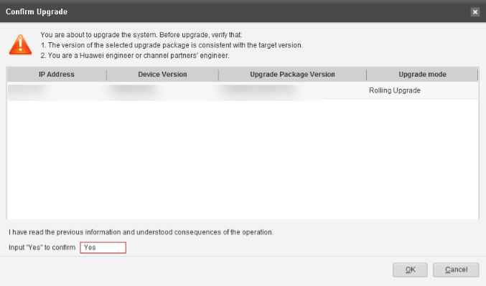

            - The system automatically imports the upgrade package, as shown in Figure 11-37.
              - Importing the upgrade package
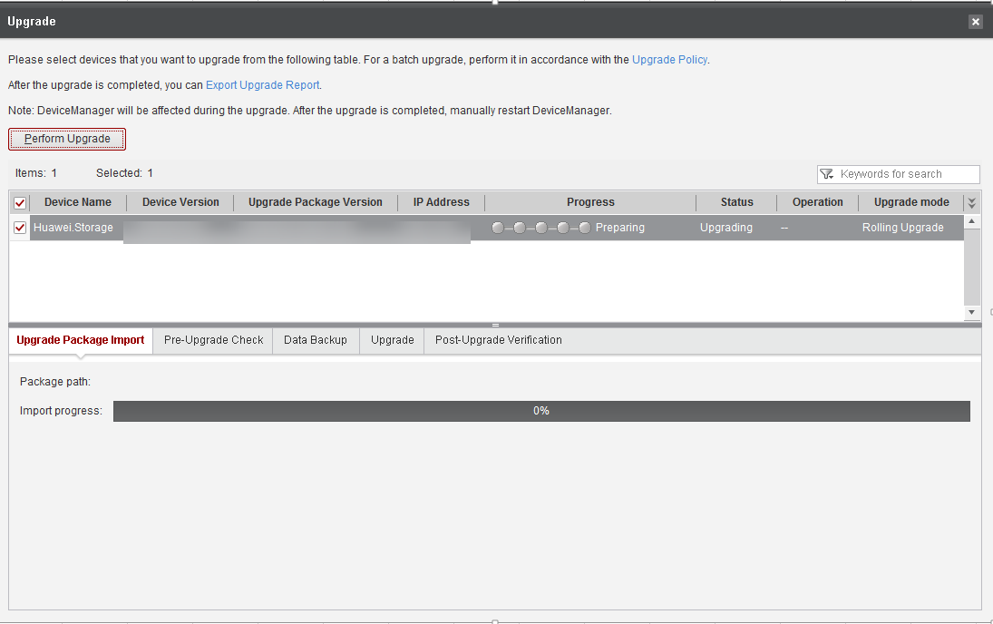

            - After the upgrade package is imported, the system automatically starts a pre-upgrade check, as shown in Figure 11-38.
              - Pre-upgrade check
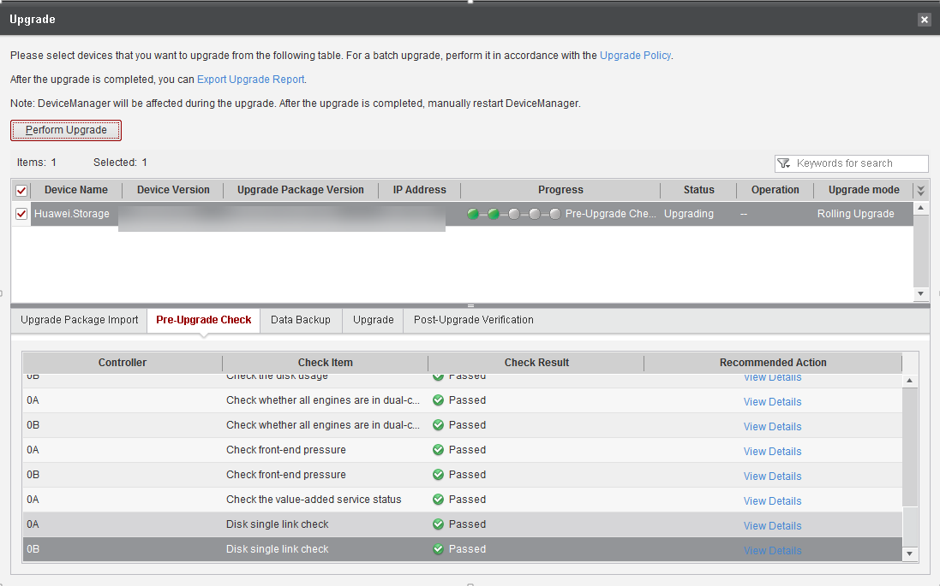

- The pre-upgrade check mainly carries out inspections directly related to the device and its health status, such as the upgrade package compatibility, device service load, redundant links of hosts, and device alarms. Some check items have been covered by the array upgrade evaluation, while other items must be checked after the upgrade package is imported.
- If the front-end link redundancy check fails, refer to 15.9 What Can I Do If the Front-End Link Redundancy Check Fails During the Upgrade?
- If certain items fail to pass the pre-upgrade check and cannot be rectified according to the handling suggestions, contact Huawei technical support engineers to evaluate the risks and proceed with the upgrade only when the risks are acceptable. To ignore the failed items and proceed with the upgrade, refer to 15.11 How Can I Ignore the Pre-Upgrade Check Items and Continue the Upgrade?
            - After the pre-upgrade check is complete, the system automatically backs up data, as shown in Figure 11-39.
              - Data backup
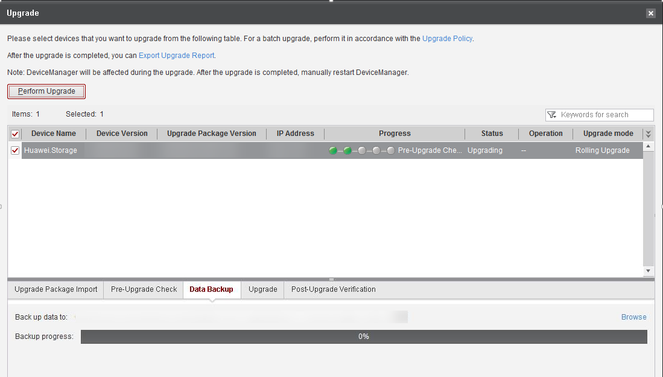

            - After data backup, the system automatically performs the upgrade, as shown in Figure 11-40.
              - Performing the upgrade
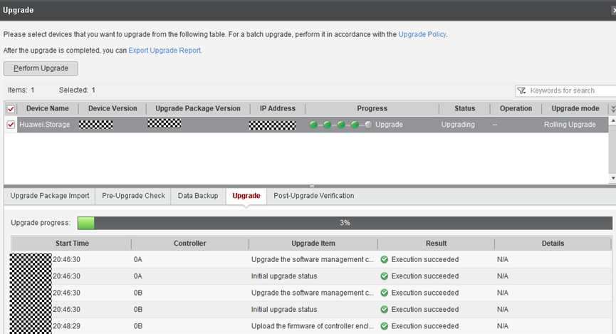

If the upgrade progress is not refreshed within 30 minutes and no upgrade failure message is reported, refer to 14.6 Upgrade Progress on the Upgrade Tool Is Not Refreshed Within 30 Minutes But No Upgrade Failure Is Displayed.
            - After the upgrade is complete, the system automatically performs a post-upgrade verification, as shown in Figure 11-41.
              - Verifying the upgrade
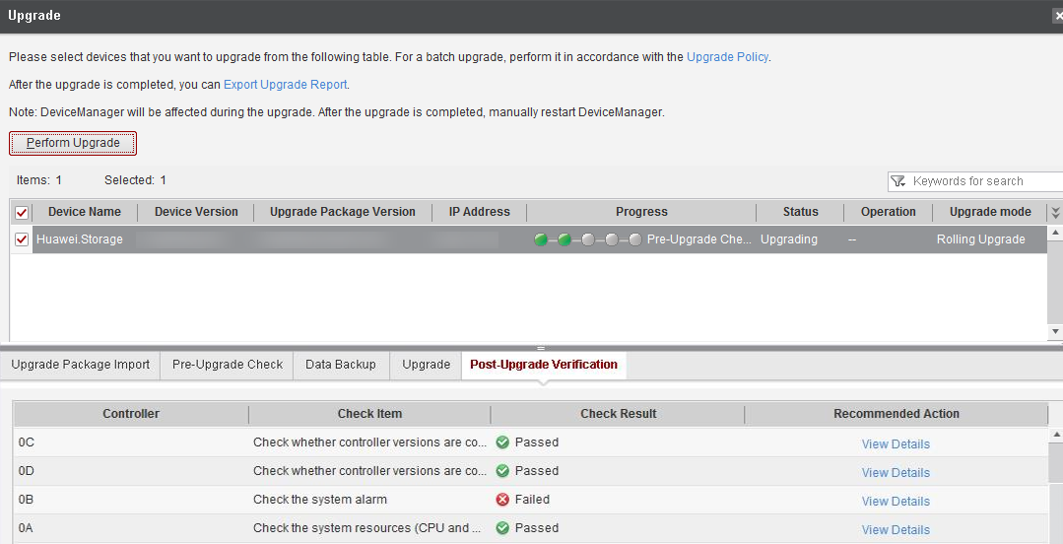

Check the post-upgrade verification result carefully to ensure no exception occurred during the upgrade.
            - After the upgrade, verify that the system version is consistent with the upgrade package version. The upgrade process is completed.
              - Confirming completion of the upgrade
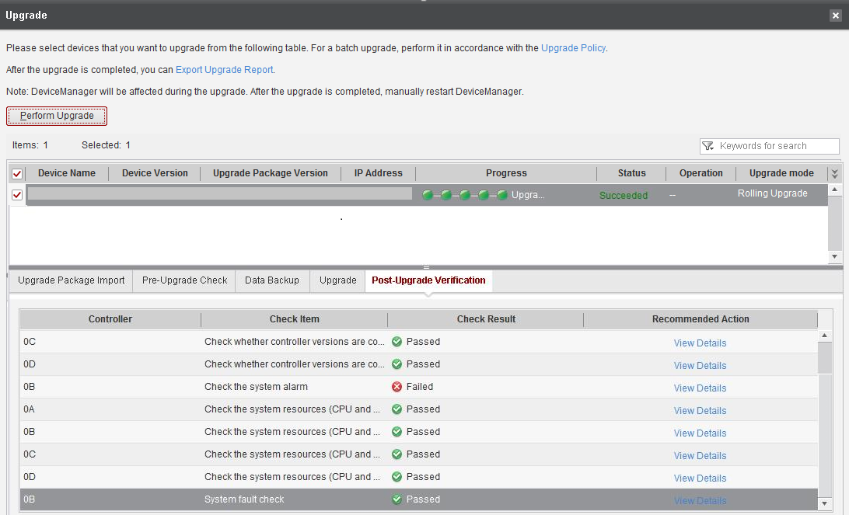

----End

Conducting an Inspection

The verification is successful only when all items pass the inspection.
For details, see 6 Conducting an Inspection.

Verifying the Upgrade
For details, see 7 Verifying the Upgrade.

Kernel and Firmware Upgrade Procedure
12.1 Before You Start
12.2 Upgrade Process
12.3 Preparations
12.4 Pre-upgrade Site Survey
12.5 Performing the Upgrade
12.6 Conducting an Inspection
12.7 Verifying the Upgrade

Before You Start

Upgrade Impact
This section describes the possible impact of the upgrade on the storage system.

Impact on the System During the Upgrade
This section describes the possible impact on the system during the kernel and firmware upgrade.
Impact on Services
Some controllers restart and their services are taken over by other functioning controllers. The read and write performance may decrease by 10% to 20%. It is recommended that you perform the upgrade in off-peak hours.
Impact on Network Communication
When a controller is being restarted, its management network is temporarily inaccessible. After the controller starts up, the management network restores.

Impact on the System After the Upgrade
There is no negative impact on the storage system after the upgrade.

Precautions
This section describes the precautions for an upgrade.
Before the Upgrade
- Before performing a rolling upgrade on an OceanStor Dorado 2000, 3000, 5000, 6000, ensure that the hosts, heterogeneous devices, and remote devices have redundant links to each controller of the storage system. To be specific:
- Each host, heterogeneous device, and remote device have available links to controller A of each controller enclosure.
- Each host, heterogeneous device, and remote device have available links to controller B of each controller enclosure.
- Before performing a rolling upgrade on an OceanStor Dorado 8000 or 18000, ensure that the hosts, heterogeneous devices, and remote devices have redundant links to interface modules of the storage system. To be specific:
- Each host, heterogeneous device, and remote device have available links to at least one interface module on the upper plane of each controller enclosure.
- Each host, heterogeneous device, and remote device have available links to at least one interface module on the lower plane of each controller enclosure.
- For storage systems in a DR Star trio, you are advised to first upgrade the third site (secondary end of the two asynchronous remote replication pairs or consistency groups).
- Before the upgrade, ensure that the service load of the controllers is normal to avoid adverse impact on the upgrade. To be specific:
- The CPU usage must be lower than 50%.
- The free memory of the controllers must be greater than 500 MB.
- The maximum disk usage must be lower than 80%, and the average disk usage must be lower than 60%.
- The front-end bandwidth usage must be lower than 80% (parallel upgrade does not have this requirement).
- Do not upgrade both the primary and secondary storage systems of remote replication at the same time. Do not perform any of the following operations when a member storage system of remote replication is being upgraded:
- Add a member to the remote replication consistency group.
- Remove a member from the remote replication consistency group.
- Delete the SAN remote replication pair.
- Switch over the primary and secondary storage systems.
- Synchronize the remote replication pair or consistency group.
During the Upgrade
- Do not access the system using non-upgrade users.
- Do not perform any operation on the hardware, such as removing or inserting interface modules, power modules, or disks.
- Ensure persistent power supply.
- Ensure normal network connections.
- Do not manually scan for disks on the host.
After the Upgrade
- If an alarm ID cannot be found in the document of the target version, find it in the document of the source version. Such an alarm does not exist in the target version and must be manually cleared.
- After the upgrade is complete, clear the cache data of the browser on the maintenance terminal. For example, if you use Internet Explorer, choose Tools > Internet Options. On the General tab, click Delete under Browsing history. In the dialog box that is displayed, clear the browser's caches as prompted. Then you can visit OceanStor DeviceManager.
- If the digital certificate or private key imported to OceanStor DeviceManager before the upgrade does not work, the backup digital certificate and private key will be used after the upgrade to ensure that background services can be started properly.

Upgrade Process
Table 12-1 shows the upgrade schedule.
                - Upgrade schedule
Item | Recommended Start Time | Duration | Remarks
Preparations | One week before the upgrade | 30 minutes | See 12.3 Preparations.
Pre-upgrade Site Survey | One week before the upgrade | 40 minutes | See 12.4 Pre-upgrade Site Survey.
Performing the Upgrade | During the upgrade | 60 to 90 minutes | The start time depends on the number of disk enclosures, interface modules, and service load of the storage device.  See 12.5.3 Performing the Kernel and Firmware Upgrade.
Conducting an Inspection | After the upgrade | 30 minutes | See 12.6 Conducting an Inspection.
Verifying the Upgrade | After the upgrade | 15 minutes | See 12.7 Verifying the Upgrade.

The preceding upgrade schedule is for reference only and varies with site conditions.

Preparations
Download the upgrade tool. For details, see 3.3.2 Downloading Tools and Upgrade Packages.
Kernel upgrade is performed in the current system version. You do not need to download software packages.

Pre-upgrade Site Survey

- The site survey is to check the storage systems and host services to ensure a successful upgrade. Perform the operations by following instructions in this section.
- OceanStor Dorado 8000 and 18000 use an active-active front-end architecture. Resetting a single controller does not interrupt front-end links or trigger a switchover. If you do not need to upgrade front-end interface modules or the front-end interface modules support hot upgrade, the rolling upgrade does not trigger host compatibility issues, and compatibility evaluation will be automatically skipped during the pre-upgrade site survey.
The site survey involves installing the upgrade tool, setting the upgrade policy, collecting storage information, conducting an inspection, evaluating the array upgrade, evaluating the compatibility, and analyzing logs.
Step | Description | Duration
Installing the upgrade tool | Install SmartKit that is used to perform the pre-upgrade site survey and upgrade operations. | 10 minutes
Setting the upgrade policy | Select the device you want to upgrade and set the upgrade policy. | 5 minutes
Collecting array information | Use the information collection tool to collect the storage system's run logs for health status evaluation. | 5 minutes for dual controllers
Conducting an inspection | Check the software and hardware status, value-added services, and alarms on the storage system. | 10 minutes
Evaluating array upgrade | Use the upgrade evaluation tool to automatically check the storage system status to ensure a smooth upgrade. | 5 minutes for dual controllers
Evaluating the compatibility | For OceanStor Dorado 8000 and 18000 storage systems, if the hosts connect to the storage systems through Fibre Channel networks and the front-end interface modules support hot upgrade, skip this step. Otherwise, evaluate the host network compatibility. | 5 minutes for 100 devices
Analyzing logs | Use the fault diagnosis tool of eService to analyze logs (skip this step if it is not included in the pre-upgrade site survey on SmartKit). | 10 minutes

Installing the Upgrade Tool
For details, see 4.1 Installing the Upgrade Tool.

Setting the Upgrade Policy
On the Set Strategy page, select Kernel&Firmware upgrade. For details, see 4.3 Setting the Upgrade Policy.
To select Kernel&Firmware upgrade, click Show>>.
              - Setting the strategy
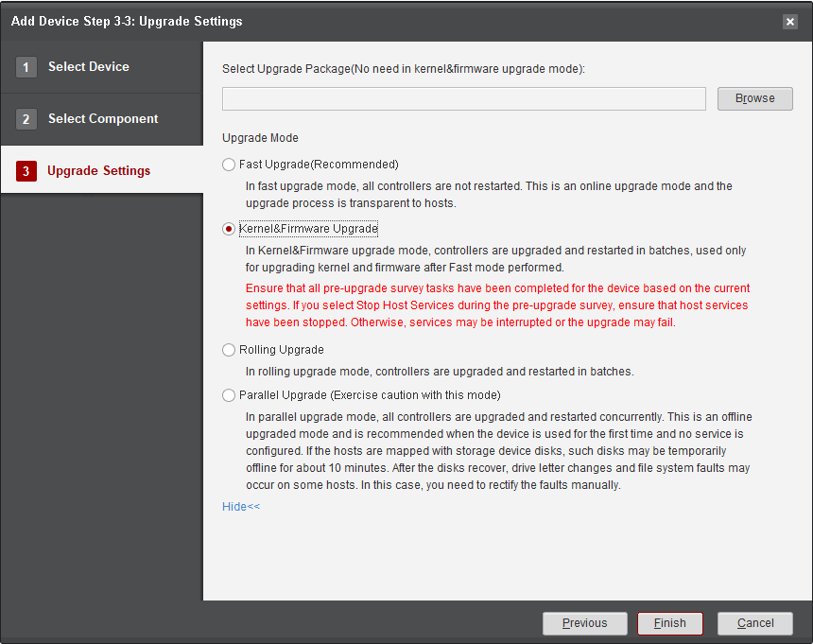

Collecting Array Information
For details, see 4.5 Collecting Array Information.

Conducting an Inspection

The verification is successful only when all items pass the inspection.
For details, see 6 Conducting an Inspection.

Evaluating Array Upgrade
For details, see 11.4.5 Evaluating Array Upgrade.

Evaluating Compatibility
For details, see 11.4.6 Evaluating Compatibility.

Analyzing Logs
For details, see 11.4.7 Analyzing Logs.

Performing the Upgrade

Setting the Upgrade Policy
Procedure
            - On the SmartKit home page, click Device Upgrade in Upgrade/Patch Installation and then click Upgrade Policy Setting, as shown in Figure 12-2.
              - Setting the upgrade policy

            - Click Add Device, as shown in Figure 12-3.
              - Adding a device
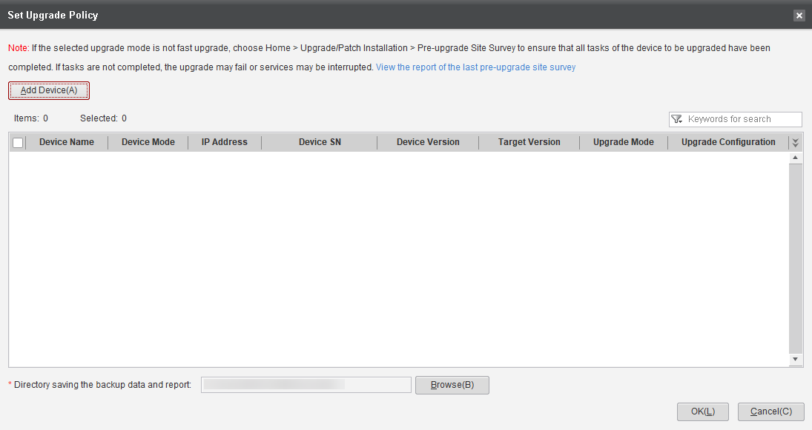
            - On the Select Device page, click Add Device, as shown in Figure 12-4.
              - Selecting a device
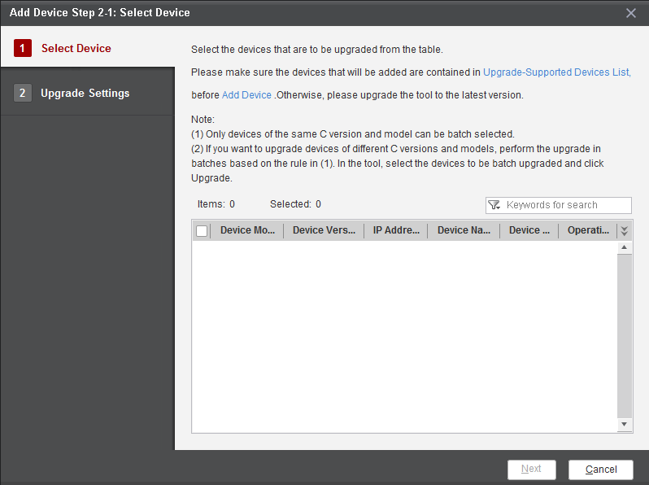

            - On the Basic Information page, enter the management IP address of the device and click Next, as shown in Figure 12-5.
              - Entering the management IP address of the device
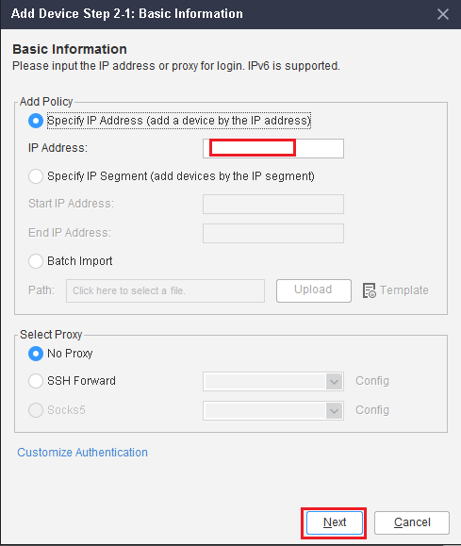

            - Enter Username and Password of the device and click Finish, as shown in Figure 12-6.
The default port number is 22. Require Certificate Verification is set to No by default. Leave Need Debugging Password and Switch to user root empty.
              - Entering the username and password

            - A dialog box is displayed indicating that the device fingerprint is not registered. Click OK to register it, as shown in Figure 12-7.
              - Registering the fingerprint

If a message is displayed indicating that the security certificate of this device is untrusted, click OK to continue.
            - Select the added device and click Next, as shown in Figure 12-8.
              - Selecting a device

            - Select the component to be upgraded and click Next, as shown in Figure 12-9.
              - Selecting component to be upgraded

            - On the Upgrade Settings page, set Upgrade Mode to Kernel&Firmware Upgrade, and click Finish, as shown in Figure 12-10.
Fast upgrade is selected by default. To select Kernel&Firmware Upgrade, click Show>>.
              - Selecting an upgrade mode
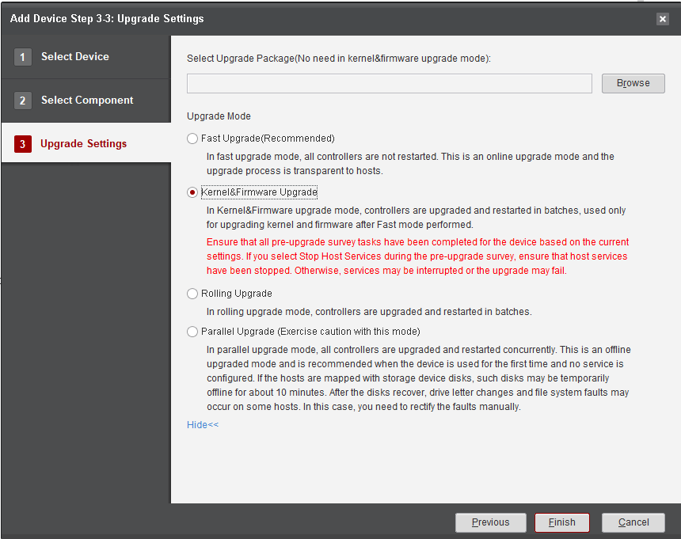
            - Click Browse on the right of Directory saving the backup data and report to select a backup path and click Save, as shown in Figure 12-11.
              - Selecting a backup path
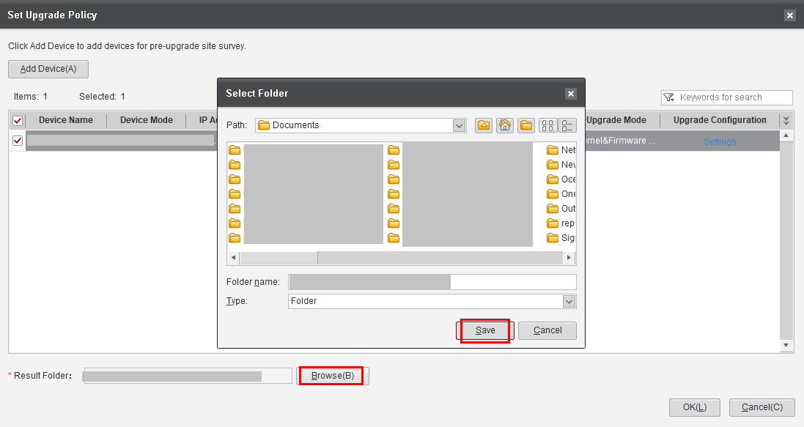
            - Return to the Set Upgrade Policy page. Select the added device, select the confirmation item, and click OK to complete the upgrade policy setting, as shown in Figure 12-12.
              - Setting the upgrade policy
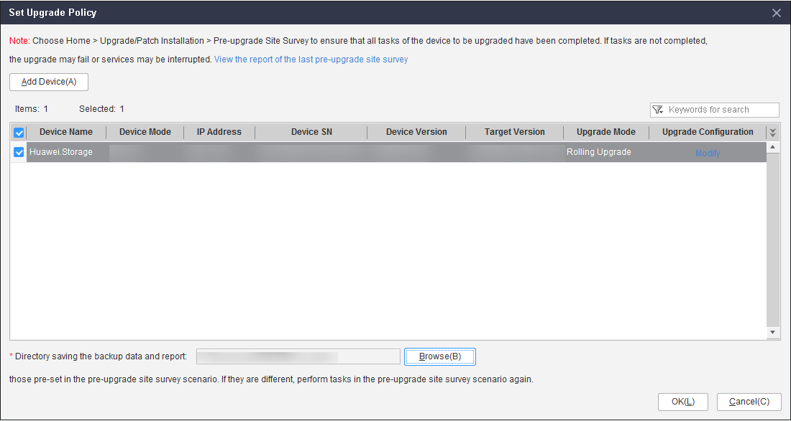

----End

Evaluating Array Upgrade
This section describes how to evaluate the system upgrade.
            - If the upgrade is to be performed more than one day after the site survey is complete, you must perform the array upgrade evaluation again to ensure a smooth upgrade.
            - You can skip this section if either of the following conditions is met:
- The pre-upgrade site survey has been conducted on the day when the upgrade is performed and all check items of array upgrade evaluation are passed.
- All failed check items have been rectified, and the storage settings, host service configurations, and host networking are not changed after the evaluation.
Procedure
            - Click Array Upgrade Evaluation, as shown in Figure 12-13.
              - Starting storage system evaluation

            - On the Upgrade Evaluation Tool page, select the desired device and click Execute, as shown in Figure 12-14.
              - Selecting a device

            - After the evaluation is complete, click the failed items (if any) and follow the instructions in Reference in the Details dialog box to rectify them. Then perform the evaluation again until all items are passed.
              - Detailed check information

If the hot patch check fails, as shown in Figure 12-16, perform Step 4 to Step 10.
              - Upgrade evaluation tool

            - Click Install Patch, as shown in Figure 12-17.
              - Installing the patch

            - On the Patch Tool page, click Select patch, as shown in Figure 12-18.
              - Selecting a patch package

            - Download the required patch package according to the information in the Patch Details dialog box and save it to a local directory.
              - Patch details

            - Click Modify, select the desired patch package, and click OK, as shown in Figure 12-20.
              - Selecting a patch package

            - In the Information dialog box that is displayed, click OK.
              - Information dialog box

            - On the Patch Tool page, click Start to install the patch, as shown in Figure 12-22.
              - Installing the patch

            - Verify that the patch is installed successfully.
              - Patch installed successfully

----End

Performing the Kernel and Firmware Upgrade

Prerequisites
This section provides the prerequisites for the kernel and firmware upgrade using SmartKit.
Prerequisites
- The pre-upgrade site survey has been performed according to 12.4 Pre-upgrade Site Survey and all check items and evaluations are passed.
- If the site survey and upgrade are performed on different days, a recheck has been performed according to 12.5.2 Evaluating Array Upgrade and all check items are passed.

If you want to ignore failed items and continue with the upgrade, ensure that you fully understand the risks and proceed only when the risks are acceptable.
- On DeviceManager, Max. Sessions per User has been set to 0. To check the value, choose Settings > User and Security > Security Policies and find the value in Login Policy. If it is not 0, change it to 0 and restore the original value after the upgrade is complete.
              - Login policy

- All DeviceManager pages and CLI windows have been closed. Login to DeviceManager or the CLI is prohibited during the upgrade.

Performing the Kernel and Firmware Upgrade
This section describes how to perform the kernel and firmware upgrade on SmartKit.
Procedure
If you choose Parallel Upgrade for the kernel and firmware upgrade, see 15.13 How Do I Run CLI Commands to Perform the Kernel and Firmware Upgrade?.
            - On the Device Upgrade page, click Storage Array Upgrade, as shown in Figure 12-25.
              - Starting storage upgrade
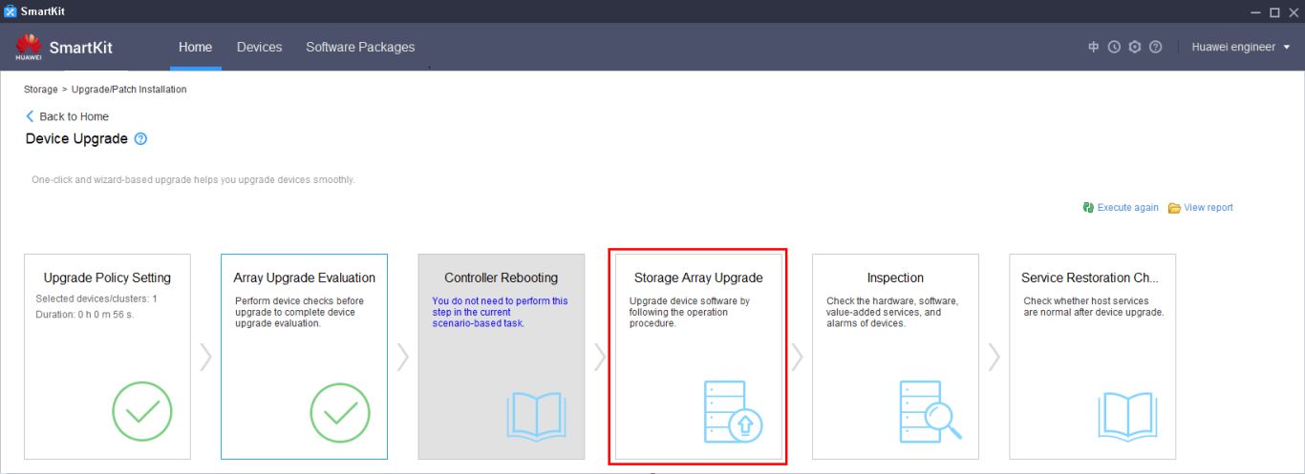

            - Click Perform Upgrade to start the upgrade, as shown in Figure 12-26.
              - Performing the upgrade
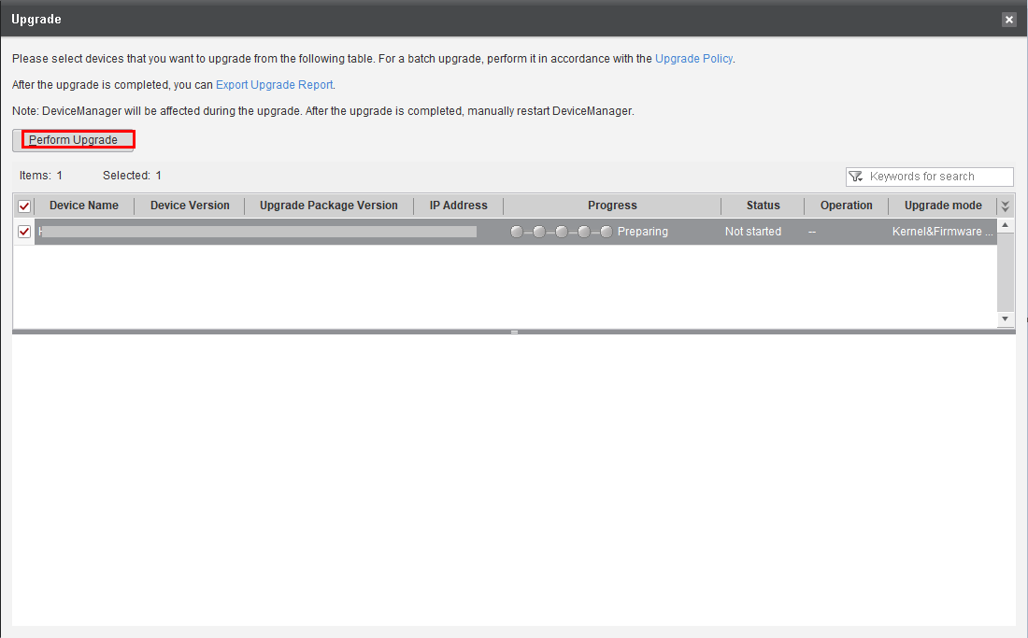

            - In the Confirm Upgrade dialog box, confirm the information, enter Yes, and click OK to start the upgrade, as shown in Figure 12-27.
              - Confirming the upgrade
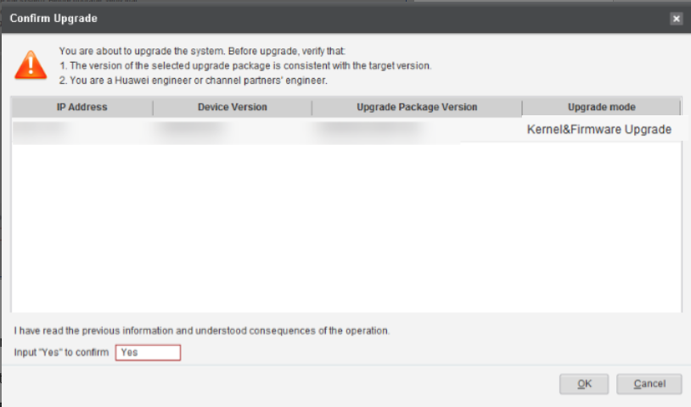

            - The system automatically starts a pre-upgrade check, as shown in Figure 12-28.
              - Pre-upgrade check
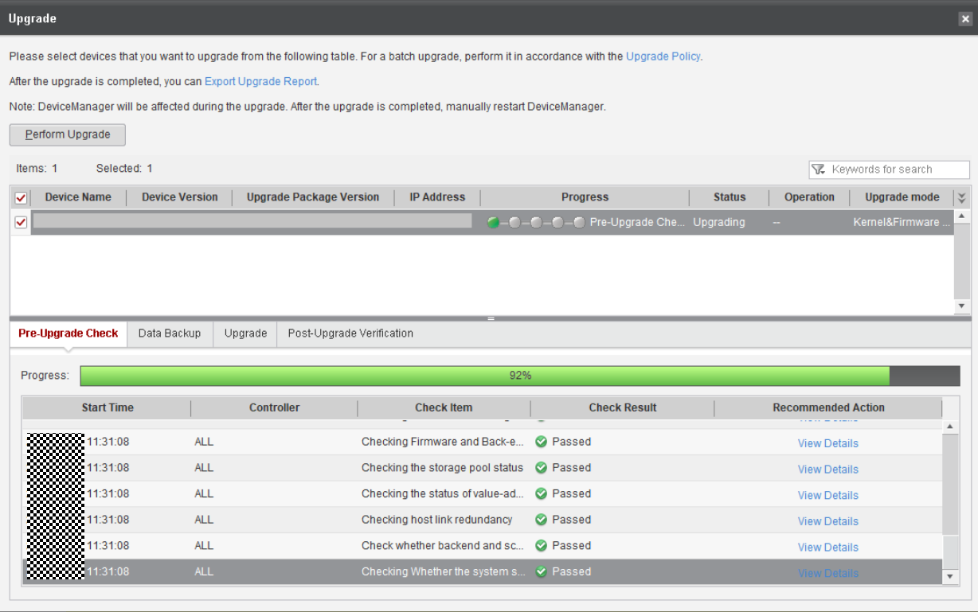

- The pre-upgrade check mainly carries out inspections directly related to the device and its health status, such as the upgrade package compatibility, device service load, redundant links of hosts, and device alarms. Some check items have been covered by the array upgrade evaluation, while other items must be checked after the upgrade package is imported.
- If the front-end link redundancy check fails, refer to 15.9 What Can I Do If the Front-End Link Redundancy Check Fails During the Upgrade?
- If certain items fail to pass the pre-upgrade check and cannot be rectified according to the handling suggestions, contact Huawei technical support engineers to evaluate the risks and proceed with the upgrade only when the risks are acceptable. To ignore the failed items and proceed with the upgrade, refer to 15.11 How Can I Ignore the Pre-Upgrade Check Items and Continue the Upgrade?
            - After the pre-upgrade check is complete, the system automatically backs up data, as shown in Figure 12-29.
              - Data backup
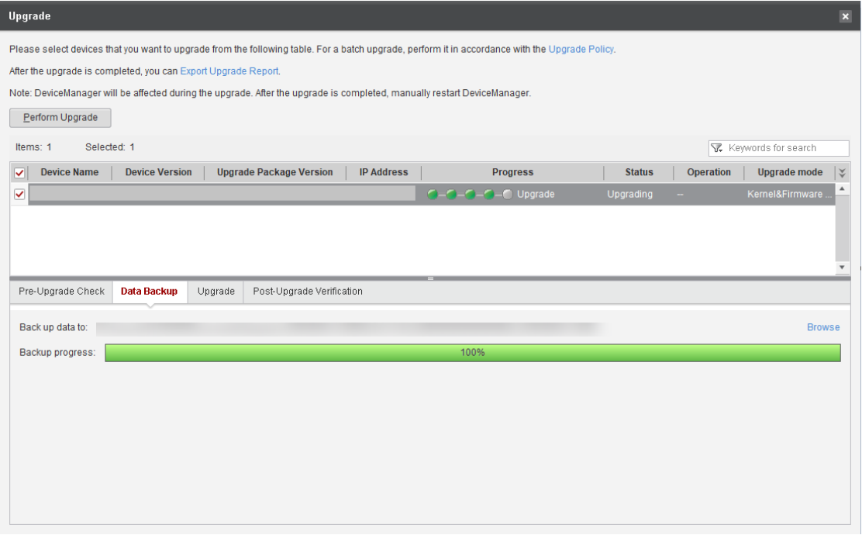

            - After data backup, the system automatically performs the upgrade, as shown in Figure 12-30.
              - Performing the upgrade
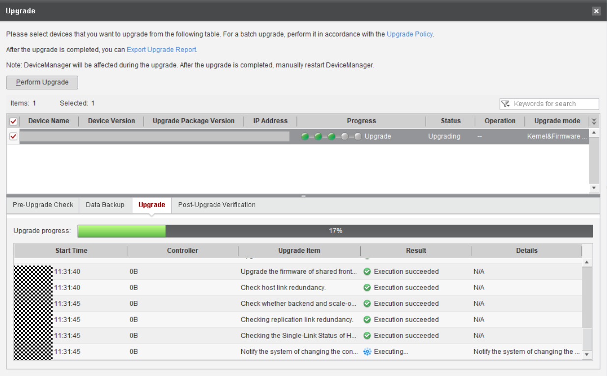

If the upgrade progress is not refreshed within 30 minutes and no upgrade failure message is reported, refer to 14.6 Upgrade Progress on the Upgrade Tool Is Not Refreshed Within 30 Minutes But No Upgrade Failure Is Displayed.
            - After the upgrade is complete, the system automatically performs a post-upgrade verification, as shown in Figure 12-31.
              - Verifying the upgrade
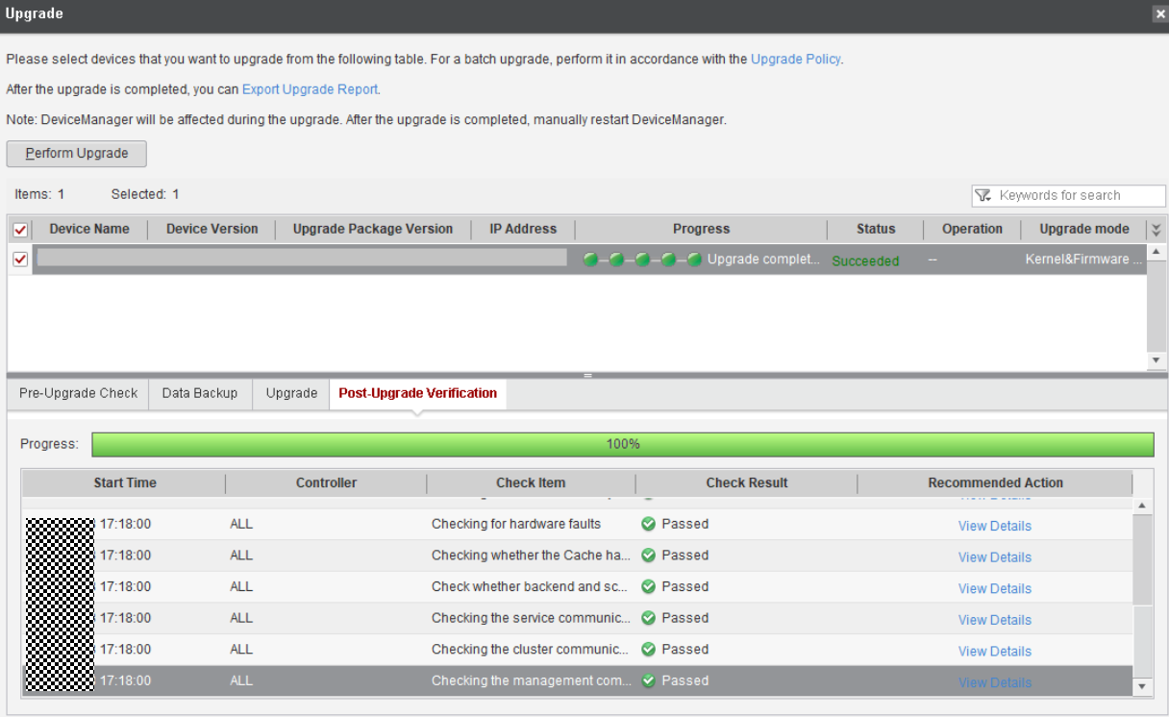

Check the post-upgrade verification result carefully to ensure no exception occurred during the upgrade.
            - After the upgrade, verify that the system version is consistent with the upgrade package version. The upgrade process is completed.
              - Confirming completion of the upgrade
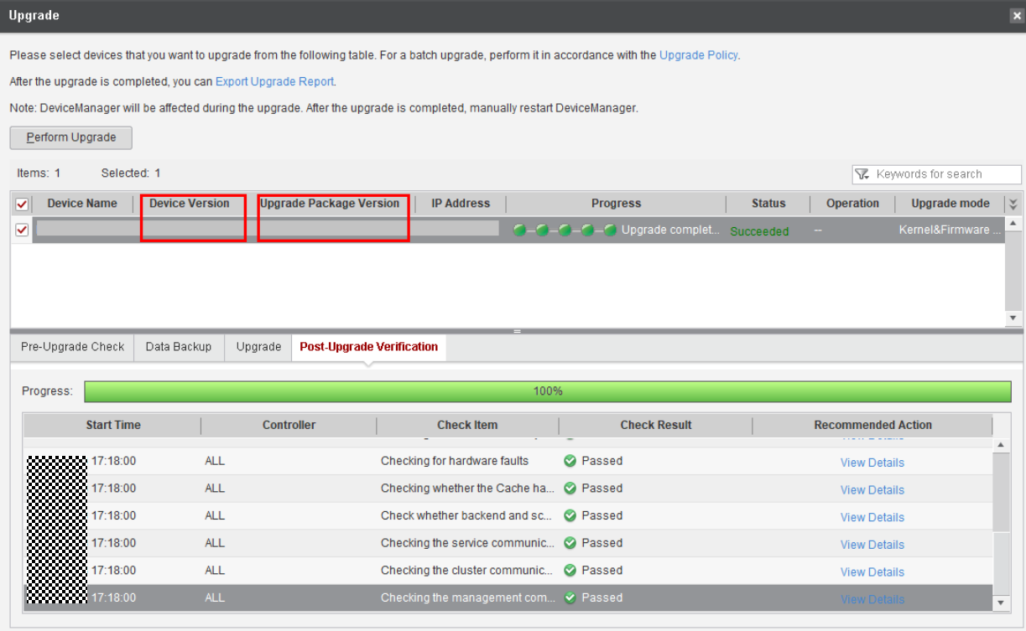

----End

Conducting an Inspection

The verification is successful only when all items pass the inspection.
For details, see 6 Conducting an Inspection.

Verifying the Upgrade
For details, see 7 Verifying the Upgrade.

Upgrading Storage Systems in a HyperMetro Deployment
This chapter describes how to upgrade storage systems in a HyperMetro deployment.
A HyperMetro deployment consists of two HyperMetro storage systems, hosts, and a quorum server. Figure 13-1 shows a typical HyperMetro network. An upgrade of the HyperMetro storage systems involves the upgrade of the controller software, and quorum server software.
              - Typical HyperMetro network
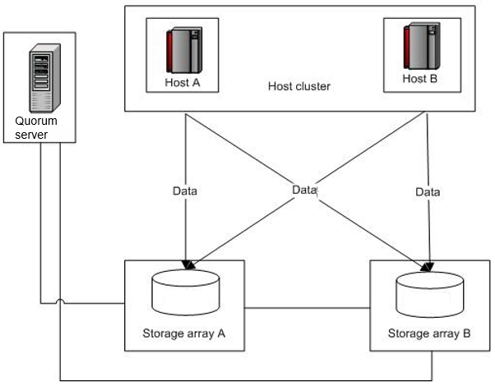

To upgrade storage systems in a SAN HyperMetro deployment, follow the instructions in 13.1 Upgrading Storage Systems in a SAN HyperMetro Deployment. To upgrade storage systems in a NAS HyperMetro deployment, follow the instructions in 13.2 Upgrading Storage Systems in a NAS HyperMetro Deployment.
13.1 Upgrading Storage Systems in a SAN HyperMetro Deployment
13.2 Upgrading Storage Systems in a NAS HyperMetro Deployment

Upgrading Storage Systems in a SAN HyperMetro Deployment
This section describes how to upgrade storage systems in a SAN HyperMetro deployment.

Upgrade Schemes
This section describes how to upgrade the storage systems when HyperMetro is not suspended. A fast upgrade or rolling upgrade can be performed for the storage controller software when host services are online. Table 13-1 describes the upgrade schemes.
                - Upgrade schemes
Host services are online.  Fast upgrade is performed for the storage systems. | Application Scenarios  Host services cannot be interrupted during the upgrade.  Procedure  - Upgrade the quorum server.  - Perform a fast upgrade on one storage system.  - After the upgrade is complete, perform a fast upgrade on the other storage system.  - After both storage systems have been upgraded, check the HyperMetro pair status.
Host services are online.  Rolling upgrade is performed for the storage systems. | Application Scenarios  Host services cannot be interrupted during the upgrade.  Procedure  - Upgrade the quorum server.  - Perform a rolling upgrade on one storage system.  - After the upgrade is complete, perform a rolling upgrade on the other storage system.  - After both storage systems have been upgraded, check the HyperMetro pair status.

Upgrade Flowchart
Figure 13-2 provides the flowchart for a fast upgrade when HyperMetro is not suspended and host services are online.
              - Fast upgrade flowchart
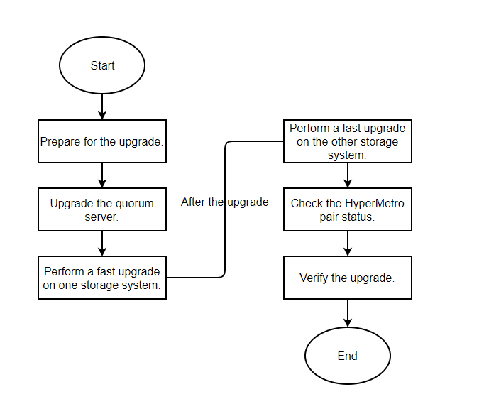

Pre-upgrade Check
This section describes how to perform a pre-upgrade check for SAN HyperMetro storage systems.
If you choose to retain the HyperMetro relationship for the upgrade, check the HyperMetro running status and host path status.
Procedure
            - Check whether the network is a standard HyperMetro network. If it is not, modify the network before the upgrade.
For the standard HyperMetro networks, see Standard Networking for SAN HyperMetro.
If you cannot access the preceding link, visit https://support.huawei.com/enterprise/en/doc/EDOC1100112636 and choose Planning to find the standard networks.
            - On DeviceManager, verify that the running status of the HyperMetro pairs and consistency groups is normal, as shown in Figure 13-3 and Figure 13-4.
              - HyperMetro consistency groups in the normal state
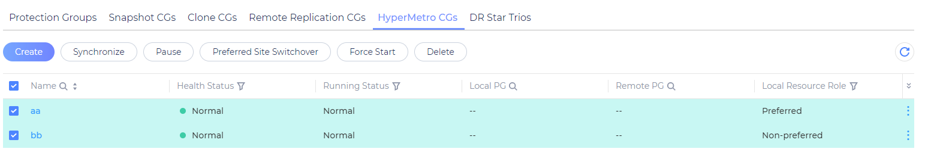

              - HyperMetro pairs in the normal state
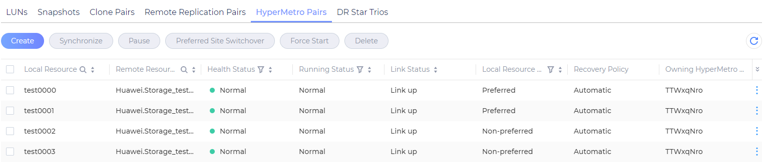

            - Query the VLUN IDs on the CLI of the host.
For example, on Linux hosts, run the upadmin show vlun type=hypermetro command to query the VLUN IDs, as shown in Figure 13-5. In AIX, Solaris, or Windows, run the upadm show vlun type=hypermetro command. In vSphere, run the esxcli upadm show vlun -t hypermetro command.
              - Querying VLUN IDs
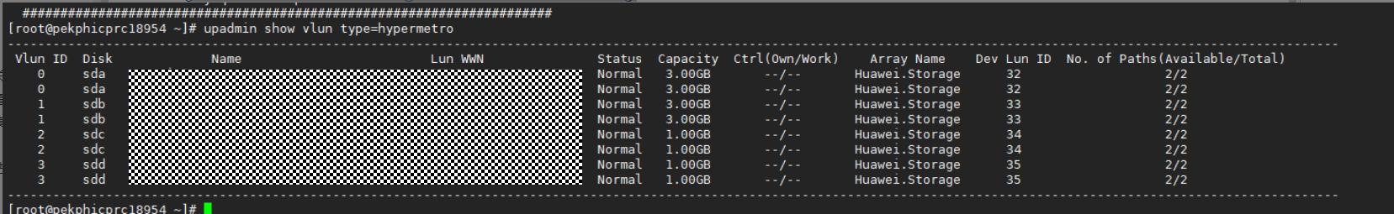

            - Check the connectivity between the HyperMetro VLUNs and the multipathing software that takes over the storage system.
For example, on Linux hosts, run the upadmin show vlun id=ID type=hypermetro command to verify that the path status is normal, as shown in Figure 13-6. In AIX, Solaris, or Windows, run the upadm show vlun id=ID type=hypermetro command. In vSphere, run the esxcli upadm show vlun -l ID -t hypermetro command.
              - Paths in normal state
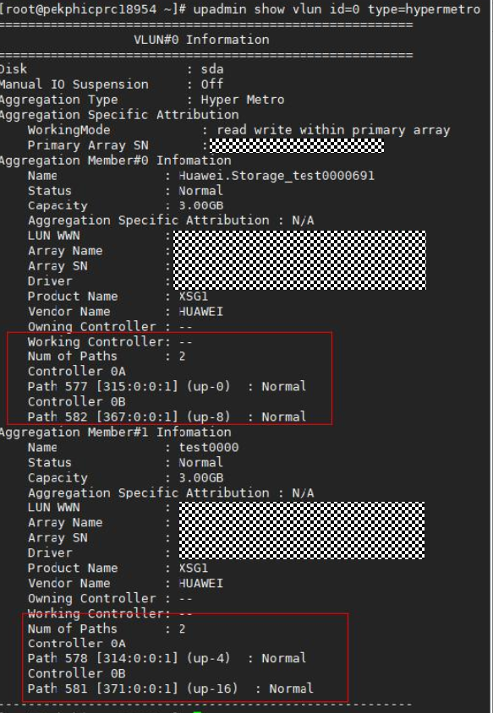

If any exception occurs in the pre-upgrade check, contact technical support engineers for help.
----End

Performing the Upgrade
This section describes the detailed operations for a fast upgrade when HyperMetro is not suspended and host services are online.
Procedure
            - Obtain the quorum server software package.
Download the package OceanStor_Dorado_6.x.x_QuorumServer_xxx_xx.zip. For details, see 3.3.2 Downloading Tools and Upgrade Packages.
            - Decompress the upgrade package and upload the software package to the quorum server. Go to the save path of the software package and run the ./quorum_server.sh -upgrade command to upgrade the software.
Before upgrading the quorum server software, ensure that the quorum server has sufficient storage space (greater than or equal to 10 GB). Otherwise, the upgrade may fail due to insufficient space. If the upgrade fails, run the ./quorum_server.sh –install command to reinstall the quorum server software.
              - Upgrading the quorum server
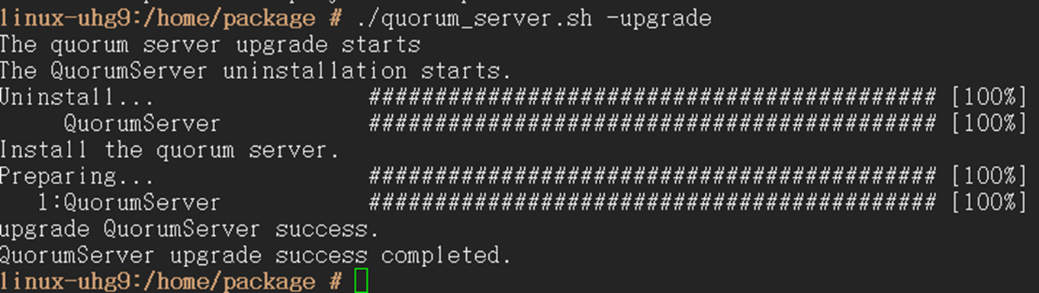

During the quorum server upgrade, the storage systems may report alarms indicating quorum link interruption. The alarms last for about 1 minute and will automatically clear after the quorum server upgrade is complete. You do not need to handle these alarms.
            - Log in to DeviceManager of the storage system that you want to upgrade. Navigate to the HyperMetro management page.
            - Check that the Running Status of all HyperMetro pairs and CGs is Normal, as shown in Figure 13-8.
              - Running Status of the HyperMetro pairs is Normal
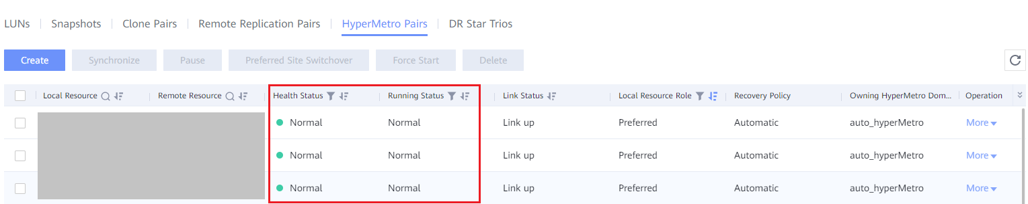

            - Upgrade the storage controller software by following instructions in 2 Upgrade Process.
            - Log in to DeviceManager of the other storage system. Navigate to the HyperMetro management page and verify that all HyperMetro pairs and CGs are in the Normal state. Then upgrade the storage controller software by following instructions in 2 Upgrade Process.
            - After both storage systems have been upgraded successfully, check the HyperMetro status. If the Running Status of the HyperMetro pairs and CGs is Paused, To be synchronized, or Force Start, synchronize the HyperMetro pairs and CGs, as shown in Figure 13-9 and Figure 13-10.
              - Synchronizing HyperMetro CGs
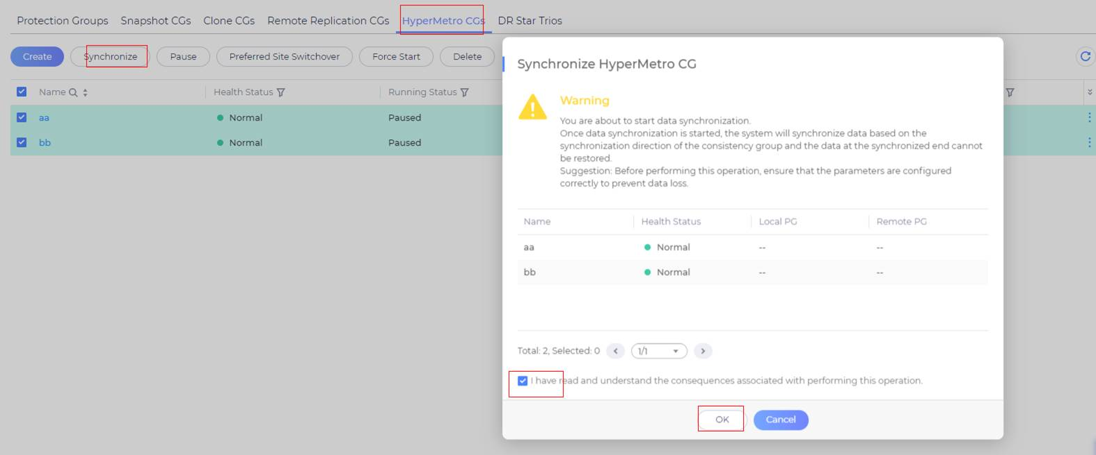

              - Synchronizing HyperMetro pairs
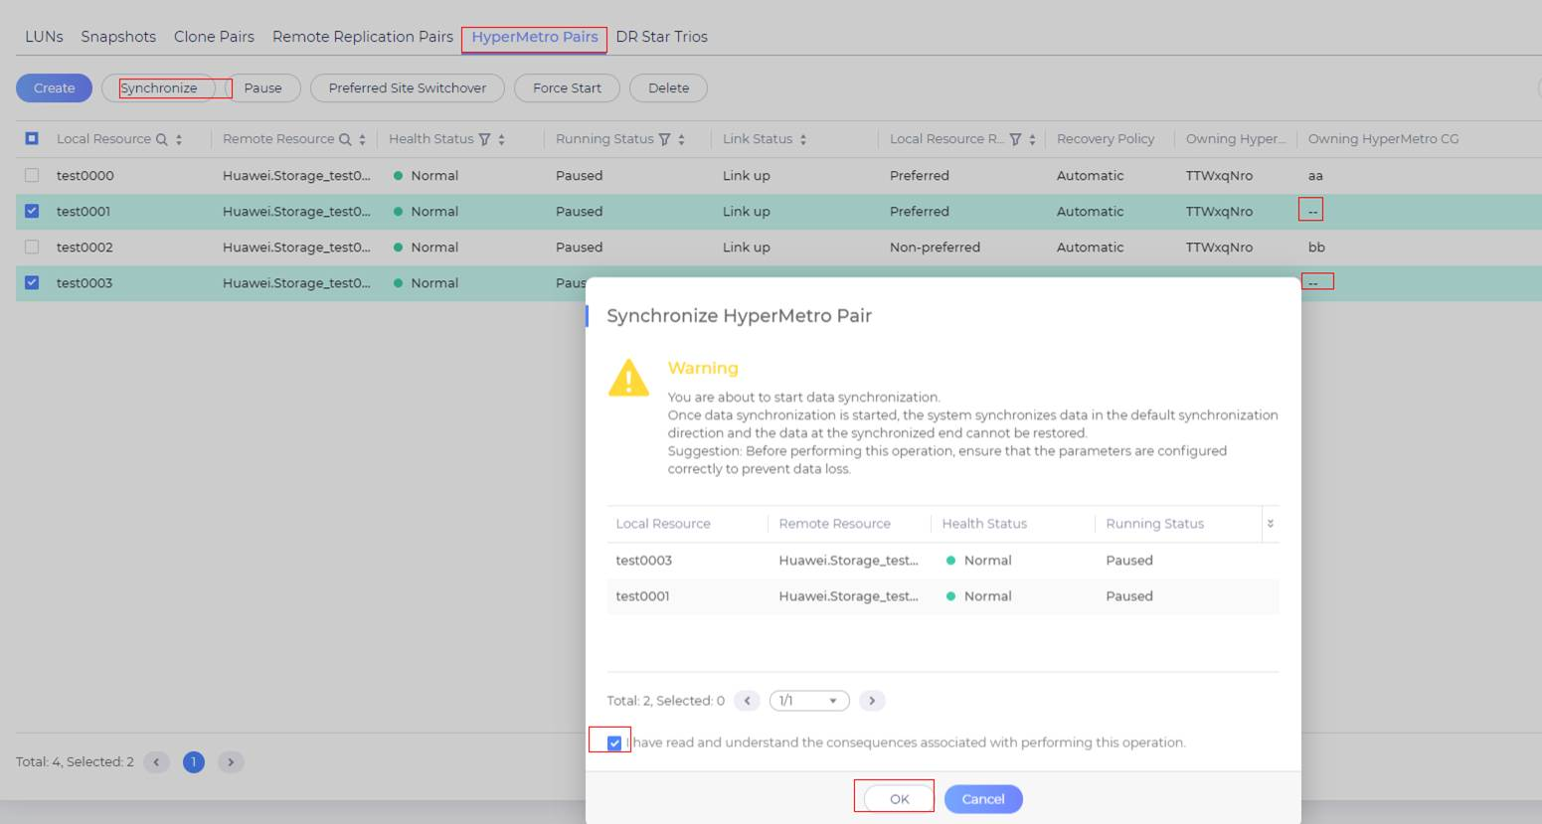

----End

Verifying the Upgrade
This section describes how to verify the upgrade.
If the storage systems connect to hosts running the ESXi operating system, perform the following steps:
- Log in to the server as the root user.
- Run the vmware -v command to check the version of the ESXi operating system. If the version is ESXi 6.0 Update 2 (build number 3620759) or later, go to the next step. If the OS is of another version, no further action is required.
[root@localhost:~] vmware -v
VMware ESXi 6.0.0 build-3620759
[root@localhost:~]
- Run the esxcli upadm show version command to check the UltraPath version. If the system prompts that this command does not exist, UltraPath is not installed. In this case, no further action is required. If the UltraPath version is 8.06.061 or later, go to the next step; if UltraPath is of an earlier version, no further action is required.
[root@localhost:~] esxcli upadm show version
Software Version : 8.06.061
Driver Version : 8.06.061
[root@localhost:~]
- Run the esxcli upadm show upconfig | grep "APD to PDL Mode" command to check whether APD to PDL is enabled for UltraPath. If it is disabled (APD to PDL Mode is off), no further action is required.
In this example, APD to PDL Mode is on. Go to the next step.
[root@localhost:~] esxcli upadm show upconfig | grep "APD to PDL Mode"
APD to PDL Mode : on
[root@localhost:~]
- Run the esxcli upadm set apdtopdl -m off command to disable APD to PDL.
[root@localhost:~] esxcli upadm set apdtopdl -m off
Succeeded in executing the command.
[root@localhost:~]
- Run the esxcli upadm show upconfig | grep "APD to PDL Mode" command to verify that APD to PDL has been disabled.
[root@localhost:~] esxcli upadm show upconfig | grep "APD to PDL Mode"
APD to PDL Mode : off
[root@localhost:~]

Upgrading Storage Systems in a NAS HyperMetro Deployment
This section describes how to upgrade storage systems in a NAS HyperMetro deployment.

Upgrade Schemes
This section describes how to upgrade the storage systems when HyperMetro is not suspended. A fast upgrade or rolling upgrade can be performed for the storage controller software when host services are online. Table 13-2 describes the upgrade schemes.
                - Upgrade schemes
Host services are online.  Fast upgrade is performed for the storage systems. | Application Scenarios  Host services cannot be interrupted during the upgrade.  Procedure  - Upgrade the quorum server.  - Perform a fast upgrade on one storage system.  - After the upgrade is complete, perform a fast upgrade on the other storage system.  - After both storage systems have been upgraded, check the status of the vStore pairs, file system HyperMetro domains, and HyperMetro pairs.
Host services are online.  Rolling upgrade is performed for the storage systems. | Application Scenarios  Host services cannot be interrupted during the upgrade.  Procedure  - Upgrade the quorum server.  - Perform a rolling upgrade on one storage system.  - After the upgrade is complete, perform a rolling upgrade on the other storage system.  - After both storage systems have been upgraded, check the status of the vStore pairs, file system HyperMetro domains, and HyperMetro pairs.

Upgrade Flowchart
Figure 13-11 provides the flowchart for a fast upgrade when HyperMetro is not suspended and host services are online.
              - Fast upgrade flowchart

Pre-upgrade Check
This section describes how to perform a pre-upgrade check for NAS HyperMetro storage systems.
If you choose to retain the HyperMetro relationship for the upgrade, check the running status and configuration status of the vStore pairs, file system HyperMetro domains, and HyperMetro pairs.
Procedure
            - Check whether the network is a standard HyperMetro network. If it is not, modify the network before the upgrade.
For details, see the HyperMetro Feature Guide for File specific to your product version.
            - On DeviceManager, verify that the running status of the vStore pairs, file system HyperMetro domains, and HyperMetro pairs is normal, as shown in Figure 13-12, Figure 13-13, and Figure 13-14.
              - Running status and configuration status of vStore pairs are normal
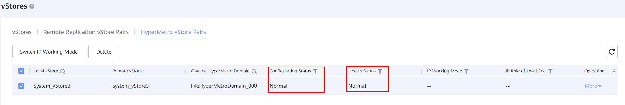
              - Running status of file system HyperMetro domains is normal
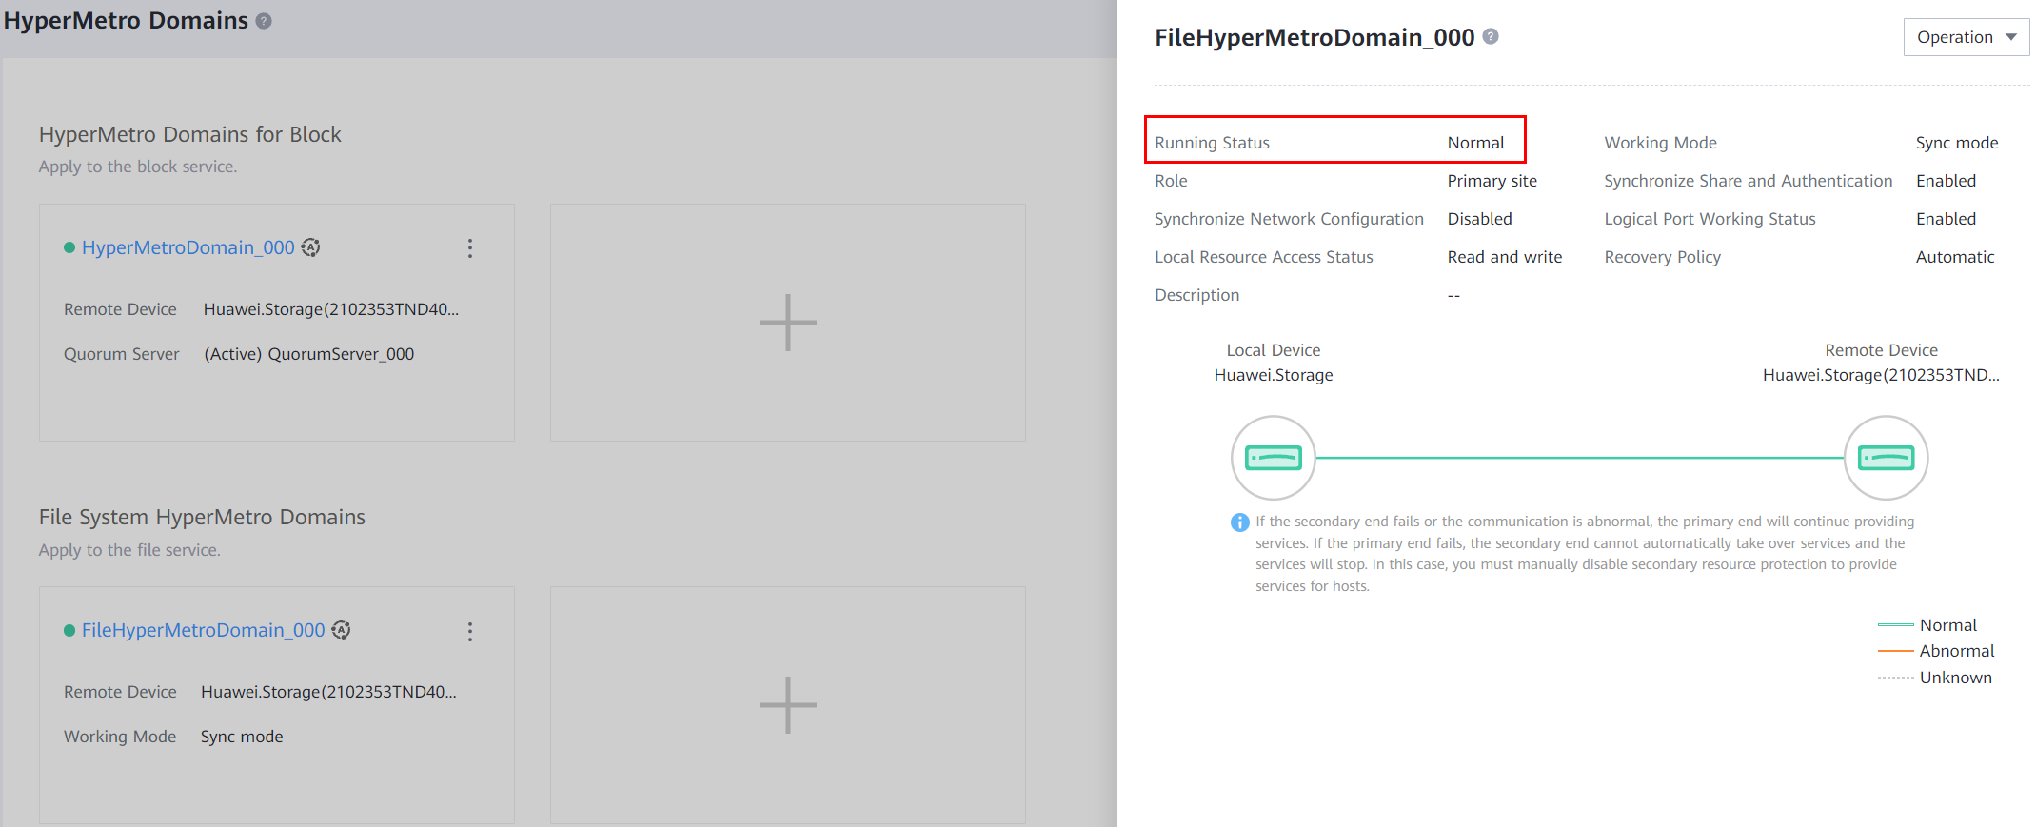
              - Running status of HyperMetro pairs is Normal or Synchronizing
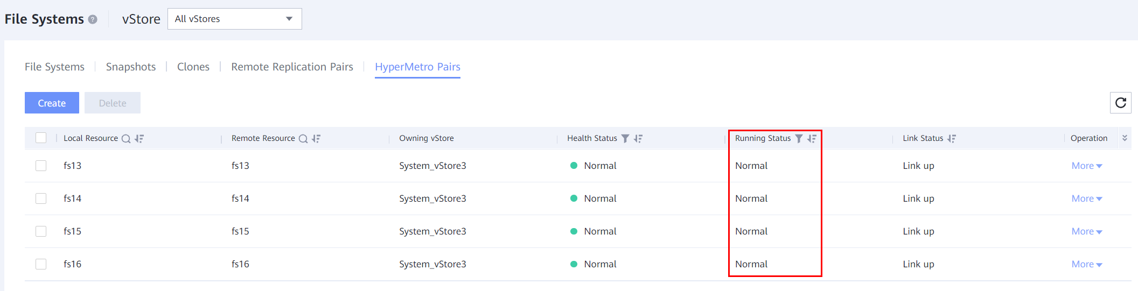
If any exception occurs in the pre-upgrade check, contact technical support engineers for help.
----End

Performing the Upgrade
This section describes the detailed operations for a fast upgrade when HyperMetro is not suspended and host services are online.
Procedure
            - Obtain the quorum server software package.
Download the package OceanStor_Dorado_6.x.x_QuorumServer_xxx_xx.zip. For details, see 3.3.2 Downloading Tools and Upgrade Packages.
            - Decompress the upgrade package and upload the software package to the quorum server. Go to the save path of the software package and run the ./quorum_server.sh -upgrade command to upgrade the software.
Before upgrading the quorum server software, ensure that the quorum server has sufficient storage space (greater than or equal to 10 GB). Otherwise, the upgrade may fail due to insufficient space. If the upgrade fails, run the ./quorum_server.sh –install command to reinstall the quorum server software.
              - Upgrading the quorum server

During the quorum server upgrade, the storage systems may report alarms indicating quorum link interruption. The alarms last for about 1 minute and will automatically clear after the quorum server upgrade is complete. You do not need to handle these alarms.
            - Log in to DeviceManager of the storage system that you want to upgrade. Navigate to the HyperMetro management page.
            - Verify that the running status and configuration status of the vStore pairs and the running status of the file system HyperMetro domains and HyperMetro pairs are normal, as shown in Figure 13-16, Figure 13-17, and Figure 13-18.
              - Running status and configuration status of vStore pairs are normal
              - Running status of file system HyperMetro domains is normal

              - Running status of HyperMetro pairs is Normal or Synchronizing

            - Upgrade the storage controller software by following instructions in 2 Upgrade Process.
            - Log in to DeviceManager of the other storage system and go to the HyperMetro management page. Verify that the running status and configuration status of the vStore pairs and the running status of the file system HyperMetro domains and HyperMetro pairs are normal. Upgrade the storage controller software by following instructions in 2 Upgrade Process.
            - After both storage systems have been upgraded successfully, check the running status of the file system HyperMetro domain. If the file system HyperMetro domain is in the Split state, recover the file system HyperMetro domain, as shown in Figure 13-19. If the file system HyperMetro domain is in the Normal state, but Running Status of the HyperMetro pair is Paused, To be synchronized, or Force started, or Running Status of the vStore pair is Unsynchronized, split the HyperMetro domain first (as shown in Figure 13-20) and then recover the HyperMetro domain (as shown in Figure 13-19).
              - Recovering the file system HyperMetro domain
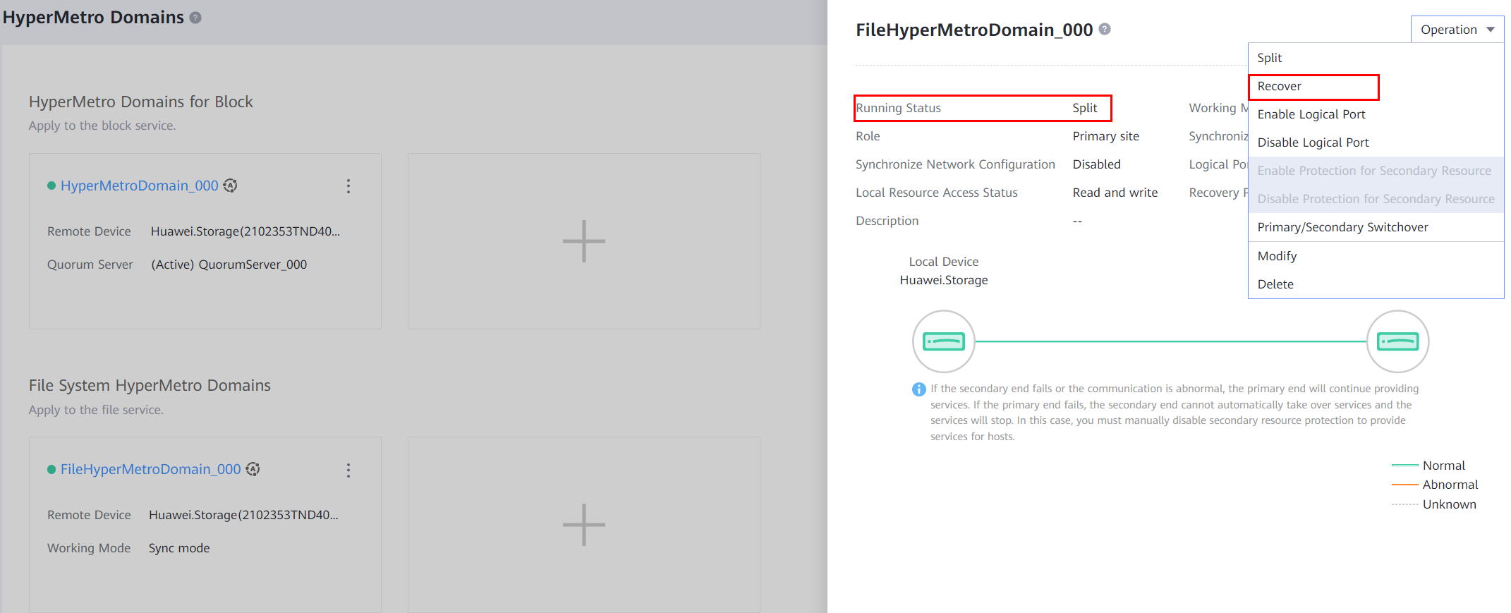
              - Splitting the file system HyperMetro domain
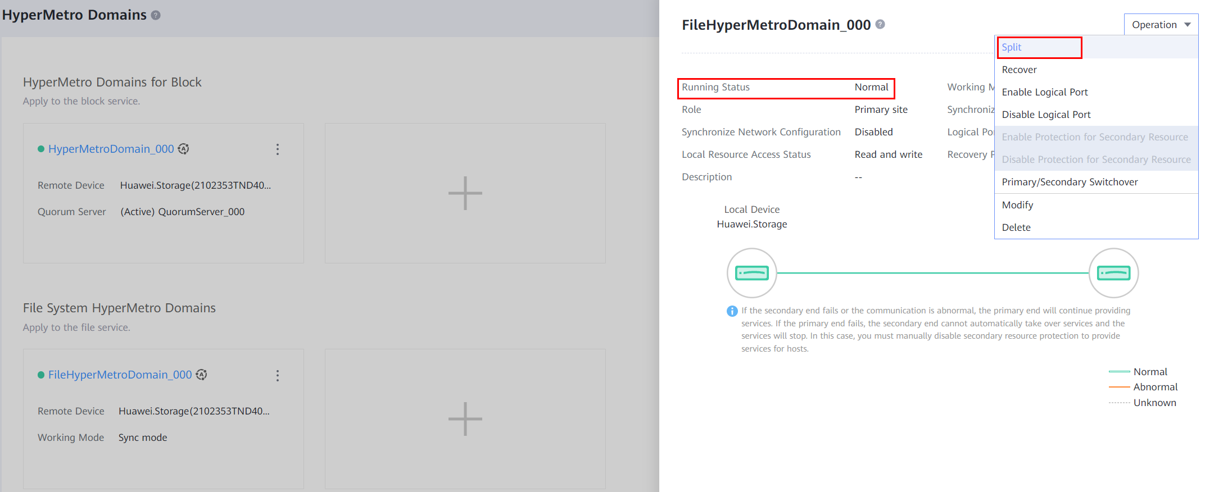
----End

Verifying the Upgrade
This section describes how to verify the upgrade.
For details on how to verify the upgrade, see 7 Verifying the Upgrade.
After the upgrade, perform the following steps to check NAS HyperMetro:
- After the HyperMetro pair synchronization is complete, verify that the running status and configuration status of the vStore pairs and the running status of the file system HyperMetro domains and HyperMetro pairs are normal, as shown in Figure 13-21, Figure 13-22, and Figure 13-23.
              - Running status and configuration status of vStore pairs are normal
              - Running status of file system HyperMetro domains is normal

              - Running status of HyperMetro pairs is Normal or Synchronizing

Troubleshooting
If any fault occurred during an upgrade and could not be handled onsite, contact Huawei technical support engineers for assistance. The following troubleshooting method is for your reference.
14.1 Common Troubleshooting Methods for an Upgrade Failure
14.2 Failed to Notify the System of Starting Upgrade
14.3 A Controller Hardware Fault Occurred During an Upgrade, Causing an Upgrade Failure
14.4 The Upgrade Is Interrupted Due to a Version Verification Failure Occurred After the Local Storage Array Restarts During an Upgrade on a Non-standard Heterogeneous Network
14.5 After an Array Is Upgraded, Status of the Physical Path and Logical Path Displayed on UltraPath Is Inconsistent
14.6 Upgrade Progress on the Upgrade Tool Is Not Refreshed Within 30 Minutes But No Upgrade Failure Is Displayed
14.7 Upgrade Failure Due to Abnormal NAS HyperMetro Domain Disconnection

Common Troubleshooting Methods for an Upgrade Failure
Symptom
An exception occurs during the upgrade and the upgrade status changes to Paused or Failed. Figure 14-1 is an example of the upgrade status becoming Paused.
              - Upgrade paused
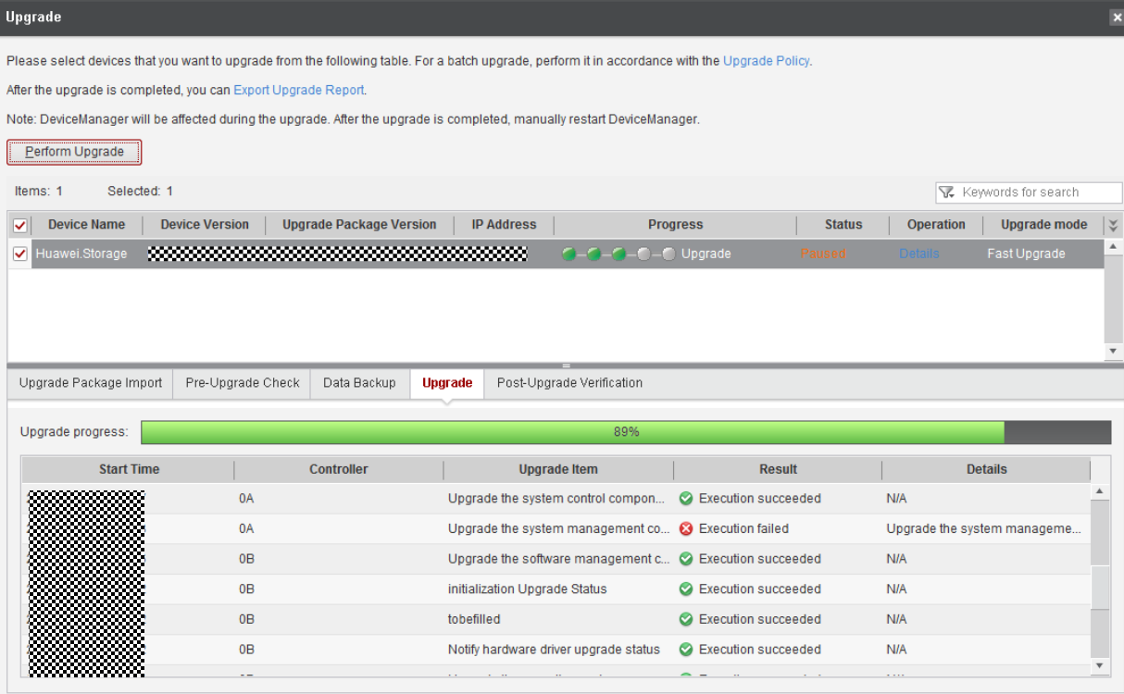

Troubleshooting Procedure
            - Click Details in the Operation column of the upgrade tool. Check whether the Retry, Roll Back, and Close options are available in the dialog box, as shown in Figure 14-2.
              - Details
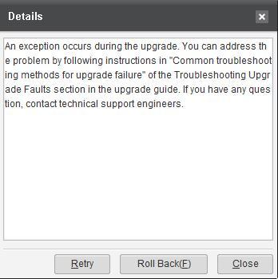

            - You are advised to select Retry in the dialog box shown in Figure 14-2. If the retry fails, click Roll Back.
Descriptions about each option are as follows:
- Retry: Perform the upgrade again. If the upgrade succeeds, the process continues. If the upgrade fails again, the process will be suspended again.
- Roll Back: Roll back all controllers to the source version.
            - If both the retry and rollback fail, log in to OceanStor DeviceManager, click the Settings icon, and choose Export Data from the drop-down list. Select System Log and click All Logs to export all system logs, as shown in Figure 14-3 and Figure 14-4. Then send the logs to technical support engineers for troubleshooting.
              - Exporting all logs (1)
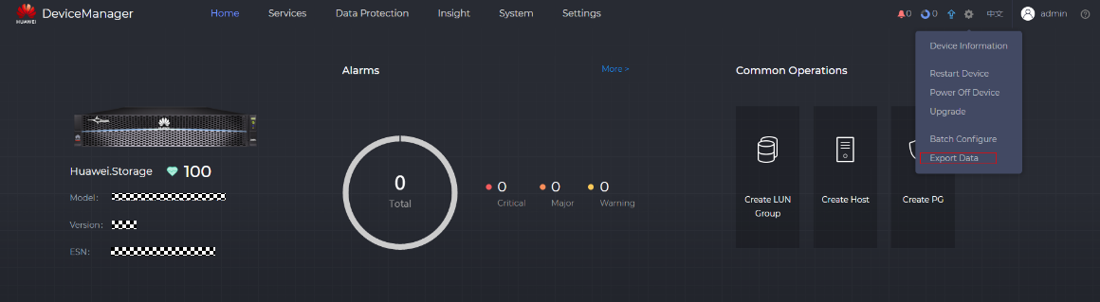

              - Exporting all logs (2)
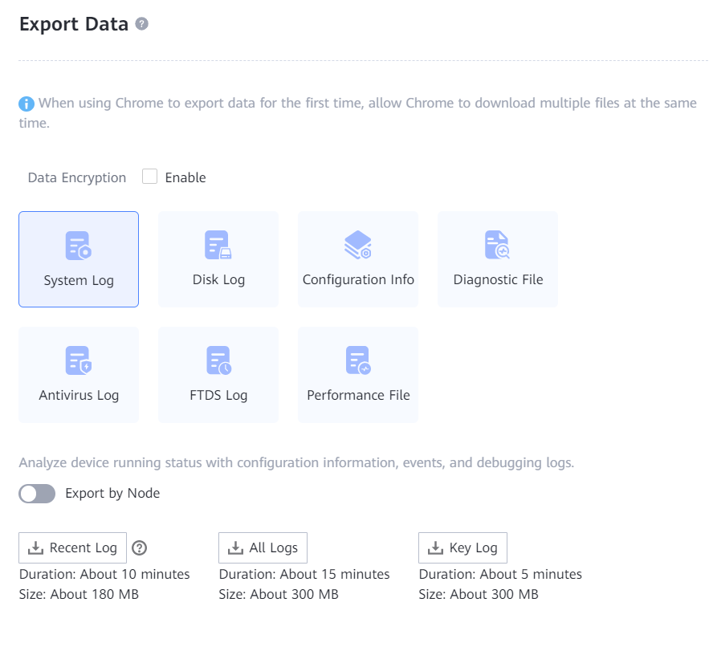

----End

Failed to Notify the System of Starting Upgrade
This section describes how to troubleshoot the problem when the system fails to be notified of starting upgrade.
Symptom
The upgrade tool fails to notify the system of starting upgrade, as shown in Figure 14-5.
              - Failed to notify the system of starting upgrade
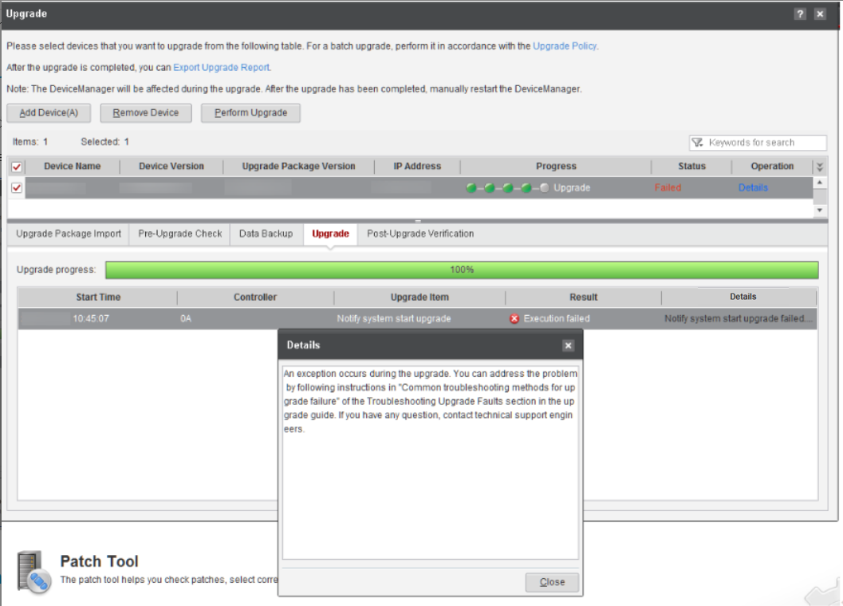

Alarm Information
None
Possible Causes
- The primary and secondary ends of the HyperMetro pair or remote replication pair cannot be upgraded simultaneously.
- The system may fail to notify service modules of starting upgrade.
Procedure
            - Use the SSH tool to log in to the active controller of the current cluster.
            - Check whether a message "System is upgrading" is displayed. If yes, go to the next step. If not, contact Huawei technical support engineers.
            - Run the minisystem command to enter the minisystem mode and run the showsystrace command in minisystem mode.
            - Check whether Success is displayed under the Status column in the SET_UPDATE_STATUS step and whether the FailCnt column is 0. If not, the system fails to be notified of starting upgrade, as shown in Figure 14-6.
              - Viewing the failed step
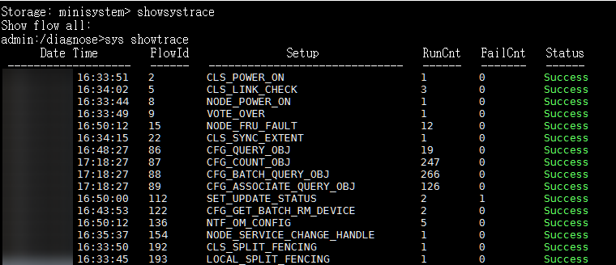

            - Run the showsystrace 112 command. If the value of Failed Action Name is Upgrade: NtfRssPre, the value-added services fail to start upgrade. The possible cause is that the primary and secondary ends of the HyperMetro pair or remote replication pair cannot be upgraded simultaneously.
----End
Suggestions
- If the failure type is Upgrade: NtfRssPre, check whether the peer end of the remote replication pair or HyperMetro pair is being upgraded. If yes, stop the service upgrade and wait until the peer end is successfully upgraded. Otherwise, contact Huawei technical support engineers.
- If other steps fail, record the name of the failed step and contact Huawei technical support engineers.

A Controller Hardware Fault Occurred During an Upgrade, Causing an Upgrade Failure
This section describes how to replace a faulty controller when Huawei technical support engineers confirm that a controller hardware fault causes an upgrade failure.
Symptom
A controller hardware fault occurred during an upgrade. As a result, the upgrade failed.
Alarm Information
None
Possible Causes
The controller hardware is faulty.
Procedure
            - On SmartKit, find out the ID of the controller that fails the upgrade. In Figure 14-7, the ID is 0B, which indicates controller B in enclosure 0.
              - Upgrade failure
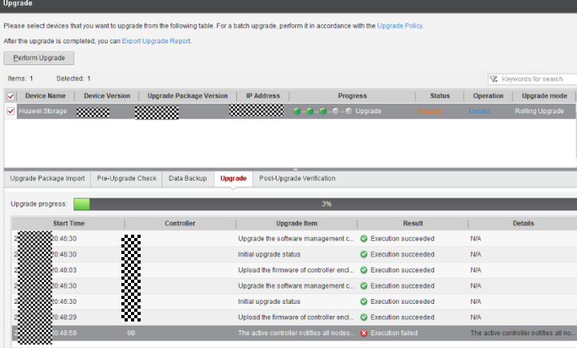

            - Remove the faulty controller and install a spare controller.
            - Verify that the controller is replaced successfully.
- Log in to OceanStor DeviceManager and view the device. Figure 14-8 shows an example of a spare controller that is in normal state.
              - Checking the status of the device
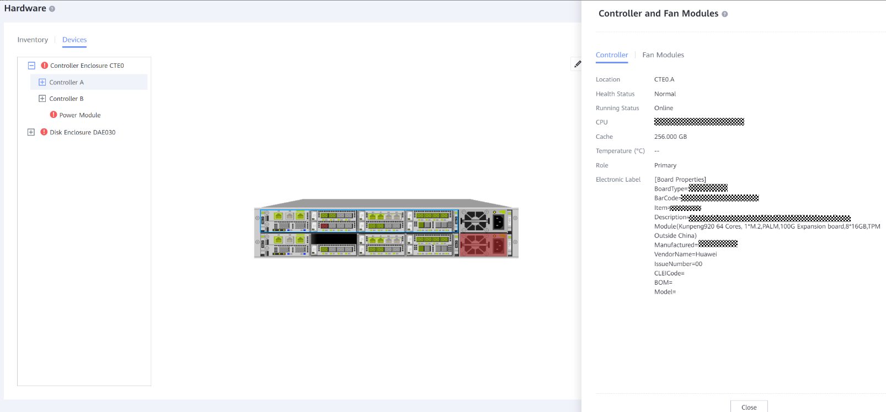

- Verify that you can successfully log in to the CLI of the spare controller, as shown in Figure 14-9.
              - Logging in to the storage array
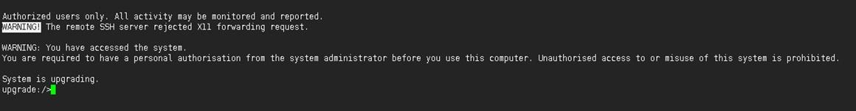

- Check whether the version information of the spare controller is correct, as shown in Figure 14-10. If Current Version and History Version of the spare controller are the target and source versions respectively, the controller replacement is successful.
If the controller replacement is not successful, remove and insert the spare controller again. Then, repeat Step 3 or contact Huawei technical support engineers.
              - Querying controller software versions
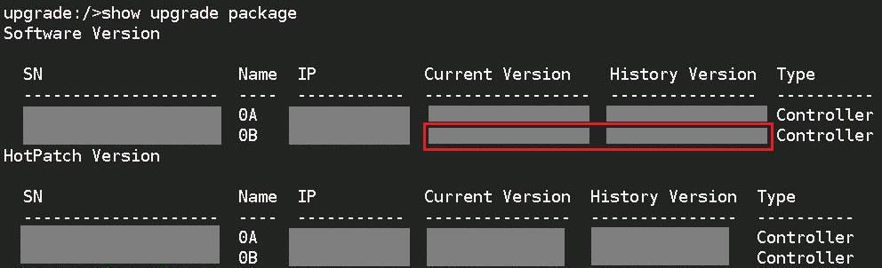

            - Retry the upgrade on SmartKit.
----End
Suggestions
None

The Upgrade Is Interrupted Due to a Version Verification Failure Occurred After the Local Storage Array Restarts During an Upgrade on a Non-standard Heterogeneous Network
This section describes how to troubleshoot the upgrade interruption caused by a version verification failure occurred after the local storage array restarts during a rolling upgrade on a non-standard heterogeneous network.
Symptom
On a non-standard heterogeneous network (for example, controller A of the local storage array is connected to that of a heterogeneous storage array through a link, and controller B of the local storage array is connected to that of the heterogeneous storage array through a link), if both storage arrays are upgraded simultaneously, a version verification failure may occur after the local storage array restarts. On a standard network, each controller of the local storage array has at least one available link to each controller of the heterogeneous storage array.
Alarm Information
None
Possible Causes
The heterogeneous network is a non-standard network. When both local and heterogeneous storage arrays are upgraded, one controller of the heterogeneous storage array resets, so the heterogeneous LUN has only one link to the local storage array. Consequently, the link check of the heterogeneous LUN fails during the upgrade check on the local storage array, causing the upgrade interruption.
Procedure
            - After the heterogeneous storage array completes the upgrade and restores to normal, click Details on the Upgrade page of SmartKit, and click Retry in the dialog box that is displayed.
            - If the local storage array still fails to be upgraded, contact Huawei technical support engineers.
----End
Suggestions
None

After an Array Is Upgraded, Status of the Physical Path and Logical Path Displayed on UltraPath Is Inconsistent
This section describes how to troubleshoot the inconsistency between the physical path status and logical path status displayed on UltraPath installed on the host after an array is upgraded.
Symptom
After an array is upgraded, the physical path status and logical path status displayed on the UltraPath installed on the host are faulty and normal, respectively.
Alarm Information
None
Possible Causes
Before the controller is restarted following an upgrade, the controller instructs UltraPath to set the logical path to faulty. After the controller restarts, UltraPath detects that the physical path is disconnected and sets the physical path to faulty. After the controller is restarted, the status of the logical path becomes normal, but the physical path status is not refreshed.
This problem does not affect the host I/O, but only the status is displayed incorrectly.
Procedure
Open the in-band commands of the mapping view on the array and scan for disks on the host to update the path information.
            - Log in to the host and run the upadmin show path (for Linux hosts) or esxcli upadm show path (for ESX hosts) command to view information about the initiator whose physical path status is faulty. The following uses Linux as an example. As shown in the following figure, the path whose Path ID is 2 is faulty and its initiator is iqn.1996-04.de.suse:01:d9aef539c136.
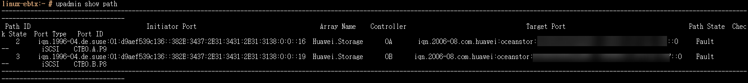
            - Use an SSH tool, such as Xshell 5, PuTTY 0.63, SecureCRT 6.7, or one of their later versions, to log in as user admin (the default password is Admin@storage) to the management network port on the storage device. Then, the admin view of the CLI is displayed.
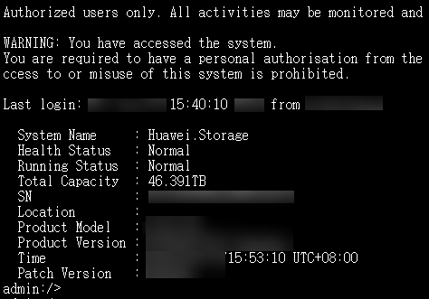
            - Log in to the array and run the following commands to query the mapping view associated with the host initiator:
- Run the show initiator command to check Host ID corresponding to the host initiator. As shown in the following figure, the host initiator is iqn.1996-04.de.suse:01:d9aef539c136 and the corresponding Host ID is 0.
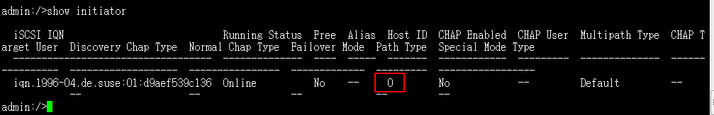
- Run the show host host_group host_id=xx command (xx is the Host ID found in the previous step) to find the corresponding Host Group ID. As shown in the following figure, Host Group ID is 0.
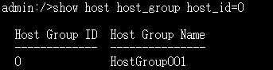
- Run the show host_group mapping_view host_group_id=xx command (xx is the Host Group ID found in the previous step) to find the corresponding mapping view. As shown in the following figure, the mapping view is MappingView001.
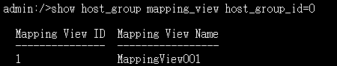
            - On the array, enable the in-band command of the mapping view found in Step 3.
- Run the show mapping_view general command to check whether the in-band command is enabled. As shown in the following figure, the in-band command of MappingView001 is Disable.
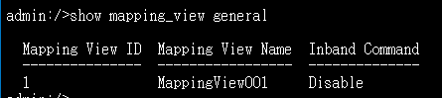
- Run the change mapping_view mapping_view_id=xx command_device=enable command (xx indicates the mapping view ID of the command device to be enabled, for example, 1), as shown in the following figure.
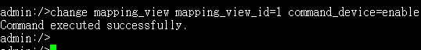
- Run the show mapping_view general command to check whether the in-band command is enabled. As shown in the following figure, the in-band command of MappingView001 is Enable.
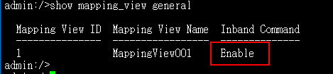
            - On the host, run the upRescan (for Linux hosts) or esxcfg rescan -A (for ESX hosts) command to scan for disks. The following uses Linux as an example:
Before scanning for disks, the disk information is as follows:
According to the disk information after disk scanning, a 16 KB LUN is displayed.
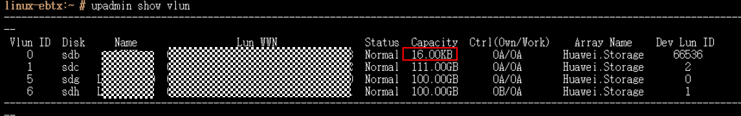
            - Run the upadmin show path (for Linux hosts) or esxcli upadm show path (for ESX hosts) command to check whether the corresponding physical path status is normal. Using a Linux host as an example, the status of the physical path whose Path ID is 4 changes to normal.
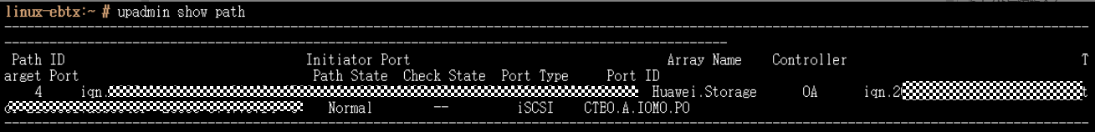
            - On the array, disable the mapping view's command device to restore the environment.
- Run the change mapping_view mapping_view_id=xx command_device=disable command (xx indicates the mapping view ID of the command device to be disabled, for example, 1), as shown in the following figure.
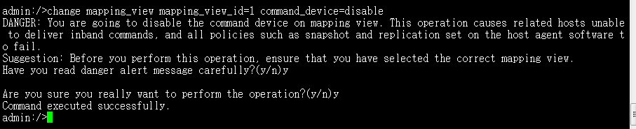
- Run the show mapping_view general command to check whether the in-band command is disabled. As shown in the following figure, the in-band command of MappingView001 is Disable.
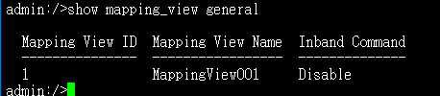
            - On the host, run the upRescan (for Linux hosts) or esxcfg rescan -A (for ESX hosts) command to restore the environment. Using a Linux host as an example, after the command for scanning for disks is executed, the 16 KB command device disappears.
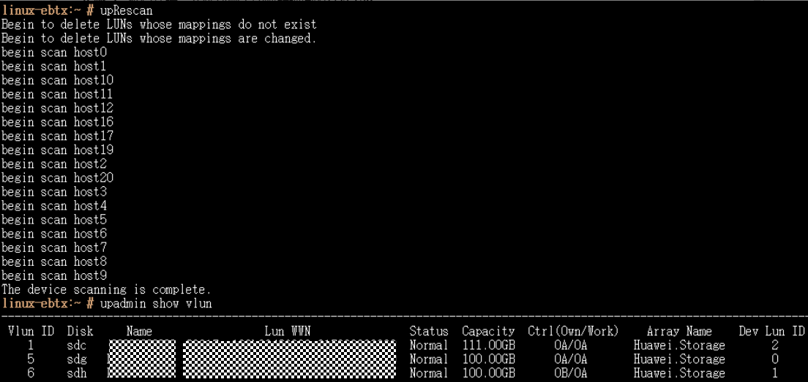
----End

Upgrade Progress on the Upgrade Tool Is Not Refreshed Within 30 Minutes But No Upgrade Failure Is Displayed
This section describes how to check whether the upgrade status is normal when the upgrade progress is not refreshed within 30 minutes but no upgrade failure is displayed.
Symptom
The upgrade progress on the upgrade tool is not refreshed within 30 minutes, but no upgrade failure is displayed.
Alarm Information
None
Possible Causes
The upgrade tool cannot communicate with the array.
Procedure
            - Use the SSH software to access any management IP address of the array and log in to the CLI as user admin.
            - If the upgrade view is displayed after the CLI is displayed and the status is System is upgrading, the system is being upgraded. Run the show upgrade status command to view the upgrade progress and status.
            - If the admin view is displayed after the CLI is displayed, run the change user_mode current_mode user_mode=developer command to go to the developer view and run the show upgrade status command to check the upgrade progress and status. If the status is Upgrade Succeed and Percent is 100, the upgrade is successful. Otherwise, the upgrade fails.
            - If the upgrade fails, contact Huawei technical support.
----End

Upgrade Failure Due to Abnormal NAS HyperMetro Domain Disconnection
This section describes how to continue the upgrade if the upgrade fails due to abnormal NAS HyperMetro domain disconnection.
Symptom
The on-going upgrade fails because the file system HyperMetro domain is abnormally disconnected.
              - Upgrade failure
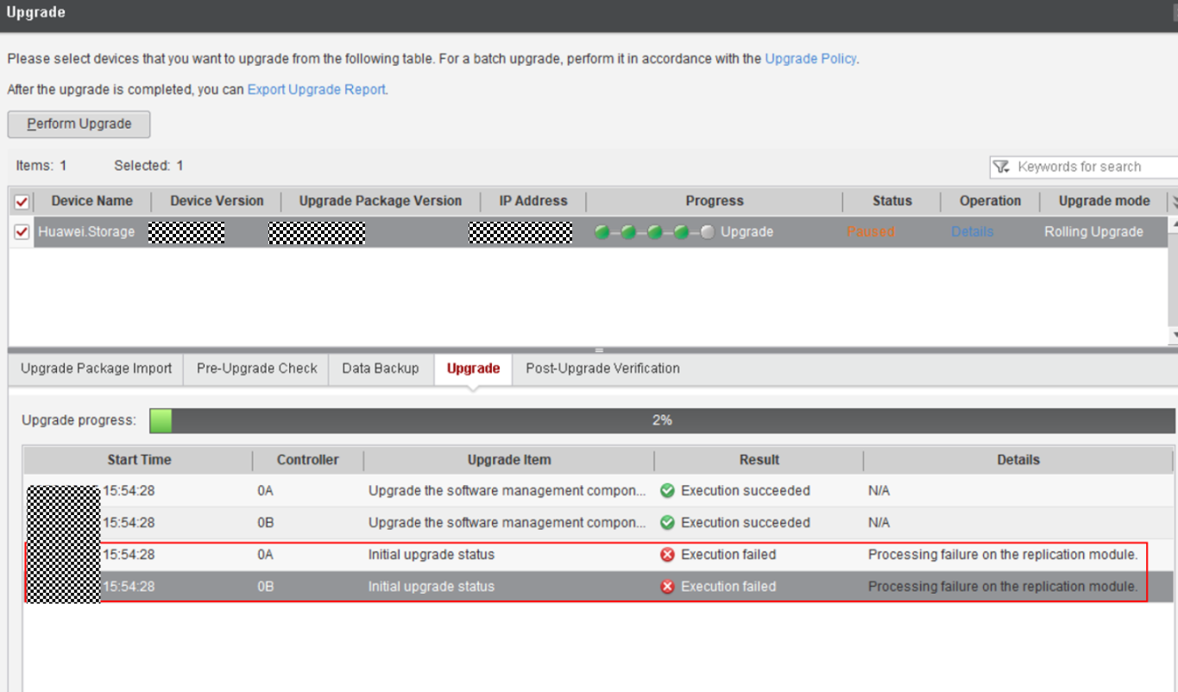
              - Alarm about abnormal disconnection of the file system HyperMetro domain
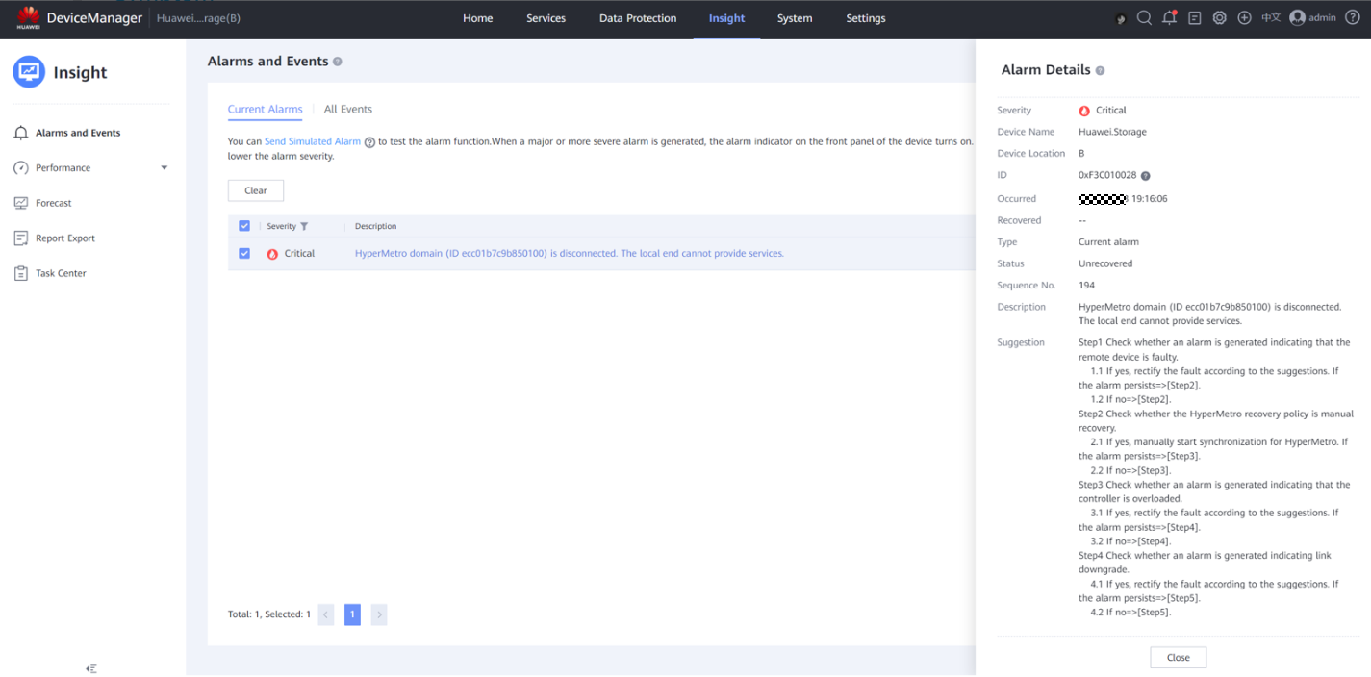
              - Faulty running status of the file system HyperMetro domain
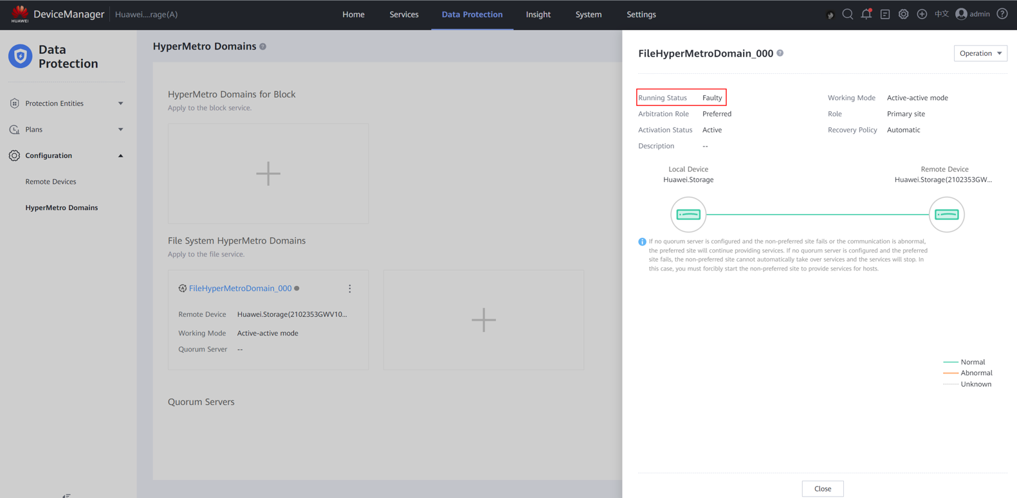
Possible Causes
The link is faulty or subhealthy, a single storage array is subhealthy, or the CCDB mirroring configuration fails.
Procedure
            - If the on-going upgrade fails due to a HyperMetro domain failure, split the HyperMetro domain and try the upgrade again.
              - Splitting the file system HyperMetro domain
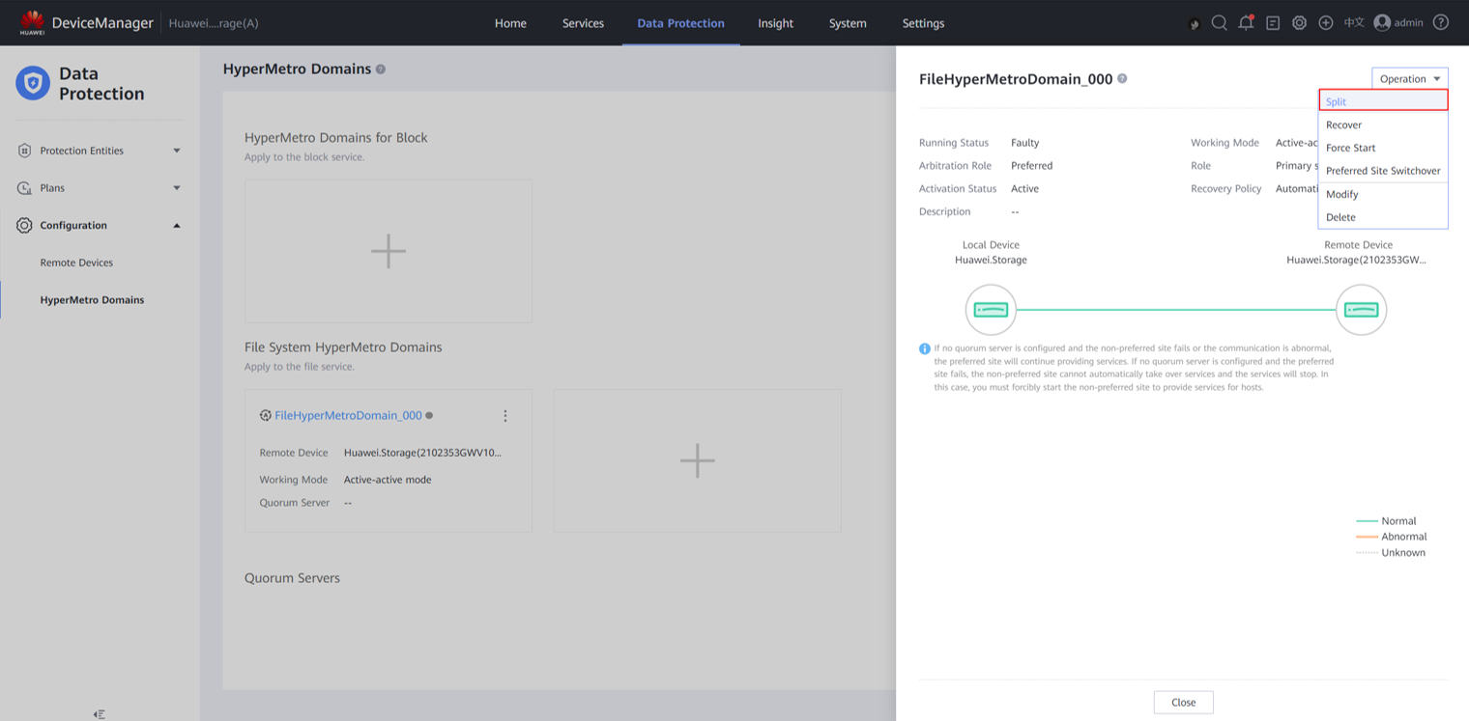
            - If the upgrade still fails on the local storage array, contact Huawei technical support engineers.
----End

FAQs
15.1 What Are the Common Methods for Logging In to a Storage System?
15.2 How Can I Upgrade a Non-Commercial Version to a Commercial One?
15.3 How Can I Query and Modify the SSH Port Number of a Controller?
15.4 How Can I Collect Storage System Information If the System Is Abnormal?
15.5 How Can I Ignore the Failed Step During the Upgrade and Proceed with the Subsequent Procedure?
15.6 How Can I Forcibly Upgrade the Storage System?
15.7 What Can I Do If Multiple Check Items Fail During a Pre-upgrade Check?
15.8 How Do I Query Major or Critical Alarms That Have Been Deleted Manually?
15.9 What Can I Do If the Front-End Link Redundancy Check Fails During the Upgrade?
15.10 How Can I Check the Compatibility of Hosts Running Non-mainstream Operating Systems?
15.11 How Can I Ignore the Pre-Upgrade Check Items and Continue the Upgrade?
15.12 What Can I Do When the Host HBA or iSCSI Timeout Parameter Does Not Pass the Check and Cannot be Modified?
15.13 How Do I Run CLI Commands to Perform the Kernel and Firmware Upgrade?
15.14 How Do I Perform a Fast Upgrade Using DeviceManager?
15.15 Why Is the Performance Data Displayed During the Upgrade Inaccurate?
15.16 How Can I Configure Upgrade Batches?
15.17 How Do I Obtain and Manually Import the CA Certificate for Disk Authentication to the Storage Array?
15.18 How Can I Upgrade the Storage System If the Interface Modules Are Incompatible?

What Are the Common Methods for Logging In to a Storage System?
Question
What are the common methods for logging in to a storage system?
Answer
- Using the SSH tool (PuTTY as an example)
            - Open PuTTY. Enter the IP address of the storage system in Host Name and click Open, as shown in Figure 15-1.
              - Using PuTTY for login
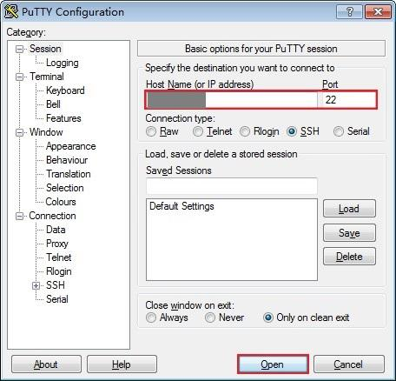

            - Enter the user name and password of the storage system. By default, the user name is admin and the password is Admin@storage. Figure 15-2 shows a successful login.
              - Successful login
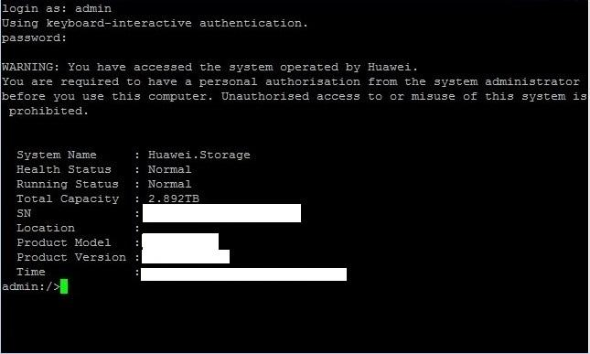

            - To log out of the storage system, run the exit command, as shown in Figure 15-3.
              - Logging out of the storage system
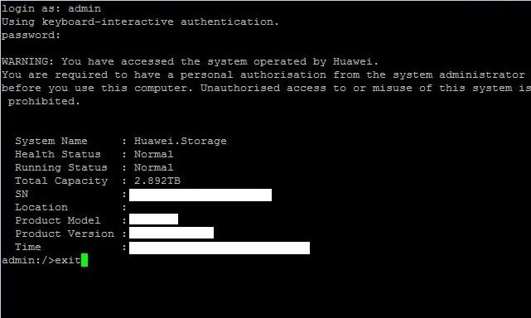

----End
- Using OceanStor DeviceManager
            - In the address box of a browser, enter the management IP address of the storage system. For example, if the management IP address is 10.20.0.101, enter https://10.20.2.101:8088 (Google Chrome and Firefox are recommended).
The browser may prompt a message indicating that there is a security certificate issue. Ignore this message and continue the login if the entered IP address is correct.
            - Enter the user name and password, and click Log In, as shown in Figure 15-4.
              - Entering the user name and password
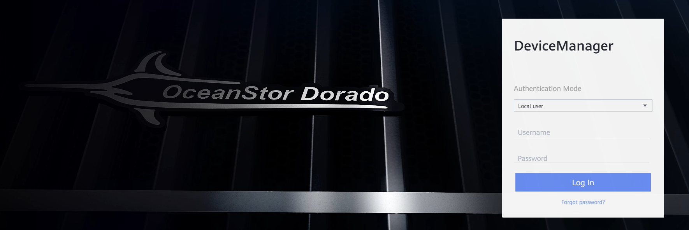

            - The home page of DeviceManager is displayed, as shown in Figure 15-5.
              - DeviceManager home page
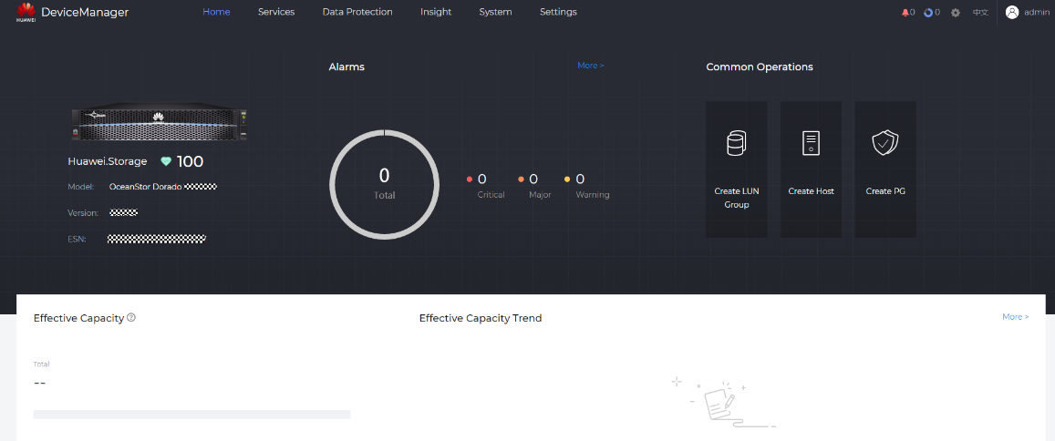

----End

How Can I Upgrade a Non-Commercial Version to a Commercial One?
Question
How can I upgrade a non-commercial version to a commercial one?
This is the only way for upgrading a non-commercial version to a commercial one. To determine whether the running version is non-commercial, contact Huawei technical support.

This approach is highly risky. It is used to format system startup partitions, reinstall the operating system, and clear the existing service configuration data. Do not perform it without the guidance of technical support engineers.
Answer
            - Log in to the CLI on any controller. Run the change user_mode current_mode user_mode=developer command to switch to the developer mode, as shown in Figure 15-6.
              - Entering the developer mode
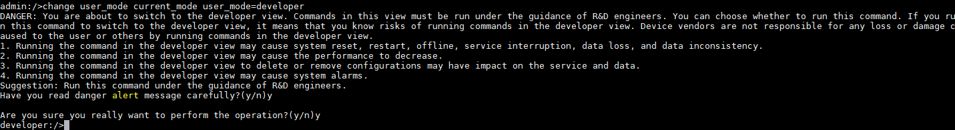

            - In developer mode, run the export configuration_data ip=x.xx.xx.xx user=xxx password=xxx db_file=XX.dat protocol=SFTP command, as shown in Figure 15-7.
              - Exporting configuration data
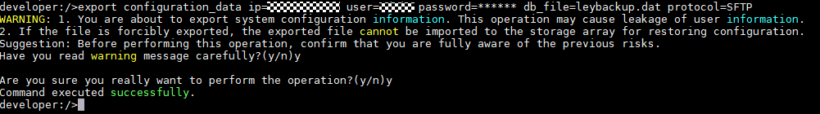

In this command, ip is the IP address of the host; user and password are the user name and password of the host; the value of db_file is user-defined, but its file name extension must be .dat; protocol can be SFTP or FTP.
            - In developer mode, run the clear configuration_data action=reboot command. Wait until the system clears the configuration data and restarts, as shown in Figure 15-8.
              - Clearing all configuration data and restarting
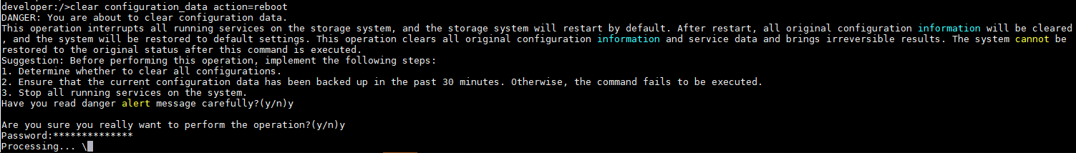

After the configuration data is cleared, the password is changed to the initial one.
            - After the system starts up, log in to each controller and run the minisystem command in developer mode on the CLI to enter the minisystem, as shown in Figure 15-9. If there are not enough IP addresses, you can run the sshtoremoteExt command in the minisystem to redirect to the desired controller. For example, to redirect to controller 0, run sshtoremoteExt 0 (0 is the controller ID) and then enter the password (same as that of user admin) as prompted, as shown in Figure 15-10. To check the current controller on which you are performing operations, run the showsysstatus command, as shown in Figure 15-11.
              - Entering the minisystem
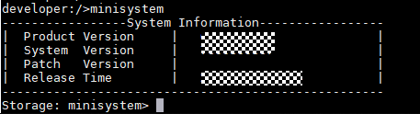

              - Redirecting to controller 0
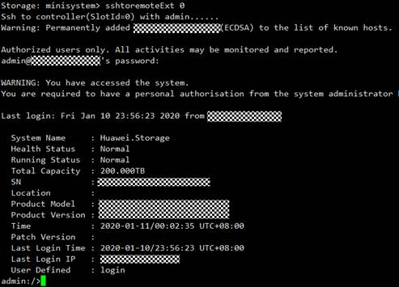

              - Checking the current controller
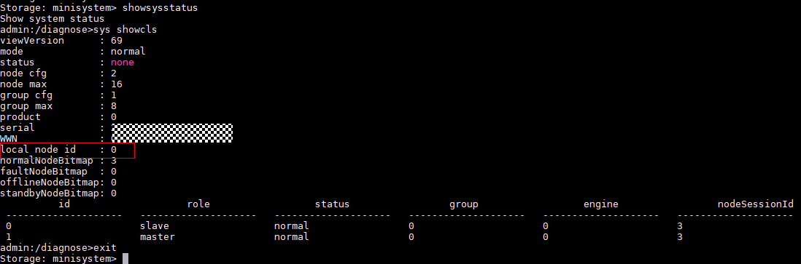

            - Run the free -m command in the minisystem of each controller to check its remaining memory, as shown in Figure 15-12. Ensure that the remaining memory is 100 MB greater than the size of the upgrade package to be uploaded.
              - Checking the remaining memory
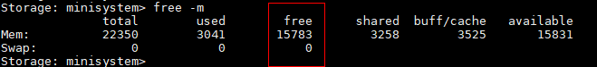

            - In the minisystem of each controller, run the sys.sh cleardirtydataflag command to clear dirty data from the memory, as shown in Figure 15-13.
              - Clearing dirty data

            - Use the FTP/SFTP tool to upload the upgrade package to the /home/permitdir directory of any controller, and run the setupsystem -a command in the minisystem of this controller. The system prompts you to enter the upgrade package name. Enter the package name and press Enter. The system automatically checks whether the upgrade package matches the device type. If they match, enter y as prompted to format and reinstall the operating system, as shown in Figure 15-14.
              - Executing the setupsystem command
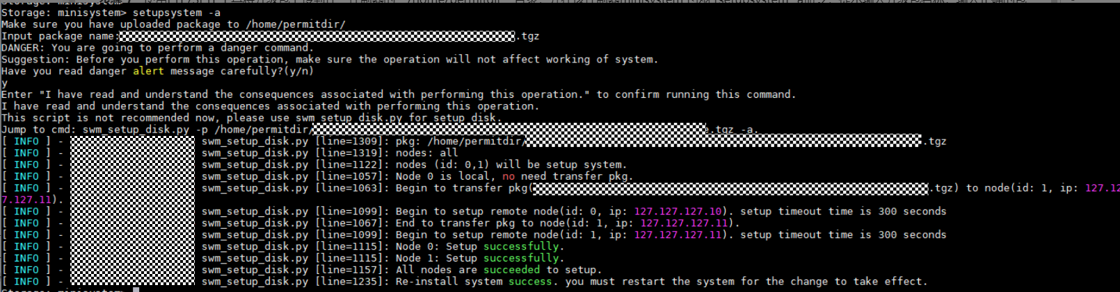

            - Press the power button to power off and then power on the entire system, or log in to all controllers and run the rebootsys command in the minisystem to restart all controllers.
----End

- To re-upload an upgrade package or cancel the upgrade, you must delete the existing upgrade package and then run ls /home/permitdir/ to verify that the package has been deleted.
- If alarm "There Is No CA Certificate For Disk Authentication On The Array" is reported after the upgrade, or disk information cannot be queried by running the show disk general command on the CLI, you need to manually import the CA certificate for disk authentication. For details, see 15.17 How Do I Obtain and Manually Import the CA Certificate for Disk Authentication to the Storage Array?.

How Can I Query and Modify the SSH Port Number of a Controller?
Question
How can I query and modify the SSH port number of a controller?
Answer
            - Log in to the CLI of the storage system and run the show system server_port server_name=SSH command to query the SSH port number of the storage system. Figure 15-15 shows an example.
              - Querying the SSH port number
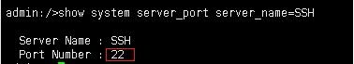

            - On the CLI of the storage system, run the change system server_port server_name=SSH port_num=** command to change the SSH port number. In the command, port_num indicates the new SSH port number you want to use. Figure 15-16 shows an example.
              - Changing the SSH port number
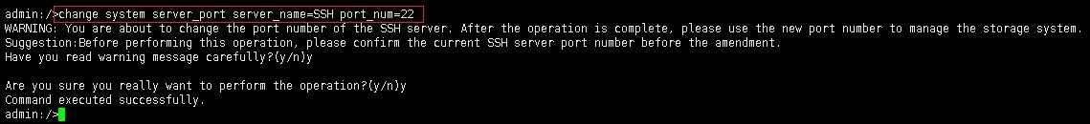

----End

How Can I Collect Storage System Information If the System Is Abnormal?
Question
How can I collect storage system information if the system is abnormal?
Answer
If the system is abnormal, contact Huawei technical support engineers to collect storage system information. As shown in Figure 15-17, if both Health Status and Running Status are Normal, the system is normal. Otherwise, the system is abnormal.
              - Device in the normal state
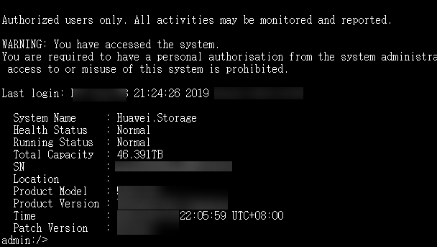

How Can I Ignore the Failed Step During the Upgrade and Proceed with the Subsequent Procedure?
Question
Can I ignore the failed step and proceed with the subsequent procedure when an exception occurs during the upgrade? How can I ignore it?
Answer
If the upgrade is suspended due to an exception, enter the minisystem and run the upgrade.sh -i command to ignore the failed step and retry the upgrade.


If you ignore the failed step and continue the upgrade, the varying risks from different failures require evaluation of Huawei technical support engineers. Only when the risks are acceptable, you can continue the upgrade. Do not perform any operations without evaluation.
          - If you ignore the step of uploading firmware XX and continue the upgrade, upgrading the firmware may fail.
          - If you ignore the steps of upgrading firmware XX and continue the upgrade, the firmware version check may fail or software and hardware compatibility issues may occur after the upgrade and restart.
          - If you ignore the step of checking redundant host links and continue the upgrade, services may be interrupted during the upgrade.
          - If you ignore the step of notifying the system of logging off controllers and continue the upgrade, services may be interrupted during the upgrade.
          - If you ignore the step of upgrading the system and continue the upgrade, the system may fail to start because the system software is not upgraded or the upgrade is abnormal.
          - If you ignore the step of restarting the controller and continue the upgrade, the re-upgrade may fail or services may be interrupted.
          - If you ignore the steps of checking disk link status, host multipathing status, and system mirroring status, and continue the upgrade, the upgrade may fail or services may be interrupted.
How Can I Ignore the Failed Step?
            - Use the SSH tool to log in to a controller and run the change user_mode current_mode=developer command to enter the developer mode, as shown in Figure 15-18.
              - Entering the developer mode
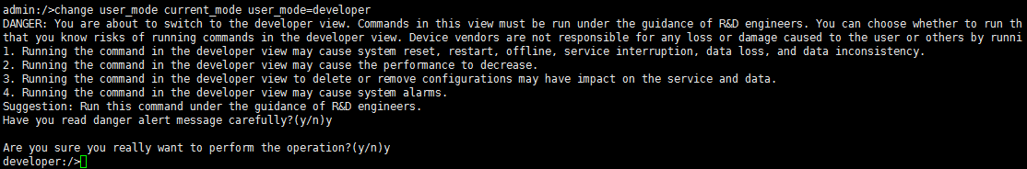

            - Run the minisystem command to enter the minisystem, as shown in Figure 15-19.
              - Entering the minisystem
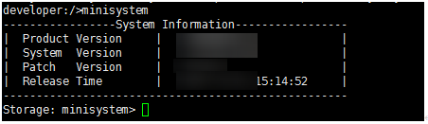

            - Run the upgrade.sh -f command to view the failed steps, as shown in Figure 15-20.
              - Viewing the failed steps

You can run the upgrade.sh -a command to view all supported commands.
            - Run the upgrade.sh -i [nodeId] [stepname] command to ignore the upgrade failure of nodeId and continue the upgrade. In this example, run the upgrade.sh -i 0 A_UploadFwAgtFlow.UploadEncStep command to ignore the UploadEncStep failed step of node 0 (controller 0A), as shown in Figure 15-21.
              - Ignoring the failed step of upgrading the enclosure of node 0
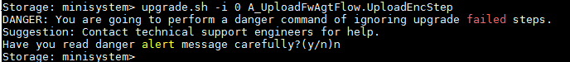

            - On SmartKit, click Details in the Status column on the Upgrade page and then click Retry to continue the upgrade, as shown in Figure 15-22. Alternatively, run the change upgrade flow resume_type=retry command on the CLI to retry the upgrade, as shown in Figure 15-23.
              - Details dialog box
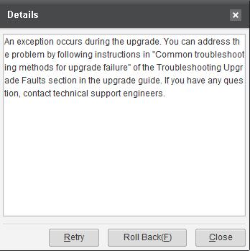

              - Retrying the upgrade on the CLI
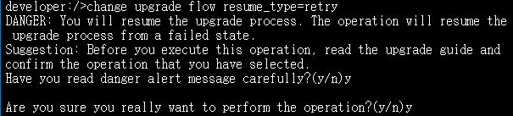

----End

How Can I Forcibly Upgrade the Storage System?
Question
How can I forcibly upgrade the storage system?

This approach is highly risky. Do not perform it without the guidance of Huawei technical support engineers.
Answer
            - Log in to any controller of an enclosure as user admin. On the CLI, enter the minisystem and run upgradesystem. The system prompts you to upload the upgrade package and enter the package name, as shown in Figure 15-24.
              - Running upgradesystem
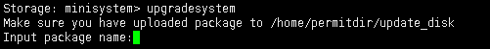

            - Use an FTP/SFTP tool to upload the upgrade package to the /home/permitdir/update_disk directory of the controller. Then, enter the package name and press Enter. Enter y to start the upgrade, as shown in Figure 15-25.
              - Entering the package name for upgrade
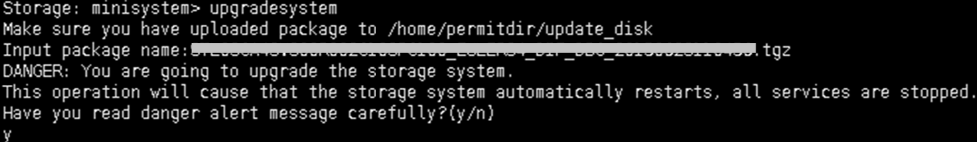

            - After the upgrade, use the power button to restart each enclosure. The upgrade is complete.
----End

What Can I Do If Multiple Check Items Fail During a Pre-upgrade Check?
Question
What can I do if multiple check items fail during a pre-upgrade check?
Answer
The possible cause is that the login user has opened four debug windows. Locate the problem as follows:
Log in to the storage system on the CLI. Run the change user_mode current_mode user_mode=developer command to enter the developer mode. Run the debug command to check whether the storage system can enter the debug mode.
If the storage system can enter the debug mode, as shown in Figure 15-26, the failure is not caused by debug windows. In this case, rectify the failed items one by one or contact Huawei technical support engineers for troubleshooting.
              - The storage system can enter the debug mode
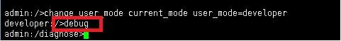

If the storage system cannot enter the debug mode, as shown in Figure 15-27, the failure is caused by debug windows. Run the exit command to close all the debug windows and retry the upgrade. If the upgrade fails again, contact Huawei technical support engineers for troubleshooting.
              - The storage system cannot enter the debug mode
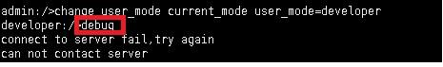

How Do I Query Major or Critical Alarms That Have Been Deleted Manually?
Question
How do I query major or critical alarms that have been deleted manually?
Answer
            - Run the show event|filterRow column=ID predict=equal_to value=0x100F00CF0027 command to filter all operation logs generated when the user clears alarms, as shown in Figure 15-28.
              - Filtering all operation logs generated when the user clears alarms

            - Based on the sequence of alarm deletion obtained in step 1, run the show event sequence command to view alarm details. Confirm the major and critical alarms only, as shown in Figure 15-29.
              - Viewing deleted alarms using the operation logs
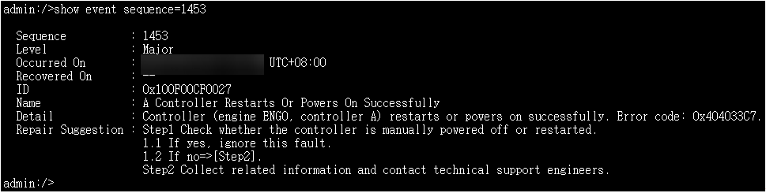

----End

What Can I Do If the Front-End Link Redundancy Check Fails During the Upgrade?
Question
What can I do if the front-end link redundancy check fails during the pre-upgrade check or controller rolling upgrade?
Answer
The possible causes of the front-end link redundancy check failure are as follows:
            - The links between the host and each controller of the storage system do not meet the rolling upgrade requirements. If the upgrade continues, host services will be interrupted.
            - In specific scenarios, for example, when the host delivers no I/O, the host does not automatically restore the links to the controllers. As a result, the links do not meet the upgrade requirements after a controller is upgraded and restarted.
            - Log in to DeviceManager and choose Insight > Alarms and Events. Check for an alarm indicating no redundant path from the host to the storage system.
- If such an alarm exists, clear the alarm according to the handling suggestions.
- If the alarm does not exist, go to Step 2.
            - Choose Services > Hosts and click the name of the host that fails the check. On the displayed host information page, click the Mapping tab and then click Path Details to check the host path information.
              - Viewing path details
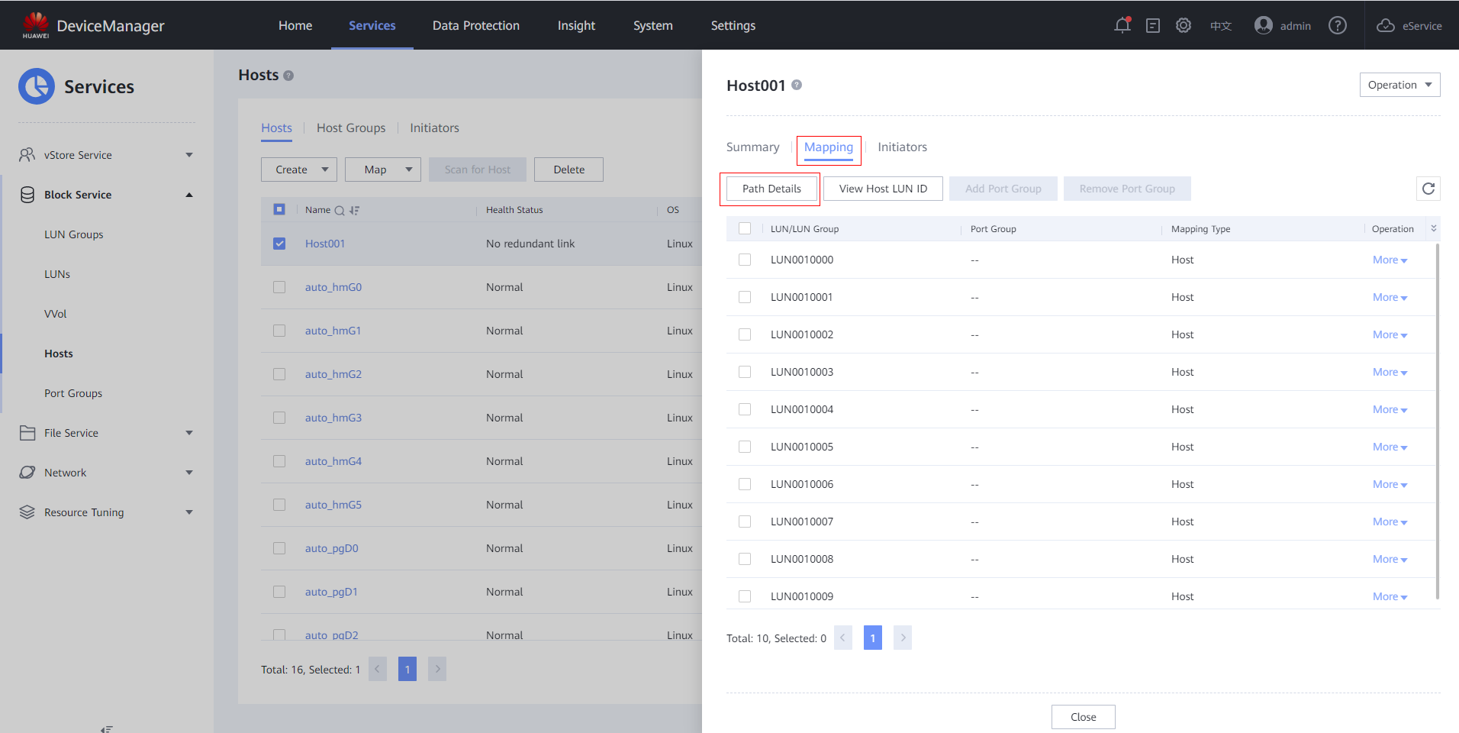

              - Host path information on a single controller enclosure with four controllers
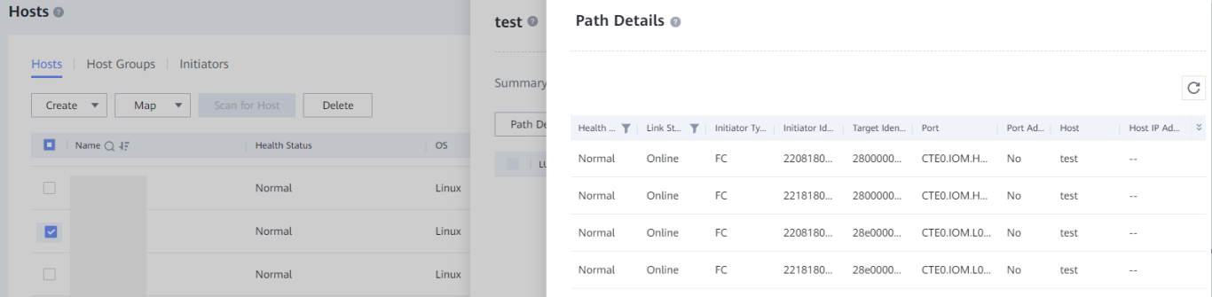

              - Host path information on a single controller enclosure with two controllers
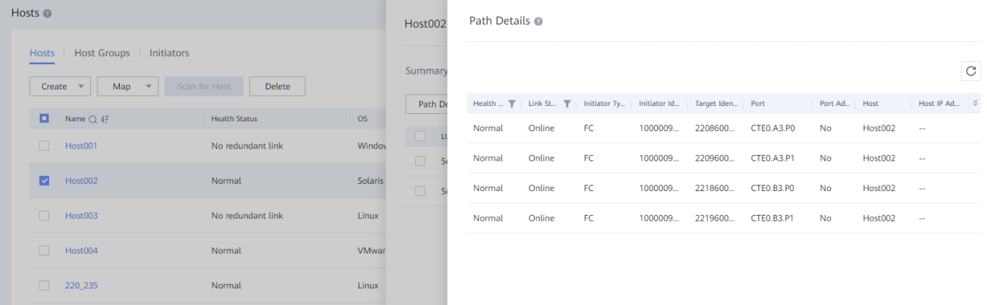

Under the default upgrade batches, if the ports of each host's paths whose Health Status is Normal and Link Status is Online meet the following conditions, the paths are redundant. Otherwise, the paths are not redundant.
- If each controller enclosure has four controllers, there are at least two ports with different port names. For example, if the port names of two paths are CTE0.IOM.H13.P0 and CTE0.IOM.L13.P0 respectively, each interface module in slots H13 and L13 of the controller enclosure CTE0 has a path to the host, and therefore the paths are redundant.
- If each controller enclosure has two controllers, there are at least one port with A in its name and one port with B in its name. For example, if the port names of two paths are CTE0.A.IOM1.P3 and CTE0.B.IOM1.P3 respectively, controllers A and B on CTE0 each have a path to the host, and therefore the paths are redundant.
- If the paths are not redundant, go to Step 3.
- If the paths are redundant, check the next host.
            - If the paths to a host are not redundant, perform the following operations:
- Check the connections between the host and controllers. If any cable is loose or removed, reconnect the cable.
- On DeviceManager, choose System > Hardware and check whether the service ports of the controllers are normal.
- Log in to the host and use the multipathing software to check the paths.
            - Rectify the fault and perform the upgrade again. If you cannot locate or rectify the fault, contact Huawei technical support engineers for troubleshooting.
----End

How Can I Check the Compatibility of Hosts Running Non-mainstream Operating Systems?
This section describes how to check the compatibility of hosts running non-mainstream operating systems other than VMware, Windows, Linux, Solaris, HP-UX, and AIX.
Question
The current host compatibility evaluation tool can only evaluate hosts running VMware, Windows, Linux, Solaris, HP-UX, and AIX. If the host connected to the storage system runs an operating system other than these mainstream ones, how can I evaluate host compatibility?
Answer
If the operating system of the host is not VMware, Windows, Linux, Solaris, HP-UX, or AIX, perform the following operations to check the host:
- Perform basic connectivity check by referring to 16.1.1 Testing Host Connectivity.
- If the Oracle database is installed on the host, check the Oracle heartbeat timeout parameters by referring to 16.1.4 Checking the Oracle Heartbeat Parameter.
- Check whether the connections between the host and storage controllers meet the rolling upgrade requirements:
  - At least one available link exists between the host and a batch of controllers with even IDs (controllers XA and XC in a single-engine four-controller device and controller XA in a single-engine dual-controller device).
  - At least one available link exists between the host and a batch of controllers with odd IDs (controllers XB and XD in a single-engine four-controller device, and controller XB in a single-engine dual-controller device).

How Can I Ignore the Pre-Upgrade Check Items and Continue the Upgrade?
This section describes how to ignore check items when the pre-upgrade check (performed by the controller restart tool or the array upgrade tool) fails and the failure can be ignored.
Question
Before the upgrade, if the controller restart tool is used to restart controllers or the array upgrade tool is used to upgrade the storage array, a check item fails. After analysis by Huawei technical support engineers, the check item can be ignored. How to perform the operation?
Answer

Before ignoring a check item, ensure that the check item is evaluated by Huawei technical support engineers. In addition, ensure that the check item does not affect host services or cause upgrade failure after being ignored. Do not ignore it without permission. Otherwise, unexpected serious results may occur.
In the following figure, the system information fails to be verified during the restart of controllers.
              - Failed to verify the system information
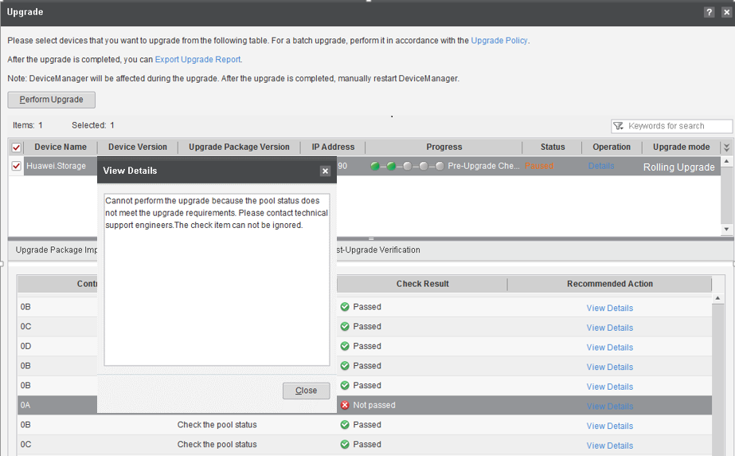

            - Go to the \tools\ArrayUpgrade directory in the tool installation directory. Open the ignoreitem.txt file, as shown in Figure 15-34. Find the option corresponding to the failed item and change the parameter to yes, as shown in Figure 15-35.
              - Going to the installation directory of the controller restart tool
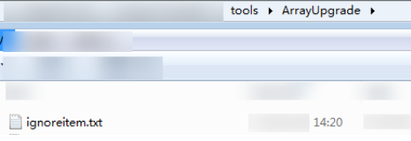

              - Change parameters of the failed item
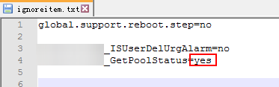

            - On the controller restart tool page, click Retry, as shown in Figure 15-36.
              - Retry
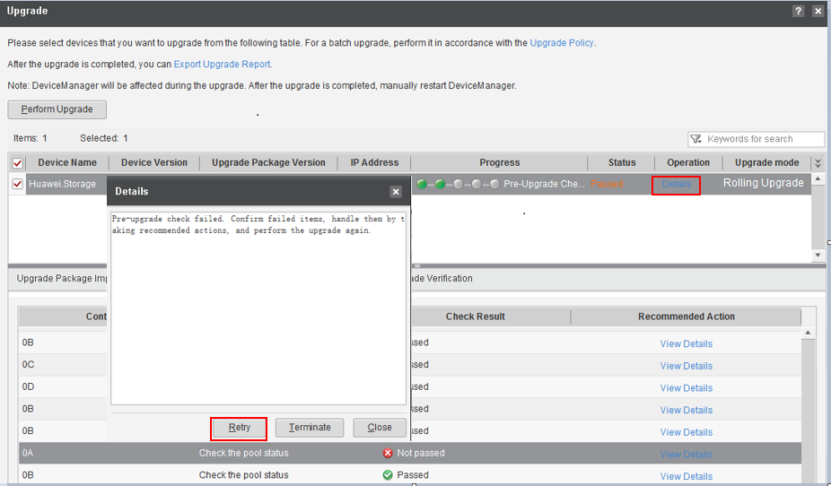

            - After the retry, the check item can be ignored. Click Ignore to continue the restart process.
              - Ignoring the failed item
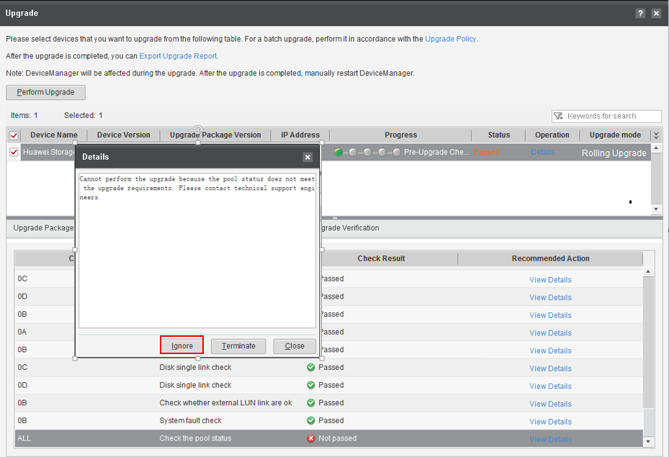

----End

What Can I Do When the Host HBA or iSCSI Timeout Parameter Does Not Pass the Check and Cannot be Modified?
Question
In some cases, the host HBA or iSCSI timeout parameter cannot be checked or modified. Can I continue the upgrade?
Answer
If the host does not use UltraPath 8.01.000 or later, the time for host I/O path switchover depends on the timeout parameter of the Fibre Channel HBA or iSCSI initiator when a controller resets during the controller software upgrade. If the timeout period is too long for the host software to tolerate, services on the host may be interrupted for a duration approximately equal to the timeout period set for the HBA or iSCSI initiator.
If the HBA or iSCSI timeout parameter cannot be checked or modified, check the following before continuing the upgrade:
- In the current HBA configuration, the storage controller failure test has been performed. Failure of multiple controllers does not interrupt host services, or the impact on I/Os upon multiple controller failures is acceptable.
- If the Oracle software is installed on the host, check the heartbeat parameters by referring to 16.1.4 Checking the Oracle Heartbeat Parameter. If the Oracle ASM parameter does not meet the rolling upgrade requirements, the parameter is modified according to the modification method.

- If the Oracle software is installed on the host, you must perform the operations in 16.1.4 Checking the Oracle Heartbeat Parameter.
- If the Oracle software is not installed on the host but you are not sure whether the I/O timeout during the upgrade affects host services, it is strongly recommended that you modify the HBA or iSCSI timeout parameters by referring to the troubleshooting cases of the host compatibility evaluation tool.

How Do I Run CLI Commands to Perform the Kernel and Firmware Upgrade?
Question
How do I run CLI commands to perform the kernel and firmware upgrade?
Answer
            - Log in to the storage system as user admin through the SSH client and run the change user_mode current_mode user_mode=developer command to go to the developer mode, as shown in Figure 15-38.
              - Entering the developer mode
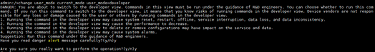

            - Run the following command in the developer mode: create upgrade session session=kernel configuration_data_path=xx.dat license_path=xxx.dat ip=xx.xx.xx.xx user=admin password=******.
Parameter description:
- session: indicates the upgrade type. Enter kernel for the kernel upgrade.
- configuration_data_path: indicates the backup path for the configuration file of the source version. The path must be a system disk path, for example, /OSM/coffer_data/update.
- license_path: indicates the license backup path of the source version. The path must be a system disk path, for example, /OSM/coffer_data/update.
- ip: indicates the management IP address of the current storage system, that is, the IP address used for logging in to the current storage system.
- user: indicates the user name for logging in to the current system.
- password: indicates the password for logging in to the current system.
For example, run the create upgrade session session=kernel configuration_data_path=/OSM/coffer_data/update/config.dat license_path=/OSM/coffer_data/update/license.dat ip=100.100.100.100 user=admin password=****** command, as shown in Figure 15-39.
              - Running the upgrade command

            - After the upgrade package is downloaded, the system prompts you to select the upgrade mode, as shown in Figure 15-40.
              - Selecting an upgrade mode
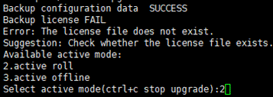

Description of upgrade modes:
- 2.active roll: rolling upgrade (online upgrade)
- 3.active offline: parallel upgrade (offline upgrade)
If a rolling upgrade is required, type 2 and press Enter. If a parallel upgrade is required, type 3 and press Enter.

To perform a parallel upgrade, ensure that no host service is configured for the storage system or host services have been stopped and the related host is disconnected from the storage system. If host services are running, services will be interrupted during the upgrade. In addition, exceptions such as drive letter changes and file system faults may occur. Ensure that you are aware of the risks in advance.
After you select the upgrade mode, the pre-upgrade check is automatically started. After the pre-upgrade check is complete, the upgrade is automatically performed without the need of manual intervention, as shown in Figure 15-41.
              - Starting the upgrade
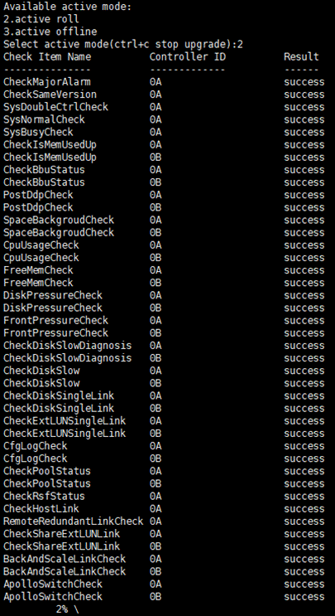

- As shown in the preceding figure, after the pre-upgrade check is complete, the system enters the upgrade state. In this case, do not perform any configuration operations on the CLI or DeviceManager.
- For an offline upgrade, if the progress reaches 57%, all controllers will be restarted.
- For an online upgrade, controllers will be upgraded and restarted in batches.
- After a controller is restarted successfully, you need to log in to the CLI again to query the upgrade progress or log in to another controller that is running properly during a rolling upgrade.
            - Open a new CLI window, as shown in Figure 15-42. Run the show upgrade status command to view the upgrade progress and status, as shown in Figure 15-43.
              - Upgrade view
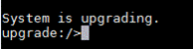

              - Querying the upgrade status
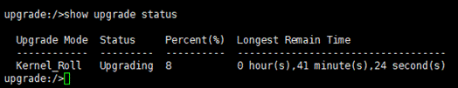

            - If Status is Success and Percent is 100, the upgrade is successful.
If Status is not Success or Upgrading, an exception occurs during the upgrade. Rectify the fault by referring to 14.1 Common Troubleshooting Methods for an Upgrade Failure.
----End

How Do I Perform a Fast Upgrade Using DeviceManager?

- Only OceanStor Dorado 2000, 3000, 5000, 5300, 5500, 5600, 5600K, and 6000 support this function.
- Only fast upgrade is supported.
- This method is applicable when SmartKit cannot be installed.
- The current version is 6.1.0 or later.
Preparations
Download the software package and check item component package by referring to 3 Preparations.
You only need to download the latest check item component package SmartKit_VxRxCxxRCx_Dorado_UpgradePreCheck.tar.gz from the SmartKit catalog on the support website.
Upgrading Procedure
            - Log in to DeviceManager (https://Storage array management IP address:8088).
              - Logging in to DeviceManager
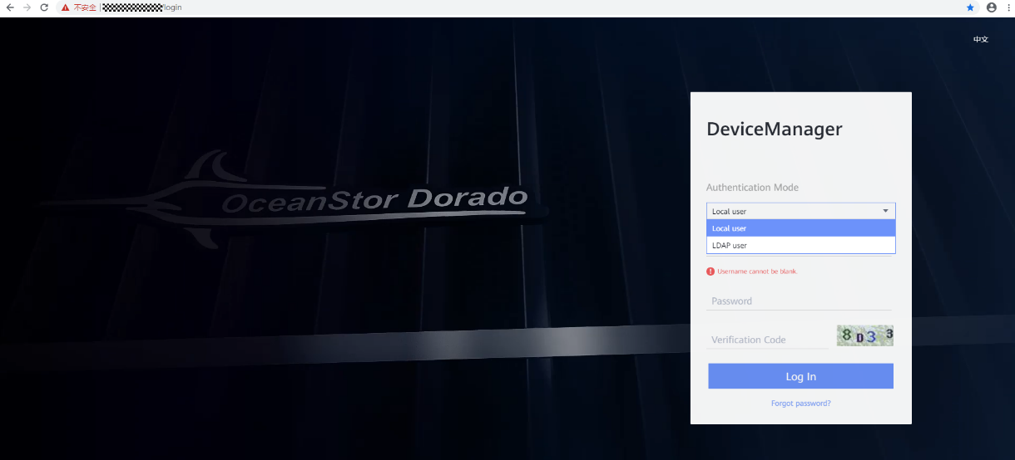

            - On the home page, click and choose Upgrade.
              - DeviceManager home page
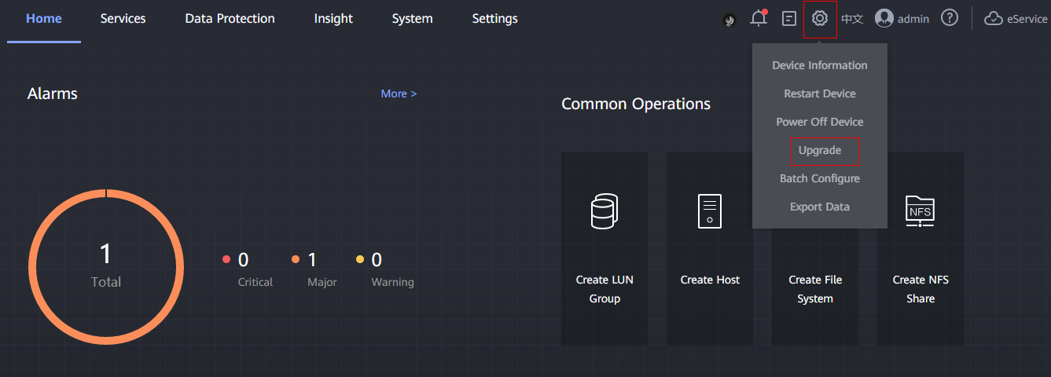

            - On the Upgrade page, select System Upgrade.
              - Selecting system upgrade
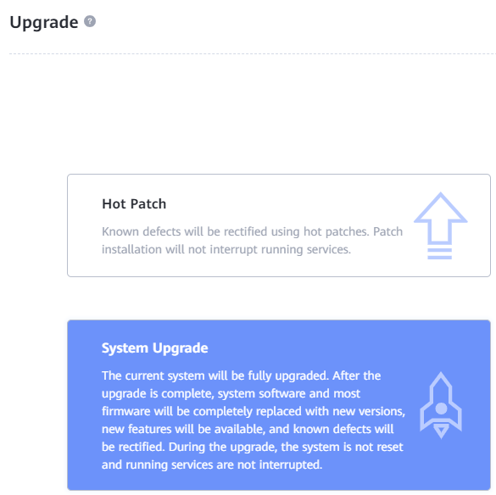

            - Select the check item component package SmartKit_VxRxCxxRCx_Dorado_UpgradePreCheck.tar.gz and click Upload.
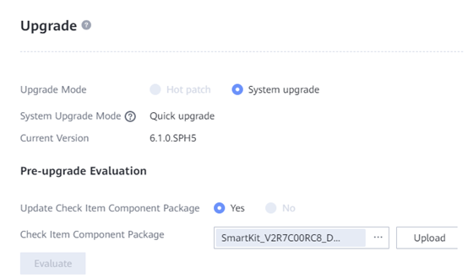
            - Click Evaluate. The Pre-upgrade Evaluation page is displayed.
              - Pre-upgrade evaluation
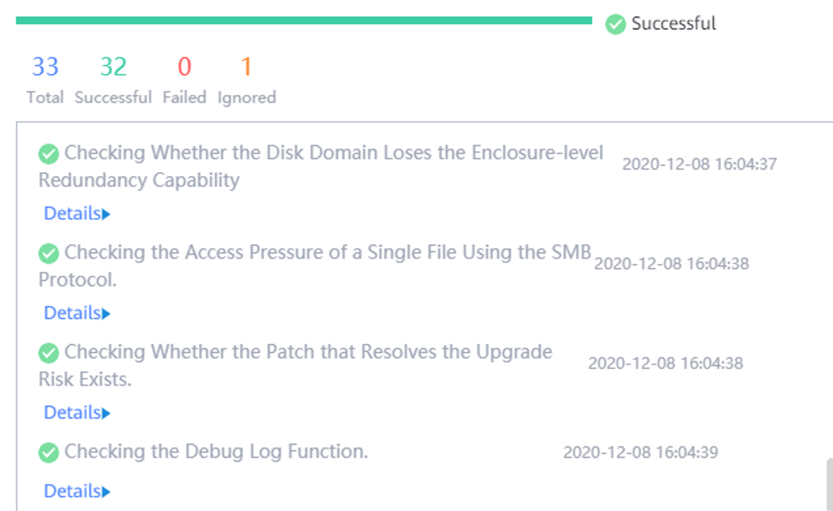

            - Back up the license and configuration database.
              - Exporting backup data
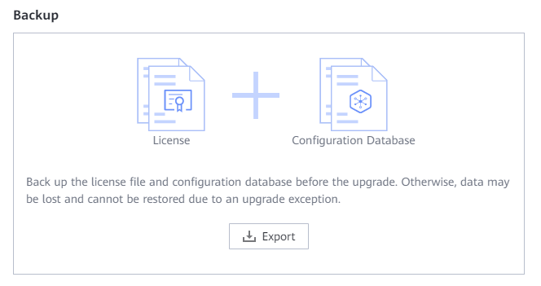

Click Export to export backup data.
              - Backup data exported successfully
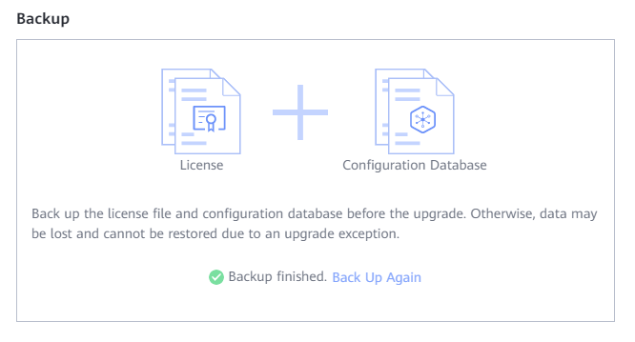

            - Click in the Upgrade Package field to select the upgrade package of the target version and click Upload.
              - Uploading the upgrade package of the target version
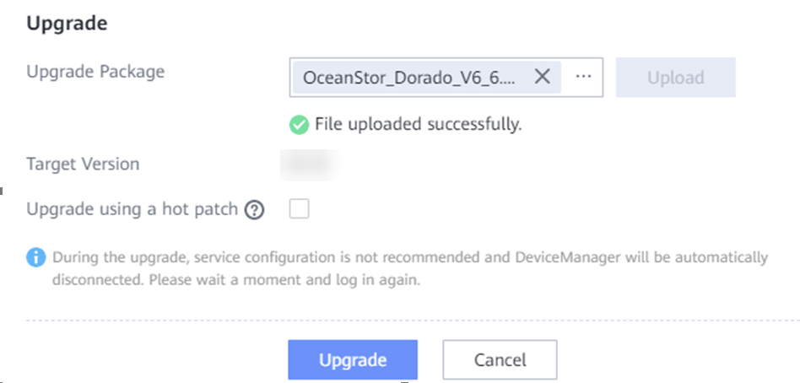
            - Select Upgrade using a hot patch and upload the hot patch package of the target version.
            - Click Upgrade. The pre-upgrade check starts.
              - Pre-upgrade check
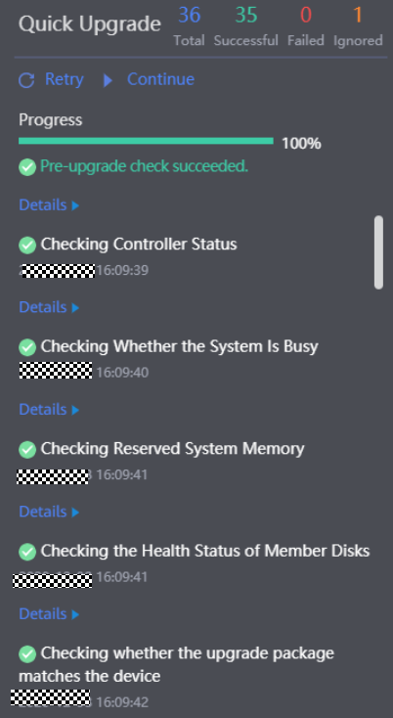

            - After the pre-upgrade check is complete, click Continue to start the upgrade.
              - Upgrade process
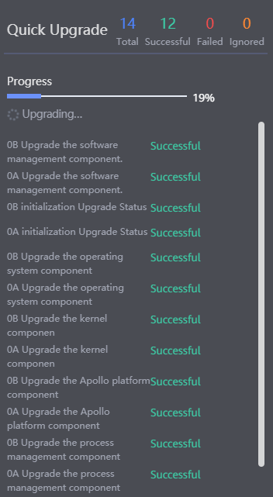

- After you click Continue, the upgrade process is automatically executed and no manual operations are allowed until the upgrade is complete. Ensure that all preparations are done before you click Continue.
- If an exception occurs during the upgrade, the upgrade is automatically suspended, and you can click Retry or Roll Back.
- If DeviceManager is disconnected during the upgrade, log in again.
            - After the upgrade is complete, click Finish.
              - Post-upgrade verification
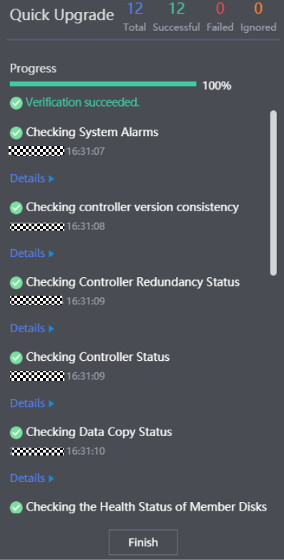

If an exception occurs during the upgrade, rectify the fault by referring to 14.1 Common Troubleshooting Methods for an Upgrade Failure.
----End

Why Is the Performance Data Displayed During the Upgrade Inaccurate?
Question
Why is the performance data displayed on DeviceManager inaccurate during the upgrade?
Answer
During the system upgrade, storage software is upgraded in batches, which means some software may have been upgraded while the others may have not. As a result, some performance indicators cannot be collected and the performance data is inaccurate. After the upgrade is complete, the performance data restores to normal.

How Can I Configure Upgrade Batches?
Question
What are configurable upgrade batches? How can I configure upgrade batches?
Answer
To meet customer needs, you can customize upgrade batches to perform online upgrades, including how many batches there are in an upgrade and what controllers are there in each batch.
- Consider the device networking information when you determine the number of batches in an upgrade. Contact technical support engineers in deciding the batch policy.
- The master node must be upgraded in the last batch. You can run show controller general on the CLI to view the master node.
- Controllers A and B, and controllers C and D of any engine cannot be configured in the same batch.
The way to configure upgrade batches is described as follows:
- 6.1.6 supports customized upgrade batches by running commands.
- Versions earlier than 6.1.6 support customized upgrade batches by using SmartKit.
Using SmartKit:
- Manually create the UpgradeFile.xml file in Huawei SmartKit\tools\ArrayUpgrade. The default installation directory of SmartKit is C:\.
- Add upgrade batch information in UpgradeFile.xml as follows:
UpgradeFile.xml:
<Upgrade>
<Batch>3</Batch>
<NodeList>1A;0B,1B,2B,3B;0A,2A,3A</NodeList>
</Upgrade>
The <Batch></Batch> field specifies the number of upgrade batches. The <NodeList></NodeList> field specifies upgrade batch information. Different batches are separated with semicolons (;). Controllers in each batch are separated with commas (,). In the following figure, for example, Batch=3 indicates three upgrade batches, and NodeList=1A;0B,1B,2B,3B;0A,2A,3A indicates that controller 1A is upgraded in the first batch, controllers 0B, 1B, 2B, and 3B are upgraded in the second batch, and controllers 0A, 2A, and 3A are upgraded in the third batch.
A controller is named in the format of digit+letter. The digit indicates the engine ID in the cluster, and the letter indicates the controller ID in the corresponding engine. For example, 0A indicates controller A in engine 0.
- Use SmartKit to perform an online upgrade. During the upgrade, SmartKit checks whether UpgradeFile.xml exists. If UpgradeFile.xml exists, SmartKit performs the upgrade based on the batch information in the file. For details about how to use SmartKit to perform an online upgrade, see section 5.6 Upgrading Controller Software.
- Restart SmartKit for the configuration file to take effect.

After completing the upgrade, delete UpgradeFile.xml to prevent any adverse impact on the next upgrade.
Using the command:
Run the upgrade.sh -B set nodeid[,nodeid] nodeid[,nodeid] command in the minisystem. For example:
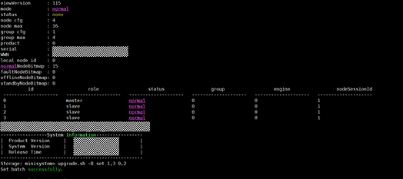

The command setting takes effect only once and only needs to be executed on one controller.

How Do I Obtain and Manually Import the CA Certificate for Disk Authentication to the Storage Array?
Question
How do I obtain the CA Certificate?
Answer
            - Download the root CA certificate. Go to Huawei certificate official website, set Type to Root CA, search for Huawei Equipment Root CA.pem, and download it, as shown in Figure 15-54.
              - Downloading the root CA certificate
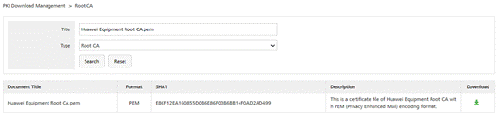

            - Download the level-2 CA certificate. On the search page in step 1, set Type to Level-2 CA Certificate, search for Huawei IT Product CA, and download it, as shown in Figure 15-55.
              - Downloading the level-2 CA certificate
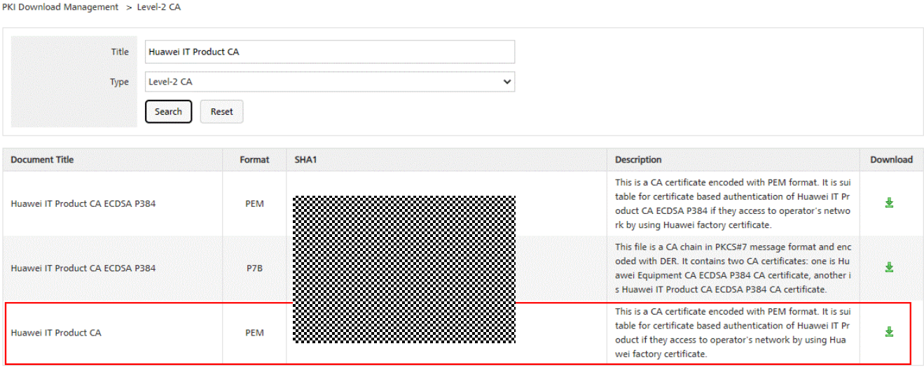
            - Combine the certificate. Open Huawei Equipment Root CA.pem and Huawei IT Product CA in TXT format, cut the content of Huawei IT Product CA under Huawei Equipment Root CA.pem, and combine them into a new CA certificate, as shown in Figure 15-56.
              - Combined CA certificate


            - Change the combined file name. Rename Huawei Equipment Root CA.pem as HDA_DefaultCACert.crt. HDA_DefaultCACert.crt is the CA certificate for disk authentication to be imported.
----End
Method 1: Manually Import Using the CLI
            - Upload the certificate to be imported to the /home/permitdir directory of the storage array through SFTP.
            - On the CLI, run the import certificate ip=? user=? password=? type=disk_authentication ca_cert_file=? use=Default command. After the command is executed successfully, the certificate is imported successfully.

- Parameter ip in the CLI is the IP address of the storage array in step 1.
- Parameter user in the CLI is the super administrator account of the storage array. Do not use other accounts.
- Parameter password in the CLI is the password of the user parameter.
- Parameter ca_cert_file in the CLI is the absolute path for storing the certificate in step 1.
- In a multi-controller environment, you only need to run the command on any node once. After the command is executed successfully, the corresponding certificate is imported to all nodes.
----End
Method 2: Manually Importing Using DeviceManager
After logging in to DeviceManager, choose Settings > Certificate and upload a file to import the CA certificate for disk authentication. During the import, set Sub-scenario to Default, as shown in Figure 15-57.
              - Importing the CA certificate for disk authentication on DeviceManager
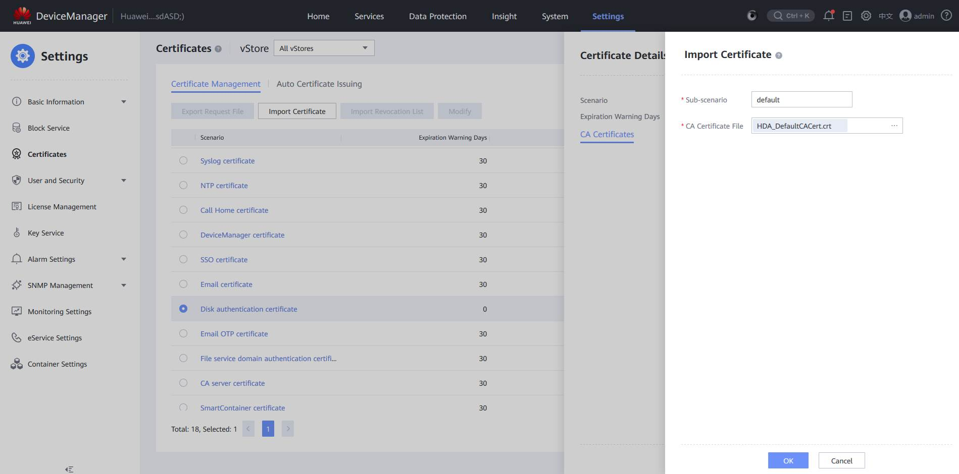

- On the Import Certificate page, set Sub-scenario to Default, which has the same effect as the CLI parameter use in method 1.
- In a multi-controller environment, you only need to run the command on any node once. After the command is executed successfully, the corresponding certificate is imported to all nodes.

How Can I Upgrade the Storage System If the Interface Modules Are Incompatible?
Question
How can I upgrade the storage system if the interface modules are incompatible?
Answer
- If the storage system version is 6.1.6, perform an upgrade by referring to "Kernel and Firmware Upgrade Procedure" in this document.
- If the storage system version is earlier than 6.1.6, perform an upgrade by referring to "Rolling and Parallel Upgrade Procedure" in this document.

Appendix
16.1 Checking Host Status
16.2 Default Batch Upgrade Policies
16.3 Obtaining the License File for the Target Version

Checking Host Status

Testing Host Connectivity
Before upgrading the storage system in rolling mode, log in to the Huawei IT open lab website and use the Huawei Storage Interoperability Navigator to query compatibility. Ensure that the host configuration is in the Huawei host compatibility list. Otherwise, services may be interrupted during the rolling upgrade of the storage system.
You can adjust the configuration by referring to the corresponding operating system's configuration guide.

Checking Host Multipathing Link Status
This section describes how to check the host multipathing link status before an upgrade to ensure that services are not affected during the upgrade.
Cause
Controllers of OceanStor Dorado 2000, 3000, 5000, 5300, 5500, 5600, 5600K, and 6000 are not fully interconnected. Rolling upgrade of controllers in batches will trigger link switchover. By default, controllers are upgraded in two batches by controller ID (for example, 0, 1, 2, or 3, which can be controllers 0A, 0B, 1A, and 1B in a single-engine four-controller device). One batch is controllers with odd IDs and the other batch is controllers with even IDs. During the upgrade and restart of each batch of controllers, ensure that there are available links between the other controllers and the hosts to prevent I/O interruption. Therefore, the links between multipathing and controllers must meet the following redundancy requirements:
- At least one available link exists between the host and a batch of controllers with even IDs (controllers XA).
- At least one available link exists between the host and a batch of controllers with odd IDs (controllers XB).
            - The preceding networking requirements are the minimum networking requirements for a rolling upgrade. To improve service reliability during the rolling upgrade, it is strongly recommended that there be available links between the host and each controller or there be available links between the host and a batch of controllers with odd IDs and between the host and a batch of controllers with even IDs in every engine.
            - To ensure that each LUN mapped to the host has redundant links, this section describes how to check link redundancy based on each LUN mapped to the host. If there are so many LUNs that the LUNs cannot be checked one by one, you can randomly select some LUNs to check their link redundancy after there are redundant links between the host and controllers.
            - This link redundancy check method described in this section applies only to Huawei UltraPath and multipathing software delivered by the system. If third-party multipathing software is used, perform a check by referring to the link check method provided by the third-party multipathing software and preceding networking requirements.

VMware ESX
This section describes how to check multipathing link redundancy for VMware ESX/ESXi.

Link Redundancy Check with Huawei UltraPath
            - Log in to the VMware ESX system and run the esxcli upadm show path command, as shown in Figure 16-1.
              - Querying path information on UltraPath
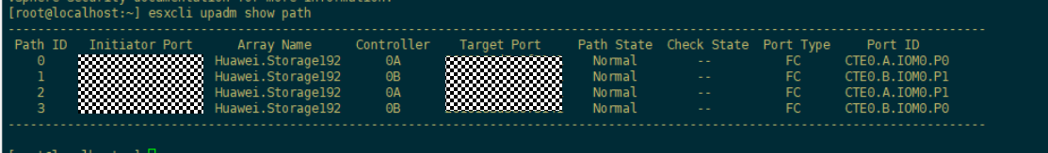

            - If an Array Name contains only paths of controller A or B, or contains only paths of the H or L plane, the storage paths are not redundant. If the storage paths are redundant, go to the next step.
            - Run the esxcli upadm show vlun command to view the Vlun ID field, as shown in Figure 16-2. If the VLUN information is not displayed, UltraPath does not take over any LUNs. In this case, refer to the link redundancy check method provided by VMware multipathing software. Otherwise, go to the next step.
              - Querying VLUN information
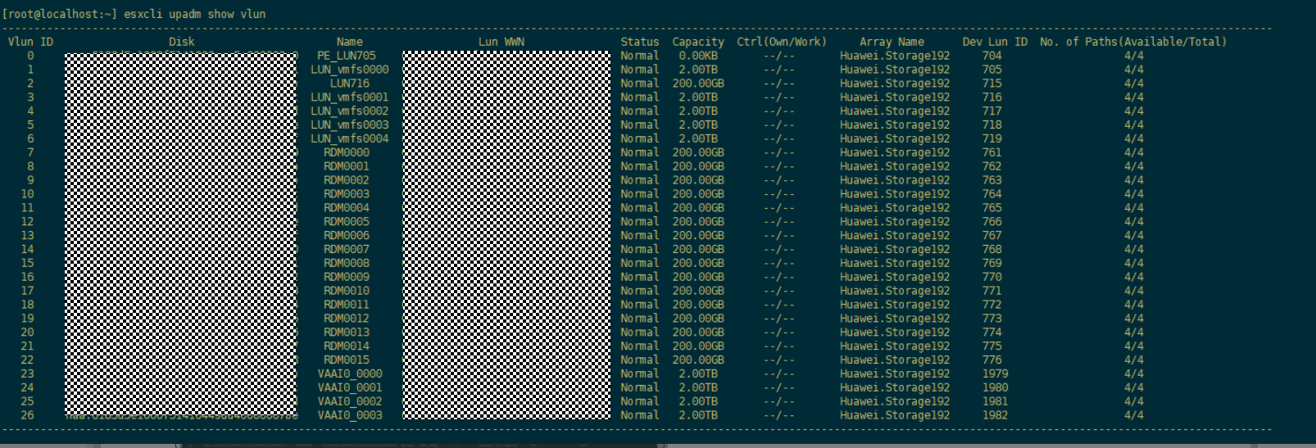

            - Run esxcli upadm show vlun -l <VLUN ID> -t all to query information about all LUN paths, as shown in Figure 16-3.
              - esxcli upadm show vlun -l -t all
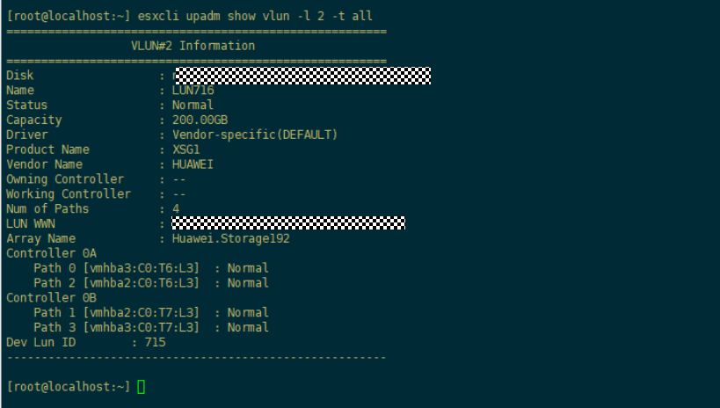

            - Determine whether the paths of each LUN are redundant based on the path information of each VLUN queried in Step 4 and the path redundancy queried in Step 1 and Step 2. In Figure 16-3, the LUN whose ID is 2 contains paths 0 to 3, all of which are in the Normal state and include both controllers A and B. This indicates that the VLUN paths are redundant.
----End

Link Redundancy Check with VMware Multipathing Software
            - Run the esxcfg-mpath -b | grep -E -i "huawei|huasy|symantec|hs|eisoo|udsafe|marstor|sanm|anystor|sugon|netposa" command to check whether Huawei disks exist, as shown in Figure 16-4. If no Huawei disk is found, the check is passed. Otherwise, go to the next step.
              - Viewing Huawei disk information
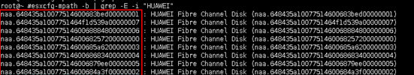

            - Run the esxcfg-mpath -b -d DeviceName command to obtain the path information of a specified LUN. Obtain the last column of the command output (WWPN of the array controller port).
              - Querying LUN path information

DeviceName is the naa.xxx information queried in Figure 16-4.
            - Convert each WWPN to a binary value and check the values of the 53rd to 56th bits and change the values into a decimal number. The value indicates the controller ID, such as controller 1 in Figure 16-6.
              - Calculating the controller ID
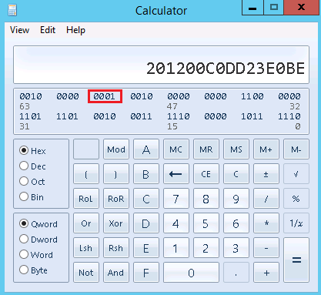

            - Based on the calculated controller ID, check whether each LUN has at least one available path to a batch of controllers with even IDs and a batch of controllers with odd IDs. If yes, a rolling upgrade can be performed; otherwise, a rolling upgrade is unavailable.
----End

Windows
This section describes how to check multipathing link redundancy on a Windows host.

Link Redundancy Check with Huawei UltraPath
            - Open the Command Prompt and run the upadmin show path command to query the path information of the storage system, as shown in Figure 16-7.
              - Querying path information on UltraPath
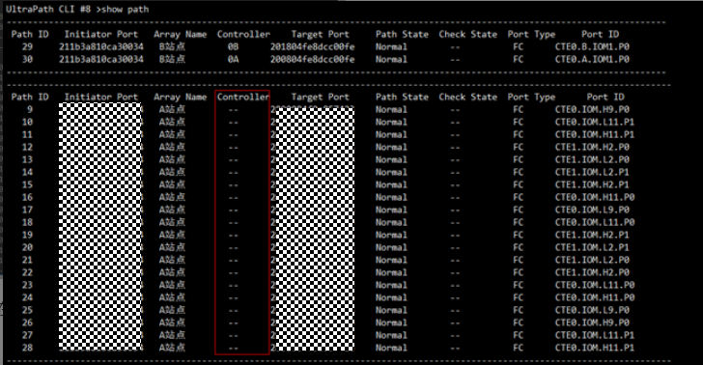

            - If an Array Name contains only paths of controller A or B (you can view the paths in the Controller column, for example, site B in Figure 16-7), or contains only paths of the H or L plane (for example, site A in Figure 16-7), the storage paths are not redundant. If the storage paths are redundant, go to the next step.
            - Run the upadmin show vlun type=all command to query the VLUN ID list, as shown in Figure 16-8.
              - Querying the VLUN ID list
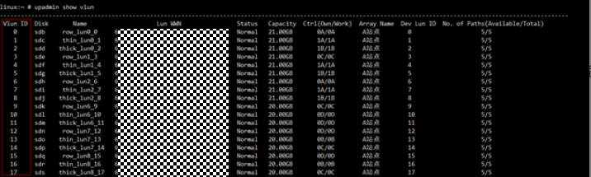

            - Run the upadmin show vlun id=VLUN ID type=all command for each VLUN ID in the list obtained in Step 3 to query the VLUN details, as shown in Figure 16-9.
              - Querying VLUN details
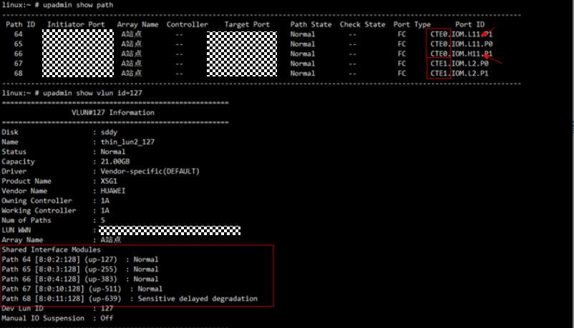

            - Determine whether the paths of each LUN are redundant based on the path information of each VLUN queried in Step 4 and the path redundancy queried in Step 1 and Step 2. In Figure 16-9, the LUN whose ID is 127 contains paths 64 to 68, among which paths 64 to 67 are in the Normal state and contain ports on both the H and L planes. This indicates that the VLUN paths are redundant.
----End

Linux
This section describes how to check multipathing link redundancy on a Linux host.

Link Redundancy Check with Huawei UltraPath
            - Log in to the Linux host and run the upadmin show path command to view the path information of the storage system, as shown in Figure 16-10.
              - Querying path information on UltraPath
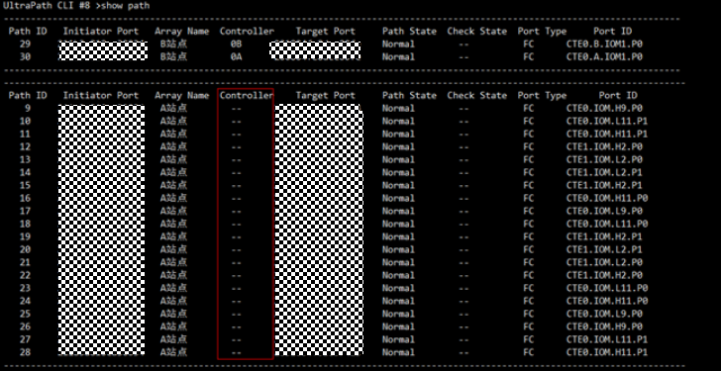

            - If an Array Name contains only paths of controller A or B (you can view the paths in the Controller column, for example, site B in Figure 16-10), or contains only paths of the H or L plane (for example, site A in Figure 16-10), the storage paths are not redundant. If the storage paths are redundant, go to the next step.
            - Run the upadmin show vlun type=all command to query the VLUN ID list, as shown in Figure 16-11.
              - Querying the VLUN ID list
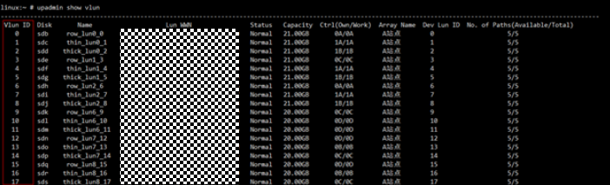

            - Run the upadmin show vlun id=VLUN ID type=all command for each VLUN ID in the list obtained in Step 3 to query the VLUN details, as shown in Figure 16-12.
              - Querying VLUN details
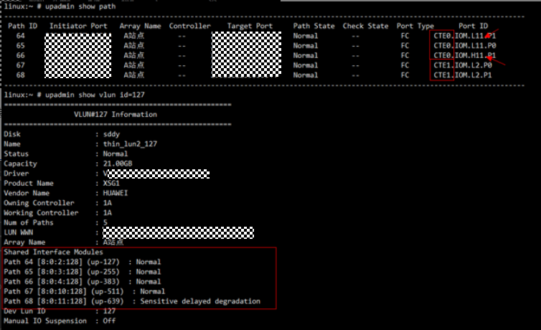

            - Determine whether the paths of each LUN are redundant based on the path information of each VLUN queried in Step 4 and the path redundancy queried in Step 1 and Step 2. In Figure 16-12, the LUN whose ID is 127 contains paths 64 to 68, among which paths 64 to 67 are in the Normal state and contain ports on both the H and L planes. This indicates that the VLUN paths are redundant.
----End

Link Redundancy Check with Linux Multipathing Software
            - Run the lsscsi command and obtain the target port ID reported by the disk array based on the first column in the command output. Check whether the disk mapped by Huawei storage exists based on the third column, as shown in Figure 16-13.
              - Viewing disk information by running lsscsi
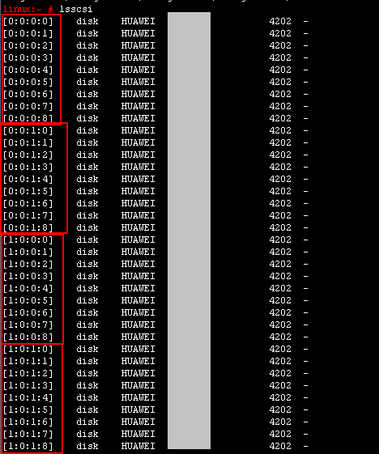

            - Check whether there are disks mapped by Huawei storage devices based on the information displayed in the third column. The following types of disks belong to Huawei storage devices (case insensitive): Huawei|huasy|symantec|hs|eisoo|udsafe|marstor|sanm|anystor|sugon|netposa. If no Huawei disk exists, skip this section.
            - After obtaining the Huawei disk list, classify the disks according to the first three digits in the first column. As shown in Figure 16-13, there are four types of disks: 0:0:0, 0:0:1, 1:0:0, and 1:0:1, indicating the port number of different targets reported by the storage device.
            - Run the cat /sys/class/fc_transport/targetX:X:X/port_name command (X:X:X is the first three digits in the first column obtained in the previous step, for example, 0:0:0, 0:0:1, 1:0:0, or 1:0:1) to query the array controllers whose targets are connected to the host. The query result is a hexadecimal port name (WWPN), as shown in Figure 16-14.
              - Querying port names

            - Convert each port name (WWPN) into a binary value, check the values of the 53rd to 56th bits, and convert the values into a decimal number. The converted number indicates the controller ID, such as controller 0 in Figure 16-15.
              - Calculating the controller ID
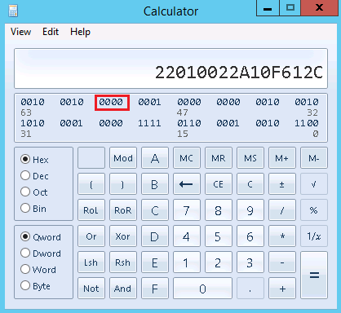

            - Based on the calculated controller ID, check whether each LUN has at least one available path to a batch of controllers with even IDs and a batch of controllers with odd IDs. If yes, a rolling upgrade can be performed; otherwise, a rolling upgrade is unavailable.
----End

Solaris
This section describes how to check multipathing link redundancy in a host running in Solaris.

Link Redundancy Check with Huawei UltraPath
            - Log in to the host and run the upadmin show path command to view the path information of the storage system, as shown in Figure 16-16.
              - Querying path information on UltraPath
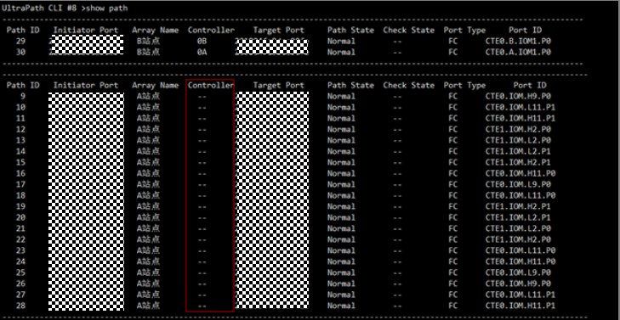

            - If an Array Name contains only paths of controller A or B (you can view the paths in the Controller column, for example, site B in Figure 16-16), or contains only paths of the H or L plane (for example, site A in Figure 16-16), the storage paths are not redundant. If the storage paths are redundant, go to the next step.
            - Run the upadmin show vlun type=all command to query the VLUN ID list, as shown in Figure 16-17.
              - Querying the VLUN ID list
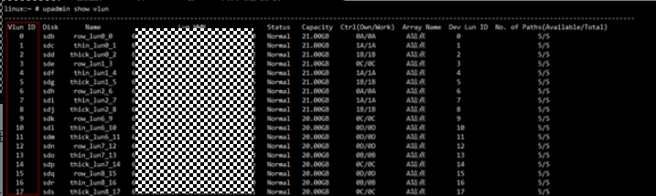

            - Run the upadmin show vlun id=VLUN ID type=all command for each VLUN ID in the list obtained in Step 3 to query the VLUN details, as shown in Figure 16-18.
              - Querying VLUN details
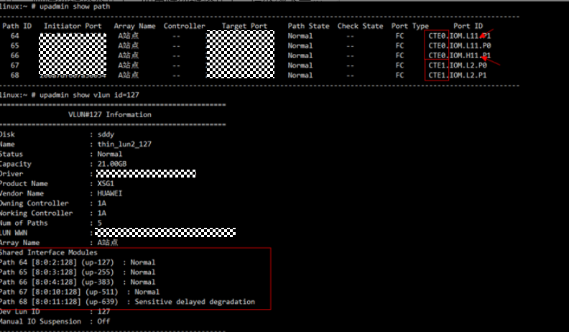

----End

Link Redundancy Check with Solaris Multipathing Software
            - Run the mpathadm list lu|grep rdsk command to obtain the disks managed by Solaris multipathing (STMS), as shown in Figure 16-19.
              - Obtaining disks managed by STMS
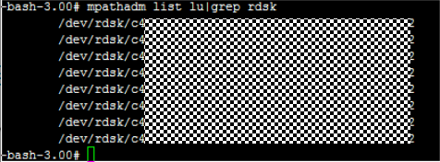

If the command output is empty, no disk managed by STMS exists. In this case, skip this section.
            - For each STMS disk, run the mpathadm show lu /dev/rdsk/XXXX command to check whether Vendor indicates Huawei disks, as shown in Figure 16-20.
              - Viewing disk details
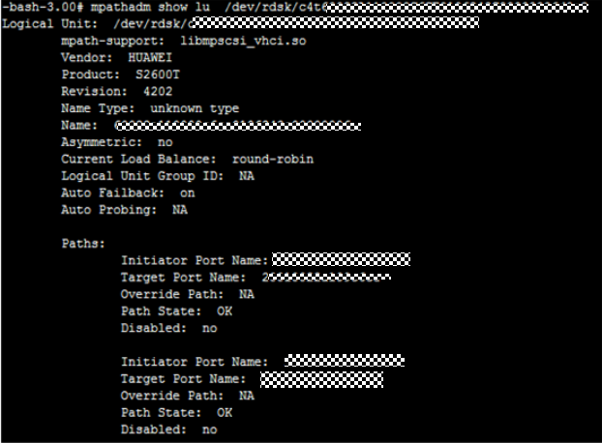

            - If the Vendor field is one of the following fields (case-insensitive), the disk is from Huawei: Huawei|huasy|symantec|hs|eisoo|udsafe|marstor|sanm|anystor|sugon|netposa.
            - If all disks are not Huawei disks, skip this section.
            - As shown in Figure 16-20, view each Target Port Name under Paths, convert each port name (WWPN) into a binary value, check the values of the 53rd to 56th bits, and convert the values into a decimal number. The converted number indicates the controller ID, such as controller 0 in Figure 16-21.
              - Calculating the controller ID

            - Based on the calculated controller ID, check whether each LUN has at least one available path to a batch of controllers with even IDs and a batch of controllers with odd IDs. If yes, a rolling upgrade can be performed; otherwise, a rolling upgrade is unavailable.
----End

HP-UX
This section describes how to check link redundancy with HP-UX multipathing software. Huawei UltraPath is not supported in HP-UX.

Link Redundancy Check with HP-UX 11i v1/v2 PVlinks
            - Log in to a host and run the uname -a command, as shown in Figure 16-22. The information in red indicates the system version, B.11.11 corresponds to HP-UX 11i v1, B.11.23 corresponds to HP-UX 11i v2, and B.11.31 corresponds to HP-UX 11i v3.
              - Checking the HP-UX system version
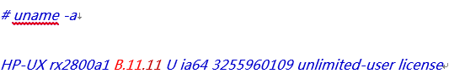

            - If the version is HP-UX 11i v1/v2, that is, B.11.11 or B.11.23, go to the next step. Otherwise, skip this section.
            - Run the ioscan -fnC fc command to obtain the H/W Path list of the current HP-UX HBA, as shown in Figure 16-23.
              - HBA H/W Path list
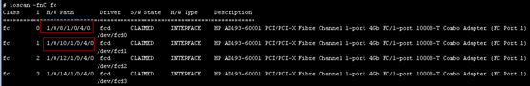

            - Run the ioscan -funC disk command to obtain the mapped disk device list. The obtained values of H/W Path are the same as those obtained in the previous step and Description contains HUAWEI device information, for example: /dev/dsk/c23t0d2, as shown in Figure 16-24.
              - Obtaining device information
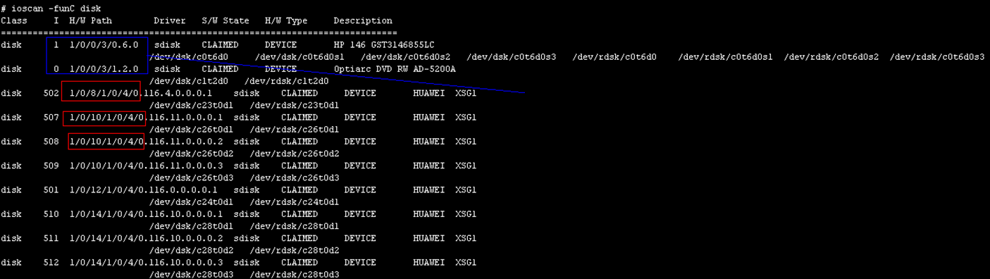

            - After obtaining the device information, run the pvdisplay xxx| grep 'PV Name' command. In the command, xxx indicates the device name obtained in the previous step, for example, /dev/dsk/c23t0d2. If the command output contains Alternate Link, the disk has no redundant links and no further check is required.
              - pvdisplay xxx| grep 'PV Name'
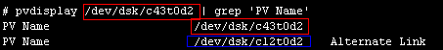

            - Run the fcmsutil /dev/xxx get remote all | grep 'Target Port Word Wide Name' command with the driver information obtained in Step 3. In the command, xxx indicates the driver name and is used to query information about the array targets connected to the port, as shown in Figure 16-26.
              - Array target information
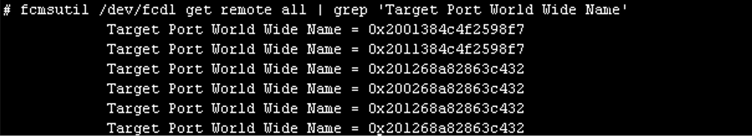

            - As shown in Figure 16-26, query each Target Port World Wide Name, convert each port name (WWPN) into a binary value, check the values of the 53rd to 56th bits, and convert the values into a decimal number. The converted number indicates the controller ID, such as controller 0 in Figure 16-27.
              - Calculating the controller ID

            - Based on the calculated controller ID, check whether each LUN has at least one available path to a batch of controllers with even IDs and a batch of controllers with odd IDs. If yes, a rolling upgrade can be performed; otherwise, a rolling upgrade is unavailable.
----End

Link Redundancy Check with HP-UX 11i v3 NMP
            - Log in to a host and run the uname -a command, as shown in Figure 16-28. The information in red indicates the system version, B.11.11 corresponds to HP-UX 11i v1, B.11.23 corresponds to HP-UX 11i v2, and B.11.31 corresponds to HP-UX 11i v3.
              - Querying the system version
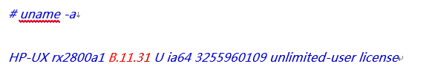

            - If the system is HP-UX 11i v3 (B.11.31), run the scsimgr get_attr -a leg_mpath_enable command to check whether NMP is installed and enabled, as shown in Figure 16-29. If both current and default are true, NMP is installed and enabled. Go to the next step; otherwise, end the check.
              - Checking whether NMP is installed and enabled
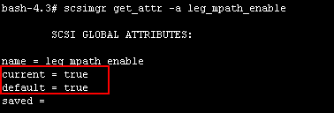

            - Run the ioscan -funNC disk command to obtain information about all disks on the host. HUAWEI and CLAIMED disks are obtained based on Description and S/W State, as shown in Figure 16-30.
              - Querying Huawei disks
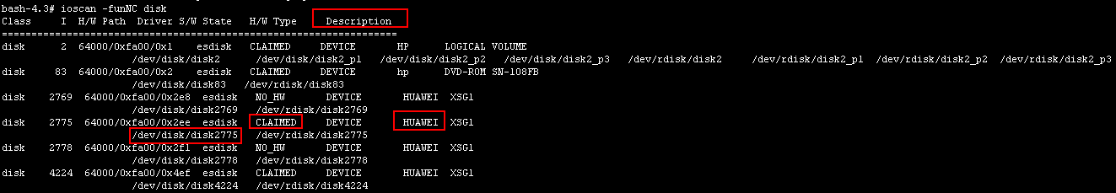

- If the Description field is one of the following fields (case-insensitive), the disk is from Huawei: Huawei|huasy|symantec|hs|eisoo|udsafe|marstor|sanm|anystor|sugon|netposa.
- If all disks are not Huawei disks, skip this section.
            - Run the ioscan -P health | grep lunpath command to obtain all online LUN WWPNs, as shown in Figure 16-31.
              - Obtaining the information about the online LUNs
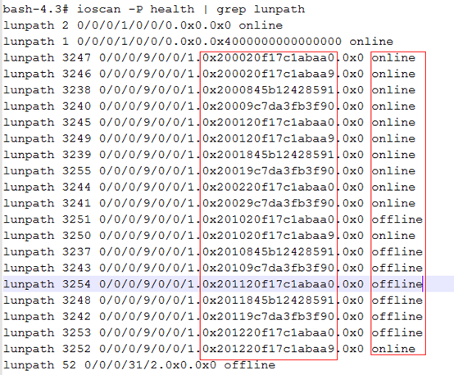

            - Run the scsimgr lun_map -D xxx command (xxx is the HUAWEI and CLAIMED disk obtained in Step 3) to obtain the disk path information, as shown in Figure 16-32.
              - Disk path information
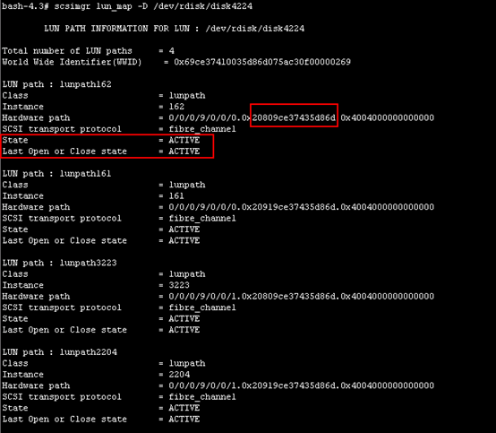

            - View each LUN path and convert the WWN of each Hardware path in every path whose State and Last Open or Close state are ACTIVE into a binary value. Check the values of the 53rd to 56th bits and convert the values into a decimal number. The number indicates the controller ID, such as controller 0 in Figure 16-33.
              - Calculating the controller ID

            - Based on the calculated controller ID, check whether each LUN has at least one available path to a batch of controllers with even IDs and a batch of controllers with odd IDs. If yes, a rolling upgrade can be performed; otherwise, a rolling upgrade is unavailable.
----End

AIX
This section describes how to check multipathing link redundancy in an AIX system. In an AIX system, the same link redundancy check method is used in UltraPath and AIX multipathing software.
            - Run the lsdev -Cc disk | grep FC command on the host to obtain the hdiskx disks taken over by the host, as shown in Figure 16-34.
              - Querying information about all disks on a host
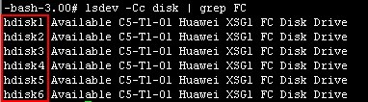

If no disk is found, the check is passed and no further check is required.
            - Run the lscfg -vpl hdisk1 command (hdisk1 is taken as an example) to obtain disk information. Check whether the disk is a Huawei disk based on the Manufacturer field and record the Huawei disk information, as shown in Figure 16-35.
              - Querying the disk manufacturer information
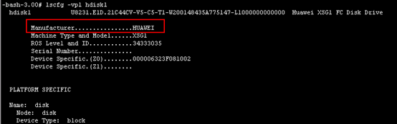

- If the Manufacturer field is one of the following fields (case-insensitive), the disk is from Huawei: Huawei|huasy|symantec|hs|eisoo|udsafe|marstor|sanm|anystor|sugon|netposa.
- If all disks are not Huawei disks, skip this section.
            - For each Huawei disk, run lspath -F "name:parent:connection:path_id:status" -l hdisk1 (hdisk1 is used as an example) to obtain the path information, as shown in Figure 16-36.
              - Querying disk path information
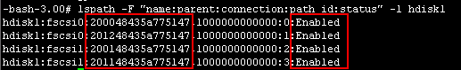

            - Convert the name (WWPN) of the ports whose status is Enabled into a binary value, check the values of the 53rd to 56th bits, and convert the values into a decimal number. The converted number indicates the controller ID, such as controller 0 in Figure 16-37.
              - Calculating the controller ID

            - Based on the calculated controller ID, check whether each LUN has at least one available path to a batch of controllers with even IDs and a batch of controllers with odd IDs. If yes, a rolling upgrade can be performed; otherwise, a rolling upgrade is unavailable.
----End

Checking Risky Emulex HBA Driver Versions in a Fibre Channel Network
In a VMware system, when Emulex HBA (Host Bus Adapter) is used for a Fibre Channel network, the host I/O may be interrupted because the host link switchover fails during the upgrade because of the known problems in the HBA driver version. If the host and storage device do not communicate with each other using Fibre Channel links, skip this section.
Cause
In a VMware ESX system, if an Emulex HBA is used for a Fibre Channel network, because of the known problems in the HBA driver version, the host HBA cannot report link interruption events to the upper-layer multipathing software after controller links are interrupted when the controllers of the storage device start upgrading. As a result, the host multipathing link fails to be switched over, or the host HBA fails to connect to controllers after the controllers restart and reconnect to the host.
Check Method
            - If the host does not communicate with the storage device through Fibre Channel links, the check is passed. Otherwise, go to the next step.
            - Use the SSH client tool to log in to the VMware ESX system and enter the CLI.
            - Run the esxcli storage core adapter list command to check whether Link State is link-up and Description contains Emulex items, as shown in Figure 16-38.
              - Querying the HBA List
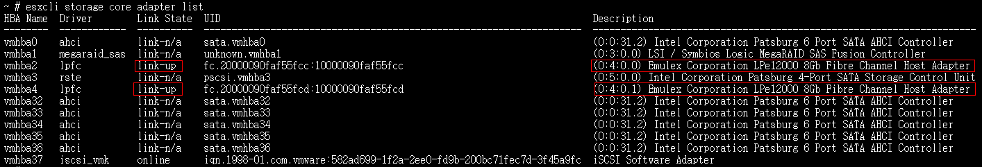

            - If the Emulex item is not displayed in Description or the value of Link State is not link-up, Emulex HBA is not installed or not enabled, skip the following steps. Otherwise, go to the next step.
            - Check the value of LPexxxxx under Description in the previous step, which indicates the HBA model, such as LPe12000 in Step 3.
            - Run the esxcfg-module -i lpfc | grep -i version command to query the Emulex driver version, for example, Version: 10.0.100.1-1vmw.550.0.0.1331820, where Version: xx.x.x.x indicates the HBA driver version.
In the preceding information, lpfc in esxcfg-module -i lpfc indicates the driver queried in Step 3.
            - Run the vmware -i or vmware -v command to view the current VMware system version, for example: VMware ESXi 5.5.0 build-2068190.
            - Compare the obtained VMware system version, HBA model, and driver version with that of the HBA version shown in Table 16-1. If the information matches, risks exist.
                - Risky HBA version information
Operating System Version | Driver Model | Driver Version
VMware ESXi 5.5.x or 6.0.x | Emulex LPe12000  Emulex LPe12002  Emulex LPe16002 | Earlier than 10.2.455.0
All VMware versions | Emulex LPe15000  Emulex LPe16000 | Earlier than 11.1.145.18

1. Risks occur only on the direct connection networking.
            - If the operating system, HBA model, and driver version match the information in the preceding table, a link switchover or setup failure may occur due to HBA driver bugs during the upgrade. As a result, host services are interrupted.
----End
Recommended Actions
You are advised to log in to the VMware official website: https://www.vmware.com/resources/compatibility/search.php and download the driver of the latest version to upgrade the HBA.

Checking the Oracle Heartbeat Parameter
This section describes how to check whether the Oracle heartbeat parameters meet the rolling upgrade requirements. If the Oracle database is not installed, skip this section.
Cause
The Oracle database deployed on the host uses the Automatic Storage Management (ASM) mode to manage disks, the Oracle version is 11.2.0.3 to 12.1.01, and the default value of the ASM disk heartbeat parameter is 15 seconds (120 seconds by default for other versions). If I/O timeout exceeds 15 seconds due to controller service switchover during the upgrade, the ASM disk is dismounted from the database and is kicked off. As a result, the database breaks down.
Oracle official statement: https://support.oracle.com/epmos/faces/DocumentDisplay?_afrLoop=533716944762019&id=1581684.1&_afrWindowMode=0&_adf.ctrl-state=1dkv36pc56_4
This section describes how to check whether the Oracle ASM disk heartbeat parameters need to be modified based on the Oracle version, configuration, host multipathing, and storage system version.
If the HBA or iSCSI timeout parameters are modified by referring to 16.1.5 Checking the HBA Timeout Parameter in a Fibre Channel Network or 16.1.6 Checking the Initiator Timeout Parameter in an iSCSI Network, and the ASM disk timeout parameter is not modified after Oracle database installation, skip this section.
Check Method
            - The Oracle database is installed on the host. Check whether ASM disk groups are used to manage database disks.
The procedures are as follows:
- Windows host: On the control panel, choose Administrative Tools > Services. If the OracleASMService+ASM service is displayed, ASM disk groups are used to manage disks.
- Other hosts: Run the ps -ef |grep pmon command. If the command output contains +ASM1, ASM disk groups are used to manage disks.
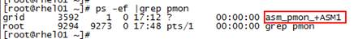
- Disk in the Oracle 11g/12c database can be managed by file system or ASM.
            - If the Oracle database is not installed or ASM disk groups are not used to manage disks, the check is passed. Otherwise, go to the next step.
            - If the Oracle database uses ASM disk groups to manage disks but the Oracle database version is not from 11.2.0.3 (included) to 12.1.0.1 (included), the check is passed. Otherwise, go to the next step.
To view the version, do as follows:
- Checking the database version on Windows hosts
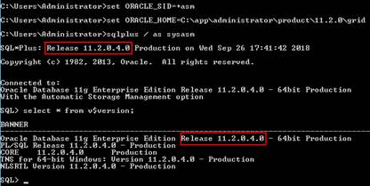
Note: You need to set environment variables in Windows for ASM administrator to access the database. The path specified by ORACLE_HOME is the installation path. You need to find the installation path of the Oracle database before setting the path.
- Checking the database version information on other hosts
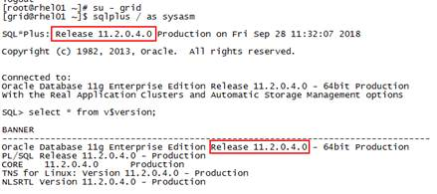
            - Check the disk type. If the disk type is not high/normal, the check is passed. Otherwise, go to the next step.
To check the disk type, do as follows:
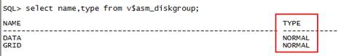
In ASM disk management, the following types of disks are managed: high, normal, and extern.
            - Check the ASM disk timeout parameter. If the value is greater than or equal to 120 seconds, the check is passed. Otherwise, go to the next step.
To query the ASM disk timeout duration, do as follows:
You must query the duration as ASM administrator rather than as dba user. To query the information, run the following command:
select a.ksppinm name,b.ksppstvl value,a.ksppdesc describe from x$ksppi a,x$ksppcv b where a.inst_id = userenv('instance') and b.inst_id = userenv('instance') and a.indx = b.indx and a.ksppinm like '\_asm_hbeatio%' escape '\';
The command output is as follows:
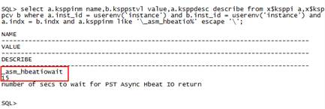
The default timeout duration of ASM disks in Oracle 11g/12c is 15 seconds.
            - Use the SSH client software to log in to the host where the Oracle database is installed. On the CLI, run the upadm show version command to check whether UltraPath is installed and the version of the multipathing software.
For details about how to check the UltraPath version, see the methods for each operating system in 16.1.2 Checking Host Multipathing Link Status.
            - Use the SSH client software to log in to the storage system associated with the Oracle database and run the show system general command to check the storage system version. Run the show lun general | filterColumn include columnList=ID to query the number of storage LUNs.
            - If the operating system, multipathing software type and version, storage system version of the host where Oracle exists, and number of LUNs meet the following requirements, the check is passed and no further check is required; otherwise, go to the next step.
                - Version mapping without Oracle ASM timeout parameter modification
Host Multipathing and Version | Storage System Version | Number of Storage LUNs | Operating System Type of the Host Where the Oracle Database Exists | Recommended Actions
UltraPath 8.01.000 (AIX 8.03.028) and later | All versions | N/A | N/A | No processing is required.

            - If the version mapping does not match these in Table 16-2, modify the ASM timeout parameter by referring to Modifying the Oracle ASM Timeout Parameter or modify the HBA/iSCSI timeout parameter by referring to 16.1.5 Checking the HBA Timeout Parameter in a Fibre Channel Network or 16.1.6 Checking the Initiator Timeout Parameter in an iSCSI Network.
Change the HBA/iSCSI timeout duration or Oracle ASM disk timeout duration of the host. You need to modify only one of the two parameters.
            - After the Oracle ASM disk timeout duration is modified, restart the Oracle database for the modification to take effect (if the Oracle database is deployed in a RAC cluster, change the disk timeout duration on each node). The host HBA timeout duration can be modified in some hosts online but other hosts need to be restarted for the modification to take effect. Therefore, use a solution that has minor impact on service continuity after evaluation.
            - After the storage device is upgraded, the modified parameters can remain.
----End
Modifying the ORACLE ASM Timeout Parameter
            - Log in to the host as user root and run the ps -ef |grep pmon command. In the command output, check the line with keyword asm_pmon_*. The line starts with the ASM instance administrator and ends with the ASM instance name (ORACLE_SID). Record the system process ID, as shown in Figure 16-39.
              - Querying the ASM instance and process ID
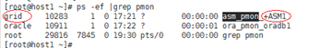

            - Run the ls -l/proc/xx/fd command to view the user directory opened by the process ID (xx indicates the system process ID recorded in the previous step). Check whether the command output contains the ASM instance name and record the path before dbs (the path is the ORACLE_HOME of grid).
              - Querying the ORACLE HOME directory
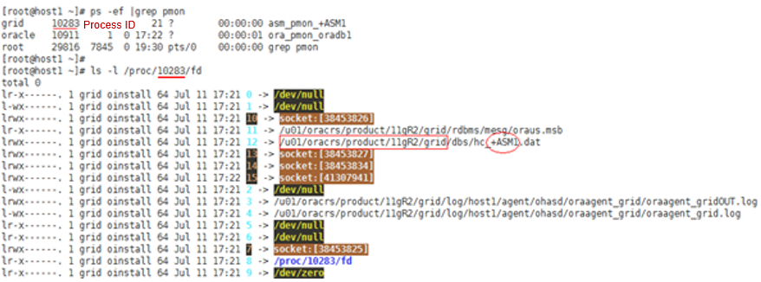

            - Switch to the ASM instance administrator, set environment variables ORACLE_HOME and ORACLE_SID, and log in to the ASM instance by entering sqlplus / as sysasm to collect or modify the ASM heartbeat parameter.
              - Switching to the ASM instance administrator
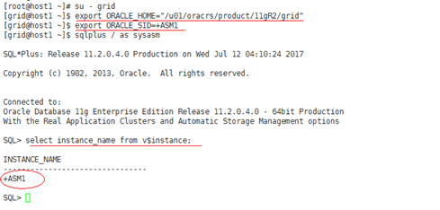

            - Modify the _asm_hbeatiowait parameter by running alter system set "_asm_hbeatiowait" =120 scope=spfile sid='*';.
              - Modifying the heartbeat parameter
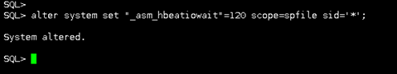

            - (Optional) Switch to the database administrator, log in to the database as an Oracle DBA user (entering sqlplus / as sysdba), and stop the database instance.
              - Stopping a database instance
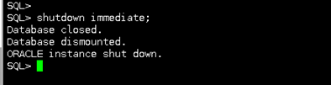

            - Go to the ORACLE_HOME directory of grid as user root and run the crsctl stop crs command to stop the cluster service (running the crsctl stop has command to stop the service on a node).
              - Stopping the cluster service on a node
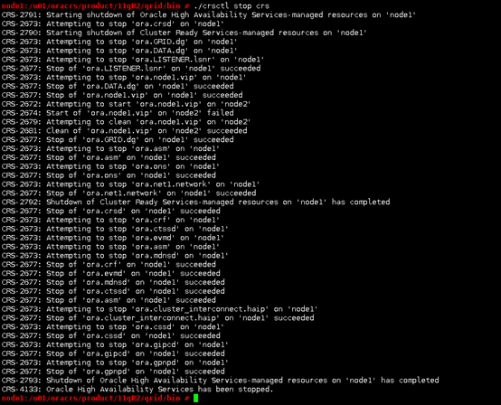

            - Go to the ORACLE_HOME directory of grid as user root and run the crsctl start crs command to start the CRS service. In a single-node system, run the crsctl start has command to start the CRS service.
              - Starting CRS

            - Go to the ORACLE_HOME directory of grid as user root and wait for 5 minutes to check whether the database starts.
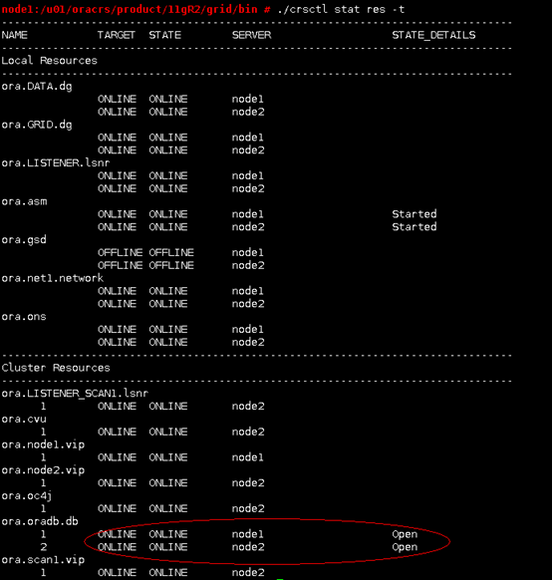
            - Repeat Step 1 to Step 3 to log in to the ASM instance and check whether the modification of parameter _asm_hbeatiowait takes effect by running the following command: select a.ksppinm name, b.ksppstvl value, a.ksppdesc describe from x$ksppi a, x$ksppcv b where a.inst_id = userenv('instance') and b.inst_id = userenv('instance') and a.indx = b.indx and a.ksppinm like '\_asm_hbeatio%' escape '\' ;.
            - Repeat the preceding operations on the other Oracle node.
----End

Checking the HBA Timeout Parameter in a Fibre Channel Network
This section describes how to check the HBA timeout parameter in a Fibre Channel network.
This section describes the timeout parameter check performed when the Oracle heartbeat parameter check fails. If the Oracle database is not installed on the host, you do not need to perform the timeout parameter check.
Cause
- If a host is installed with UltraPath 8.0.0.0 or later and is connected to Huawei storage devices, the controller can automatically instruct UltraPath to switch the host I/O path during rolling controller software upgrade of the storage device. In this case, the upgrade has a small impact on host I/Os (less than 1 second).
- If the host is not installed with UltraPath 8.0.0.0 or later, during the controller software upgrade, the host I/O path switchover depends on the timeout mechanism of the Fibre Channel HBA or iSCSI initiator during controller reset. How long I/Os are affected depends on the timeout parameter. If the timeout parameter is set to a large value, the host software cannot tolerate the I/O timeout. As a result, services on the host software may be interrupted.
            - If the host and storage device do not communicate with each other through a Fibre Channel network, skip this section.
            - In the current HBA configuration, the storage controller failure test has been performed. If multiple controllers are faulty, host software services are not interrupted, or the I/O impact caused by the host software upon multiple controller failures is acceptable. In this case, you can skip this section.

VMware ESX
This section describes how to check and rectify the HBA timeout duration in an ESXi Fibre Channel network.
Check Method
            - Log in to the VMware ESX system and run the esxcli storage core adapter list command to obtain the HBA information. QLogic and Emulex HBAs are used as an example, as shown in Figure 16-46.
              - Obtaining HBA information
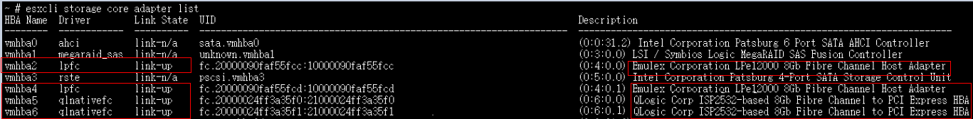

For non-QLogic or Emulex HBAs, query the HBAs according to the method provided by the HBA vendor.
            - In the command output of the previous step, record Driver (such as lpfc and qlxx for QLogic and Emulex HBAs), for example, Driver: lpfc.
            - For a QLogic HBA, run the esxcli system module parameters list -m Driver| grep qlport_down_retry command. For an Emulex HBA, run the esxcli system module parameters list -m Driver| grep lpfc_devloss_tmo command to query the HBA timeout duration, as shown in Figure 16-47.
              - Querying HBA timeout duration
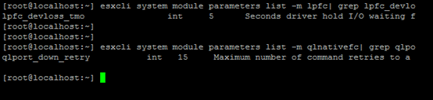

            - If nothing is displayed after int, the timeout parameter is set to the default 10 seconds.
            - In the command, Driver indicates the driver information obtained in Step 2.
            - If the timeout duration queried in the previous step is longer than 10 seconds, change the timeout duration to 10 seconds to reduce the impact on host I/Os during the upgrade.
----End
Recommended Actions
            - For a QLogic HBA, run the esxcli system module parameters set -p "lpfc_devloss_tmo=10" -m lpfc command to modify the timeout parameter.
            - For an Emulex HBA, run the esxcli system module parameters set -p "qlport_down_retry=10" -m qlnativefc command to modify the timeout parameter.
For Emulex and QLogic HBAs, the command of modifying the timeout parameter is effective for the HBA ports with the same type of drivers. If multiple HBAs are inserted, you only need to execute the command once.
            - After the modification, restart the VMware ESX system to make the timeout parameter take effect.
----End

Windows
This section describes how to check and rectify the HBA timeout duration in a Windows Fibre Channel network.
Check Method
            - In a Windows networking, use the management tool provided by the HBA vendor to query the HBA timeout duration. The following steps describe how to query the timeout duration of QLogic and Emulex HBAs.
            - For a QLogic HBA, install Fibre Channel Information Tool (fcinfo). The tool can be downloaded from Microsoft's official website. After installing fcinfo, open the CMD CLI and run fcinfo to get the HBA type, as shown in Figure 16-48.
              - Obtaining the HBA model
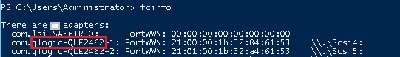

            - In the QLogic area on the Downloads page of QLogic's official website (see Figure 16-49), select the corresponding HBA model and operating system, and click Go, as shown in Figure 16-50.
              - Download path
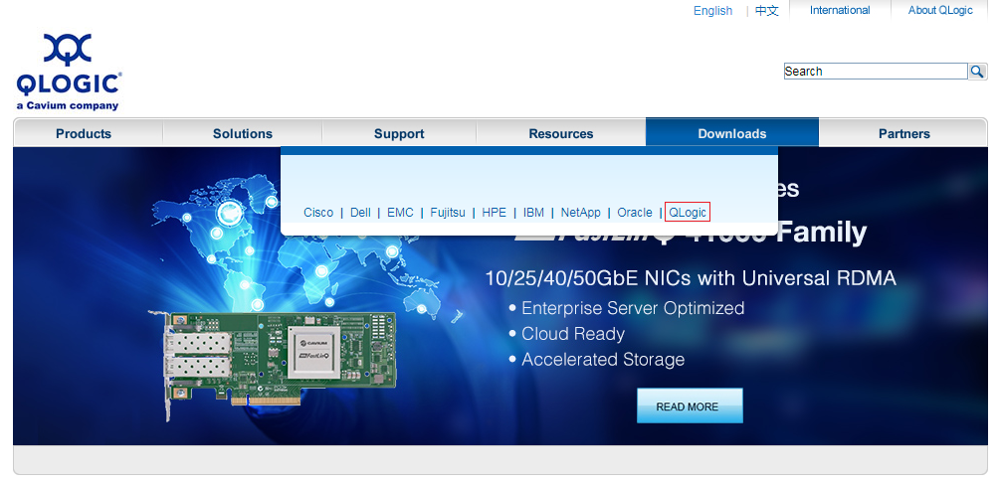

              - Choosing the HBA type and operating system
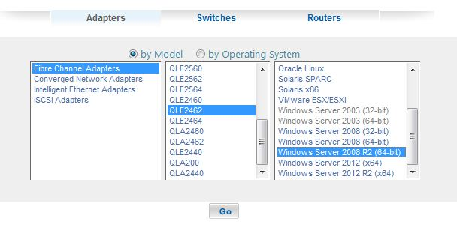

            - Click Previously released versions under the Management Tools area.
              - Selecting the management tool
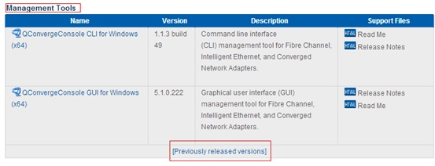

            - Download the QConvergeConsole, as shown in Figure 16-52.
              - Downloading the QConvergeConsole
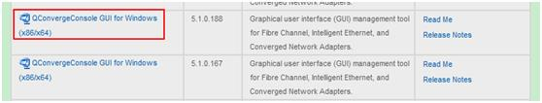

            - Install QConvergeConsole and view and set the timeout parameter, as shown in Figure 16-53.
              - Viewing and setting the timeout parameter for a QLogic HBA
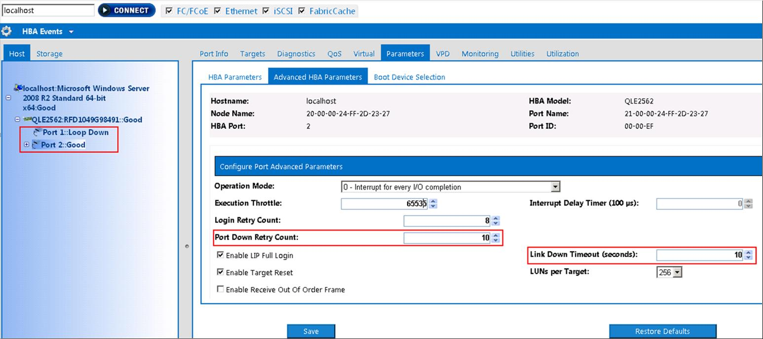

Check whether Port Down Retry Count and Link Down Timeout are set to 10. If the two parameters are not 10, set them to 10 and save the settings before you perform a rolling upgrade.
If the QConvergeConsole tool cannot be used after being installed, download and install SANsurfer FC HBA Manager in Step 5, and then open the QConvergeConsole tool again.
              - Installing SANsurfer FC HBA Manager
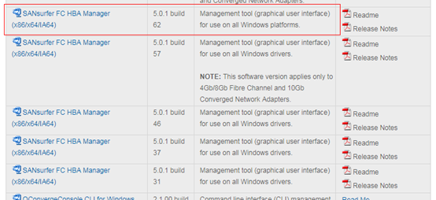

            - For an Emulex HBA, install OneCommand Manager, the software can be downloaded from Broadcom's official website.
            - Download OneCommand Manager based on the operating system type, as shown in Figure 16-55.
              - Downloading based on the operating system type
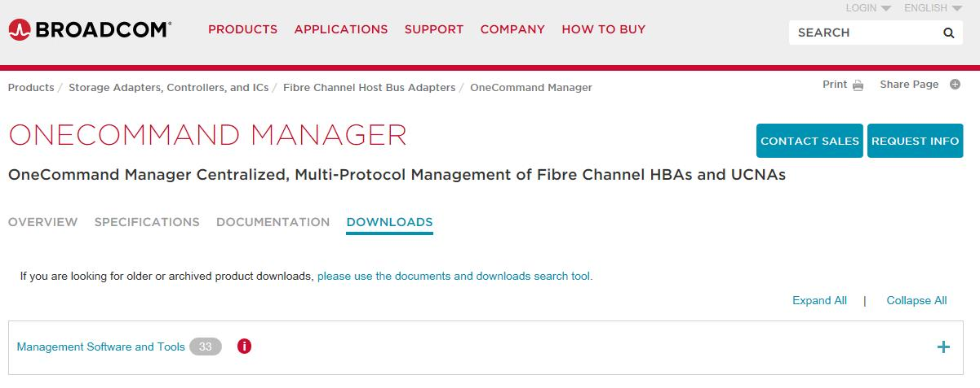

            - Use OneCommand Manager to view and set the timeout parameter, as shown in Figure 16-56.
              - Viewing and setting the timeout parameter for an Emulex HBA
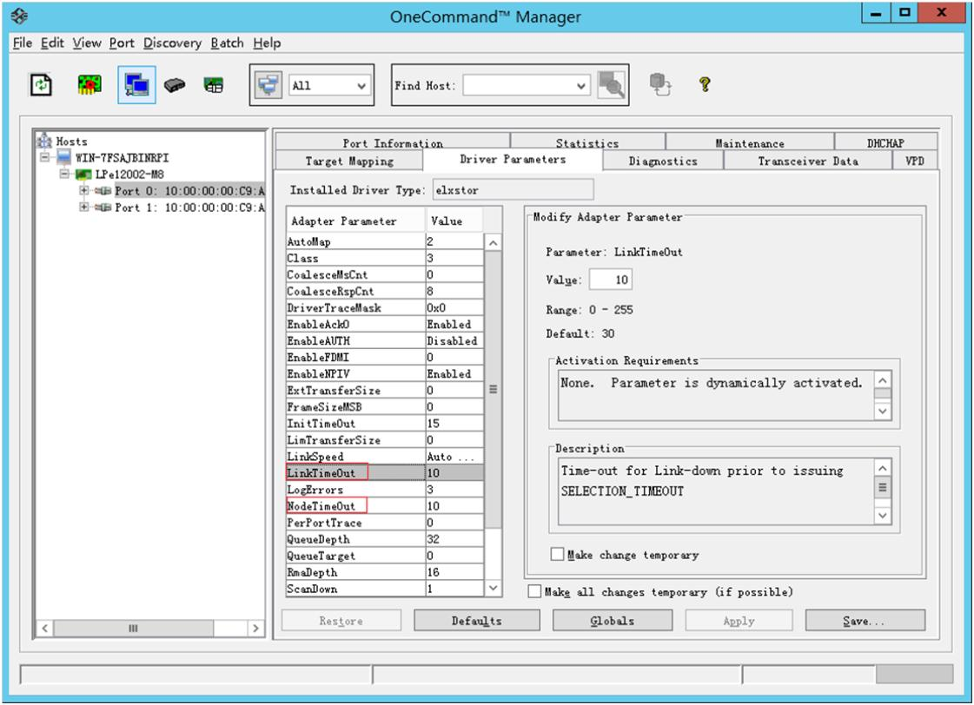

Check whether LinkTimeOut and NodeTimeOut are set to 10. If the two parameters are not 10, set them to 10 and save the settings before you perform a rolling upgrade.
----End
Recommended Actions
You are advised to set LinkTimeOut and NodeTimeOut to 10 and then perform a rolling upgrade.

Linux
This section describes how to check and rectify the HBA timeout parameter in Linux.
            - The check methods described in this section involve some operating systems. For the operating systems not listed, you can perform the check by referring to this section. If there is any difference, refer to the documents provided by the HBA vendor.
            - The check methods described in this chapter involve only Emulex and QLogic HBAs. If other HBAs are used, perform operations by referring the documents provided by the HBA vendor.
            - If the HBA timeout parameter is not set to 5, you are advised to change the value to 5 to reduce the impact on host I/Os during the upgrade.

SUSE 10
Check Method
            - After logging in to the device, run the cat /etc/*-release command to obtain the operating system version. If the operating system is SUSE Linux Enterprise Server 10, go to Step 2.
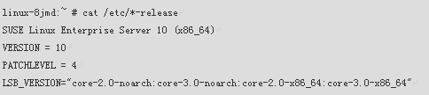
            - Run the ls /sys/class/fc_host command to obtain the host list.
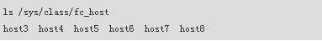
            - Run the cat /sys/class/fc_host/hostX/port_state command to query the port status. X in hostX indicates the HBA port number. host* can also be used to query information about all the hosts in Online state.
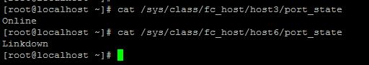
            - Run the cat /sys/class/scsi_host/host*/model*name command to query the HBA model of all hosts based on the hostX information recorded in step 3. Check whether the HBA comes from Emulex or QLogic.
              - Emulex HBA
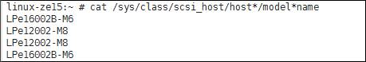

              - QLogic HBA
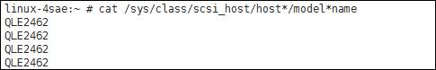

            - Collect timeout parameters by running commands based on the HBA model.
- If the HBA model is Emulex (starting with LPe), use the following method to query the timeout parameters:
  - Run the cat /sys/class/scsi_host/host*/lpfc_devloss_tmo command to query the timeout duration of all Fibre Channel ports.
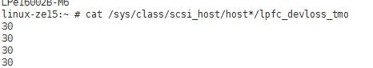
- If the HBA model is QLogic (starting with QLE), use the following method to query the timeout parameter (going to the QLogic official website to download and install QConvergeConsole CLI plug-in):
  - Run the qaucli command that can be executed only after the plug-in is installed. After the qaucli command is executed, if the command output contains Please Enter Selection, the command is executed successfully. Go to the next step.
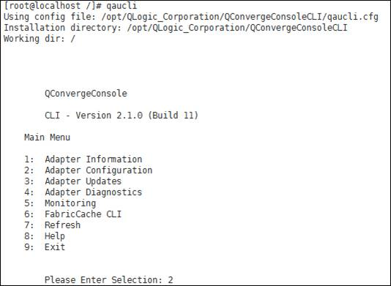
  - Enter 2 (Adapter Configuration).
  - Enter 3 (HBA Parameters).
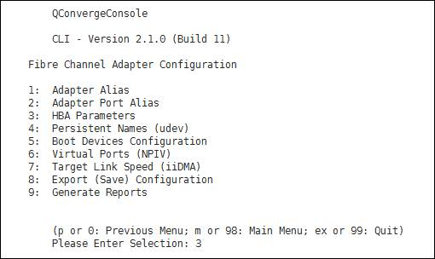
  - On the page shown in the following figure, enter the port number of each HBA, for example, 1, 2, 3, and 4.
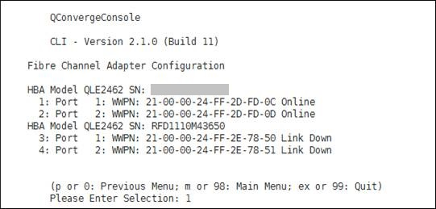
  - For example, enter 1.
    - Enter port 1.
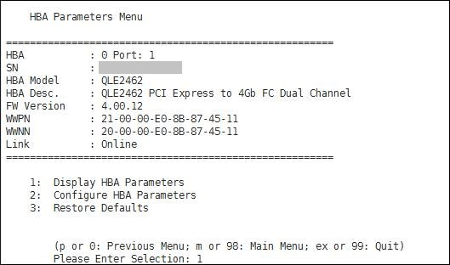
    - Enter 1 (Display HBA Parameters) to query HBA information. The value of Link Down Timeout (seconds) is the HBA timeout duration.
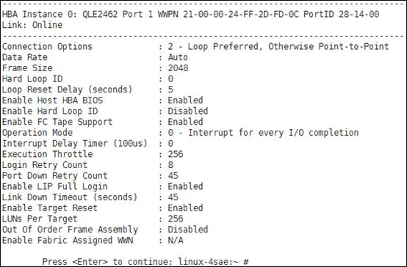
    - Enter 0 to go back to the previous directory. Repeat the steps to query information about the next port. After all the ports are queried, input quit.
----End
Recommended Actions
- For an Emulex HBA, run the echo X > /sys/class/scsi_host/hostY/lpfc_devloss_tmo command to modify the HBA timeout parameters. X indicates the timeout parameter and Y indicates the Fibre Channel port number. In the following figure, set the timeout interval to 5 seconds.
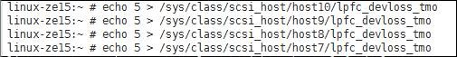
- For a QLogic HBA:
  - Run the qaucli command to modify the HBA timeout parameter.
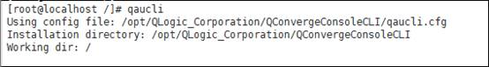
  - Enter 2 (Adapter Configuration).
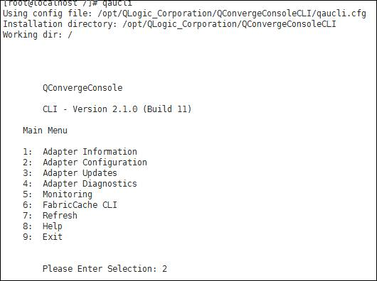
  - Enter 3 (HBA Parameters).
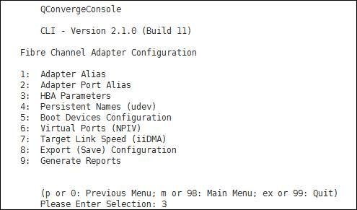
  - Enter the number of the port for which you want to modify the timeout setting. Port 1 is used as an example here.
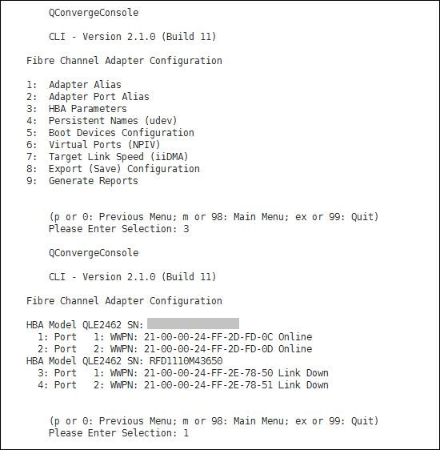
  - Enter 2 (Configure HBA Parameters).
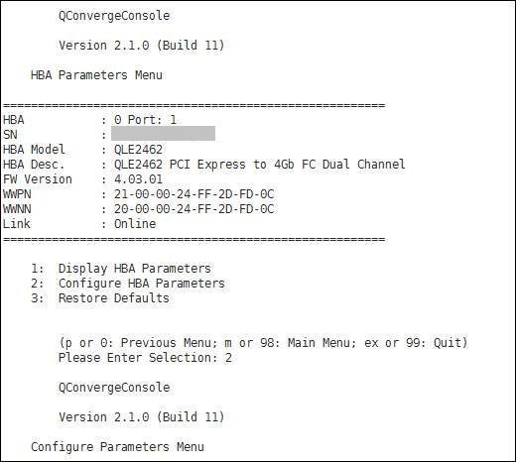
  - Set the timeout parameter. In the following figure, the timeout parameter is set to 15 seconds.
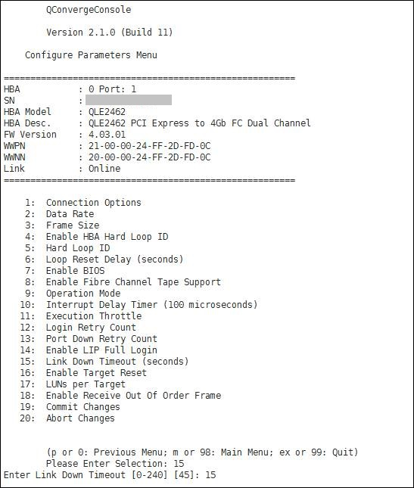
  - Enter 19 (Commit Changes).
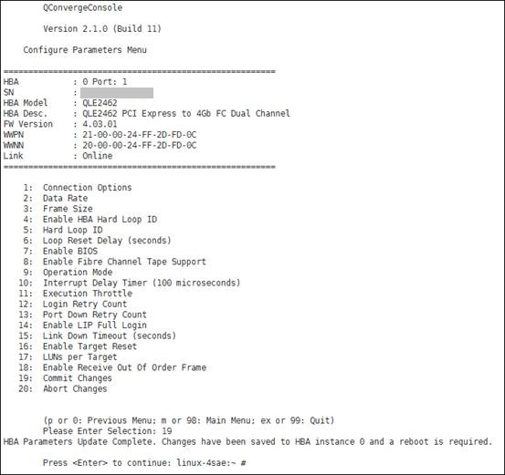

SUSE 11 and SUSE 12
Check Method
            - After logging in to the device, run the cat /etc/*-release command to obtain the operating system version. If the operating system is SUSE Linux Enterprise Server 11, go to Step 2.
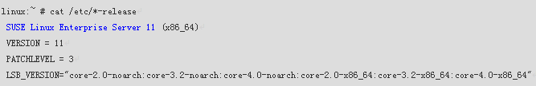
            - Run the ls /sys/class/fc_host command to obtain the host list.
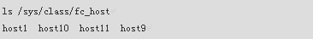
            - Run the cat /sys/class/fc_host/hostX/port_state command to query the port status. X in hostX indicates the HBA port number. Record information about all the hostX in Online state.
            - Based on the hostX information recorded in step 3, run the cat /sys/class/fc_host/host3/dev_loss_tmo command to query the HBA timeout duration of all hosts, as shown in the following figure.

----End
Recommended Actions
Run the echo X > /sys/class/fc_host/hostY/dev_loss_tmo command to modify the HBA timeout parameter, where X indicates the timeout parameter and Y indicates the Fibre Channel port number. In the following figure, set the timeout parameter to 5 seconds.


CentOS 5.11
Check Method
            - After logging in to the device, run the cat /etc/*-release command to obtain the operating system version. If the operating system is CentOS release 5.11, go to Step 2.
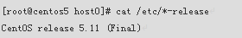
            - Run the ls /sys/class/fc_host command to obtain the host list.
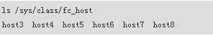
            - Run the cat /sys/class/fc_host/hostX/port_state command to query the port status. X in hostX indicates the HBA port number. Record information about all the hostX in Online state.
            - Run the cat /sys/class/scsi_host/hostX/model*name command to query the model of every HBA port and record the results. X in hostX indicates the HBA port number. Or you can replace hostX with host* to query the models of all HBA ports. HBA models include Emulex and QLogic.
              - Emulex HBA

              - QLogic HBA
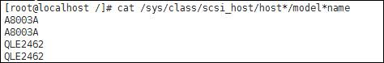

            - Collect timeout parameters by running commands based on the HBA model.
- If the HBA model is Emulex (starting with LPe), use the following method to query the timeout parameters:
  - Collect a list of all Emulex HBA ports. Run the cat /sys/class/scsi_host/hostX/lpfc_devloss_tmo command to obtain the timeout duration of every HBA port one by one. X in hostX indicates the HBA port number. Or you can replace hostX with host* to query the timeout duration of all the Fibre Channel ports.
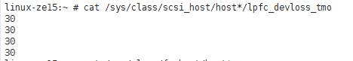
  - Run the cat /sys/class/fc_host/hostX/port_name command to obtain the WWPN of every port when an error occurs. X in hostX indicates the HBA port number.
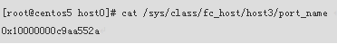
- If the HBA model is QLogic (starting with QLE), use the following method to query the timeout parameters:
  - Run the qaucli command that can be executed only after the plug-in is installed. If Please Enter Selection can be seen in the command output, the command has been executed successfully. Then go to the next step; otherwise, the timeout value is Unknown and the collection ends.
  - When the command output ends with Please Enter Selection, enter 2 (Adapter Configuration).
  - Enter 3 (HBA Parameters).
  - Obtain the following information from the command output, including the HBA model, port, and WWPN. (Information about ports in Link Down state does not need to be collected).
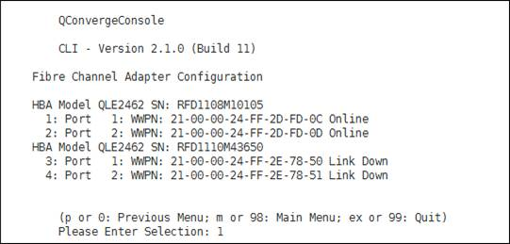
  - Perform the following steps for every port (ports 1, 2, 3, 4). Port 1 is used as an example here.
    - Input the port number 1.
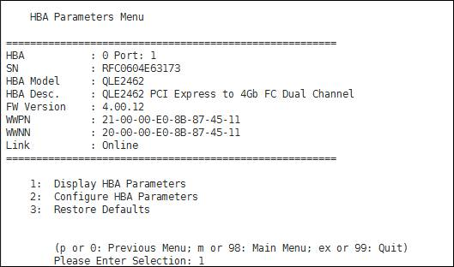
    - Enter 1 (Display HBA Parameters) to query HBA information. The value of Link Down Timeout (seconds) is the HBA timeout duration.
    - Enter 0 to go back to the previous directory. Repeat the steps to query information about the next port. After all the ports are queried, input quit.
----End
Modifying HBA Timeout Settings
- For an Emulex HBA:
Run the echo X > /sys/class/scsi_host/hostY/lpfc_devloss_tmo command to modify the HBA timeout setting, where X indicates the timeout value and Y the Fibre Channel port number. In the following figure, set the timeout parameter to 5 seconds.
- For a QLogic HBA:
  - Run the qaucli command to modify the HBA timeout parameter.
  - Enter 2 (Adapter Configuration).
  - Enter 3 (HBA Parameters).
  - Enter the number of the port for which you want to modify the timeout setting. Port 1 is used as an example here.
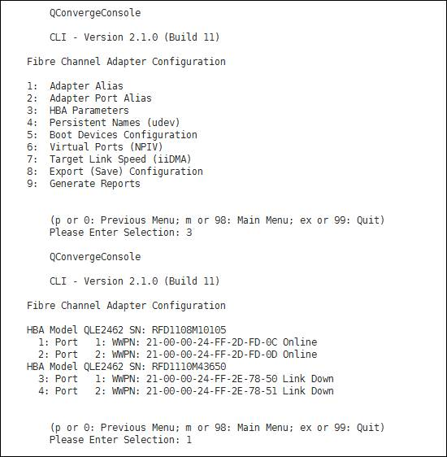
  - Enter 2 (Configure HBA Parameters).
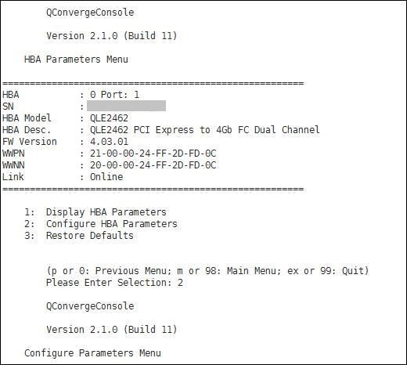
  - Set the timeout parameter. In the following figure, the timeout parameter is set to 15 seconds.
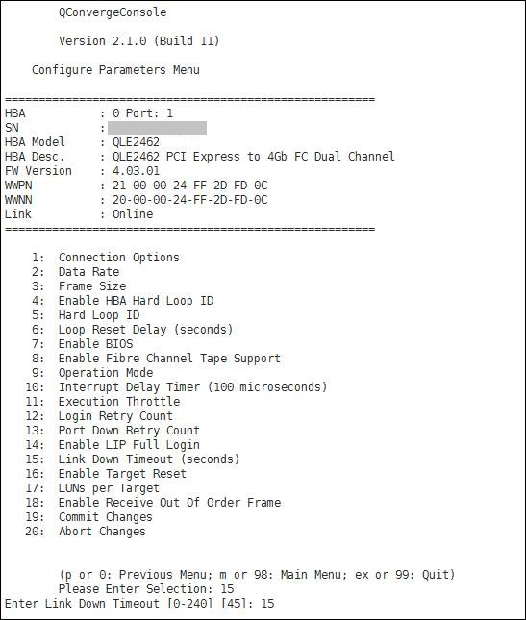
  - Enter 19 (Commit Changes).
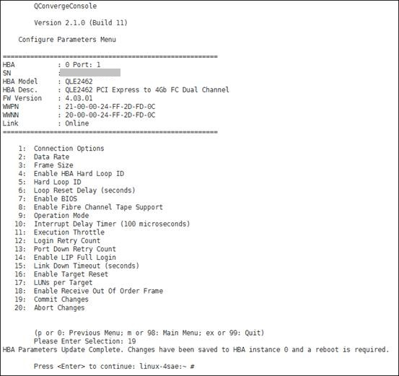

CentOS 6.5 and CentOS 7.2
Check Method
            - After logging in to the device, run the cat /etc/*-release command to obtain the operating system version. If the operating system is CentOS release 6.5, go to Step 2.
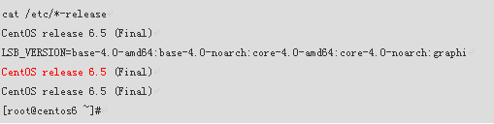
            - Run the ls /sys/class/fc_host command to obtain the host list.
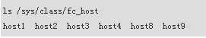
            - Run the cat /sys/class/fc_host/hostX/port_state command to query the port status. X in hostX indicates the HBA port number. Record information about all the hostX in Online state.
            - Run the cat /sys/class/scsi_host/hostX/model*name command to query the model of every HBA port and record the results. X in hostX indicates the HBA port number. Or you can replace hostX with host* to query the timeout settings of all HBA ports.
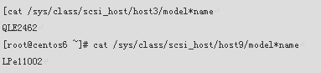
            - Run the cat /sys/class/fc_host/hostX/dev_loss_tmo command to query the timeout setting of every HBA port and record the results. X in hostX indicates the HBA port number. Or you can replace hostX with host* to query the timeout settings of all HBA ports.
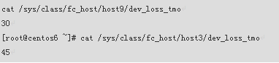
----End
Recommended Actions
Run the echo X > /sys/class/fc_host/hostY/dev_loss_tmo command to modify the HBA timeout parameter, where X indicates the timeout parameter and Y indicates the Fibre Channel port number. In the following figure, set the timeout parameter to 5 seconds.

Red Hat 5.10 and Red Hat 5.6
The solution is the same as that of CentOS 5.11.

Red Hat 6.8 and Red Hat 7.1
The solution is the same as that of CentOS 6.5 and CentOS 7.2.

Red Hat 7.3
The solution is the same as that of CentOS 6.5 and CentOS 7.2.

OEL 5.11 and OEL 6.1
The solution is the same as that of CentOS 5.11.

OEL 7.2
The solution is the same as that of Red Hat 6.8 and Red Hat 7.1.

Ubuntu 12.04, Ubuntu 14.10, and Ubuntu 16.04
The solution is the same as that of CentOS 6.5 and CentOS 7.2.

Solaris
This section describes how to check and rectify HBA timeout parameters in Solaris.
This section uses Oracle Solaris 10 and Oracle Solaris 11 as examples. For other operating system versions, refer to this section. If there is any difference, refer to the documents provided by the HBA vendor.
Check Method
            - Log in to the Solaris OS as an administrator.
            - Run the fcinfo hba-port command to obtain information about the HBA port whose State is Online, as shown in Figure 16-61.
              - Querying HBA port information
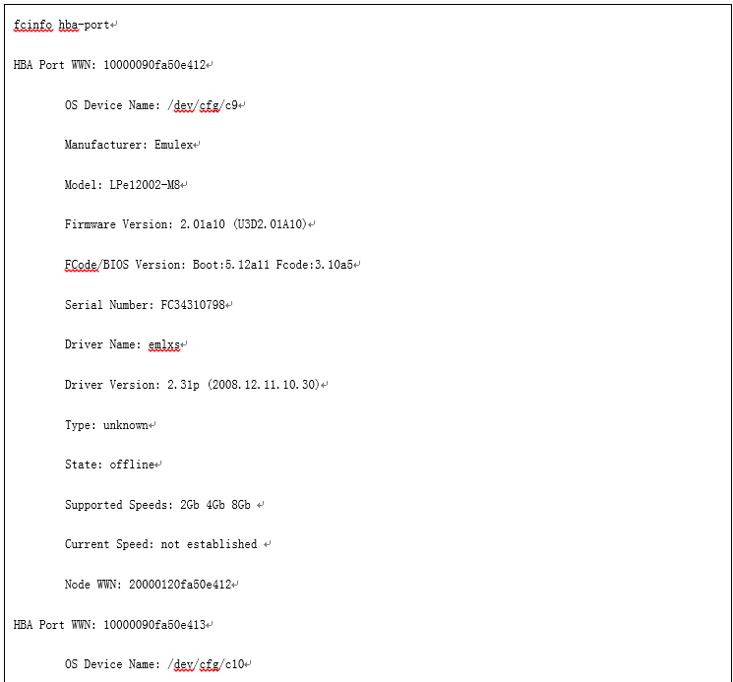

            - Check the Manufacturer field to obtain the HBA vendor (Emulex or QLogic).
            - If an Emulex HBA exists, run the cat /kernel/drv/emlxs.conf |grep linkup-delay command to obtain the value of linkup-delay, that is, the value of the Emulex HBA timeout parameter.
            - If a QLogic HBA exists, going to the QLogic official website to download and install QConvergeConsole CLI plug-in.
            - After the QConvergeConsole CLI plug-in is installed, run the qaucli command, as shown in Figure 16-62.
              - Running qaucli
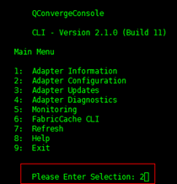

            - Enter 2 (Adapter Configuration), as shown in Figure 16-63.
              - Adapter Configuration command output
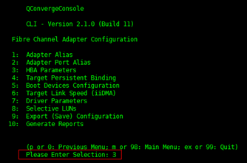

            - Enter 3 (HBA Parameters), as shown in Figure 16-64. The QLogic HBA of the current system is displayed.
              - HBA Parameters command output
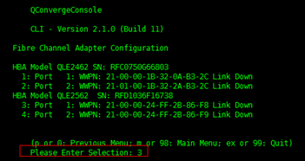

            - Enter the serial number of each HBA in sequence, such as 3. On the basic HBA information page, enter 1 to display the HBA details, as shown in Figure 16-65.
              - Querying HBA information
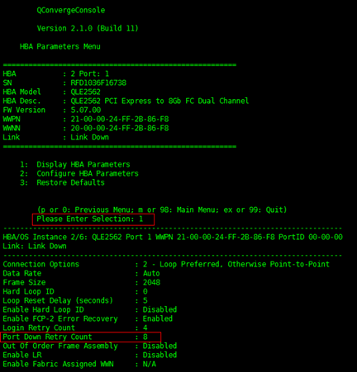

----End
Recommended Actions
            - For an Emulex HBA, change the value of linkup-delay in /kernel/drv/emlxs.conf to 5.
            - If the HBA model is QLogic, use the following method to query the timeout parameters (going to the QLogic official website to download and install QConvergeConsole CLI plug-in):
- Run the qaucli command that can be executed only after the plug-in is installed. After the qaucli command is executed, if the command output contains Please Enter Selection, the command is executed successfully. Go to the next step.
- Enter 2 (Adapter Configuration).
- Enter 3 (HBA Parameters).
- On the page shown in the following figure, enter the port number of each HBA, for example, 1, 2, 3, and 4.
- For example, enter 1.
  - Enter port 1.
  - Enter 1 (Display HBA Parameters) to query HBA information. The value of Link Down Timeout (seconds) is the HBA timeout duration.
  - Enter 0 to go back to the previous directory. Repeat the steps to query information about the next port. After all the ports are queried, input quit.
----End

HP-UX
This section describes how to check and rectify the HBA timeout parameters in HP-UX (querying the timeout parameters of each LUN instead).

HP-UX 11i v1 and v2
Collecting Timeout Parameters
            - Run the ioscan -fnC fc command to obtain the H/W Path list of the current HP-UX HBA, as shown in Figure 16-66.
              - HBA H/W Path list
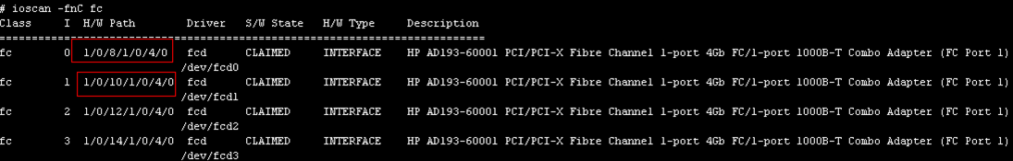

            - Run the ioscan -funC disk command to obtain the mapped disk device list. Match the current H/W Path with H/W Path obtained in Step 1 and obtain the corresponding disk, for example, /dev/dsk/c23t0d1.
              - Obtaining disk information
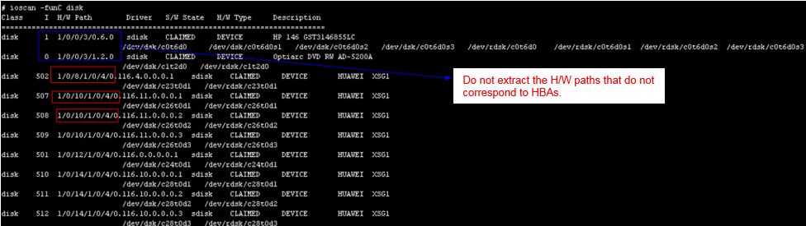

            - Run the vgdisplay -v | grep 'PV Name' command. Disks displayed in the command output have PVs created.
              - Querying PVs
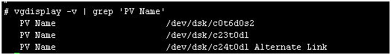

            - Run the pvdisplay /dev/dsk/c23t0d1 command to obtain the value of IO Timeout (Seconds). The value is 30 seconds by default.
              - Querying the timeout parameter
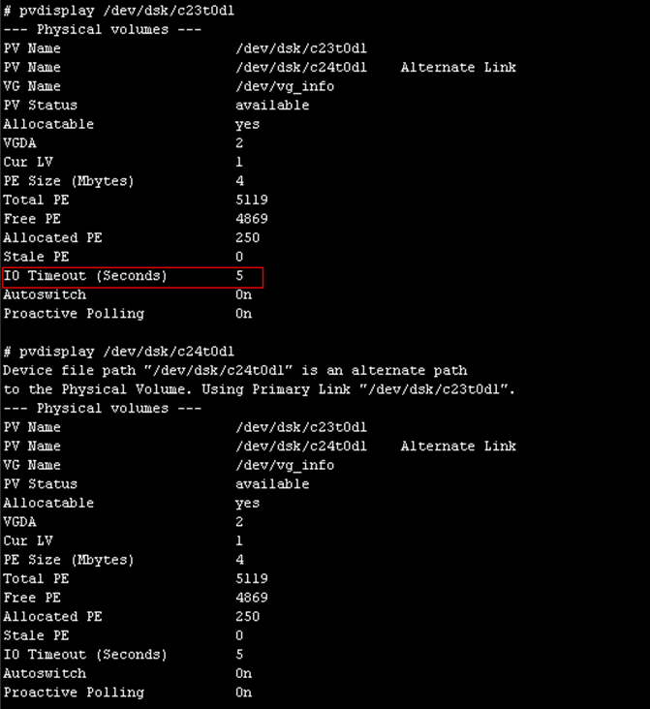

----End
Recommended Actions
Run the pvchange -t X Y command to modify the LUN timeout parameter. X indicates the timeout parameter, and Y indicates the obtained disk. Check whether the modification is successful. As shown in the following figure, set the timeout parameter to 5 seconds.
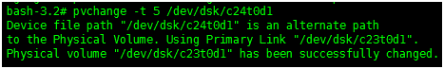

HP-UX 11i v3
Check Method
            - Run the ioscan -P health -C disk command to obtain the H/W Path values of the disks in online state (such as 64000/0xfa00/0x1).
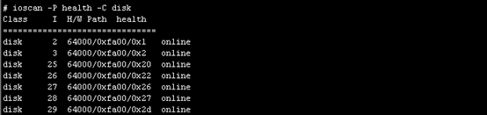
            - Run the scsimgr lun_map -H 64000/0xfa00/0x20 | grep 'SCSI transport protocol' command to check whether SCSI transport protocol is fibre_channel. If two records are displayed, there are two paths.
If SCSI transport protocol is sas, it is a DVD-ROM or other kinds of SAS interface devices; if SCSI transport protocol is sata, it is a local disk.
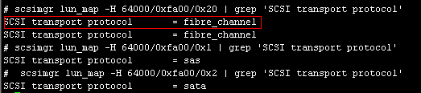
            - Based on the value in the H/W Path column obtained in step 2 and fibre_channel, run the scsimgr get_attr -H 64000/0xfa00/0x20 -a path_fail_secs command to obtain the current value, which is the timeout duration of the LUN mapped to the HBA.
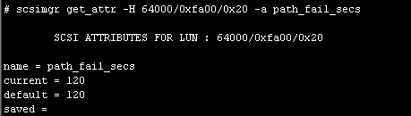
----End
Recommended Actions
Run the scsimgr set_attr -H 64000/0xfa00/0x20 -a path_fail_secs=X command to modify the timeout setting of an HBA. X indicates the timeout threshold that you want to set. The value of current in the command output is the timeout threshold. Check whether the modification is successful.
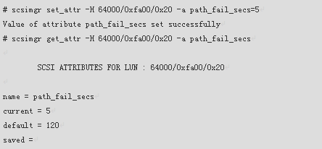

AIX
This section describes how to check and rectify AIX HBA timeout parameters.

This operation may require restarting hosts or stopping services. Exercise caution before performing this operation.
Check Method
            - Run the lspath command on the AIX host. The command output shows that how many ports on the HBA are connected to the disk array. As shown in Figure 16-70, two Fibre Channel ports on the host are connected to the disk array.
              - Viewing port information
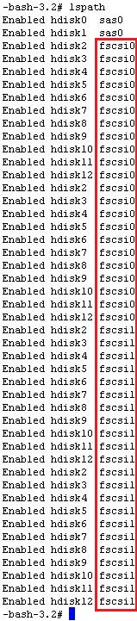

            - Run the lsattr -El fscsi* command to check whether the attributes of each connected port are modified, as shown in Figure 16-71. In the following figure, the value of dyntrk is yes and the value of fc_err_recov is fast_fail, indicating that the port attribute value has been changed. Otherwise, the attributes are not modified.
              - Viewing port attributes
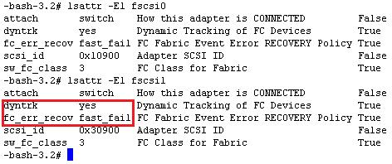

- If DAS networking is used, set the value of fc_err_recov to delayed_fail and that of dyntrk to no.
- In SAN networking mode, change the value of fc_err_recov to fast_fail and that of dyntrk to yes.
- IBM has configuration requirements on the Fibre Channel network of an AIX system, that is, the HBA attributes must be modified. This has nothing to do with the storage system.
----End
Recommended Actions
- If attributes of all ports have been modified, skip the following steps.
- Running the attribute modification command one time modifies attributes of only one port. You must modify the attributes of all ports connected to the storage array.
- If the host can be restarted, perform the following operations:
  - Run the chdev -l fscsi* -a drntrk=yes -P command to modify HBA attributes.
  - Restart the host for the settings to take effect.
- If services cannot be interrupted and multiple ports on the host are connected to the storage array, perform the following operations (assuming that ports fscsi0 and fscsi1 are connected to the storage array):
  - Run rmdev -l fscsi0 -R to set the status of fscsi0 to defined.
  - Run chdev -l fscsi0 -a dyntrk=yes and chdev -l fscsi0 -a fc_err_recov=fast_fail to modify the attributes of fscsi0.
  - Run cfgmgr -l fcs0 to establish a link to fscsi0.
  - Run lspath to confirm that the link to fscsi0 is recovered.
  - Run rmdev -l fscsi1 -R.
  - Run chdev -l fscsi1 -a dyntrk=yes and chdev -l fscsi1 -a fc_err_recov=fast_fail to modify the attributes of fscsi1.
  - Run cfgmgr -l fcs1.
  - Run lspath to confirm that the link to fscsi1 is recovered.
- If services cannot be interrupted and only one port on the host is connected to the storage array, port attributes cannot be modified. Negotiate with the customer over service suspension.

Checking the Initiator Timeout Parameter in an iSCSI Network
This section describes how to check the timeout parameter of an initiator in an iSCSI network.
This section describes the timeout parameter check performed when the Oracle heartbeat parameter check fails. If the Oracle database is not installed on the host, you do not need to perform the timeout parameter check.
Cause
- If UltraPath 8.0.0.0 or later is installed on the host, during the controller software upgrade, the controller will notify UltraPath of the host I/O path switchover. This minimizes the impact of the upgrade on host I/Os (less than 1 second).
- If UltraPath 8.0.0.0 or later is not installed on the host, during the controller software upgrade, the host I/O path switchover depends on the timeout mechanism of the Fibre Channel HBA or iSCSI initiator during controller reset. How long I/Os are affected depends on the timeout parameter. If the timeout parameter is set to a large value, the host applications cannot tolerate the I/O timeout. As a result, services on the host applications may be interrupted.
            - If the host and storage device do not communicate with each other through an iSCSI network, skip this section.
            - With the current iSCSI configuration parameters, the storage controller failure test has been performed. If multiple controllers are faulty, host application services are not interrupted, or the I/O impact caused by the host application upon multiple controller failures is acceptable. In this case, skip this section.

VMware ESX
This section describes how to check and modify the iSCSI initiator timeout value of an ESXi host. For an ESXi host, you must set the iSCSI initiator timeout value to 12 seconds before performing a rolling upgrade.

This operation may require restarting hosts or stopping services. Exercise caution before performing this operation.
Check Method
            - Log in to the VMware ESX system and run the esxcfg-scsidevs –a command to check the iSCSI initiator name. As shown in Figure 16-72, the iSCSI initiator is vmhba35.
              - Checking the iSCSI initiator name
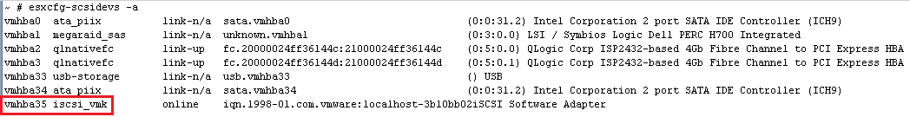

If multiple online iSCSI vmhba adapters exist, check and modify their settings one by one.
            - Run the esxcli iscsi adapter param get –A vmhba35 command (vmhba35 is the iSCSI initiator name queried in step 1) to check the values of NoopOutInterval, NoopOutTimeout, and RecoveryTimeout, as shown in Figure 16-73
              - Checking the current parameter settings of the iSCSI vmhba adapter
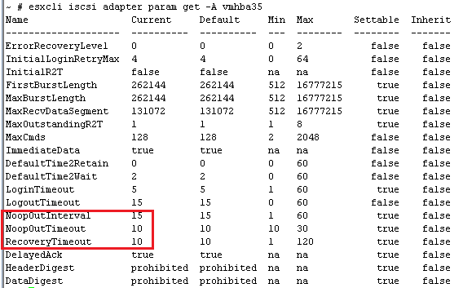

            - If the sum of NoopOutInterval, NoopOutTimeout, and RecoveryTimeout values is greater than 12, you are advised to change the value to 12.
----End
Recommended Actions
            - Run the following commands to modify the parameter settings of the iSCSI vmhba adapter (the values specified in the following commands are the optimal values obtained from tests):
esxcli iscsi adapter param set -A vmhba35 -k NoopOutInterval -v 1
esxcli iscsi adapter param set -A vmhba35 -k NoopOutTimeout -v 10
esxcli iscsi adapter param set -A vmhba35 -k RecoveryTimeout -v 1

          - The preceding parameters are recommended values. Set them based on the site requirements.
          - After the upgrade, restore the values of the timeout parameters to the original values.
            - The modification takes effect only after the ESXi host is restarted.
            - Check whether the settings take effect after the ESXi host is started.
----End

Windows
This section describes how to check and modify the iSCSI initiator timeout value of a Windows host.

This operation may require restarting hosts or stopping services. Exercise caution before performing this operation.
Check Method
            - Open the CLI and run the following commands to check the timeout parameters of the iSCSI initiator.
iscsiConfig get timeout value
iscsiConfig get linkdowntime value
            - If the timeout parameter is not set to 5, you are advised to set this parameter to 5 to reduce the impact on I/Os during the upgrade.
----End
Recommended Actions
            - If the values of the timeout parameters are not 5, run the following commands to set the values to 5:
iscsiConfig set timeout 5
iscsiConfig set linkdowntime 5
            - If the iscsiConfig command cannot be executed using the CLI, manually open registration entry HKEY_LOCAL_MACHINE\SYSTEM\CurrentControlSet\Control\Class\{4D36E97B-E325-11CE-BFC1-08002BE10318}, find the nodes with digits and pluses (+), and click the Parameters registration entry to check whether LinkDownTime and MaxRequestHoldTime are set to 5. If not, set the parameters to 5, as shown in Figure 16-74.
              - Querying and setting timeout parameters through the registration entry
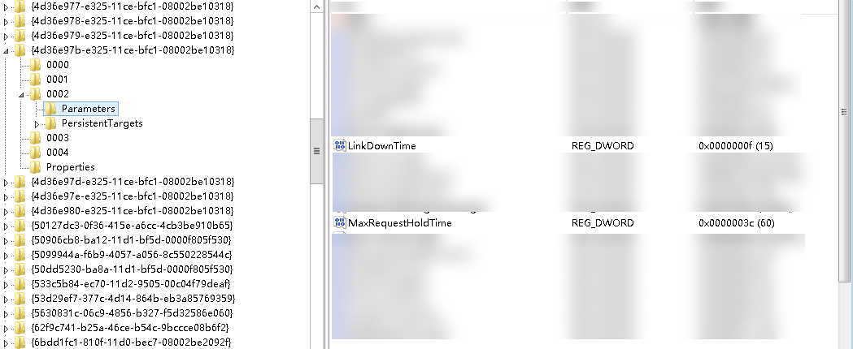

After the upgrade, restore the values of the timeout parameters to the original values.
            - Restart the host after getting the customer's approval.
----End

Linux
This section describes how to check and modify the iSCSI initiator timeout value of a Linux host.
Check Method
            - Run iscsiadm -m node -p iSCSI service IP address | grep replacement_timeout, as shown in Figure 16-75. Check the timeout parameters of all iSCSI service IP addresses.
              - Checking the timeout parameter
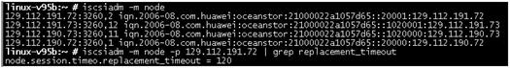

            - If the timeout parameter is not set to 1, you are advised to set this parameter to 1 to reduce the impact on I/Os during the upgrade.
----End
Recommended Actions
Run the iscsiadm -m node -o update -n node.session.timeo.replacement_timeout -v 1 command to modify the configuration, as shown in Figure 16-76.
              - Modifying the timeout parameter value

Default Batch Upgrade Policies
                - Default batch upgrade policies for OceanStor Dorado
Number of Controllers | Primary Controller | First Batch | Second Batch
OceanStor Dorado 2000, 3000, 5000, 5300, 5500, 5600, 5600K, or 6000 that provides two controllers | 0A | 0B | 0A
 | 0B | 0A | 0B
OceanStor Dorado 2000, 3000, 5000, 5300, 5500, 5600, 5600K, or 6000 provides four controllers | 0A, 1A | 0B, 1B | 0A, 1A
 | 0B, 1B | 0A, 1A | 0B, 1B
OceanStor Dorado 8000, 18000, 6800, 18500, 18800, or 18800K that provides four controllers | 0A, 0C | 0B, 0D | 0A, 0C
 | 0B, 0D | 0A, 0C | 0B, 0D
OceanStor Dorado 2000, 3000, 5000, 5300, 5500, 5600, 5600K, or 6000 that provides eight controllers | 0A, 1A, 2A, 3A | 0B, 1B, 2B, 3B | 0A, 1A, 2A, 3A
 | 0B, 1B, 2B, 3B | 0A, 1A, 2A, 3A | 0B, 1B, 2B, 3B
OceanStor Dorado 8000, 18000, 6800, 18500, 18800, or 18800K that provides eight controllers | 0A, 0C, 1A, 1C | 0B, 0D, 1B, 1D | 0A, 0C, 1A, 1C
 | 0B, 0D, 1B, 1D | 0A, 0C, 1A, 1C | 0B, 0D, 1B, 1D

The rolling upgrade is performed in batches. When one batch of controllers is upgraded, their services are taken over by the other batch of controllers. The system automatically detects and upgrades the firmware. After the upgrade, the controllers are restarted and services are switched back. Then the other batch of controllers is upgraded in the same way.
A storage system can have multiple controller enclosures. Each controller enclosure contains two or four controllers, namely, controllers A and B or controllers A, B, C, and D. A controller is named in digit+letter format. The digit indicates the ID of a controller enclosure in the cluster and the letter indicates the ID of a controller in the enclosure. For example, 0A indicates controller A in enclosure 0.

Obtaining the License File for the Target Version
This section describes how to obtain the license file for the target version.
To obtain a license file, visit http://app.huawei.com/sdp/portal.html and apply for a license by following instructions in the product documentation.
Principles for Applying for a License
- If a new function is required, apply for a new license.
- In other cases, you do not need to apply for a license additionally. When you apply for a license, you can contact Huawei technical support engineers for help.

