
 | AC  V200R022  Patch Installation Guide |  | 
 | Issue | 01
 | Date | 2022-12-30
 | HUAWEI TECHNOLOGIES CO., LTD.

Copyright © Huawei Technologies Co., Ltd. 2022. All rights reserved.
No part of this document may be reproduced or transmitted in any form or by any means without prior written consent of Huawei Technologies Co., Ltd.

Trademarks and Permissions
and other Huawei trademarks are trademarks of Huawei Technologies Co., Ltd.
All other trademarks and trade names mentioned in this document are the property of their respective holders.

Notice
The purchased products, services and features are stipulated by the contract made between Huawei and the customer. All or part of the products, services and features described in this document may not be within the purchase scope or the usage scope. Unless otherwise specified in the contract, all statements, information, and recommendations in this document are provided "AS IS" without warranties, guarantees or representations of any kind, either express or implied.
The information in this document is subject to change without notice. Every effort has been made in the preparation of this document to ensure accuracy of the contents, but all statements, information, and recommendations in this document do not constitute a warranty of any kind, express or implied.

Huawei Technologies Co., Ltd.
Address: | Huawei Industrial Base  Bantian, Longgang  Shenzhen 518129  People's Republic of China
Website: | https://e.huawei.com

Contents
1 Precautions 1
2 Preparing to Install 2
2.1 Preinstallation To-Do List 2
2.2 Obtaining Patch Files and Reference Documents 2
2.3 Verifying Software Integrity 3
2.4 Checking the Current Version 3
2.5 Collecting Device Diagnostic Information 4
2.6 Backing Up Configuration 4
3 Installing Patches (Local Mode) 6
3.1 Patch Installation Process 6
3.2 Loading and Activating a Patch Package 6
3.3 Loading the Web File 8
4 Installing Patches (Intelligent Upgrade) 11
5 Verifying Patch Installation 13
5.1 Verifying Version Information 13
6 Rolling Back Patch Installation 14
6.1 Guidelines 14
6.2 Rollback Version and Patch 14
7 FAQs 16

Precautions
Before you install the patch, read the patch release notes to understand basic information about the patch, impact of the installation, and updates on version mappings.
This document assumes that an AirEngine 9700-M is running V200R022C00SPC100 and describes how to install the V200R022C00SPH001 patch. The patch installation methods for other models are similar.

Preparing to Install

Preinstallation To-Do List
Table 2-1 lists the items to be accomplished before starting patch installation.
                - Preinstallation to-do list
No. | Item | Start Time | Time Required (Minutes)
1 | 2.2 Obtaining Patch Files and Reference Documents  2.3 Verifying Software Integrity | One day before patch installation | 30
2 | 2.4 Checking the Current Version | One day before patch installation | 10
3 | 2.5 Collecting Device Diagnostic Information | One day before patch installation | 10
4 | 2.6 Backing Up Configuration | One day before patch installation | 10

Obtaining Patch Files and Reference Documents
Obtain the patch software and required reference documents one day before the installation. To obtain the required software and documents, perform the following steps:
- Go to http://support.huawei.com/enterprise/ to access the page for the required patch.
            - Go to http://support.huawei.com to access the page for the required patch.
            - Download the patch package and patch release notes.
----End

Verifying Software Integrity
Using the OpenPGP Tool to Verify Integrity of a File
To prevent a software package from being maliciously tampered with during transmission or storage, download the corresponding digital signature file for integrity verification when downloading the software package.
After the software package is downloaded, verify its PGP digital signature according to the OpenPGP Signature Verification Guide. If the software package fails the verification, do not use the software package, and contact Huawei technical support engineers.
Before a software package is used in installation or upgrade, its digital signature also needs to be verified according to the OpenPGP Signature Verification Guide to ensure that the software package is not tampered with.
Visit either of the following websites to obtain the OpenPGP Signature Verification Guide:
https://support.huawei.com/enterprise/en/tool/pgp-verify-TL1000000054
https://support.huawei.com/carrier/digitalSignatureAction

Checking the Current Version
CLI
<AC> display version
Huawei Versatile Routing Platform Software
VRP (R) software, Version 5.170 (AirEngine 9700-M V200R022C00SPC100)
Copyright (C) 2011-2022 HUAWEI TECH CO., LTD
Huawei AirEngine9700-M Router uptime is 0 week, 2 days, 0 hour, 55 minutes
MPU 0(Master) : uptime is 0 week, 2 days, 0 hour, 55 minutes
SDRAM Memory Size : 16384 M bytes
Flash Memory Size : 2048 M bytes
MPU version information :
1. PCB Version : H852V26S VER.A
2. MAB Version : 2
3. Board Type : AirEngine 9700-M
4. CPLD0 Version : 273
5. CPLD1 Version : 277
6. CPLD2 Version : 273
7. BootROM Version : 1106
PWRCARD I information
PCB Version : PWR VER VER.NC
Web System
Log in to the AC web system and choose Monitoring > AC. The AC page is displayed. In the AC Basic Information area, check the running version of the device.
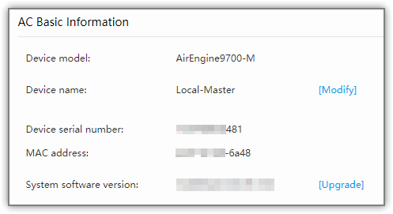

Collecting Device Diagnostic Information
                - Required information
Item | Purpose
AirEngine 9700-M running status | Check whether the AirEngine 9700-M works properly.

CLI
- Run the display diagnostic-information saved-file command to save diagnostic information to a file. If no file name is specified, the system automatically saves the file as diagnostic-information.txt.
<AC> display diagnostic-information saved-file
Begin to save file ,this operation will take several minutes, please wait.....
.............................................
Info: The diagnostic information was saved to the device successfully.
- Download the diagnosis information file to the local PC through FTP or SFTP.
Web System
- Log in to the AC and choose Diagnosis > One-Click Information Collection. The One-Click Information Collection page is displayed.
- Select AC and One-click diagnostic info, and click Collect.
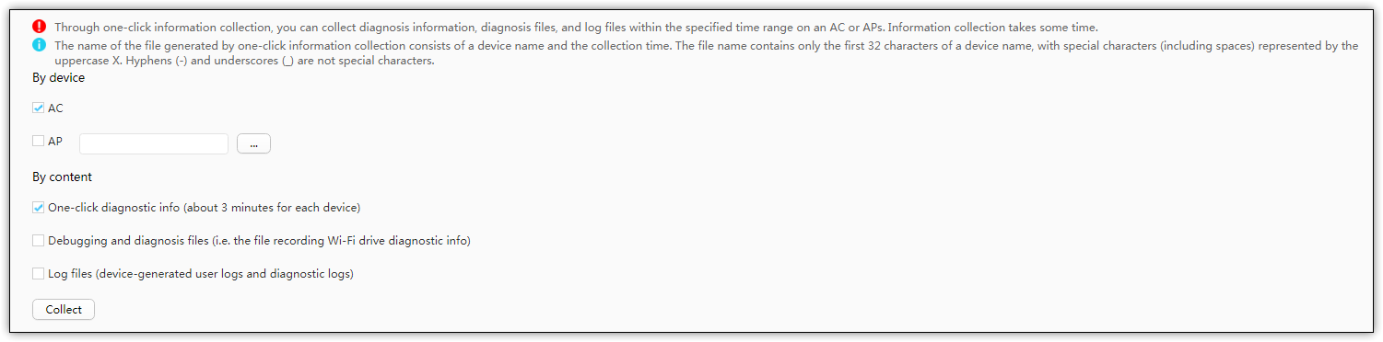
- In the dialog box that is displayed, click OK. The system starts to collect information. After the collection is complete, save the file to the local PC as prompted.

Backing Up Configuration
CLI
- Save the system configuration.
<AC> save
The current configuration will be written to the device.
Are you sure to continue? (y/n)[n]:y
It will take several minutes to save configuration file, please wait.......
Configuration file had been saved successfully
Note: The configuration file will take effect after being activated
- Back up the configuration file.
Check the current configuration file.
<AC> display startup
Configed startup system software: flash:/AirEngine9700-M_V200R022C00SPC100.cc
Startup system software: flash:/AirEngine9700-M_V200R022C00SPC100.cc
Next startup system software: flash:/AirEngine9700-M_V200R022C00SPC100.cc
Startup saved-configuration file: flash:/vrpcfg.zip
Next startup saved-configuration file: flash:/vrpcfg.zip
Startup patch package: NULL
Next startup patch package: NULL
Upload the configuration file to the TFTP server.
<AC> tftp 192.168.0.2 put vrpcfg.zip
Info: Transfer file in binary mode.
Uploading the file to the remote TFTP server. Please wait...
100%
TFTP: Uploading the file successfully.
----End
Web System
- Log in to the AC web system and click Save in the upper right corner of the page to save the current device configuration.

            - Choose Maintenance > Device Upgrade > AC Upgrade. The AC Upgrade page is displayed. Click Export Startup Files and save the configuration file to the local PC as prompted.
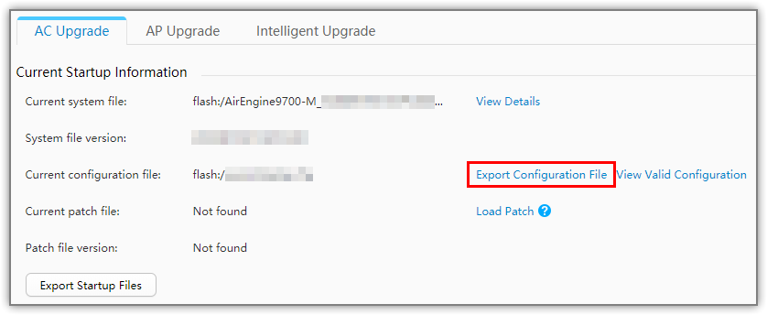
----End

Installing Patches (Local Mode)

Patch Installation Process
Table 3-1 describes the patch installation process.
                - Patch installation process
Stage | Recommended Start Time | Time Required (Minutes)
Load the patch package | 00:00 | < 10
Active the patch package | 00:10 | < 10

Loading and Activating a Patch Package
CLI
- Load the patch package.
<AC> tftp 192.168.0.2 get AirEngine9700-M_V200R022C00SPH001.pat
Info: Transfer file in binary mode.
Downloading the file from the remote TFTP server. Please wait...
|
26228 bytes received in 1 second.
TFTP: Downloading the file successfully.
Now begins to save file, please wait...
File had been saved successfully.
            - Activating the patch
<AC> patch load AirEngine9700-M_V200R022C00SPH001.pat all run
Info: The patch is being runned. Please wait for a moment......
Info: Succeeded in running the patch.
Info: Finished loading the patch.
----End
Web System
- Log in to the AC web system and choose Maintenance > Device Upgrade > AC Upgrade. The AC Upgrade page is displayed.
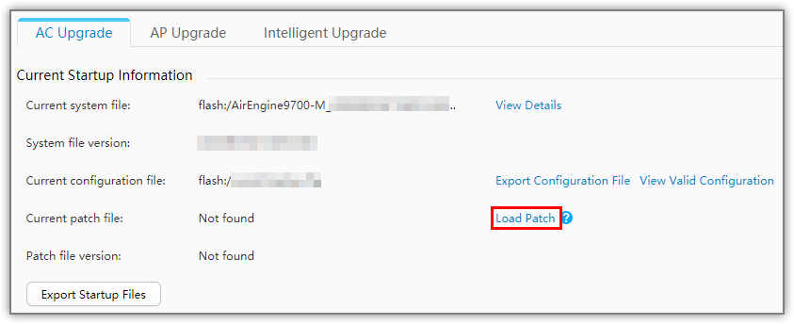
            - Click Load Patch. The Load Patch dialog box is displayed.

If a patch has been installed, Uninstall Patch and Load Patch are displayed. If the patch to be installed is compatible with the installed patch, click Load Patch to install the patch in incremental mode. Otherwise, click Uninstall Patch to uninstall the current patch and then install the new patch.
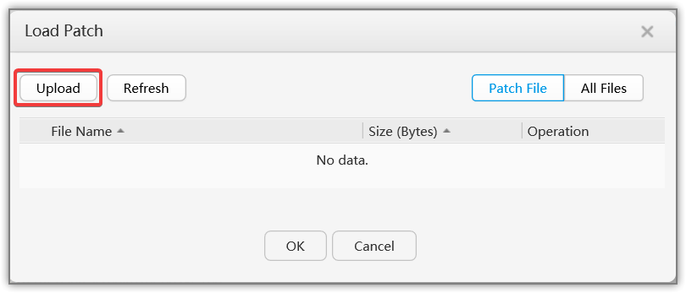
            - Click Upload. The Upload dialog box is displayed. Click Browse, select the patch package from the local PC, and click OK.
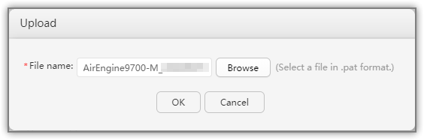
            - After the patch package is uploaded, the system returns to the Load Patch dialog box. Click the newly uploaded patch package and click OK. The system starts to load and activate the patch.
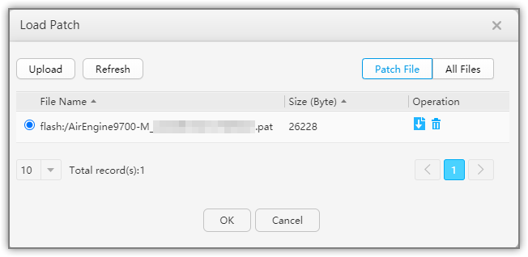
----End

Loading the Web File
CLI
<AC> system-view
[AC] http server load AC_V200R022C00SPC100.001.web.7z
Web System
- Log in to the AC web system and choose Maintenance > AC Maintenance > Web File Upgrade. The Web File Upgrade page is displayed.
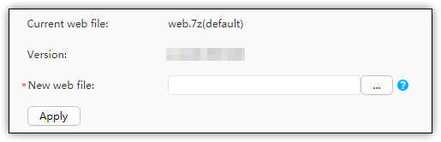
            - Clicknext to New web file. The Replacing the Web File page is displayed.
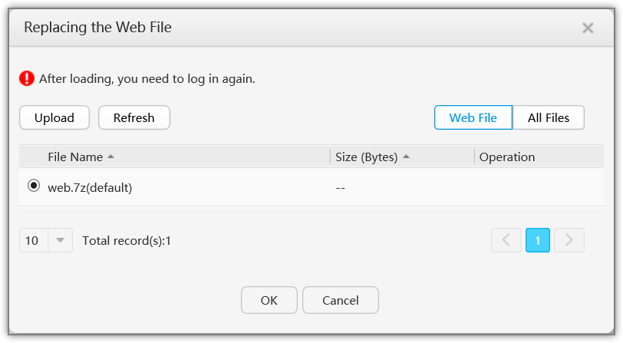
            - Click Upload. The Upload dialog box is displayed. Click Browse, select the web file from the local PC, and click OK.
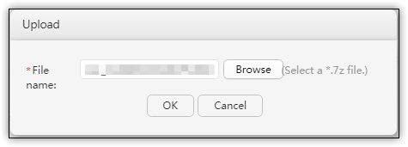
            - After the web file is uploaded, the system returns to the Replacing the Web File dialog box. Click the newly uploaded web file and click OK.
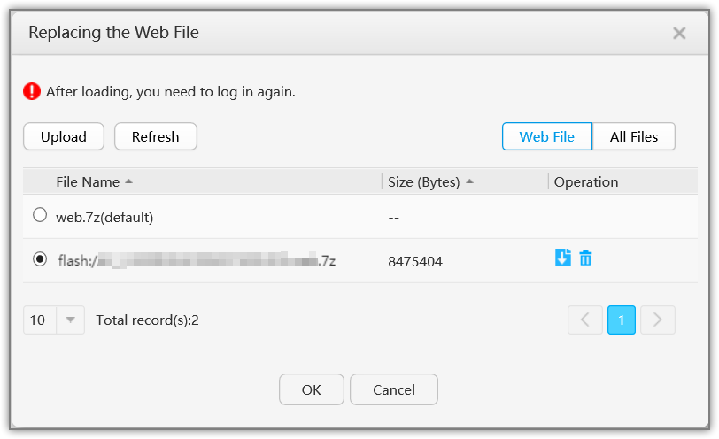
            - The system returns to the Replacing the Web File dialog box. Click Apply. In the dialog box that is displayed, click OK. The system starts to load the web file. After the file is loaded, log in to the web system again.
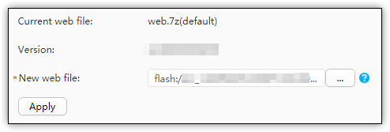
----End

Installing Patches (Intelligent Upgrade)
Context
Huawei devices support automatic download and self-service upgrade to help you learn about the mainstream versions of the devices and quickly perform device upgrade and repair. After enabling the intelligent upgrade function on the web system of devices, you hereby authorize Huawei Technologies Co., Ltd. to exchange information with your devices through the Huawei Online Upgrade Platform (HOUP) at http://houp.huawei.com to collect information such as device models, basic software versions and patches, and device ESNs. The information will be used to match the versions or patches that can be upgraded and return the information such as the upgrade versions or patches and the download URLs of software packages to your devices. After you confirm the upgrade, the devices will automatically download the software packages and implement an upgrade. When the upgrade is completed, the upgrade result will be uploaded to Huawei online upgrade platform. You are advised to enter your email and phone number for emergency contact upon any upgrade error. We will contact you if necessary so that your network services can work properly after the upgrade.
Prerequisites
Intelligent upgrade requires that an AC be able to access the Huawei Online Upgrade Platform (http://houp.huawei.com). A DNS server has been configured to resolve the IP address mapping the domain name of the HOUP.
The software version of the AC is V200R010C00 or later.
Precautions
HOUP connectivity can be checked on the intelligent upgrade page. If the AC cannot connect to the HOUP, check the following configurations:
- If a DNS server has been configured on the intranet, verify that the IP address of the DNS server has been added to the DNS configuration on the AC. If no DNS server has been configured on the intranet, add the public DNS server address to the DNS configuration, for example, 114.114.114.114.
- If security devices such as firewalls exist on the network, verify that the security defense policy allows access to the HOUP and the AC can properly download files from the HOUP.
Procedure
The following example describes how to perform an intelligent upgrade of an AirEngine9700-M.
- Log in to the web system and access the Intelligent Upgrade page.
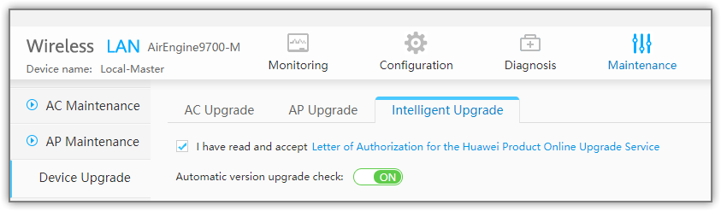
            - After Automatic version upgrade check is enabled, the recommended target software versions are displayed. Click Immediate Upgrade or Scheduled Upgrade to perform an upgrade.
----End

Verifying Patch Installation

Verifying Version Information
CLI
<AC> display patch-information
Patch Package Name :flash:/AirEngine9700-M_V200R022C00SPH001.pat
Patch Package Version :V200R022C00SPC100
The current state is:Running
******************************************************************
* The patch information, as follows *
******************************************************************
------------------------------------------------------------------
VRP Running 15 2022-12-21 15:20:22+08:00
WMI Running 10 2022-12-21 15:20:22+08:00
WMC Running 10 2022-12-21 15:20:22+08:00
NAC Running 5 2022-12-21 15:20:22+08:00
Web System
- Log in to the AC web system and choose Maintenance > Device Upgrade > AC Upgrade. The AC Upgrade page is displayed. Verify Current patch file and Patch file version.
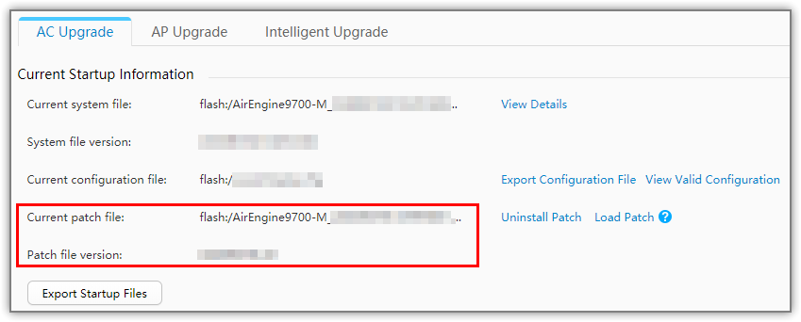
----End

Rolling Back Patch Installation

Guidelines
In the cases that the patch installation fails and a rollback procedure is necessary, perform the following procedure to roll back to the previous state.

Rollback Version and Patch
CLI
- Delete all patches.
<AC> patch delete all
The patch will be deleted. Continue? (y/n)[n]:y
Info: Deleting the patch. Please wait for a moment...
Info: Finished deleting the patch.
            - Check whether the patches have been deleted.
<AC> display patch-information
Info: No patch exists.
The current state is:Idle
            - Install the previous patches.
----End
Web System
- Log in to the AC web system and choose Maintenance > Device Upgrade > AC Upgrade. The AC Upgrade page is displayed.
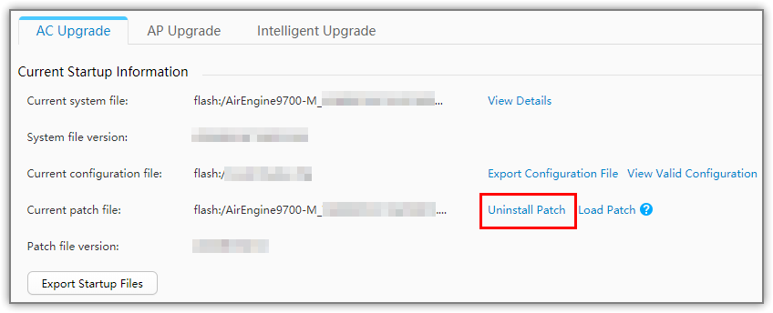
            - Click Uninstall Patch. In the dialog box that is displayed, click OK.
----End

FAQs
Q: When should I restart the device to make the patch take effect?
A: Restart the device if the patch is a cold patch or the restart is mandatory for the patch to take effect according to the patch release notes.
Q: What is a cold patch?
A: A cold patch is a group of new files that are released to fix the known issues or meet new requirements and take effect after the software module is reset. The emergency cold patches are named CPxxxx, and the accumulative cold patches are named SPCxxx.
Q: What is a hot patch?
A: A hot patch is a group of new code that will replace the old code to fix known issues or meet new requirements without interrupting the long-term device operation. The emergency hot patches are named HPxxxx, and the accumulative hot patches are named SPHxxx.
Q: How to identify fully-compiled patch packages and incremental patch packages according to their version number?
A: The patch package name is in SPxabc format, where x indicates whether the patch package is a hot or cold patch package, and bc determines whether the patch package is fully compiled or incremental. The details are as follows:
- When x=C and bc=00, the patch package is a fully-compiled patch package.
- When x=H and bc≠00, the patch package is an incremental hot patch package.
- When x=C and bc≠00, the patch package is an incremental cold patch package.

