HUAWEI VP9660, VP9650, VP9630
V600R019C10SPCd00
 | Upgrade Guide
 | Issue | 02
 | Date | 2022-01-25

 | HUAWEI TECHNOLOGIES CO., LTD. |  | 

Copyright © Huawei Technologies Co., Ltd. 2022. All rights reserved.
No part of this document may be reproduced or transmitted in any form or by any means without prior written consent of Huawei Technologies Co., Ltd.

Trademarks and Permissions
and other Huawei trademarks are trademarks of Huawei Technologies Co., Ltd.
All other trademarks and trade names mentioned in this document are the property of their respective holders.

Notice
The purchased products, services and features are stipulated by the contract made between Huawei and the customer. All or part of the products, services and features described in this document may not be within the purchase scope or the usage scope. Unless otherwise specified in the contract, all statements, information, and recommendations in this document are provided "AS IS" without warranties, guarantees or representations of any kind, either express or implied.
The information in this document is subject to change without notice. Every effort has been made in the preparation of this document to ensure accuracy of the contents, but all statements, information, and recommendations in this document do not constitute a warranty of any kind, express or implied.

Huawei Technologies Co., Ltd.
Address: | Huawei Industrial Base  Bantian, Longgang  Shenzhen 518129  People's Republic of China
Website: | https://e.huawei.com

Contents
1 Before You Start 1
1.1 Impact of the Upgrade 1
1.1.1 Impact on the System During the Upgrade 1
1.1.2 Impact on the System After the Upgrade 1
1.2 Upgrade Paths 2
1.3 Precautions 6
2 Upgrade Process Overview 7
3 Preparing for the Upgrade 9
3.1 Obtaining Software and Reference Documents 9
3.1.1 Obtaining the Upgrade Software 9
3.1.2 Verifying Software Package Integrity 12
3.1.3 Obtaining Upgrade Reference Documents 12
3.2 Performing Pre-upgrade Check 12
3.2.1 Pre-upgrade Checklist 12
3.2.2 Verifying the Device Running Status 13
3.3 Backing Up Data 14
3.3.1 Exporting Data on the Built-in Web Page 14
3.3.2 Exporting a License on the Built-in Web Page 15
3.3.3 Exporting Data by Using the CLI in SSH or Telnet Mode 15
3.4 Obtaining a License File of the Target Version 16
3.4.1 Obtaining a License File in Normal Scenarios 16
3.4.2 Obtaining a License File in Exception Scenarios 17
3.5 Stopping Services Before the Upgrade 17
4 Performing the Upgrade 19
4.1 Upgrading the System Software 19
4.1.1 Upgrading the System Software on the Built-in Web Page 19
4.1.2 Upgrading the System Software by Using the CLI in SSH or Telnet Mode 20
4.1.3 Upgrading the System Software on the SMC2.0 Console 22
4.2 Fully Upgrading 24
4.2.1 Fully Upgrading by Using the Build-in Web Page 24
4.2.2 Fully Upgrading by Using the CLI in SSH or Telnet Mode 26
4.2.3 Upgrading the System Software on the SMC2.0 Console 27
4.3 Importing IVR Files 29
4.3.1 Importing IVR Files on the Built-in Web Page 29
4.3.2 Importing Data by Using the CLI in SSH or Telnet Mode 31
4.4 Importing a License File 32
4.4.1 Importing a License File on the Built-in Web Page 32
4.4.2 Importing Data by Using the CLI in SSH or Telnet Mode 33
5 Verifying Version Compatibility 35
6 Verifying the Upgrade 36
6.1 Verification Checklist 36
6.2 Logging In to the MCU and Checking MCU Alarm Information 36
6.3 (Optional) Verifying that the MCU Is Online on the SMC 37
6.4 Holding a Conference 38
7 Rolling Back to the Source Version 40
7.1 Rolling Back the MCU in a Normal Way 40
7.2 Impact of the Rollback 40
8 Delivery of Associated Documents 41
9 Upgrade Preparation Checklist 42
10 Upgrade Checklist 43
11 Version Rollback Checklist 44
12 Setting Up the FTP Server Upgrade Environment 46
13 MCU Serial Port Settings 55

Before You Start

Impact of the Upgrade
Before upgrading to VP9660 V600R019C10, you need to read this chapter carefully to understand possible impact on the existing system.

Impact on the System During the Upgrade
Impact on Services
During the upgrade, the system load is high, affecting ongoing conferences. Therefore, it is recommended that you upgrade the MCU when there is no conference on the MCU. The upgrade takes effect only after an MCU restart, which interrupts all services for 15 to 30 minutes.
The estimated time for service interruption is as follows:
- HUAWEI VP9630: 15 minutes
- HUAWEI VP9650 (full configuration): 20 minutes
- HUAWEI VP9660 (full configuration): 30 minutes
Impact on Network Communication
Communication between MCU network elements and the network management system (NMS) is normal during the upgrade but is interrupted for 15 to 30 minutes due to an MCU restart. Before the upgrade, inform the NMS personnel of the MCU upgrade time so they know to ignore alarms that are generated within this period.

Impact on the System After the Upgrade
Version | Impact | Solution
Upgrade from V600R006C10 to an above version | The system time may change to a time point in 200X , and need to be corrected manually or through NTP service. After reconfigure time, this problem will no longer occur. | On the main control board, manually configure time on the web page or restart the NTP service to calibrate time on the web page.
Roll Back from a version later than V600R019C10SPC720 to an earlier version. | The SHA256 authentication protocol is added to the SNMP configuration of SPC720. In earlier versions, only SHA1 is supported. Therefore, some configurations will be restored to the default values after the roll back. | Before the downgrade, change the SNMP authentication algorithm to SHA1 on the SMC and MCU, and then perform the downgrade.

Upgrade Paths
Upgrading the MCU from an Earlier Version to a Later Version
Perform the upgrade according to the upgrade paths specified in the table. If the version span between the source version and the target version is large, you need to perform the upgrade multiple times according to the upgrade paths. If a version earlier than V600R019C10SPC610 needs to be upgraded to a version later than V600R019C10SPC610, the source version must be upgraded to V600R019C10SPC610 based on the upgrade path and then to the target version.
                - Upgrade paths
Source Version | Target Version | Upgrade Method | Remarks
V600R006C10 | V600R006C10SPC100 | Use HUAWEI-VP9660-FULL.bin of the target version to perform a full upgrade on the command-line interface (CLI). | -
V600R006C10SPC100 | V600R006C10SPC200 | Use HUAWEI-VP9660-UPGRADE.bin to upgrade the host software to V600R006C10SPC200, and then use HUAWEI-VP9660-FULL.bin of V600R006C10SPC200 to perform the full upgrade of the same version on the CLI. | The first upgrade is to upgrade the host software and hardware drive. The second upgrade is a full upgrade that upgrades the operating system.
V600R006C10SPC200, V600R006C10SPC300, and V600R006C10SPC301 | V600R006C10SPC200, V600R006C10SPC300, and V600R006C10SPC301 | Use HUAWEI-VP9660-UPGRADE.bin of the target version to upgrade the host software to the target version. | HUAWEI-VP9660-UPGRADE.bin can be used for free upgrades among the three versions.
V600R006C10SPC200, V600R006C10SPC300, and V600R006C10SPC301 | V600R006C10SPC400 and later | Use HUAWEI-VP9660-FULL.bin on the CLI to upgrade the MCU to the target version, and then use HUAWEI-VP9660-FULL.bin to perform a full upgrade of the same version. | If you use HUAWEI-VP9660-FULL.bin to perform the upgrade for the first time, you can perform the upgrade only on the CLI. This is because the full upgrade function on the web interface is supported since V600R006C10SPC400.  Since V600R019C00SPC100, HUAWEI-VP9660-UPGRADE.bin is no longer provided and only HUAWEI-VP9660-FULL.bin is provided.
V600R006C10SPC400 and later | V600R006C10SPC400 and later, and V600R019C10SPC610 and earlier | Use HUAWEI-VP9660-FULL.bin of the target version to perform a full upgrade to the target version. | HUAWEI-VP9660-FULL.bin can be used for free upgrades among these versions.
V600R006C10SPC400 and later, and V600R019C10SPC610 and earlier | V600R019C10SPC700 | Use HUAWEI-VP9660-FULL.bin of V600R019C10SPC610 to perform a full upgrade to V600R019C10SPC610, and then use HUAWEI-VP9660-UPGRADE.bin of the target version to perform the upgrade. | A version earlier than V600R019C10SPC610 cannot be directly upgraded to a version later than V600R019C10SPC700. You need to upgrade the source version to V600R019C10SPC610 first and then upgrade it to the target version.
V600R019C10SPC610 and later, and V600R019C10SPC700 and earlier | V600R019C10SPC730 | Use HUAWEI-VP9660-FULL.bin of the target version to perform a full upgrade to the target version. | HUAWEI-VP9660-FULL.bin can be used for free upgrades among these versions.
V600R019C10SPC610 and later, and V600R019C10SPC700 and earlier | V600R019C10SPC750 | Use HUAWEI-VP9660-FULL.bin of the target version to perform a full upgrade to the target version. | HUAWEI-VP9660-FULL.bin can be used for free upgrades among these versions.
V600R019C10SPC610 and later, and V600R019C10SPC750 and earlier | V600R019C10SPC800 | Use HUAWEI-VP9660-FULL.bin of the target version to perform a full upgrade to the target version. | HUAWEI-VP9660-FULL.bin can be used for free upgrades among these versions.
V600R019C10SPC610 and later, and V600R019C10SPC800 and earlier | V600R019C10SPC900 | Use HUAWEI-VP9660-FULL.bin of the target version to perform a full upgrade to the target version. | HUAWEI-VP9660-FULL.bin can be used for free upgrades among these versions.
V600R019C10SPC610 and later, and V600R019C10SPC900 and earlier | V600R019C10SPCc00 | Use HUAWEI-VP9660-FULL.bin of the target version to perform a full upgrade to the target version. | HUAWEI-VP9660-FULL.bin can be used for free upgrades among these versions.
V600R019C10SPC610 and later, and V600R019C10SPCc00 and earlier | V600R019C10SPCd00 | Use HUAWEI-VP9660-FULL.bin of the target version to perform a full upgrade to the target version. | HUAWEI-VP9660-FULL.bin can be used for free upgrades among these versions.

Downgrading the MCU from a Later Version to an Earlier Version
The downgrade or upgrade is actually a version replacement. The operations on the MCU are the same. Therefore, the description in this section does not distinguish between downgrade and upgrade.
Perform the upgrade according to the upgrade paths specified in the table. If the version span between the source version and the target version is large, you need to perform the upgrade multiple times according to the upgrade paths.
                - Upgrade paths
Source Version | Target Version | Upgrade Method | Remarks
V600R006C10SPC400 and later | V600R006C10SPC400 and later | Use HUAWEI-VP9660-FULL.bin of the target version to perform a full upgrade to the target version. | HUAWEI-VP9660-FULL.bin can be used for free upgrades among these versions.
V600R006C10SPC400 and later | V600R006C10SPC200  V600R006C10SPC300  V600R006C10SPC301 | Use HUAWEI-VP9660-FULL.bin of the target version to perform a full upgrade to the target version.
V600R006C10SPC200, V600R006C10SPC300, and V600R006C10SPC301 | V600R006C10SPC200, V600R006C10SPC300, and V600R006C10SPC301 | Use HUAWEI-VP9660-UPGRADE.bin of the target version to upgrade the host software to the target version. | HUAWEI-VP9660-UPGRADE.bin can be used for free upgrades among the three versions.
V600R006C10SPC200 | V600R006C10SPC100 | First, use HUAWEI-VP9660-FULL.bin of V600R006C10SPC200 to perform the full upgrade of the same version. (Skip this step if the MCU is upgraded from V600R006C10SPC100 by strictly according to the upgrade procedure in the previous section.)  Then, use HUAWEI-VP9660-FULL.bin of the V600R006C10SPC100 to perform the full upgrade on the CLI. Next, use HUAWEI-VP9660-UPGRADE.bin to upgrade the host software of the same version. | To upgrade V600R006C10SPC300/V600R006C10SPC301 to V600R006C10SPC100, upgrade it to the intermediate version V600R006C10SPC200 first.  There are many prerequisites, complicated operations, and error-prone procedures. You are not advised to perform a downgrade to V600R006C10SPC100.
V600R006C10SPC100 | V600R006C10 | The upgrade is not supported.

Precautions
- If you perform the upgrade in command-line interface (CLI) mode, the CLI tool must support SHA256 and SHA512 encryption. Before using the CLI tool to log in, ensure that SHA256 and SHA512 are selected.
- Communication between MCU network elements and the NMS is normal during the upgrade but is interrupted for 5 to 6 minutes due to an MCU restart. Before the upgrade, inform the NMS personnel of the MCU upgrade time so they know to ignore alarms that are generated within this period.
- If the device is abnormal due to misoperations during the upgrade, such as restart, power-off, or board removal, you need to upgrade the MCU again to recover it.

Upgrade Process Overview
              - Upgrade flowchart
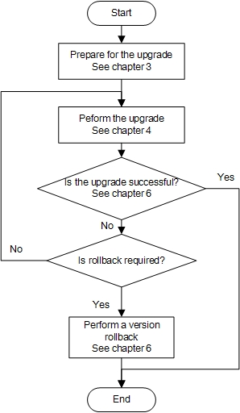

Table 2-1 describes the time required for each procedure, which is an estimate and for reference only.
                - Estimated upgrade schedule
Procedure | Recommended Start Time | Time Required (Minutes) | Remarks
Obtain upgrade software and reference documents. | Before the upgrade | About 15 minutes | -
Perform the pre-upgrade check. | Before the upgrade | About 15 minutes | -
Back up data. | Before the upgrade | About 5 minutes | -
Obtain the license file. | Before the upgrade | - | Obtain the license file before deployment.
Stop services before the upgrade. | Before the upgrade | About 5 minutes | Stop services if a conference is being held on the MCU.
Upgrade the system software. | During upgrade | About 25 minutes | -
Import the IVR file. | During upgrade | About 25 minutes | -
Import the license file. | During upgrade | About 5 minutes | -
Verify the upgrade. | After the upgrade | About 20 minutes | -


For details about the upgrade preparation checklist, upgrade checklist, and version rollback preparation checklist, see section A "Upgrade Preparation Checklist," B "Upgrade Checklist," C "Version Rollback Checklist."

Preparing for the Upgrade

Obtaining Software and Reference Documents

Obtaining the Upgrade Software
Table 3-1 lists the software package and digital signature file that you must download from the Huawei Support-E website before the upgrade. Obtain the digital signature file when obtaining the upgrade package.
To obtain the software package, visit https://support.huawei.com/enterprise/en/index.html. Enter VP9660 in the search box and choose VP9660 from the drop-down list box, as shown in Figure 3-1. Click Software Download to browse or obtain the software of the mapping version, as shown in Figure 3-2.
              - VP9660 entered
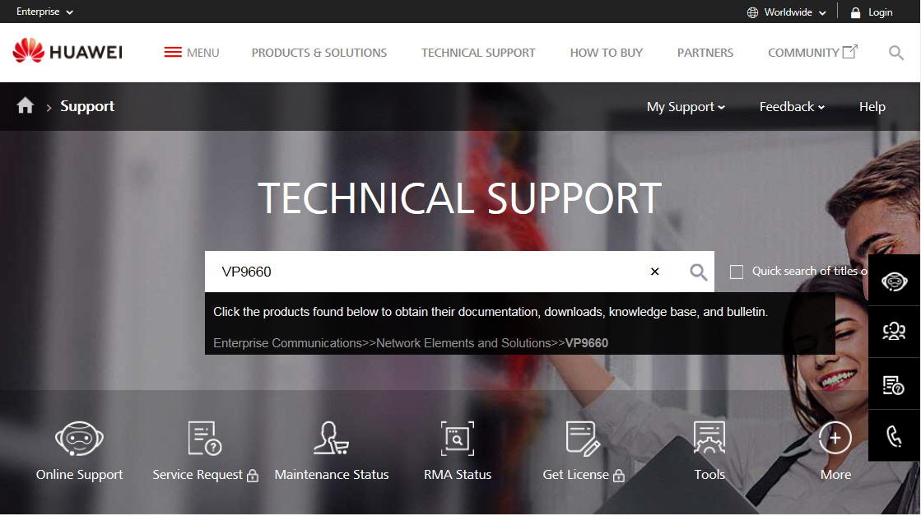

              - Clicking Software Download
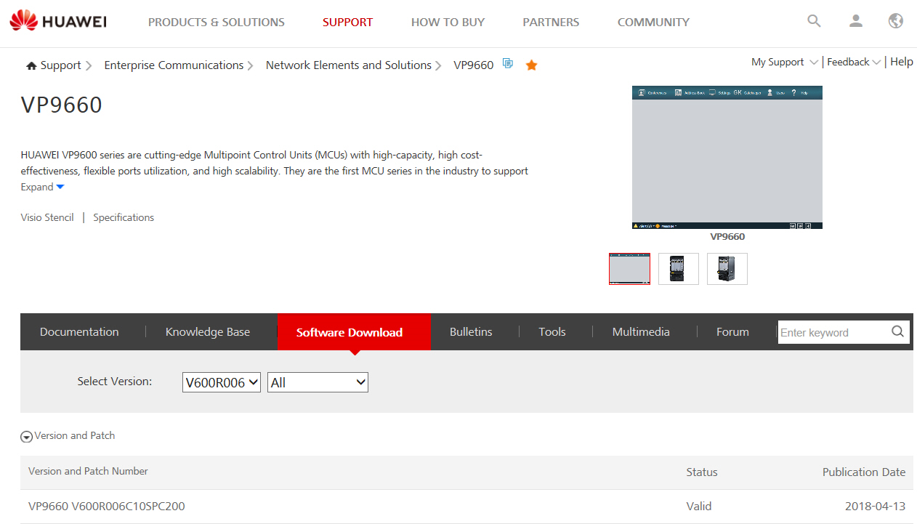

                - Basic information about the upgrade package
Type | Software Package | Size (Byte) | Digital Signature File
VP9660 software upgrade package for the EC solution | HUAWEI-VP9660-FULL_EC.zip | The actual size is subject to the file that you downloaded. | HUAWEI-VP9660-FULL.zip.asc

The iManagerM2000_VP9660_MATCH.zip package is used only when the VP9660 is to interconnect with the IMS network management system.

Verifying Software Package Integrity
To prevent a software package from being maliciously tampered with during transmission or storage, download the corresponding digital signature file for integrity verification when downloading the software package
After the software package is downloaded, verify its PGP digital signature according to the OpenPGP Signature Verification Guide. If the software package fails the verification, do not use the software package, and contact Huawei technical support engineers.
Before a software package is used in installation or upgrade, its digital signature also needs to be verified according to the OpenPGP Signature Verification Guide to ensure that the software package is not tampered with.
Visit either of the following websites to obtain the OpenPGP Signature Verification Guide:
- Carrier customers: https://support.huawei.com/carrier/digitalSignatureAction
- Enterprise customers: https://support.huawei.com/enterprise/en/tool/pgp-verify-TL1000000054

Obtaining Upgrade Reference Documents
- Log in to http://support.huawei.com/enterprise.
You must apply for the rights to download the software packages and reference document at http://support.huawei.com/enterprise.
            - In the search text box, enter VP9660, choose VP9660, and query or obtain the documents for upgrade to the corresponding version. For details about how to use commands to perform upgrade, see the VP9660 V600R019C10 Command Reference.
----End

Performing Pre-upgrade Check

Pre-upgrade Checklist
                - Pre-upgrade checklist of Huawei VP9660, VP9650, and VP9630
Item | Expected Result | Time Required
Check the device software version number, CPU usage, memory usage, and running status. | - The MCU software version number is VP9660 V600R006C10 or later.  - If there is no conference, the CPU usage and memory usage are equal to or less than 90%.  - The MCU is running properly. | About 10 minutes

Time required varies according to the environment (such as onsite data volume and server performance).

Verifying the Device Running Status
Procedure
- Use the computer to connect to the MCU as follows: Open the browser, enter the MCU IP address in the address box, press Enter, and go to the built-in web login page of the MCU.
It is recommended that the browser be used to access the MCU. You can also access the MCU in SSH or Telnet mode and run the display cpu-mem-usage command to check memory usage.
            - On the login page, enter the user name and password and click the login button. The default user name and password are admin and Change_Me respectively.
            - On the right of the web home page, check the system version number.
            - On the lower part of the web home page, verify that the CPU usage and memory usage of the first board are equal to or less than 90%.
            - Check whether the MCU indicator is running properly.
----End
Expected Result
- The found version number is later than the basic version HUAWEI VP9660 V600R006C10.
- The CPU usage and memory usage are equal to or less than 90%.
- The alarm indicator on each MCU board is blinking green.
Troubleshooting
- If the version is earlier than V600R006C10, contact R&D engineers to check whether the version can be upgraded.
- If the CPU usage and memory usage of the MCU are high, terminate the conference, restart the MCU, and perform upgrade.

Backing Up Data
User data compatibility is maintained during upgrade of Huawei VP9660, Huawei VP9650, and Huawei VP9630. However, to ensure data security and prevent faults such as hardware faults, you are advised to back up the configuration in advance.
Generally, backup data does not need to be re-imported to the MCU because software automatically ensures data compatibility.

Exporting Data on the Built-in Web Page
Prerequisites
The MCU server can be pinged on the local host.
Procedure
- On a computer, open a browser, enter the IP address of the MCU in the address box, and press Enter. On the login page, enter the user name and password. (The default user name and password are admin and Change_Me respectively.)
            - Choose Maintenance > Configuration. On the Configuration page that is displayed, export the current configuration or download the configuration file that is automatically backed up.
              - Exporting the configuration
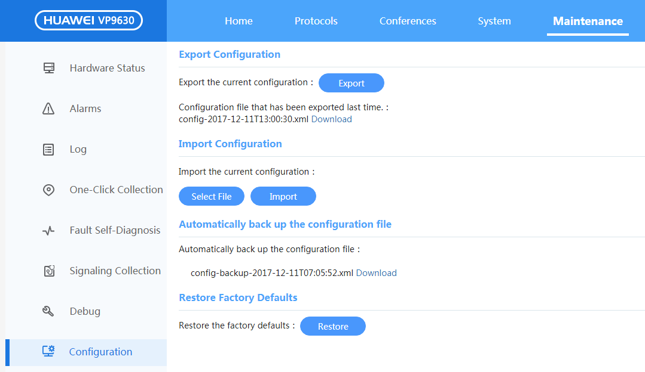

            - Verify that the browser automatically downloads the exported configuration file.
----End

Exporting a License on the Built-in Web Page
Prerequisites
The MCU server can be pinged on the local host.
Procedure
- On a computer, open a browser, enter the IP address of the MCU in the address box, and press Enter. On the login page, enter the user name and password. (The default user name and password are admin and Change_Me respectively.)
            - Choose System > License. On the License page that is displayed, click Export next to Export the current license.
              - Export the license
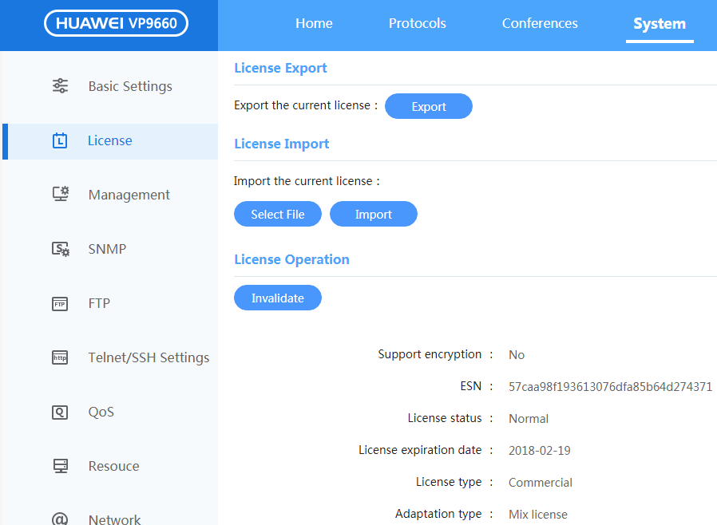

            - Verify that the browser automatically downloads the exported license file.
----End

Exporting Data by Using the CLI in SSH or Telnet Mode
Prerequisites
- The FTP server has been set up, and parameters have been set. For details, see section D "Setting Up the FTP Server Upgrade Environment."
- The MCU server can be pinged on the local host.
Procedure
- Enter the user name and password (for example, administrator and Change_Me, respectively) and log in to the system in SSH or Telnet mode.
            - Run the system-view ftp-server command to configure the IP address of the FTP server and save the configuration for the configuration to take effect. In this case, you need to ensure that the FTP server is available.
<HUAWEI VP9660>system-view ftp-server
ftp server ip addr[192.168.1.122]:
user name{max len:32}[9660]:
user password{string, max len:32}[******]:
Info:set the Ftp server config finish!
            - In the root directory, enter upgrade and enter export at the prompt [HUAWEI VP9660-upgrade]. If the root certificate of the FTP server is not uploaded on the web page, a message is displayed indicating that the FTP server is untrusted. In this case, import the root certificate of the FTP server for upgrade on the web page or directly enter y to ignore the message. Select the software content to be exported as prompted.
            - After the export is successful, save the file in the directory on the FTP server.
----End

Obtaining a License File of the Target Version
The validity period of the MCU commercial license is not limited. Generally, you do not need to import a license file.
If only the upgrade is performed but the capacity is not expanded, no new license file needs to be imported. If both the upgrade and capacity expansion are performed, a new license file needs to be imported.

Obtaining a License File in Normal Scenarios
In normal scenarios, the license file is obtained when orders exist. (Orders have been placed, and the FNO has captured orders from the ERP.) To obtain the license file, perform the following steps:
- Apply for an account of Huawei license system at http://app.huawei.com/isdp/. If an account has been obtained, skip this step.
            - Extract the ESN from the device where the license file needs to be installed.
            - Obtain the activation ID or LAC from the license certificate (generally delivered with the product).
            - Log in to Huawei license system at http://app.huawei.com/isdp/, enter the activation ID to find the unique license record, click the license record, enter the ESN to activate the license record, and download the license file to the local host.
----End

Obtaining a License File in Exception Scenarios
In exception scenarios generally where the license file needs to be obtained when the order process is not triggered, license file obtaining needs to be reviewed. Therefore, you need to apply for the license in advance. For details, see the HUAWEI VP96x0&VP86x0 MCU License Application Guide that can be obtained at http://support.huawei.com/enterprise. Figure 3-4 shows the method of obtaining the document. Currently, the following scenarios are involved. License file obtaining in the following scenarios is described:
- Original site migration to Huawei platform
- Quotation template problems, for example, in which the contract is inconsistent with the license file or the product is delivered with a contract but without a license
- Commercial temporary license required when the customer wants to use the product in trial before purchasing, the customer requires the product urgently after signing a contact and before the contract process is completed, or the customer wants to use the product before paying.
              - HUAWEI VP96x0&VP86x0 License Application Guide
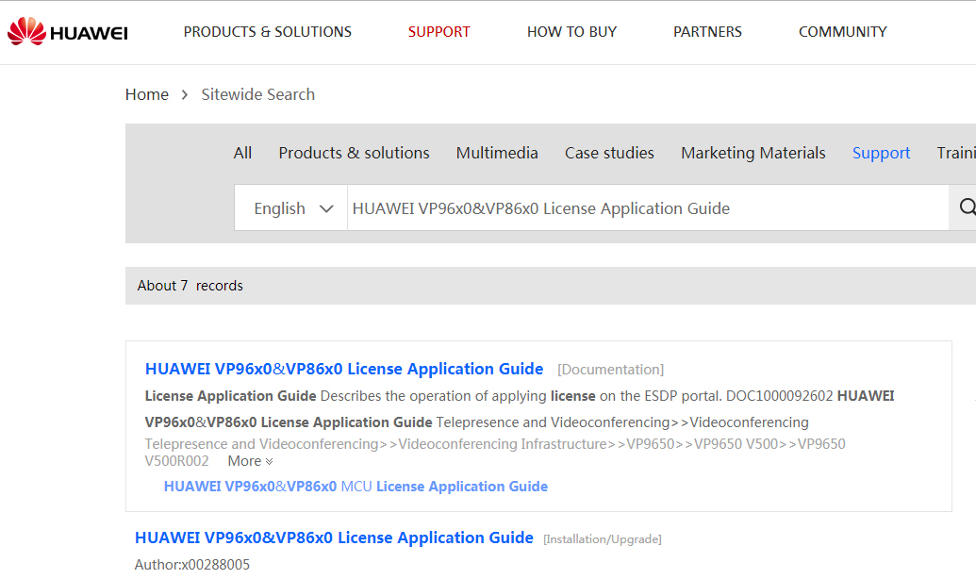

Stopping Services Before the Upgrade
Procedure
- Log in to the SMC.
            - Open the conference list on the SMC.
            - Select conferences one by one on the SMC and check for MCUs to be upgraded in the MCU list of each conference. If MCUs of a conference need to be upgraded, terminate the conference.
----End

Performing the Upgrade

Upgrading the System Software
For V600R019C00SPC100 and later versions, and V600R019C10SPC610 and earlier versions, no independent upgrade package is provided for upgrading the host software. If you want to upgrade to these versions, see 4.2 Fully Upgrading.
The MCU provides the following system software upgrade modes: built-in web page, CLI, and SMC2.0 console. A user can select a mode based on the site requirements.

Upgrading the System Software on the Built-in Web Page
Prerequisites
The MCU server can be pinged on the local host.
Procedure
- On a computer, open a browser, enter the IP address of the MCU in the address box, and press Enter. On the login page, enter the user name and password. (The default user name and password are admin and Change_Me respectively.)
            - Choose Maintenance > Upgrade. On the Upgrade page that is displayed, click Select File on the left, select the HUAWEI-VP9660-FULL.bin file, and click Upgrade to start upgrade, as shown in Figure 4-1
              - MCU upgrade
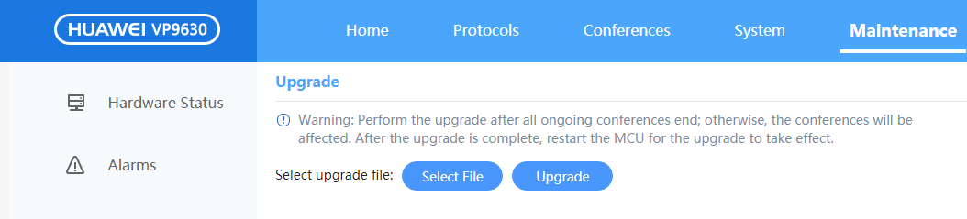

            - On the upgrade confirmation page that is displayed after the file is uploaded, click OK, as shown in Figure 4-2
              - Upgrade confirmation window
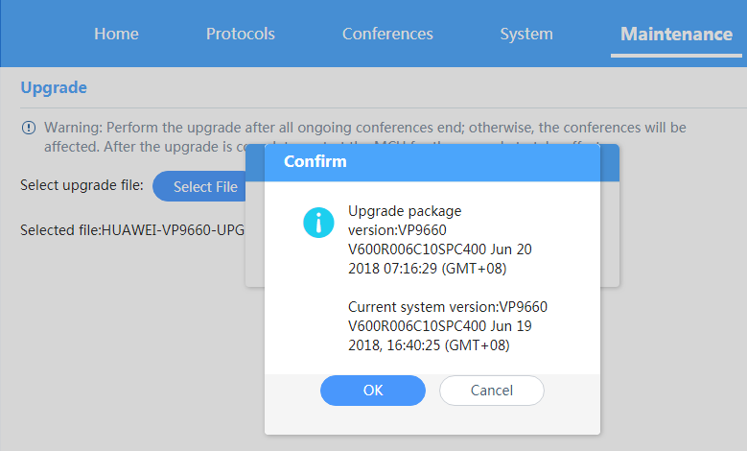

            - Wait until the system restarts after the upgrade is completed.
After the MCU restarts, the new version is running properly.
----End
Verification
Check whether the MCU version number is the same as the target version number as follows:
- (Recommended) Use the computer to connect to the MCU, open a browser, enter the user name and password, and log in to the MCU web page.
            - Check whether the version number on the right of the home page is the target version number.
----End
Troubleshooting
If the system upgrade fails, check the causes as prompted on the built-in web page.
For example, if information on the built-in web page indicates that upgrade times out, upgrade the software again. If the upgrade still fails, restart the MCU and perform upgrade again.

Upgrading the System Software by Using the CLI in SSH or Telnet Mode
Prerequisites
- The FTP server has been set up and parameters have been set. For details, see section D "Setting Up the FTP Server Upgrade Environment."
- The FTP server is available, and the directory on the FTP server contains the HUAWEI-VP9660-FULL.bin file of the corresponding version.
Procedure
- Log in to the MCU main control board in SSH or Telnet mode and enter the user name and password (for example, administrator and Change_Me).
            - Run the system-view ftp-server command to configure the IP address of the FTP server in the root directory.
<HUAWEI VP9660>system-view ftp-server
ftp server ip addr[192.168.11.200]:
user name{max len:32}[mcu]:
user password{string, max len:32}[******]:
Info:set the Ftp server config finish!
            - In the root directory, run upgrade, enter upgrade at the prompt HUAWEI VP9660-upgrade, and then enter the ID of the board to be upgraded. If you enter 10, all boards will be upgraded. No board ID needs to be entered for VP9630. If you choose to upgrade a single board, then you are asked to choose which part of software to upgrade. Normally ,enter 0 to upgrade the whole software system.
<HUAWEI VP9660(upgrade)>upgrade
ftp server information:
Ftp server ip address : 192.168.1.200
Ftp server port : 21
Ftp server user name : mcu_v6r6
Ftp server user password : ******
Info:Check FTPS server's certificate failed.
This FTP server is untrusted.
Are you sure to continue downloading file from this untrusted FTP server? ?(y/n):y
online board is:[0] [1] [2] [6] [8]
please input board id[0-9, 10:All]:10
Current Version :VP9660 V600R006C10SPC400 Jun 19 2017 16:40:25
Target Version :VP9660 V600R019C10 Jan 20 2019 07:16:29
Info:board will reboot automatically after upgrade success,are you sure to upgrade the software?(y/n):
            - After the upgrade is successful, the MCU will automatically reboot. Then the new version takes effect and starts running.
----End
Verification
Check whether the MCU version number is the same as the target version number as follows:
- Log in to the MCU main control board in SSH or Telnet mode by using the CLI and enter display version.
            - Verify that the version number displayed in the text information is the target version number
<HUAWEI VP9660>display versionBoard 1:
HCCA PCB Version: A
HCCA PCB-BOM Version: 0
Main CPLD Version: 17032501
Main FPGA Version: 17040701
CPU 0: main-node-id:1000 media-node-id:1008
BIOS 0 Version: LOG-iWare uniBIOS V100R007C30 07/12/2017 10:30:00
BIOS 1 Version: LOG-iWare uniBIOS V100R007C30 07/12/2017 10:30:00
BIOS 0 Me Version: Consumer_11.0.18.1002
BIOS 1 Me Version: Consumer_11.0.18.1002
MCU(x86_64) Version :VP9660 V600R019C10 Jan 20 2019 2018, 07:16:29 (GMT+08)
<HUAWEI VP9660>
----End
Troubleshooting
If the upgrade fails, check the causes based on the error information displayed by the CLI.
For example, if the error information indicates that the upgrade user name or password is incorrect, you need to ensure that the FTP user name and password configured on the MCU are consistent with those on the FTP server. For details, see section D "Setting Up the FTP Server Upgrade Environment."

Upgrading the System Software on the SMC2.0 Console
Prerequisites
The solution works on SMC2.0 networking.
The MCU is added on the SMC2.0 as a manageable MCU and is online.
Procedure
- Upload software.
- Upload software on the SMC2.0. Choose Devices > Updates > Software Management. The Software Management page is displayed, as shown in Figure 4-3.
              - Software Management page
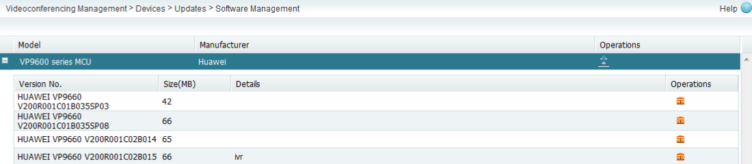

- Click in the row displaying the device for which you want to add a software version.
- In the dialog box that is displayed, select HUAWEI-VP9660-FULL.zip to be imported. After the file is imported, click Finish, as shown in Figure 4-4.
              - File upload
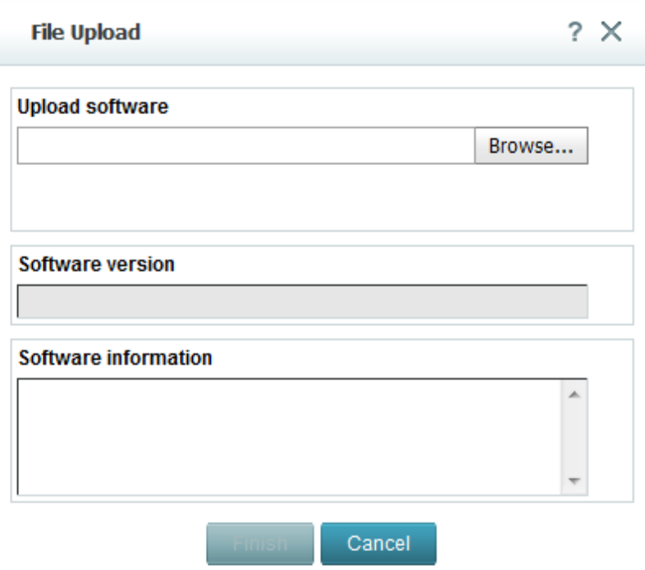

            - Upgrade software.
- Choose Devices > Upgrade > Update Participant/MCU. Click MCU at the upper left corner to switch to the MCU list and click Update at the upper right corner.
- Wait for 15 to 30 minutes until the upgrade status changes to Update succeeded, as shown in Figure 4-5.
              - Update succeeded
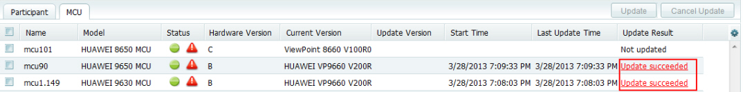

----End
Verification
Check whether the MCU version number is the same as the target version number as follows:
- (Recommended) Open Internet Explorer, enter the user name and password, and log in to the built-in web page of the MCU.
            - Check whether the system version number is the target version number
----End
Troubleshooting
If the upgrade fails, check the causes based on the fault information on the web page.
For example, if information on the built-in web page indicates that upgrade times out, upgrade the software again. If the upgrade still fails, restart the MCU and perform upgrade again.

Fully Upgrading
Fully upgrading will upgrade the operating system as well as the system software. It can only be performed by using the CLI.

Fully Upgrading by Using the Build-in Web Page
Prerequisites
The local host can ping the MCU server.
The MCU version is V600R006C10SPC400 or later, V600R019C10SPC610 or earlier. (The MCU can perform the fully upgrading using the built-in web page since V600R006C10SPC400.)
Procedure
- On a PC, open a browser, enter the IP address of the MCU in the address box, and press Enter. On the login page, enter the user name and password. (The default user name and password are admin and Change_Me separately.)
            - Choose Maintenance > Upgrade. The MCU upgrade page is displayed. Click Select File, select HUAWEI-VP9660-FULL.bin, and click Upgrade, as shown in
              - MCU upgrade page

            - Click OK in the windows displayed after the file is uploaded. The upgrade starts. If you click Cancel, the upgrade is paused.
              - Upgrade confirmation window

            - Veryfy that the system automatically restart after the upgrade.
The new version takes effect when the restart is complete.
----End
Verification
Check whether the MCU version number is the same as the target version number as follows.
- Open a browser, enter the IP address of the MCU in the address box, and press Enter. On the login page, enter the user name and password to log in to the web page(recommended).
            - Verirgy that the version information displayed on the right of the home page is the target version.
----End
Troubleshooting
If the upgrad fails, check the causes based on the error information displayed
For example, if the upgrade times out, retry. If the upgrade still fails, restart the MCU and retry.

Fully Upgrading by Using the CLI in SSH or Telnet Mode
Prerequisites
- The FTP server has been set up and parameters have been set. For details, see section D "Setting Up the FTP Server Upgrade Environment."
- The FTP server is available, and the directory on the FTP server contains the HUAWEI-VP9660-FULL.bin file of the corresponding version.
Procedure
- Log in to the MCU main control board in SSH or Telnet mode and enter the user name and password (for example, administrator and Change_Me).
            - Run the system-view ftp-server command to configure the IP address of the FTP server in the root directory.
<HUAWEI VP9660>system-view ftp-server
ftp server ip addr[192.168.11.200]:
user name{max len:32}[mcu]:
user password{string, max len:32}[******]:
Info:set the Ftp server config finish!
            - In the root directory, run upgrade, enter osupgrade at the prompt HUAWEI VP9660-upgrade, and then enter the ID of the board to be upgraded. No board ID needs to be entered for VP9630.
If you enter 10, all boards will be upgraded.
<HUAWEI VP9630(upgrade)>osupgrade
ftp server information:
Ftp server ip address : 192.168.1.200
Ftp server port : 21
Ftp server user name : mcured
Ftp server user password : ******
Info:Check FTPS server's certificate failed.
This FTP server is untrusted.
Are you sure to continue downloading file from this untrusted FTP server? ?(y/n):y
Current Version :VP9660 V600R006C10SPC400 Jun 19 2017 16:40:25
Target Version :VP9660 V600R019C10 Jan 20 2019 07:16:29
Info:are you sure to upgrade mcu os?(y/n):
            - After the upgrade is successful, the MCU will automatically reboot. Then the new version takes effect and starts running.
----End
Verification
Check whether the MCU version number is the same as the target version number as follows:
- Log in to the MCU main control board in SSH or Telnet mode by using the CLI and enter display version.
            - Verify that the version number displayed in the text information is the target version number
<HUAWEI VP9660>display versionBoard 1:
HCCA PCB Version: A
HCCA PCB-BOM Version: 0
Main CPLD Version: 17032501
Main FPGA Version: 17040701
CPU 0: main-node-id:1000 media-node-id:1008
BIOS 0 Version: LOG-iWare uniBIOS V100R007C30 04/28/2017 17:30:00
BIOS 1 Version: LOG-iWare uniBIOS V100R007C30 04/28/2017 17:30:00
BIOS 0 Me Version: Consumer_11.0.18.1002
BIOS 1 Me Version: Consumer_11.0.18.1002
MCU(x86_64) Version: VP9660 V600R019C10 Jan 20 2019, 07:16:29 (GMT+08)
<HUAWEI VP9660>
----End
Troubleshooting
If the upgrade fails, check the causes based on the error information displayed by the CLI.
For example, if the error information indicates that the upgrade user name or password is incorrect, you need to ensure that the FTP user name and password configured on the MCU are consistent with those on the FTP server. For details, see section D "Setting Up the FTP Server Upgrade Environment."

Upgrading the System Software on the SMC2.0 Console
Prerequisites
The solution works on SMC2.0 networking.
The MCU is added on the SMC2.0 as a manageable MCU and is online.
Procedure
- Upload software.
- Upload software on the SMC2.0. Choose Devices > Updates > Software Management. The Software Management page is displayed, as shown in Figure 4-8.
              - Software Management page

- Click in the row displaying the device for which you want to add a software version.
- In the dialog box that is displayed, select HUAWEI-VP9660-FULL.bin to be imported. After the file is imported, click Finish, as shown in Figure 4-9.
              - File upload

            - Upgrade software.
- Choose Devices > Upgrade > Update Participant/MCU. Click MCU at the upper left corner to switch to the MCU list and click Update at the upper right corner.
- Wait for 15 to 30 minutes until the upgrade status changes to Update succeeded, as shown in Figure 4-10.
              - Update succeeded

----End
Verification
Check whether the MCU version number is the same as the target version number as follows:
- (Recommended) Open Internet Explorer, enter the user name and password, and log in to the built-in web page of the MCU.
            - Check whether the system version number is the target version number
----End
Troubleshooting
If the upgrade fails, check the causes based on the fault information on the web page.
For example, if information on the built-in web page indicates that upgrade times out, upgrade the software again. If the upgrade still fails, restart the MCU and perform upgrade again.

Importing IVR Files
IVR files can be imported using the built-in web page, CLI, and SMC2.0 console.

Importing IVR Files on the Built-in Web Page
Prerequisites
The MCU server can be pinged on the local host.
Procedure
- On a computer, open a browser, enter the IP address of the MCU in the address box, and press Enter. On the login page, enter the user name and password. (The default user name and password are admin and Change_Me respectively.)
            - Choose Maintenance > Import. On the Import page that is displayed, set the to-be-imported file type to audio/video IVR. Click Select File. In the file browser that is displayed, select the audio or video IVR compression package to be imported. Click Import, as shown in Figure 4-11.
              - Importing IVR files
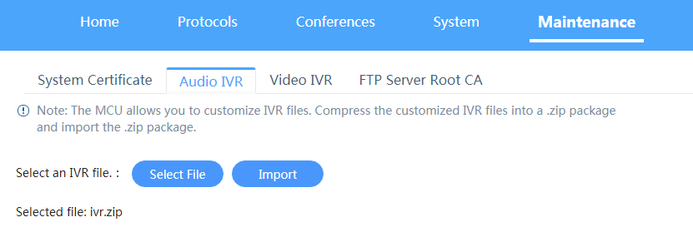

            - Wait until the import is successful and the system prompts you to restart the MCU, as shown in Figure 4-12.
              - Import confirmation
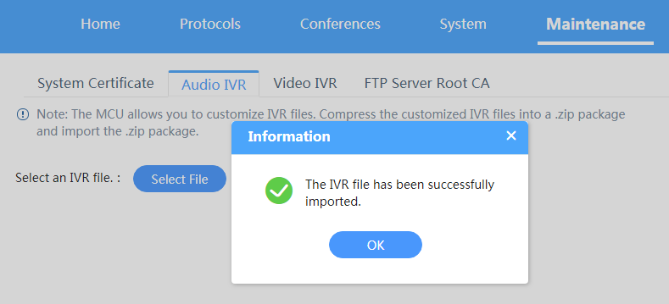

            - Restart the MCU, as shown in Step 4
              - Restarting the MCU
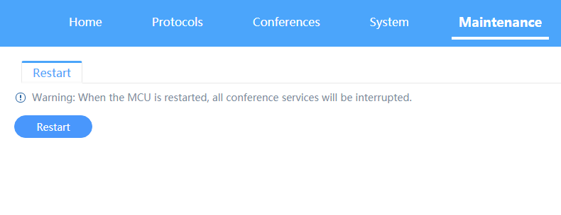

----End
Verification
Hold a conference and check whether the IVR announcement is properly played.
- Schedule a conference and add two participants in SIP or H.323 mode.
            - Hold a conference and check for IVR announcements that are properly played on the terminal.
----End
Troubleshooting
If the import fails, check the causes based on the fault information on the web page.
For example, if information on the built-in web page indicates that import times out, import data again. If the import still fails, restart the MCU and perform import again.

Importing Data by Using the CLI in SSH or Telnet Mode
Prerequisites
The FTP server has been set up and parameters have been set. For details, see section D "Setting Up the FTP Server Upgrade Environment."
Procedure
- Enter the user name and password (for example, administrator and Change_Me, respectively) and log in to the MCU main control board in SSH or Telnet mode.
            - Run the system-view ftp-server command to configure the IP address of the FTP server. (You need to ensure that the FTP server is available and that mcu-ivr.zip has been copied to the FTP directory.)
<HUAWEI VP9660>system-view ftp-server
ftp server ip addr[192.168.1.122]:
user name{max len:32}[9660]:
user password{string, max len:32}[******]:
Info:set the Ftp server config finish!
            - In the root directory, enter upgrade, enter import at the prompt [HUAWEI VP9660-upgrade], and select software content to be loaded as prompted.
            - After the import is successful, run the reboot command to restart the MCU.
----End
Verification
Hold a conference and check whether the IVR announcement is properly played.
- Schedule a conference and add two participants in SIP or H.323 mode.
            - Hold a conference and check for IVR announcements that are properly played on the terminal.
----End
Troubleshooting
If the import fails, check the causes based on the fault information on the web page.
For example, if information on the built-in web page indicates that import times out, import data again. If the import still fails, restart the MCU and perform import again.

Importing a License File
A license file can be imported using the web page or CLI.

Importing a License File on the Built-in Web Page
Prerequisites
The web page of the MCU can be connected.
Procedure
- On a computer, open a browser, enter the IP address of the MCU in the address box, and press Enter. On the login page, enter the user name and password. (The default user name and password are admin and Change_Me respectively.)
            - Choose System > License. The License page is displayed. Click Select File. In the file browser that is displayed, select the license.dat file to be imported. Click Import to import files, as shown in Figure 4-14.
              - Importing a license file
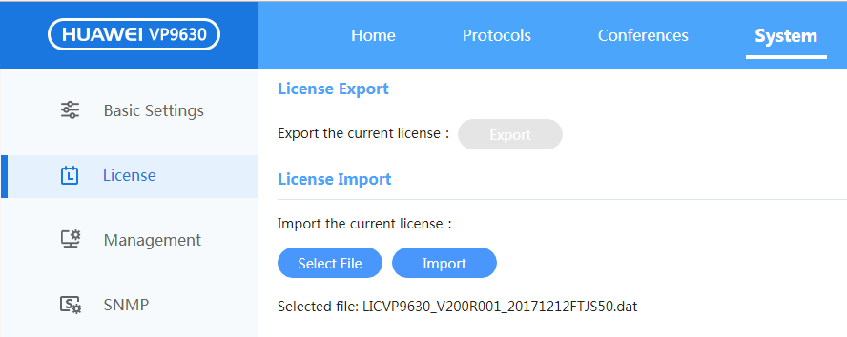

            - Wait until the following dialog box is displayed indicating that the import is successful, as shown in Figure 4-15. Then, the license can be used.
              - Import succeeded.
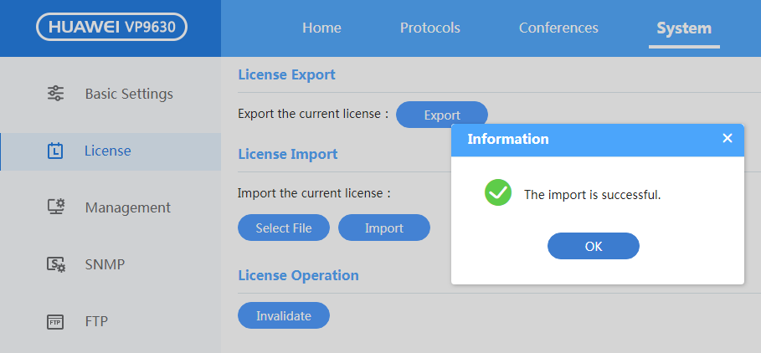

----End
Verification
After a license file is imported, check whether the license of the MCU is properly parsed.
- Log in to the web management page of the MCU, choose System > License, and check whether the number of licensed ports is as expected.
            - Schedule a conference and add two participants in SIP or H.323 mode. The conference can be held properly.
----End
Troubleshooting
If the import fails, check the causes based on the fault information on the web page.
For example, if the fault information indicates that the imported ESN is not matched, you need to verify that the license is that of the MCU and import the license file again. The license is applied for based on the ESN.

Importing Data by Using the CLI in SSH or Telnet Mode
Prerequisites
The FTP server has been set up and parameters have been set. For details, see section "Setting Up the FTP Server Upgrade Environment."
Procedure
- Enter the user name and password (for example, administrator and Change_Me, respectively) and log in to the MCU main control board in SSH or Telnet mode.
            - Run the system-view ftp-server command to configure the IP address of the FTP server. (You need to ensure that the FTP server is available and that license.dat has been copied to the FTP directory.)
<HUAWEI VP9660>system-view ftp-server
ftp server ip addr[192.168.1.122]:
user name{max len:32}[9660]:
user password{string, max len:32}[******]:
Info:set the Ftp server config finish!
            - In the root directory, enter upgrade, enter import at the prompt [HUAWEI VP9660-upgrade], and select 100: license.dat as prompted.
            - After the import is successful, run the reboot command to restart the MCU.
----End
Verification
- Log in to the web page of the MCU, choose System > License, and check whether the number of licensed ports is as expected.
            - Schedule a conference and add two participants in SIP or H.323 mode. The conference can be held properly.
----End
Troubleshooting
If the import fails, check the causes based on the fault information on the web page.
For example, if the fault information indicates that the imported ESN is not matched, you need to verify that the license is that of the MCU and import the license file again. The license is applied for based on the ESN.

Verifying Version Compatibility
On the SMC2.0 networking, when the version of a main control board is V600R006C10SPC200 or later, mixed insertion of a service board of V500R002C10 or later is supported. For each main control board of the version later than V600R006C10SPC200, a unique V500 service board is matched. When the service board version and main control board version are not matched, the service board is automatically upgraded.
When several service boards of V500R002C10 can be added to a VP9660/VP9650 of V600R006V100C10SPC200, the MCU needs to be restarted to identify the V500 board. After the MCU restarts, the V500 board is automatically upgraded. After the upgrade, the V500 board is online. The upgrade may fail. If the upgrade fail, No. 179 alarm can be found on the main board, indicating that proactive upgrade of multiple boards fails. You need to manually upgrade the V500 board on the main control board. For details, see
4.1.2 Upgrading the System Software by Using the CLI in SSH or Telnet Mode. After the upgrade, you need to restart the MCU.

Verifying the Upgrade

Verification Checklist
Table 5-1 lists the verification checklist for basic features.
                - Verification checklist for basic features
No. | Item | Expected Result | Actual Result
1 | 6.2 Logging In to the MCU and Checking MCU Alarm Information | - You can log in to the MCU through the web interface and CLI.  - No alarm is generated. | -
2 | 6.3 (Optional) Verifying that the MCU Is Online on the SMC | The MCU is online on the SMC. | -
3 | 6.4 Holding a Conference | The conference is held, and audio and video functions are available. | -

Logging In to the MCU and Checking MCU Alarm Information
Procedure
- On the local computer, open a web browser, enter the IP address of the MCU main control board, and press Enter. Verify that the login page is displayed.
            - On the login page that is displayed, enter the user name and password and click Log In. Verify that the login is successful.
The default user name is admin, and the default password is Change_Me.
            - Open the CLI. Log in to the MCU through SSH or Telnet with your user name and password, for example, user and Change_Me. Run the display version command and verify that the command runs successfully.
            - Wait 5 minutes and check whether any alarm information is generated.
If no alarm information is generated, the MCU system is running properly.
----End
Expected Result
You can log in to the MCU web interface using a web browser and access the MCU CLI using SSH and perform operations properly.
Troubleshooting
- If a network fault occurs, run the ping IP address of the MCU main control board command to check the network connection between your computer and the MCU. If the IP address cannot be pinged, connect your computer to the MCU through the serial port and verify that the IP address of the MCU main control board is correct.
- If you can log in to the built-in web page, collect and export one-click diagnosis information of the MCU and send the information to R&D engineers for analysis.
If you can log in to the system in SSH mode, configure FTP by referring to en-us_topic_0041799071.xml, run the diagnose diagnose command to collect one-click diagnosis information, run the upgrade export command to export the one-click diagnosis information as a file, and send the file to R&D engineers for analysis.
If you cannot log in using either of the preceding methods, check the MCU status at the serial ports in the equipment room. If the ports are connected, export logs through the ports and send the logs to R&D engineers for analysis.
Configuration Notes When the MCU Works with the IMS
If the MCU needs to work with the IMS, add the MRFC IP address to the MCU's whitelist. To add the MRFC IP address to the MCU's whitelist, perform the following steps:
- Connect to the MCU through Telnet or SSH and enter the user name and password.
            - Run the display snmp-connect-ipconfig command to check whether the MRFC IP address has been added to the whitelist.
            - Run the system-view snmp-connect-ipconfig command to manually add the MRFC IP address to the whitelist and run the save command to save the configuration if the address is not in the whitelist.
----End

(Optional) Verifying that the MCU Is Online on the SMC
If the MCU is not managed on the SMC/SMC2.0, skip this section.
Procedure
On the SMC2.0 networking:
- Log in to the SMC and choose Devices > MCUs.
The MCU management page is displayed
            - Check the status of the MCU in the MCU list.
If the icon is displayed in the Status column for the MCU, the MCU is online.
----End
On the SMC working:
- Log in to the SMC and choose Devices > MCUs.
The MCU management page is displayed
            - Check the status of the MCU in the MCU list.
If the icon is displayed in the Status column for the MCU, the MCU is online.
----End
Expected Result
In the MCU list on the SMC/SMC2.0, you can see that the added MCU is online.
Troubleshooting
If a network fault occurs, run the ping IP address of the MCU main control board command to check the network connection between your computer and the MCU. If the IP address cannot be pinged, connect your computer to the MCU through the serial port and verify that the IP address of the MCU main control board is correct.

Holding a Conference
Procedure
- Log in to the web interface of the conference management platform you use.
            - Create a conference and add two sites to the conference.
            - Click Join Conference and check whether the conference can be held successfully. Test the audio and video functions.
----End
Expected Result
The conference is set up successfully with smooth audio and video.
Troubleshooting
If a fault occurs, perform a ping test to check the network connections between the MCU, SMC/MediaX, and endpoints. If the ping test fails, rectify the network connection fault.
If an H.323 participant is added by using its number, ensure that the participant and the MCU register to the same GK.
If an SIP participant is added by using its number, ensure that the participant and the MCU register to the same SIP.

Rolling Back to the Source Version

Rolling Back the MCU in a Normal Way
Procedure
The methods for software upgrade and version rollback are similar. For details, see section 4.1 Upgrading the System Software"4.1 Upgrading the System Software."
Expected Result
The host software version is rolled back successfully.

Impact of the Rollback
Before you roll back the MCU VP9660 V600R006C10SPC100 or a later version to an earlier version, read this section carefully to understand the possible impact on the system.
Rollback Path | Impact | Solution
Rollback V600R006C10SPC100 to an earlier version | None | -
Rollback V600R006C10SPC200 or a later version to V600R006C10SPC100 or a earlier version | Mixed inserting of V500R005 boards no longer suppported | -

Delivery of Associated Documents
Obtain the release notes of the latest version from http://support.huawei.com/enterprise and customize the release notes based on the site requirements before delivering the document to the customer.
Deliver only the after-sales documents included in "Related Documentation" in the release notes to the customer.

Upgrade Preparation Checklist
                - Upgrade preparation checklist
Preparation | Completion Status | Deadline | Remarks
Obtain software packages. | - | - | -
Verify software package integrity. | - | - | -
Obtain reference documents. | - | - | -
Check the current software version. | - | - | -
Check the system running status. | - | - | -
Obtain the license file. | - | - | -

Upgrade Checklist
                - Upgrade checklist
Upgrade Task | Completion Status | Deadline | Remarks
Decompress the software packages. | - | - | -
Upgrade the MCU software. | - | - | -
Verify the upgrade. | - | - | -
Upgrade mixed inserted V500R005 boards if needed | - | - | -
Import the IVR file. | - | - | -
Import license file if necessary. | - | - | -
Modify software configuration if necessary. | - | - | -
Restart the MCU for the new version to take effect. | - | - | -

Version Rollback Checklist
                - Rollback preparation checklist
Preparation Task | Completion Status | Deadline | Remarks
Obtain software packages. | - | - | -
Verify software package integrity. | - | - | -
Obtain reference documents. | - | - | -
Check the current software version. | - | - | -
Check the system running status. | - | - | -
Obtain the license file. | - | - | -

                - Rollback checklist
Upgrade Task | Completion Status | Deadline | Remarks
Decompress the software packages. | - | - | -
Upgrade the MCU software. | - | - | -
Verify the upgrade. | - | - | -
Upgrade mixed inserted V500R005 boards if needed | - | - | -
Import the IVR file. | - | - | -
Import license file if necessary. | - | - | -
Modify software configuration if necessary. | - | - | -
Restart the MCU for the new version to take effect. | - | - | -

Setting Up the FTP Server Upgrade Environment
Setting Up the FTP Server Upgrade Environment
Configuring the Network Where the FTP Server Is Installed
To ensure that the computer running the FTP server software is connected to the MCU, add one fixed TCP/IP address and set the IP address and subnet mask in Network Properties on the computer. On the computer, ping the IP address of the MCU main control board to check whether the computer and the MCU are connected. If they are not connected, rectify the network connection fault.
Setting FTP Server Parameters on the Computer Where the FTP Server Is Installed
You must use authorized FTP server software based on the site requirements. The following procedure uses the FileZilla Server software as an example to describe how to set FTP server parameters.
- Frequently used FTP server software includes Serv_U and FileZilla Server, FileZilla Servers should be version 0.9.4.3 or higher.
- You must perform the operations described in this section when you use the FTP server software for the first time.
- Create the mcu directory in D: \VersionUp on the computer. Copy files HUAWEI-VP9660.bin and mcu-ivr.zip to the mcu directory.
The path must be on a local disk, but not on a shared network disk. Ensure that the path contains only letters.
            - On the desktop, double-click the FileZilla Server Interface icon shown in Figure1 FileZilla Server Interface icon to start the FTP server.
              - FileZilla Server Interface icon


In the dialog box that is displayed as Figure2 Connect to Server, retain the default values and click OK.
              - Connect to Server
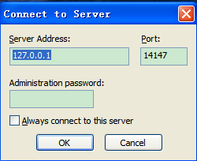

            - Add an FTP user.
- On the FileZilla Server main interface, choose Edit > Users.
- In the window that is displayed, click Add in the Users area, set the user name and password to mcu, and click OK.
The mcu user is created, as shown in Figure 12-3.
              - Adding an FTP user
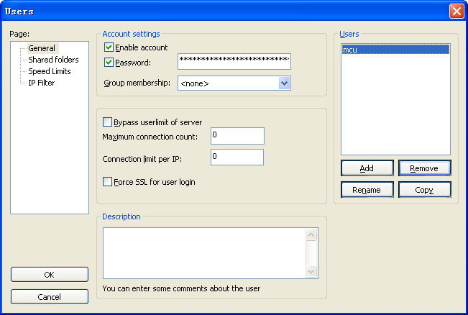

            - Set the FTP root directory.
- Click Shared folders in the navigation tree on the left.
- In the window that is displayed, click Add in the Shared folders area, set the path to D: \ VersionUp\mcu, and click OK.
- In the Files and Directories areas, select Read, Write, Delete, and List. Retain the default selection for other options, as shown in Figure 12-4.
- Click OK.
              - Setting the FTP root directory
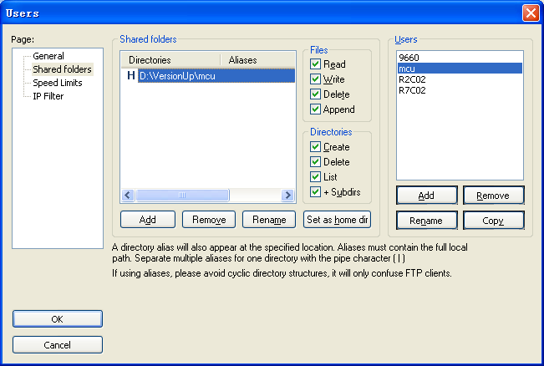

            - Enable Secure Sockets Layer (SSL) encryption.
- On the FileZilla Server main interface, choose Edit > Settings.
- In the window that is displayed, click SSL/TLS Settings in the navigation tree on the left and select Enable FTP over SSL/TLS support (FTPS), as shown in Figure 12-5. If the version of Filezilla Server is above "FileZilla_Server-0_9_50.exe", then the SSL/TLS Settings is as shown in Figure 12-6. The optionbox "Require TLS session resumption on data connection when using PROT P" must not be chose, or MCU would not be able to connect with FTP server.
              - Enabling SSL encryption
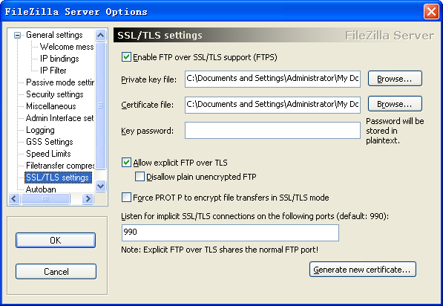

              - Enabling SSL encryption (new version)
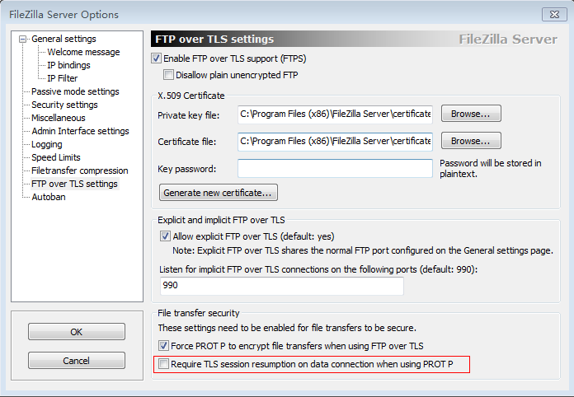

- Generate a certificate.
              - Generating a certificate
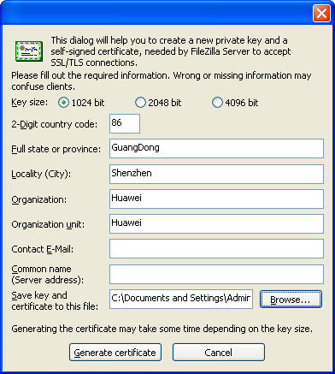

----End
Setting FTP Server Parameters on the MCU
- Connect the network cable to the GE0 port on the General Center Control Board E (GCCE) under test.
The GCCE is used in this example.
            - Log in to the MCU through SSH (recommended) or Telnet.
            - Set FTP server parameters.
- When the <HUAWEI 9660> prompt is displayed, run the system-view command.
- When the [VP9660] prompt is displayed, run the ftp-server command and set the FTP server parameters as follows:
- IP address: an IP address in xxx.xxx.xxx.xxx format
- User name: mcu
- Password: mcu
            - Exit to the root directory and type save to save your settings.
----End
What If I Fail to Log In to the MCU Through the Web Interface?
The possible cause is that you entered a Hypertext Transfer Protocol (HTTP) URL.
By default, the Hypertext Transfer Protocol Secure (HTTPS) protocol is enabled for the MCU. You must enter an HTTPS URL, for example, https://192.168.1.1, to log in to the MCU.
To find out which protocol is used, run the display Telnet-config command.
In the command output, if the value of enable https is enable, the HTTPS protocol is used:
<HUAWEI VP96560>display Telnet-config
enable security mode : disable
Telnet port : 23
Telnet timeout(minutes) : 30
cli prompt : HUAWEI
enable https : enable
FE0 login: : enable
GE0 login: : enable
GE1 login: : enable
What If the Upgrade Timed Out or Failed After FTP Server Configuration?
To resolve this problem, perform the following operations:
- Perform a ping test to check whether the FTP server and MCU are connected properly. If they are not connected, rectify the network connection fault.
            - Verify that the SSL certificate is enabled on the FTP server.
- On the FileZilla Server main interface, choose Edit > Settings.
- In the window shown in Figure 12-8, click SSL/TLS Settings in the navigation tree on the left and verify that Enable FTP over SSL/TLS support (FTPS) is selected.
              - FileZilla Server Options window
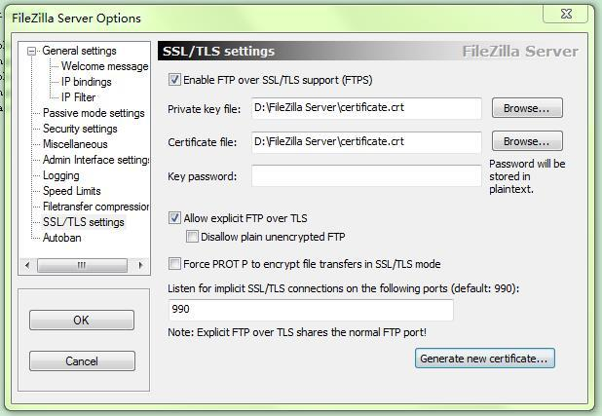

----End
What If an FTP User Name or Password Error Is Generated During the Upgrade?
Verify that the FTP user names and passwords specified on the MCU and FTP server are the same. For example, if the system shows that the user name and password specified on the FTP server are update, the user name and password specified on the MCU must be update.
What If I Failed to Find the Upgrade File During the Upgrade?
Check whether the required upgrade file, for example, HUAWEI-VP9660.bin, exists on the FTP server. If the upgrade file does not exist, copy the file to the specified directory on the FTP server.
What If the MCU Upgrade Failed Although FTP Server Parameters Are Set Correctly?
To resolve this problem, verify the following:
- Port 21 used by the FTP server is not occupied by other software.
- The Windows firewall is disabled. If the Windows firewall is enabled, port 990 has been added as an exception to the firewall.
During an MCU upgrade, the FTP server must listen to port 990. If port 990 is blocked by the Windows firewall, the upgrade fails.
- The FileZilla Server FTP server and FileZilla Server are started.
If you start FileZilla Server only, the upgrade fails, as shown in Figure 12-9.
              - Upgrade failure
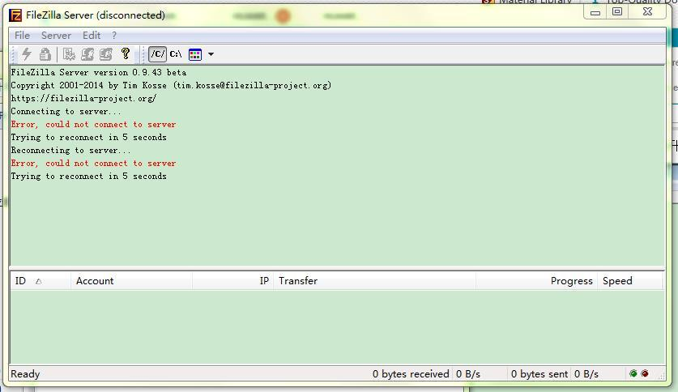

MCU Serial Port Settings
MCU Serial Port Settings
Serial Port Parameters
The following lists the MCU serial port parameters and their settings:
- Bits per second: 115200
- Data bits: 8
- Stop bits: 1
- Parity: None

