 | HoloSens SDC 10.0.0.SPC200 Upgrade Guide
 | Issue | 01
 | Date | 2023-01-28

 | HUAWEI TECHNOLOGIES CO., LTD. |  | 

Copyright © Huawei Technologies Co., Ltd. 2023. All rights reserved.
No part of this document may be reproduced or transmitted in any form or by any means without prior written consent of Huawei Technologies Co., Ltd.

Trademarks and Permissions
and other Huawei trademarks are trademarks of Huawei Technologies Co., Ltd.
All other trademarks and trade names mentioned in this document are the property of their respective holders.

Notice
The purchased products, services and features are stipulated by the contract made between Huawei and the customer. All or part of the products, services and features described in this document may not be within the purchase scope or the usage scope. Unless otherwise specified in the contract, all statements, information, and recommendations in this document are provided "AS IS" without warranties, guarantees or representations of any kind, either express or implied.
The information in this document is subject to change without notice. Every effort has been made in the preparation of this document to ensure accuracy of the contents, but all statements, information, and recommendations in this document do not constitute a warranty of any kind, express or implied.

Huawei Technologies Co., Ltd.
Address: | Huawei Industrial Base  Bantian, Longgang  Shenzhen 518129  People's Republic of China
Website: | https://www.huawei.com
Email: | support@huawei.com

Contents
1 Before You Start 1
1.1 Version Requirements 1
1.2 Upgrade Impact 5
1.3 Upgrade Precautions 6
2 Upgrade Process 7
3 Preparing for Installation 10
3.1 Pre-upgrade Check 10
3.2 Obtaining Upgrade Packages, Tools, and Reference Documents 11
3.3 Verifying Software Integrity 12
3.4 Checking the Current Version 12
4 Upgrade Procedure 14
4.1 Installing the Basic Software Package in the Camera Web System 14
4.2 Installing Algorithm Packages in the Camera Web System 23
4.3 Installing the Basic Software Package and Algorithm Packages for Cameras in Batches Using the iClient SDC 39
5 Verifying the Installation 42
5.1 Verifying Basic Software Upgrade Package Installation 42
5.2 Verifying Algorithm Upgrade Package Installation 43
6 FAQs 44

Before You Start
1.1 Version Requirements
1.2 Upgrade Impact
1.3 Upgrade Precautions

Version Requirements
Table 1-1 Upgrade paths
Model Type | Model | Source Version | Target Version
Distribution | D3020-10-LI-PV(3.6mm) | HoloSens SDC 9.0.0  HoloSens SDC 9.0.0-LG0001  HoloSens SDC 9.0.0-LG0002  HoloSens SDC 9.0.0.SPC307  HoloSens SDC SW 10.0.RC11  HoloSens SDC SW 10.0.RC11.SPC100  HoloSens SDC SW 10.0.RC11.SPC200  HoloSens SDC SW 10.0.RC11.SPC201  HoloSens SDC SW 10.0.0 | HoloSens SDC SW 10.0.0.SPC200
Distribution | D3020-10-LI-PV(2.8mm) |  | HoloSens SDC SW 10.0.0.SPC200
Distribution | C3050-10-LI-PV(3.6mm) |  | HoloSens SDC SW 10.0.0.SPC200
Distribution | C3050-10-LI-PV(2.8mm) |  | HoloSens SDC SW 10.0.0.SPC200
Distribution | D3050-10-LI-PV(3.6mm) |  | HoloSens SDC SW 10.0.0.SPC200
Distribution | D3050-10-LI-PV(2.8mm) |  | HoloSens SDC SW 10.0.0.SPC200
Distribution | D2120-10-LI-PV(6mm) |  | HoloSens SDC SW 10.0.0.SPC200
Distribution | D2120-10-LI-PV(3.6mm) |  | HoloSens SDC SW 10.0.0.SPC200
Distribution | C2150-10-LI-PV(3.6mm) |  | HoloSens SDC SW 10.0.0.SPC200
Distribution | C2150-10-LI-PV(6mm) |  | HoloSens SDC SW 10.0.0.SPC200
Distribution | D2150-10-SIU-Up | HoloSens SDC SW 10.0.RC11.SPC100  HoloSens SDC SW 10.0.RC11.SPC201  HoloSens SDC SW 10.0.0 | HoloSens SDC SW 10.0.0.SPC200
Distribution | D2150-10-LI-PV(3.6mm) |  | HoloSens SDC SW 10.0.0.SPC200
Distribution | D2150-10-LI-PV(6mm) |  | HoloSens SDC SW 10.0.0.SPC200
Distribution | D2150-10-SIU | HoloSens SDC 8.1.1.SPC115  HoloSens SDC 8.1.1.SPC119  HoloSens SDC 8.1.1.SPC123  HoloSens SDC 9.0.0  HoloSens SDC 9.0.0-LG0001  HoloSens SDC 9.0.0-LG0002  HoloSens SDC 9.0.0.SPC307  HoloSens SDC SW 10.0.RC11  HoloSens SDC SW 10.0.RC11.SPC100  HoloSens SDC SW 10.0.RC11.SPC200  HoloSens SDC SW 10.0.RC11.SPC201  HoloSens SDC SW 10.0.0 | HoloSens SDC SW 10.0.0.SPC200
Distribution | C2150-10-SIU |  | HoloSens SDC SW 10.0.0.SPC200
Distribution | D2120-10-SIU |  | HoloSens SDC SW 10.0.0.SPC200
Distribution | C2120-10-SIU |  | HoloSens SDC SW 10.0.0.SPC200
Distribution | C3220-10-SIU |  | HoloSens SDC SW 10.0.0.SPC200
Distribution | D3220-10-SIU |  | HoloSens SDC SW 10.0.0.SPC200
Distribution | D3250-10-SIU |  | HoloSens SDC SW 10.0.0.SPC200
Distribution | C3250-10-SIU |  | HoloSens SDC SW 10.0.0.SPC200
Distribution | D2120-10-LI-SV | HoloSens SDC 9.0.0-LG0001  HoloSens SDC 9.0.0-LG0002  HoloSens SDC SW 10.0.RC11  HoloSens SDC SW 10.0.RC11.SPC100  HoloSens SDC SW 10.0.RC11.SPC200  HoloSens SDC SW 10.0.RC11.SPC201  HoloSens SDC SW 10.0.RC31  HoloSens SDC SW 10.0.RC31.SPC100  HoloSens SDC SW 10.0.0 | HoloSens SDC SW 10.0.0.SPC200
Distribution | D2150-10-LI-SV |  | HoloSens SDC SW 10.0.0.SPC200
 | X6741-20-GZ40-E2-Wp | HoloSens SDC SW 10.0.RC21  HoloSens SDC SW 10.0.RC51  HoloSens SDC SW 10.0.RC51.SPC100  HoloSens SDC SW 10.0.0 | HoloSens SDC SW 10.0.0.SPC200
 | M6741-10-Z40 | HoloSens SDC 9.0.0.SPC323  HoloSens SDC SW 10.0.RC51  HoloSens SDC SW 10.0.RC51.SPC100  HoloSens SDC SW 10.0.0 | HoloSens SDC SW 10.0.0.SPC200
 | M6641-10-Z32 | HoloSens SDC SW 10.0.RC51  HoloSens SDC SW 10.0.RC51.SPC100  HoloSens SDC SW 10.0.0 | HoloSens SDC SW 10.0.0.SPC200
 | C6520-10-Z23-SV |  | HoloSens SDC SW 10.0.0.SPC200
 | C6550-10-Z33-SV |  | HoloSens SDC SW 10.0.0.SPC200
 | M2141-10-EL-SV(3.3~9mm) |  | HoloSens SDC SW 10.0.0.SPC200
 | D6550-10-Z33-SV |  | HoloSens SDC SW 10.0.0.SPC200
 | D6520-10-Z23-SV |  | HoloSens SDC SW 10.0.0.SPC200
 | C2141-10-L-PV(3.6mm) |  | HoloSens SDC SW 10.0.0.SPC200
 | C3240-10-EI-PU(2.8mm) |  | HoloSens SDC SW 10.0.0.SPC200
 | C3240-10-EI-PU(3.6mm) |  | HoloSens SDC SW 10.0.0.SPC200
 | C2141-10-EL(2.8-12mm) |  | HoloSens SDC SW 10.0.0.SPC200
 | C2141-10-EI |  | HoloSens SDC SW 10.0.0.SPC200
 | C3220-10-EI |  | HoloSens SDC SW 10.0.0.SPC200
 | M2141-10-IU-Up(8-32mm) |  | HoloSens SDC SW 10.0.0.SPC200
 | C2150-10-SIU-Up |  | HoloSens SDC SW 10.0.0.SPC200
 | HSMDU2141 |  | HoloSens SDC SW 10.0.0.SPC200
 | HSMDU6650-Z33 |  | HoloSens SDC SW 10.0.0.SPC200
 | HSMDU2140-Ex | HoloSens SDC 9.0.0-L00001  HoloSens SDC 9.0.0-L00001.SPC1  HoloSens SDC SW 10.0.RC51  HoloSens SDC SW 10.0.RC51.SPC100  HoloSens SDC SW 10.0.0 | HoloSens SDC SW 10.0.0.SPC200
 | M2281-QL-T | HoloSens SDC 8.2.0.SPC123  HoloSens SDC SW 10.0.0 | HoloSens SDC SW 10.0.0.SPC200
 | D2140-10-ELI-PV(3.6mm) | HoloSens SDC SW 10.0.RC31  HoloSens SDC SW 10.0.RC31.SPC100  HoloSens SDC SW 10.0.0 | HoloSens SDC SW 10.0.0.SPC200
 | D2140-10-ELI-PV(6mm) |  | HoloSens SDC SW 10.0.0.SPC200
 | D3040-10-ELI-PV(2.8mm) |  | HoloSens SDC SW 10.0.0.SPC200
 | D3040-10-ELI-PV(3.6mm) |  | HoloSens SDC SW 10.0.0.SPC200
 | C2140-10-ELI-PV(3.6mm) |  | HoloSens SDC SW 10.0.0.SPC200
 | C2140-10-ELI-PV(6mm) |  | HoloSens SDC SW 10.0.0.SPC200
 | C3040-10-ELI-PV(2.8mm) |  | HoloSens SDC SW 10.0.0.SPC200
 | C3040-10-ELI-PV(3.6mm) |  | HoloSens SDC SW 10.0.0.SPC200
 | M2141-10-EL(2.8~12mm) | HoloSens SDC 8.1.0  HoloSens SDC 8.1.0.SPC5  HoloSens SDC 8.2.0  HoloSens SDC 9.0.0  HoloSens SDC 9.0.0.SPC303  HoloSens SDC 9.0.0.SPC325  HoloSens SDC SW 10.0.RC51  HoloSens SDC SW 10.0.RC51.SPC100  HoloSens SDC SW 10.0.0 | HoloSens SDC SW 10.0.0.SPC200
 | M2141-10-EL(8~32mm) |  | HoloSens SDC SW 10.0.0.SPC200
 | M2281-QL | HoloSens SDC 8.2.0.SPC123  HoloSens SDC 8.2.0.SPC130  HoloSens SDC 8.2.0.SPC136  HoloSens SDC 8.2.0.SPC139 | HoloSens SDC SW 10.0.0.SPC200
 | M2241-QL | HoloSens SDC 8.2.0.SPC109  HoloSens SDC 8.2.0.SPC130  HoloSens SDC 8.2.0.SPC136  HoloSens SDC 8.2.0.SPC139  HoloSens SDC 8.2.0.SPC142 | HoloSens SDC SW 10.0.0.SPC200
 | M2241-10-QL | HoloSens SDC 9.0.RC1  HoloSens SDC 9.0.0  HoloSens SDC 9.0.0.SPC303 | HoloSens SDC SW 10.0.0.SPC200


- SDC SW 10.0.RC51->SDC SW 10.0.RC21: The OSD text cannot be moved, and privacy mask, mosaic, and ROI parameters cannot be set. To use RC21, clear the control and reinstall the RC21 control.
- To downgrade the M2141-10-EL (2.8–12 mm) or M2141-10-EL (8–32 mm) (basic software package named in V.B format) from SDC 10.0.0 to SDC 8.1.0.SPC5, first downgrade the device from SDC 10.0.0 to SDC 9.0.0.SPC325 and then to SDC 8.1.0.SPC5. You can obtain the SDC 9.0.0.SPC325 package from https://support.huawei.com/enterprise/en/intelligent-vision/m2141-10-el-pid-251305648/software/256236269.
- If a version that is not in the version incorporation scope is forcibly upgraded to the target version, risks may exist. Customers need to control the risks by themselves.
- When the D3250-10-SIU, D3220-10-SIU, D2150-10-SIU, D2120-10-SIU, C3250-10-SIU, C3220-10-SIU, C2150-10-SIU or C2120-10-SIU is directly upgraded from 8.1.1 to 10.0.0 TR6, if overcast adaptation is enabled, backlight adaptation will be disabled. In this case, you need to manually enable backlight adaptation.
- When an exception occurs on the device of the SIU model, if an upgrade package whose name contains V.B needs to be installed on the device but the upgrade package fails to be verified, perform the following operations: Install the upgrade package whose name does not contain V.B. After the device is recovered, log in to the device background, change the device version number, and install the upgrade package whose name contains V.B. To change the version number, perform the following operations: Run the vi /usr/app/bin/version command, press i to enter the editing mode, change the version number from B0XX to B0YY, press Esc to exit the editing mode, and run :wq! to save the configuration.
- After SDC 8.1.0.B002 is upgraded to SDC 9.0.0 or SDC 10.0.0, if the auto focus sensitivity is set to high, the actual sensitivity is low; if the auto focus sensitivity is set to low, the actual sensitivity is high.

Upgrade Impact
None

Upgrade Precautions
Before installing an upgrade package, carefully read this document to understand the basic information about the upgrade package, the impact of the upgrade, and updates on version mappings.

Upgrade Process
Prepare for the installation, for example, preparing the software package and algorithm packages required for the upgrade. For details, see Table 3-1.
            - Obtain the software package and algorithm packages required for the upgrade. For details, see 3.2 Obtaining Upgrade Packages, Tools, and Reference Documents.
            - Verify the software integrity. For details, see 3.3 Verifying Software Integrity.
            - Query and record the current version. For details, see 3.4 Checking the Current Version.
            - Install the upgrade package and algorithm package. Table 2-1 lists the upgrade software packages and algorithm packages.

- You must upgrade the basic software package before upgrading the algorithm package.
- The algorithm upgrade packages do not need to be installed in a fixed sequence, but multiple algorithm upgrade packages cannot be installed at the same time.
                - Process of installing the basic software package and algorithm package
Scenario | Step | Time Required (in Minutes, Depending on Network Conditions and Computer Configurations) | Reference
Upgrade a single camera | Install the basic software package | 5 | For details, see 4.1 Installing the Basic Software Package in the Camera Web System.
Upgrade a single camera | Install the algorithm package | 5 | For details, see 4.2 Installing Algorithm Packages in the Camera Web System.
Upgrade a single camera | Install the ZIP package | The upgrade duration consists of the time for installing the basic software package and that for installing algorithm upgrade packages. For example, if there is one basic software upgrade package and five algorithm upgrade packages, the upgrade duration is 30 minutes (1 x 5 + 5 x 5 = 30). | For details, see 4.1 Installing the Basic Software Package in the Camera Web System.
Upgrade multiple cameras in batches | Install the basic software package for multiple cameras in batches using the iClient SDC | Number of cameras/30 x 5  (The value 30 indicates the maximum number of cameras for which the algorithm package can be installed in batches.) | For details, see 4.3 Installing the Basic Software Package and Algorithm Packages for Cameras in Batches Using the iClient SDC.
Upgrade multiple cameras in batches | Install the algorithm package for multiple cameras in batches using the iClient SDC | Number of cameras/30 x 5  (The value 30 indicates the maximum number of cameras for which the algorithm package can be installed in batches.) | For details, see 4.3 Installing the Basic Software Package and Algorithm Packages for Cameras in Batches Using the iClient SDC.

            - After the installation is complete, verify that the software package and algorithm package are successfully installed. For details, see 5 Verifying the Installation.
----End

Preparing for Installation
3.1 Pre-upgrade Check
3.2 Obtaining Upgrade Packages, Tools, and Reference Documents
3.3 Verifying Software Integrity
3.4 Checking the Current Version

Pre-upgrade Check
Table 3-1 lists the items to be accomplished before installation.
                - Pre-installation checklist
No. | Item | Start Time | Time Required
1 | Obtain the upgrade package, digital signature of the upgrade package, digital signature verification tool, and reference documents. | One day before upgrade | 30
2 | iClient SDC | One day before upgrade | 10
3 | Install the SSH tool (SecureCRT recommended). | One day before upgrade | 10
4 | Check the current version. | When the upgrade package is loaded | 5
5 | Check the algorithm upgrade packages supported by the SDC. | When algorithm upgrade packages are loaded | 3


The upgrade package includes the basic software upgrade package and algorithm upgrade package. The version of the basic software upgrade package must match that of the algorithm upgrade package.

Obtaining Upgrade Packages, Tools, and Reference Documents
Prepare the basic software package (with its digital signature), algorithm packages (with their digital signatures), digital signature verification tool, iClient SDC, SSH tool, and reference documents one week in advance. To prepare the preceding items, perform the following steps:
            - Obtain the basic software upgrade package and algorithm upgrade packages.
- For an enterprise user, visit https://support.huawei.com/enterprise, search for SDC 10.0.0.SPC200, and download the basic software upgrade package (with the digital signature of the basic software upgrade package), algorithm upgrade packages (with the digital signature of the algorithm upgrade packages), and upgrade guide.
- For a carrier user, visit https://support.huawei.com/carrierindex/en/hwe/index.html, search for and select the desired camera model, select SDC 10.0.0.SPC200 from the Software Version drop-down list box, and download the basic software upgrade package (with the digital signature of the basic software upgrade package), algorithm upgrade packages (with the digital signature of the algorithm upgrade packages), and upgrade guide.
            - Obtain the signature verification tool.
- For an enterprise user, visit https://support.huawei.com/enterprise/en/tool, search for PGP Verify, select the software version (current software version: V100R001C00), and download the digital signature verification tool installation package VerificationTools.rar, public key file KEYS, and digital signature verification guide OpenPGP Signature Verification Guide.
- For a carrier user, visit https://support.huawei.com/carrier/digitalSignatureAction, download the package named OpenPGP Signature Verification Guide, and extract the public key file KEYS and digital signature verification tool installation package VerificationTools.zip from the package. After decompressing VerificationTools.zip, you can obtain the PGPVerify tool.
            - Prepare the iClient SDC configuration tool and related documents.
Log in to the HoloSens Store (https://www.holowits.com.sg/support), search for iClient SDC, and download the iClient SDC software of the latest version.
----End
.
A user name and password are required for downloading the preceding upgrade packages, tools, and reference documents. Huawei technical support engineers can use their W3 accounts. Other personnel must apply for accounts as prompted.
Before the upgrade, prepare the basic software package and algorithm packages to be installed. Additionally, you need to prepare the basic software package and algorithm packages of the source version. For details about how to check the source version, see 3.4 Checking the Current Version. If the upgrade fails or the function works improperly after the upgrade, you can roll back the camera to the source version.

Verifying Software Integrity
To prevent a software package from being maliciously tampered with during transmission or storage, download the corresponding digital signature file for integrity verification when downloading the software package.
After the software package is downloaded, verify its PGP digital signature by referring to the OpenPGP Signature Verification Guide. If the software package fails to be verified, do not use the software package, and contact Huawei technical support.
Before a software package is used for installation or upgrade, its digital signature also needs to be verified by referring to the OpenPGP Signature Verification Guide to ensure that the software package is not tampered with. Visit either of the following websites to obtain the OpenPGP Signature Verification Guide:
Carrier customers: http://support.huawei.com/carrier/digitalSignatureAction
Enterprise customers: https://support.huawei.com/enterprise/en/tool/pgp-verify-TL1000000054

Checking the Current Version
Method 1: Checking the Current Version Using the iClient SDC
            - Start the iClient SDC.
            - Choose Device Search, search for the device to be operated, and check the device version, as shown in Figure 3-1.
              - Checking the version information using the iClient SDC
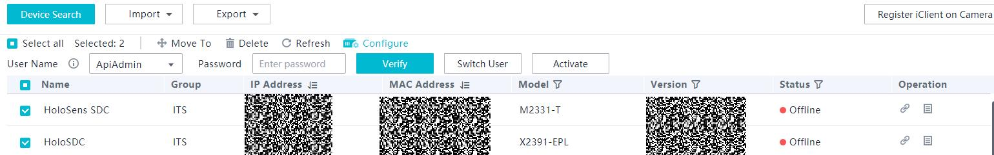

----End
Method 2: Checking the Current Version in the Camera Web System
Enter the correct user name and password to log in to the camera web system. For details about how to log in to the camera web system, see Step 1 and Step 2. The camera model and version number are displayed in the lower left corner of the web page, as shown in Figure 3-2.
              - Checking the camera version on the camera web page
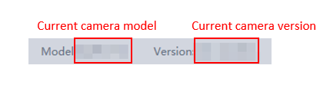

Method 3: Checking the Current Version Using SSH
Before checking the current version of the camera, ensure that SSH is enabled. You can enable SSH in either of the following ways: Method 1: Log in to the camera web system, choose Configuration > Network > Advanced Settings > SSH/SFTP, and select Enable SSH. Method 2: Start the iClient SDC and choose Settings. In the navigation tree on the left, select the camera to be configured, choose Network > SSH/SFTP > SSH Configuration on the right, and select Enable SSH.
            - Start the SSH tool and connect to the device. Enter the IP address of the device to be logged in to. The default port number is 22, and the user name is admin.
            - After the camera is connected, and the system prompts you to enter the password of the admin user, enter the corresponding password. The default password of the admin user is ChangeMe123. Change the password upon the first login.
            - Enter y as prompted and run the su command to switch to the root user. The default password of the root user is HuaWei123.
            - Run the cat /usr/app/bin/version command to check the version number. (If the displayed version number contains B, ignore the version number.)
Before the upgrade, record the version number of the device to prevent function exceptions after the upgrade. You can roll back the device to the source version.
----End

Upgrade Procedure
4.1 Installing the Basic Software Package in the Camera Web System
4.2 Installing Algorithm Packages in the Camera Web System
4.3 Installing the Basic Software Package and Algorithm Packages for Cameras in Batches Using the iClient SDC

Installing the Basic Software Package in the Camera Web System
Prerequisites
You have obtained the basic software package.


The software packages required for upgrading cameras of the same model to 10.0.0.SPC200 vary depending on the source versions. Therefore, you are advised to download all software packages related to the model and load the desired one as prompted on the upgrade page in the camera web system.
                - Mapping between camera models and software upgrade packages (in .bin format)
Software Package | Applicable Model
SDC-D165_10.0.0.SPC200_SS.bin  SDC-D165_10.0.0.SPC200_SS_V.B.bin | C2120-10-SIU
SDC-D161_10.0.0.SPC200_N_SS.bin | C2140-10-ELI-PV(3.6mm)
SDC-D161_10.0.0.SPC200_N_SS.bin | C2140-10-ELI-PV(6mm)
SDC-D162_10.0.0.SPC200_N_SS.bin | C2141-10-EI
SDC-D162_10.0.0.SPC200_N_SS.bin | C2141-10-EL(2.8-12mm)
SDC-D162_10.0.0.SPC200_N_SS.bin | C2141-10-L-PV(3.6mm)
SDC-D162_10.0.0.SPC200_N_SS.bin | C2150-10-LI-PV(3.6mm)
SDC-D162_10.0.0.SPC200_N_SS.bin | C2150-10-LI-PV(6mm)
SDC-D165_10.0.0.SPC200_SS.bin  SDC-D165_10.0.0.SPC200_SS_V.B.bin | C2150-10-SIU
SDC-D165_10.0.0.SPC200_SS_V.B.bin | C2150-10-SIU-Up
SDC-D161_10.0.0.SPC200_N_SS.bin | C3040-10-ELI-PV(2.8mm)
SDC-D161_10.0.0.SPC200_N_SS.bin | C3040-10-ELI-PV(3.6mm)
SDC-D162_10.0.0.SPC200_N_SS.bin | C3050-10-LI-PV(2.8mm)
SDC-D162_10.0.0.SPC200_N_SS.bin | C3050-10-LI-PV(3.6mm)
SDC-D161_10.0.0.SPC200_N_SS.bin | C3220-10-EI
SDC-D165_10.0.0.SPC200_SS.bin  SDC-D165_10.0.0.SPC200_SS_V.B.bin | C3220-10-SIU
SDC-D161_10.0.0.SPC200_N_SS.bin | C3240-10-EI-PU(2.8mm)
SDC-D161_10.0.0.SPC200_N_SS.bin | C3240-10-EI-PU(3.6mm)
SDC-D165_10.0.0.SPC200_SS.bin  SDC-D165_10.0.0.SPC200_SS_V.B.bin | C3250-10-SIU
SDC-A162_10.0.0.SPC200_N_SS.bin | C6520-10-Z23-SV
SDC-A162_10.0.0.SPC200_N_SS.bin | C6550-10-Z33-SV
SDC-D162_10.0.0.SPC200_N_SS.bin | D2120-10-LI-PV(3.6mm)
SDC-D162_10.0.0.SPC200_N_SS.bin | D2120-10-LI-PV(6mm)
SDC-A16E_10.0.0.SPC200_V.C.bin | D2120-10-LI-SV
SDC-D165_10.0.0.SPC200_SS.bin  SDC-D165_10.0.0.SPC200_SS_V.B.bin | D2120-10-SIU
SDC-D161_10.0.0.SPC200_N_SS.bin | D2140-10-ELI-PV(3.6mm)
SDC-D161_10.0.0.SPC200_N_SS.bin | D2140-10-ELI-PV(6mm)
SDC-D162_10.0.0.SPC200_N_SS.bin | D2150-10-LI-PV(3.6mm)
SDC-D162_10.0.0.SPC200_N_SS.bin | D2150-10-LI-PV(6mm)
SDC-A16E_10.0.0.SPC200_V.C.bin | D2150-10-LI-SV
SDC-D165_10.0.0.SPC200_SS.bin  SDC-D165_10.0.0.SPC200_SS_V.B.bin | D2150-10-SIU
SDC-D165_10.0.0.SPC200_SS_V.B.bin | D2150-10-SIU-Up
SDC-D162_10.0.0.SPC200_N_SS.bin | D3020-10-LI-PV(2.8mm)
SDC-D162_10.0.0.SPC200_N_SS.bin | D3020-10-LI-PV(3.6mm)
SDC-D161_10.0.0.SPC200_N_SS.bin | D3040-10-ELI-PV(2.8mm)
SDC-D161_10.0.0.SPC200_N_SS.bin | D3040-10-ELI-PV(3.6mm)
SDC-D162_10.0.0.SPC200_N_SS.bin | D3050-10-LI-PV(2.8mm)
SDC-D162_10.0.0.SPC200_N_SS.bin | D3050-10-LI-PV(3.6mm)
SDC-D165_10.0.0.SPC200_SS.bin  SDC-D165_10.0.0.SPC200_SS_V.B.bin | D3220-10-SIU
SDC-D165_10.0.0.SPC200_SS.bin  SDC-D165_10.0.0.SPC200_SS_V.B.bin | D3250-10-SIU
SDC-A162_10.0.0.SPC200_N_SS.bin | D6520-10-Z23-SV
SDC-A162_10.0.0.SPC200_N_SS.bin | D6550-10-Z33-SV
SDC-D162_10.0.0.SPC200_N_SS.bin | HSMDU2140-Ex
SDC-D165_10.0.0.SPC200_V.B.bin | HSMDU2141
SDC-D165_10.0.0.SPC200_V.B.bin | HSMDU6650-Z33
SDC-D165_10.0.0.SPC200_V.B.bin  SDC-D165_10.0.0.SPC200.bin | M2141-10-EL(2.8-12mm)
SDC-D165_10.0.0.SPC200.bin  SDC-D165_10.0.0.SPC200_V.B.bin | M2141-10-EL(8-32mm)
SDC-A165_10.0.0.SPC200_V.B.bin | M2141-10-EL-SV(3.3-9mm)
SDC-A16E_10.0.0.SPC200_V.C.bin | M2141-10-IU-Up(8-32mm)
SDC-M195_10.0.0.SPC200_V.B.bin | M2281-QL-T
SDC-D165_10.0.0.SPC200_V.B.bin | M6641-10-Z32
SDC-D165_10.0.0.SPC200_V.B.bin | M6741-10-Z40
SDC-S28E_10.0.0.SPC200_V.C.bin | X6741-20-GZ40-E2-Wp
SDC-M195_10.0.0.SPC200.bin  SDC-M195_10.0.0.SPC200_V.B.bin | M2281-QL
SDC-M195_10.0.0.SPC200.bin  SDC-M195_10.0.0.SPC200_V.B.bin | M2241-QL
SDC-D16M_10.0.0.SPC200_V.B.bin | M2241-10-QL

                - Mapping between camera models and software upgrade packages (in .zip format)
Software Package | Applicable Model
SDC-A16_10.0.0.SPC200_C6520-10-Z23-SV.zip | C6520-10-Z23-SV
SDC-A16_10.0.0.SPC200_C6550-10-Z33-SV.zip | C6550-10-Z33-SV
SDC-A16_10.0.0.SPC200_D2120-10-LI-SV.zip | D2120-10-LI-SV
SDC-A16_10.0.0.SPC200_D2150-10-LI-SV.zip | D2150-10-LI-SV
SDC-A16_10.0.0.SPC200_D6520-10-Z23-SV.zip | D6520-10-Z23-SV
SDC-A16_10.0.0.SPC200_D6550-10-Z33-SV.zip | D6550-10-Z33-SV
SDC-A16_10.0.0.SPC200_M2141-10-EL-SV(3.3-9mm).zip | M2141-10-EL-SV(3.3~9mm)
SDC-D16_10.0.0.SPC200_C2120-10-SIU.zip | C2120-10-SIU
SDC-D16_10.0.0.SPC200_C2140-10-ELI-PV(3.6mm&6mm).zip | C2140-10-ELI-PV(3.6mm)/C2140-10-ELI-PV(6mm)
SDC-D16_10.0.0.SPC200_C2141-10-EI.zip | C2141-10-EI
SDC-D16_10.0.0.SPC200_C2141-10-EL(2.8-12mm).zip | C2141-10-EL(2.8-12mm)
SDC-D16_10.0.0.SPC200_C2141-10-L-PV(3.6mm).zip | C2141-10-L-PV(3.6mm)
SDC-D16_10.0.0.SPC200_C2150-10-LI-PV(3.6mm&6mm).zip | C2150-10-LI-PV(3.6mm)/C2150-10-LI-PV(6mm)
SDC-D16_10.0.0.SPC200_C2150-10-SIU-Up.zip | C2150-10-SIU-Up
SDC-D16_10.0.0.SPC200_C2150-10-SIU.zip | C2150-10-SIU
SDC-D16_10.0.0.SPC200_C3040-10-ELI-PV(2.8mm&3.6mm).zip | C3040-10-ELI-PV(2.8mm)/C3040-10-ELI-PV(3.6mm)
SDC-D16_10.0.0.SPC200_C3050-10-LI-PV(2.8mm&3.6mm).zip | C3050-10-LI-PV(2.8mm)/C3050-10-LI-PV(3.6mm)
SDC-D16_10.0.0.SPC200_C3220-10-EI.zip | C3220-10-EI
SDC-D16_10.0.0.SPC200_C3220-10-SIU.zip | C3220-10-SIU
SDC-D16_10.0.0.SPC200_C3240-10-EI-PU(2.8mm&3.6mm).zip | C3240-10-EI-PU(2.8mm)/C3240-10-EI-PU(3.6mm)
SDC-D16_10.0.0.SPC200_C3250-10-SIU.zip | C3250-10-SIU
SDC-D16_10.0.0.SPC200_D2120-10-LI-PV(3.6mm&6mm).zip | D2120-10-LI-PV(3.6mm)/D2120-10-LI-PV(6mm)
SDC-D16_10.0.0.SPC200_D2120-10-SIU.zip | D2120-10-SIU
SDC-D16_10.0.0.SPC200_D2140-10-ELI-PV(3.6mm&6mm).zip | D2140-10-ELI-PV(3.6mm)/D2140-10-ELI-PV(6mm)
SDC-D16_10.0.0.SPC200_D2150-10-LI-PV(3.6mm&6mm).zip | D2150-10-LI-PV(3.6mm)/D2150-10-LI-PV(6mm)
SDC-D16_10.0.0.SPC200_D2150-10-SIU-Up.zip | D2150-10-SIU-Up
SDC-D16_10.0.0.SPC200_D2150-10-SIU.zip | D2150-10-SIU
SDC-D16_10.0.0.SPC200_D3020-10-LI-PV(2.8mm&3.6mm).zip | D3020-10-LI-PV(2.8mm)/D3020-10-LI-PV(3.6mm)
SDC-D16_10.0.0.SPC200_D3040-10-ELI-PV(2.8mm&3.6mm).zip | D3040-10-ELI-PV(2.8mm)/D3040-10-ELI-PV(3.6mm)
SDC-D16_10.0.0.SPC200_D3050-10-LI-PV(2.8mm&3.6mm).zip | D3050-10-LI-PV(2.8mm)/D3050-10-LI-PV(3.6mm)
SDC-D16_10.0.0.SPC200_D3220-10-SIU.zip | D3220-10-SIU
SDC-D16_10.0.0.SPC200_D3250-10-SIU.zip | D3250-10-SIU
SDC-D16_10.0.0.SPC200_HSMDU2140-Ex.zip | HSMDU2140-Ex
SDC-D16_10.0.0.SPC200_HSMDU2141.zip | HSMDU2141
SDC-D16_10.0.0.SPC200_HSMDU6650-Z33.zip | HSMDU6650-Z33
SDC-D16_10.0.0.SPC200_M2141-10-EL(2.8-12mm).zip | M2141-10-EL(2.8-12mm)
SDC-D16_10.0.0.SPC200_M2141-10-EL(8-32mm).zip | M2141-10-EL(8-32mm)
SDC-D16_10.0.0.SPC200_M2141-10-IU-Up(8-32mm).zip | M2141-10-IU-Up(8-32mm)
SDC-D16_10.0.0.SPC200_M6641-10-Z32.zip | M6641-10-Z32
SDC-D16_10.0.0.SPC200_M6741-10-Z40.zip | M6741-10-Z40
SDC-M19_10.0.0.SPC200_M2281-QL-T.zip | M2281-QL-T
SDC-S03_10.0.0.SPC200_X6741-20-GZ40-E2-Wp.zip | X6741-20-GZ40-E2-Wp
SDC-M19_10.0.0.SPC200_M2281-QL.zip | M2281-QL
SDC-M19_10.0.0.SPC200_M2241-QL.zip | M2241-QL
SDC-D16_10.0.0.SPC200_M2241-10-QL.zip | M2241-10-QL

Procedure

- The upgrade will interrupt all services for about 5 minutes. Therefore, you are advised to perform the upgrade during off-peak hours.
- Ensure that the power functions properly and the network is connected during the upgrade. In addition, do not perform other operations during the upgrade.
- After the upgrade, if you cannot log in to the camera web system, you need to clear the cache of Internet Explorer and log in again. For details about how to clear the cache of Internet Explorer, see 6 FAQs.
- After the basic software package is installed, you need to reinstall the algorithm packages and application packages of the required version.
- Before upgrading a device, you can select an upgrade file whose name contains V.* or does not contain V.* under Configuration > System > System Maintenance > Upgrade.
            - Open Internet Explorer, enter the camera IP address in the address box, for example, 192.168.0.120 and press Enter. The login page is displayed.
            - Select a system language, for example, English. Enter the user name and password and click Log In. If you log in to the system for the first time, the system prompts you to set the login password.
            - Choose Configuration > System > System Maintenance > Upgrade. For devices to be upgraded from version 9.0.0 or an earlier version, choose Maintenance > Upgrade.
            - Click Browse and select the correct upgrade file whose name contains V.* or does not contain V.*. The upgrade file must be an officially released .zip, .bin, or .tar file.
              - Selecting a basic upgrade package whose name does not contain V.*
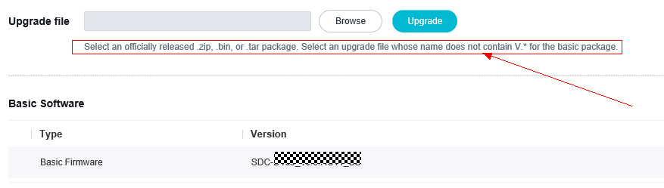

              - Selecting a basic upgrade package whose name contains V.*
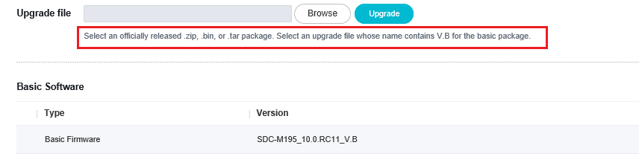

            - Install the .zip package (recommended) or .bin package. Currently, the .tar package is not supported.
If the upgrade package is in .zip format, click Upgrade. The available upgrade files are displayed, as shown in Figure 4-3. Select the required file and click Upgrade.
              - List of available upgrade files
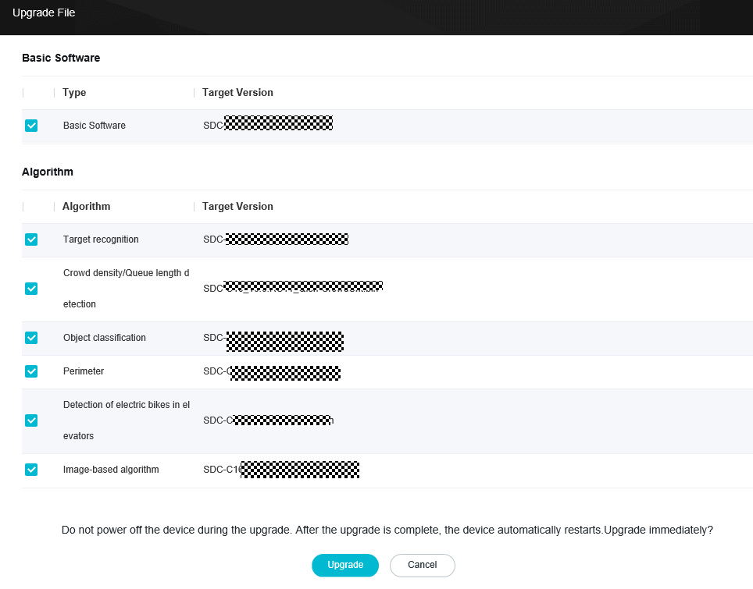

The .zip package applies only to Internet Explorer. In addition, to install the .zip package, you need to install the required plug-in and disable the protected mode of Internet Explorer.
            - If the page shown in the following figure is displayed, the upgrade file is being uploaded. During the upload, do not refresh or close the page before the upgrade is completed. After the upgrade is successful, the camera restarts, and the login page in Step 1 is automatically displayed.
              - Upgrade page
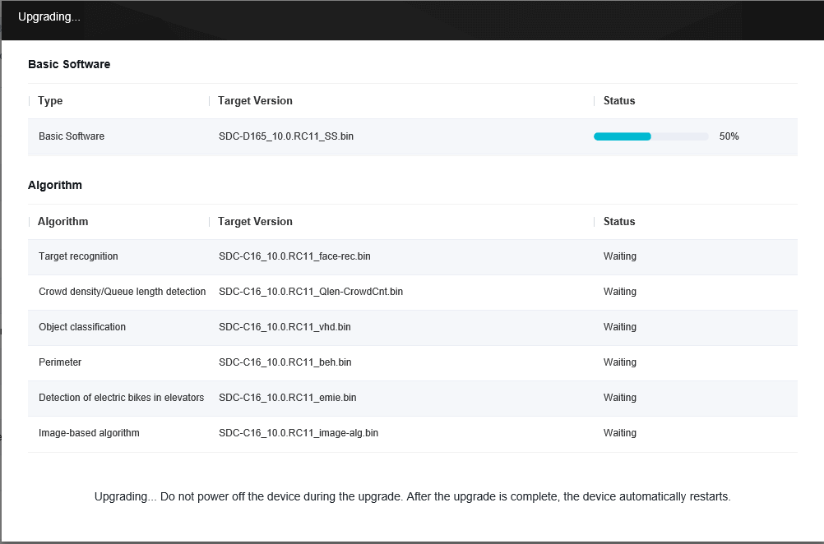

            - If the upgrade package is in .bin format, click Upgrade.
            - In the dialog box that is displayed, click OK. If the following page is displayed, the upgrade is in progress. During the upgrade, do not refresh or close the page until the upgrade is successful. After the upgrade is successful, the camera restarts, and the login page in step 1 is automatically displayed.
              - Upgrade page
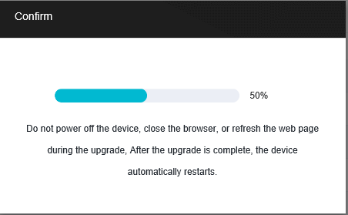

----End

Installing Algorithm Packages in the Camera Web System
Prerequisites
You have obtained desired algorithm upgrade packages.

The SDC-xxx_10.0.0.SPC200_GB28181_armv7l.rpm.tar (GB/T 28181-compliant component package) and SDC-xxx_10.0.0.SPC200_GAT1400_armv7l.rpm.tar (GA/T 1400-compliant component package) are preset in the basic software package and do not need to be upgraded separately.
                - Mapping between camera models and algorithm upgrade packages
Camera | Algorithm Upgrade Package
C2120-10-SIU | Target recognition:  SDC-C16_10.0.0.SPC200_face-rec.bin  Head and shoulder detection:  SDC-C16_10.0.0.SPC200_Qlen-CrowdCnt.bin  Perimeter detection  SDC-C16_10.0.0.SPC200_beh.bin  Electric bike detection in elevators:  SDC-C16_10.0.0.SPC200_emie.bin  Image-based algorithm:  SDC-C16_10.0.0.SPC200_image-alg.bin  Object classification:  SDC-C16_10.0.0.SPC200_vhd.bin
C2140-10-ELI-PV(3.6mm) | Perimeter detection  SDC-C16_10.0.0.SPC200_beh-Lite.bin
C2140-10-ELI-PV(6mm) | Perimeter detection:  SDC-C16_10.0.0.SPC200_beh-Lite.bin
C2141-10-EI | Target/Person detection:  SDC-C16_10.0.0.SPC200_facedt-dl.bin  Head and shoulder detection:  SDC-C16_10.0.0.SPC200_Qlen-CrowdCnt.bin  Perimeter detection:  SDC-C16_10.0.0.SPC200_beh-Lite.bin  Image-based algorithm:  SDC-C16_10.0.0.SPC200_image-alg.bin
C2141-10-EL(2.8-12mm) | Target/Person detection:  SDC-C16_10.0.0.SPC200_facedt-dl.bin  Object classification:  SDC-C16_10.0.0.SPC200_vhd.bin  Head and shoulder detection:  SDC-C16_10.0.0.SPC200_Qlen-CrowdCnt.bin  Perimeter detection:  SDC-C16_10.0.0.SPC200_beh.bin  Image-based algorithm:  SDC-C16_10.0.0.SPC200_image-alg.bin
C2141-10-L-PV(3.6mm) | Target recognition:  SDC-C16_10.0.0.SPC200_face-rec.bin  Head and shoulder detection:  SDC-C16_10.0.0.SPC200_Qlen-CrowdCnt.bin  Perimeter detection:  SDC-C16_10.0.0.SPC200_beh.bin  Electric bike detection in elevators:  SDC-C16_10.0.0.SPC200_emie.bin  Image-based algorithm:  SDC-C16_10.0.0.SPC200_image-alg.bin
C2150-10-LI-PV(3.6mm) | Target recognition:  SDC-C16_10.0.0.SPC200_face-rec.bin  Head and shoulder detection:  SDC-C16_10.0.0.SPC200_Qlen-CrowdCnt.bin  Perimeter detection:  SDC-C16_10.0.0.SPC200_beh.bin  Electric bike detection in elevators:  SDC-C16_10.0.0.SPC200_emie.bin  Image-based algorithm:  SDC-C16_10.0.0.SPC200_image-alg.bin
C2150-10-LI-PV(6mm) | Target recognition:  SDC-C16_10.0.0.SPC200_face-rec.bin  Head and shoulder detection:  SDC-C16_10.0.0.SPC200_Qlen-CrowdCnt.bin  Perimeter detection:  SDC-C16_10.0.0.SPC200_beh.bin  Electric bike detection in elevators:  SDC-C16_10.0.0.SPC200_emie.bin  Image-based algorithm:  SDC-C16_10.0.0.SPC200_image-alg.bin
C2150-10-SIU | Target recognition:  SDC-C16_10.0.0.SPC200_face-rec.bin  Head and shoulder detection:  SDC-C16_10.0.0.SPC200_Qlen-CrowdCnt.bin  Perimeter detection:  SDC-C16_10.0.0.SPC200_beh.bin  Electric bike detection in elevators:  SDC-C16_10.0.0.SPC200_emie.bin  Image-based algorithm:  SDC-C16_10.0.0.SPC200_image-alg.bin  Object classification:  SDC-C16_10.0.0.SPC200_vhd.bin
C2150-10-SIU-Up | Target recognition:  SDC-C16_10.0.0.SPC200_face-rec.bin  Head and shoulder detection:  SDC-C16_10.0.0.SPC200_Qlen-CrowdCnt.bin  Perimeter detection:  SDC-C16_10.0.0.SPC200_beh.bin  Electric bike detection in elevators:  SDC-C16_10.0.0.SPC200_emie.bin  Image-based algorithm:  SDC-C16_10.0.0.SPC200_image-alg.bin  Object classification:  SDC-C16_10.0.0.SPC200_vhd.bin
C3040-10-ELI-PV(2.8mm) | Perimeter detection:  SDC-C16_10.0.0.SPC200_beh-Lite.bin
C3040-10-ELI-PV(3.6mm) | Perimeter detection:  SDC-C16_10.0.0.SPC200_beh-Lite.bin
C3050-10-LI-PV(2.8mm) | Target recognition:  SDC-C16_10.0.0.SPC200_face-rec.bin  Head and shoulder detection:  SDC-C16_10.0.0.SPC200_Qlen-CrowdCnt.bin  Perimeter detection:  SDC-C16_10.0.0.SPC200_beh.bin  Electric bike detection in elevators:  SDC-C16_10.0.0.SPC200_emie.bin  Image-based algorithm:  SDC-C16_10.0.0.SPC200_image-alg.bin
C3050-10-LI-PV(3.6mm) | Target recognition:  SDC-C16_10.0.0.SPC200_face-rec.bin  Head and shoulder detection:  SDC-C16_10.0.0.SPC200_Qlen-CrowdCnt.bin  Perimeter detection:  SDC-C16_10.0.0.SPC200_beh.bin  Electric bike detection in elevators:  SDC-C16_10.0.0.SPC200_emie.bin  Image-based algorithm:  SDC-C16_10.0.0.SPC200_image-alg.bin
C3220-10-EI | Perimeter detection:  SDC-C16_10.0.0.SPC200_beh-Lite.bin
C3220-10-SIU | Target recognition:  SDC-C16_10.0.0.SPC200_face-rec.bin  Head and shoulder detection:  SDC-C16_10.0.0.SPC200_Qlen-CrowdCnt.bin  Perimeter detection:  SDC-C16_10.0.0.SPC200_beh.bin  Electric bike detection in elevators:  SDC-C16_10.0.0.SPC200_emie.bin  Image-based algorithm:  SDC-C16_10.0.0.SPC200_image-alg.bin  Object classification:  SDC-C16_10.0.0.SPC200_vhd.bin
C3240-10-EI-PU(2.8mm) | Perimeter detection:  SDC-C16_10.0.0.SPC200_beh-Lite.bin
C3240-10-EI-PU(3.6mm) | Perimeter detection:  SDC-C16_10.0.0.SPC200_beh-Lite.bin
C3250-10-SIU | Target recognition:  SDC-C16_10.0.0.SPC200_face-rec.bin  Head and shoulder detection:  SDC-C16_10.0.0.SPC200_Qlen-CrowdCnt.bin  Perimeter detection:  SDC-C16_10.0.0.SPC200_beh.bin  Electric bike detection in elevators:  SDC-C16_10.0.0.SPC200_emie.bin  Image-based algorithm:  SDC-C16_10.0.0.SPC200_image-alg.bin  Object classification:  SDC-C16_10.0.0.SPC200_vhd.bin
C6520-10-Z23-SV | Target/Person detection:  SDC-C16_10.0.0.SPC200_facedt-dl.bin  Head and shoulder detection:  SDC-C16_10.0.0.SPC200_Qlen-CrowdCnt.bin  Perimeter detection:  SDC-C16_10.0.0.SPC200_beh-track.bin  Image-based algorithm:  SDC-C16_10.0.0.SPC200_image-alg.bin
C6550-10-Z33-SV | Target/Person detection:  SDC-C16_10.0.0.SPC200_facedt-dl.bin  Object classification:  SDC-C16_10.0.0.SPC200_vhd.bin  Head and shoulder detection:  SDC-C16_10.0.0.SPC200_Qlen-CrowdCnt.bin  Perimeter detection:  SDC-C16_10.0.0.SPC200_beh.bin  Image-based algorithm:  SDC-C16_10.0.0.SPC200_image-alg.bin
D2120-10-LI-PV(3.6mm) | Target recognition:  SDC-C16_10.0.0.SPC200_face-rec.bin  Head and shoulder detection:  SDC-C16_10.0.0.SPC200_Qlen-CrowdCnt.bin  Perimeter detection:  SDC-C16_10.0.0.SPC200_beh.bin  Electric bike detection in elevators:  SDC-C16_10.0.0.SPC200_emie.bin  Image-based algorithm:  SDC-C16_10.0.0.SPC200_image-alg.bin
D2120-10-LI-PV(6mm) | Target recognition:  SDC-C16_10.0.0.SPC200_face-rec.bin  Head and shoulder detection:  SDC-C16_10.0.0.SPC200_Qlen-CrowdCnt.bin  Perimeter detection:  SDC-C16_10.0.0.SPC200_beh.bin  Electric bike detection in elevators:  SDC-C16_10.0.0.SPC200_emie.bin  Image-based algorithm:  SDC-C16_10.0.0.SPC200_image-alg.bin
D2120-10-LI-SV | Target recognition:  SDC-C16_10.0.0.SPC200_face-rec.bin  Head and shoulder detection:  SDC-C16_10.0.0.SPC200_Qlen-CrowdCnt.bin  Perimeter detection:  SDC-C16_10.0.0.SPC200_beh.bin  Electric bike detection in elevators:  SDC-C16_10.0.0.SPC200_emie.bin  Image-based algorithm:  SDC-C16_10.0.0.SPC200_image-alg.bin  Object classification:  SDC-C16_10.0.0.SPC200_vhd.bin
D2120-10-SIU | Target recognition:  SDC-C16_10.0.0.SPC200_face-rec.bin  Head and shoulder detection:  SDC-C16_10.0.0.SPC200_Qlen-CrowdCnt.bin  Perimeter detection:  SDC-C16_10.0.0.SPC200_beh.bin  Electric bike detection in elevators:  SDC-C16_10.0.0.SPC200_emie.bin  Image-based algorithm:  SDC-C16_10.0.0.SPC200_image-alg.bin  Object classification:  SDC-C16_10.0.0.SPC200_vhd.bin
D2140-10-ELI-PV(3.6mm) | Perimeter detection:  SDC-C16_10.0.0.SPC200_beh-Lite.bin
D2140-10-ELI-PV(6mm) | Perimeter detection:  SDC-C16_10.0.0.SPC200_beh-Lite.bin
D2150-10-LI-PV(3.6mm) | Target recognition:  SDC-C16_10.0.0.SPC200_face-rec.bin  Head and shoulder detection:  SDC-C16_10.0.0.SPC200_Qlen-CrowdCnt.bin  Perimeter detection:  SDC-C16_10.0.0.SPC200_beh.bin  Electric bike detection in elevators:  SDC-C16_10.0.0.SPC200_emie.bin  Image-based algorithm:  SDC-C16_10.0.0.SPC200_image-alg.bin
D2150-10-LI-PV(6mm) | Target recognition:  SDC-C16_10.0.0.SPC200_face-rec.bin  Head and shoulder detection:  SDC-C16_10.0.0.SPC200_Qlen-CrowdCnt.bin  Perimeter detection:  SDC-C16_10.0.0.SPC200_beh.bin  Electric bike detection in elevators:  SDC-C16_10.0.0.SPC200_emie.bin  Image-based algorithm:  SDC-C16_10.0.0.SPC200_image-alg.bin
D2150-10-LI-SV | Target recognition:  SDC-C16_10.0.0.SPC200_face-rec.bin  Head and shoulder detection:  SDC-C16_10.0.0.SPC200_Qlen-CrowdCnt.bin  Perimeter detection:  SDC-C16_10.0.0.SPC200_beh.bin  Electric bike detection in elevators:  SDC-C16_10.0.0.SPC200_emie.bin  Image-based algorithm:  SDC-C16_10.0.0.SPC200_image-alg.bin  Object classification:  SDC-C16_10.0.0.SPC200_vhd.bin
D2150-10-SIU | Target recognition:  SDC-C16_10.0.0.SPC200_face-rec.bin  Head and shoulder detection:  SDC-C16_10.0.0.SPC200_Qlen-CrowdCnt.bin  Perimeter detection:  SDC-C16_10.0.0.SPC200_beh.bin  Electric bike detection in elevators:  SDC-C16_10.0.0.SPC200_emie.bin  Image-based algorithm:  SDC-C16_10.0.0.SPC200_image-alg.bin  Object classification:  SDC-C16_10.0.0.SPC200_vhd.bin
D2150-10-SIU-Up | Target recognition:  SDC-C16_10.0.0.SPC200_face-rec.bin  Head and shoulder detection:  SDC-C16_10.0.0.SPC200_Qlen-CrowdCnt.bin  Perimeter detection:  SDC-C16_10.0.0.SPC200_beh.bin  Electric bike detection in elevators:  SDC-C16_10.0.0.SPC200_emie.bin  Image-based algorithm:  SDC-C16_10.0.0.SPC200_image-alg.bin  Object classification:  SDC-C16_10.0.0.SPC200_vhd.bin
D3020-10-LI-PV(2.8mm) | Target recognition:  SDC-C16_10.0.0.SPC200_face-rec.bin  Head and shoulder detection:  SDC-C16_10.0.0.SPC200_Qlen-CrowdCnt.bin  Perimeter detection:  SDC-C16_10.0.0.SPC200_beh.bin  Electric bike detection in elevators:  SDC-C16_10.0.0.SPC200_emie.bin  Image-based algorithm:  SDC-C16_10.0.0.SPC200_image-alg.bin
D3020-10-LI-PV(3.6mm) | Target recognition:  SDC-C16_10.0.0.SPC200_face-rec.bin  Head and shoulder detection:  SDC-C16_10.0.0.SPC200_Qlen-CrowdCnt.bin  Perimeter detection:  SDC-C16_10.0.0.SPC200_beh.bin  Electric bike detection in elevators:  SDC-C16_10.0.0.SPC200_emie.bin  Image-based algorithm:  SDC-C16_10.0.0.SPC200_image-alg.bin
D3040-10-ELI-PV(2.8mm) | Perimeter detection:  SDC-C16_10.0.0.SPC200_beh-Lite.bin
D3040-10-ELI-PV(3.6mm) | Perimeter detection:  SDC-C16_10.0.0.SPC200_beh-Lite.bin
D3050-10-LI-PV(2.8mm) | Target recognition:  SDC-C16_10.0.0.SPC200_face-rec.bin  Head and shoulder detection:  SDC-C16_10.0.0.SPC200_Qlen-CrowdCnt.bin  Perimeter detection:  SDC-C16_10.0.0.SPC200_beh.bin  Electric bike detection in elevators:  SDC-C16_10.0.0.SPC200_emie.bin  Image-based algorithm:  SDC-C16_10.0.0.SPC200_image-alg.bin
D3050-10-LI-PV(3.6mm) | Target recognition:  SDC-C16_10.0.0.SPC200_face-rec.bin  Head and shoulder detection:  SDC-C16_10.0.0.SPC200_Qlen-CrowdCnt.bin  Perimeter detection:  SDC-C16_10.0.0.SPC200_beh.bin  Electric bike detection in elevators:  SDC-C16_10.0.0.SPC200_emie.bin  Image-based algorithm:  SDC-C16_10.0.0.SPC200_image-alg.bin
D3220-10-SIU | Target recognition:  SDC-C16_10.0.0.SPC200_face-rec.bin  Head and shoulder detection:  SDC-C16_10.0.0.SPC200_Qlen-CrowdCnt.bin  Perimeter detection:  SDC-C16_10.0.0.SPC200_beh.bin  Electric bike detection in elevators:  SDC-C16_10.0.0.SPC200_emie.bin  Image-based algorithm:  SDC-C16_10.0.0.SPC200_image-alg.bin  Object classification:  SDC-C16_10.0.0.SPC200_vhd.bin
D3250-10-SIU | Target recognition:  SDC-C16_10.0.0.SPC200_face-rec.bin  Head and shoulder detection:  SDC-C16_10.0.0.SPC200_Qlen-CrowdCnt.bin  Perimeter detection:  SDC-C16_10.0.0.SPC200_beh.bin  Electric bike detection in elevators:  SDC-C16_10.0.0.SPC200_emie.bin  Image-based algorithm:  SDC-C16_10.0.0.SPC200_image-alg.bin  Object classification:  SDC-C16_10.0.0.SPC200_vhd.bin
D6520-10-Z23-SV | Target/Person detection:  SDC-C16_10.0.0.SPC200_facedt-dl.bin  Head and shoulder detection:  SDC-C16_10.0.0.SPC200_Qlen-CrowdCnt.bin  Perimeter detection:  SDC-C16_10.0.0.SPC200_beh-track.bin  Image-based algorithm:  SDC-C16_10.0.0.SPC200_image-alg.bin
D6550-10-Z33-SV | Target/Person detection:  SDC-C16_10.0.0.SPC200_facedt-dl.bin  Object classification:  SDC-C16_10.0.0.SPC200_vhd.bin  Head and shoulder detection:  SDC-C16_10.0.0.SPC200_Qlen-CrowdCnt.bin  Perimeter detection:  SDC-C16_10.0.0.SPC200_beh.bin  Image-based algorithm:  SDC-C16_10.0.0.SPC200_image-alg.bin
HSMDU2140-Ex | Image-based algorithm:  SDC-C16_10.0.0.SPC200_image-alg.bin
HSMDU2141 | Target recognition:  SDC-C16_10.0.0.SPC200_face-rec.bin  Omni-data structuring  SDC-C16_10.0.0.SPC200_mix-structured.bin  Head and shoulder detection:  SDC-C16_10.0.0.SPC200_Qlen-CrowdCnt.bin  Perimeter detection:  SDC-C16_10.0.0.SPC200_beh.bin  Image-based algorithm:  SDC-C16_10.0.0.SPC200_image-alg.bin
HSMDU6650-Z33 | Object classification:  SDC-C16_10.0.0.SPC200_vhd.bin  Head and shoulder detection:  SDC-C16_10.0.0.SPC200_Qlen-CrowdCnt.bin  Perimeter detection:  SDC-C16_10.0.0.SPC200_beh.bin  Image-based algorithm:  SDC-C16_10.0.0.SPC200_image-alg.bin
M2141-10-EL(2.8-12mm) | Target recognition:  SDC-C16_10.0.0.SPC200_face-rec.bin  Omni-data structuring  SDC-C16_10.0.0.SPC200_mix-structured.bin  Head and shoulder detection:  SDC-C16_10.0.0.SPC200_Qlen-CrowdCnt.bin  Perimeter detection:  SDC-C16_10.0.0.SPC200_beh.bin  Image-based algorithm:  SDC-C16_10.0.0.SPC200_image-alg.bin
M2141-10-EL(8-32mm) | Target recognition:  SDC-C16_10.0.0.SPC200_face-rec.bin  Omni-data structuring:  SDC-C16_10.0.0.SPC200_mix-structured.bin  Head and shoulder detection:  SDC-C16_10.0.0.SPC200_Qlen-CrowdCnt.bin  Perimeter detection:  SDC-C16_10.0.0.SPC200_beh.bin  Image-based algorithm:  SDC-C16_10.0.0.SPC200_image-alg.bin
M2141-10-EL-SV(3.3-9mm) | Target/Person detection:  SDC-C16_10.0.0.SPC200_facedt-dl.bin  Object classification:  SDC-C16_10.0.0.SPC200_vhd.bin  Head and shoulder detection:  SDC-C16_10.0.0.SPC200_Qlen-CrowdCnt.bin  Perimeter detection:  SDC-C16_10.0.0.SPC200_beh.bin  Image-based algorithm:  SDC-C16_10.0.0.SPC200_image-alg.bin
M2141-10-IU-Up(8-32mm) | Target recognition:  SDC-C16_10.0.0.SPC200_face-rec.bin  Object classification:  SDC-C16_10.0.0.SPC200_vhd.bin  Head and shoulder detection:  SDC-C16_10.0.0.SPC200_Qlen-CrowdCnt.bin  Perimeter detection:  SDC-C16_10.0.0.SPC200_beh.bin  Image-based algorithm:  SDC-C16_10.0.0.SPC200_image-alg.bin
M2281-QL-T | Omni-data structuring:  SDC-M19_10.0.0.SPC200_mix-structured.bin  Head and shoulder detection:  SDC-M19_10.0.0.SPC200_Qlen-CrowdCnt.bin  Perimeter detection:  SDC-M19_10.0.0.SPC200_beh.bin  Image-based algorithm:  SDC-M19_10.0.0.SPC200_image-alg.bin
M6641-10-Z32 | Omni-data structuring:  SDC-C16_10.0.0.SPC200_mix-structured.bin  Head and shoulder detection:  SDC-C16_10.0.0.SPC200_Qlen-CrowdCnt.bin  Perimeter detection:  SDC-C16_10.0.0.SPC200_beh.bin  Image-based algorithm:  SDC-C16_10.0.0.SPC200_image-alg.bin
M6741-10-Z40 | Omni-data structuring:  SDC-C16_10.0.0.SPC200_mix-structured.bin  Head and shoulder detection:  SDC-C16_10.0.0.SPC200_Qlen-CrowdCnt.bin  Perimeter detection:  SDC-C16_10.0.0.SPC200_beh.bin  Image-based algorithm:  SDC-C16_10.0.0.SPC200_image-alg.bin
X6741-20-GZ40-E2-Wp | Perimeter detection  SDC-S28_10.0.0.SPC200_beh.bin  Image-based algorithm:  SDC-S28_10.0.0.SPC200_image-alg.bin
M2281-QL | Omni-data structuring:  SDC-M19_10.0.0.SPC200_mix-structured.bin  Head and shoulder detection:  SDC-M19_10.0.0.SPC200_Qlen-CrowdCnt.bin  Perimeter detection:  SDC-M19_10.0.0.SPC200_beh.bin  Image-based algorithm:  SDC-M19_10.0.0.SPC200_image-alg.bin
M2241-QL | Omni-data structuring:  SDC-M19_10.0.0.SPC200_mix-structured.bin  Head and shoulder detection:  SDC-M19_10.0.0.SPC200_Qlen-CrowdCnt.bin  Perimeter detection:  SDC-M19_10.0.0.SPC200_beh.bin  Image-based algorithm:  SDC-M19_10.0.0.SPC200_image-alg.bin
M2241-10-QL | Head and shoulder detection:  SDC-C16_10.0.0.SPC200_Qlen-CrowdCnt.zip  Perimeter detection:  SDC-C16_10.0.0.SPC200_beh.zip  Target recognition:  SDC-C16_10.0.0.SPC200_face-rec.zip  Image-based algorithm:  SDC-C16_10.0.0.SPC200_image-alg.zip  Omni-data structuring:  SDC-C16_10.0.0.SPC200_mix-structured.bin

Procedure

- The upgrade will interrupt all services for about 5 minutes. Therefore, you are advised to perform the upgrade during off-peak hours.
- Ensure that the power functions properly and the network is connected during the upgrade. In addition, do not perform other operations during the upgrade.
            - Open Internet Explorer, enter the camera IP address in the address box and press Enter. The login page is displayed.
            - Select a system language, for example, English. Enter the user name and password and click Log In. If you log in to the system for the first time, the system prompts you to set the login password.
            - Choose Configuration > System > System Maintenance > Upgrade. The Upgrade tab page is displayed, as shown in Figure 4-6. For devices to be upgraded from version 9.0.0 or an earlier version, choose Maintenance > Software-defined Camera.
              - Checking the algorithm package version on the camera web page
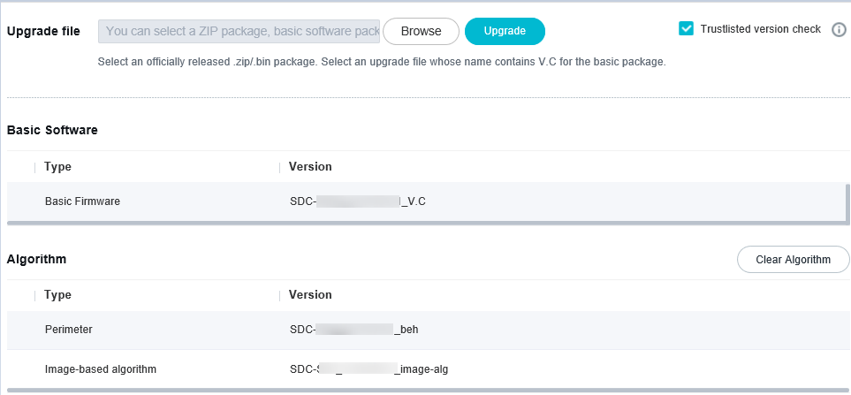
            - Click Browse and select the upgrade file.
- The selected upgrade file is in .bin format, for example, SDC-C16_10.0.0.SPC200_beh.bin. For details about the algorithm upgrade packages supported by the device, see Table 4-3.
- The algorithm upgrade packages do not need to be installed in a fixed sequence, but multiple algorithm upgrade packages cannot be installed at the same time.
            - Click Upgrade. In the dialog box that is displayed, click OK.
If the message "Uploading file... Perform other operations later." shown in Figure 4-7 is displayed, the upgrade file is being uploaded. During the upload, do not refresh or close the page before the upgrade is complete. After the upgrade succeeds, a message indicating the upgrade success is displayed.
              - Message displayed during the upgrade
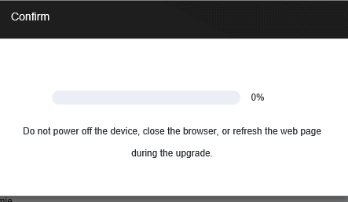

If the path of the upgrade file is similar to C:\fakepath\, the possible cause is that Include local directory path when uploading files to a server is disabled for Internet Explorer, which does not affect the upgrade. (To change the configuration, choose Tools > Internet Options > Security > Custom Level, and set Include local directory path when uploading files to a server to Enable.)
----End

Installing the Basic Software Package and Algorithm Packages for Cameras in Batches Using the iClient SDC
Prerequisites
You have obtained the basic software upgrade package by referring to Table 4-1.
Procedure

- Do not cut off power, disconnect the network, or perform other operations during the upgrade. Otherwise, the camera may be unable to work properly.
- After the upgrade, if you cannot log in to the camera web system, clear the cache of Internet Explorer and log in again. For details about how to clear the cache of Internet Explorer, see section 6 "FAQ."
- After the basic software package is installed, you need to reinstall the algorithm packages and application packages of the required version.
- In emergency mode, if the current version is 10.0.0, upgrade the camera directly. If the current version is not 10.0.0, first upgrade the camera to a version earlier than 10.0.0.
- If you downgrade a device of 10.0.0 to 9.0.0 on the emergency maintenance page of the iClient SDC, the device version number and vendor information may not be displayed on the web page. Therefore, you are advised not to directly downgrade devices of 10.0.0 on the emergency maintenance page of the iClient SDC. You can first upgrade a device to 10.0.0 on the emergency maintenance page of the iClient SDC and then downgrade it to 9.0.0 in the camera web system.
            - Choose Device Search on the iClient SDC home page. The Device Search page is displayed. Select a device to configure, select the user name, enter the password, and click Verify. Then the device is displayed in online state.
            - Choose Upgrade on the iClient SDC home page. The Upgrade page is displayed. In the device navigation tree on the left, select the model of cameras to be upgraded. Select one or more cameras from the camera list on the right.
              - Local upgrade
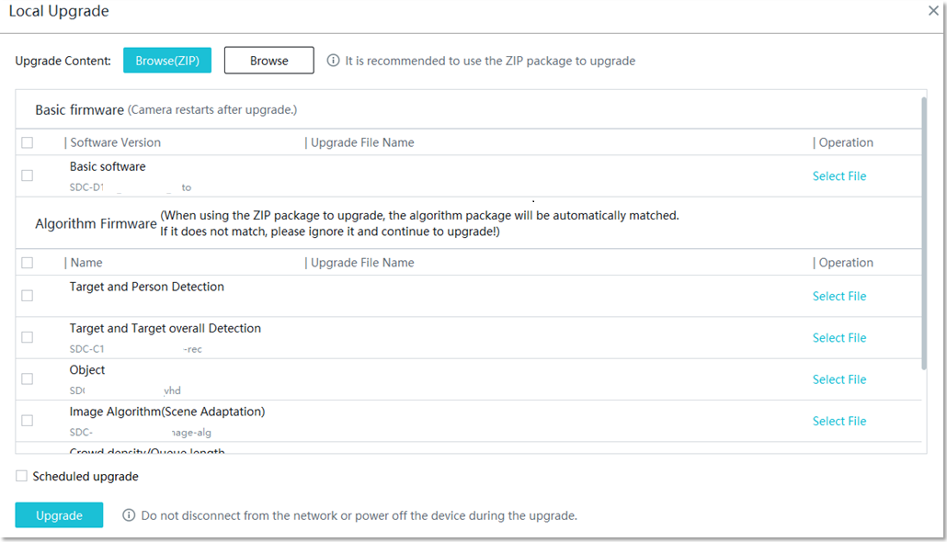
A maximum of 500 cameras can be selected for upgrade or rollback at a time. (The actual number of cameras that can be upgraded or rolled back in batches depends on the network bandwidth. It is recommended that 10–15 cameras be upgraded or rolled back in batches at a network bandwidth of 100 Mbit/s and 30 cameras be upgraded or rolled back in batches at a network bandwidth of 1000 Mbit/s.)
            - Click Browse(ZIP) or Browse. If you click Browse and select a local folder, the system automatically detects upgrade files in the folder, including the basic software package and algorithm packages.
(Optional) If the matched upgrade file does not meet the current requirements, you can click Change File next to the file and select a new upgrade file.
            - (Optional) Select Scheduled upgrade depending on your needs.
            - Click Upgrade. The system starts to upgrade the camera software.
----End

Verifying the Installation
5.1 Verifying Basic Software Upgrade Package Installation
5.2 Verifying Algorithm Upgrade Package Installation

Verifying Basic Software Upgrade Package Installation
            - Open Internet Explorer, enter the camera IP address in the address box, and press Enter. On the login page that is displayed, enter the user name (for example, admin) and password and click Log In.
            - Choose Configuration > System > System Maintenance > Upgrade and check the software version.
              - Checking software version
- If the upgrade is successful, the software version is the target version.
- If the software version is not the target version, the upgrade fails due to an exception. Perform the upgrade again.
----End

If you deselect alarm linkage options (such as SDK, ONVIF, and dynamic frame rate or bit rate) that are selected by default in a version earlier than 10.0.0, you need to reconfigure alarm linkage after upgrading the device to 10.0.0 or a later version.

Verifying Algorithm Upgrade Package Installation
Choose Configuration > System > Maintenance > Upgrade and check whether the algorithm package version information is the same as that described in Figure 5-2.
              - Checking the algorithm package version on the camera web page
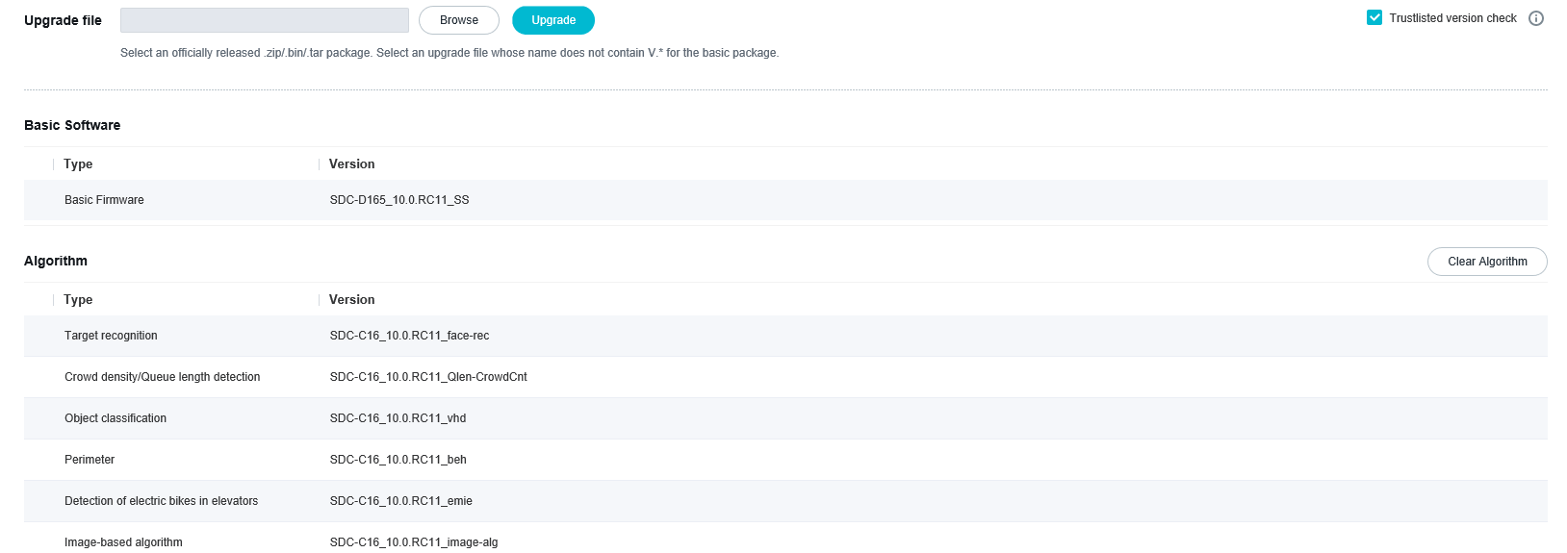
- If the upgrade is successful, the algorithm package version is the target version.
- If the algorithm package version is not the target version, the upgrade fails due to an exception. Perform the upgrade again.
- If the algorithm package version does not match the basic software package version, the message shown in Figure 5-2 is displayed.
              - Message displayed on the web page
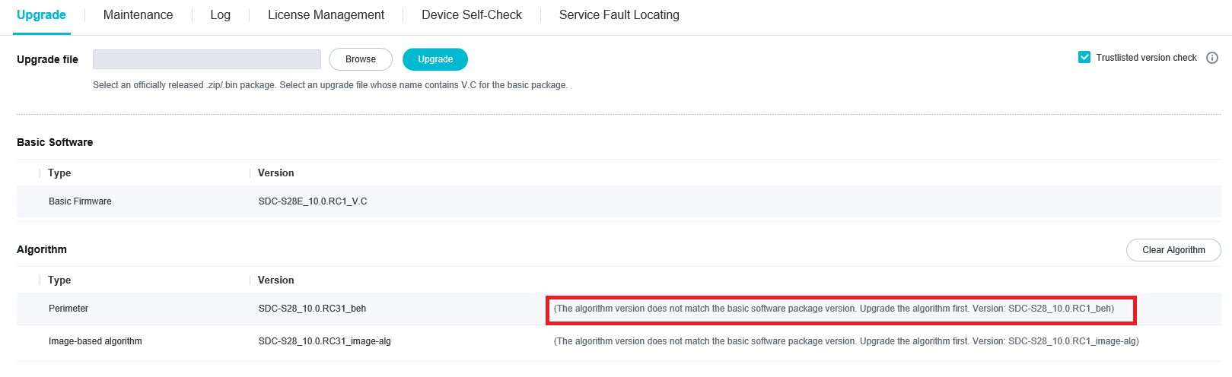

FAQs
What Can I Do If I Cannot Log In to the Camera Web System After the Upgrade?
After the upgrade is displayed as complete in the camera web system, the system will take a few seconds to copy some configuration files. If you power off the camera immediately after the upgrade is displayed as complete, you will fail to log in to the camera web system after the camera is powered on.
After the upgrade is complete, the version information is correct in the camera web system. However, after you power off and power on the camera again, you cannot log in to the camera. In this case, you need to upgrade the camera again using the iClient SDC by referring to 4.3 Installing the Basic Software Package and Algorithm Packages for Cameras in Batches Using the iClient SDC.
What Can I Do If the Device Cannot Be Upgraded from 9.0.0 TR5 to 10.0.0 After a Third-Party App with Data Disks Is Installed?
If a third-party app with data disks is installed on a device of the 9.0.0 TR5 version, the device cannot be upgraded to version 10.0.0 because an issue is not fixed. To upgrade the device, first uninstall the app and then upgrade the SDC version package.
How Can I Clear the Cache of Internet Explorer?
Open Internet Explorer and press F12 on the keyboard. Click the icon indicated by the red arrow shown in the following figure to clear cache of Internet Explorer.
How Can I Delete Target Records in a Target Library?
            - Log in to the camera web system and choose Configuration > Intelligence and toggle-on Target Match.
            - Click Settings next to Target Match. The configuration page is displayed.
            - Click the Target Library Management tab. On the tab page that is displayed, click next to the target library to delete the whole target library. Alternatively, select desired target records from a target library and delete the selected records.
----End
How Can I Import Target Records into a Target Library?
You can import target records into a target library in the camera web system. The detailed procedure is as follows:
            - Log in to the camera web system and choose Configuration > Intelligence. Toggle-on Target Match. Click Settings next to Target Match. On the page that is displayed, click Target Library Management.
            - Click New to create a target library and click Import Target Library to import target records into the new target library.
----End
If the upgrade fails, wait for about 1 minute and then perform the upgrade again.
After-Sales Contact Information
Enterprise users can obtain after-sales contact information from http://support.huawei.com/enterprise.
Carrier users can obtain after-sales contact information from http://carrier.huawei.com/en/.

