iMaster NCE-Campus
V300R023C00SPC100
 | Upgrade Guide
 | Issue | 01
 | Date | 2024-03-30

 | HUAWEI TECHNOLOGIES CO., LTD. |  | 

Copyright © Huawei Technologies Co., Ltd. 2024. All rights reserved.
No part of this document may be reproduced or transmitted in any form or by any means without prior written consent of Huawei Technologies Co., Ltd.

Trademarks and Permissions
and other Huawei trademarks are trademarks of Huawei Technologies Co., Ltd.
All other trademarks and trade names mentioned in this document are the property of their respective holders.

Notice
The purchased products, services and features are stipulated by the contract made between Huawei and the customer. All or part of the products, services and features described in this document may not be within the purchase scope or the usage scope. Unless otherwise specified in the contract, all statements, information, and recommendations in this document are provided "AS IS" without warranties, guarantees or representations of any kind, either express or implied.
The information in this document is subject to change without notice. Every effort has been made in the preparation of this document to ensure accuracy of the contents, but all statements, information, and recommendations in this document do not constitute a warranty of any kind, express or implied.

Huawei Technologies Co., Ltd.
Address: | Huawei Industrial Base  Bantian, Longgang  Shenzhen 518129  People's Republic of China
Website: | https://www.huawei.com
Email: | support@huawei.com

Security Declaration
Vulnerability
Huawei's regulations on product vulnerability management are subject to the Vul. Response Process. For details about this process, visit the following web page:
https://www.huawei.com/en/psirt/vul-response-process
For vulnerability information, enterprise customers can visit the following web page:
https://securitybulletin.huawei.com/enterprise/en/security-advisory

Contents
1 Before You Start 1
1.1 Upgrade Scheme 1
1.1.1 System Version Requirements 1
1.1.2 DR System Upgrade Scheme 2
1.2 Version Requirements 3
1.3 Upgrade Impact 3
1.3.1 Impact on the System During the Upgrade 3
1.3.2 Impact on the System After the Upgrade 4
1.3.3 Impact on Spare Parts 4
1.4 Precautions 4
2 Upgrade Process 6
3 Upgrade Preparations 10
3.1 Collecting Information 11
3.2 Pre-upgrade Operations 13
3.3 (Optional) Upgrading FusionCompute 13
3.4 Obtaining Required Upgrade Software and Tools 14
3.4.1 (Recommended) Downloading Software Packages Using EasyGet 14
3.4.2 Manually Downloading Software Packages 16
3.4.3 Downloading Tool Packages 30
3.5 Checking Port Changes 31
3.6 (Optional) Checking Whether Automatic DR Switchover Is Configured 31
3.7 (Optional) Deleting the DR System 32
3.7.1 Deleting the Controller DR System 32
3.8 Logging In to the Upgrade Tool 32
3.9 Uploading Software Packages 35
4 DR System Upgrade (One-Click Upgrade Solution) 36
4.1 Evaluating the Upgrade (DR System) 36
4.2 Upgrading a DR System 37
5 DR System Upgrade (Solution A with a DR System Split) 40
5.1 Disabling Services 41
5.1.1 Disabling Services in the Secondary Cluster 41
5.1.2 Disabling Services in the Primary Cluster 41
5.2 Evaluating the Upgrade of the Secondary Cluster 42
5.3 Upgrading the Secondary Cluster 43
5.4 Enabling Services of the Secondary Cluster 45
5.5 Evaluating the Upgrade of the Primary Cluster 45
5.6 Upgrading the Primary Cluster 46
5.7 Canceling the Configuration of Disabling Services of the Original Primary Cluster 48
5.8 Creating a DR System 48
5.8.1 Creating a DR System 48
5.8.1.1 Single-Node Scenario (Automatic Switchover) 48
5.8.1.1.1 Creating a DR System 48
5.8.1.2 Single-Node Scenario (Manual Switchover) 50
5.8.1.2.1 Creating a DR System 51
5.8.1.3 Cluster Scenario (Automatic Switchover) 52
5.8.1.3.1 Creating a DR System 52
5.8.1.4 Cluster Scenario (Manual Switchover) 54
5.8.1.4.1 Creating a DR System 55
5.9 (Optional) Performing a DR Switchover 56
6 DR System Upgrade (Solution B with a DR System Split) 58
6.1 Disabling Services of the Secondary Cluster 58
6.2 Evaluating the Upgrade of the Primary Cluster 59
6.3 Upgrading the Primary Cluster 61
6.4 Evaluating the Upgrade of the Secondary Cluster 62
6.5 Upgrading the Secondary Cluster 63
6.6 Canceling the Configuration of Disabling Services of the Original Secondary Cluster 64
6.7 Creating a DR System 64
6.7.1 Creating a DR System 64
7 Post-upgrade Check 65
7.1 Upgrading the Terminal Identification Signature Database 65
7.2 Updating a License 66
7.3 Checking the Southbound Access Configuration 67
8 Version Rollback (One-Click Upgrade) 69
8.1 Precautions for Rollback After the Upgrade 69
8.2 Rolling Back a DR System 70
9 Version Rollback (Solution A or B with a DR System Split) 71
9.1 Precautions for Rollback After the Upgrade 71
9.2 Rolling Back the Primary Cluster 72
9.3 Rolling Back the Secondary Cluster 72
9.4 Building a New DR System 73
10 FAQ 74
10.1 Residual Temporary Directories in the HDFS 75
10.2 How Can I Find an OMP Node of the Management Plane? 76
10.3 How Do I Check Whether the SecoManager Is Installed? 77
10.4 How Do I Check Whether the Source IP Address Feature Patch Has Been Installed? 78
10.5 How Do I Check Whether a Wireless Non-operating Plug-in Has Been Installed? 79
10.6 How Do I Check Whether the Nmap Feature Has Been Installed? 80
10.7 Checking Communication Matrix Changes 81
10.8 How Do I Use FileZilla to Transfer Files by SFTP? 113
10.9 How Do I Use PuTTY to Log In to a Server? 115
10.10 What Can I Do If the HUAWEI-ROUTER-SYSTEMSND Package Fails to Be Activated? 116
10.11 Checking RPM Packages of the SUSE OS 117
10.12 How Do I Check the SAC Configuration? 119
10.13 How Do I Delete Consumer Groups L2topoDiscovery and campus_alarm_notification? 120
10.14 How Do I Check Whether the Situational Awareness, SRv6, Remote Attestation, or IoT Management Feature Has Been Installed in an Environment? 122
10.15 How Do I Reset the Passwords of OS Users ossadm, sopuser, and ftpuser? 123
10.16 How Do I Reset the Passwords for the ossadm and sopuser Users of the Arbitration Node at the Third-Party Site? 123
10.17 What Do I Do If the OS Is Suspended During the Upgrade? 123
10.18 How Do I Deploy EasySuite on the Backend? 124
10.19 What Do I Do If a Message Indicating an Unfinished Upgrade Task Is Displayed When I Set Upgrade Parameters? 125
10.20 What Do I Do If Software Packages Fail to Be Verified on the Upgrade Tool? 127
10.21 How Do I Use a Third-Party Tool to Upload Software Packages to the Server? 127
10.22 How Do I Inspect Trust Certificates of Authentication Components and Rectify Problems 127
10.23 How Do I Enable Scheduled Backup Tasks on the Management Plane? 133
10.24 How Do I Handle Health Check Errors? 134
10.25 How Do I Start or Stop the EasySuite Process? 135
10.26 How Do I Back up the Device Security Configuration Check Report? 136

Before You Start

In this document, each content in blue is a hyperlink. You can hold down Ctrl and click the content in blue to access the corresponding web page or topic.
1.1 Upgrade Scheme
1.2 Version Requirements
1.3 Upgrade Impact
1.4 Precautions

Upgrade Scheme

System Version Requirements
In this iMaster NCE-Campus upgrade, the controller and OS (EulerOS or Huawei-delivered SUSE OS) are upgraded concurrently. If the customer has prepared an SUSE OS by themselves, upgrade the OS to SUSE 12 SP5 by referring to the corresponding guide listed in the following table before upgrading iMaster NCE-Campus.
                - Controller version requirements
Source Controller Version | Upgrade Description
iMaster NCE-Campus V300R022C00SPC100  iMaster NCE-Campus V300R022C00SPC101  iMaster NCE-Campus V300R022C00SPC102  iMaster NCE-Campus V300R022C00SPC120 | Upgrade the OS by referring to iMaster NCE-Campus V300R023C00SPC100 SUSE 12SP5 OS Upgrade Guide (SUSE 12SP2, SUSE 12SP4).
iMaster NCE-Campus V300R022C00SPC130  iMaster NCE-Campus V300R022C00SPC150  iMaster NCE-Campus V300R022C00SPC151  iMaster NCE-Campus V300R022C00SPC180  iMaster NCE-Campus V300R022C00SPC1b0 | Upgrade the OS by referring to iMaster NCE-Campus V300R022C00SPC130 SUSE 12SP5 OS Upgrade Guide (SUSE 12SP2, SUSE 12SP4).

DR System Upgrade Scheme
- If an authentication component is involved, you are advised to upgrade the authentication component before upgrading iMaster NCE-Campus.
- If iMaster NCE-Campus fails to be upgraded and is rolled back, you do not need to roll back the authentication component. (In this case, the data synchronization channel between iMaster NCE-Campus and the authentication component is disconnected, and the access authentication policies changed on iMaster NCE-Campus cannot be synchronized to the authentication component. These policies will be automatically synchronized to the authentication component after iMaster NCE-Campus re-upgrade succeeds.)
- This document provides three solutions to upgrade a DR system: one-click DR system upgrade, and upgrade solutions A and B with a DR system split.
- (Recommended) One-click DR system upgrade solution: You only need to complete the upgrade task on the upgrade tool by following the guide. No action on the background is required. This solution is recommended because it delivers high reliability.
- Upgrade solutions A and B with a DR system split
Solution A:
- When using this solution, you need to upgrade the secondary cluster first and then the primary cluster. If the secondary cluster fails to be upgraded, you can still start the primary cluster to ensure service continuity. This delivers relatively high reliability.
- During the upgrade of the secondary cluster, services in the primary cluster are interrupted for 2 hours. This solution is recommended in scenarios that are not sensitive to the upgrade interruption duration.
- After the upgrade, configure the original secondary cluster as the new primary cluster, and set the data replication direction to Secondary cluster before the upgrade -> Primary cluster before the upgrade.
- If you want the clusters to retain the original DR roles, perform an active/standby switchover after creating a DR system.
Solution B:
- When using this solution, you need to upgrade the primary cluster first and then the secondary cluster. If the primary cluster fails to be upgraded, perform operations in 5.1.2 Disabling Services in the Primary Cluster and then in 5.4 Enabling Services of the Secondary Cluster.
- Throughout the entire upgrade process, the secondary cluster does not take over services and services in the primary cluster are interrupted for about 45 minutes.
- After the upgrade, configure the clusters to retain the original DR roles when creating a DR system and set the data replication direction to Primary cluster before the upgrade -> Secondary cluster before the upgrade.

Version Requirements
                - Version requirements
Version | Description
iMaster NCE-Campus V300R022C00SPC100  iMaster NCE-Campus V300R022C00SPC101  iMaster NCE-Campus V300R022C00SPC102  iMaster NCE-Campus V300R022C00SPC120  iMaster NCE-Campus V300R022C00CP1201  iMaster NCE-Campus V300R022C00SPC130  iMaster NCE-Campus V300R022C00SPC150  iMaster NCE-Campus V300R022C00SPC151  iMaster NCE-Campus V300R022C00SPC180  iMaster NCE-Campus V300R022C00SPC1b0 | It can be upgraded to iMaster NCE-Campus V300R023C00SPC100.

Upgrade Impact

Impact on the System During the Upgrade
Impact on Services
iMaster NCE-Campus services will be interrupted during the upgrade. For details about the interruption duration, log in to the Huawei technical support website and check the corresponding specification.
- For enterprise users:
  - Log in to https://info.support.huawei.com/info-finder/search-center/en/enterprise/network-management-and-analysis-software/imaster-nce-campus-pid-250852420.
  - Click Specifications Query and select the target version from the Version drop-down list box.
  - Search for Service interruption duration during the upgrade to view the detailed specification.
- For carrier users:
  - Log in to https://info.support.huawei.com/info-finder/search-center/en/carrier/network-management-and-analysis-software/imaster-nce-campus-pid-250852420.
  - Click Specifications Query and select the target version from the Version drop-down list box.
  - Search for Service interruption duration during the upgrade to view the detailed specification.

Impact on the System After the Upgrade
None

Impact on Spare Parts
None

Precautions
- During the upgrade or rollback, forbid concurrent operations by multiple users on the server. Otherwise, the upgrade or rollback may fail.
- During the upgrade, do not perform any operation on the management node. Otherwise, the upgrade will fail.
- After an upgrade task is created, incremental deployment or capacity expansion cannot be performed. If incremental deployment or capacity expansion has been performed, create a new upgrade task.
- During the upgrade, do not open multiple pages on EasySuite to repeat the upgrade task. Otherwise, the page may be displayed abnormally (for example, showing that the task fails). This is a display exception and can be resolved by refreshing the pages.
- Ensure that you have performed the operations in 3.8 Logging In to the Upgrade Tool before uploading the EasySuiteSolution-Campus_{version}_ESSolution_XXX.zip software package on EasySuite. Otherwise, the upgrade may fail.
- If iMaster NCE-Campus is upgraded from an earlier version to V300R023C00SPC100 or a later version, check the SAC configuration by referring to 10.12 How Do I Check the SAC Configuration?.
- If the upgrade fails, you can only retry or roll back the upgrade. Other operations are not allowed.
- You are advised to perform the upgrade during off-peak hours during which a few terminals are connected.
- During the upgrade or rollback, ensure that the network between management plane nodes and service plane nodes is normal. Do not restart any node to avoid upgrade or rollback failures.
- If feature expansion has been performed after the upgrade, version rollback is not supported.
- If the upgraded cluster has set up a DR system with a newly installed cluster, version rollback is not supported.
- After iMaster NCE-Campus is upgraded to V300R023C00, if the number of tunnels between APs and WACs exceeds the upper limit, you need to manually disconnect the APs that have not set up tunnels with WACs.
Huawei and its subsidiaries do not assume any liability for maintenance issues and commercial legal issues that are the result of customer's purchase of non-matching software versions, or failure to proactively upgrade the software version based on the new software version released on the Huawei official website or other channels, with such actions causing the arrival of software EOM, EOFS, or EOS to be earlier than that of the product. When upgrading iMaster NCE-Campus, customers are advised to pay attention to the latest software version information from channels such as the Huawei official website and upgrade the software to the required version.

Upgrade Process
              - One-click upgrade flowchart
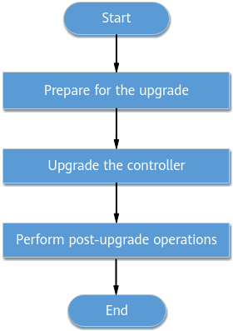

              - Upgrade flowchart for solution A
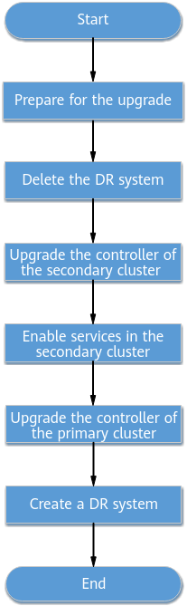
              - Upgrade flowchart for solution B
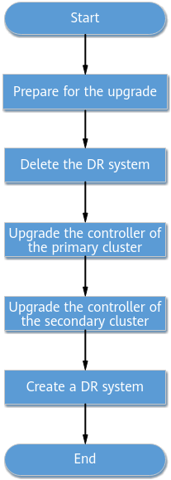

                - Estimated upgrade schedule
Step | Recommended Start Time | Time Required
Preparing for the upgrade | One day before the upgrade | About 130 minutes
Upgrading the controller | Based on customer requirements | Less than 120 minutes

The time required for each step is for reference only. The actual duration depends on onsite conditions.

Upgrade Preparations
- The time required is affected by many factors, such as the onsite data volume and server performance.
- The Check Result column must be filled by onsite upgrade personnel.
Recommended Start Time | Preparation | Description | Check Result | Time Required
One day before the one-click DR system upgrade | 3.1 Collecting Information | Collect the environment information required for the upgrade. |  | 10 minutes
One day before the one-click DR system upgrade | 3.4 Obtaining Required Upgrade Software and Tools | Download tools and software packages. |  | 20 minutes
One day before the one-click DR system upgrade | 3.8 Logging In to the Upgrade Tool | Log in to EasySuite of the online version. |  | 20 minutes
One day before the one-click DR system upgrade | 4.1 Evaluating the Upgrade (DR System) | Prepare for upgrading a DR system using EasySuite. |  | 60 minutes

Recommended Start Time | Preparation | Description | Check Result | Time Required
One day before the upgrade with a DR system split | 3.1 Collecting Information | Collect the environment information required for the upgrade. |  | 10 minutes
One day before the upgrade with a DR system split | 3.4 Obtaining Required Upgrade Software and Tools | Download tools and software packages. |  | 20 minutes
One day before the upgrade with a DR system split | 3.8 Logging In to the Upgrade Tool | Log in to EasySuite of the online version. |  | 20 minutes
One day before the upgrade with a DR system split | 5 DR System Upgrade (Solution A with a DR System Split) | Prepare for upgrading the secondary cluster using EasySuite. |  | 60 minutes
One day before the upgrade with a DR system split | 6 DR System Upgrade (Solution B with a DR System Split) | Prepare for upgrading the primary cluster using EasySuite. |  | 60 minutes

3.1 Collecting Information
3.2 Pre-upgrade Operations
3.3 (Optional) Upgrading FusionCompute
3.4 Obtaining Required Upgrade Software and Tools
3.5 Checking Port Changes
3.6 (Optional) Checking Whether Automatic DR Switchover Is Configured
3.7 (Optional) Deleting the DR System
3.8 Logging In to the Upgrade Tool
3.9 Uploading Software Packages

Collecting Information
Obtaining IP Addresses and Passwords
To ensure successful upgrade, collect the information listed in the following table before the upgrade.
Item | Actual Value | Description
IP address of the iMaster NCE-Campus management plane and password of the admin user | - | -
IP address of the iMaster NCE-Campus service plane and password of the admin user | - | -
IP addresses of all iMaster NCE-Campus nodes | - | -
Passwords for the root, ossadm, sopuser, and ftpuser OS users on the iMaster NCE-Campus management node | - | If you forget the password of an OS user, reset the password according to 10.15 How Do I Reset the Passwords of OS Users ossadm, sopuser, and ftpuser?.
Preset username and password for logging in to EasySuite | - | If you forget the password, see section "Retrieving the EasySuite Login Password During iMaster NCE-Campus Upgrade" under Maintenance and Troubleshooting > NCE&Solution Troubleshooting Guide > Common Troubleshooting Cases > Login Failures in the CloudCampus Solution V100R023C00 & iMaster NCE-Campus V300R023C00 Product Documentation.
Passwords of the root and omm users for logging in to FusionInsight nodes | - | -
IP address of the FusionInsight management plane and password of the admin user | - | -
Passwords for the sopuser, ossadm, and root users for logging in to the arbitration node at the third-party site | - | If you forget a user password of the arbitration node at the third-party site, reset the password according to 10.16 How Do I Reset the Passwords for the ossadm and sopuser Users of the Arbitration Node at the Third-Party Site?.
Port | 19090: port used by users to log in to EasySuite | To use the specified port for communication, you need to enable the network port between the PC and the OMP_01 node. For details about how to check the IP address of the OMP_01 node, see 10.2 How Can I Find an OMP Node of the Management Plane?.
Supported web browsers | - | Web browsers:  - Google Chrome 94 or later  - Firefox 80 or later  - Microsoft Edge 94 or later (64-bit)

Pre-upgrade Operations
Perform operations in this section only in the primary cluster if you use the one-click DR system upgrade solution, and in both primary and secondary clusters if you use upgrade solution A or B with a DR system split.
- Log in to each node as the sopuser user and run the following command:
# su - root
Password: Password of the root user
            - Run the following commands:
# rm -f /opt/oss/log/NCECAMPUS/PortalServerService/log/memory*
# rm -f /opt/oss/log/NCECAMPUS/RadiusServerService/log/memory*
# rm -f /opt/oss/log/NCECAMPUS/CampusAccountService/log/memory*
----End

(Optional) Upgrading FusionCompute


In the address box of a browser, enter https://VRM floating IP address:8443, enter the administrator's username and password, click Log In, and choose Help > About to check the FusionCompute version. If the version is FusionCompute 8.5.0 or later, skip this section. If the version is FusionCompute 8.2.0, upgrade it to FusionCompute 8.5.0 and then upgrade the controller.
For a distributed cluster, upgrade FusionCompute to 8.5.0. For details, see the iMaster NCE-Campus FusionCompute 8.5.0 Upgrade Guide (for enterprise users) or iMaster NCE-Campus FusionCompute 8.5.0 Upgrade Guide (for carrier users).

Obtaining Required Upgrade Software and Tools
- Place all the software packages required for the upgrade in the same folder.
- Software package download information is available on EasyGet two days after software packages are released.

(Recommended) Downloading Software Packages Using EasyGet
- Log in to EasyGet at https://info.support.huawei.com/comdev/easyget/#/software-package using a Huawei engineer account.
            - Set parameters in the Solution area and click OK to view the software packages required by the current solution.
Select a user type based on your site type.
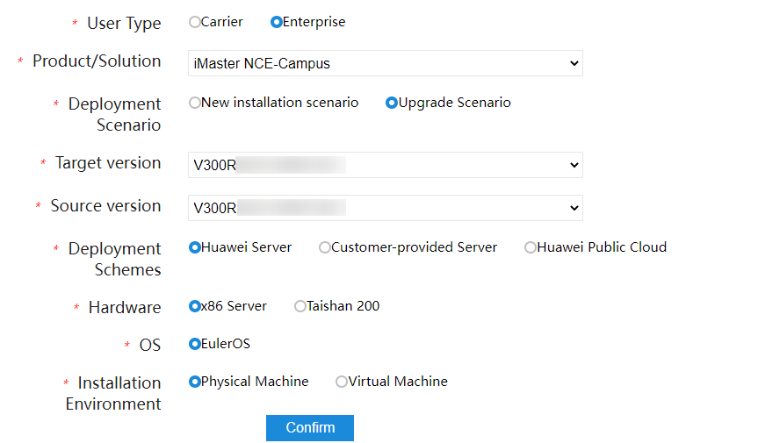
            - Apply for software packages.
- Apply for and download the iMasterNCE-Campus_V300R023C00_SecoManager_linux-x86-64.7z software package if the SecoManager has been installed. For details about how to check whether the SecoManager has been installed, see 10.3 How Do I Check Whether the SecoManager Is Installed?.
- Apply for and download the iMasterNCE-Campus_V300R023C00_NMAP-Plugin_linux-***.7z software package if the Nmap feature has been installed. For details about how to check whether the Nmap feature has been installed, see 10.6 How Do I Check Whether the Nmap Feature Has Been Installed?.
- Apply for and download the iMasterNCE-Campus_V300R023C00_AAMonitor_linux-***.zip software package if DR arbitration needs to be installed.
- Apply for and download the AppAnalysis-Plugin_V300R023C00_linux-***.zip software package if the source IP address patch has been installed. For details about how to check whether the source IP address patch has been installed, see 10.4 How Do I Check Whether the Source IP Address Feature Patch Has Been Installed?.
- Apply for and download the WIFIAudit_V300R023C00_linux-x86-64.zip software package if the wireless non-operating plug-in has been installed. For details about how to check whether the wireless non-operating plug-in has been installed, see 10.5 How Do I Check Whether a Wireless Non-operating Plug-in Has Been Installed?.
Apply for mandatory software packages. You can apply for optional software packages based on the site requirements.
- For carrier users, click Apply to apply for all required software packages.
- For enterprise users, apply for the required software packages by product.
            - After the software package application is approved, select the software packages to be downloaded on the EasyGet page and click Download. The following dialog box is displayed. Use ICS Lite to download the software packages as prompted.
Place the downloaded software packages and the corresponding .cms and .crl signature files in the same folder, and delete unnecessary .p7s and .asc signature files from the folder.
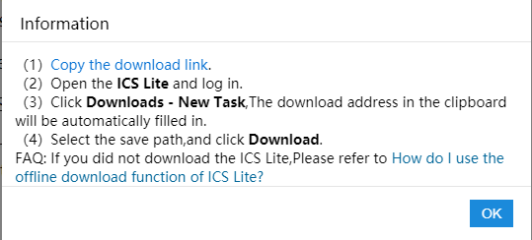
            - Download the upgrade reference documents. On the EasyGet page, click Documentation and click Download. The following dialog box is displayed. Use ICS Lite to download the documents as prompted.
----End

Manually Downloading Software Packages
- Download the health check patch EasyOps software package and the corresponding digital certificate files (.cms and .crl files).
EasyOps Hot Patch | How to Obtain
EasyOps V100R022C00HP0012 | Enterprise, Carrier

            - Contact Huawei technical support to download the required software packages and the corresponding digital certificate files (.cms and .crl files, or .p7s file), as listed in Table 3-2. The names and versions of the required software packages may vary depending on the actual situation.
              - .cms and .crl signature files, or .p7s signature file
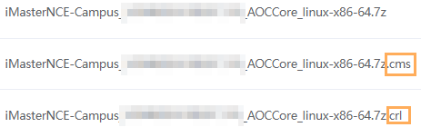
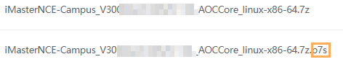

How to download the required iMaster NCE-Campus software packages:
For enterprise users, access the iMaster NCE-Campus software download website, select the required version, and download the required packages.
For carrier users, access the iMaster NCE-Campus software download website, select the required version, and download the required packages.
You can download required software packages in integrated or separate package mode. In integrated package mode, one integrated package contains all required iMaster NCE-Campus software packages, for easy upload and download. The separate package mode applies when the integrated software package fails to be downloaded due to poor network conditions. In this mode, you can separately download the software packages contained in the integrated package.
                - Software packages to be downloaded (integrated package download)
Type | Software Package | Description | How to Obtain
X86 | EasySuiteSolution-Campus_{version}_x86-64.zip | Used to upgrade iMaster NCE-Campus deployed on x86-based servers. | - For enterprise users, visit the EasySuiteSolution software download website and select the EasySuiteSolution-Campus V300R023C00SPC900 version.  - For carrier users, visit the EasySuiteSolution software download website and select the EasySuiteSolution-Campus V300R023C00SPC900 version.
X86 | EasySuite_{version}_OM_linux-x86-64.zip | EasySuite package used to upgrade the controller deployed on x86-based servers. | - For enterprise users, visit the EasySuite software download website, select EasySuite V100R023C00SPC905, and download the required package.  - For carrier users, visit the EasySuite software download website, select EasySuite V100R023C00SPC905, and download the required package.
X86 | iMasterNCEServerInstall_{version}_EulerOS2.11Patch-x86-64_pkg.tar | Used to upgrade EulerOS on x86-based servers. | - For enterprise users, visit the iMaster NCE Server_Install software download website, select iMaster NCE Server_Install V100R023C00SPC905, and download the required package.  - For carrier users, visit the iMaster NCE Server_Install software download website, select iMaster NCE Server_Install V100R023C00SPC905, and download the required package.
X86 | iMasterNCEServerInstall_{version}_OSPatchtool_EulerOS2.11-x86-64.zip | Used to upgrade EulerOS on x86-based servers.
X86 | iMasterNCEServerInstall_{version}_suse12.5Patch-x86-64_pkg.tar | Used to upgrade the self-developed SUSE OS on x86-based servers. | - For enterprise users, visit the iMaster NCE Server_Install software download website, select iMaster NCE Server_Install V100R023C00SPC905, and download the required package.  - For carrier users, visit the iMaster NCE Server_Install software download website, select iMaster NCE Server_Install V100R023C00SPC905, and download the required package.
X86 | iMasterNCEServerInstall_{version}_OSPatchtool_suse12.5-x86-64.zip
X86 | iMasterNCE-Campus_{version}_Campus_Combine_linux-x86-64.zip | This integrated software package contains all required iMaster NCE-Campus software packages, for easy upload and download. If this integrated software package fails to be downloaded due to poor network conditions, you can separately download the software packages contained in the integrated package. For details about the software packages to be downloaded separately, see Table 3-2. | - For enterprise users, visit the iMaster NCE-Campus software download website and select the iMaster NCE-Campus V300R023C00SPC100 version.  - For carrier users, visit the iMaster NCE-Campus software download website and select the iMaster NCE-Campus V300R023C00SPC100 version.
X86 | AppAnalysis-Plugin_{version}_linux-x86-64.7z | (Optional) If the source IP address feature patch has been installed before the upgrade, download this software package. For details about how to check whether the source IP address feature patch has been installed in the source environment, see 10.4 How Do I Check Whether the Source IP Address Feature Patch Has Been Installed?. | - For enterprise users:  Access the AppAnalysis-Plugin package download website using a Support account, select AppAnalysis-Plugin V300R023C00SPC100, and download the required package.
X86 | WIFIAudit_{version}_linux-x86-64.7z | (Optional) If the wireless non-operating plug-in has been installed before the upgrade, download this software package. For details about how to check whether the wireless non-operating plug-in has been installed in the source environment, see 10.5 How Do I Check Whether a Wireless Non-operating Plug-in Has Been Installed?. | - For carrier users:  Access the software package download website using a Support account, select WIFIAudit V300R023C00SPC100, and download the required package.  - For enterprise users:  Access the software package download website using a Support account, select WIFIAudit V300R023C00SPC100, and download the required package.
ARM | EasySuiteSolution-Campus_{version}_aarch64.zip | Used to upgrade iMaster NCE-Campus deployed on ARM-based servers. | - For enterprise users, visit the EasySuiteSolution software download website and select the EasySuiteSolution-Campus V300R023C00SPC900 version.  - For carrier users, visit the EasySuiteSolution software download website and select the EasySuiteSolution-Campus V300R023C00SPC900 version.
ARM | EasySuite_{version}_OM_linux-aarch64.zip | EasySuite package used to upgrade the controller deployed on ARM-based servers. | - For enterprise users, visit the EasySuite software download website, select EasySuite V100R023C00SPC905, and download the required package.  - For carrier users, visit the EasySuite software download website, select EasySuite V100R023C00SPC905, and download the required package.
ARM | iMasterNCEServerInstall_{version}_EulerOS2.11Patch-aarch64_pkg.tar | Used to upgrade EulerOS on ARM-based servers. | - For enterprise users, visit the iMaster NCE Server_Install software download website, select iMaster NCE Server_Install V100R023C00SPC905, and download the required package.  - For carrier users, visit the iMaster NCE Server_Install software download website, select iMaster NCE Server_Install V100R023C00SPC905, and download the required package.
ARM | iMasterNCEServerInstall_{version}_OSPatchtool_EulerOS2.11-aarch64.zip | Used to upgrade EulerOS on ARM-based servers.
ARM | iMasterNCE-Campus_{version}_Campus_Combine_linux-aarch64.zip | This integrated software package contains all required iMaster NCE-Campus software packages, for easy upload and download. If this integrated software package fails to be downloaded due to poor network conditions, you can separately download the software packages contained in the integrated package. For details about the software packages to be downloaded separately, see Table 3-2. | - For enterprise users, visit the iMaster NCE-Campus software download website and select the iMaster NCE-Campus V300R023C00SPC100 version.  - For carrier users, visit the iMaster NCE-Campus software download website and select the iMaster NCE-Campus V300R023C00SPC100 version.
ARM | AppAnalysis-Plugin_{version}_linux-aarch64.7z | (Optional) If the source IP address feature patch has been installed before the upgrade, download this software package. For details about how to check whether the source IP address feature patch has been installed in the source environment, see 10.4 How Do I Check Whether the Source IP Address Feature Patch Has Been Installed?. | - For enterprise users:  Access the AppAnalysis-Plugin package download website using a Support account, select AppAnalysis-Plugin V300R023C00SPC100, and download the required package.
ARM | WIFIAudit_{version}_linux-aarch64.7z | (Optional) If the wireless non-operating plug-in has been installed before the upgrade, download this software package. For details about how to check whether the wireless non-operating plug-in has been installed in the source environment, see 10.5 How Do I Check Whether a Wireless Non-operating Plug-in Has Been Installed?. | - For carrier users:  Access the software package download website using a Support account, select WIFIAudit V300R023C00SPC100, and download the required package.  - For enterprise users:  Access the software package download website using a Support account, select WIFIAudit V300R023C00SPC100, and download the required package.

                - Software packages to be downloaded (separate package download)
Type | No. | Software Package | Description
x86 | 1 | EasySuiteSolution-Campus_V300R023C00SPC900_x86-64.zip | Used to upgrade iMaster NCE-Campus deployed on x86-based servers.
x86 | 2 | EasySuite_V100R023C00SPC905_OM_linux-x86-64.zip | EasySuite package used to upgrade the controller deployed on x86-based servers.  - For enterprise users, visit the EasySuite software download website, select EasySuite V100R023C00SPC905, and download the required package.  - For carrier users, visit the EasySuite software download website, select EasySuite V100R023C00SPC905, and download the required package.
x86 | 3 | iMasterNCE-Campus_V300R023C00SPC100_AOCCore_linux-x86-64.7z | Used to upgrade iMaster NCE-Campus deployed on x86-based servers.
x86 | 4 | iMasterNCE-Campus_V300R023C00SPC100_BKSigntool_linux-x86-64_pkg.zip | Used to upgrade iMaster NCE-Campus deployed on x86-based servers.
x86 | 5 | iMasterNCE-Campus_V300R023C00SPC100_Bigdata_linux-x86-64.7z | Used to upgrade iMaster NCE-Campus deployed on x86-based servers.
x86 | 6 | iMasterNCE-Campus_V300R023C00SPC100_Campus_linux-x86-64.7z | Used to upgrade iMaster NCE-Campus deployed on x86-based servers.
x86 | 7 | iMasterNCE-Campus_V300R023C00SPC100_CloudSopService_linux-x86-64.7z | Used to upgrade iMaster NCE-Campus deployed on x86-based servers.
x86 | 8 | iMasterNCE-Campus_V300R023C00SPC100_CommonService_linux-x86-64.7z | Used to upgrade iMaster NCE-Campus deployed on x86-based servers.
x86 | 9 | iMasterNCE-Campus_V300R023C00SPC100_OMP-Extend_linux-x86-64.zip | Used to upgrade iMaster NCE-Campus deployed on x86-based servers.
x86 | 10 | iMasterNCE-Campus_V300R023C00SPC100_OMP_linux-x86-64.zip | Used to upgrade iMaster NCE-Campus deployed on x86-based servers.
x86 | 11 | iMasterNCE-Campus_V300R023C00SPC100_linux-GaussDBPatch-x86-64_pkg.tar | Used to upgrade iMaster NCE-Campus deployed on x86-based servers.
x86 | 12 | iMasterNCE-Campus_V300R023C00SPC100_ExtAdvancedSEC_linux-x86-64.7z | (Optional) If the situational awareness feature has been installed before the upgrade, download this software package. For details about how to check whether the situational awareness feature has been installed in the source environment, see 10.14 How Do I Check Whether the Situational Awareness, SRv6, Remote Attestation, or IoT Management Feature Has Been Installed in an Environment?.
x86 | 13 | iMasterNCE-Campus_V300R023C00SPC100_IPService_linux-x86-64.7z | (Optional) If the SRv6 feature has been installed before the upgrade, download this software package. For details about how to check whether the SRv6 feature has been installed in the source environment, see 10.14 How Do I Check Whether the Situational Awareness, SRv6, Remote Attestation, or IoT Management Feature Has Been Installed in an Environment?.
x86 | 14 | iMasterNCE-Campus_V300R023C00SPC100_TrustCenter_linux-x86-64.7z | (Optional) If the remote attestation feature has been installed before the upgrade, download this software package. For details about how to check whether the remote attestation feature has been installed in the source environment, see 10.14 How Do I Check Whether the Situational Awareness, SRv6, Remote Attestation, or IoT Management Feature Has Been Installed in an Environment?.
x86 | 15 | iMasterNCE-Campus_V300R023C00SPC100_SecoManager_linux-x86-64.7z | (Optional) If the SecoManager has been installed before the upgrade, download this software package. For details about how to check whether the SecoManager has been installed in the source environment, see 10.3 How Do I Check Whether the SecoManager Is Installed?.
x86 | 16 | iMasterNCE-Campus_V300R023C00SPC100_NMAP-Plugin_linux-x86-64.7z | (Optional) If the Nmap feature has been installed before the upgrade, download this software package. For details about how to check whether the Nmap feature has been installed in the source environment, see 10.6 How Do I Check Whether the Nmap Feature Has Been Installed?.
x86 | 17 | iMasterNCE-Campus_V300R023C00SPC100_OSMediation_linux-x86-64.zip | Used to upgrade the OSMediation feature on x86-based servers.
x86 | 18 | iMasterNCE-Campus_V300R023C00SPC100_AAMonitor_linux-x86-64.zip | (Optional) In a DR scenario, download this package if you need to install arbitration software.
x86 | 19 | iMasterNCE-Campus_V300R023C00SPC100_IOT_linux-x86-64.7z | (Optional) If the IoT management feature has been installed before the upgrade, download this software package. For details about how to check whether the IoT management feature has been installed, see 10.14 How Do I Check Whether the Situational Awareness, SRv6, Remote Attestation, or IoT Management Feature Has Been Installed in an Environment?.
x86 | 20 | AppAnalysis-Plugin_V300R023C00SPC100_linux-x86-64.7z | (Optional) If the source IP address feature patch has been installed before the upgrade, download this software package. For details about how to check whether the source IP address feature patch has been installed in the source environment, see 10.4 How Do I Check Whether the Source IP Address Feature Patch Has Been Installed?.  - For enterprise users:  Access the AppAnalysis-Plugin package download website using a Support account, select AppAnalysis-Plugin V300R023C00SPC100, and download the required package.
x86 | 21 | WIFIAudit_V300R023C00SPC100_linux-x86-64.7z | (Optional) If the wireless non-operating plug-in has been installed before the upgrade, download this software package. For details about how to check whether the wireless non-operating plug-in has been installed in the source environment, see 10.5 How Do I Check Whether a Wireless Non-operating Plug-in Has Been Installed?.  - For carrier users:  Access the software package download website using a Support account, select WIFIAudit V300R023C00SPC100, and download the required package.  - For enterprise users:  Access the software package download website using a Support account, select WIFIAudit V300R023C00SPC100, and download the required package.
x86 | 22 | iMasterNCE-Campus_V300R023C00SPC100_APaaSCore_linux-x86-64.7z | Used to upgrade iMaster NCE-Campus deployed on x86-based servers.
x86 | 23 | iMasterNCEServerInstall_{version}_OSPatchtool_EulerOS2.11-x86-64.zip | Used to upgrade EulerOS on x86-based servers.  - For enterprise users, visit the iMaster NCE Server_Install software download website, select iMaster NCE Server_Install V100R023C00SPC905, and download the required package.  - For carrier users, visit the iMaster NCE Server_Install software download website, select iMaster NCE Server_Install V100R023C00SPC905, and download the required package.
x86 | 24 | iMasterNCEServerInstall_{version}_EulerOS2.11Patch-x86-64_pkg.tar
x86 | 25 | iMasterNCEServerInstall_{version}_suse12.5Patch-x86-64_pkg.tar | Used to upgrade the self-developed SUSE OS on x86-based servers.  - For enterprise users, visit the iMaster NCE Server_Install software download website, select iMaster NCE Server_Install V100R023C00SPC905, and download the required package.  - For carrier users, visit the iMaster NCE Server_Install software download website, select iMaster NCE Server_Install V100R023C00SPC905, and download the required package.
x86 | 26 | iMasterNCEServerInstall_{version}_OSPatchtool_suse12.5-x86-64.zip
ARM | 1 | EasySuiteSolution-Campus_V300R023C00SPC900_aarch64.zip | Used to upgrade iMaster NCE-Campus deployed on ARM-based servers.
ARM | 2 | EasySuite_V100R023C00SPC905_OM_linux-aarch64.zip | EasySuite package used to upgrade the controller deployed on ARM-based servers.  - For enterprise users, visit the EasySuite software download website, select EasySuite V100R023C00SPC905, and download the required package.  - For carrier users, visit the EasySuite software download website, select EasySuite V100R023C00SPC905, and download the required package.
ARM | 3 | iMasterNCE-Campus_V300R023C00SPC100_AOCCore_linux-aarch64.7z | Used to upgrade iMaster NCE-Campus deployed on ARM-based servers.
ARM | 4 | iMasterNCE-Campus_V300R023C00SPC100_BKSigntool_linux-aarch64_pkg.zip | Used to upgrade iMaster NCE-Campus deployed on ARM-based servers.
ARM | 5 | iMasterNCE-Campus_V300R023C00SPC100_Bigdata_linux-aarch64.7z | Used to upgrade iMaster NCE-Campus deployed on ARM-based servers.
ARM | 6 | iMasterNCE-Campus_V300R023C00SPC100_Campus_linux-aarch64.7z | Used to upgrade iMaster NCE-Campus deployed on ARM-based servers.
ARM | 7 | iMasterNCE-Campus_V300R023C00SPC100_CloudSopService_linux-aarch64.7z | Used to upgrade iMaster NCE-Campus deployed on ARM-based servers.
ARM | 8 | iMasterNCE-Campus_V300R023C00SPC100_CommonService_linux-aarch64.7z | Used to upgrade iMaster NCE-Campus deployed on ARM-based servers.
ARM | 9 | iMasterNCE-Campus_V300R023C00SPC100_OMP-Extend_linux-aarch64.zip | Used to upgrade iMaster NCE-Campus deployed on ARM-based servers.
ARM | 10 | iMasterNCE-Campus_V300R023C00SPC100_OMP_linux-aarch64.zip | Used to upgrade iMaster NCE-Campus deployed on ARM-based servers.
ARM | 11 | iMasterNCE-Campus_V300R023C00SPC100_linux-GaussDBPatch-aarch64_pkg.tar | Used to upgrade iMaster NCE-Campus deployed on ARM-based servers.
ARM | 12 | iMasterNCE-Campus_V300R023C00SPC100_ExtAdvancedSEC_linux-aarch64.7z | (Optional) If the situational awareness feature has been installed before the upgrade, download this software package. For details about how to check whether the situational awareness feature has been installed in the source environment, see 10.14 How Do I Check Whether the Situational Awareness, SRv6, Remote Attestation, or IoT Management Feature Has Been Installed in an Environment?.
ARM | 13 | iMasterNCE-Campus_V300R023C00SPC100_IPService_linux-aarch64.7z | (Optional) If the SRv6 feature has been installed before the upgrade, download this software package. For details about how to check whether the SRv6 feature has been installed in the source environment, see 10.14 How Do I Check Whether the Situational Awareness, SRv6, Remote Attestation, or IoT Management Feature Has Been Installed in an Environment?.
ARM | 14 | iMasterNCE-Campus_V300R023C00SPC100_TrustCenter_linux-aarch64.7z | (Optional) If the remote attestation feature has been installed before the upgrade, download this software package. For details about how to check whether the remote attestation feature has been installed in the source environment, see 10.14 How Do I Check Whether the Situational Awareness, SRv6, Remote Attestation, or IoT Management Feature Has Been Installed in an Environment?.
ARM | 15 | iMasterNCE-Campus_V300R023C00SPC100_SecoManager_linux-aarch64.7z | (Optional) If the SecoManager has been installed before the upgrade, download this software package. For details about how to check whether the SecoManager has been installed in the source environment, see 10.3 How Do I Check Whether the SecoManager Is Installed?.
ARM | 16 | iMasterNCE-Campus_V300R023C00SPC100_NMAP-Plugin_linux-aarch64.7z | (Optional) If the Nmap feature has been installed before the upgrade, download this software package. For details about how to check whether the Nmap feature has been installed in the source environment, see 10.6 How Do I Check Whether the Nmap Feature Has Been Installed?.
ARM | 17 | iMasterNCE-Campus_V300R023C00SPC100_OSMediation_linux-aarch64.zip | Used to upgrade the OSMediation feature on ARM-based servers.
ARM | 18 | iMasterNCE-Campus_V300R023C00SPC100_AAMonitor_linux-aarch64.zip | (Optional) In a DR scenario, download this package if you need to install arbitration software.
ARM | 19 | iMasterNCE-Campus_V300R023C00SPC100_IOT_linux-aarch64.7z | (Optional) If the IoT management feature has been installed before the upgrade, download this software package. For details about how to check whether the IoT management feature has been installed, see 10.14 How Do I Check Whether the Situational Awareness, SRv6, Remote Attestation, or IoT Management Feature Has Been Installed in an Environment?.
ARM | 20 | AppAnalysis-Plugin_V300R023C00SPC100_linux-aarch64.7z | (Optional) If the source IP address feature patch has been installed before the upgrade, download this software package. For details about how to check whether the source IP address feature patch has been installed in the source environment, see 10.4 How Do I Check Whether the Source IP Address Feature Patch Has Been Installed?.  - For enterprise users:  Access the AppAnalysis-Plugin package download website using a Support account, select AppAnalysis-Plugin V300R023C00SPC100, and download the required package.
ARM | 21 | WIFIAudit_V300R023C00SPC100_linux-aarch64.7z | (Optional) If the wireless non-operating plug-in has been installed before the upgrade, download this software package. For details about how to check whether the wireless non-operating plug-in has been installed in the source environment, see 10.5 How Do I Check Whether a Wireless Non-operating Plug-in Has Been Installed?.  - For carrier users:  Access the software package download website using a Support account, select WIFIAudit V300R023C00SPC100, and download the required package.  - For enterprise users:  Access the software package download website using a Support account, select WIFIAudit V300R023C00SPC100, and download the required package.
ARM | 22 | iMasterNCE-Campus_V300R023C00SPC100_APaaSCore_linux-aarch64.7z | Used to upgrade iMaster NCE-Campus deployed on ARM-based servers.
ARM | 23 | iMasterNCEServerInstall_{version}_OSPatchtool_EulerOS2.11-aarch64.zip | Used to upgrade EulerOS on ARM-based servers.  - For enterprise users, visit the iMaster NCE Server_Install software download website, select iMaster NCE Server_Install V100R023C00SPC905, and download the required package.  - For carrier users, visit the iMaster NCE Server_Install software download website, select iMaster NCE Server_Install V100R023C00SPC905, and download the required package.
ARM | 24 | iMasterNCEServerInstall_{version}_EulerOS2.11Patch-aarch64_pkg.tar

----End

Downloading Tool Packages
Download the tool packages listed in the following table from official websites.
                - Tools to be downloaded
Tool | Description | How to Obtain
PuTTY | Provides SSH remote management and centralized server management functions.  NOTE  PuTTY 0.78 or later is required. | https://www.chiark.greenend.org.uk/~sgtatham/putty/
FileZilla | Used to upload files to servers.  NOTE  FileZilla 3.65.0 or later is required. | https://filezilla-project.org
7-Zip | Used to decompress software packages. | https://downloads.sourceforge.net/sevenzip

Checking Port Changes
If the source controller version is iMaster NCE-Campus V300R022C00, check the port information in Table 10-2 in 10.7 Checking Communication Matrix Changes and enable or disable ports on security devices as required.

(Optional) Checking Whether Automatic DR Switchover Is Configured

Perform operations in this section only when you use upgrade solution A or B with a DR system split. Skip this section if you use the one-click DR system upgrade solution.
Precautions
This section helps you check whether the arbitration service needs to be installed in 5.8.1 Creating a DR System.
Procedure
- Access the management plane of the primary cluster in the DR system at https://management plane IP address:18102, and choose HA > Remote High Availability System from the main menu.
            - Click Modify in the upper right corner of the page.
            - Click the DR Extended Configuration tab. Check whether Automatic Switch is enabled and whether Arbitration Type is set to Default third-party arbitration. If so, automatic DR switchover with the arbitration service is enabled.
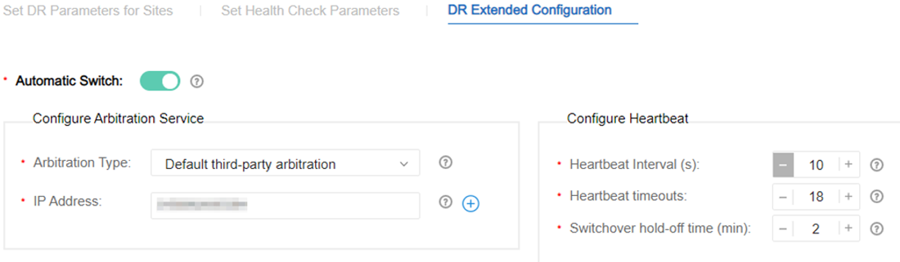
----End

(Optional) Deleting the DR System

Perform operations in this section only when you use upgrade solution A or B with a DR system split. Skip this section if you use the one-click DR system upgrade solution.

Deleting the Controller DR System
- If there is any anomaly in the primary or secondary cluster, rectify it before performing subsequent operations.
- Access the management plane of the primary cluster in the DR system at https://management plane IP address:18102, and choose HA > Remote High Availability System > Manage DR System from the main menu.
            - Record information on the Set DR Parameters for Sites, Set Health Check Parameters, and DR Extended Configuration tab pages.
            - Click Delete in the upper right corner of the page, click the task list icon  in the upper right corner, and wait until Task Status changes to Execution Succeeded.
            - Check the operation result. If the operation result is not as expected, contact Huawei technical support.
- On the management plane, choose HA > Remote High Availability System > Manage DR System from the main menu.
- On the Manage DR System page, verify that the deleted DR system no longer exists.
- Verify that you can log in to the service plane of the primary cluster.
----End

Logging In to the Upgrade Tool

Perform operations in this section only in the primary cluster if you use the one-click DR system upgrade solution, and in both primary and secondary clusters if you use upgrade solution A or B with a DR system split.
Procedure
For a single-node system, access the management plane at https://IP address of the service plane:31945.
- Access the management plane at https://IP address of the management plane:18102.
If the upgrade tool has not been deployed and you cannot log in to the management plane, perform operations by following the instructions provided in 10.18 How Do I Deploy EasySuite on the Backend?.
            - Choose Product > Project Management > Upgrade Tool from the main menu, click , select the EasySuite_{version}_OM_linux-***.zip software package and the corresponding .cms and .crl signature files, and click Upload Software Package.
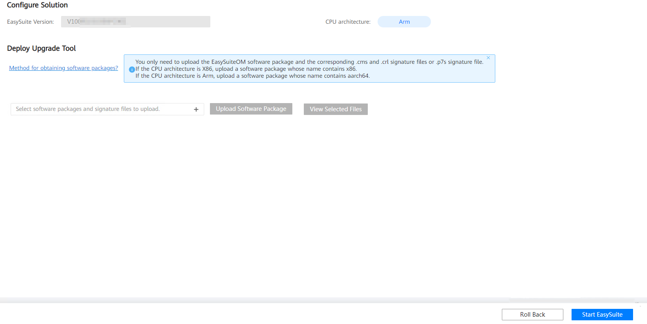
            - After the files are uploaded successfully, select the software package and click Verification and Deployment.

If the system displays a message indicating that software package verification fails as shown in the following figure, rectify the fault by following the instructions provided in 10.20 What Do I Do If Software Packages Fail to Be Verified on the Upgrade Tool?.
If the fault persists, perform the operations in 10.18 How Do I Deploy EasySuite on the Backend?.
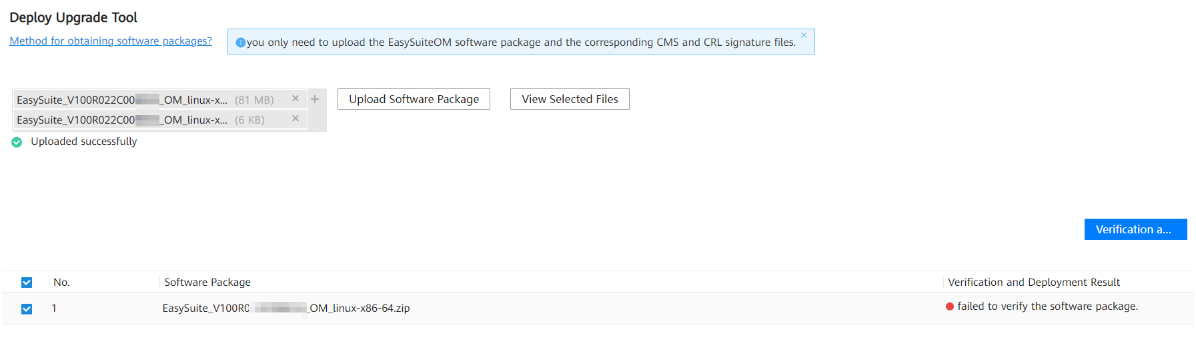
            - After the verification is successful, click Start EasySuite. The upgrade tool login page (at https://northbound communication IP address of the OMP_01 node:19090) is automatically displayed.

If a timeout error is reported during EasySuite startup, you cannot be automatically redirected to the upgrade tool login page. In this case, perform the following operations to log in to the upgrade tool:
In the address box of a browser, enter https://northbound communication IP address of the OMP_01 node:19090 and press Enter.
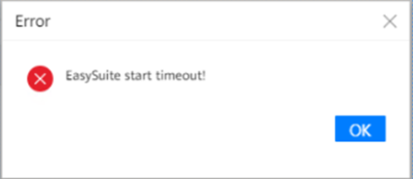
            - (Optional) Enter a username and password, and click Log In.
- Username: The preset username is esadmin.
- Password: If you have used EasySuite to upgrade the system from an earlier version to V300R023C00, enter the new password you set for login.
- If the controller has been upgraded to V300R023C00, you can switch to the EasySuite page through the management plane without entering the username and password.
- Preset user passwords are available in the iMaster NCE-Campus Preset Account and Password (enterprise or carrier). If you have not obtained the access permission of the document, see Help on the website to find out how to obtain it. For security purposes, change the password periodically and keep the new password secure. You need to change the password upon the first login.
- If you forget the password for the esadmin user of EasySuite, see section "Retrieving the EasySuite Login Password During iMaster NCE-Campus Upgrade" under Maintenance and Troubleshooting > NCE&Solution Troubleshooting Guide > Common Troubleshooting Cases > Login Failures in the CloudCampus Solution Version & iMaster NCE-Campus Version Product Documentation.
----End

Uploading Software Packages

Perform operations in this section only in the primary cluster if you use the one-click DR system upgrade solution, and in both primary and secondary clusters if you use upgrade solution A or B with a DR system split.
Log in to the upgrade tool. On the upgrade evaluation tab page, click . Select the required software packages and the corresponding .cms and .crl signature files or .p7s signature file and then click Upload Software Package.
Place all the required software packages and the corresponding signature files in the same folder. The software packages to be uploaded include the EasyOps health check patch package downloaded in 3.4.1 (Recommended) Downloading Software Packages Using EasyGet.
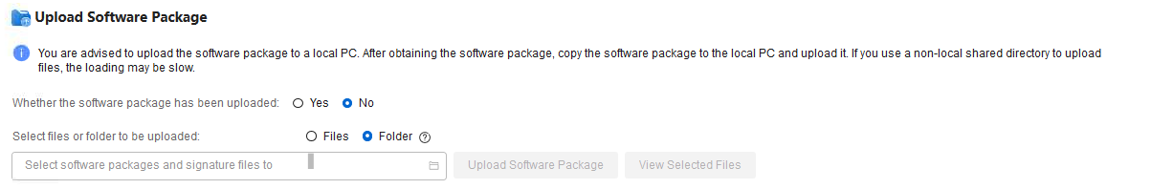
- Set Whether the software package has been uploaded as follows:
No: This option is selected by default.
Yes: Select this option if the required software packages have been uploaded to the OMP_01 node in advance. For details, see 10.21 How Do I Use a Third-Party Tool to Upload Software Packages to the Server?.
- If you set Select files or folder to be uploaded to Files, click , select all the downloaded software packages and the corresponding .cms and .crl signature files or .p7s signature file, and then click Upload Software Package.

DR System Upgrade (One-Click Upgrade Solution)
4.1 Evaluating the Upgrade (DR System)
4.2 Upgrading a DR System

Evaluating the Upgrade (DR System)
- Select the upgrade content, enter information such as user passwords as prompted, and click Evaluation.
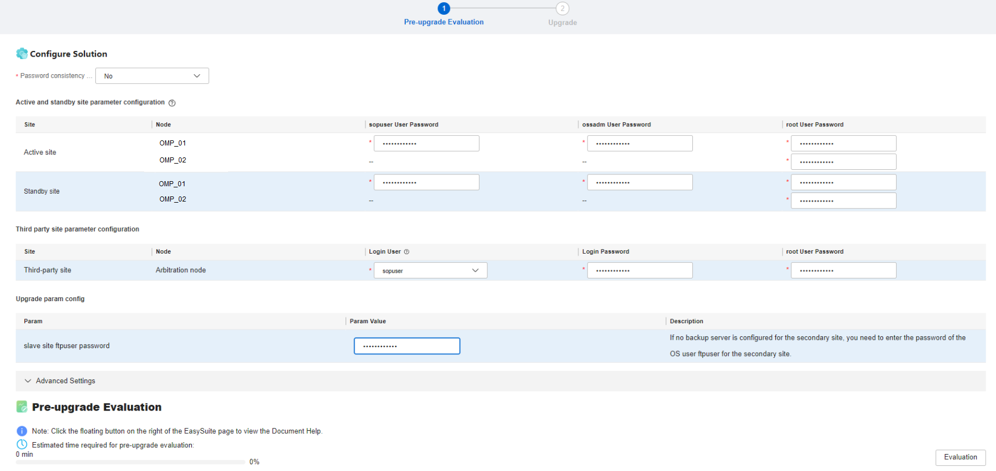
- When evaluating the upgrade, EasySuite disables scheduled backup tasks on the management plane. After the upgrade is complete, the tasks are automatically enabled. If an upgrade is no longer required after the upgrade evaluation is complete, you need to manually enable scheduled backup tasks on the management plane by following the instructions provided in 10.23 How Do I Enable Scheduled Backup Tasks on the Management Plane?.
- Set Password consistency between Active and Standby site as follows:
No: When this option is selected, you need to enter each user password of the primary and secondary sites.
Yes: When this option is selected, you need to enter each user password of the primary or secondary site.
- If there is an arbitration node before the upgrade, you need to enter information such as the user password of the third-party site.
- If no backup server is configured before the upgrade, you need to configure the password for the ftpuser user.
Set advanced parameters as follows:
- Default Mode: In this mode, services will be interrupted throughout the upgrade.
- Advanced Mode (If this mode is required, select it from the Upgrade Mode drop-down list box.):
Set Whether to maintain the active/standby DR relationship as follows:
If you select YES, the active and standby statuses of clusters in the DR system remain unchanged after the upgrade.
If you select NO, the original standby cluster becomes the new active cluster after the upgrade. If the parameter for enabling HBase DR is not set before the upgrade and you select NO for this parameter, historical performance data related to HBase DR is not displayed after the upgrade, and only new data is displayed. Affected services include terminal authentication logs, historical signature database data, device channel logs, WAN monitoring data, and device management information in file management. For details, see "Unrestored data impact" in section "Maintenance and Troubleshooting > NCE Maintenance Guide > Maintenance and Monitoring (Management Plane) > Backup and Restore > Restoring Product Data from a Remote Site" in the product documentation.
To retain the original active/standby relationship after the upgrade, select NO for this parameter and perform a DR switchover after the upgrade. Alternatively, select YES for this parameter.
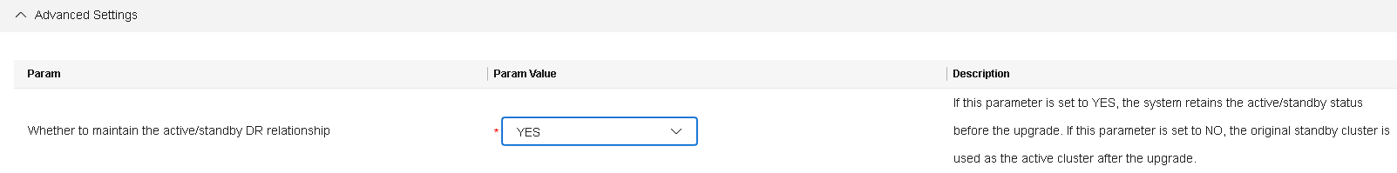
            - Wait until the evaluation is completed.
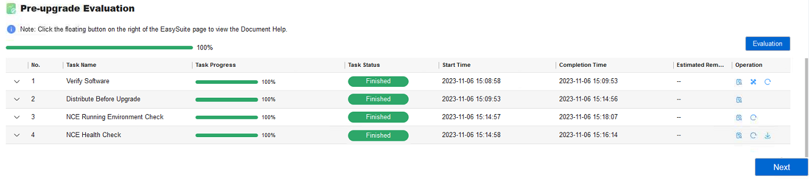
----End

Upgrading a DR System
Upgrading a DR system takes about 8 hours.

For a DR system, perform operations in this section only at the primary site.
Prerequisites
You have performed the operations in 4.1 Evaluating the Upgrade (DR System).
Procedure
- Log in to EasySuite. Click the Project Management tab on the homepage, find the corresponding upgrade project, and click in the Operation column.
            - On the Upgrade tab page, click Perform Upgrade.
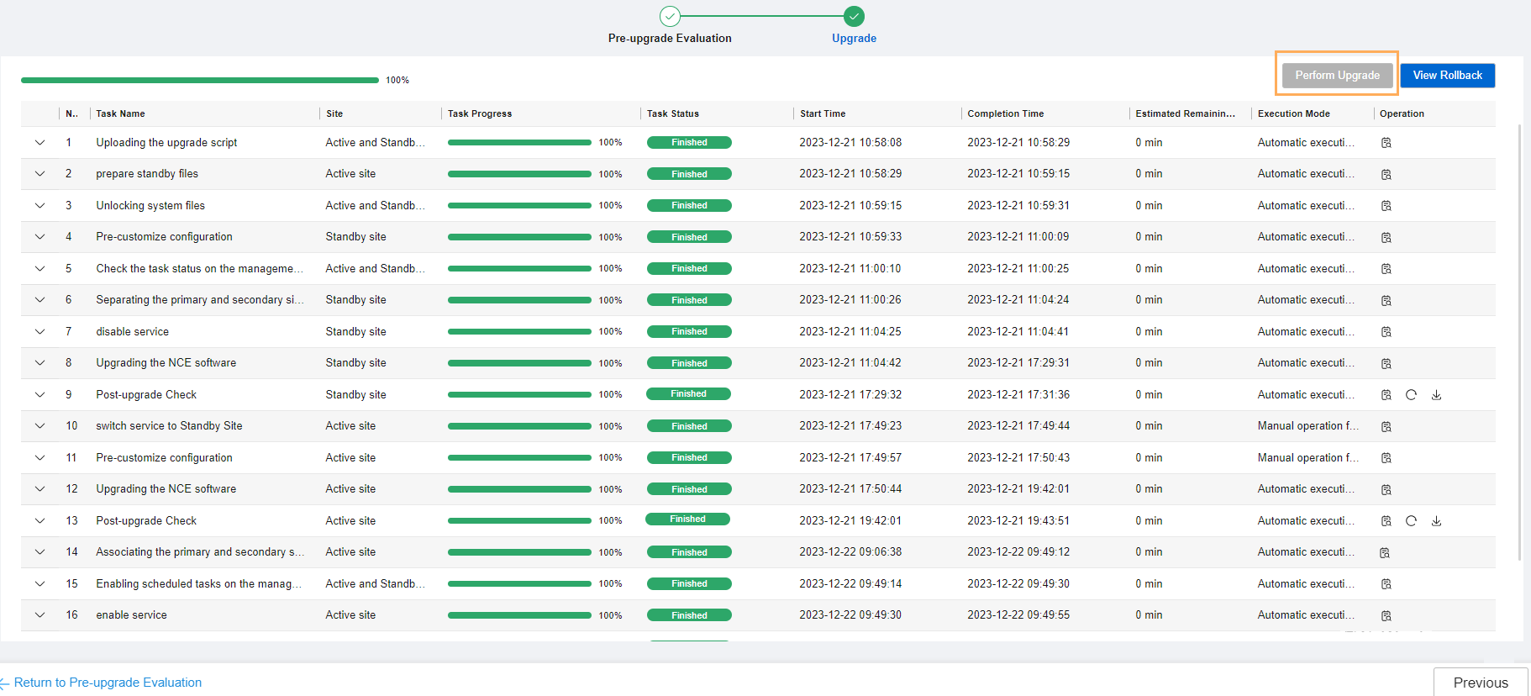

- Controller services will be interrupted for about 45 minutes during the second upgrade stage, which starts from the Upgrading the O&M plane services of the second phase(NCECAMPUS) step and ends with the Start Product(NCECAMPUS) step of the Upgrading the NCE software task. If you select YES for Business Disruption Manual Confirm on the upgrade evaluation page, a dialog box is displayed during the upgrade, prompting you of service interruptions in the second stage. The second stage will start after you confirm that no service will be affected. If you select NO for Business Disruption Manual Confirm, no such a dialog box is displayed and the second stage starts automatically.
- When the OS is restarted, the EasySuite web page cannot be accessed. You need to wait for about 10 minutes, refresh the web page, and log in to EasySuite again.
            - After the Post-upgrade Check task is complete, click View Check Result or Download All Reports to view the check result. Download All Reports requires approval from the customer. Pay attention to the check items at No go and Risky levels. These check items need to be confirmed or handled according to suggestions in the check report. After the items are handled or you have confirmed that they do not affect the upgrade, click Continue to Upgrade.
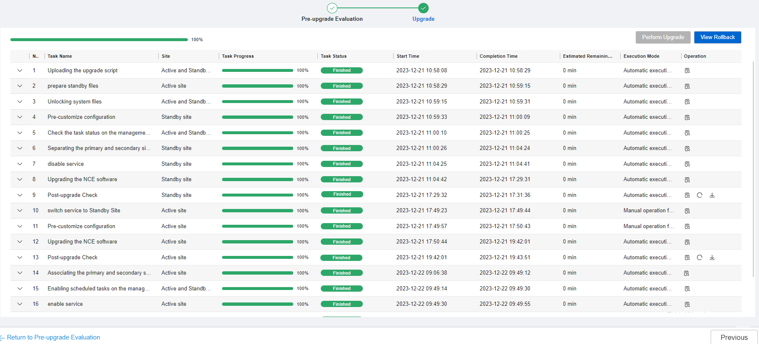
            - After all tasks are completed, click Finish. The product upgrade is completed.
----End

DR System Upgrade (Solution A with a DR System Split)
- When using this solution, you need to upgrade the secondary cluster first and then the primary cluster. If the secondary cluster fails to be upgraded, you can still start the primary cluster to ensure service continuity. This delivers relatively high reliability.
- During the upgrade of the secondary cluster, services in the primary cluster are interrupted for 1.5 hours. This solution is recommended in scenarios that are not sensitive to the service interruption duration.
- After the upgrade, configure the original secondary cluster as the new primary cluster, and set the data replication direction to Secondary cluster before the upgrade -> Primary cluster before the upgrade.
If the parameter for enabling HBase DR is not set before the upgrade, historical performance data related to HBase DR is not displayed after the upgrade, and only new data is displayed. Affected services include terminal authentication logs, historical signature database data, device channel logs, WAN monitoring data, and device management information in file management. For details, see "Unrestored data impact" in section "Maintenance and Troubleshooting > NCE Maintenance Guide > Maintenance and Monitoring (Management Plane) > Backup and Restore > Restoring Product Data from a Remote Site" in the product documentation.
- If you want the clusters to retain the original DR roles, perform an active/standby switchover after creating a DR system.
5.1 Disabling Services
5.2 Evaluating the Upgrade of the Secondary Cluster
5.3 Upgrading the Secondary Cluster
5.4 Enabling Services of the Secondary Cluster
5.5 Evaluating the Upgrade of the Primary Cluster
5.6 Upgrading the Primary Cluster
5.7 Canceling the Configuration of Disabling Services of the Original Primary Cluster
5.8 Creating a DR System
5.9 (Optional) Performing a DR Switchover

Disabling Services

Disabling Services in the Secondary Cluster
For details about how to find the OMP_01 node, see 10.2 How Can I Find an OMP Node of the Management Plane?.
- Log in to the OMP_01 node in the secondary cluster as the sopuser user, run the su - root command to switch to the root user, and run the following command: Performing this step will interrupt all services in the secondary cluster.
su - ossadm -c "sh /opt/oss/easysuite/easysuite/easysuite/plugins/NCE-Campus/upgrade_online/service/scripts/disable_lvs.sh NCECAMPUS"
The command output is as follows.
            - Log in to the management plane of the secondary cluster, choose Service Monitoring > Services, click Start, and choose Start Service from the drop-down list box.
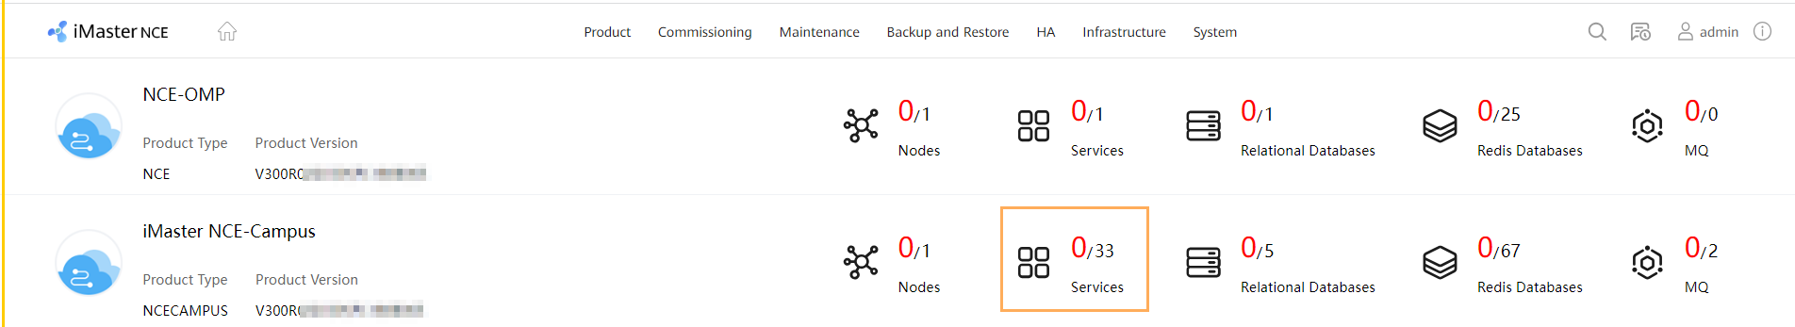
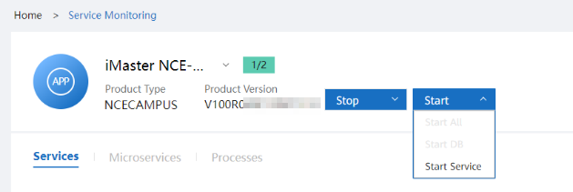
----End

Disabling Services in the Primary Cluster

For details about how to find the OMP_01 node, see 10.2 How Can I Find an OMP Node of the Management Plane?.
Log in to the OMP_01 node in the primary cluster as the sopuser user, run the su - root command to switch to the root user, and run the following command:
su - ossadm -c "sh /opt/oss/easysuite/easysuite/easysuite/plugins/NCE-Campus/upgrade_online/service/scripts/disable_lvs.sh NCECAMPUS"
The command output is as follows.

Evaluating the Upgrade of the Secondary Cluster
- Click Evaluation as prompted.
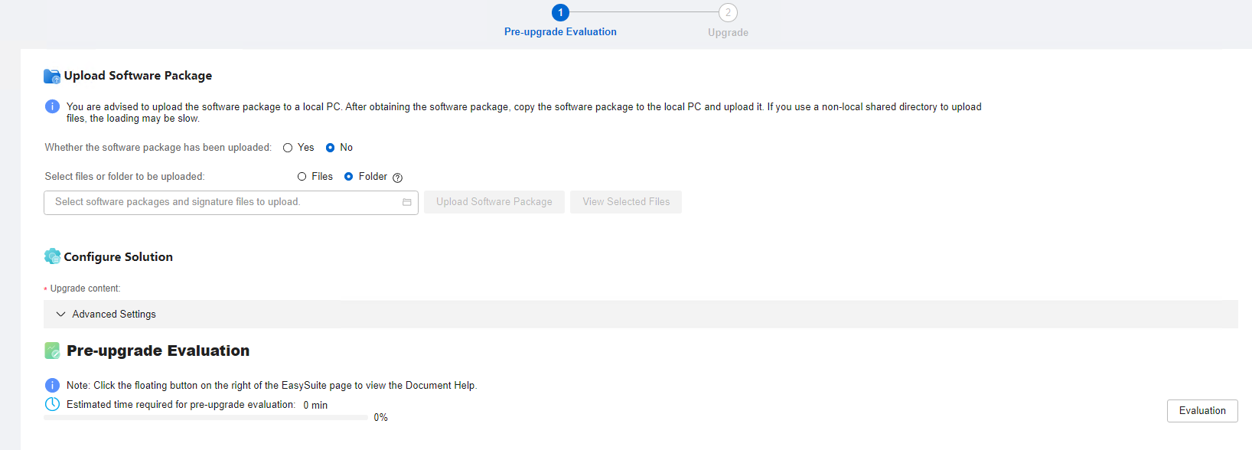
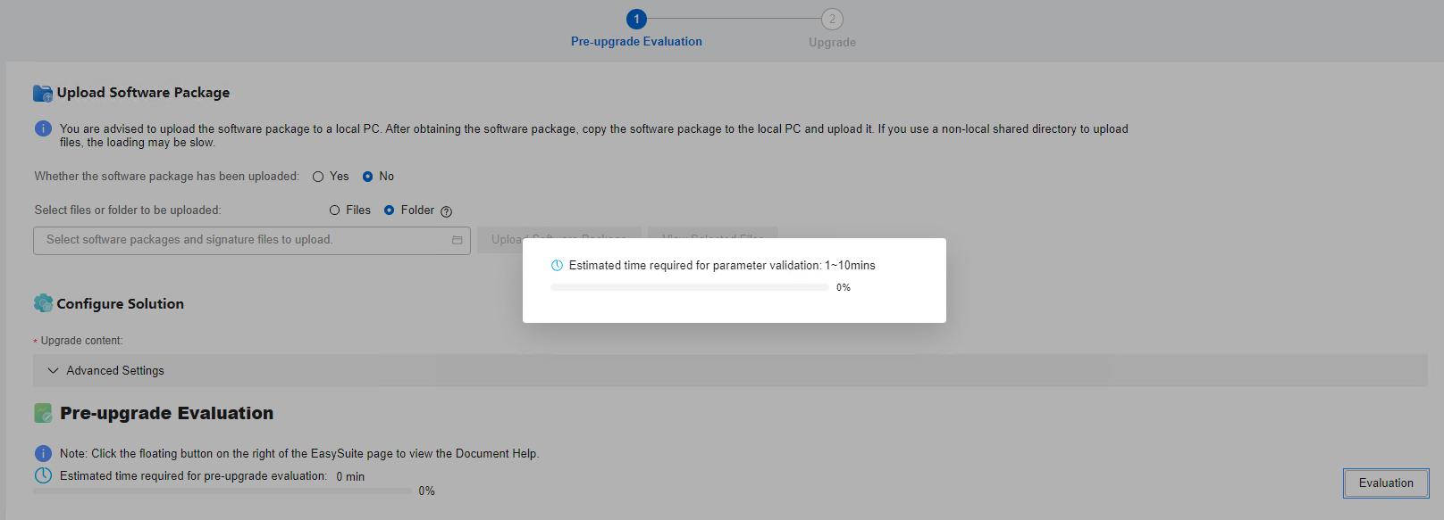
- When evaluating the upgrade, EasySuite disables scheduled backup tasks on the management plane. After the upgrade is complete, the tasks are automatically enabled. If an upgrade is no longer required after the upgrade evaluation is complete, you need to manually enable scheduled backup tasks on the management plane by following the instructions provided in 10.23 How Do I Enable Scheduled Backup Tasks on the Management Plane?.
- If no backup server is configured before the upgrade, you need to configure the password for the ftpuser user.
Advanced Settings: is collapsed by default. To perform advanced settings, expand it.
- Upgrade Mode: Select the default mode if upgrade solution A is used. Services will be interrupted throughout the upgrade in this mode.
            - After the evaluation is complete, click Next.
            - On the Data Backup page, click One-click execute. In the dialog box that is displayed, click OK.
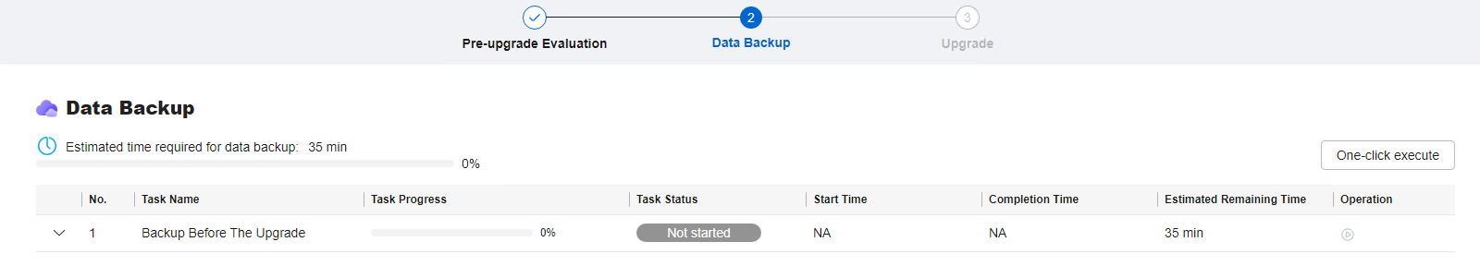
            - Wait until the data backup is complete.
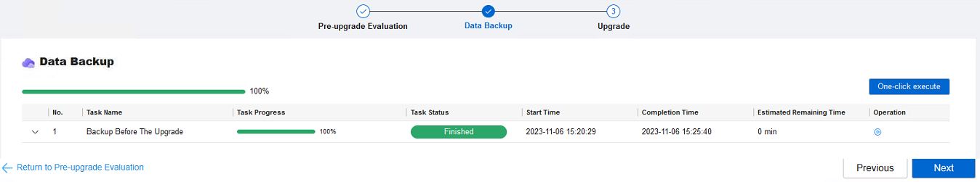
----End

Upgrading the Secondary Cluster
Prerequisites
You have performed the operations in 3.9 Uploading Software Packages.
Procedure
- Log in to EasySuite and click on the right of the corresponding upgrade project.
            - On the Upgrade page, click Perform upgrade.
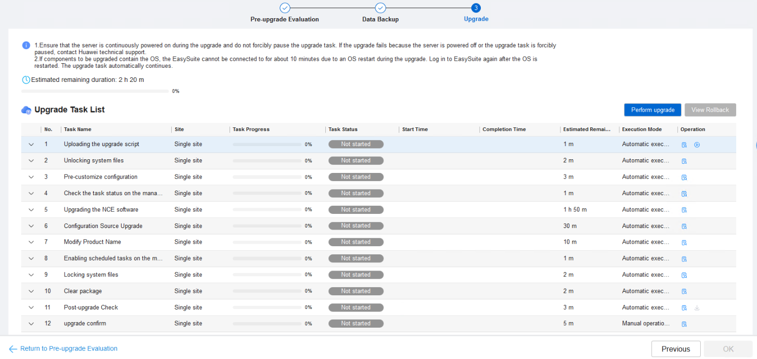

- Controller services will be interrupted for about 45 minutes during the second upgrade stage, which starts from the Upgrading the O&M plane services of the second phase(NCECAMPUS) step and ends with the Start Product(NCECAMPUS) step of the Upgrading the NCE software task. If you select YES for Business Disruption Manual Confirm on the upgrade evaluation page, a dialog box is displayed during the upgrade, prompting you of service interruptions in the second stage. The second stage will start after you confirm that no service will be affected. If you select NO for Business Disruption Manual Confirm, no such a dialog box is displayed and the second stage starts automatically.
- When the OS is restarted, the EasySuite web page cannot be accessed. You need to wait for about 10 minutes, refresh the web page, and log in to EasySuite again.
            - After the Post-upgrade Check task is complete, click Post-upgrade Check in the task list or View Upgrade Report in the upper right corner to view the check result. View Upgrade Report requires approval from the customer. If there is any check item at the No go or Risky level, confirm or handle it according to the handling suggestions in the check report.
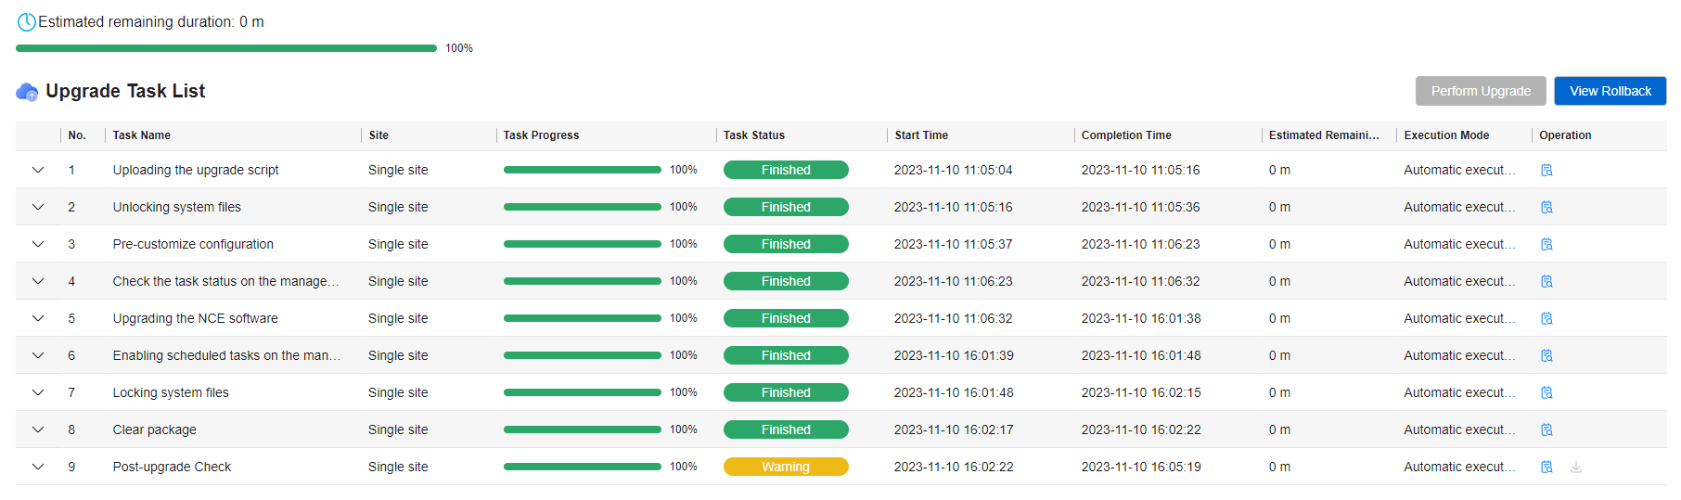
            - Click OK. The product upgrade is complete.
----End

Enabling Services of the Secondary Cluster
- Log in to the OMP_01 node in the secondary cluster as the sopuser user, run the su - root command to switch to the root user, and run the following command:
su - ossadm -c "sh /opt/oss/easysuite/easysuite/easysuite/plugins/NCE-Campus/upgrade_online/service/scripts/enable_lvs.sh NCECAMPUS true"
The command output is as follows.
            - (Optional) If multiple southbound addresses are involved, switch the primary and secondary southbound IP addresses by referring to 7.3 Checking the Southbound Access Configuration.
Perform the following steps to check whether multiple southbound addresses are involved:
- Log in to the service plane and choose System > Southbound Access > Southbound Access Configuration from the main menu.
- Check whether the Secondary IP Address column displays any IP addresses. If so, the DR system provides multiple southbound access addresses. Otherwise, skip this section.
----End

Evaluating the Upgrade of the Primary Cluster
- Click Evaluation as prompted.
- When evaluating the upgrade, EasySuite disables scheduled backup tasks on the management plane. After the upgrade is complete, the tasks are automatically enabled. If an upgrade is no longer required after the upgrade evaluation is complete, you need to manually enable scheduled backup tasks on the management plane by following the instructions provided in 10.23 How Do I Enable Scheduled Backup Tasks on the Management Plane?.
- If no backup server is configured before the upgrade, you need to configure the password for the ftpuser user.
Advanced Settings: is collapsed by default. To perform advanced settings, expand it.
- Upgrade Mode: Select the default mode if upgrade solution A is used. Services will be interrupted throughout the upgrade in this mode.
            - After the evaluation is complete, click Next.
            - On the Data Backup page, click One-click execute. In the dialog box that is displayed, click OK.
            - Wait until the data backup is complete.
----End

Upgrading the Primary Cluster
Prerequisites
You have performed the operations in 3.9 Uploading Software Packages.
Procedure
- Log in to EasySuite and click on the right of the corresponding upgrade project.
            - On the Upgrade page, click Perform upgrade.

- Controller services will be interrupted for about 45 minutes during the second upgrade stage, which starts from the Upgrading the O&M plane services of the second phase(NCECAMPUS) step and ends with the Start Product(NCECAMPUS) step of the Upgrading the NCE software task. If you select YES for Business Disruption Manual Confirm on the upgrade evaluation page, a dialog box is displayed during the upgrade, prompting you of service interruptions in the second stage. The second stage will start after you confirm that no service will be affected. If you select NO for Business Disruption Manual Confirm, no such a dialog box is displayed and the second stage starts automatically.
- When the OS is restarted, the EasySuite web page cannot be accessed. You need to wait for about 10 minutes, refresh the web page, and log in to EasySuite again.
            - After the Post-upgrade Check task is complete, click Post-upgrade Check in the task list or View Upgrade Report in the upper right corner to view the check result. View Upgrade Report requires approval from the customer. If there is any check item at the No go or Risky level, confirm or handle it according to the handling suggestions in the check report.
            - Click OK. The product upgrade is complete.
----End

Canceling the Configuration of Disabling Services of the Original Primary Cluster
- Log in to the OMP_01 node in the primary cluster before the upgrade as the sopuser user, and run the su - root command to switch to the root user.
For details about how to find the OMP_01 node, see 10.2 How Can I Find an OMP Node of the Management Plane?.
            - Run the following command:
su - ossadm -c "sh /opt/oss/easysuite/easysuite/easysuite/plugins/NCE-Campus/upgrade_online/service/scripts/enable_lvs.sh NCECAMPUS false"
The command output is as follows.
----End

Creating a DR System

Creating a DR System
You need to log in to EasySuite first.

Single-Node Scenario (Automatic Switchover)
Check whether automatic DR switchover is configured by referring to 3.6 (Optional) Checking Whether Automatic DR Switchover Is Configured. This step is required in the automatic DR switchover scenario with the arbitration service.

Creating a DR System
Associate the primary and secondary sites with the third-party arbitration site to set up an automatic DR switchover system.
Procedure
- Enter basic project information.
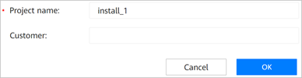
            - On the Deployment Solution Planning page, set parameters as needed and click Save.
            - Set basic information parameters, enter information about primary and secondary sites, and click Next.
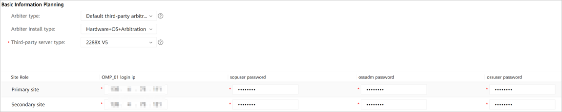
The primary and secondary sites must be able to communicate with the local PC.
            - On the Prepare Software Packages page, click Check Integrity. After the verification succeeds, click Next.
- Select the path where the software packages are located (only a local path is supported) and click Load to copy the software packages to the EasySuite decompression directory/var/software/ directory. If the required software packages have been downloaded to the EasySuite decompression directory/var/software/ directory, skip this step.
- If is displayed under Check Result, rectify the fault based on the fault locating information, and verify the software packages again.
- The software packages displayed on this page vary according to the actual situation.
            - On the HLD page, view product specifications and other information. You can click Export to export product specifications to the local PC. Click Close.
            - Set parameters on the Parameter Planning page.
- In addition to directly planning installation on the web UI, you can click Export in the upper right corner of the page to download the content to be configured to the local PC in Excel format. After the planning is complete, click Import to import the modified file to EasySuite.
- If you select the import and export mode for planning, ensure that the solutions selected when the projects are created on the two sets of EasySuite are the same. For security purposes, planned passwords cannot be exported. You can manually plan passwords in the exported file.
- If you select the import and export mode for planning, to prevent data parsing exceptions, do not change the table style during editing.
- Select LLD.
- EasySuite automatically reads information about the primary and secondary sites. Set site names and DR parameters as planned.
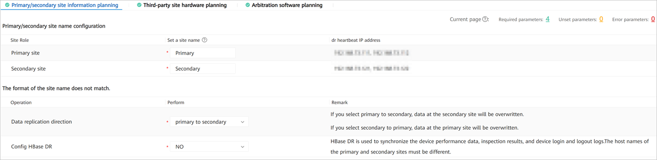
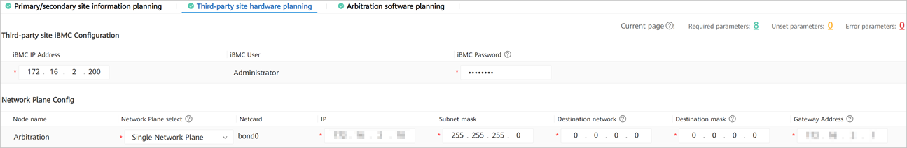
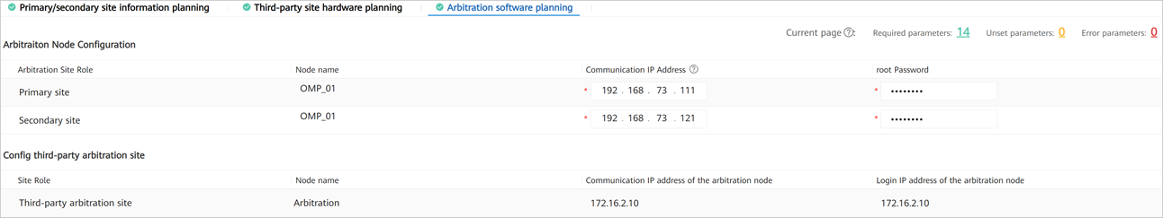
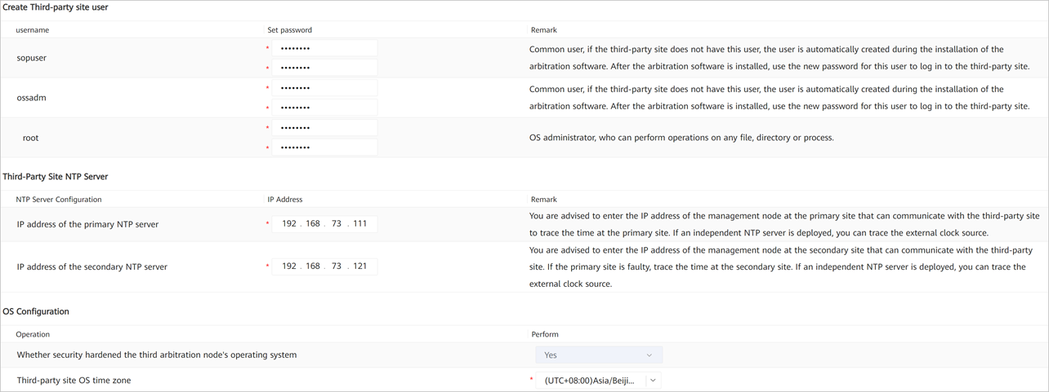
            - Check local and remote environments.
- On the Precheck page, click Start Check and wait until the check is completed.
Product business rules check includes the following check items: CPU, memory, disks, partitions, I/O, OS version, port numbers, and IP addresses.
If Task status of a check item is Failed, locate and rectify the fault based on the information displayed on EasySuite.
- Check the task status. If Task status of a check item is Error, click in the Operation column of this check item to view fault location information.
- If Task status of each check item is Finished, the local and remote environments are ready. Click Next to go to the Installation & Deployment page.
            - If "Installation completed. Please check installation report." is displayed at the bottom, the arbitration service is successfully installed. Download and view the installation report.
----End

Single-Node Scenario (Manual Switchover)
Check whether automatic DR switchover is configured by referring to 3.6 (Optional) Checking Whether Automatic DR Switchover Is Configured. This section applies to the automatic DR switchover scenario without the arbitration service.

Creating a DR System
Procedure
- Enter basic project information.
            - On the Deployment Solution Planning page, set parameters as needed and click Save.
            - Set basic information parameters, enter information about primary and secondary sites, and click Next.
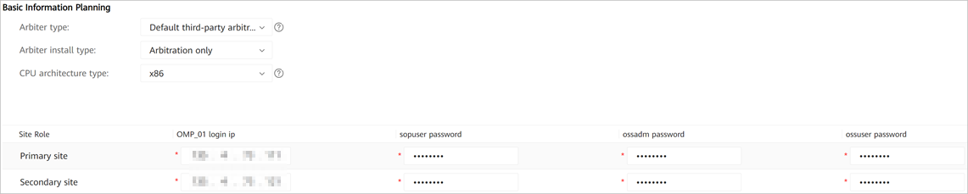
The primary and secondary sites must be able to communicate with the local PC.
            - On the Prepare Software Packages page, click Check Integrity. After the verification succeeds, click Next.
- Select the path where the software packages are located (only a local path is supported) and click Load to copy the software packages to the EasySuite decompression directory/var/software/ directory. If the required software packages have been downloaded to the EasySuite decompression directory/var/software/ directory, skip this step.
- If is displayed under Check Result, rectify the fault based on the fault locating information, and verify the software packages again.
- The software packages displayed on this page vary according to the actual situation.
            - Set parameters on the Parameter Planning page.
- In addition to directly planning installation on the web UI, you can click Export in the upper right corner of the page to download the content to be configured to the local PC in Excel format. After the planning is complete, click Import to import the modified file to EasySuite.
- If you select the import and export mode for planning, ensure that the solutions selected when the projects are created on the two sets of EasySuite are the same. For security purposes, planned passwords cannot be exported. You can manually plan passwords in the exported file.
- If you select the import and export mode for planning, to prevent data parsing exceptions, do not change the table style during editing.
- Select LLD.
- EasySuite automatically reads information about the primary and secondary sites. Set site names and DR parameters as planned.
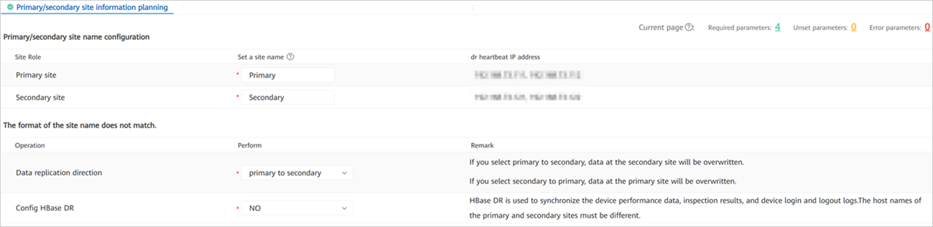
            - Check local and remote environments.
- On the Precheck page, click Start Check and wait until the check is completed.
Product business rules check includes the following check items: CPU, memory, disks, partitions, I/O, OS version, port numbers, and IP addresses.
If Task status of a check item is Failed, locate and rectify the fault based on the information displayed on EasySuite.
- Check the task status. If Task status of a check item is Error, click in the Operation column of this check item to view fault location information.
- If Task status of each check item is Finished, the local and remote environments are ready. Click Next to go to the Installation & Deployment page.
            - If "Installation completed. Please check installation report." is displayed at the bottom, the arbitration service is successfully installed. Download and view the installation report.
----End

Cluster Scenario (Automatic Switchover)
Check whether automatic DR switchover is configured by referring to 3.6 (Optional) Checking Whether Automatic DR Switchover Is Configured. This step is required in the automatic DR switchover scenario with the arbitration service.

Creating a DR System
Associate the primary and secondary sites with the third-party arbitration site to set up an automatic DR switchover system.
Procedure
- Enter basic project information.
            - On the Deployment Solution Planning page, set parameters as needed and click Save.
            - Set basic information parameters, enter information about primary and secondary sites, and click Next.
The primary and secondary sites must be able to communicate with the local PC.
            - On the Prepare Software Packages page, click Check Integrity. After the verification succeeds, click Next.
- Select the path where the software packages are located (only a local path is supported) and click Load to copy the software packages to the EasySuite decompression directory/var/software/ directory. If the required software packages have been downloaded to the EasySuite decompression directory/var/software/ directory, skip this step.
- If is displayed under Check Result, rectify the fault based on the fault locating information, and verify the software packages again.
- The required software packages vary according to the actual situation.
            - On the HLD page, view product specifications and other information. You can click Export to export product specifications to the local PC. Click Close.
            - Set parameters on the Parameter Planning page.
- In addition to directly planning installation on the web UI, you can click Export in the upper right corner of the page to download the content to be configured to the local PC in Excel format. After the planning is complete, click Import to import the modified file to EasySuite.
- If you select the import and export mode for planning, ensure that the solutions selected when the projects are created on the two sets of EasySuite are the same. For security purposes, planned passwords cannot be exported. You can manually plan passwords in the exported file.
- If you select the import and export mode for planning, to prevent data parsing exceptions, do not change the table style during editing.
- Select LLD.
- EasySuite automatically reads information about the primary and secondary sites. Set site names and DR parameters as planned.
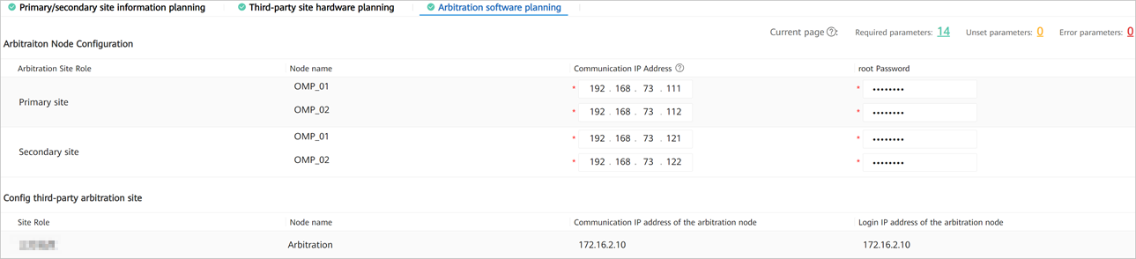
            - Check local and remote environments.
- On the Precheck page, click Start Check and wait until the check is completed.
Product business rules check includes the following check items: CPU, memory, disks, partitions, I/O, OS version, port numbers, and IP addresses.
If Task status of a check item is Failed, locate and rectify the fault based on the information displayed on EasySuite.
- Check the task status. If Task status of a check item is Error, click in the Operation column of this check item to view fault location information.
- If Task status of each check item is Finished, the local and remote environments are ready. Click Next to go to the Installation & Deployment page.
            - If "Installation completed. Please check installation report." is displayed at the bottom, the arbitration service is successfully installed. Download and view the installation report.
----End

Cluster Scenario (Manual Switchover)
Check whether automatic DR switchover is configured by referring to 3.6 (Optional) Checking Whether Automatic DR Switchover Is Configured. This section applies to the automatic DR switchover scenario without the arbitration service.

Creating a DR System
Context
Creating a DR system establishes a data synchronization relationship between the primary and secondary sites to ensure data consistency. When creating a data synchronization relationship between the primary and secondary sites, the DR system backs up all data at the primary site to a backup server, and then restores all data at the secondary site to ensure data consistency between the two sites. Therefore, the primary and secondary sites must use the same backup server.
Procedure
- Enter basic project information.
            - On the Deployment Solution Planning page, set parameters as needed and click Save.
            - Set basic information parameters, enter information about primary and secondary sites, and click Next.
The primary and secondary sites must be able to communicate with the local PC.
            - On the Prepare Software Packages page, click Check Integrity. After the verification succeeds, click Next.
- Select the path where the software packages are located (only a local path is supported) and click Load to copy the software packages to the EasySuite decompression directory/var/software/ directory. If the required software packages have been downloaded to the EasySuite decompression directory/var/software/ directory, skip this step.
- If is displayed under Check Result, rectify the fault based on the fault locating information, and verify the software packages again.
- The software packages displayed on this page vary according to the actual situation.
            - Set parameters on the Parameter Planning page.
- In addition to directly planning installation on the web UI, you can click Export in the upper right corner of the page to download the content to be configured to the local PC in Excel format. After the planning is complete, click Import to import the modified file to EasySuite.
- If you select the import and export mode for planning, ensure that the solutions selected when the projects are created on the two sets of EasySuite are the same. For security purposes, planned passwords cannot be exported. You can manually plan passwords in the exported file.
- If you select the import and export mode for planning, to prevent data parsing exceptions, do not change the table style during editing.
- Select LLD.
- EasySuite automatically reads information about the primary and secondary sites. Set site names and DR parameters as planned.
            - Check local and remote environments.
- On the Precheck page, click Start Check and wait until the check is completed.
Product business rules check includes the following check items: CPU, memory, disks, partitions, I/O, OS version, port numbers, and IP addresses.
If Task status of a check item is Failed, locate and rectify the fault based on the information displayed on EasySuite.
- Check the task status. If Task status of a check item is Error, click in the Operation column of this check item to view fault location information.
- If Task status of each check item is Finished, the local and remote environments are ready. Click Next to go to the Installation & Deployment page.
            - If "Installation completed. Please check installation report." is displayed at the bottom, the arbitration service is successfully installed. Download and view the installation report.
----End

(Optional) Performing a DR Switchover
Perform operations in this section if you want the clusters to retain the original DR roles. Otherwise, skip this section.
- Access the management plane of the primary cluster in the DR system at https://management plane IP address:18102, and choose HA > Remote High Availability System > Manage DR System from the main menu.
            - On the Manage Remote DR System page, select the product that requires an active/standby switchover and click Switch Over above the product list.
            - Perform operations as prompted.
            - Check the operation result. If the operation result is not as expected, contact Huawei technical support.
- On the management plane, choose HA > Remote High Availability System > Manage DR System from the main menu.
- On the Manage Remote DR System page, check whether the heartbeat status between the primary and secondary clusters is .
- Check the Primary Site Product and Secondary Site Product columns. Verify that the product DR status and the switchover result are consistent.
- Verify that Data Synchronization Status of all the products is Synchronized or Synchronizing. If Data Synchronization Status is Delayed, a large volume of data is being synchronized between the primary and secondary clusters. Check the status after data synchronization is complete.
- Verify that the service plane at the active cluster can be logged in to.
----End

DR System Upgrade (Solution B with a DR System Split)
- When using this solution, you need to upgrade the primary cluster first and then the secondary cluster. If the primary cluster fails to be upgraded, perform operations in 5.1.2 Disabling Services in the Primary Cluster and then in 5.4 Enabling Services of the Secondary Cluster.
- Throughout the entire upgrade process, the secondary cluster does not take over services and services in the primary cluster are interrupted for about 45 minutes.
- After the upgrade is complete, configure the clusters to retain the original DR roles when creating a DR system and set the data replication direction to Primary cluster before the upgrade -> Secondary cluster before the upgrade.
6.1 Disabling Services of the Secondary Cluster
6.2 Evaluating the Upgrade of the Primary Cluster
6.3 Upgrading the Primary Cluster
6.4 Evaluating the Upgrade of the Secondary Cluster
6.5 Upgrading the Secondary Cluster
6.6 Canceling the Configuration of Disabling Services of the Original Secondary Cluster
6.7 Creating a DR System

Disabling Services of the Secondary Cluster
For details about how to find the OMP_01 node, see 10.2 How Can I Find an OMP Node of the Management Plane?.
- Log in to the OMP_01 node in the secondary cluster as the sopuser user, run the su - root command to switch to the root user, and run the following command:
su - ossadm -c "sh /opt/oss/easysuite/easysuite/easysuite/plugins/NCE-Campus/upgrade_online/service/scripts/disable_lvs.sh NCECAMPUS"
The command output is as follows.
            - Log in to the management plane of the secondary cluster, choose Service Monitoring > Services, click Start, and choose Start Service from the drop-down list box.
----End

Evaluating the Upgrade of the Primary Cluster
- Set the upgrade content as prompted and click Evaluation.
- When evaluating the upgrade, EasySuite disables scheduled backup tasks on the management plane. After the upgrade is complete, the tasks are automatically enabled. If an upgrade is no longer required after the upgrade evaluation is complete, you need to manually enable scheduled backup tasks on the management plane by following the instructions provided in 10.23 How Do I Enable Scheduled Backup Tasks on the Management Plane?.
- If no backup server is configured before the upgrade, you need to configure the password for the ftpuser user.
- Advanced Mode (If this mode is required, select it from the Upgrade Mode drop-down list box.):
Select this mode if upgrade solution B is used. In this mode, services will also be interrupted temporarily during the upgrade, but the service interruption duration is shorter than that in default mode. Using this mode may increase the time needed for upgrade.
- Business Disruption Manual Confirm:
The upgrade process is divided into two stages and services will be interrupted during the second upgrade stage. If you select YES for this parameter, a dialog box will be displayed after the first stage of the upgrade is complete, asking you whether you want to proceed to the second stage. The second stage starts after your confirmation. If you select NO, no such a dialog box is displayed and the second stage starts automatically.
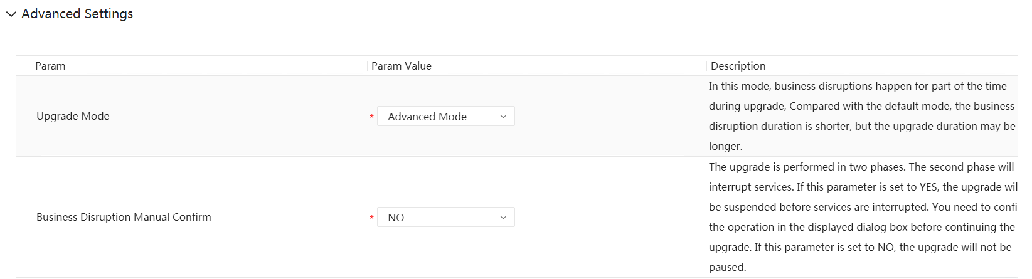
            - After the evaluation is complete, click Next.
            - On the Data Backup page, click One-click execute. In the dialog box that is displayed, click OK.
            - Wait until the data backup is complete.
----End

Upgrading the Primary Cluster
Prerequisites
You have performed the operations in 3.9 Uploading Software Packages.
Procedure
- Log in to EasySuite and click on the right of the corresponding upgrade project.
            - On the Upgrade page, click Perform upgrade.
            - After the Post-upgrade Check task is complete, click Post-upgrade Check in the task list or View Upgrade Report in the upper right corner to view the check result. View Upgrade Report requires approval from the customer. If there is any check item at the No go or Risky level, confirm or handle it according to the handling suggestions in the check report.
            - Click OK. The product upgrade is complete.
----End

Evaluating the Upgrade of the Secondary Cluster
- Click Evaluation as prompted.
- When evaluating the upgrade, EasySuite disables scheduled backup tasks on the management plane. After the upgrade is complete, the tasks are automatically enabled. If an upgrade is no longer required after the upgrade evaluation is complete, you need to manually enable scheduled backup tasks on the management plane by following the instructions provided in 10.23 How Do I Enable Scheduled Backup Tasks on the Management Plane?.
- If no backup server is configured before the upgrade, you need to configure the password for the ftpuser user.
Advanced Settings: is collapsed by default. To perform advanced settings, expand it.
- Upgrade Mode: Select the default mode if upgrade solution A is used. Services will be interrupted throughout the upgrade in this mode.
            - After the evaluation is complete, click Next.
            - On the Data Backup page, click One-click execute. In the dialog box that is displayed, click OK.
            - Wait until the data backup is complete.
----End

Upgrading the Secondary Cluster
Prerequisites
You have performed the operations in 3.9 Uploading Software Packages.
Procedure
- Log in to EasySuite and click on the right of the corresponding upgrade project.
            - On the Upgrade page, click Perform upgrade.
            - After the Post-upgrade Check task is complete, click Post-upgrade Check in the task list or View Upgrade Report in the upper right corner to view the check result. View Upgrade Report requires approval from the customer. If there is any check item at the No go or Risky level, confirm or handle it according to the handling suggestions in the check report.
            - Click OK. The product upgrade is complete.
----End

Canceling the Configuration of Disabling Services of the Original Secondary Cluster
- Log in to the OMP_01 node in the secondary cluster before the upgrade as the sopuser user, and run the su - root command to switch to the root user.
For details about how to find the OMP_01 node, see 10.2 How Can I Find an OMP Node of the Management Plane?.
            - Run the following command:
su - ossadm -c "sh /opt/oss/easysuite/easysuite/easysuite/plugins/NCE-Campus/upgrade_online/service/scripts/enable_lvs.sh NCECAMPUS false"
The command output is as follows.
----End

Creating a DR System

Creating a DR System
Build a new DR system. For details, see 5.8.1 Creating a DR System.

Post-upgrade Check
7.1 Upgrading the Terminal Identification Signature Database
7.2 Updating a License
7.3 Checking the Southbound Access Configuration

Upgrading the Terminal Identification Signature Database

You need to check whether the terminal identification signature database has been manually upgraded. If it has been manually upgraded, the terminal identification function may be unavailable.
- Log in to the O&M plane as the system administrator, choose Maintenance > Maintenance > Signature Database Upgrade, and click the Terminal Identification Signature Database tab.
If there is an upgrade record, the terminal identification signature database has been manually upgraded. In this case, you need to download the latest terminal signature database file and upload it to the controller.
If there is no upgrade record, skip this section.
            - Download the latest terminal identification signature database file.
Download path:
https://isecurity.huawei.com/sec/web/freesignature.do?productCategoryName=&productName=&productVersion=&signatureCategoryId=209
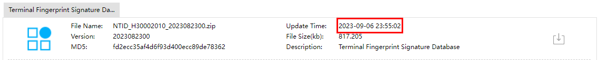
            - Upload the terminal identification signature database file.
- Log in to the O&M plane as the system administrator, choose Maintenance > Maintenance > Signature Database Upgrade, and click the Upgrade Policy tab.
- Click Local Upgrade. In the dialog box that is displayed, set Signature database type to Terminal and upload the file downloaded in Step 2.
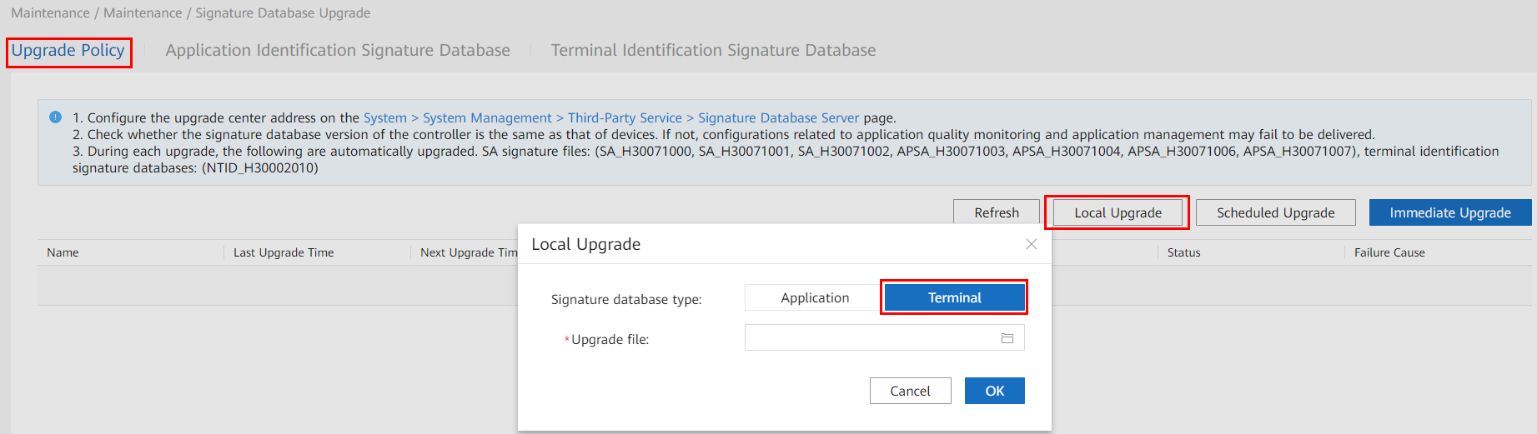
- Click the Terminal Identification Signature Database tab and verify that the latest database file is uploaded successfully.
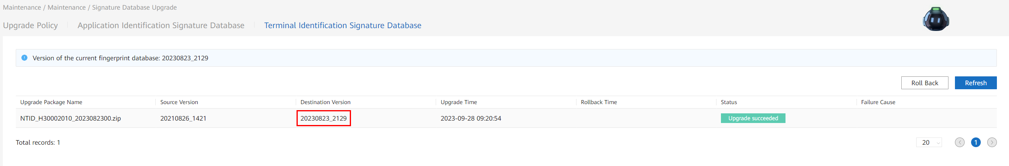
----End

Updating a License
- Update a license by referring to CloudCampus Solution version & iMaster NCE-Campus version License Usage Guide (enterprise users and carrier users).
- Global perpetual license model (N1 mode): For details, see "Commercial License > Global Perpetual License Usage Guide in the On-Premises Scenario (N1 Mode) > Upgrade and Downgrade Scenarios > iMaster NCE-Campus License Operations".
- Global perpetual license model (a-la-carte mode): For details, see "Commercial License > Global Perpetual License Usage Guide in an On-Premises Scenario (A-la-carte Mode) > Upgrade and Downgrade Scenarios > iMaster NCE-Campus License Operations".
- Global subscription license model (TBL subscription mode): For details, see "Commercial License > Global Subscription License Usage Guide in an MSP-Owned Cloud Scenario (TBL Subscription Mode) > Upgrade and Downgrade Scenarios > iMaster NCE-Campus License Operations".
- Points-based mode: For details, see "Commercial License > License Usage Guide in an MSP-Owned Cloud Scenario (Points-based Mode) > Upgrade and Downgrade Scenarios > iMaster NCE-Campus License Operations".
- The license version cannot be upgraded for the tenant subscription model (SaaS mode).
            - (Optional) After the upgrade, if you need to use the functions that require licenses, apply for and load the required licenses. For details, see CloudCampus Solution version & iMaster NCE-Campus version License Usage Guide (enterprise users and carrier users).
- Global perpetual license model (N1 mode): For details, see "Commercial License > Global Perpetual License Usage Guide in the On-Premises Scenario (N1 Mode) > Fresh Deployment Scenario > iMaster NCE-Campus License Operations".
- Global perpetual license model (a-la-carte mode): For details, see "Commercial License > Global Perpetual License Usage Guide in an On-Premises Scenario (A-la-carte Mode) > Fresh Deployment Scenario > iMaster NCE-Campus License Operations".
- Global subscription license model (TBL subscription mode): For details, see "Commercial License > Global Subscription License Usage Guide in an MSP-Owned Cloud Scenario (TBL Subscription Mode) > Fresh Deployment Scenario > iMaster NCE-Campus License Operations".
- Points-based mode: For details, see "Commercial License > License Usage Guide in an MSP-Owned Cloud Scenario (Points-based Mode) > Fresh Deployment Scenario > iMaster NCE-Campus License Operations".
- Tenant subscription license model (SaaS mode): For details, see "iMaster NCE-Campus License Operations (Tenant Subscription Mode + License Redistribution Enabled)" or "iMaster NCE-Campus License Operations (Tenant Subscription Mode + License Redistribution Disabled)" in Commercial License > Tenant Subscription License Usage Guide in a Huawei Public Cloud Scenario (SaaS Mode) > Fresh Deployment Scenario".
----End

Checking the Southbound Access Configuration

This section applies only to a DR system with multiple southbound access addresses. For details about how to check whether a DR system provides multiple southbound access addresses, perform Step 1 to Step 2.
- Log in to the service plane and choose System > Southbound Access > Southbound Access Configuration from the main menu.
            - Check whether the Secondary IP Address column displays any IP addresses. If so, the DR system provides multiple southbound access addresses. Proceed to the next step. If not, skip the following steps.
            - If a secondary IP address is available, check whether the primary and secondary IP addresses are consistent with the actual ones. If not, click Primary/Secondary Switchover.
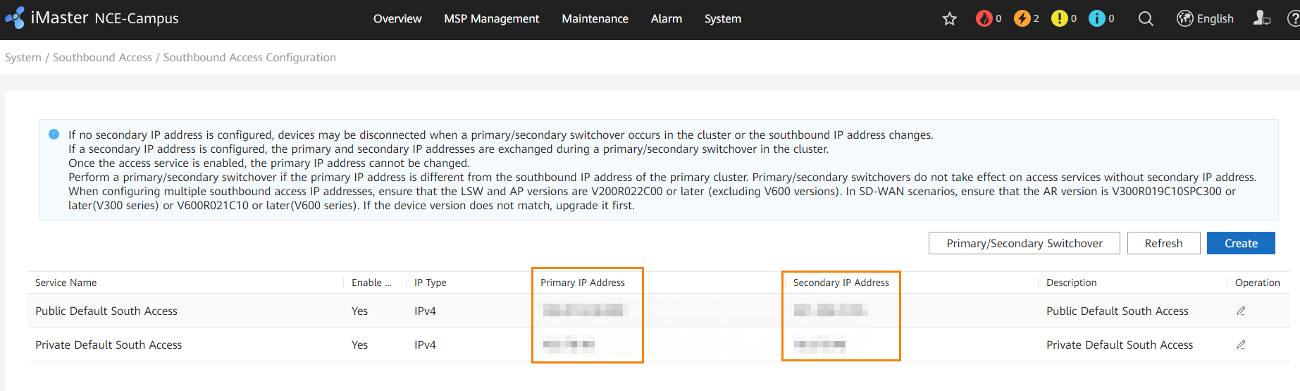
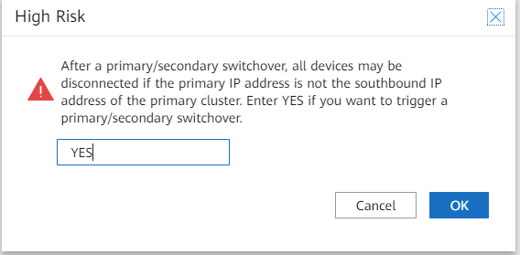
----End

Version Rollback (One-Click Upgrade)
Perform operations in this section as required if you use the one-click DR system upgrade solution. Skip this section if you use upgrade solution A or B with a DR system split.
8.1 Precautions for Rollback After the Upgrade
8.2 Rolling Back a DR System

Precautions for Rollback After the Upgrade
Upgrade rollback has the following restrictions, which, if not followed, will cause a rollback failure:
- A rollback depends on the upgrade project on EasySuite and must be completed within 30 days after the upgrade. If the project is lost, a rollback cannot be performed.
- If incremental deployment or capacity expansion has been performed before a rollback, the rollback is not allowed.
- Before a rollback, do not modify system parameter settings, such as IP addresses, database passwords, certificates, and keys.
- Before a rollback, do not clear the backup data required for rollback, such as product data, database applications, and management plane files backed up during the upgrade.
- Before a rollback, do not clear the residual data, such as databases and deployment paths that are no longer used, and backup files of product data and database software generated during the upgrade.
- Before a rollback, do not clear the software packages of the source version on the management plane.
- Before a rollback, do not format OS partitions. For example, do not format the system partition or use the backup data to restore the OS.
- A rollback cannot be performed when a scheduled backup task is in progress on the management plane. EasySuite can automatically disable scheduled backup tasks on the management plane before a rollback and enable the tasks after the rollback.
- After a rollback succeeds, you need to create a new upgrade task for re-upgrade.
- After a rollback succeeds, you are not allowed to use the old task for re-upgrade. In addition, you need to apply for a new time window for re-upgrade.

Rolling Back a DR System
- Perform operations in this section only in a DR scenario.
- If the following problem occurs, see 10.1 Residual Temporary Directories in the HDFS for the solution.
In a DR scenario, after iMaster NCE-Campus V300R022C00SPC100 is upgraded to V300R023C00 and then rolled back to V300R022C00SPC100, there is a small probability that the HDFS pre-check for the DR system fails.
- Log in to the upgrade tool and select the upgrade task.
            - On the Upgrade tab page, click View Rollback.
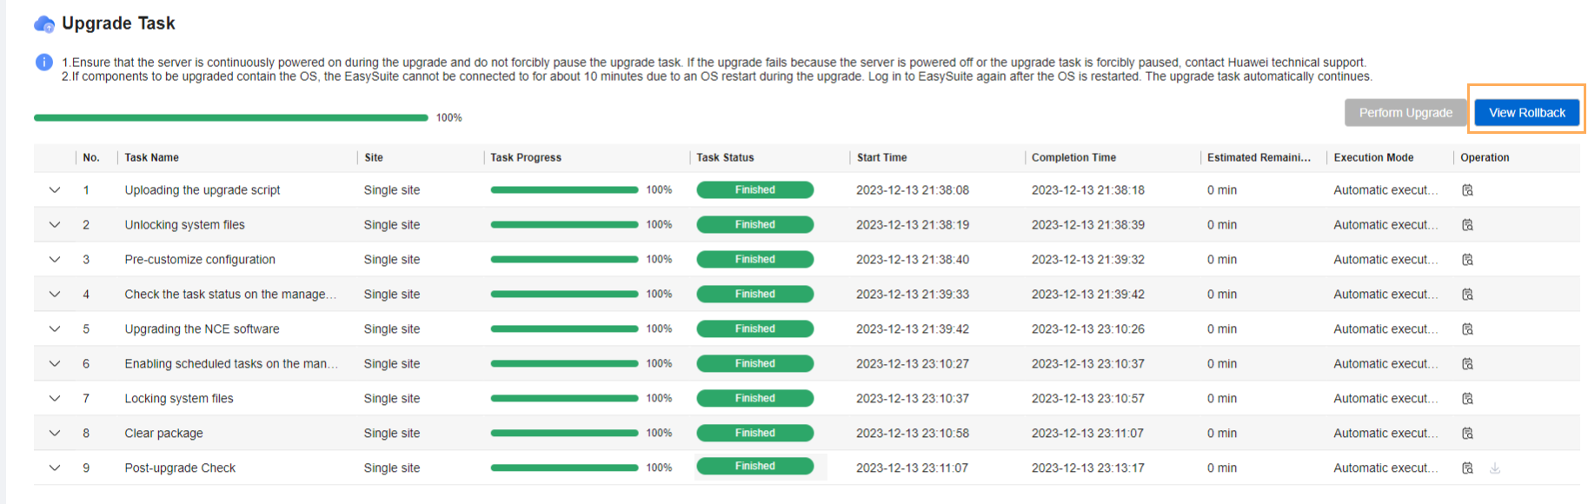
            - Click Perform rollback and wait until the rollback task is complete.
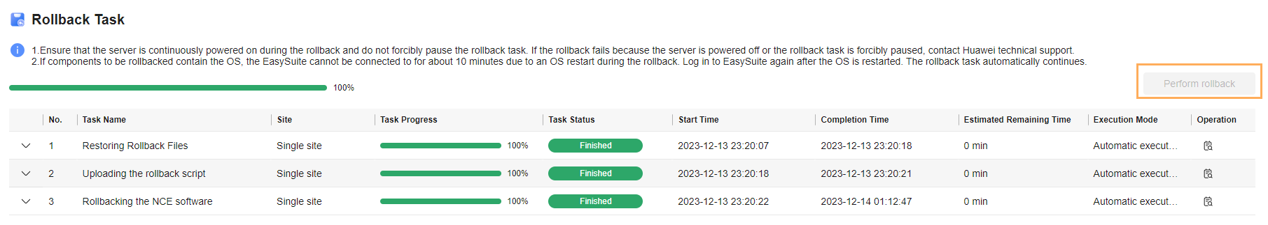

If the source version is iMaster NCE-Campus V300R022C00SPC100, V300R022C00SPC101, or V300R022C00SPC102 and the error message "stop server fail: NCECAMPUS/CampusDataCollector/DataCollectorService" is displayed, click Continue to rollback to roll back the system to the source version.
----End

Version Rollback (Solution A or B with a DR System Split)
Perform operations in this section as required if you use upgrade solution A or B with a DR system split. Skip this section if you use the one-click DR system upgrade solution.
If the following problem occurs, see 10.1 Residual Temporary Directories in the HDFS for the solution.
In a DR scenario, after iMaster NCE-Campus V300R022C00SPC100 is upgraded to V300R023C00 and then rolled back to V300R022C00SPC100, there is a small probability that the pre-check for the HDFS component in the primary cluster fails.
9.1 Precautions for Rollback After the Upgrade
9.2 Rolling Back the Primary Cluster
9.3 Rolling Back the Secondary Cluster
9.4 Building a New DR System

Precautions for Rollback After the Upgrade
Upgrade rollback has the following restrictions, which, if not followed, will cause a rollback failure:
- A rollback depends on the upgrade project on EasySuite and must be completed within 30 days after the upgrade. If the project is lost, a rollback cannot be performed.
- If incremental deployment or capacity expansion has been performed before a rollback, the rollback is not allowed.
- Before a rollback, do not modify system parameter settings, such as IP addresses, database passwords, certificates, and keys.
- Before a rollback, do not clear the backup data required for rollback, such as product data, database applications, and management plane files backed up during the upgrade.
- Before a rollback, do not clear the residual data, such as databases and deployment paths that are no longer used, and backup files of product data and database software generated during the upgrade.
- Before a rollback, do not clear the software packages of the source version on the management plane.
- Before a rollback, do not format OS partitions. For example, do not format the system partition or use the backup data to restore the OS.
- A rollback cannot be performed when a scheduled backup task is in progress on the management plane. EasySuite can automatically disable scheduled backup tasks on the management plane before a rollback and enable the tasks after the rollback.
- After a rollback succeeds, you need to create a new upgrade task for re-upgrade.
- After a rollback succeeds, you are not allowed to use the old task for re-upgrade. In addition, you need to apply for a new time window for re-upgrade.

Rolling Back the Primary Cluster
- If feature expansion has been performed after the upgrade, version rollback is not supported.
- Before a rollback, do not modify system parameter settings, such as IP addresses, database passwords, certificates, and keys. Otherwise, the rollback may fail.
- If the upgraded cluster has set up a DR system with a newly installed cluster, version rollback is not supported.
- Log in to the upgrade tool and select the upgrade task.
            - On the Upgrade tab page, click View Rollback.
            - Click Perform rollback and wait until the rollback task is complete.
----End

Rolling Back the Secondary Cluster
- If feature expansion has been performed after the upgrade, version rollback is not supported.
- Before a rollback, do not modify system parameter settings, such as IP addresses, database passwords, certificates, and keys. Otherwise, the rollback may fail.
- If the upgraded cluster has set up a DR system with a newly installed cluster, version rollback is not supported.
- Log in to the upgrade tool and select the upgrade task.
            - On the Upgrade tab page, click View Rollback.
            - Click Perform rollback and wait until the rollback task is complete.
----End

Building a New DR System
Create a DR system according to "Installation > Software Installation > Geographic Redundancy System Installation" in the CloudCampus Solution V300R022C00 & iMaster NCE-Campus V300R022C00 Product Documentation.

FAQ
10.1 Residual Temporary Directories in the HDFS
10.2 How Can I Find an OMP Node of the Management Plane?
10.3 How Do I Check Whether the SecoManager Is Installed?
10.4 How Do I Check Whether the Source IP Address Feature Patch Has Been Installed?
10.5 How Do I Check Whether a Wireless Non-operating Plug-in Has Been Installed?
10.6 How Do I Check Whether the Nmap Feature Has Been Installed?
10.7 Checking Communication Matrix Changes
10.8 How Do I Use FileZilla to Transfer Files by SFTP?
10.9 How Do I Use PuTTY to Log In to a Server?
10.10 What Can I Do If the HUAWEI-ROUTER-SYSTEMSND Package Fails to Be Activated?
10.11 Checking RPM Packages of the SUSE OS
10.12 How Do I Check the SAC Configuration?
10.13 How Do I Delete Consumer Groups L2topoDiscovery and campus_alarm_notification?
10.14 How Do I Check Whether the Situational Awareness, SRv6, Remote Attestation, or IoT Management Feature Has Been Installed in an Environment?
10.15 How Do I Reset the Passwords of OS Users ossadm, sopuser, and ftpuser?
10.16 How Do I Reset the Passwords for the ossadm and sopuser Users of the Arbitration Node at the Third-Party Site?
10.17 What Do I Do If the OS Is Suspended During the Upgrade?
10.18 How Do I Deploy EasySuite on the Backend?
10.19 What Do I Do If a Message Indicating an Unfinished Upgrade Task Is Displayed When I Set Upgrade Parameters?
10.20 What Do I Do If Software Packages Fail to Be Verified on the Upgrade Tool?
10.21 How Do I Use a Third-Party Tool to Upload Software Packages to the Server?
10.22 How Do I Inspect Trust Certificates of Authentication Components and Rectify Problems
10.23 How Do I Enable Scheduled Backup Tasks on the Management Plane?
10.24 How Do I Handle Health Check Errors?
10.25 How Do I Start or Stop the EasySuite Process?
10.26 How Do I Back up the Device Security Configuration Check Report?

Residual Temporary Directories in the HDFS
Context
In the DR scenario, after iMaster NCE-Campus V300R022C00SPC100 is upgraded to V300R023C00 and then rolled back to V300R022C00SPC100, the pre-check is unlikely to fail on the HDFS at the active and standby sites.
Possible Causes
When the DR relationship is deleted, the residual process exists when the synchronization process is ended in the iMaster NCE-Campus V300R022C00SPC100. This process creates a snapshot of the /backup_dayu directory. After the snapshot of the /backup_dayu directory is deleted, the residual process creates a snapshot before the /backup_dayu directory is deleted. As a result, the /backup_dayu directory exists. When iMaster NCE-Campus is upgraded to V300R023C00, the HDFS directory (including the /backup_dayu directory and snapshots) is backed up. When iMaster NCE-Campus is rolled back to V300R022C00SPC100, the /backup_dayu directory is detected when DR is created. As a result, the pre-check fails.
Procedure
Perform the following steps on both the active and standby nodes:
- Obtain the management IP address of the big data node.
Log in to the management plane and choose Maintenance > Panoramic Monitoring > Service Monitoring > > Process. Enter HDFS in the search box and click . Click the instance name corresponding to NdpHDFS and click the name of the node where the HDFS service is located.
            - Use PuTTY to log in to the NdpHDFS management node as the sopuser user in SSH mode.
            - Run the following command to switch to the ossuser user:
su - ossuser
Password: Enter the password of the ossuser user.
            - Run the following commands to clear residual HDFS files. If the information similar to the following figure is displayed, residual files are successfully cleared.
source /opt/oss/*/apps/NdpNameNodeService/etc/HDClient/bigdata_env
list=($(hdfs dfs -ls -t /backup_dayu/hdfs/.snapshot | awk -F'.snapshot/' '{print $2}'))
for target_snapshot in ${list[*]}; do hdfs dfs -deleteSnapshot /backup_dayu/hdfs $target_snapshot >/dev/null 2>&1; done
hdfs dfs -rm -R -skipTrash /backup_dayu
hdfs dfs -ls /backup_dayu
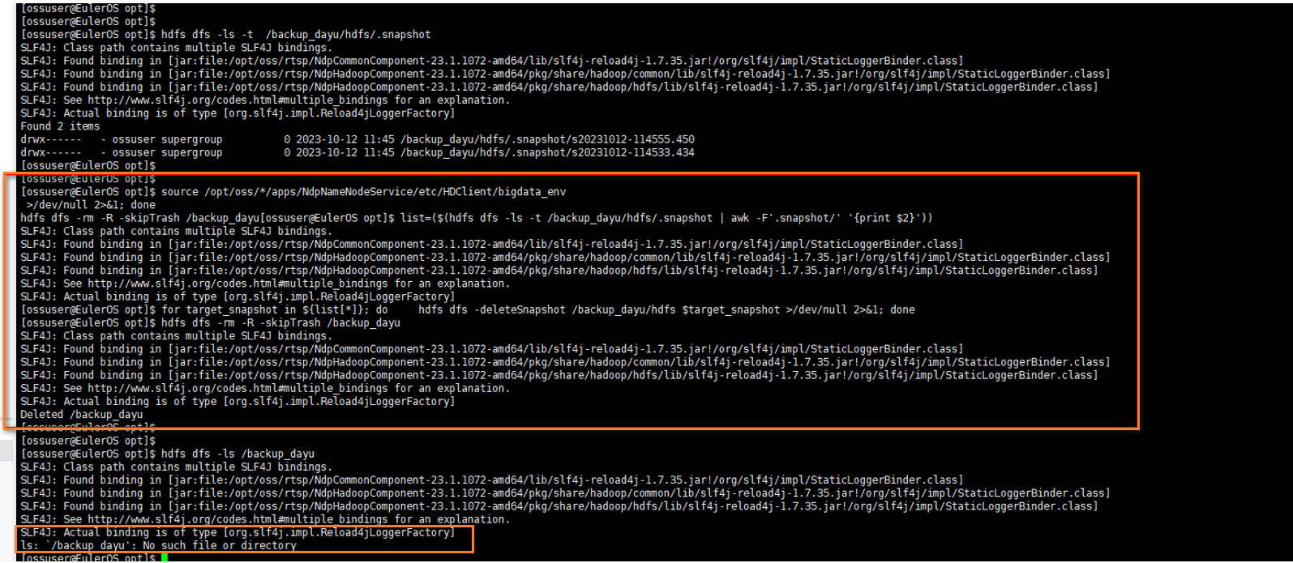
            - On the EasySuite page, click Rollback.
            - Verify the result.
Return to the management plane and perform a DR pre-check. Choose HA > Managing the DR System > Configuring the DR System, set DR parameters as prompted, and click Add Product and Pre-check. The pre-check is successful.
----End

How Can I Find an OMP Node of the Management Plane?
Question
How do I find an OMP node of the management plane in an iMaster NCE-Campus cluster?
Answer

The IP address of the OMP_01 node displayed on the management plane is its internal communication IP address. If your PC cannot communicate with the node through the obtained internal communication IP address, use the node's service, southbound, or northbound IP address for login.
- Log in to the management plane and choose Maintenance > Operation and Maintenance Management > Panoramic Monitoring from the main menu.
            - Click and select NCE-OMP. To view information about the OMP_01 node, click OMP_01.
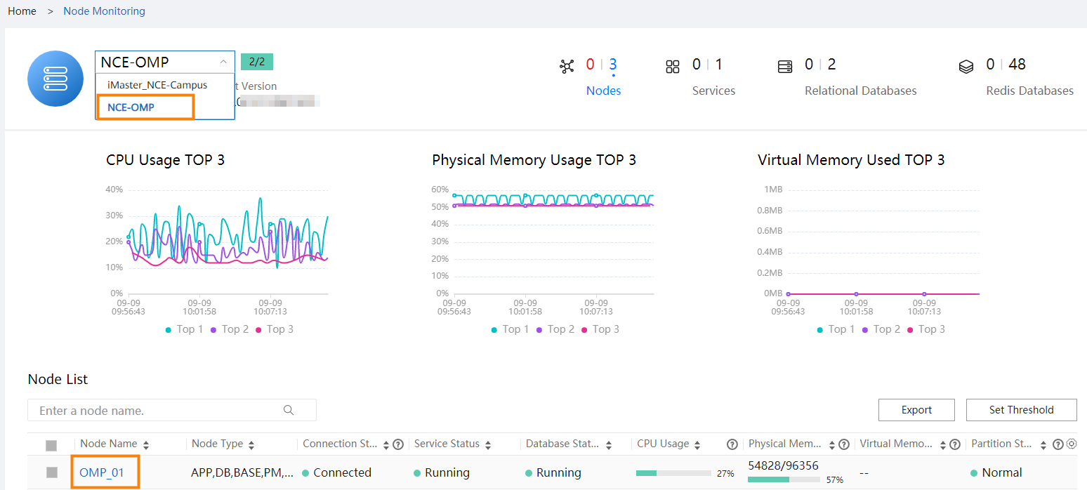
            - View the management IP address (internal communication IP address) of the OMP_01 node.
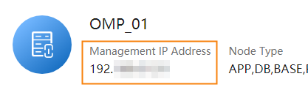
----End

How Do I Check Whether the SecoManager Is Installed?
Question
How do I check whether the SecoManager is installed?
Answer
- Access the management plane as the admin user at https://management plane IP address:18102.
            - Choose Product > Software Management > Deploy Product Software from the main menu, click the cluster in the installed state and check whether the component package list contains NCESECOM. If so, the SecoManager has been installed.
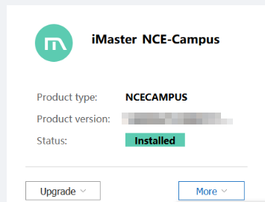
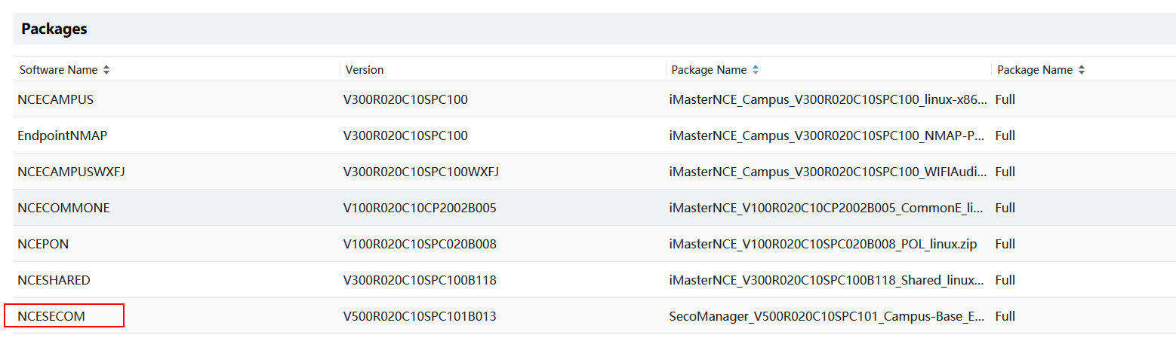
----End

How Do I Check Whether the Source IP Address Feature Patch Has Been Installed?
Procedure
- Log in to the management plane of iMaster NCE-Campus as the system administrator (using port 18102).
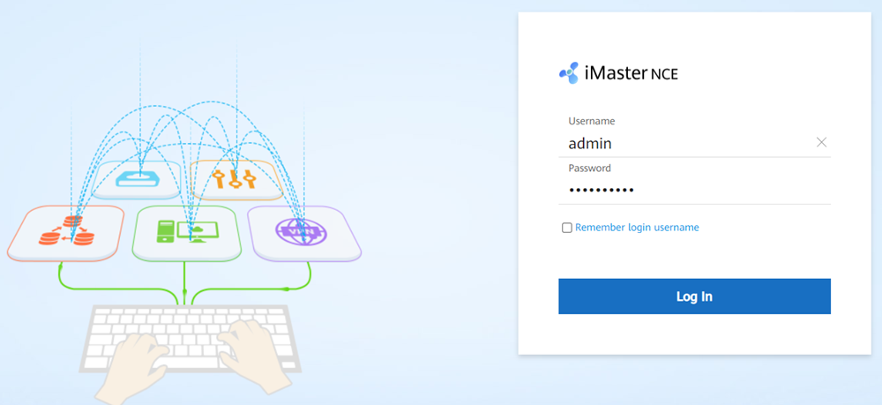
            - On the home page, choose Maintenance > Operation and Maintenance Management > Panoramic Monitoring > Service Monitoring from the main menu. On the Services tab page, search for SDWANAppAnalysis. If the service is found, the source IP address feature patch has been installed.
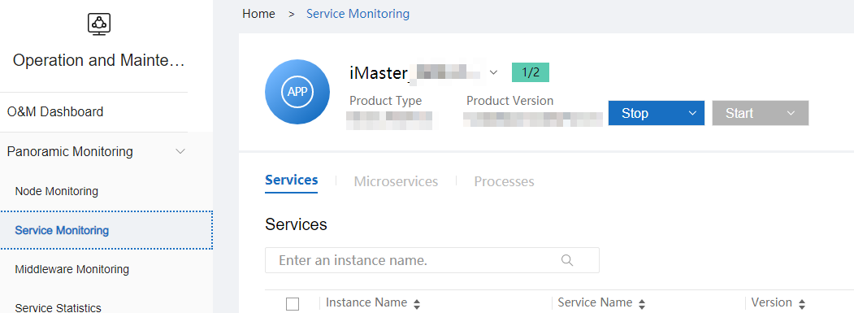
----End

How Do I Check Whether a Wireless Non-operating Plug-in Has Been Installed?
- Access the management plane at https://login IP address of the management plane client:18102.
            - Choose Product > Software Management > Deploy Product Software from the main menu. Click the cluster in the installed state and check whether the component package list contains NCECAMPUSWXFJ. If NCECAMPUSWXFJ exists, the wireless non-operating plug-in has been installed.
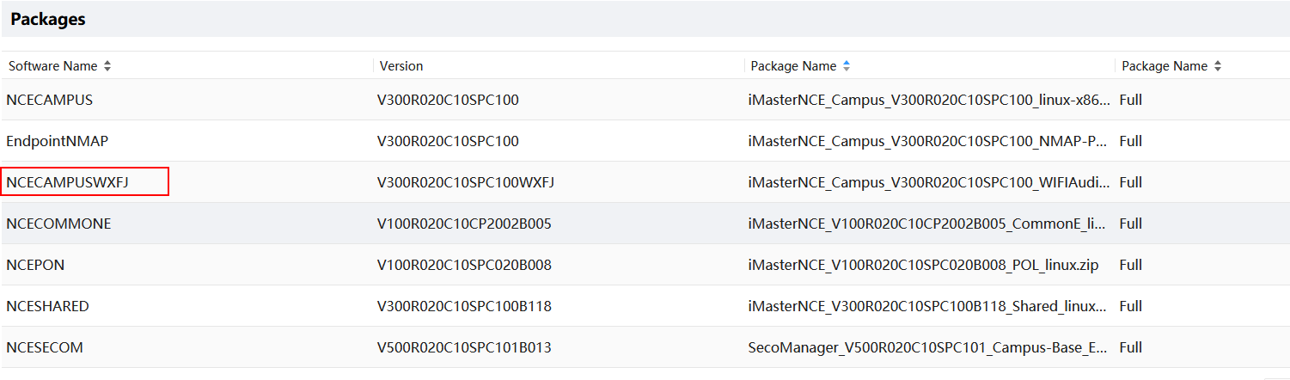
----End

How Do I Check Whether the Nmap Feature Has Been Installed?
- Access the management plane at https://login IP address of the management plane client:18102.
            - Choose Product > Software Management > Deploy Product Software from the main menu. Click the cluster in the installed state and check whether the component package list contains EndpointNMAP. If EndpointNMAP exists, the Nmap feature has been installed.
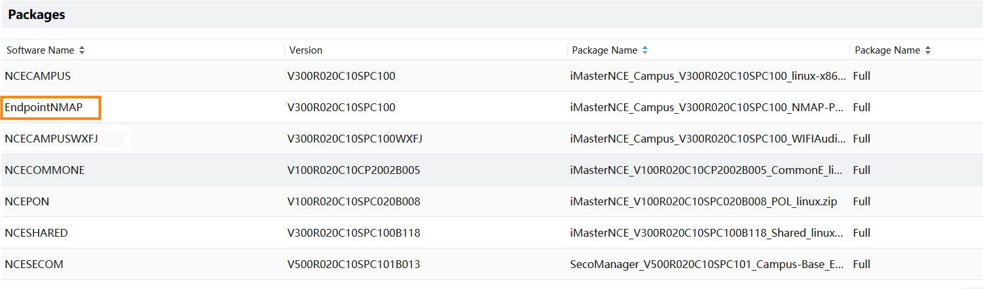
----End

Checking Communication Matrix Changes
                - communication matrix changes
Source Device | Source IP Address | Source Port | Support for NAT | Destination IP Address (Before NAT) | Destination Port (Before NAT) | Destination IP Address (After NAT) | Protocol/Destination Port (After NAT) | Destination Device | Change History | Function | Direction | Usage Scenario
Controller | Local NIC IP address of the controller  (which is reachable to the destination IP address through routing) | 48880~48889 | No | / | / | Device IP address | UDP/Specified by the device (161 by default) | Device | New | This port is used by the controller to send SNMP requests to devices. The destination port number for device access is determined by devices and is port 161 by default.  NOTE  This port is not used in public cloud and HCS scenarios. | Southbound port (outbound) | This port is involved in the traditional device management scenario.
Device | Device IP address | Random port | No | / | / | Floating IP address for southbound load balancing | TCP/179 | Controller | New | This port is the listening port of BGP sessions, which is used to establish sessions with BGP peers.  NOTE  This port is not used in public cloud and HCS scenarios. | Southbound port (inbound) | This port is involved in the SRv6 scenario.
Device | Device IP address | Random port | Yes | Southbound service IP address | 49 | Floating IP address for southbound load balancing | TCP/49 | Controller | New | This port is used by the RadiusServerService process to receive requests from port 30049, as well as requests forwarded by port 49 to this port, to provide the TACACS service. | Southbound port (inbound) | This port is involved in the TACACS authentication scenario.
Device | Device IP address | Random port | Yes | Southbound service IP address | 30049 | Floating IP address for southbound load balancing | TCP/30049 | Controller | New | This port is used by the RadiusServerService process to receive requests from port 30049, as well as requests forwarded by port 49 to this port, to provide the TACACS service. | Southbound port (inbound) | This port is involved in the TACACS authentication scenario.
Device | Device IP address | Random port | No | / | / | Floating IP address for southbound load balancing | TCP/4189 | Controller | New | This port is the listening port of PCEP sessions, which is used to establish sessions with PCCs.  NOTE  This port is not used in public cloud and HCS scenarios. | Southbound port (inbound) | This port is involved in the SRv6 scenario.
Device | Device IP address | Random port | Yes | Southbound service IP address | 10035 | Floating IP address for southbound load balancing | TCP/10035 | Controller | New | This port is used by the data collection service to provide the device performance data collection service. | Southbound port (inbound) | This port is used for performance data collection and is involved only in the scenario where third-party certificates are used.
Device | Device IP address | Random port | Yes | Southbound service IP address | 10034 | Floating IP address for southbound load balancing | TCP/10034 | Controller | New | This port is used by the data collection service to provide the device performance data collection service. | Southbound port (inbound) | This port is used for performance data collection and is involved only in the scenario where V600 devices are managed.
Device | Device IP address | Random port | Yes | Southbound service IP address | 30217 | Floating IP address for southbound load balancing | TCP/30217 | Controller | New | This port is used by the BootstrapProxyService process to listen to TCP connections of southbound devices and receive packets from the devices in TLS mode. | Southbound port (inbound) | This port is used for issuing device certificates during deployment. In the current version, preset certificates are used and therefore this port does not need to be enabled.
Device | Device IP address | Random port | Yes | Southbound service IP address | 50309 | Floating IP address for southbound load balancing | TCP/50309 | Controller | New | This port is used by CampusAccesscfgService to provide the IP-group service and is involved only in the scenario where third-party certificates are used. | Southbound port (inbound) | This port is used by the IP-GROUP service for access authentication. It is involved only in the scenario where third-party certificates are used.
NE | NE IP address | Any | Yes | Southbound service IP address | 30228 | Floating IP address for southbound load balancing | TCP/30228 | Controller | New | This port is used by FIProxyService to provide file upload and download services for IoT devices. The difference between ports 30228 and 18020 is that port 30228 uses the ECC certificate. | Southbound port (inbound) | This port is involved in the IoT device management scenario.
NE | NE IP address | Any | Yes | Southbound service IP address | 30226 | Floating IP address for southbound load balancing | TCP/30226 | Controller | New | This port is used by the IoTMqttService process to receive connection requests from southbound devices. | Southbound port (inbound) | This port is involved in the IoT device management scenario.
NE | NE IP address | Any | Yes | Southbound service IP address | 30225 | Floating IP address for southbound load balancing | TCP/30225 | Controller | New | This port is used by the IoTMqttService process to provide the device registration function. | Southbound port (inbound) | This port is involved in the IoT device management scenario.
NCE server | NCE server IP address | Any | No | / | / | CA server IP address | TCP/26803 | CA server | New | This port is used by LiteCAService to apply for, update, and revoke certificates. Port 26803 is a CMP port used by a client to apply for a certificate from the CA server through CMP over HTTP. HTTP is an insecure protocol. Enabling it has security risks. Therefore, port 26803 is disabled by default. To enable it, choose System > Security Management > Certificate Authority Service from the main menu of the O&M plane. On the displayed page, choose Global Configuration > Port Management from the navigation pane, click Enable on the right of port 26803, and restart the CA service. | Southbound port (outbound) | This port is involved in the scenario where device certificates need to be issued.
NE | NE IP address | Any | Yes | Southbound service IP address | 26803 | Floating IP address for southbound load balancing | TCP/26803 | Controller | New | This port is used by LiteCAService. This service enables ports, initializes TLS channels, and forwards NE certificate application requests to LiteCASignService. Port 26803 is a CMP port used by a client to apply for a certificate from the CA server through CMP over HTTP or CMP over TLS. Port 26803 is disabled by default. To enable it, choose System > Security Management > Certificate Authority Service from the main menu of the O&M plane. On the page that is displayed, choose Global Configuration > Port Management from the navigation pane, click Enable on the right of the port 26803, configure a TLS certificate (a TLS certificate must be configured when the CMP over TLS protocol is used to apply for a certificate from a CA server), and restart the CA service. | Southbound port (inbound) | This port is involved in the scenario where device certificates need to be issued.
NCE server | NCE server IP address | Any | No | / | / | CA server IP address | TCP/26802 | CA server | New | This port is used by LiteCAService to apply for, update, and revoke certificates. Port 26802 is a CMP port used by a client to apply for a certificate from the CA server through CMP over HTTP. HTTP is an insecure protocol. Enabling it has security risks. Therefore, port 26802 is disabled by default. To enable it, choose System > Security Management > Certificate Authority Service from the main menu of the O&M plane. On the displayed page, choose Global Configuration > Port Management from the navigation pane, click Enable on the right of port 26802, and restart the CA service. | Southbound port (outbound) | This port is involved in the scenario where device certificates need to be issued.
NE | NE IP address | Any | Yes | Southbound service IP address | 26802 | Floating IP address for southbound load balancing | TCP | Controller | New | This port is used by LiteCAService (whose process is litecaservice). This service enables ports, initializes TLS channels, and forwards NE certificate application requests to LiteCASignService. Port 26802 is a CMP port used by a client to apply for a certificate from the CA server through CMP over HTTP or CMP over TLS. Port 26802 is disabled by default. To enable it, choose System > Security Management > Certificate Authority Service from the main menu of the O&M plane. On the page that is displayed, choose Global Configuration > Port Management from the navigation pane, click Enable on the right of the port 26802, configure a TLS certificate (a TLS certificate must be configured when the CMP over TLS protocol is used to apply for a certificate from a CA server), and restart the CA service. | Southbound port (inbound) | This port is involved in the scenario where device certificates need to be issued.
NE | NE IP address | Any | Yes | Southbound service IP address | 26801 | Floating IP address for southbound load balancing | TCP/26801 | Controller | New | This port is used by LiteCAService. This service enables ports, initializes TLS channels, and forwards NE certificate application requests to LiteCASignService. Port 26801 is a CMP port used by a client to apply for a certificate from the CA server through CMP over HTTP or CMP over TLS. HTTP is an insecure protocol. Enabling it has security risks. Therefore, port 26801 is disabled by default. To enable it, choose System > Security Management > Certificate Authority Service from the main menu of the O&M plane. On the displayed page, choose Global Configuration > Port Management from the navigation pane, click Enable on the right of port 26801, configure a TLS certificate (a TLS certificate must be configured when the CMP over TLS protocol is used to apply for a certificate from a CA server), and restart the CA service. | Southbound port (inbound) | This port is involved in the scenario where device certificates need to be issued.
NCE server | NCE server IP address | Any | No | / | / | CA server IP address | TCP/26801 | CA server IP address | New | This port is used by LiteCAService to apply for, update, and revoke certificates. Port 26801 is a CMP port used by a client to apply for a certificate from the CA server through CMP over HTTP. HTTP is an insecure protocol. Enabling it has security risks. Therefore, port 26801 is disabled by default. To enable it, choose System > Security Management > Certificate Authority Service from the main menu of the O&M plane. On the displayed page, choose Global Configuration > Port Management from the navigation pane, click Enable on the right of port 26801, and restart the CA service. | Southbound port (outbound) | This port is involved in the scenario where device certificates need to be issued.

                - communication matrix changes
Source Device | Source IP Address | Source Port | Support for NAT | Destination IP Address (Before NAT) | Destination Port (Before NAT) | Destination IP Address (After NAT) | Protocol/Destination Port (After NAT) | Destination Device | Change History | Function | Direction | Usage Scenario
NE | NE IP address | Any | Yes | Southbound service IP address | 30228 | Floating IP address for southbound load balancing | TCP/30228 | Controller | New | This port is used by FIProxyService to provide file upload and download services for IoT devices. The difference between ports 30228 and 18020 is that port 30228 uses the ECC certificate. | Southbound port (inbound) | This port is involved in the IoT device management scenario.
NE | NE IP address | Any | Yes | Southbound service IP address | 30226 | Floating IP address for southbound load balancing | TCP/30226 | Controller | New | This port is used by the IoTMqttService process to receive connection requests from southbound devices. | Southbound port (inbound) | This port is involved in the IoT device management scenario.
NE | NE IP address | Any | Yes | Southbound service IP address | 30225 | Floating IP address for southbound load balancing | TCP/30225 | Controller | New | This port is used by the IoTMqttService process to provide the device registration function. | Southbound port (inbound) | This port is involved in the IoT device management scenario.
NCE server | NCE server IP address | Any | No | / | / | CA server IP address | TCP/26803 | CA server | New | This port is used by LiteCAService to apply for, update, and revoke certificates. Port 26803 is a CMP port used by a client to apply for a certificate from the CA server through CMP over HTTP. HTTP is an insecure protocol. Enabling it has security risks. Therefore, port 26803 is disabled by default. To enable it, choose System > Security Management > Certificate Authority Service from the main menu of the O&M plane. On the displayed page, choose Global Configuration > Port Management from the navigation pane, click Enable on the right of port 26803, and restart the CA service. | Southbound port (outbound) | This port is involved in the scenario where device certificates need to be issued.
NE | NE IP address | Any | Yes | Southbound service IP address | 26803 | Floating IP address for southbound load balancing | TCP/26803 | Controller | New | This port is used by LiteCAService. This service enables ports, initializes TLS channels, and forwards NE certificate application requests to LiteCASignService. Port 26803 is a CMP port used by a client to apply for a certificate from the CA server through CMP over HTTP or CMP over TLS. Port 26803 is disabled by default. To enable it, choose System > Security Management > Certificate Authority Service from the main menu of the O&M plane. On the page that is displayed, choose Global Configuration > Port Management from the navigation pane, click Enable on the right of the port 26803, configure a TLS certificate (a TLS certificate must be configured when the CMP over TLS protocol is used to apply for a certificate from a CA server), and restart the CA service. | Southbound port (inbound) | This port is involved in the scenario where device certificates need to be issued.
NCE server | NCE server IP address | Any | No | / | / | CA server IP address | TCP/26802 | CA server | New | This port is used by LiteCAService to apply for, update, and revoke certificates. Port 26802 is a CMP port used by a client to apply for a certificate from the CA server through CMP over HTTP. HTTP is an insecure protocol. Enabling it has security risks. Therefore, port 26802 is disabled by default. To enable it, choose System > Security Management > Certificate Authority Service from the main menu of the O&M plane. On the displayed page, choose Global Configuration > Port Management from the navigation pane, click Enable on the right of port 26802, and restart the CA service. | Southbound port (outbound) | This port is involved in the scenario where device certificates need to be issued.
NE | NE IP address | Any | Yes | Southbound service IP address | 26802 | Floating IP address for southbound load balancing | TCP | Controller | New | This port is used by LiteCAService (whose process is litecaservice). This service enables ports, initializes TLS channels, and forwards NE certificate application requests to LiteCASignService. Port 26802 is a CMP port used by a client to apply for a certificate from the CA server through CMP over HTTP or CMP over TLS. Port 26802 is disabled by default. To enable it, choose System > Security Management > Certificate Authority Service from the main menu of the O&M plane. On the page that is displayed, choose Global Configuration > Port Management from the navigation pane, click Enable on the right of the port 26802, configure a TLS certificate (a TLS certificate must be configured when the CMP over TLS protocol is used to apply for a certificate from a CA server), and restart the CA service. | Southbound port (inbound) | This port is involved in the scenario where device certificates need to be issued.
NE | NE IP address | Any | Yes | Southbound service IP address | 26801 | Floating IP address for southbound load balancing | TCP/26801 | Controller | New | This port is used by LiteCAService. This service enables ports, initializes TLS channels, and forwards NE certificate application requests to LiteCASignService. Port 26801 is a CMP port used by a client to apply for a certificate from the CA server through CMP over HTTP or CMP over TLS. HTTP is an insecure protocol. Enabling it has security risks. Therefore, port 26801 is disabled by default. To enable it, choose System > Security Management > Certificate Authority Service from the main menu of the O&M plane. On the displayed page, choose Global Configuration > Port Management from the navigation pane, click Enable on the right of port 26801, configure a TLS certificate (a TLS certificate must be configured when the CMP over TLS protocol is used to apply for a certificate from a CA server), and restart the CA service. | Southbound port (inbound) | This port is involved in the scenario where device certificates need to be issued.
NCE server | NCE server IP address | Any | No | / | / | CA server IP address | TCP/26801 | CA server | New | This port is used by LiteCAService to apply for, update, and revoke certificates. Port 26801 is a CMP port used by a client to apply for a certificate from the CA server through CMP over HTTP. HTTP is an insecure protocol. Enabling it has security risks. Therefore, port 26801 is disabled by default. To enable it, choose System > Security Management > Certificate Authority Service from the main menu of the O&M plane. On the displayed page, choose Global Configuration > Port Management from the navigation pane, click Enable on the right of port 26801, and restart the CA service. | Southbound port (outbound) | This port is involved in the scenario where device certificates need to be issued.

                - communication matrix changes
Source Device | Source IP Address | Source Port | Support for NAT | Destination IP Address (Before NAT) | Destination Port (Before NAT) | Destination IP Address (After NAT) | Protocol/Destination Port (After NAT) | Destination Device | Change History | Function | Direction | Usage Scenario
NE | NE IP address | Any | Yes | Southbound service IP address | 30228 | Floating IP address for southbound load balancing | TCP/30228 | Controller | New | This port is used by FIProxyService to provide file upload and download services for IoT devices. The difference between ports 30228 and 18020 is that port 30228 uses the ECC certificate. | Southbound port (inbound) | This port is involved in the IoT device management scenario.
NE | NE IP address | Any | Yes | Southbound service IP address | 30226 | Floating IP address for southbound load balancing | TCP/30226 | Controller | New | This port is used by the IoTMqttService process to receive connection requests from southbound devices. | Southbound port (inbound) | This port is involved in the IoT device management scenario.
NE | NE IP address | Any | Yes | Southbound service IP address | 30225 | Floating IP address for southbound load balancing | TCP/30225 | Controller | New | This port is used by the IoTMqttService process to provide the device registration function. | Southbound port (inbound) | This port is involved in the IoT device management scenario.

                - Communication matrix changes
Source Device | Source IP Address | Source Port | Support for NAT | Destination IP Address (Before NAT) | Destination Port (Before NAT) | Destination IP Address (After NAT) | Protocol/Destination Port (After NAT) | Destination Device | Change History | Function | Direction | Usage Scenario
Device | Device IP address | 5684 | Yes | Southbound service IP address | 5684 | Floating IP address for southbound load balancing | TCP/5684 | Controller server | New | This port is opened for LwM2MServerService and is used to support CoAP-compliant device onboarding and O&M operations. | Inbound (southbound) | This port is involved in onboarding and O&M operations of the S380.
Controller server | Local NIC IP address of each controller node  (This IP address is the IP address of the local NIC on the network plane where the local routing gateway that matches the destination IP address resides.) | Any port | N/A | Third-party server IP address | Any port | N/A | N/A | Third-party server | New | This port is used for interconnection with OneNet. NCE functions as the client to report AP data and terminal data to the third-party system. | Interconnection with a third-party system (outbound) | This port is involved in the OneNet interconnection scenario.
Controller server | Local NIC IP address of each controller node  (This IP address is the IP address of the local NIC on the network plane where the local routing gateway that matches the destination IP address resides.) | 15953~15962 | N/A | RADIUS server IP address | Any port | N/A | N/A | Third-party server | New | The NCE server functions as the client and forwards authentication and accounting packets to the external RADIUS server through ports 15953 to 15962. | Interconnection with a third-party system (outbound) | These ports are involved in the scenario where a third-party RADIUS server functions as the relay for access authentication.

How Do I Use FileZilla to Transfer Files by SFTP?
Question
How do I use FileZilla to transfer files by SFTP?
Answer
- Double-click the FileZilla icon on the PC or laptop to launch the tool.
Access https://filezilla-project.org/ and download the latest version of FileZilla.
            - Set up a connection.
- Enter a server IP address in the Host text box.
- Enter the OS username in the User text box.
- Enter the password in Password.
- Enter 22 in the Port text box.
- Click Quickconnect.
The following figure uses the ossadm user as an example.
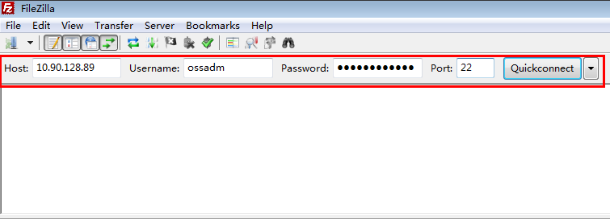
- If "Directory listing successful" is displayed, as shown in the following figure, the SFTP connection is successful.
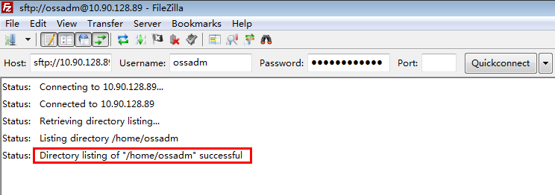
            - Upload files.

The name of the directory with the file to be transferred must not contain any spaces, brackets, or Chinese characters. Only letters, digits, and underscores (_) are allowed. If the directory name contains Chinese characters, garbled characters will appear, but this will not affect the software packages to be uploaded.
- In the Local site directory tree, locate the folder in which the files to be uploaded reside and click it. The folder will be displayed in Filename under Local site.
- In the Remote site directory tree, locate the folder in which the uploaded files are to be stored and click it. All files in the folder will be displayed in Filename under Remote site.
- Select a file in the source folder and drag it to the destination folder.
- Release the button. File uploading starts.
For example, upload the test.txt file in D:\test on a PC to the /opt/upgrade directory on the server, as shown in the following figure.
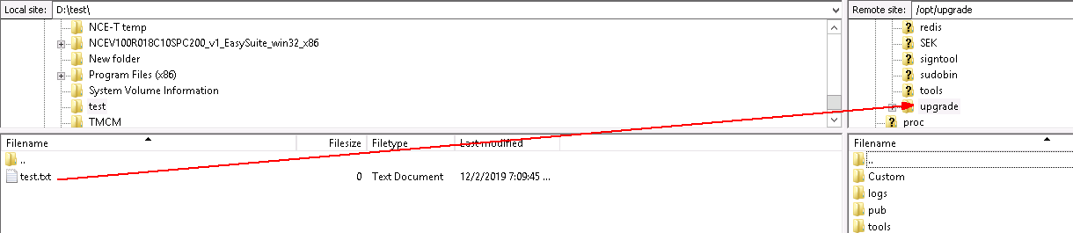
            - After the file is successfully uploaded, a success message is displayed, as shown in the following figure.
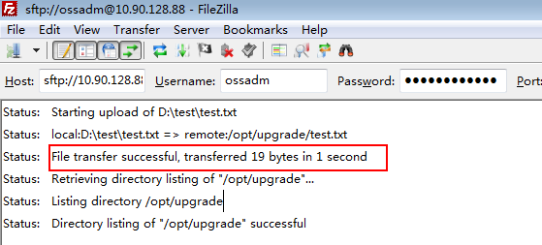
----End

How Do I Use PuTTY to Log In to a Server?
This section describes how to use PuTTY to log in to a server in SSH mode after the operating system is installed. The following uses PuTTY 0.70 as an example.
Prerequisites
You have obtained PuTTY of the latest version from https://www.chiark.greenend.org.uk/~sgtatham/putty/ and have installed it on your local PC.
PuTTY 0.67 or later is required.
Procedure
- Start PuTTY.
            - In the Host Name (or IP address) text box, enter the IP address of the server to which you want to log in.
Log in to the server using its fixed IP address to prevent floating IP address abnormalities from interrupting the SSH connection.
            - Set Connection type to SSH.
            - In the Close window on exit field, select Only on clean exit.
            - In the navigation pane, choose Window > Translation.
            - Set Remote character set to UTF-8.
Set the encoding format to UTF-8 each time you use PuTTY.
            - Click Open.
If this is the first time you are using PuTTY, the PuTTY Security Alert dialog box may be displayed. Click Yes.
            - When the following information is displayed, enter a username and press Enter:
login as:
After security hardening is performed for the OS, only users with the SSH permission (for example, sopuser) are allowed to log in to the server.
            - When the following information is displayed, enter the user password and press Enter.
Username@IP address's password:
For security purposes, keep the password secure and change it regularly.
----End

What Can I Do If the HUAWEI-ROUTER-SYSTEMSND Package Fails to Be Activated?
Question
What can I do if the HUAWEI-ROUTER-SYSTEMSND package fails to be activated?
Answer
- Access the controller service plane at https://floating IP address for northbound load balancing:18008.
            - Enter the administrator's username admin and password and click Log In.
            - Choose System > Service Programming > Package Repo, choose Package Management from the navigation pane, and check whether the 8090_V800R013C00_SYSTEMSND package exists. If so, select the package and click the Uninstall button. On the displayed page, enter the password of the admin user to uninstall the package. If the package does not exist, skip the following operations.
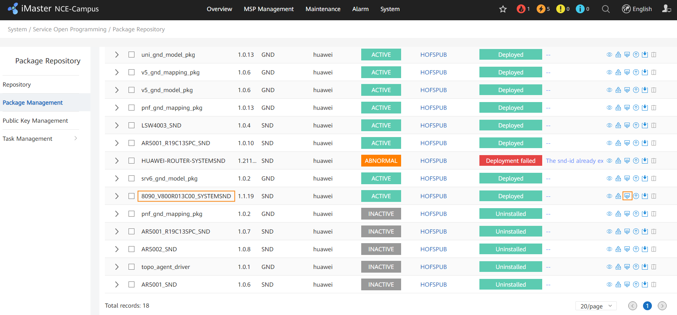
            - If SRv6 is required, select the HUAWEI-ROUTER-SYSTEMSND package and click the Deploy button to activate it. If SRv6 is not required, no action is required.
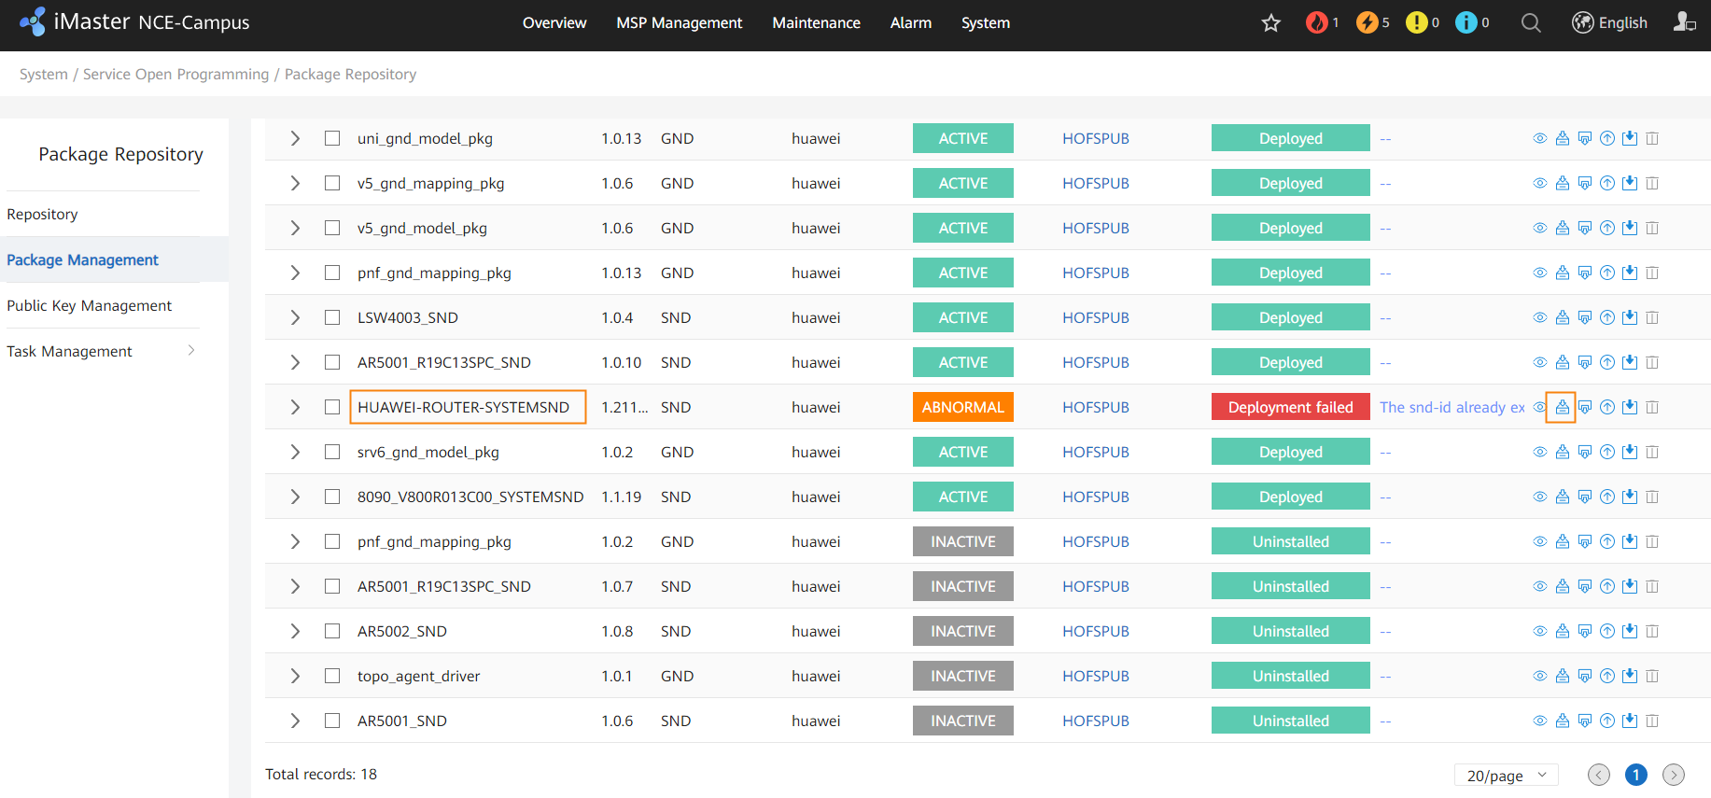
----End

Checking RPM Packages of the SUSE OS
- Log in to each FusionInsight node as the sopuser user, run the su - root command to switch to the root user, and copy and run the following commands to check whether some RPM packages are missing:
ldap_rmp=$(rpm -qa | grep -E 'ldap|libev|krb5|libopenssl|libcap-progs')
check_list="libev4 libevent libopenssl libverto-libev pam_krb5 libcap-progs"
for list in ${check_list} ; do
[ "`echo $ldap_rmp | grep $list`x" == "x" ] && echo "The OpenLDAP RPM package is missing in the current environment,current rpm is: [$list]"
done
If any RPM package is missing, the name of the missing RPM package is displayed in the command output, as shown in the following figure.
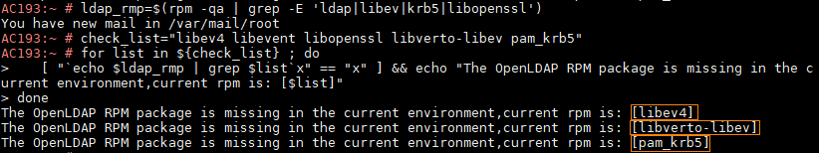
            - Log in to https://www.suse.com/download/sles/, download the SUSE image SLE-12-SP*-Server-DVD-x86_64-GM-DVD1 of the corresponding version, mount the ISO image, and go to the image directory /suse/ to obtain the required RPM packages.
The following RPM packages of the SUSE OS need to be downloaded:
SUSE 12SP2:
- libev4-4.22-1.3.x86_64.rpm
- pam_krb5-2.4.4-4.5.x86_64.rpm
- libverto-libev1-0.2.6-2.4.x86_64.rpm
- libcap-progs-2.22-13.1.x86_64.rpm
SUSE 12SP4:
- libev4-4.22-1.3.x86_64.rpm
- pam_krb5-2.4.4-4.5.x86_64.rpm
- libverto-libev1-0.2.6-3.2.2.x86_64.rpm
- libcap-progs-2.22-13.1.x86_64.rpm
SUSE 12SP5:
- libev4-4.22-3.2.1.x86_64.rpm
- pam_krb5-2.4.4-4.5.x86_64.rpm
- libverto-libev1-0.2.6-3.2.2.x86_64.rpm
- libcap-progs-2.22-13.1.x86_64.rpm
If the RPM package versions in the image are different from those listed above, contact Huawei engineers to check the RPM package versions.
            - Log in to each FusionInsight node as the sopuser user, run the su - root command to switch to the root user, and use FileZilla to upload the obtained RPM packages to any directory, for example, /root/RPM.
If security hardening has been performed on a node, run the sh /opt/SEK/cmd/SetEnv.sh command to disable security hardening on the node.
            - Access the path where RPM packages are stored, such as /root/RPM.
cd /root/RPM
            - Run the following command to install the missing RPM packages (displayed in the command output in Step 1):
rpm -Uvh --force --nodeps RPM package name
After all missing RPM packages are installed, run the following command to perform security hardening on the node:
sh /opt/SEK/cmd/RollBackEnv.sh
----End

How Do I Check the SAC Configuration?
In a DR scenario, perform operations in this section for both the primary and secondary clusters.
- Log in to the service plane as a tenant, choose Policy > Application Management > Application Management from the main menu, and click the SAC Configuration tab.
            - Perform this step only when Configuration is toggled off and Application scope is set to All in the Application Identification Configuration area, and also you want the SAC function to remain enabled on V600 devices after the controller upgrade.
Click in the Operation column of the application identification feature. In the Application Identification Configuration area, toggle on Configuration, set Application scope to Customized, set V600R021C00 and later versions to Yes, and click Search. Select all the sites displayed in the list below, click , and click OK.
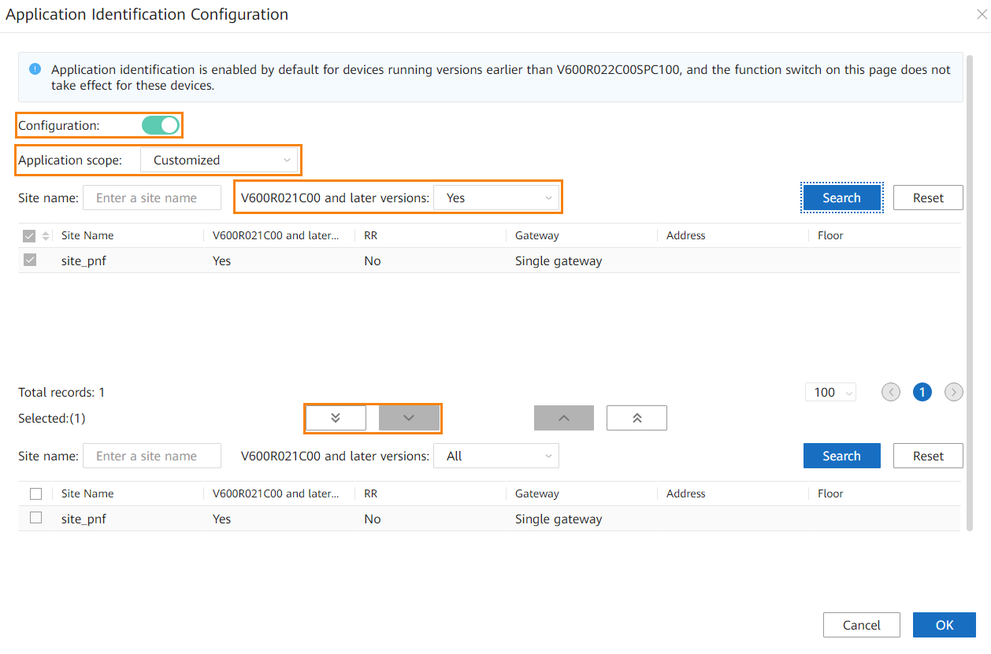
            - Perform this step only when Configuration is toggled on, Application scope is set to Customized, and No is selected for V600R021C00 and later versions in the Application Identification Configuration area (as shown in the following figure), and also you want the SAC function to remain enabled on V600 devices after the controller upgrade. You can click in the Operation column of the application identification feature to check the V600R021C00 and later versions setting.
Select Yes for V600R021C00 and later versions and click Search. Then select all the sites displayed in the list below, click , and click OK.
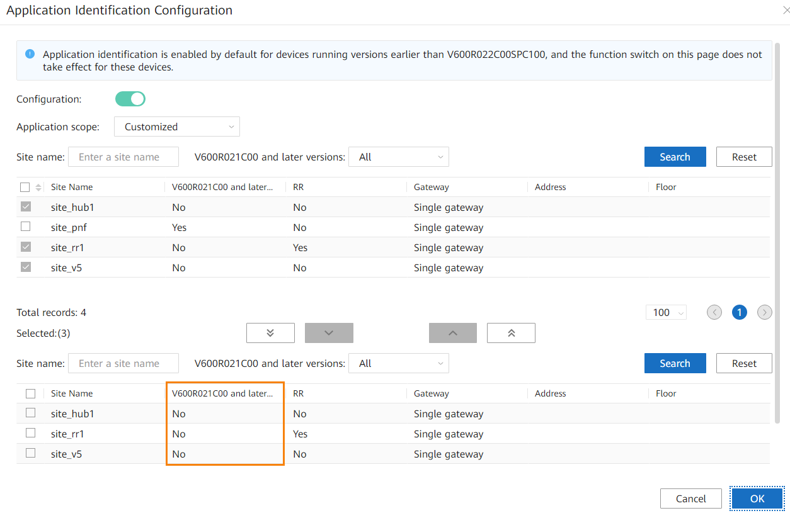
----End

How Do I Delete Consumer Groups L2topoDiscovery and campus_alarm_notification?
- Log in to the management plane and choose Maintenance > Operation and Maintenance Management > Panoramic Monitoring from the main menu. Click and select iMaster_NCE-Campus.
            - Choose Service Monitoring from the navigation pane, click the Microservices tab, enter DmqKafkaService in the search box, and select the DmqKafkaService instance.
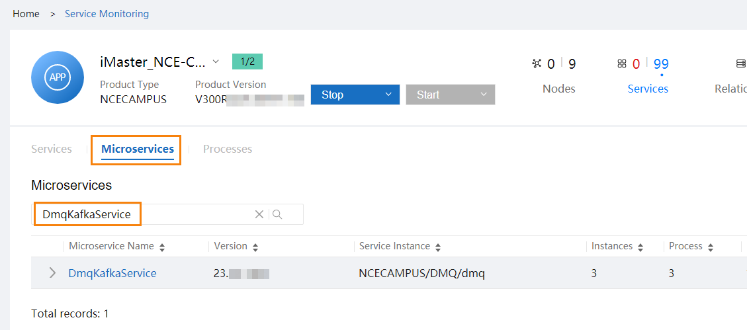
            - Click the node name in the Node Name column to obtain the management IP addresses of the nodes where DmqKafkaService resides.
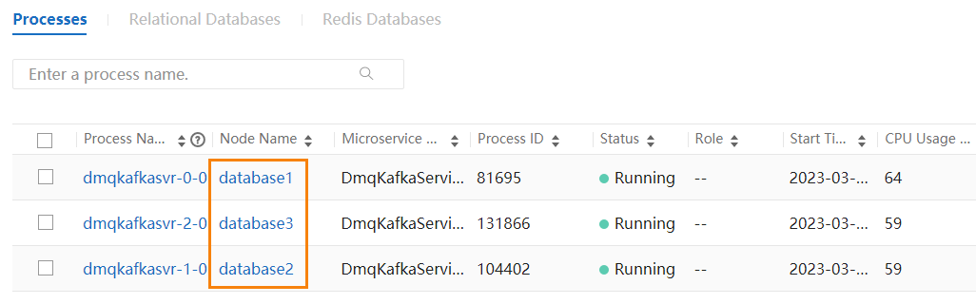
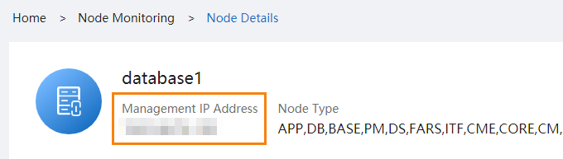
            - Log in to a node where DmqKafkaService resides as the sopuser user, run the su - root command to switch to the root user, and run the following command:
# cd /opt/oss/NCECAMPUS/apps/DmqKafkaService/tools/kafka/bin
            - Run the following commands to delete consumer groups L2topoDiscovery and campus_alarm_notification:
# sh set-env.sh kafka-consumer-groups.sh --boot --command-config ../config/consumer.properties --group L2topoDiscovery --topic topic_ncf_notification:0,1,2,3,4,5,6,7 --delete-offsets
# sh set-env.sh kafka-consumer-groups.sh --boot --command-config ../config/consumer.properties --group campus_alarm_notification --topic topic_ncf_notification:0,1,2,3,4,5,6,7 --delete-offsets
            - Run the following commands to check whether the deletion is successful. If the command output does not contain L2topoDiscovery or campus_alarm_notification, the deletion is successful. If the deletion fails, contact Huawei technical support.
sh set-env.sh kafka-consumer-groups.sh --boot --command-config ../config/consumer.properties --describe --all-groups |grep topic_ncf_notification |grep L2topoDiscovery
sh set-env.sh kafka-consumer-groups.sh --boot --command-config ../config/consumer.properties --describe --all-groups |grep topic_ncf_notification |grep campus_alarm_notification
----End

How Do I Check Whether the Situational Awareness, SRv6, Remote Attestation, or IoT Management Feature Has Been Installed in an Environment?
- Access the management plane as the admin user at https://management plane IP address:18102.
            - Choose Product > Software Management > Deploy Product Software from the main menu, click the cluster in the installed state and check the component package list.
- If the list contains ExtAdvancedSEC, the situational awareness feature has been installed in the environment.
- If the list contains NCESRV6, the SRv6 feature has been installed in the environment.
- If the list contains TrustCenter, the remote attestation feature has been installed in the environment.
- If the list contains NCEIOT, the IoT management feature has been installed in the environment.
----End

How Do I Reset the Passwords of OS Users ossadm, sopuser, and ftpuser?
Log in to each controller node as the root user.

The password must meet the following requirements:
          - The password can contain uppercase letters, lowercase letters, digits, and special characters ~@#^*-_+[{}]:./? %=!
          - The password can contain a maximum of 64 characters.
- To reset the password of the OS user ossadm, run the passwd ossadm command on each controller node.
- To reset the password of the OS user sopuser, run the passwd sopuser command on each controller node.
- To reset the password of the OS user ftpuser, run the passwd ftpuser command on each controller node.

How Do I Reset the Passwords for the ossadm and sopuser Users of the Arbitration Node at the Third-Party Site?
Log in to the arbitration node at the third-party site as the root user.

The password must meet the following requirements:
          - The password can contain uppercase letters, lowercase letters, digits, and special characters ~@#^*-_+[{}]:./? %=!
          - The password can contain a maximum of 64 characters.
- To reset the password for the ossadm user of the arbitration node at the third-party site, run the passwd ossadm command on each controller node.
- To reset the password for the sopuser user of the arbitration node at the third-party site, run the passwd sopuser command on each controller node.

What Do I Do If the OS Is Suspended During the Upgrade?
Symptoms
The OS is suspended during the upgrade. After you check for the IP address of the faulty node on EasySuite, search for the IP address of the faulty node on the FusionCompute web client, and click the VNC login button on the VM page of the faulty node, the login page is suspended and the cursor is not blinking, as shown in the following figure.
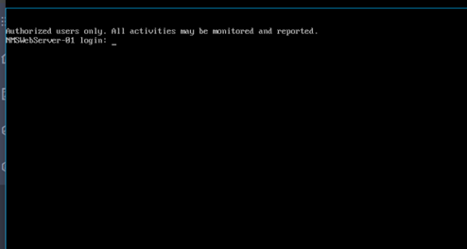
Solution
On the FusionCompute web client, search for the IP address of the faulty node, forcibly restart the faulty node on the VM page of the faulty node, and continue the upgrade.

How Do I Deploy EasySuite on the Backend?

In a DR scenario, you need to perform operations in this section only in the primary cluster.
Procedure
- For details about how to find the OMP_01 node, see 10.2 How Can I Find an OMP Node of the Management Plane?.
- For details about how to upload files using FileZilla, see 10.8 How Do I Use FileZilla to Transfer Files by SFTP?.
- Use FileZilla to upload the EasySuite installation package EasySuite_{version}_OM_linux-***.zip to the /tmp directory on the OMP_01 node of the secondary cluster as the sopuser user.
If you cannot log in to the OMP_01 node using the internal communication IP address, use the service communication plane IP address of the OMP_01 node for login.
            - Log in to the OMP_01 node of the secondary cluster as the sopuser user and run the following commands to install the upgrade tool:
su - root
Enter the password for the root user.
- Run the following command if servers use the x86 architecture:
cd /tmp;unzip -qo /tmp/EasySuite_*_OM_linux-x86-64.zip deploy_es_om.sh -d /opt/;bash /opt/deploy_es_om.sh EasySuite_*_OM_linux-x86-64.zip
- Run the following command if servers use the aarch64 architecture:
cd /tmp;unzip -qo /tmp/EasySuite_*_OM_linux-aarch64.zip deploy_es_om.sh -d /opt/;bash /opt/deploy_es_om.sh EasySuite_*_OM_linux-aarch64.zip
If the following information is displayed, the upgrade tool is started successfully. You can log in to the upgrade tool using the link displayed in the command output.
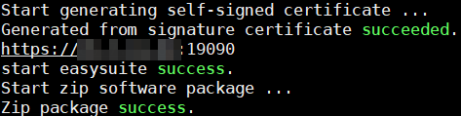
Run the exit command to log out the root user.
            - Open a browser, enter https://IP address in the command output in Step 2:19090 in the address box, and press Enter to access the login page of the upgrade tool.
            - Enter a username and password, and click Log In.
- Username: The preset username is esadmin.
- Password: If you have used EasySuite to upgrade the system from an earlier version to the target version, enter the new password you set for login.
- The preset password is Changeme_123. Change the password upon your first login. For security purposes, change the password periodically and keep it secure.
- If you forget the password for the esadmin user of EasySuite, see section "Retrieving the EasySuite Login Password During iMaster NCE-Campus Upgrade" under Maintenance and Troubleshooting > NCE&Solution Troubleshooting Guide > Common Troubleshooting Cases > Login Failures in the CloudCampus Solution Version & iMaster NCE-Campus Version Product Documentation.
----End

What Do I Do If a Message Indicating an Unfinished Upgrade Task Is Displayed When I Set Upgrade Parameters?
- Log in to the management plane as the admin user and choose Product > Project Management > Upgrade Tool from the main menu.
            - Click Roll Back, select the check box in the displayed dialog box, and click Yes to perform a rollback.
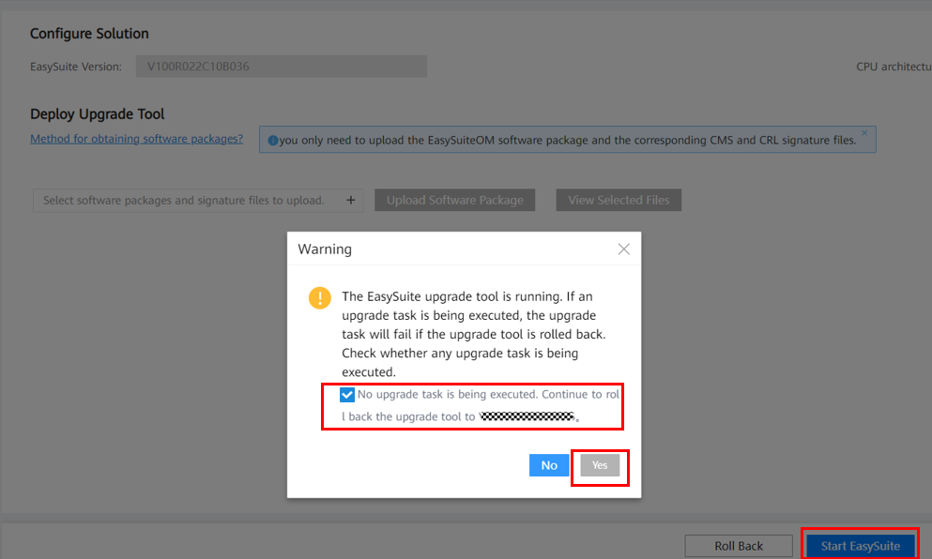
            - After the rollback is complete, click Start EasySuite.
            - After EasySuite is started, find the previous upgrade task and click in the row of upgrade confirm in the lower right corner.
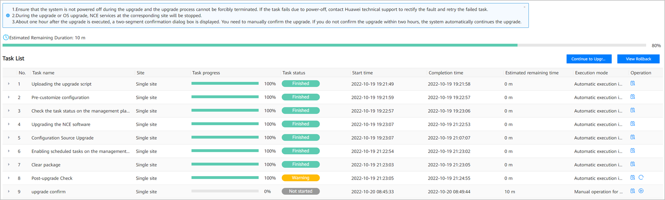
            - After the operation succeeds, click Finish in the lower right corner.
            - Log in to the OMP_01 node as the sopuser user and run the following commands to stop EasySuite.
For details about how to find the OMP_01 node, see 10.2 How Can I Find an OMP Node of the Management Plane?.
su - ossadm
sh /opt/oss/easysuite/easysuite/stop.sh
            - Go to 3.8 Logging In to the Upgrade Tool and upgrade the controller again.
----End

What Do I Do If Software Packages Fail to Be Verified on the Upgrade Tool?
Log in to the OMP_02 node as the sopuser user and run the following command. For details about how to find the OMP_02 node of the management plane, see 10.2 How Can I Find an OMP Node of the Management Plane?.
su - root su - ossadm -c "mkdir -p /opt/oss/easysuite/easysuite/var/software"

How Do I Use a Third-Party Tool to Upload Software Packages to the Server?
Question
How do I use a third-party tool to upload software packages to the server?
Answer
- Use PuTTY to log in to the OMP_01 node as the sopuser user in SSH mode and run the following commands to create a directory (/opt/upgrade is used as an example) to which the patch package is to be uploaded.
> su - root
Password: password for the root user
# cd /opt/
# mkdir -p upgrade
# chown ossadm:$(id -gn sopuser 2>/dev/null || echo ossgroup) /opt/upgrade
# id sopuser &>/dev/null && setfacl -m u:sopuser:rwx /opt/upgrade
# chmod 770 upgrade/
# exit
            - Upload the software package to the /opt/upgrade directory. For details, see 10.8 How Do I Use FileZilla to Transfer Files by SFTP?.
----End

How Do I Inspect Trust Certificates of Authentication Components and Rectify Problems
Operations in this section are not required in the following scenarios:
- iMaster NCE-Campus is not interconnected with an authentication component.
- iMaster NCE-Campus has been interconnected with an authentication component and their connection is normal.
- You have replaced the certificates related to the authentication component with applied certificates.
Symptom
On the Authentication Component Management page, an authentication component status is displayed as Offline.
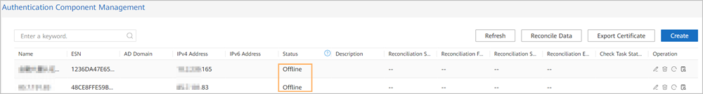
Possible Causes
The trust certificate of the authentication component is lost.
Troubleshooting Procedure
Steps 1 and 2 aim to check whether iMaster NCE-Campus uses default certificates and provide guidance for handling trust certificate loss.
- Check whether a trust certificate exists on the certificate management page.
- Log in to iMaster NCE-Campus as the system administrator, choose System > Security Management > Certificate Management, and click the Service Certificate Management tab.
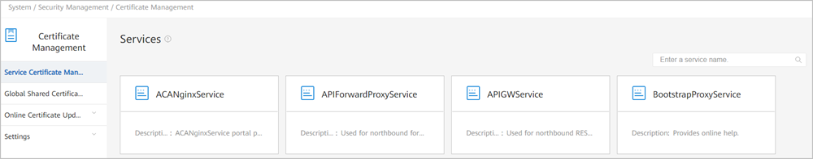
- Select the service card corresponding to IAEService.
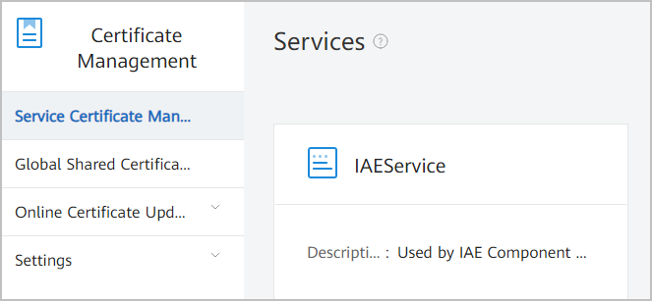
- Click the Trust Certificate tab and check whether a trust certificate exists.
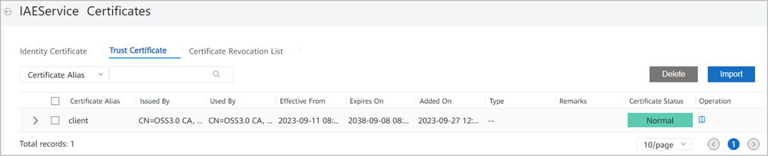
- If a trust certificate exists, no further action is required. If no trust certificate is available, go to the Identity Certificate page, expand the certificate information, and check the identity certificate's issuer.
If the issuer is OSS3.0, go to Step 2 to restore the default certificate.
If the issuer is not OSS3.0, the certificate has been replaced. In this case, you need to replace the certificate by yourself. Otherwise, the authentication component cannot connect to iMaster NCE-Campus at the headquarters. If emergency recovery is required onsite, go to Step 3 to restore all default certificates.
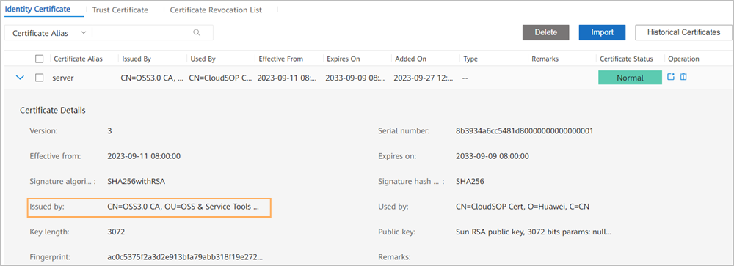
            - Restore the default trust certificate.
- Decrypt the certificate password.
  - View the content of the /opt/oss/NCECAMPUS/etc/ssl/common_cert/cert_pwd file.
Log in to the primary iMaster NCE-Campus node as the sopuser user and run the following commands:
# su - root
Password:
# more /opt/oss/NCECAMPUS/etc/ssl/common_cert/cert_pwd
The command output is as follows.
Then run the following commands:
# su ossadm
# . /opt/oss/manager/bin/engr_profile.sh
# python
# from util import ossext
# ossext.Cipher.decrypt ("output of the more command ")
# exit
- Download the trust certificate file to a local directory.
Use a download tool to download the trust.jks file from the /opt/oss/NCECAMPUS/etc/ssl/common_cert/ folder on the OMP_01 node of iMaster NCE-Campus to a local directory.
- Upload the trust certificate to iMaster NCE-Campus.
Repeat Step 1.1, Step 1.2, and Step 1.3 to access the IAEService certificate card page, click the Trust Certificate tab, and import the certificate file trust.jks downloaded in Step 2.2.
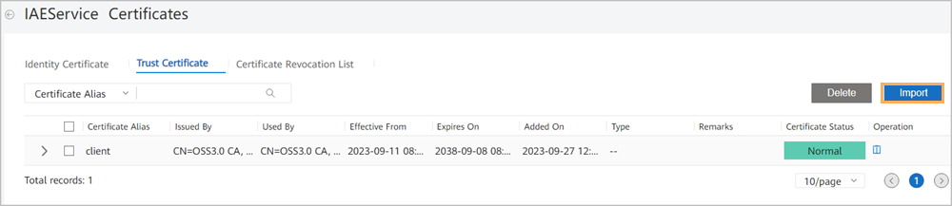
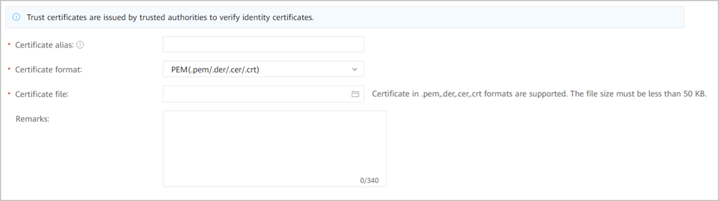
Certificate alias: Set this parameter based on the site requirements. Ensure that the value is unique.
Certificate format: Select JKS (.jks).
Certificate file: Select the certificate file downloaded in Step 2.2.
Certificate password: Enter the decrypted content in Step 2.1.
After filling in the preceding information, click Submit. After the operation is successful, the imported certificate is displayed on the Trust Certificate page.
            - Restore all default certificates.
Step 3 is applicable when you do not have a certificate, iMaster NCE-Campus cannot connect to the authentication component, and certificate restoration is required. In this step, the certificates related to the authentication component are replaced with default certificates of iMaster NCE-Campus.
- Decrypt the certificate password.
  - View the content of the /opt/oss/NCECAMPUS/etc/ssl/common_cert/cert_pwd file.
Log in to the primary iMaster NCE-Campus node as the sopuser user and run the following commands:
# su - root
Password:
# more /opt/oss/NCECAMPUS/etc/ssl/common_cert/cert_pwd
The command output is as follows.
Then run the following commands:
# su ossadm
# . /opt/oss/manager/bin/engr_profile.sh
# python
# from util import ossext
# ossext.Cipher.decrypt ("output of the more command ")
# exit
- Download certificate files to a local directory.
Use a download tool to download the server.jks and trust.jks files from the /opt/oss/NCECAMPUS/etc/ssl/common_cert folder on the OMP_01 node of iMaster NCE-Campus to a local directory.
- Upload the identity certificate to iMaster NCE-Campus.
Repeat Step 1.1, Step 1.2, and Step 1.3 to access the IAEService certificate card page, click the Identity Certificate tab, and import the certificate file server.jks downloaded in Step 3.2.
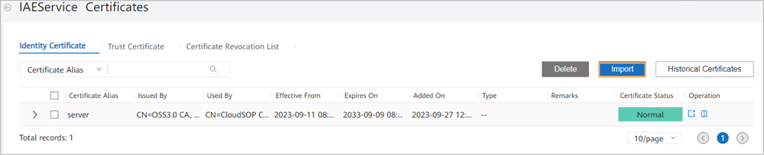
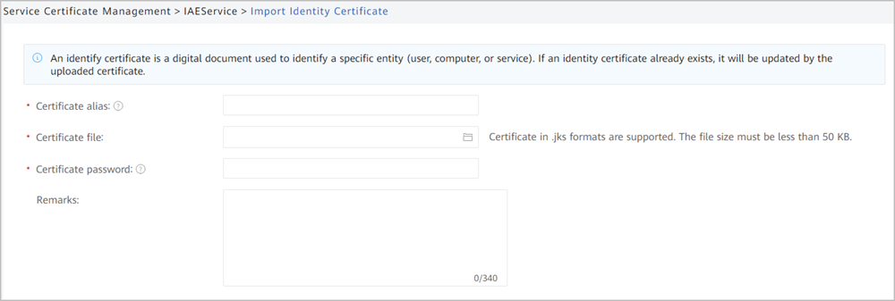
Certificate alias: Enter a name that can identify the certificate based on the site requirements.
Certificate file: Select the server.jks file downloaded in Step 3.2.
Certificate password: Enter the plaintext decoded in Step 3.1.
- Upload the trust certificate to iMaster NCE-Campus.
Repeat Step 1.1, Step 1.2, and Step 1.3 to access the IAEService certificate card page, click the Trust Certificate tab, and import the certificate file trust.jks downloaded in Step 3.2.
Certificate alias: Set this parameter based on the site requirements. Ensure that the value is unique.
Certificate format: Select JKS (.jks).
Certificate file: Select the trust.jks file downloaded in Step 3.2.
Certificate password: Enter the plaintext decoded in Step 3.1.
After filling in the preceding information, click Submit. After the operation is successful, the imported certificate is displayed on the Trust Certificate page.
- Overwrite iMaster NCE-Campus files and restart background services.
Perform this step on each iMaster NCE-Campus node.
In the local directory, rename the server.jks file downloaded in Step 3.2 to sc-kstore.jks and the trust.jks file to sc-tstore.jks.
  - Upload the certificate files.
Upload the sc-kstore.jks and sc-tstore.jks files to the following directory of iMaster NCE-Campus:
/opt/oss/envs/Product-CampusAccountService/{version}/controller/configuration/iae/client
If a node does not have the /opt/oss/envs/Product-CampusAccountService/{version}/controller/configuration/iae/client directory, skip steps Step 3.5.b and Step 3.5.c.
  - Modify the configuration file.
Run the vi command to modify the /opt/oss/envs/Product-CampusAccountService/{version}/controller/configuration/iae/client/sc.properties file on the iMaster NCE-Campus node.
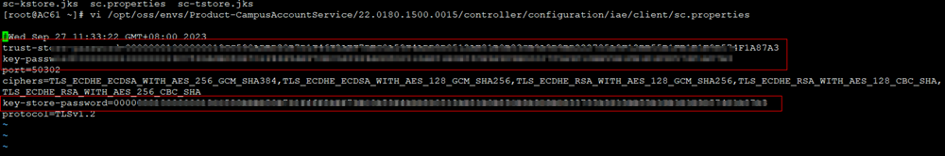
Change the values following the equal signs (=) of the trust-store-password, key-password and key-store-password attributes to the cert_pwd ciphertext obtained in Step 3.1. Save the modification and exit.
  - Restart services.
Run the su - ossadm -c "bash /opt/oss/manager/agent/bin/ipmc_adm -cmd restartapp -app CampusAccountService" command as the root user.
- Export the trust certificate from iMaster NCE-Campus and import the trust certificate to the authentication component.
  - Export the trust certificate from iMaster NCE-Campus.
- Log in to iMaster NCE-Campus as a tenant administrator, choose System > System Management > Authentication Component, go to the Authentication Component Management page, and export the certificate.
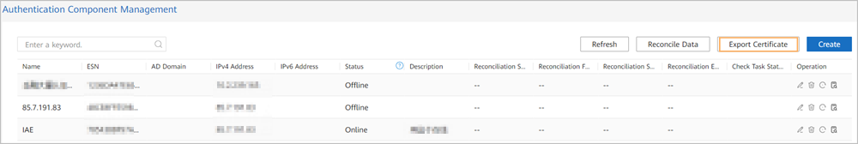
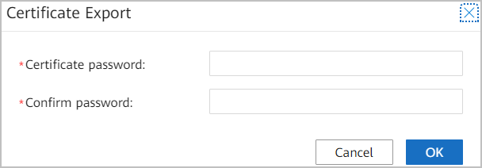
Set the certificate password based on the actual situation.
- Click OK and save the file to the local PC.
  - Import the trust certificate to the authentication component.
- Log in to the management plane of the authentication component as the admin user and choose Commissioning > Service Controller > Connection Management from the main menu.
- Click Import to import the trust certificate.
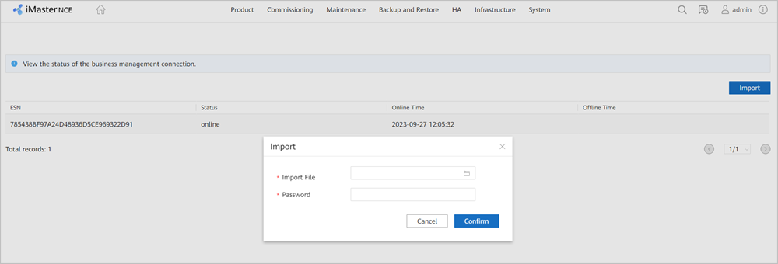
Import File: Select the compressed package exported in Step 3.6.a.
Password: Enter the password you set when exporting the trust certificate in Step 3.6.a.
----End

How Do I Enable Scheduled Backup Tasks on the Management Plane?
This section describes how to enable a default scheduled backup task.
Precautions
In a DR scenario, perform the following operations at both primary and secondary sites.
Procedure
- Log in to the management plane.
            - Choose Backup and Restore > Configuration > Configure Scheduled Backup Task from the main menu.
            - Check whether scheduled backup tasks are enabled. If not, enable them.
- If multiple scheduled backup tasks have been disabled before the patch installation, enable all of them.
- If a task is already in the disabled state before the patch installation, keep the task disabled.
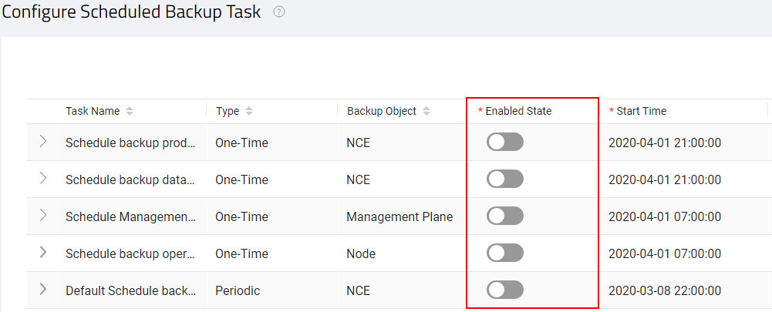
----End

How Do I Handle Health Check Errors?
Question
What should I do if information similar to the following is displayed on the pre-upgrade evaluation page?
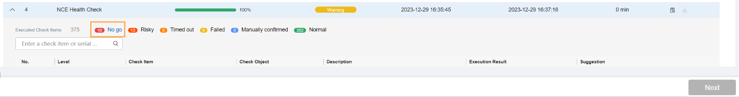
Procedure
Rectify the fault based on the handling suggestions for inspection items on the pre-upgrade evaluation tab page.
- If the fault is rectified, no further action is required.
- If the fault persists, perform the following operations after confirmation with Huawei engineers:
  - Record the IP address of the node where EasySuite is installed and the task_id information.
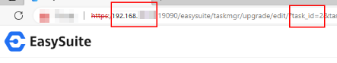
  - Log in to the node where EasySuite is installed as the sopuser user using the node's IP address, and run the su - ossadm command to switch to the ossadm user. Then run the following command:
# cd /opt/oss/easysuite/easysuite/easysuite/plugins/common/NCE-Common/upgrade_online/website/scripts/tools
# bash skip_dfs_nogo.sh -task_id number following task_id in step 1
If the following information is displayed, the operation is successful.
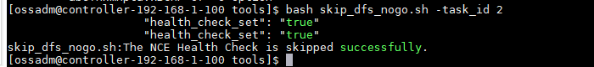
  - Refresh the EasySuite upgrade tool page.

How Do I Start or Stop the EasySuite Process?
Question
How do I start or stop the EasySuite process?
Answer
- Log in to the OMP_01 node as the sopuser user in SSH mode. For details, see 10.9 How Do I Use PuTTY to Log In to a Server?.
> su - ossadm
Password: password for the ossadm user
            - Run the following command to open the EasySuite deployment directory:
> cd /opt/oss/easysuite/easysuite
If the directory does not exist, perform operations in 10.18 How Do I Deploy EasySuite on the Backend? If the directory exists, EasySuite has been deployed on the management node. Go to the next step.
            - Run the following command to start the EasySuite process:
> bash start.sh
The command output is as follows:
Starting, please wait...
Start unzip osconfig and sudosconfig package ...
unzip osconfig and sudoconfig package succeeded.
Start loading Solution package ...
Generated from signature certificate succeeded.
https://10.118.178.90:19090
start easysuite success.
Start zip software package ...
Zip package success.
If the preceding information is displayed, the EasySuite process is successfully started. If other information is displayed, contact Huawei technical support.
            - To stop the EasySuite process, run the following command:
> bash stop.sh
The command output is as follows:
kill pid 8988
stop easysuite success.
If the preceding information is displayed, the EasySuite process is successfully stopped. If other information is displayed, contact Huawei technical support.
----End

How Do I Back up the Device Security Configuration Check Report?
Context
The controller of an earlier version has been installed with the HiSec advanced feature and needs to be upgraded to V300R023C00SPC100. After the upgrade, the advanced security feature data related to HiSec is not affected, but the database for device security configuration check will be cleared. To prevent data loss in the upgrade, you need to manually back up the device security configuration check result on the GUI.
Procedure
- Log in to the service plane as a tenant administrator and choose Network Maintenance > Device Maintenance > Device Security Configuration Check from the main menu.
            - Export check results.
- To export the check results of some devices, select the target devices and click Export in the upper right corner.
- To export the check results of the devices on the current page, click Export in the upper right corner.
----End

