iMaster NCE-Campus
V300R023C00
 | Upgrade Guide
 | Issue | 01
 | Date | 2023-09-30

 | HUAWEI TECHNOLOGIES CO., LTD. |  | 

Copyright © Huawei Technologies Co., Ltd. 2023. All rights reserved.
No part of this document may be reproduced or transmitted in any form or by any means without prior written consent of Huawei Technologies Co., Ltd.

Trademarks and Permissions
and other Huawei trademarks are trademarks of Huawei Technologies Co., Ltd.
All other trademarks and trade names mentioned in this document are the property of their respective holders.

Notice
The purchased products, services and features are stipulated by the contract made between Huawei and the customer. All or part of the products, services and features described in this document may not be within the purchase scope or the usage scope. Unless otherwise specified in the contract, all statements, information, and recommendations in this document are provided "AS IS" without warranties, guarantees or representations of any kind, either express or implied.
The information in this document is subject to change without notice. Every effort has been made in the preparation of this document to ensure accuracy of the contents, but all statements, information, and recommendations in this document do not constitute a warranty of any kind, express or implied.

Huawei Technologies Co., Ltd.
Address: | Huawei Industrial Base  Bantian, Longgang  Shenzhen 518129  People's Republic of China
Website: | https://www.huawei.com
Email: | support@huawei.com

Security Declaration
Vulnerability
Huawei's regulations on product vulnerability management are subject to "Vul. Response Process". For details about the policy, see the following website:
https://www.huawei.com/en/psirt/vul-response-process
For enterprise customers who need to obtain vulnerability information, visit:
https://securitybulletin.huawei.com/enterprise/en/security-advisory

Contents
1 Before You Start 1
1.1 Upgrade Scheme 1
1.2 Version Requirements 2
1.3 Upgrade Impact 3
1.3.1 Impact on the System During the Upgrade 3
1.3.2 Impact on the System After the Upgrade 3
1.3.3 Impact on Spare Parts 3
1.4 Precautions 4
2 Upgrade Process 5
3 Upgrade Preparations 8
3.1 Collecting Information 9
3.2 (Optional) Upgrading FusionCompute 10
3.3 Checking Whether the License Has Expired 11
3.4 Obtaining Required Upgrade Software and Tools 11
3.4.1 (Recommended) Downloading Software Packages Using EasyGet 11
3.4.2 Manually Downloading Software Packages 13
3.4.3 Downloading Tool Packages 21
3.5 Checking Port Changes 22
3.6 Performing a Health Check 22
3.7 Checking Whether Automatic DR Switchover Is Configured 24
3.8 Deleting the DR System 24
3.8.1 Deleting the Controller DR System 24
3.9 Logging In to the Upgrade Tool 25
3.10 Uploading Software Packages 27
4 Upgrade Solution A (Recommended) 28
4.1 Disabling Services 28
4.1.1 Disabling Services in the Secondary Cluster 28
4.1.2 Disabling Services in the Primary Cluster 29
4.2 Evaluating the Upgrade 30
4.3 Upgrading the Secondary Cluster 31
4.3.1 Upgrading the Secondary Cluster 31
4.4 Enabling Services of the Secondary Cluster 33
4.5 Evaluating the Upgrade 33
4.6 Upgrading the Primary Cluster 35
4.6.1 Upgrading the Primary Cluster 35
4.7 (Optional) Upgrading the Arbitration Node 37
4.8 Creating a DR System 38
4.8.1 Creating a New DR System 38
4.8.1.1 Single-Node Scenario (Automatic Switchover) 39
4.8.1.1.1 Configuring a DR System 39
4.8.1.1.2 (Optional) Synchronizing Historical HBase DR Data 43
4.8.1.2 Single-Node Scenario (Manual Switchover) 44
4.8.1.2.1 Configuring a DR System 44
4.8.1.2.2 (Optional) Synchronizing Historical HBase DR Data 47
4.8.1.3 Cluster Scenario (Automatic Switchover) 48
4.8.1.3.1 Configuring a DR System 48
4.8.1.3.2 (Optional) Synchronizing Historical HBase DR Data 52
4.8.1.4 Cluster Scenario (Manual Switchover) 52
4.8.1.4.1 Configuring a DR System 52
4.8.1.4.2 (Optional) Synchronizing Historical HBase DR Data 56
4.9 (Optional) Performing a DR Switchover 57
5 Upgrade Solution B 58
5.1 Disabling Services of the Secondary Cluster 58
5.2 Evaluating the Upgrade 59
5.3 Upgrading the Primary Cluster 61
5.3.1 Upgrading the Primary Cluster 61
5.4 Evaluating the Upgrade 62
5.5 Upgrading the Secondary Cluster 64
5.5.1 Upgrading the Secondary Cluster 64
5.6 (Optional) Upgrading the Arbitration Node 66
5.7 Creating a DR System 67
5.7.1 Creating a DR System 67
6 Post-upgrade Check 69
6.1 Checking the Southbound Access Configuration 69
7 Version Rollback 71
7.1 Rolling Back the Primary Cluster 71
7.2 Rolling Back the Secondary Cluster 72
7.3 Building a New DR System 73
8 FAQ 74
8.1 Residual Temporary Directory in HDFS 75
8.2 How Can I Find an OMP Node of the Management Plane? 76
8.3 How Do I Check Whether the SecoManager Is Installed? 77
8.4 How Do I Reset the Password for Logging In to the FusionInsight Upgrade Tool? 78
8.5 How Do I Check Whether the Source IP Address Feature Patch Has Been Installed? 79
8.6 How Do I Check Whether a Wireless Non-operating Plug-in Has Been Installed? 80
8.7 How Do I Check Whether the Nmap Feature Has Been Installed? 81
8.8 Checking Communication Matrix Changes 82
8.9 How Do I Use FileZilla to Transfer Files by SFTP? 110
8.10 How Do I Use PuTTY to Log In to a Server? 112
8.11 What Can I Do If the HUAWEI-ROUTER-SYSTEMSND Package Fails to Be Activated? 114
8.12 Checking RPM Packages of the SUSE OS 115
8.13 How Do I Check the SAC Configuration? 116
8.14 How Do I Delete Consumer Groups L2topoDiscovery and campus_alarm_notification? 118
8.15 How Do I Check Whether the Situational Awareness, SRv6, or Remote Attestation Feature Has Been Installed in an Environment? 119
8.16 How Do I Reset the Passwords of OS Users ossadm, sopuser, and ftpuser? 120
8.17 How Do I Reset the Passwords for the ossadm and sopuser Users of the Arbitration Node at the Third-Party Site? 120
8.18 What Do I Do If the OS Is Suspended During the Upgrade? 121
8.19 Deploying EasySuite on the Backend 122
8.20 What Do I Do If a Message Indicating an Unfinished Upgrade Task Is Displayed When I Set Upgrade Parameters? 123
8.21 What Do I Do If Software Packages Fail to Be Verified on the Upgrade Tool? 124
8.22 How Do I Use a Third-Party Tool to Upload Software Packages to the Server? 124
8.23 How Do I Inspect Trust Certificates of Authentication Components and Rectify Problems 125

Before You Start

In this document, each content in blue is a hyperlink. You can hold down Ctrl and click the content in blue to access the corresponding web page or topic.
1.1 Upgrade Scheme
1.2 Version Requirements
1.3 Upgrade Impact
1.4 Precautions

Upgrade Scheme
- In this iMaster NCE-Campus upgrade, the controller and OS (EulerOS or Huawei-delivered SUSE OS) are upgraded concurrently. If the customer has prepared an SUSE OS by themselves, upgrade the OS to SUSE 12 SP5 by referring to the corresponding guide listed in the following table, and then upgrade iMaster NCE-Campus.
                - Controller version requirements
Source Version | Upgrade Description
iMaster NCE-Campus V300R022C00SPC100  iMaster NCE-Campus V300R022C00SPC101  iMaster NCE-Campus V300R022C00SPC102  iMaster NCE-Campus V300R022C00SPC120 | Upgrade the OS by referring to iMaster NCE-Campus V300R023C00 SUSE 12SP5 OS Upgrade Guide (SUSE 12SP2, SUSE 12SP4).
iMaster NCE-Campus V300R022C00SPC130  iMaster NCE-Campus V300R022C00SPC150  iMaster NCE-Campus V300R022C00SPC151 | Upgrade the OS by referring to iMaster NCE-Campus V300R022C00SPC130 SUSE 12SP5 OS Upgrade Guide (SUSE 12SP2, SUSE 12SP4).

- If an authentication component is involved, you must upgrade the authentication component before upgrading iMaster NCE-Campus.
- If iMaster NCE-Campus fails to be upgraded and is rolled back, you do not need to roll back the authentication component. (In this case, the data synchronization channel between iMaster NCE-Campus and the authentication component is disconnected, and the access authentication policies changed on iMaster NCE-Campus cannot be synchronized to the authentication component. These policies will be automatically synchronized to the authentication component after iMaster NCE-Campus re-upgrade succeeds.)
- This document provides solutions A and B for the DR upgrade. Select a solution as required.
Solution A (recommended):
- Upgrade the secondary cluster first and then the primary cluster. If the secondary cluster fails to be upgraded, you can still start the primary cluster to ensure service continuity. This delivers relatively high reliability.
- During the upgrade of the secondary cluster, services in the primary cluster are interrupted for 2 hours. This solution is recommended in scenarios that are not sensitive to the upgrade interruption duration.
- After the upgrade, configure the original secondary cluster as the primary cluster, and set the data replication direction to Secondary cluster before the upgrade -> Primary cluster before the upgrade.
- If you want the clusters to retain the original DR roles, perform an active/standby switchover after creating a DR system.
Solution B:
- Upgrade the primary cluster first and then the secondary cluster. If the primary cluster fails to be upgraded, perform operations in 4.1.2 Disabling Services in the Primary Cluster and then in 4.4 Enabling Services of the Secondary Cluster.
- Throughout the entire upgrade process, the secondary cluster does not take over services and services in the primary cluster are interrupted for about 45 minutes.
- After the upgrade is complete, configure the clusters to retain the original DR roles when creating a DR system and set the data replication direction to Primary cluster before the upgrade -> Secondary cluster before the upgrade.

Version Requirements
                - Version requirements
Version | Description
iMaster NCE-Campus V300R022C00SPC100  iMaster NCE-Campus V300R022C00SPC101  iMaster NCE-Campus V300R022C00SPC102  iMaster NCE-Campus V300R022C00SPC120  iMaster NCE-Campus V300R022C00CP1201  iMaster NCE-Campus V300R022C00SPC130  iMaster NCE-Campus V300R022C00SPC150  iMaster NCE-Campus V300R022C00SPC151 | It can be upgraded to iMaster NCE-Campus V300R023C00.

Upgrade Impact

Impact on the System During the Upgrade
Impact on Services
iMaster NCE-Campus services will be interrupted during the upgrade. For details about the interruption duration, log in to the Huawei technical support website and check the corresponding specification.
- For enterprise users:
  - Log in to https://info.support.huawei.com/info-finder/search-center/en/enterprise/network-management-and-analysis-software/imaster-nce-campus-pid-250852420.
  - Click Specifications Query and select the target version from the Version drop-down list box.
  - Search for Upgrade Interruption Duration to view the detailed specification.
- For carrier users:
  - Log in to https://info.support.huawei.com/info-finder/search-center/en/carrier/network-management-and-analysis-software/imaster-nce-campus-pid-250852420.
  - Click Specifications Query and select the target version from the Version drop-down list box.
  - Search for Upgrade Interruption Duration to view the detailed specification.

Impact on the System After the Upgrade
None

Impact on Spare Parts
None

Precautions
- During the upgrade and rollback, forbid concurrent operations by multiple users on the server. Otherwise, the upgrade or rollback may fail.
- During the upgrade, do not perform any operation on the management node. Otherwise, the upgrade will fail.
- After an upgrade task is created, incremental deployment or capacity expansion cannot be performed. If incremental deployment or capacity expansion has been performed, create an upgrade task.
- During the upgrade, do not open multiple pages on EasySuite to repeat the upgrade task. Otherwise, the page may be displayed abnormally (for example, showing that the task fails). This is a display exception and can be resolved by refreshing the pages.
- Ensure that you have performed the operations in 3.9 Logging In to the Upgrade Tool before uploading the EasySuiteSolution-Campus_{version}_ESSolution_XXX.zip software package on EasySuite. Otherwise, the upgrade may fail.
- If iMaster NCE-Campus is upgraded from an earlier version to V300R023C00 or a later version, check the SAC configuration by referring to 8.13 How Do I Check the SAC Configuration?.
- If the upgrade fails, you can only retry or roll back the upgrade. Other operations are not allowed.
- You are advised to perform the upgrade during off-peak hours during which a few terminals are connected.
- During the upgrade or rollback, ensure that the network between management plane nodes and service plane nodes is normal. Do not restart any node, because the restart may cause upgrade or rollback failures.
- If feature expansion has been performed after the upgrade, version rollback is not supported.
- If the upgraded cluster has set up a DR system with a newly installed cluster, version rollback is not supported.
Huawei and its subsidiaries do not assume any liability for maintenance issues and commercial legal issues that are the result of customer's purchase of non-matching software versions, or failure to proactively upgrade the software version based on the new software version released on the Huawei official website or other channels, with such actions causing the arrival of software EOM, EOFS, or EOS to be earlier than that of the product. When upgrading iMaster NCE-Campus, customers are advised to pay attention to the latest software version information from channels such as the Huawei official website and upgrade the software to the required version.

Upgrade Process
              - Upgrade flowchart for solution A
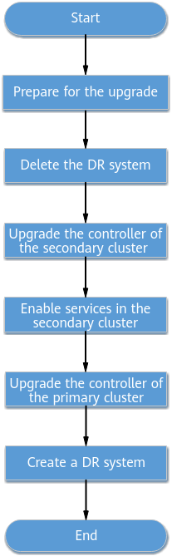
              - Upgrade flowchart for solution B
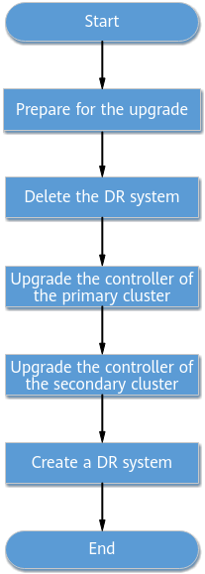

                - Estimated upgrade schedule
Step | Recommended Start Time | Time Required
Preparing for the upgrade | One day before the upgrade | About 130 minutes
Upgrading the controller | Based on customer requirements | Less than 120 minutes

The time required for each step is for reference only. The actual duration depends on onsite conditions.

Upgrade Preparations
- The time required is affected by many factors, such as the onsite data volume and server performance.
- The Check Result column must be filled by onsite upgrade personnel.
Recommended Start Time | Preparation | Description | Check Result | Time Required
One day before the upgrade | 3.1 Collecting Information | Collect the environment information required for the upgrade. |  | 10 minutes
One day before the upgrade | 3.4 Obtaining Required Upgrade Software and Tools | Download tools and software packages. |  | 20 minutes
One day before the upgrade | 3.9 Logging In to the Upgrade Tool | Log in to EasySuite of the online version. |  | 20 minutes
One day before the upgrade | 4 Upgrade Solution A (Recommended) | Prepare for the upgrade of the secondary cluster using EasySuite. |  | 60 minutes
One day before the upgrade | 5 Upgrade Solution B | Prepare for the upgrade of the primary cluster using EasySuite. |  | 60 minutes

3.1 Collecting Information
3.2 (Optional) Upgrading FusionCompute
3.3 Checking Whether the License Has Expired
3.4 Obtaining Required Upgrade Software and Tools
3.5 Checking Port Changes
3.6 Performing a Health Check
3.7 Checking Whether Automatic DR Switchover Is Configured
3.8 Deleting the DR System
3.9 Logging In to the Upgrade Tool
3.10 Uploading Software Packages

Collecting Information
Obtaining IP Addresses and Passwords
To ensure successful upgrade, collect the information listed in the following table before the upgrade.
Item | Actual Value | Description
IP address of the iMaster NCE-Campus management plane and password of the admin user | - | -
IP address of the iMaster NCE-Campus service plane and password of the admin user | - | -
IP addresses of all iMaster NCE-Campus nodes | - | -
Passwords for the root, ossadm, sopuser, and ftpuser OS users on the iMaster NCE-Campus management node | - | If you forget the password of an OS user, reset the password according to 8.16 How Do I Reset the Passwords of OS Users ossadm, sopuser, and ftpuser?.
Preset username and password for logging in to EasySuite | - | If you forget the password, see section "Retrieving the EasySuite Login Password During iMaster NCE-Campus Upgrade" under Maintenance and Troubleshooting > NCE&Solution Troubleshooting Guide > Common Troubleshooting Cases > Login Failures in the CloudCampus Solution V100R023C00 & iMaster NCE-Campus V300R023C00 Product Documentation.
Passwords of the root and omm users for logging in to FusionInsight nodes | - | -
IP address of the FusionInsight management plane and password of the admin user | - | -
Passwords for the sopuser, ossadm, and root users for logging in to the arbitration node at the third-party site | - | If you forget a user password of the arbitration node at the third-party site, reset the password according to 8.17 How Do I Reset the Passwords for the ossadm and sopuser Users of the Arbitration Node at the Third-Party Site?.
Port | 19090: port used by users to log in to EasySuite | To use the specified port for communication, you need to enable the network port between the PC and the OMP_01 node. For details about how to check the IP address of the OMP_01 node, see 8.2 How Can I Find an OMP Node of the Management Plane?.
Supported web browsers | - | Web browsers:  - Google Chrome 94 or later  - Firefox 80 or later  - Microsoft Edge 94 or later (64-bit)

(Optional) Upgrading FusionCompute


In the address box of a browser, enter https://VRM floating IP address:8443, enter the administrator's username and password, click Log In, and choose Help > About to check the FusionCompute version. If the version is FusionCompute 8.5.0 or later, skip this section. If the version is FusionCompute 8.2.0, upgrade it to FusionCompute 8.5.0 and then upgrade the controller.
For a distributed cluster, upgrade FusionCompute to 8.5.0. For details, see the iMaster NCE-Campus FusionCompute 8.5.0 Upgrade Guide (for enterprise users) or iMaster NCE-Campus FusionCompute 8.5.0 Upgrade Guide (for carrier users).

Checking Whether the License Has Expired
- Log in to the service plane of iMaster NCE-Campus as the system administrator (with the username admin) using the port number 18008.
            - Choose System > User Management > License Management from the main menu.
            - Click the License File tab, check whether the status of the imported license file is normal, and check the value of License expiration date. If the time when you attempt to perform an upgrade is later than the value of License expiration date, the license has expired.
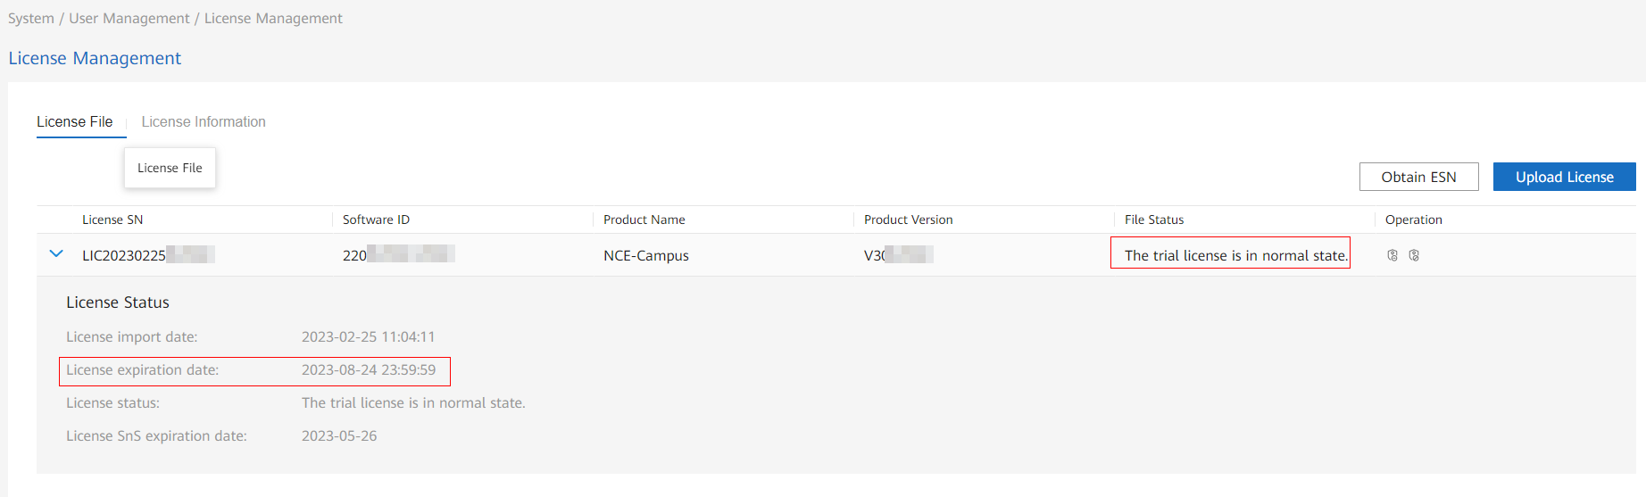
            - If File Status displays The trial license is in normal state and the license has expired, import a valid license file (a commercial license or temporary commercial license that has not expired) before the upgrade. Otherwise, the license will be suspended after the upgrade. For details, see CloudCampus Solution version & iMaster NCE-Campus version License Usage Guide (enterprise users and carrier users). The specific directories are as follows:
- Temporary license
- Commercial License > Global Perpetual License Usage Guide in the On-Premises Scenario (N1 Mode) > Fresh Deployment Scenario > iMaster NCE-Campus License Operations
- Commercial License > Global Perpetual License Usage Guide in an On-Premises Scenario (A-la-carte Mode) > Fresh Deployment Scenario > iMaster NCE-Campus License Operations
----End

Obtaining Required Upgrade Software and Tools
- Place all the software packages required for the upgrade in the same folder.
- Software package download information is available on EasyGet two days after software packages are released.

(Recommended) Downloading Software Packages Using EasyGet
- Download the EasyOps health check patch package. (This package cannot be downloaded using EasyGet. You need to download it using the following method.)
EasyOps Hot Patch | How to Obtain
EasyOps V100R022C00HP0007 | Enterprise users, Carrier users

            - Log in to EasyGet at https://info.support.huawei.com/comdev/nce_easyget/Login using a Huawei engineer account.
            - Set parameters in the Solution area and click OK to view the software packages required by the current solution.
Select a user type based on your site type.
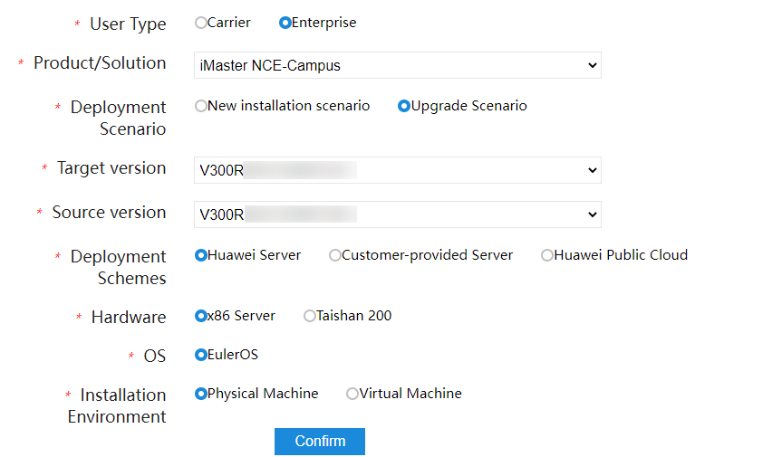
            - Apply for software packages.
- Apply for and download the iMasterNCE-Campus_V300R023C00_SecoManager_linux-x86-64.7z software package if the SecoManager has been installed. For details about how to check whether the SecoManager has been installed, see 8.3 How Do I Check Whether the SecoManager Is Installed?.
- Apply for and download the iMasterNCE-Campus_V300R023C00_NMAP-Plugin_linux-***.zip software package if the Nmap feature has been installed. For details about how to check whether the Nmap feature has been installed, see 8.7 How Do I Check Whether the Nmap Feature Has Been Installed?.
- Apply for and download the iMasterNCE-Campus_V300R023C00_AAMonitor_linux-***.zip software package if DR arbitration needs to be installed.
- Apply for and download the AppAnalysis-Plugin_V300R023C00_linux-***.zip software package if the source IP address patch has been installed. For details about how to check whether the source IP address patch has been installed, see 8.5 How Do I Check Whether the Source IP Address Feature Patch Has Been Installed?.
- Apply for and download the WIFIAudit_V300R023C00_linux-x86-64.zip software package if the wireless non-operating plug-in has been installed. For details about how to check whether the wireless non-operating plug-in has been installed, see 8.6 How Do I Check Whether a Wireless Non-operating Plug-in Has Been Installed?.
Apply for mandatory software packages. You can apply for optional software packages based on the site requirements.
- For carrier users, click Apply to apply for all required software packages.
- For enterprise users, apply for the required software packages by product.
            - After the software package application is approved, select the software packages to be downloaded on the EasyGet page and click Download. The following dialog box is displayed. Use ICS Lite to download the software packages as prompted.
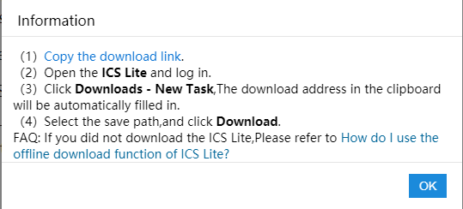
            - Download the upgrade reference documents. On the EasyGet page, click Documentation and click Download. The following dialog box is displayed. Use ICS Lite to download the documents as prompted.
----End

Manually Downloading Software Packages
- Download the EasyOps health check patch package.
EasyOps Hot Patch | How to Obtain
EasyOps V100R022C00HP0007 | Enterprise users, Carrier users

            - Contact Huawei technical support to obtain the required software packages and the corresponding .cms and .crl digital signature files as listed in Table 3-1. The software package names and versions may vary depending on the actual situation.
              - .cms and .crl signature files
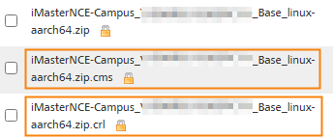

How to download the required iMaster NCE-Campus software package:
For enterprise users, access the iMaster NCE-Campus software download page, select the required version, and download the corresponding package.
For carrier users, access the iMaster NCE-Campus software download page, select the required version, and download the corresponding package.
                - Software packages to be downloaded
Type | No. | Software Package | Description
x86 | 1 | EasySuiteSolution-Campus_V300R023C00SPC800_x86-64.zip | Used to upgrade iMaster NCE-Campus deployed on x86-based servers.
x86 | 2 | EasySuite_V100R023C00SPC900_OM_linux-x86-64.zip | EasySuite package used to upgrade the controller deployed on x86-based servers.  - For enterprise users, visit the EasySuite software download website, select EasySuite V100R023C00SPC900, and download the required package.  - For carrier users, visit the EasySuite software download website, select EasySuite V100R023C00SPC900, and download the required package.
x86 | 3 | iMasterNCE-Campus_V300R023C00_AOCCore_linux-x86-64.7z | Used to upgrade iMaster NCE-Campus deployed on x86-based servers.
x86 | 4 | iMasterNCE-Campus_V300R023C00_BKSigntool_linux-x86-64_pkg.zip | Used to upgrade iMaster NCE-Campus deployed on x86-based servers.
x86 | 5 | iMasterNCE-Campus_V300R023C00_Bigdata_linux-x86-64.7z | Used to upgrade iMaster NCE-Campus deployed on x86-based servers.
x86 | 6 | iMasterNCE-Campus_V300R023C00_Campus_linux-x86-64.7z | Used to upgrade iMaster NCE-Campus deployed on x86-based servers.
x86 | 7 | iMasterNCE-Campus_V300R023C00_CloudSopService_linux-x86-64.7z | Used to upgrade iMaster NCE-Campus deployed on x86-based servers.
x86 | 8 | iMasterNCE-Campus_V300R023C00_CommonService_linux-x86-64.7z | Used to upgrade iMaster NCE-Campus deployed on x86-based servers.
x86 | 9 | iMasterNCE-Campus_V300R023C00_OMP-Extend_linux-x86-64.zip | Used to upgrade iMaster NCE-Campus deployed on x86-based servers.
x86 | 10 | iMasterNCE-Campus_V300R023C00_OMP_linux-x86-64.zip | Used to upgrade iMaster NCE-Campus deployed on x86-based servers.
x86 | 11 | iMasterNCE-Campus_V300R023C00_linux-GaussDBPatch-x86-64_pkg.tar | Used to upgrade iMaster NCE-Campus deployed on x86-based servers.
x86 | 12 | iMasterNCE-Campus_V300R023C00_ExtAdvancedSEC_linux-x86-64.7z | (Optional) If the situational awareness feature has been installed before the upgrade, download this software package. For details about how to check whether the situational awareness feature has been installed in the source environment, see 8.15 How Do I Check Whether the Situational Awareness, SRv6, or Remote Attestation Feature Has Been Installed in an Environment?.
x86 | 13 | iMasterNCE-Campus_V300R023C00_IPService_linux-x86-64.7z | (Optional) If the SRv6 feature has been installed before the upgrade, download this software package. For details about how to check whether the SRv6 feature has been installed in the source environment, see 8.15 How Do I Check Whether the Situational Awareness, SRv6, or Remote Attestation Feature Has Been Installed in an Environment?.
x86 | 14 | iMasterNCE-Campus_V300R023C00_TrustCenter_linux-x86-64.7z | (Optional) If the remote attestation feature has been installed before the upgrade, download this software package. For details about how to check whether the remote attestation feature has been installed in the source environment, see 8.15 How Do I Check Whether the Situational Awareness, SRv6, or Remote Attestation Feature Has Been Installed in an Environment?.
x86 | 15 | iMasterNCEServerInstall_V100R023C00SPC900_EulerOS2.11Patch-x86-64_pkg.tar | Used to upgrade the OS on x86-based servers.  - For enterprise users, visit the iMaster NCE Server_Install software download website, select iMaster NCE Server_Install V100R023C00SPC900, and download the required package.  - For carrier users, visit the iMaster NCE Server_Install software download website, select iMaster NCE Server_Install V100R023C00SPC900, and download the required package.
x86 | 16 | iMasterNCE-Campus_V300R023C00_SecoManager_linux-x86-64.7z | (Optional) If the SecoManager has been installed before the upgrade, download this software package. For details about how to check whether the SecoManager has been installed in the source environment, see 8.3 How Do I Check Whether the SecoManager Is Installed?.
x86 | 17 | iMasterNCE-Campus_V300R023C00_NMAP-Plugin_linux-x86-64.zip | (Optional) If the Nmap feature has been installed before the upgrade, download this software package. For details about how to check whether the Nmap feature has been installed in the source environment, see 8.7 How Do I Check Whether the Nmap Feature Has Been Installed?.
x86 | 18 | iMasterNCE-Campus_V300R023C00_OSMediation_linux-x86-64.zip | Used to upgrade the OSMediation feature on x86-based servers.
x86 | 19 | iMasterNCE-Campus_V300R023C00_AAMonitor_linux-x86-64.zip | (Optional) In a DR scenario, download this package if you need to install arbitration software.
x86 | 20 | iMasterNCE-Campus_V300R023C00_APaaSCore_linux-x86-64.7z | Used to upgrade iMaster NCE-Campus deployed on x86-based servers.
x86 | 21 | iMasterNCEServerInstall_V100R023C00{version}_OSPatchtool_EulerOS2.11-x86-64.zip | Used to upgrade the OS on x86-based servers.
 | 22 | AppAnalysis-Plugin_V300R023C00_linux-x86-64.7z | (Optional) If the source IP address feature patch has been installed before the upgrade, download this software package. For details about how to check whether the source IP address feature patch has been installed in the source environment, see 8.5 How Do I Check Whether the Source IP Address Feature Patch Has Been Installed?.  - For enterprise users:  Access the AppAnalysis-Plugin package download website using a Support account, select AppAnalysis-Plugin V300R023C00, and download the required package.
ARM | 1 | EasySuiteSolution-Campus_V300R023C00SPC800_aarch64.zip | Used to upgrade iMaster NCE-Campus deployed on ARM-based servers.
ARM | 2 | EasySuite_V100R023C00SPC900_OM_linux-aarch64.zip | EasySuite package used to upgrade the controller deployed on ARM-based servers.  - For enterprise users, visit the EasySuite software download website, select EasySuite V100R023C00SPC900, and download the required package.  - For carrier users, visit the EasySuite software download website, select EasySuite V100R023C00SPC900, and download the required package.
ARM | 3 | iMasterNCE-Campus_V300R023C00_AOCCore_linux-aarch64.7z | Used to upgrade iMaster NCE-Campus deployed on ARM-based servers.
ARM | 4 | iMasterNCE-Campus_V300R023C00_BKSigntool_linux-aarch64_pkg.zip | Used to upgrade iMaster NCE-Campus deployed on ARM-based servers.
ARM | 5 | iMasterNCE-Campus_V300R023C00_Bigdata_linux-aarch64.7z | Used to upgrade iMaster NCE-Campus deployed on ARM-based servers.
ARM | 6 | iMasterNCE-Campus_V300R023C00_Campus_linux-aarch64.7z | Used to upgrade iMaster NCE-Campus deployed on ARM-based servers.
ARM | 7 | iMasterNCE-Campus_V300R023C00_CloudSopService_linux-aarch64.7z | Used to upgrade iMaster NCE-Campus deployed on ARM-based servers.
ARM | 8 | iMasterNCE-Campus_V300R023C00_CommonService_linux-aarch64.7z | Used to upgrade iMaster NCE-Campus deployed on ARM-based servers.
ARM | 9 | iMasterNCE-Campus_V300R023C00_OMP-Extend_linux-aarch64.zip | Used to upgrade iMaster NCE-Campus deployed on ARM-based servers.
ARM | 10 | iMasterNCE-Campus_V300R023C00_OMP_linux-aarch64.zip | Used to upgrade iMaster NCE-Campus deployed on ARM-based servers.
ARM | 11 | iMasterNCE-Campus_V300R023C00_linux-GaussDBPatch-aarch64_pkg.tar | Used to upgrade iMaster NCE-Campus deployed on ARM-based servers.
ARM | 12 | iMasterNCE-Campus_V300R023C00_ExtAdvancedSEC_linux-aarch64.7z | (Optional) If the situational awareness feature has been installed before the upgrade, download this software package. For details about how to check whether the situational awareness feature has been installed in the source environment, see 8.15 How Do I Check Whether the Situational Awareness, SRv6, or Remote Attestation Feature Has Been Installed in an Environment?.
ARM | 13 | iMasterNCE-Campus_V300R023C00_IPService_linux-aarch64.7z | (Optional) If the SRv6 feature has been installed before the upgrade, download this software package. For details about how to check whether the SRv6 feature has been installed in the source environment, see 8.15 How Do I Check Whether the Situational Awareness, SRv6, or Remote Attestation Feature Has Been Installed in an Environment?.
ARM | 14 | iMasterNCE-Campus_V300R023C00_TrustCenter_linux-aarch64.7z | (Optional) If the remote attestation feature has been installed before the upgrade, download this software package. For details about how to check whether the remote attestation feature has been installed in the source environment, see 8.15 How Do I Check Whether the Situational Awareness, SRv6, or Remote Attestation Feature Has Been Installed in an Environment?.
ARM | 15 | iMasterNCEServerInstall_V100R023C00SPC900_EulerOS2.11Patch-aarch64_pkg.tar | Used to upgrade the OS on ARM-based servers.  - For enterprise users, visit the iMaster NCE Server_Install software download website, select iMaster NCE Server_Install V100R023C00SPC900, and download the required package.  - For carrier users, visit the iMaster NCE Server_Install software download website, select iMaster NCE Server_Install V100R023C00SPC900, and download the required package.
ARM | 16 | iMasterNCE-Campus_V300R023C00_SecoManager_linux-aarch64.7z | (Optional) If the SecoManager has been installed before the upgrade, download this software package. For details about how to check whether the SecoManager has been installed in the source environment, see 8.3 How Do I Check Whether the SecoManager Is Installed?.
ARM | 17 | iMasterNCE-Campus_V300R023C00_NMAP-Plugin_linux-aarch64.zip | (Optional) If the Nmap feature has been installed before the upgrade, download this software package. For details about how to check whether the Nmap feature has been installed in the source environment, see 8.7 How Do I Check Whether the Nmap Feature Has Been Installed?.
ARM | 18 | iMasterNCE-Campus_V300R023C00_OSMediation_linux-aarch64.zip | Used to upgrade the OSMediation feature on ARM-based servers.
ARM | 19 | iMasterNCE-Campus_V300R023C00_AAMonitor_linux-aarch64.zip | (Optional) In a DR scenario, download this package if you need to install arbitration software.
ARM | 20 | iMasterNCE-Campus_V300R023C00_APaaSCore_linux-aarch64.7z | Used to upgrade iMaster NCE-Campus deployed on ARM-based servers.
ARM | 21 | iMasterNCEServerInstall_V100R023C00{version}_OSPatchtool_EulerOS2.11-aarch64.zip | Used to upgrade the OS on ARM-based servers.
 | 22 | AppAnalysis-Plugin_V300R023C00_linux-aarch64.7z | (Optional) If the source IP address feature patch has been installed before the upgrade, download this software package. For details about how to check whether the source IP address feature patch has been installed in the source environment, see 8.5 How Do I Check Whether the Source IP Address Feature Patch Has Been Installed?.  - For enterprise users:  Access the AppAnalysis-Plugin package download website using a Support account, select AppAnalysis-Plugin V300R023C00, and download the required package.

----End

Downloading Tool Packages
Download the tool packages listed in the following table from official websites.
                - Tools to be downloaded
Tool | Description | How to Obtain
PuTTY | Provides SSH remote management and centralized server management functions.  NOTE  PuTTY 0.78 or later is required. | https://www.chiark.greenend.org.uk/~sgtatham/putty/
FileZilla | Used to upload files to servers.  NOTE  FileZilla 3.65.0 or later is required. | https://filezilla-project.org
7-Zip | Used to decompress software packages. | https://downloads.sourceforge.net/sevenzip

Checking Port Changes
If the source controller version is iMaster NCE-Campus V300R022C00, check the port information in Table 8-2 in 8.8 Checking Communication Matrix Changes and enable or disable ports on security devices as required.

Performing a Health Check
If the source version is a V300R022C00 version earlier than V300R022C00SPC101, perform operations in this section.
Procedure
- Decompress the EasyOps health check patch package obtained in 3.4 Obtaining Required Upgrade Software and Tools.
            - Log in to the management plane and choose Maintenance > Operation and Maintenance Management > Health Check from the main menu.
            - Click Import. In the dialog box that is displayed, click , select the healthcheck_c.zip package extracted from the file obtained in Step 1, and click Upload to upload the health check patch package.
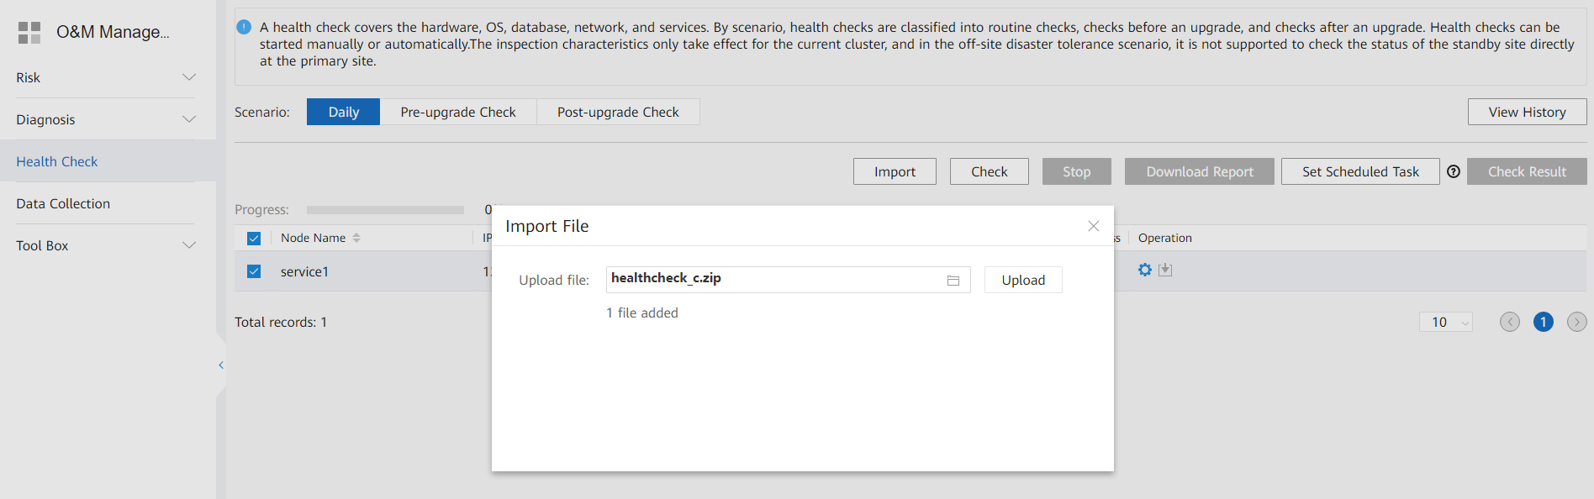
            - Check the import result.
After the import is successful, click Import again. In the dialog box that is displayed, view the imported check items.
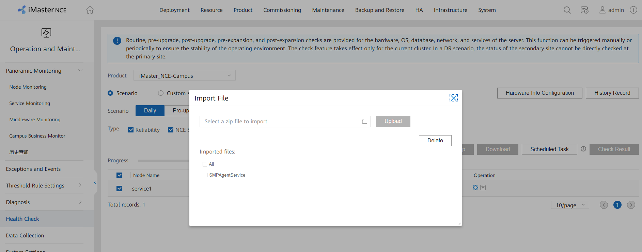
            - Set Scenario to Pre-upgrade Check and click Check.
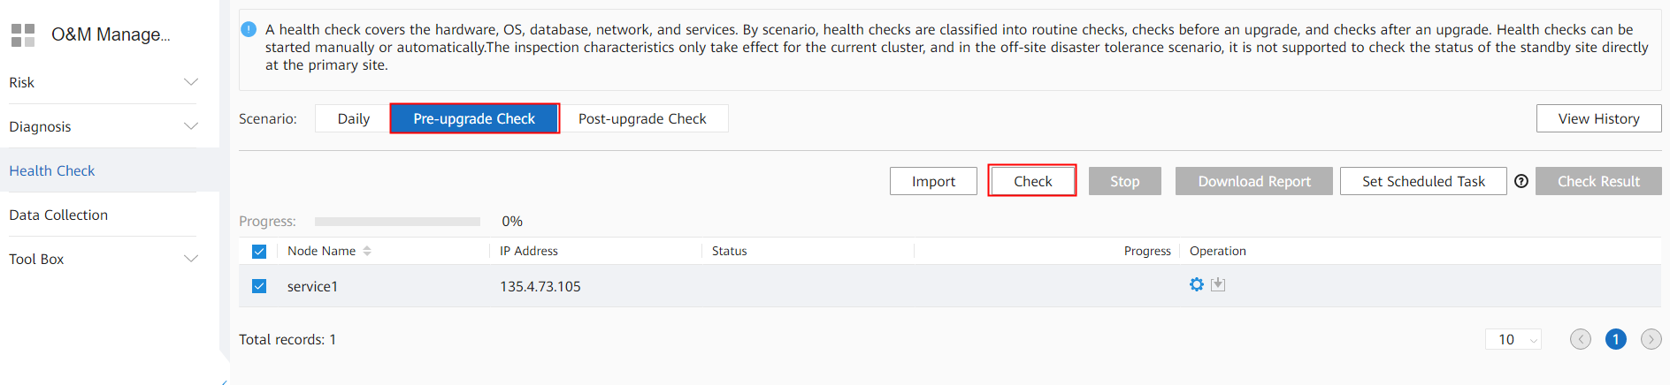
            - Wait until the check progress reaches 100% and view the check results.
- Click Check Result to view the check results online.
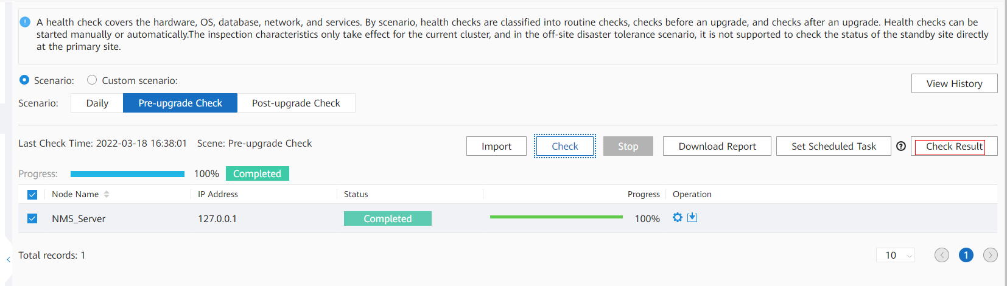
- After all check items are complete, click Download Report to download the check results in batches.
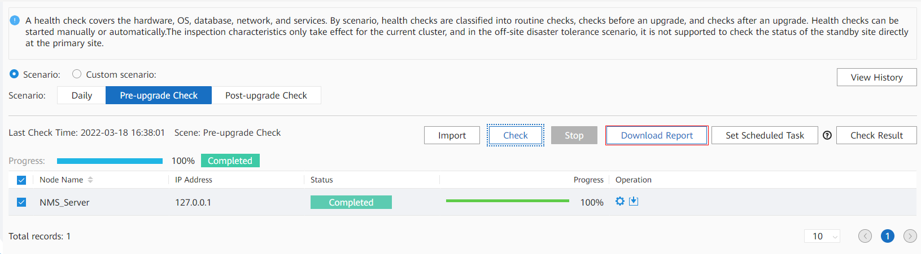
- Multiple levels of check results may be involved. All check items except the Normal ones need to be confirmed or handled according to suggestions in the check report. The check result levels are defined as follows:
- Normal: The check item is normal.
- No go: The check result is abnormal, and the problem must be resolved.
- Risky: Risks are found. Contact Huawei R&D engineers.
- Manually confirmed: The check result is abnormal, and the problem cannot be evaluated using scripts. Contact Huawei R&D engineers.
- Failed: Script execution is abnormal. Contact Huawei R&D engineers.
- Timed out: Script execution times out. Contact Huawei R&D engineers.
----End

Checking Whether Automatic DR Switchover Is Configured
Precautions
The operation result in this section determines whether operations in 4.7 (Optional) Upgrading the Arbitration Node are required.
Procedure
- Access the management plane of the primary cluster in the DR system at https://management plane IP address:18102, and choose HA > Remote High Availability System from the main menu.
            - Click Modify in the upper right corner of the page.
            - Click the DR Extended Configuration tab. Check whether Automatic Switch is enabled and whether Arbitration Type is set to External arbitration, Default third-party arbitration, or No Arbitration Switching. If so, automatic DR switchover with the arbitration service is enabled.
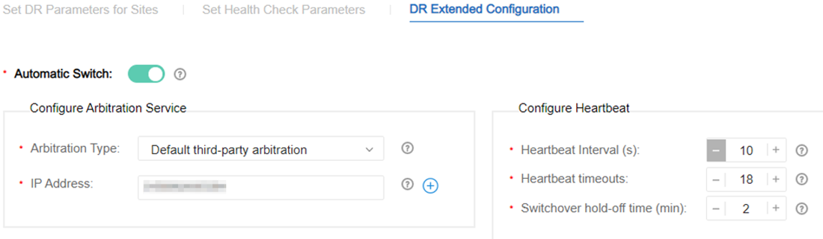
----End

Deleting the DR System

Deleting the Controller DR System
If there is any anomaly in the primary or secondary cluster, rectify it before performing subsequent operations.
- Access the management plane of the primary cluster in the DR system at https://management plane IP address:18102, and choose HA > Remote High Availability System > Manage DR System from the main menu.
            - Click Delete in the upper right corner of the page, click the task list icon  in the upper right corner, and wait until Task Status changes to Execution Succeeded.
            - Check the operation result. If the operation result is not as expected, contact Huawei technical support.
- On the management plane, choose HA > Remote High Availability System > Manage DR System from the main menu.
- On the Manage DR System page, verify that the deleted DR system no longer exists.
- Verify that you can log in to the service plane of the primary cluster.
----End

Logging In to the Upgrade Tool

Perform the operations in this section in both the primary and secondary clusters.
Procedure (V300R022C00)
For a single-node system, access the management plane at https://IP address of the service plane:31945.
- Access the management plane at https://IP address of the management plane:18102.
If the upgrade tool has not been deployed and you cannot log in to the management plane, perform operations by following the instructions provided in 8.19 Deploying EasySuite on the Backend.
            - Choose Product > Project Management > Upgrade Tool from the main menu, click , select the EasySuite_{version}_OM_linux-***.zip software package and the corresponding .cms and .crl signature files, and click Upload Software Package.
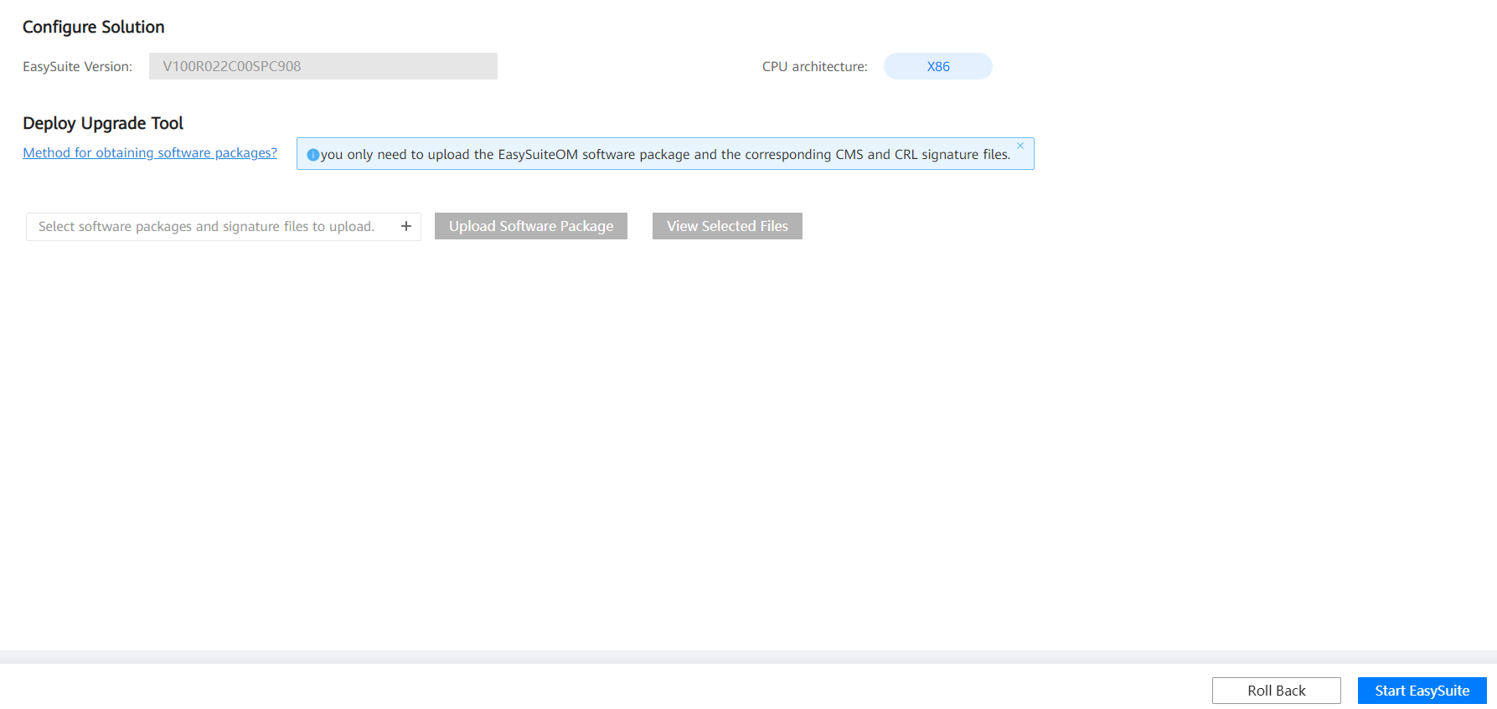
            - After the files are uploaded successfully, select the software package and click Verification and Deployment. If the EasySuite version changes to V100R023C00SPC900, the verification is successful.

If the system displays a message indicating that the software package verification fails as shown in the following figure, rectify the fault by following the instructions provided in 8.21 What Do I Do If Software Packages Fail to Be Verified on the Upgrade Tool?.
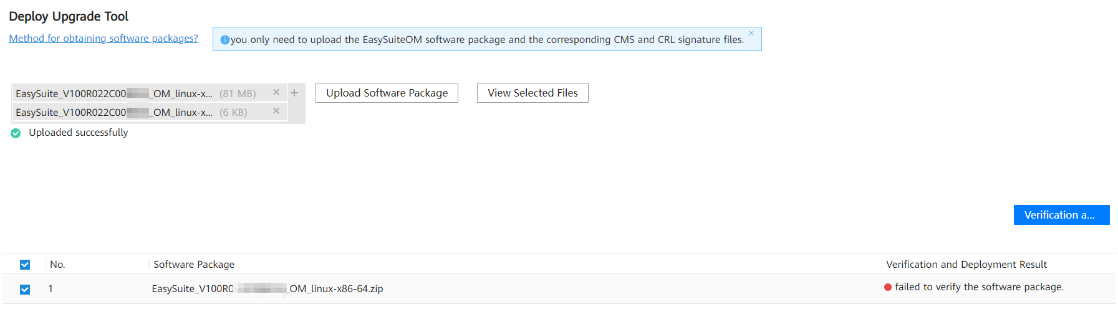
            - After the verification is successful, click Start EasySuite. The upgrade tool login page (at https://northbound communication IP address of the OMP_01 node:19090) is automatically displayed.

If a timeout error is reported during EasySuite startup, you cannot be automatically redirected to the upgrade tool login page. In this case, perform the following operations to log in to the upgrade tool:
In the address box of the browser, enter https://northbound communication IP address of the OMP_01 node:19090 and press Enter.
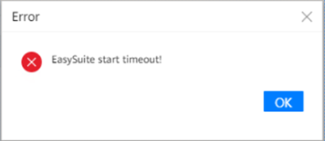
            - Enter a username and password, and click Log In.
- Username: The preset username is esadmin.
- User password: You can obtain the preset usernames and passwords from the iMaster NCE-Campus Preset Account and Password (enterprise users, carrier users). To obtain this document, you must have the required permission. For details about how to apply for the permission, see the help on the website.For security purposes, change the password upon the first login, update it periodically, and keep it secure.
- If the controller has been upgraded to V300R023C00, you can switch to the EasySuite page through the management plane without entering the username and password.
- If you forget the password for the esadmin user of EasySuite, see section "Retrieving the EasySuite Login Password During iMaster NCE-Campus Upgrade" under Maintenance and Troubleshooting > NCE&Solution Troubleshooting Guide > Common Troubleshooting Cases > Login Failures in the CloudCampus Solution Version & iMaster NCE-Campus Version Product Documentation.
----End

Uploading Software Packages
Log in to the upgrade tool. On the Pre-upgrade Evaluation tab page, click , select the required software packages and the corresponding .cms and .crl signature files, and click Upload Software Package.
Place all the required software packages and the corresponding signature files in the same folder. If the source version is a V300R022C00 version later than V300R022C00SPC101, the EasyOps health check patch package downloaded in 3.4 Obtaining Required Upgrade Software and Tools needs to be uploaded.
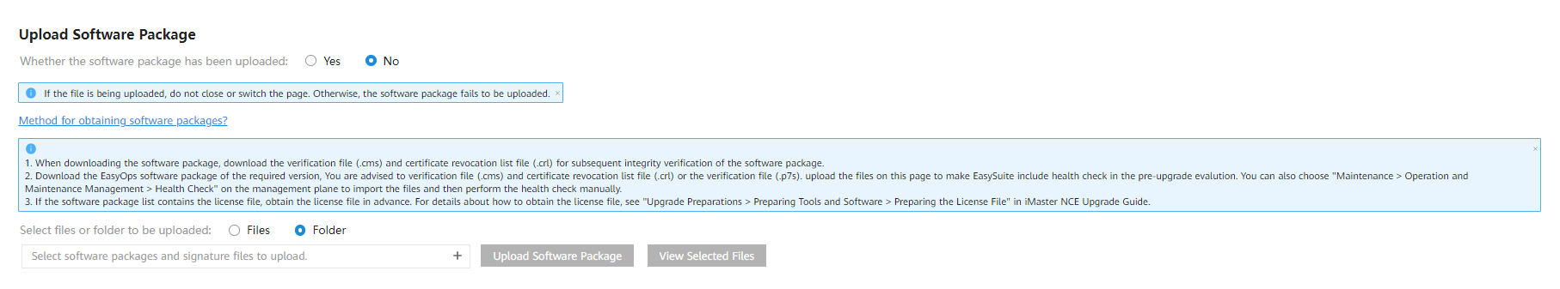
- If the source version is a V300R022C00 version earlier than V300R022C00SPC101, you cannot upload the EasyOps health check patch package or perform a health check on EasySuite. In this case, import the EasyOps health check patch package and perform a health check on the management plane by following the instructions provided in 3.6 Performing a Health Check.
- Whether the software package has been uploaded:
No: This option is selected by default.
Yes: Select this option if the required software packages have been uploaded to the OMP_01 node in advance. For details, see 8.22 How Do I Use a Third-Party Tool to Upload Software Packages to the Server?.
- If you set Select files or folder to be uploaded to Files, click , select all downloaded software packages and the corresponding .cms and .crl signature files, and click Upload Software Package.

Upgrade Solution A (Recommended)
- Upgrade the secondary cluster first and then the primary cluster. If the secondary cluster fails to be upgraded, you can still start the primary cluster to ensure service continuity. This delivers relatively high reliability.
- During the upgrade of the secondary cluster, services on the primary cluster are interrupted for 2 hours. This solution is recommended in scenarios that are not sensitive to the upgrade interruption duration.
- After the upgrade, configure the original secondary cluster as the primary cluster, and set the data replication direction to Secondary cluster before the upgrade -> Primary cluster before the upgrade.
- If you want the clusters to retain the original DR roles, perform an active/standby switchover after creating a DR system.
4.1 Disabling Services
4.2 Evaluating the Upgrade
4.3 Upgrading the Secondary Cluster
4.4 Enabling Services of the Secondary Cluster
4.5 Evaluating the Upgrade
4.6 Upgrading the Primary Cluster
4.7 (Optional) Upgrading the Arbitration Node
4.8 Creating a DR System
4.9 (Optional) Performing a DR Switchover

Disabling Services

Disabling Services in the Secondary Cluster
For details about how to find the OMP_01 node, see 8.2 How Can I Find an OMP Node of the Management Plane?.
- Log in to the OMP_01 node in the secondary cluster as the sopuser user, run the su - root command to switch to the root user, and run the following command: Performing this step will interrupt all services in the secondary cluster.
su - ossadm -c "sh /opt/oss/easysuite/easysuite/easysuite/plugins/NCE-Campus/upgrade_online/service/scripts/disable_lvs.sh NCECAMPUS"
The command output is as follows.
            - Log in to the management plane of the secondary cluster, choose Service Monitoring > Services, click Start, and choose Start Service from the drop-down list box.
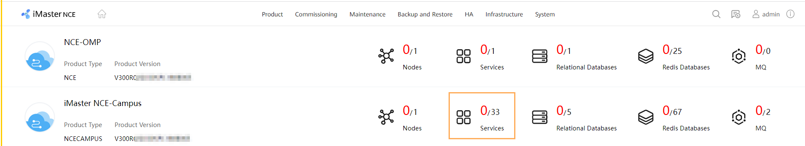
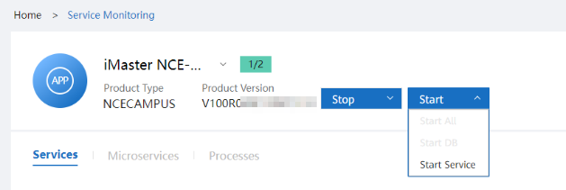
----End

Disabling Services in the Primary Cluster

For details about how to find the OMP_01 node, see 8.2 How Can I Find an OMP Node of the Management Plane?.
Log in to the OMP_01 node in the primary cluster as the sopuser user, run the su - root command to switch to the root user, and run the following command:
su - ossadm -c "sh /opt/oss/easysuite/easysuite/easysuite/plugins/NCE-Campus/upgrade_online/service/scripts/disable_lvs.sh NCECAMPUS"
The command output is as follows.

Evaluating the Upgrade
- Select the upgrade content as prompted, enter information such as the password for the root user of the OMP node, and click Evaluation.
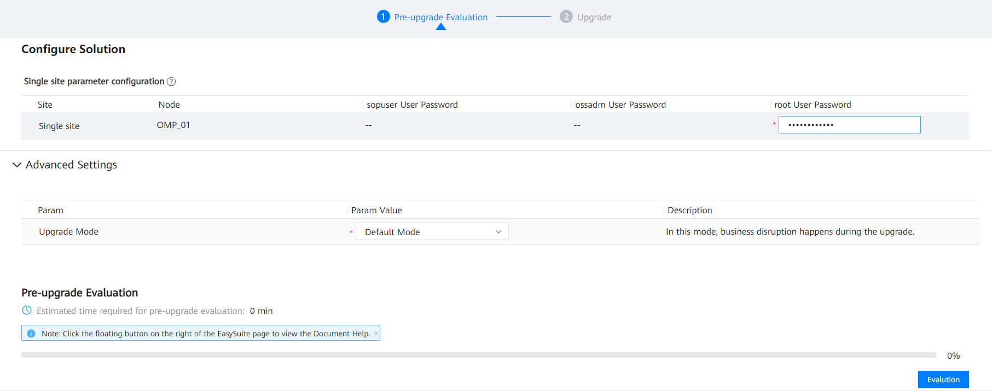
If no backup server is configured before the upgrade, you need to configure the password for the ftpuser user.
Set upgrade parameters as follows:
- Default Mode: Select this mode if upgrade solution A is used. Services will be interrupted throughout the upgrade in this mode.
            - After the evaluation is complete, click Next.
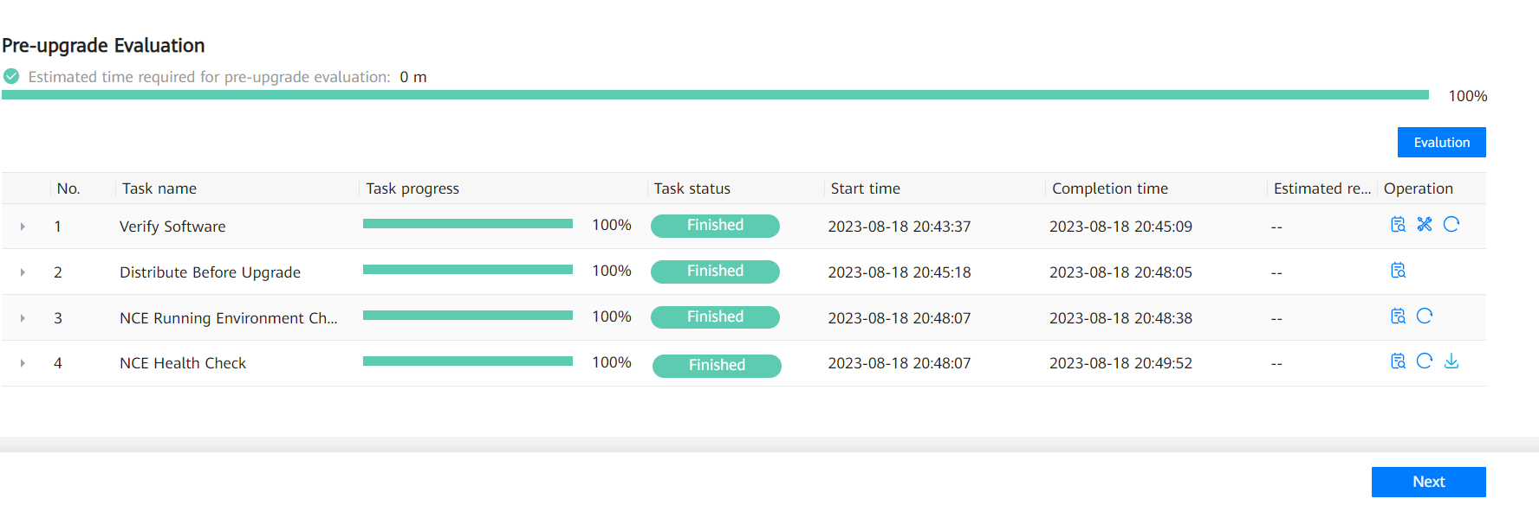
            - In the Data Backup area, click One-click execute. In the dialog box that is displayed, click OK.
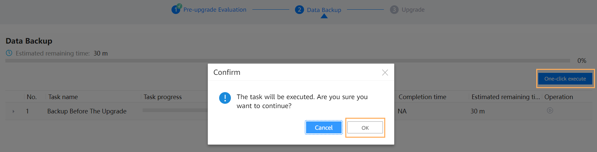
            - Wait until the data backup is complete.
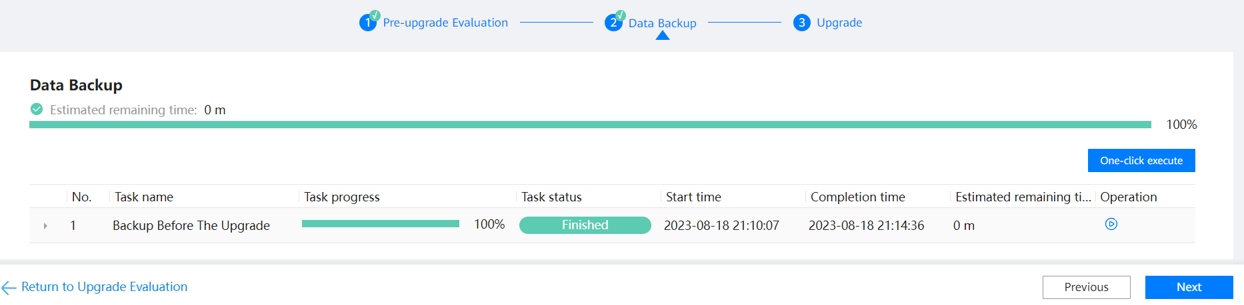
----End

Upgrading the Secondary Cluster
Perform the following operations only in the secondary cluster.

Upgrading the Secondary Cluster
Prerequisites
You have performed the operations in 3.10 Uploading Software Packages.
Procedure
- Log in to EasySuite and click Management under Manage Project on the homepage.
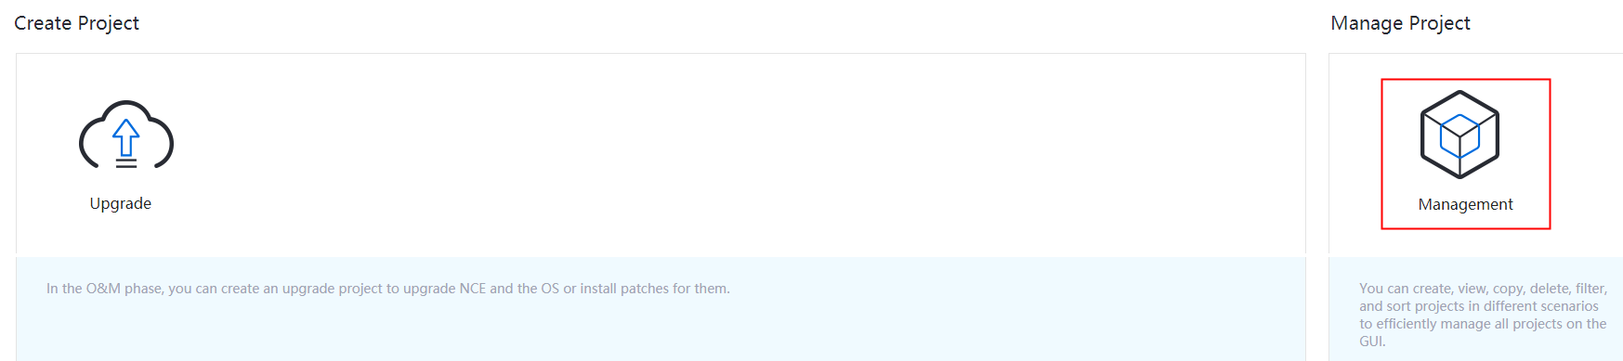
            - Click Plan in the Operation column of an upgrade project.
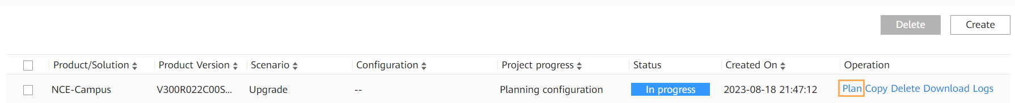
            - On the Upgrade page, click Perform upgrade.
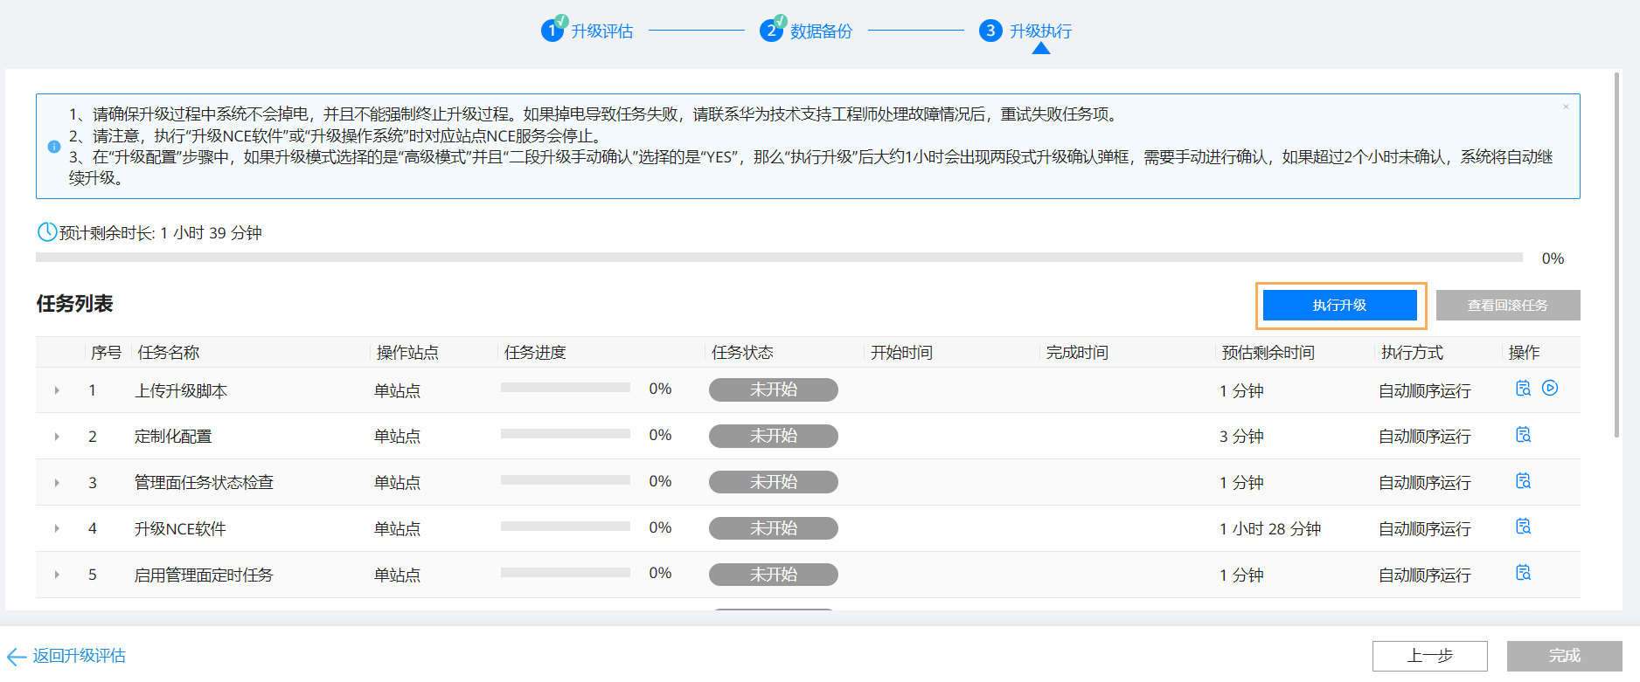
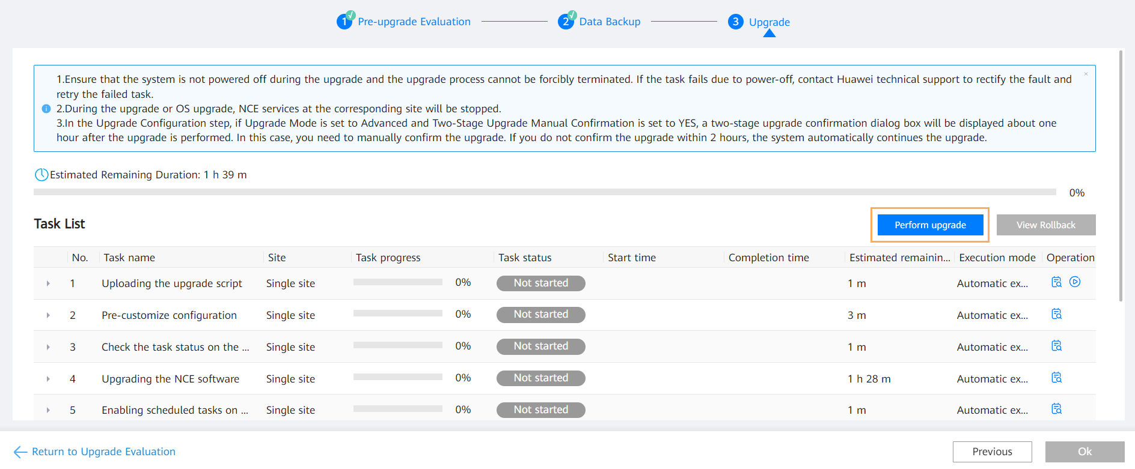

- Controller services will be interrupted for about 45 minutes during the second upgrade stage, which starts from the Upgrading the O&M plane services of the second phase(NCECAMPUS) step and ends with the Start Product(NCECAMPUS) step of the Upgrading the NCE software task. If you select YES for Business Disruption Manual Confirm on the upgrade evaluation page, a dialog box is displayed during the upgrade, prompting you of service interruptions in the second stage. Proceed to the second stage after confirming that no service will be affected. If you select NO for Business Disruption Manual Confirm, no such a dialog box will be displayed and the second stage starts automatically.
- When the OS is restarted, the EasySuite web page cannot be accessed. You need to wait for about 10 minutes and refresh the web page to log in to EasySuite again.
            - After the post-upgrade check task is complete, click Post-upgrade Check in the task list or View Upgrade Report in the upper right corner to view the check result. You can view the upgrade report only after being approved by the customer. If there is any check item at the No go or Risky level, confirm or handle it according to the handling suggestions in the check report.
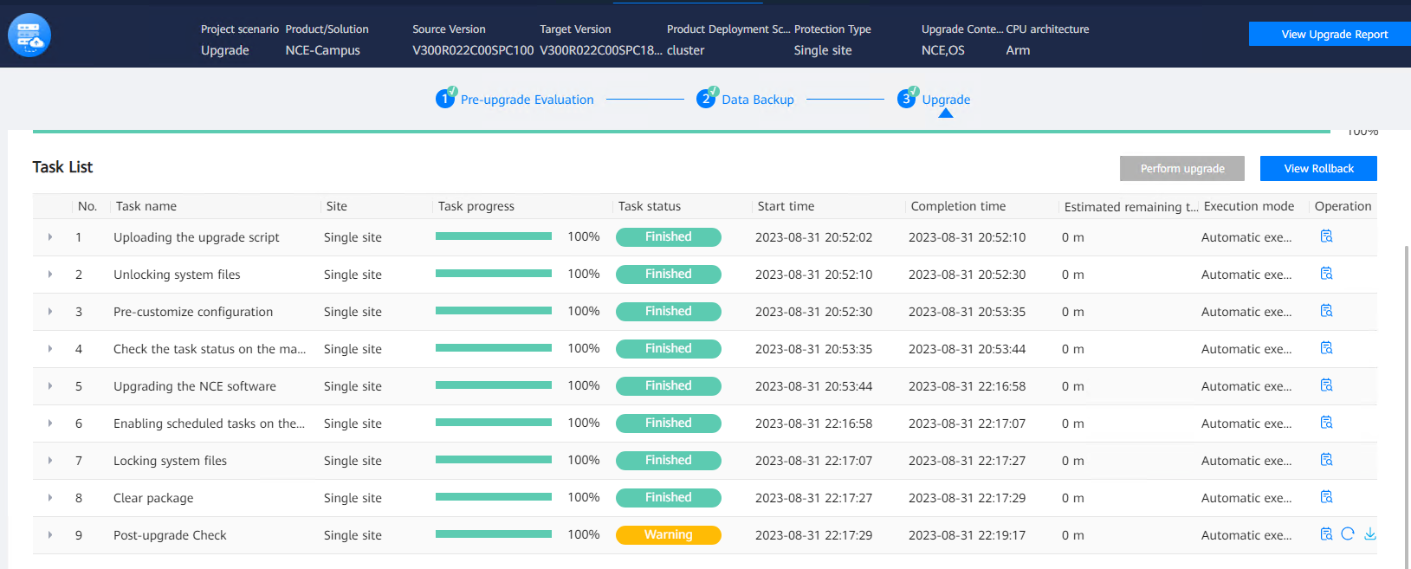
            - Click OK. The product upgrade is complete.
----End

Enabling Services of the Secondary Cluster
- Log in to the OMP_01 node in the secondary cluster as the sopuser user, run the su - root command to switch to the root user, and run the following command:
su - ossadm -c "sh /opt/oss/easysuite/easysuite/easysuite/plugins/NCE-Campus/upgrade_online/service/scripts/enable_lvs.sh NCECAMPUS true"
The command output is as follows.
            - (Optional) If multiple southbound addresses are involved, switch the primary and secondary southbound IP addresses by referring to 6.1 Checking the Southbound Access Configuration.
Perform the following steps to check whether multiple southbound addresses are involved:
- Log in to the service plane and choose System > Southbound Access > Southbound Access Configuration from the main menu.
- Check whether the Secondary IP Address column displays any IP addresses. If so, the DR system provides multiple southbound access addresses. Otherwise, skip this section.
----End

Evaluating the Upgrade
- Select the upgrade content as prompted, enter information such as the password for the root user of the OMP node, and click Evaluation.
If no backup server is configured before the upgrade, you need to configure the password for the ftpuser user.
Set upgrade parameters as follows:
- Default Mode: Select this mode if upgrade solution A is used. Services will be interrupted throughout the upgrade in this mode.
            - After the evaluation is complete, click Next.
            - In the Data Backup area, click One-click execute. In the dialog box that is displayed, click OK.
            - Wait until the data backup is complete.
----End

Upgrading the Primary Cluster

Upgrading the Primary Cluster
Prerequisites
You have performed the operations in 3.10 Uploading Software Packages.
Procedure
- Log in to EasySuite and click Management under Manage Project on the homepage.
            - Click Plan in the Operation column of an upgrade project.
            - On the Upgrade page, click Perform upgrade.

- Controller services will be interrupted for about 45 minutes during the second upgrade stage, which starts from the Upgrading the O&M plane services of the second phase(NCECAMPUS) step and ends with the Start Product(NCECAMPUS) step of the Upgrading the NCE software task. If you select YES for Business Disruption Manual Confirm on the upgrade evaluation page, a dialog box is displayed during the upgrade, prompting you of service interruptions in the second stage. Proceed to the second stage after confirming that no service will be affected. If you select NO for Business Disruption Manual Confirm, no such a dialog box will be displayed and the second stage starts automatically.
- When the OS is restarted, the EasySuite web page cannot be accessed. You need to wait for about 10 minutes and refresh the web page to log in to EasySuite again.
            - After the post-upgrade check task is complete, click Post-upgrade Check in the task list or View Upgrade Report in the upper right corner to view the check result. You can view the upgrade report only after being approved by the customer. If there is any check item at the No go or Risky level, confirm or handle it according to the handling suggestions in the check report.
            - Click OK. The product upgrade is complete.
----End

(Optional) Upgrading the Arbitration Node
For details, see 3.7 Checking Whether Automatic DR Switchover Is Configured. This step is required in the automatic DR scenario with the arbitration service.
- Download required software packages. For details, see 3.4 Obtaining Required Upgrade Software and Tools.
            - Reinstall the OS of the node.
- In a single-node system scenario, see "Building a DR System with Manual Switchover" or "Building a DR System with Automatic Switchover (with the Arbitration Service)" under Installation > Software Installation > Installing iMaster NCE-Campus > Geographic Redundancy System Installation (Single-Node Scenario) in the CloudCampus Solution V100R023C00 & iMaster NCE-Campus V300R023C00 Product Documentation.
  - If the x86 system is used, see "Configuring the arbitration server environment (Huawei-delivered Server 2288X V5/RS221G1)".
  - If the ARM system is used, see "Configuring the arbitration server environment (Huawei-delivered Server TaiShan)".
- In a cluster scenario, see "Building a DR System with Manual Switchover" or "Building a DR System with Automatic Switchover (with the Arbitration Service)" under Installation > Software Installation > Installing iMaster NCE-Campus > Geographic Redundancy System Installation (Cluster Scenario) in the CloudCampus Solution V100R023C00 & iMaster NCE-Campus V300R023C00 Product Documentation.
  - If the x86 system is used, see "Configuring the arbitration server environment (Huawei-delivered Server 2288X V5/RS221G1)".
  - If the ARM system is used, see "Configuring the arbitration server environment (Huawei-delivered Server TaiShan)".
            - Reinstall the arbitration node.
- In a single-node system scenario, reinstall the arbitration node by referring to Installation > Software Installation > Installing iMaster NCE-Campus > Geographic Redundancy System Installation (Single-Node Scenario) > Building a DR System with Automatic Switchover (With the Arbitration Service) > Installing the Arbitration Service in the CloudCampus Solution V100R023C00 & iMaster NCE-Campus V300R023C00 Product Documentation.
- In a cluster scenario, reinstall the arbitration node by referring to Installation > Software Installation > Installing iMaster NCE-Campus > Geographic Redundancy System Installation (Cluster Scenario) > Building a DR System with Automatic Switchover (With the Arbitration Service) > Installing the Arbitration Service in the CloudCampus Solution V100R023C00 & iMaster NCE-Campus V300R023C00 Product Documentation.
----End

Creating a DR System

Creating a New DR System

- The primary and secondary clusters can be rolled back only before they set up a DR system. The clusters in a DR system cannot be rolled back even if their DR relationship has been deleted.
- When creating a DR system, set the data replication direction to Secondary cluster before the upgrade - > Primary cluster before the upgrade.
- Log in to the management planes of the primary and secondary clusters, respectively, choose Product > Deploy Product Software, click More, choose Modify Configurations from the drop-down list box, and check the DAYU_HBASE_DR_ENABLE value. If the values of the primary and secondary clusters are the same, skip this step. If the values of the primary and secondary clusters are different, change the value of the secondary cluster to that of the primary cluster to ensure that the values of the two clusters are the same.
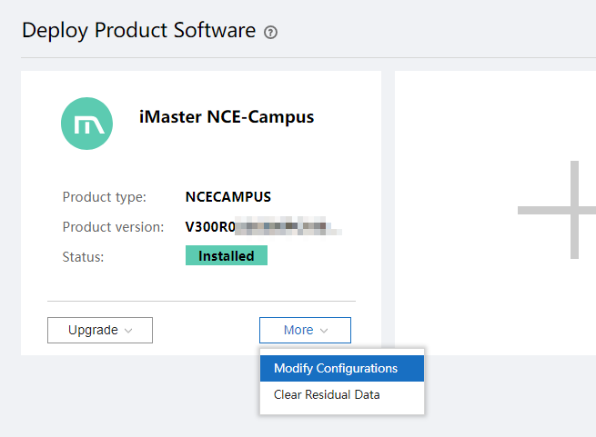
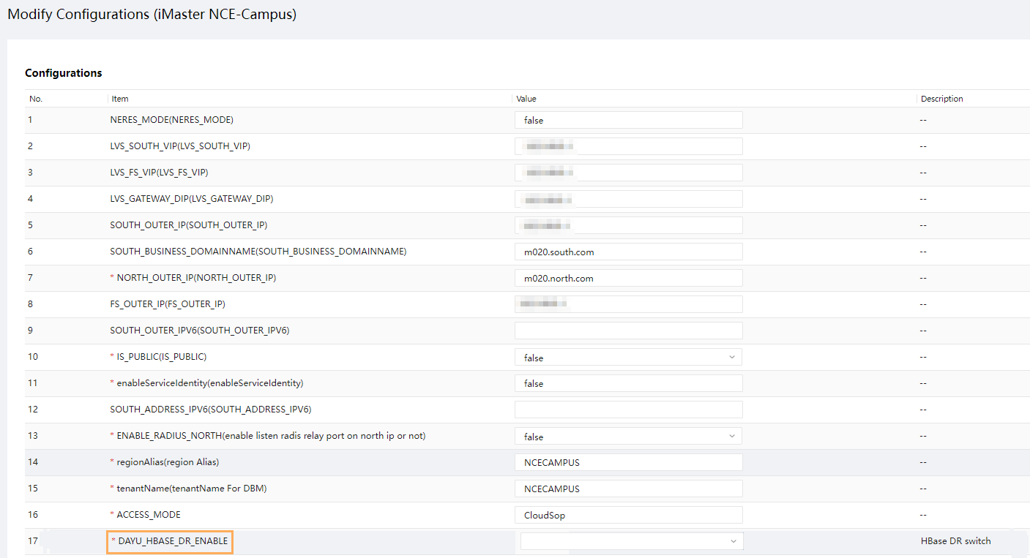
            - Build a new DR system. For details, see 4.8.1 Creating a New DR System.
            - Log in to the OMP_01 node in the primary cluster before the upgrade as the sopuser user, and run the su - root command to switch to the root user.
For details about how to find the OMP_01 node, see 8.2 How Can I Find an OMP Node of the Management Plane?.
su - ossadm -c "sh /opt/oss/easysuite/easysuite/easysuite/plugins/NCE-Campus/upgrade_online/service/scripts/enable_lvs.sh NCECAMPUS false"
The command output is as follows.
----End

Single-Node Scenario (Automatic Switchover)

Configuring a DR System
Associate the primary and secondary sites with the third-party arbitration site to set up an automatic switchover system.
Procedure
- Log in to the management plane at the primary and secondary sites separately and choose Product > Software Management > Deploy Product Software from the main menu.
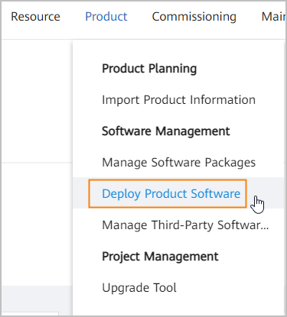
            - Click More and choose Clear Residual Data from the shortcut menu.
If both the primary and secondary sites are newly installed, there is no need to clear residual data. Go to Step 5.
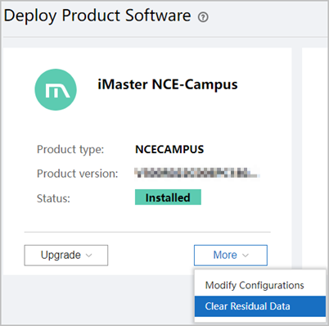
            - Select all data records, select the I understand the risk and want to continue checkbox, and click OK.
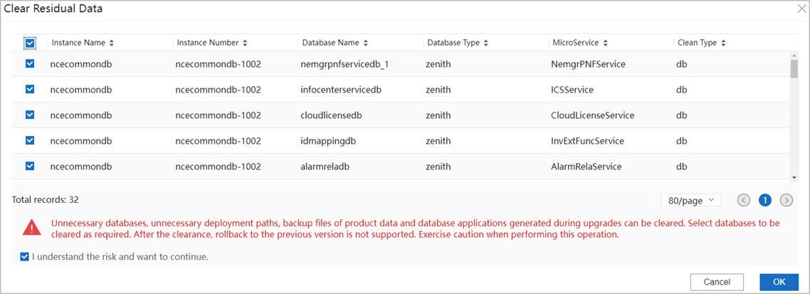
            - After the data clearance task is created, you can view the task progress in the upper right corner of the page.
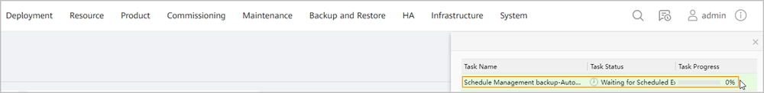
            - Log in to the management plane of the primary or secondary site and choose HA > Remote High Availability System > Manage DR System from the main menu.
            - On the Manage DR System page, click Configure DR System.
            - On the Set DR Parameters for Sites tab page, set the site and product information according to Table 4-1 and click Precheck.
                - Parameter description
Parameter | Description
Site name | Identifier of a site. The names of the primary and secondary sites must be different.
Heartbeat IP address | IP address of the internal communication NIC on the OMP_01 node.

              - Setting DR parameters for sites
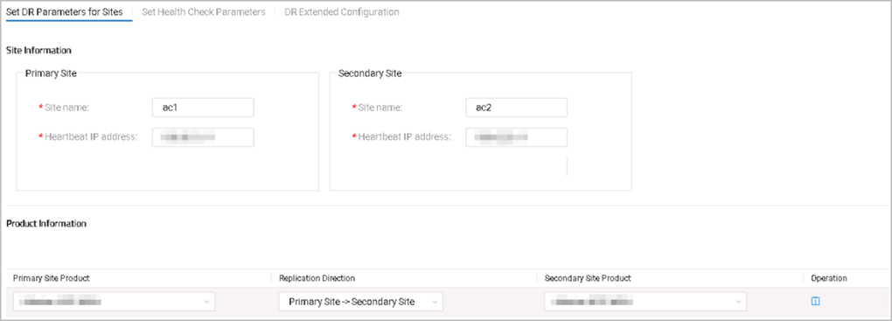

            - Click Add Product and set the products at the primary and secondary sites, as well as the data replication direction.
Set Replication Direction to Primary Site -> Secondary Site.
            - On the Set Health Check Parameters tab page, configure a scheduled health evaluation task.
After you toggle on Start Scheduled Task and set the start time, the system performs a health evaluation of the DR system at the specified time every day.
You can also click Evaluate Health on the Manage DR System page to start a health evaluation task.
On the Manage DR System page, click View Evaluation and view the health evaluation report.
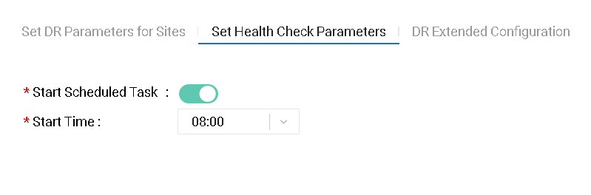
            - On the DR Extended Configuration tab page, click to enable the automatic switchover function.
            - Configure heartbeat information such as automatic switchover configuration and switchover delay time, determine whether to enable application-level DR settings, and click OK.
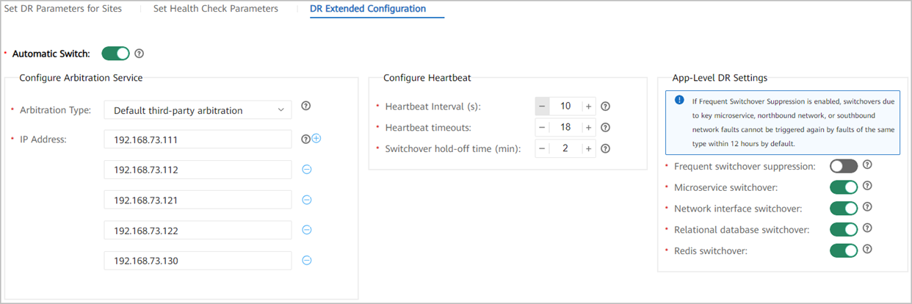
- Automatic switchover type: NCE uses Default third-party arbitration.
- IP Address: Enter the internal communication plane IP address of the arbitration node where the arbitration service is deployed. That is, the internal communication plane IP addresses of the arbitration node, OMP_01 at the primary site, and OMP_01 at the secondary site.
- Configure Heartbeat: The default heartbeat interruption detection and switchover delay time is 5 minutes, which is calculated as follows: Heartbeat Interval (10 seconds by default) x Heartbeat timeouts (18 by default) + Switching hold-off time (2 minutes by default). You can adjust the settings based on the site requirements.
- App-Level DR Settings: You can enable or disable the DR switchover capability in different fault scenarios based on the site requirements.
            - Click Precheck.
The check before creating a DR system verifies that:
- The primary and secondary sites can communicate with each other through the heartbeat link.
If the communication between the two sites is normal, the network between the two sites is normal and the CA certificates, root keys, and working keys, are consistent respectively between the two sites.
- The primary and secondary sites have the same number of nodes.
- Services and service versions are consistent between the primary and secondary sites.
- The time of the primary and secondary sites is the same.
- If the check is passed, go to Step 13.
- Otherwise, resolve the issues and re-establish a DR system.
            - Click OK and create a DR system as prompted.
After the primary and secondary sites are associated, services at the primary site are still running, and some services at the secondary site are stopped.
            - Check the operation result. If the operation result is not as expected, contact Huawei technical support.
- On the management plane, choose HA > Remote High Availability System > Manage DR System from the main menu.
- On the Manage DR System page, check whether Heartbeat Status is displayed as .
- On the Manage DR System page, check whether Data Synchronization Status of all products is Synchronized or Synchronizing. If Data Synchronization Status is Delayed, a large volume of data is being synchronized between the primary and secondary sites. Check the status after data synchronization is complete.
- Check whether you can log in to the O&M plane of the active site.
----End
Verifying Automatic Switchover
After the primary and secondary sites are associated and before services are not rolled out, shut down the internal communication NICs of the arbitration nodes at the primary site. After the switchover delay time, check whether the secondary site automatically becomes active and the primary site automatically becomes standby. If so, the arbitration software is successfully installed.

(Optional) Synchronizing Historical HBase DR Data
Procedure
- Log in to the OMP_01 node at the primary site as the sopuser user, run the su - ossadm command to switch to the ossadm user, and enter the user password.
            - Synchronize all historical HBase data. Run the following command:
/opt/oss/manager/apps/NdpUIHomeWebsite/bin/sync_hbase_table_history_data.sh -p NCECAMPUS -a internal communication IP address of the OMP_01 node at the secondary site
Enter the passwords for ossuser and ossadm users as prompted.
If the following information is displayed, the synchronization is completed.
----End

Single-Node Scenario (Manual Switchover)

Configuring a DR System
Procedure
- Log in to the management plane at the primary and secondary sites separately and choose Product > Software Management > Deploy Product Software from the main menu.
            - Click More and choose Clear Residual Data from the shortcut menu.
If both the primary and secondary sites are newly installed, there is no need to clear residual data. Go to Step 5.
            - Select all data records, select the I understand the risk and want to continue checkbox, and click OK.
            - After the data clearance task is created, you can view the task progress in the upper right corner of the page.
            - Log in to the management plane of the primary or secondary site and choose HA > Remote High Availability System > Manage DR System from the main menu.
            - On the Manage DR System page, click Configure DR System.
            - On the Set DR Parameters for Sites tab page, set the site and product information according to Table 4-2.
                - Parameter description
Parameter | Description
Site name | Identifier of a site. The names of the primary and secondary sites must be different.
Heartbeat IP address | IP address of the internal communication NIC on the OMP_01 node.

              - Setting DR parameters for sites

            - Click Add Product and set the products at the primary and secondary sites, as well as the data replication direction.
Set Replication Direction to Primary Site -> Secondary Site.
            - On the Set Health Check Parameters tab page, configure a scheduled health evaluation task.
After you toggle on Start Scheduled Task and set the start time, the system performs a health evaluation of the DR system at the specified time every day.
You can also click Evaluate Health on the Manage DR System page to start a health evaluation task.
On the Manage DR System page, click View Evaluation and view the health evaluation report.
            - There is no need to set parameters on the DR Extended Configuration tab page.
            - Click Precheck.
The check before creating a DR system verifies that:
- The primary and secondary sites can communicate with each other through the heartbeat link.
If the communication between the two sites is normal, the network between the two sites is normal and the CA certificates, root keys, and working keys, are consistent respectively between the two sites.
- The primary and secondary sites have the same number of nodes.
- Services and service versions are consistent between the primary and secondary sites.
- The time of the primary and secondary sites is the same.
- The primary and secondary sites use the same backup server and data can be transmitted through the backup server.
- Big data analytics nodes at the primary and secondary sites can be logged in to and there is no running synchronization tasks.
- If the check is passed, go to Step 12.
- Otherwise, resolve the issues and re-establish a DR system.
            - Configure a DR system as prompted.
After the primary and secondary sites are associated, services at the primary site are still running, and some services at the secondary site are stopped.
            - Check the operation result. If the operation result is not as expected, contact Huawei technical support.
- Choose HA > Remote High Availability System > Manage DR System from the main menu of the management plane.
- On the Manage DR System page, check whether Heartbeat Status is displayed as .
- On the Manage DR System page, check whether Data Synchronization Status of all products is Synchronized or Synchronizing. If Data Synchronization Status is Delayed, a large volume of data is being synchronized between the primary and secondary sites. Check the status after data synchronization is complete.
- Verify that you can log in to the O&M plane at the active site.
----End

(Optional) Synchronizing Historical HBase DR Data
After a DR system is set up, if you need to synchronize historical HBase data from the primary site to the secondary site, perform the operations in this section.
Procedure
- Log in to the OMP_01 node at the primary site as the sopuser user, run the su - ossadm command to switch to the ossadm user, and enter the user password.
            - Synchronize all historical HBase data. Run the following command:
/opt/oss/manager/apps/NdpUIHomeWebsite/bin/sync_hbase_table_history_data.sh -p NCECAMPUS -a internal communication IP address of the OMP_01 node at the secondary site
Enter the passwords for ossuser and ossadm users as prompted.
If the following information is displayed, the synchronization is completed.
----End

Cluster Scenario (Automatic Switchover)

Configuring a DR System
Associate the primary and secondary sites with the third-party arbitration site to set up an automatic switchover system.
Procedure
- Log in to the management plane at the primary and secondary sites separately and choose Product > Software Management > Deploy Product Software from the main menu.
            - Click More and choose Clear Residual Data from the shortcut menu.
If both the primary and secondary sites are newly installed, there is no need to clear residual data. Go to Step 5.
            - Select all data records, select the I understand the risk and want to continue checkbox, and click OK.
            - After the data clearance task is created, you can view the task progress in the upper right corner of the page.
            - Log in to the management plane of the primary or secondary site and choose HA > Remote High Availability System > Manage DR System from the main menu.
            - On the Manage DR System page, click Configure DR System.
            - On the Set DR Parameters for Sites tab page, set the site and product information according to Table 4-3 and click Precheck.
                - Parameter description
Parameter | Description
Site name | Identifier of a site. The names of the primary and secondary sites must be different.
Heartbeat IP address | IP addresses of the internal communication NICs on OMP_01 and OMP_02 nodes.

              - Setting DR parameters for sites
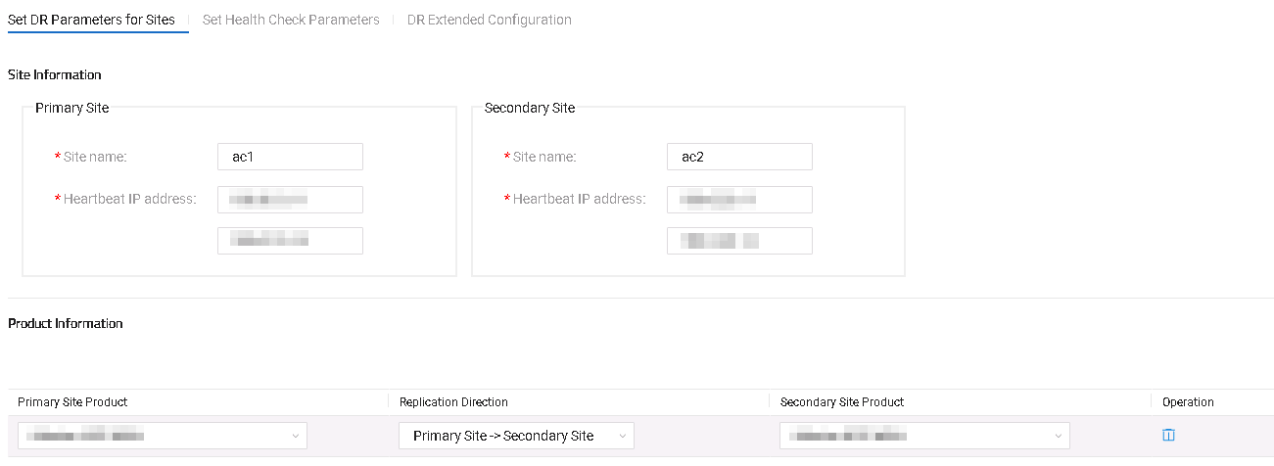

            - Click Add Product and set the products at the primary and secondary sites, as well as the data replication direction.
Set Replication Direction to Primary Site -> Secondary Site.
            - On the Set Health Check Parameters tab page, configure a scheduled health evaluation task.
After you toggle on Start Scheduled Task and set the start time, the system performs a health evaluation of the DR system at the specified time every day.
You can also click Evaluate Health on the Manage DR System page to start a health evaluation task.
On the Manage DR System page, click View Evaluation and view the health evaluation report.
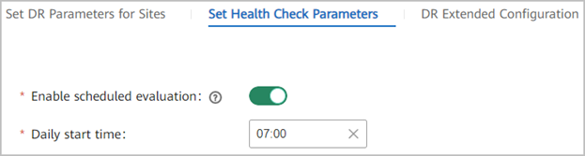
            - On the DR Extended Configuration tab page, click to enable the automatic switchover function.
            - Configure heartbeat information such as automatic switchover configuration and switchover delay time, determine whether to enable application-level DR settings, and click OK.
- Automatic switchover type: NCE uses Default third-party arbitration.
- IP Address: Enter the internal communication plane IP address of the arbitration node where the arbitration service is deployed. That is, the internal communication plane IP addresses of the arbitration node, OMP_01 at the primary site, OMP_02 at the primary site, OMP_01 at the secondary site, and OMP_02 at the secondary site.
- Configure Heartbeat: The default heartbeat interruption detection and switchover delay time is 5 minutes, which is calculated as follows: Heartbeat Interval (10 seconds by default) x Heartbeat timeouts (18 by default) + Switching hold-off time (2 minutes by default). You can adjust the settings based on the site requirements.
- App-Level DR Settings: You can enable or disable the DR switchover capability in different fault scenarios based on the site requirements.
            - Click Precheck.
The check before creating a DR system verifies that:
- The primary and secondary sites can communicate with each other through the heartbeat link.
If the communication between the two sites is normal, the network between the two sites is normal and the CA certificates, root keys, and working keys, are consistent respectively between the two sites.
- The primary and secondary sites have the same number of nodes.
- Services and service versions are consistent between the primary and secondary sites.
- The time of the primary and secondary sites is the same.
- If the check is passed, go to Step 13.
- Otherwise, resolve the issues and re-establish a DR system.
            - Click OK and create a DR system as prompted.
After the primary and secondary sites are associated, services at the primary site are still running, and some services at the secondary site are stopped.
            - Check the operation result. If the operation result is not as expected, contact Huawei technical support.
- On the management plane, choose HA > Remote High Availability System > Manage DR System from the main menu.
- On the Manage DR System page, check whether Heartbeat Status is displayed as .
- On the Manage DR System page, check whether Data Synchronization Status of all products is Synchronized or Synchronizing. If Data Synchronization Status is Delayed, a large volume of data is being synchronized between the primary and secondary sites. Check the status after data synchronization is complete.
- Check whether you can log in to the O&M plane of the active site.
----End
Verifying Automatic Switchover
After the primary and secondary sites are associated and before services are not rolled out, shut down the internal communication NICs of the arbitration nodes at the primary site. After the switchover delay time, check whether the secondary site automatically becomes active and the primary site automatically becomes standby. If so, the arbitration software is successfully installed.

(Optional) Synchronizing Historical HBase DR Data
Procedure
- Log in to the OMP_01 node at the primary site as the sopuser user, run the su - ossadm command to switch to the ossadm user, and enter the user password.
            - Synchronize all historical HBase data. Run the following command:
/opt/oss/manager/apps/NdpUIHomeWebsite/bin/sync_hbase_table_history_data.sh -p NCECAMPUS -a internal communication IP address of the OMP_01 node at the secondary site
Enter the passwords for ossuser and ossadm users of different nodes as prompted.
If the following information is displayed, the synchronization is completed.
----End

Cluster Scenario (Manual Switchover)

Configuring a DR System
Context
Creating a DR system establishes a data synchronization relationship between the primary and secondary sites to ensure data consistency. When creating a data synchronization relationship between the primary and secondary sites, the DR system backs up all data at the primary site to a backup server, and then restores all data at the secondary site to ensure data consistency between the two sites. Therefore, the primary and secondary sites must use the same backup server.
Procedure
- Log in to the management plane at the primary and secondary sites separately and choose Product > Software Management > Deploy Product Software from the main menu.
            - Click More and choose Clear Residual Data from the shortcut menu.
If both the primary and secondary sites are newly installed, there is no need to clear residual data. Go to Step 5.
            - Select all data records, select the I understand the risk and want to continue checkbox, and click OK.
            - After the data clearance task is created, you can view the task progress in the upper right corner of the page.
            - Log in to the management plane of the primary or secondary site and choose HA > Remote High Availability System > Manage DR System from the main menu.
            - On the Manage DR System page, click Configure DR System.
            - On the Set DR Parameters for Sites tab page, set the site and product information according to Table 4-4.
                - Parameter description
Parameter | Description
Site name | Identifier of a site. The names of the primary and secondary sites must be different.
Heartbeat IP address | IP addresses of the internal communication NICs on OMP_01 and OMP_02 nodes.

              - Setting DR parameters for sites

            - Click Add Product and set the products at the primary and secondary sites, as well as the data replication direction.
Set Replication Direction to Primary Site -> Secondary Site.
            - On the Set Health Check Parameters tab page, configure a scheduled health evaluation task.
After you toggle on Start Scheduled Task and set the start time, the system performs a health evaluation of the DR system at the specified time every day.
You can also click Evaluate Health on the Manage DR System page to start a health evaluation task.
On the Manage DR System page, click View Evaluation and view the health evaluation report.
            - There is no need to set parameters on the DR Extended Configuration tab page.
            - Click Precheck.
The check before creating a DR system verifies that:
- The primary and secondary sites can communicate with each other through the heartbeat link.
If the communication between the two sites is normal, the network between the two sites is normal and the CA certificates, root keys, and working keys, are consistent respectively between the two sites.
- The primary and secondary sites have the same number of nodes.
- Services and service versions are consistent between the primary and secondary sites.
- The time of the primary and secondary sites is the same.
- If the check is passed, go to Step 12.
- Otherwise, resolve the issues and re-establish a DR system.
            - Configure a DR system as prompted.
After the primary and secondary sites are associated, services at the primary site are still running, and some services at the secondary site are stopped.
            - Check the operation result. If the operation result is not as expected, contact Huawei technical support.
- Choose HA > Remote High Availability System > Manage DR System from the main menu of the management plane.
- On the Manage DR System page, check whether Heartbeat Status is displayed as .
- On the Manage DR System page, check whether Data Synchronization Status of all products is Synchronized or Synchronizing. If Data Synchronization Status is Delayed, a large volume of data is being synchronized between the primary and secondary sites. Check the status after data synchronization is complete.
- Verify that you can log in to the O&M plane at the active site.
----End

(Optional) Synchronizing Historical HBase DR Data
Procedure
- Log in to the OMP_01 node at the primary site as the sopuser user, run the su - ossadm command to switch to the ossadm user, and enter the user password.
            - Synchronize all historical HBase data. Run the following command:
/opt/oss/manager/apps/NdpUIHomeWebsite/bin/sync_hbase_table_history_data.sh -p NCECAMPUS -a internal communication IP address of the OMP_01 node at the secondary site
Enter the passwords for ossuser and ossadm users of different nodes as prompted.
If the following information is displayed, the synchronization is completed.
----End

(Optional) Performing a DR Switchover
Perform operations in this section if you want the clusters to retain the original DR roles. Otherwise, skip this section.
- Access the management plane of the primary cluster in the DR system at https://management plane IP address:18102, and choose HA > Remote High Availability System > Manage DR System from the main menu.
            - On the Manage Remote DR System page, select the product that requires an active/standby switchover and click Switch Over above the product list.
            - Perform operations as prompted.
            - Check the operation result. If the operation result is not as expected, contact Huawei technical support.
- On the management plane, choose HA > Remote High Availability System > Manage DR System from the main menu.
- On the Manage Remote DR System page, check whether the heartbeat status between the primary and secondary clusters is .
- Check the Primary Site Product and Secondary Site Product columns. Verify that the product DR status and the switchover result are consistent.
- Verify that Data Synchronization Status of all the products is Synchronized or Synchronizing. If Data Synchronization Status is Delayed, a large volume of data is being synchronized between the primary and secondary clusters. Check the status after data synchronization is complete.
- Verify that the service plane at the active cluster can be logged in to.
----End

Upgrade Solution B
- Upgrade the primary cluster first and then the secondary cluster. If the primary cluster fails to be upgraded, perform operations in 4.1.2 Disabling Services in the Primary Cluster and then in 4.4 Enabling Services of the Secondary Cluster.
- Throughout the entire upgrade process, the secondary cluster does not take over services and services in the primary cluster are interrupted for about 45 minutes.
- After the upgrade is complete, configure the clusters to retain the original DR roles when creating a DR system and set the data replication direction to Primary cluster before the upgrade -> Secondary cluster before the upgrade.
5.1 Disabling Services of the Secondary Cluster
5.2 Evaluating the Upgrade
5.3 Upgrading the Primary Cluster
5.4 Evaluating the Upgrade
5.5 Upgrading the Secondary Cluster
5.6 (Optional) Upgrading the Arbitration Node
5.7 Creating a DR System

Disabling Services of the Secondary Cluster
For details about how to find the OMP_01 node, see 8.2 How Can I Find an OMP Node of the Management Plane?.
- Log in to the OMP_01 node in the secondary cluster as the sopuser user, run the su - root command to switch to the root user, and run the following command:
su - ossadm -c "sh /opt/oss/easysuite/easysuite/easysuite/plugins/NCE-Campus/upgrade_online/service/scripts/disable_lvs.sh NCECAMPUS"
The command output is as follows.
            - Log in to the management plane of the secondary cluster, choose Service Monitoring > Services, click Start, and choose Start Service from the drop-down list box.
----End

Evaluating the Upgrade
- Select the upgrade content as prompted, enter information such as the password for the root user of the OMP node, and click Evaluation.
If no backup server is configured before the upgrade, you need to configure the password for the ftpuser user.
Set upgrade parameters as follows:
- Advanced Mode (If this mode is required, select it from the Upgrade Mode drop-down list box.):
Select this mode if upgrade solution B is used. In this mode, services will be interrupted temporarily during the upgrade, but the service interruption duration is shorter than that in default mode. Using this mode may increase the time needed for upgrade.
- Business Disruption Manual Confirm:
The upgrade process is divided into two stages and services will be interrupted during the second upgrade stage. If you select YES for this parameter, a dialog box will be displayed after the first stage of the upgrade is complete, asking you whether you want to proceed to the second stage. The second stage starts after your confirmation. If you select NO, no such a dialog box is displayed and the second stage starts automatically.
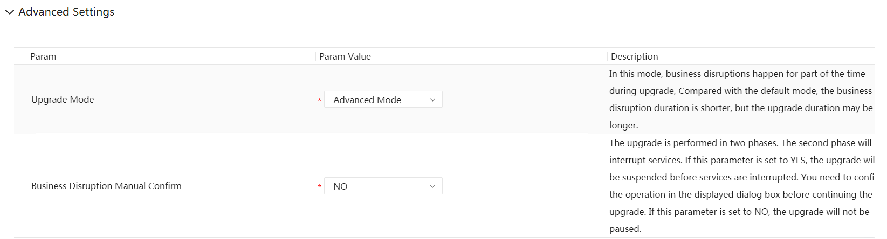
            - After the evaluation is complete, click Next.
            - In the Data Backup area, click One-click execute. In the dialog box that is displayed, click OK.
            - Wait until the data backup is complete.
----End

Upgrading the Primary Cluster

Upgrading the Primary Cluster
Prerequisites
You have performed the operations in 3.10 Uploading Software Packages.
Procedure
- Log in to EasySuite and click Management under Manage Project on the homepage.
            - Click Plan in the Operation column of an upgrade project.
            - On the Upgrade page, click Perform upgrade.
            - After the post-upgrade check task is complete, click Post-upgrade Check in the task list or View Upgrade Report in the upper right corner to view the check result. You can view the upgrade report only after being approved by the customer. If there is any check item at the No go or Risky level, confirm or handle it according to the handling suggestions in the check report.
            - Click OK. The product upgrade is complete.
----End

Evaluating the Upgrade
- Select the upgrade content as prompted, enter information such as the password for the root user of the OMP node, and click Evaluation.
If no backup server is configured before the upgrade, you need to configure the password for the ftpuser user.
Set upgrade parameters as follows:
- Advanced Mode (If this mode is required, select it from the Upgrade Mode drop-down list box.):
Select this mode if upgrade solution B is used. In this mode, services will be interrupted temporarily during the upgrade, but the service interruption duration is shorter than that in default mode. Using this mode may increase the time needed for upgrade.
- Business Disruption Manual Confirm:
The upgrade process is divided into two stages and services will be interrupted during the second upgrade stage. If you select YES for this parameter, a dialog box will be displayed after the first stage of the upgrade is complete, asking you whether you want to proceed to the second stage. The second stage starts after your confirmation. If you select NO, no such a dialog box is displayed and the second stage starts automatically.
            - After the evaluation is complete, click Next.
            - In the Data Backup area, click One-click execute. In the dialog box that is displayed, click OK.
            - Wait until the data backup is complete.
----End

Upgrading the Secondary Cluster
Perform the following operations only in the secondary cluster.

Upgrading the Secondary Cluster
Prerequisites
You have performed the operations in 3.10 Uploading Software Packages.
Procedure
- Log in to EasySuite and click Management under Manage Project on the homepage.
            - Click Plan in the Operation column of an upgrade project.
            - On the Upgrade page, click Perform upgrade.
            - After the post-upgrade check task is complete, click Post-upgrade Check in the task list or View Upgrade Report in the upper right corner to view the check result. You can view the upgrade report only after being approved by the customer. If there is any check item at the No go or Risky level, confirm or handle it according to the handling suggestions in the check report.
            - Click OK. The product upgrade is complete.
----End

(Optional) Upgrading the Arbitration Node
For details, see 3.7 Checking Whether Automatic DR Switchover Is Configured. This step is required in the automatic DR scenario with the arbitration service.
- Download required software packages. For details, see 3.4 Obtaining Required Upgrade Software and Tools.
            - Reinstall the OS of the node.
- In a single-node system scenario, see "Building a DR System with Manual Switchover" or "Building a DR System with Automatic Switchover (with the Arbitration Service)" under Installation > Software Installation > Installing iMaster NCE-Campus > Geographic Redundancy System Installation (Single-Node Scenario) in the CloudCampus Solution V100R023C00 & iMaster NCE-Campus V300R023C00 Product Documentation.
  - If the x86 system is used, see "Configuring the arbitration server environment (Huawei-delivered Server 2288X V5/RS221G1)".
  - If the ARM system is used, see "Configuring the arbitration server environment (Huawei-delivered Server TaiShan)".
- In a cluster scenario, see "Building a DR System with Manual Switchover" or "Building a DR System with Automatic Switchover (with the Arbitration Service)" under Installation > Software Installation > Installing iMaster NCE-Campus > Geographic Redundancy System Installation (Cluster Scenario) in the CloudCampus Solution V100R023C00 & iMaster NCE-Campus V300R023C00 Product Documentation.
  - If the x86 system is used, see "Configuring the arbitration server environment (Huawei-delivered Server 2288X V5/RS221G1)".
  - If the ARM system is used, see "Configuring the arbitration server environment (Huawei-delivered Server TaiShan)".
            - Reinstall the arbitration node.
- In a single-node system scenario, reinstall the arbitration node by referring to Installation > Software Installation > Installing iMaster NCE-Campus > Geographic Redundancy System Installation (Single-Node Scenario) > Building a DR System with Automatic Switchover (With the Arbitration Service) > Installing the Arbitration Service in the CloudCampus Solution V100R023C00 & iMaster NCE-Campus V300R023C00 Product Documentation.
- In a cluster scenario, reinstall the arbitration node by referring to Installation > Software Installation > Installing iMaster NCE-Campus > Geographic Redundancy System Installation (Cluster Scenario) > Building a DR System with Automatic Switchover (With the Arbitration Service) > Installing the Arbitration Service in the CloudCampus Solution V100R023C00 & iMaster NCE-Campus V300R023C00 Product Documentation.
----End

Creating a DR System

Creating a DR System

- The primary and secondary clusters can be rolled back only before they set up a DR system. The clusters in a DR system cannot be rolled back even if their DR relationship has been deleted.
- When creating a DR system, set the data replication direction to Primary cluster before the upgrade -> Secondary cluster before the upgrade.
- Log in to the management planes of the primary and secondary clusters, respectively, choose Product > Deploy Product Software, click More, choose Modify Configurations from the shortcut menu, and check the DAYU_HBASE_DR_ENABLE value. If the values of the primary and secondary clusters are the same, skip this step. If the values are different, change the value of the secondary cluster to that of the primary cluster to ensure that the values of the two clusters are the same.
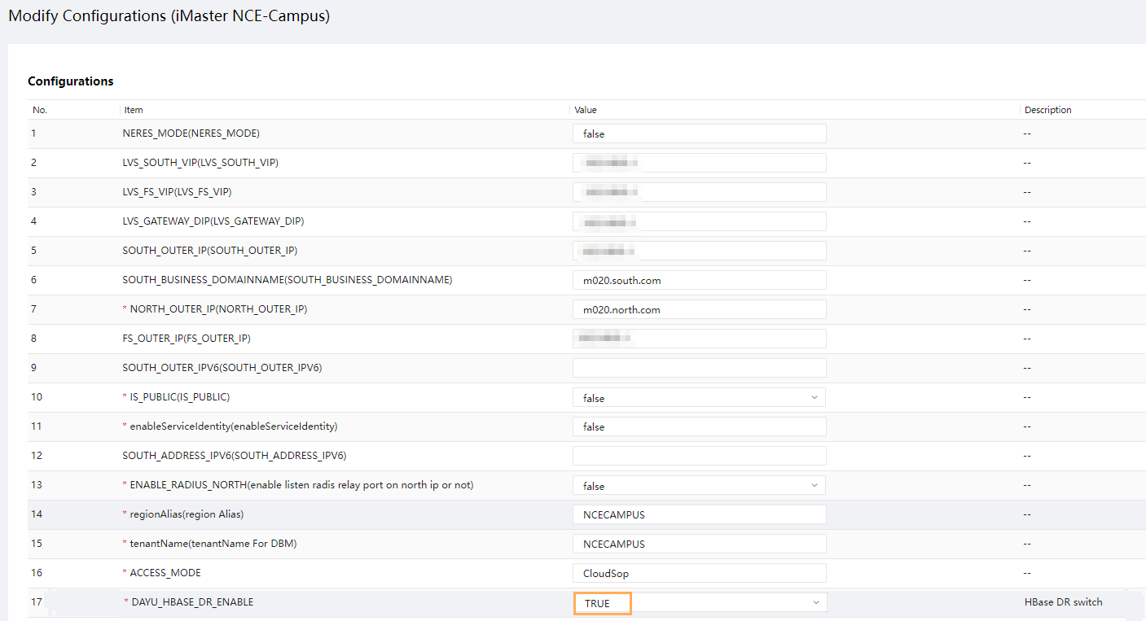
            - Build a new DR system. For details, see 4.8.1 Creating a New DR System.
            - Log in to the OMP_01 node in the secondary cluster before the upgrade as the sopuser user, switch to the root user, and run the following command:
For details about how to find the OMP_01 node, see 8.2 How Can I Find an OMP Node of the Management Plane?.
su - ossadm -c "sh /opt/oss/easysuite/easysuite/easysuite/plugins/NCE-Campus/upgrade_online/service/scripts/enable_lvs.sh NCECAMPUS false"
The command output is as follows.
----End

Post-upgrade Check
6.1 Checking the Southbound Access Configuration

Checking the Southbound Access Configuration

This section applies only to a DR system with multiple southbound access addresses. For details about how to check whether a DR system with multiple southbound access addresses is deployed, perform Step 1 to Step 2.
- Log in to the service plane and choose System > Southbound Access > Southbound Access Configuration from the main menu.
            - Check whether the Secondary IP Address column displays any IP addresses. If so, the DR system provides multiple southbound access addresses. Proceed to the next step. If not, skip the following steps.
            - If a secondary IP address is available, check whether the primary and secondary IP addresses are consistent with the actual ones. If not, click Primary/Secondary Switchover.
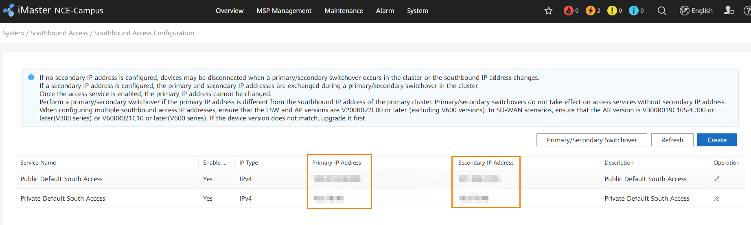
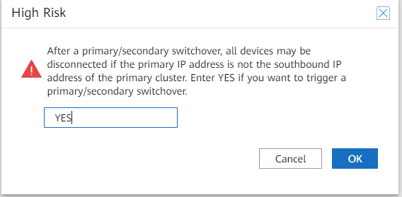
----End

Version Rollback
If the following problem occurs, see 8.1 Residual Temporary Directory in HDFS for the solution.
In the DR scenario, after iMaster NCE-Campus V300R022C00SPC100 is upgraded to V300R023C00 and then rolled back to V300R022C00SPC100, there is a small probability that the pre-check for DR system fails in an HDFS component.
7.1 Rolling Back the Primary Cluster
7.2 Rolling Back the Secondary Cluster
7.3 Building a New DR System

Rolling Back the Primary Cluster
- If feature expansion has been performed after the upgrade, version rollback is not supported.
- Before the rollback, do not modify system parameter settings, such as changing the IP address and database password and updating certificates and keys. Otherwise, the rollback may fail.
- If the upgraded cluster has set up a DR system with a newly installed cluster, version rollback is not supported.
- Log in to the upgrade tool and select the upgrade task.
            - On the Upgrade tab page, click View Rollback.
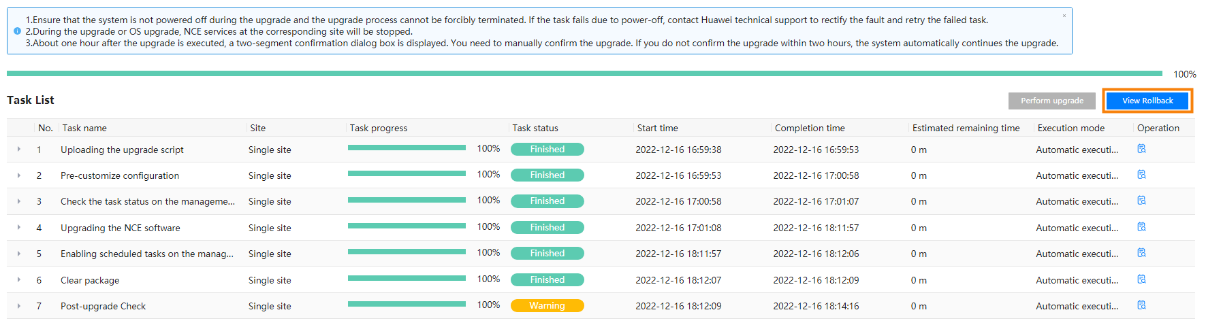
            - Click Perform rollback and wait until the rollback task is complete.
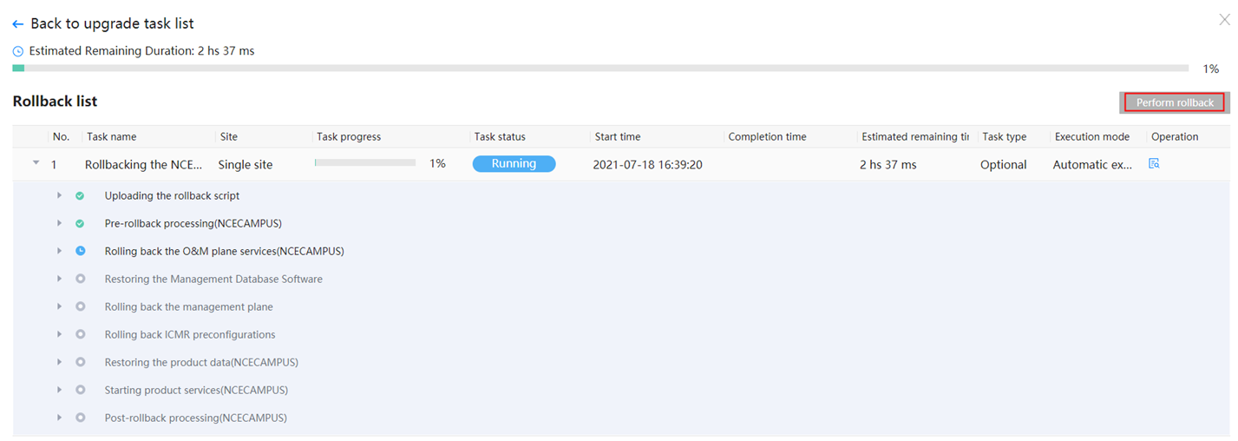
----End

Rolling Back the Secondary Cluster
- If feature expansion has been performed after the upgrade, version rollback is not supported.
- Before the rollback, do not modify system parameter settings, such as changing the IP address and database password and updating certificates and keys. Otherwise, the rollback may fail.
- If the upgraded cluster has set up a DR system with a newly installed cluster, version rollback is not supported.
- Log in to the upgrade tool and select the upgrade task.
            - On the Upgrade tab page, click View Rollback.
            - Click Perform rollback and wait until the rollback task is complete.
----End

Building a New DR System
For details, see Installation > Software Installation > Geographic Redundancy System Installation in the iMaster NCE-Campus V300R023C00 Product Documentation.

FAQ
8.1 Residual Temporary Directory in HDFS
8.2 How Can I Find an OMP Node of the Management Plane?
8.3 How Do I Check Whether the SecoManager Is Installed?
8.4 How Do I Reset the Password for Logging In to the FusionInsight Upgrade Tool?
8.5 How Do I Check Whether the Source IP Address Feature Patch Has Been Installed?
8.6 How Do I Check Whether a Wireless Non-operating Plug-in Has Been Installed?
8.7 How Do I Check Whether the Nmap Feature Has Been Installed?
8.8 Checking Communication Matrix Changes
8.9 How Do I Use FileZilla to Transfer Files by SFTP?
8.10 How Do I Use PuTTY to Log In to a Server?
8.11 What Can I Do If the HUAWEI-ROUTER-SYSTEMSND Package Fails to Be Activated?
8.12 Checking RPM Packages of the SUSE OS
8.13 How Do I Check the SAC Configuration?
8.14 How Do I Delete Consumer Groups L2topoDiscovery and campus_alarm_notification?
8.15 How Do I Check Whether the Situational Awareness, SRv6, or Remote Attestation Feature Has Been Installed in an Environment?
8.16 How Do I Reset the Passwords of OS Users ossadm, sopuser, and ftpuser?
8.17 How Do I Reset the Passwords for the ossadm and sopuser Users of the Arbitration Node at the Third-Party Site?
8.18 What Do I Do If the OS Is Suspended During the Upgrade?
8.19 Deploying EasySuite on the Backend
8.20 What Do I Do If a Message Indicating an Unfinished Upgrade Task Is Displayed When I Set Upgrade Parameters?
8.21 What Do I Do If Software Packages Fail to Be Verified on the Upgrade Tool?
8.22 How Do I Use a Third-Party Tool to Upload Software Packages to the Server?
8.23 How Do I Inspect Trust Certificates of Authentication Components and Rectify Problems

Residual Temporary Directory in HDFS
Context
In the DR scenario, after iMaster NCE-Campus V300R022C00SPC100 is upgraded to V300R023C00 and then rolled back to V300R022C00SPC100, there is a small probability that the pre-check for DR system fails in an HDFS component.
Possible Causes
When the DR task is deleted, the iMaster NCE-Campus V300R022C00SPC100 causes residual processes when the synchronization process is ended. This process creates a snapshot of the /backup_dayu directory. After the DR task is deleted, the residual process still creates a snapshot before the /backup_dayu directory is deleted. As a result, the /backup_dayu directory becomes a residual directory. When iMaster NCE-Campus is upgraded to V300R023C00, the HDFS directory (including the /backup_dayu directory and snapshot) is backed up. After iMaster NCE-Campus is rolled back to V300R022C00SPC100, the /backup_dayu directory is detected when a DR check task is created. As a result, the pre-check for DR system fails.
Procedure
Perform the following steps on the active and standby nodes separately:
- Obtain the management IP address of the big data node.
Log in to the management plane and choose Maintenance > Panoramic Monitoring > Service Monitoring > Process. Enter HDFS in the search box and click . Click the instance name corresponding to NdpHDFS and click the name of the node where the HDFS service is deployed.
            - Use PuTTY to log in to the backend of the NdpHDFS management node as user sopuser in SSH mode.
            - Run the following command to switch to the ossuser user:
su - ossuser
Password: Enter the password of the ossuser user.
            - Run the following commands to clear residual HDFS files. If the information similar to the following figure is displayed, residual files are successfully cleared.
source /opt/oss/*/apps/NdpNameNodeService/etc/HDClient/bigdata_env
list=($(hdfs dfs -ls -t /backup_dayu/hdfs/.snapshot | awk -F'.snapshot/' '{print $2}'))
for target_snapshot in ${list[*]}; do hdfs dfs -deleteSnapshot /backup_dayu/hdfs $target_snapshot >/dev/null 2>&1; done
hdfs dfs -rm -R -skipTrash /backup_dayu
hdfs dfs -ls /backup_dayu
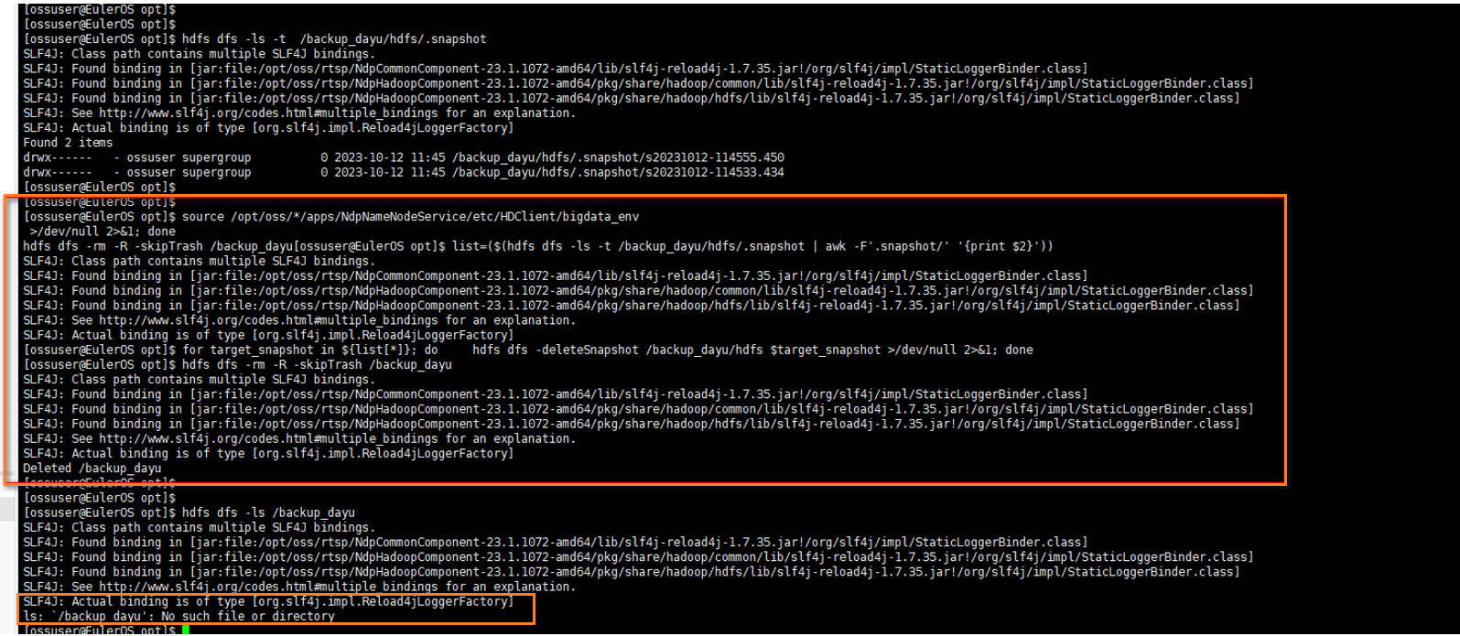
            - On the EasySuite page, click Rollback.
            - Verify the result.
Return to the management plane and perform a pre-check for DR system. Choose HA > Managing the DR System > Configuring the DR System, set DR parameters as prompted, and click Add Product and Precheck. The expected result is that the pre-check is successful.
----End

How Can I Find an OMP Node of the Management Plane?
Question
How do I find an OMP node of the management plane in an iMaster NCE-Campus cluster?
Answer

The IP address of the OMP_01 node displayed on the management plane is its internal communication IP address. If your PC cannot communicate with the node through the obtained internal communication IP address, use the node's service, southbound, or northbound IP address for login.
- Log in to the management plane and choose Maintenance > O&M Management > Panoramic Monitoring from the main menu.
            - Click and select NCE-OMP. To view information about the OMP_01 node, click OMP_01.
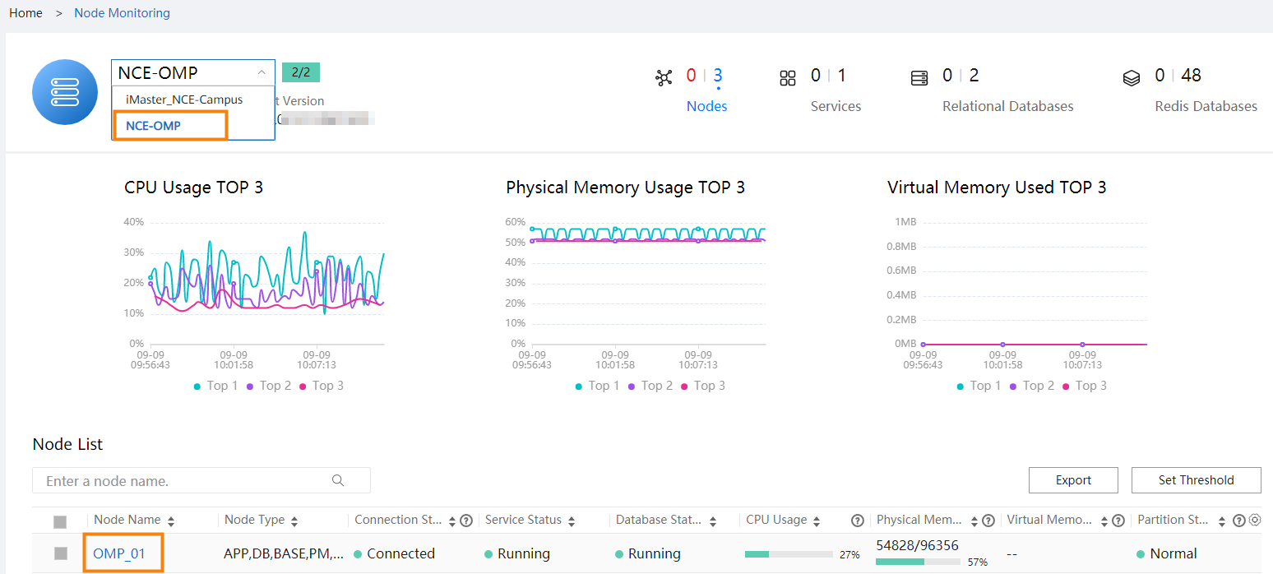
            - View the management IP address (internal communication IP address) of the OMP_01 node.
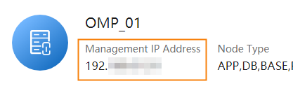
----End

How Do I Check Whether the SecoManager Is Installed?
Question
How do I check whether the SecoManager is installed?
Answer
- Access the management plane as the admin user at https://management plane IP address:18102.
            - Choose Product > Software Management > Deploy Product Software from the main menu, click the cluster in the installed state and check whether the component package list contains NCESECOM. If so, the SecoManager has been installed.
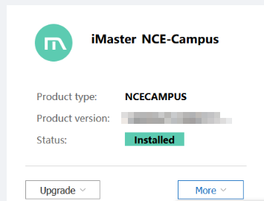
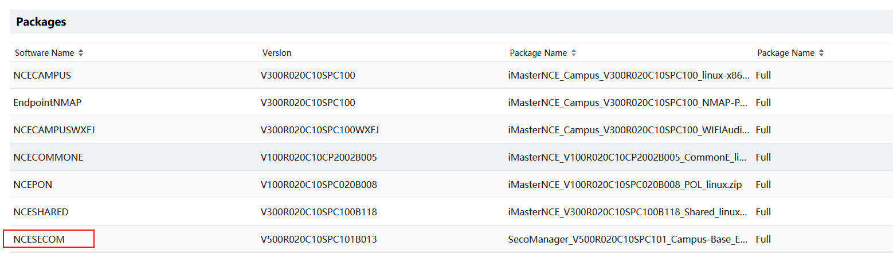
----End

How Do I Reset the Password for Logging In to the FusionInsight Upgrade Tool?
Question
How do I reset the password for logging in to the FusionInsight upgrade tool?
Answer
- Log in to the active FusionInsight management node as the sopuser user and run the following commands:
If FusionInsight is deployed in a single-node system, the only node is the active management node, that is, the active OMS node.
If FusionInsight is deployed in a cluster, log in to FusionInsight Manager as the admin user and access the hosts page. The node marked with a solid star icon (★) is the active management node whereas the node marked with a hollow start icon (☆) is the standby management node.
su - omm
Enter the password of the omm user.
cd /opt/huawei/Bigdata/update-service/conf
cp -arf authenticate.properties authenticate.properties_bak
            - Run the following command to edit the authenticate.properties key configuration file:
vi authenticate.properties
Change the values of userker and salt in the file to their default values, and save the file. The default value of userkey is 7B5EEE638E441080D49D0C2714A13E59E9CC339465B748BABB9810B7729B523B and the default value of salt is 261dfd134e05c236.
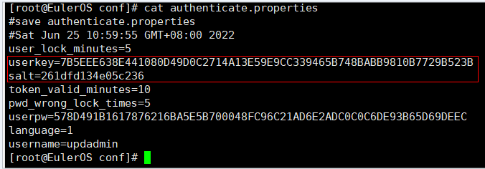
The password of the updadmin user of the FusionInsight upgrade tool is reset to Huawei12#$.
            - Run the following commands:
ps -ef | grep -w update-service |grep -v grep | awk '{print $2}' | xargs kill -9
            - Open a browser and log in to the FusionInsight upgrade tool using the reset password. Reset the password on the FusionInsight upgrade tool page as required.
----End

How Do I Check Whether the Source IP Address Feature Patch Has Been Installed?
Procedure
- Log in to the management plane of iMaster NCE-Campus as the system administrator (using port 18102).
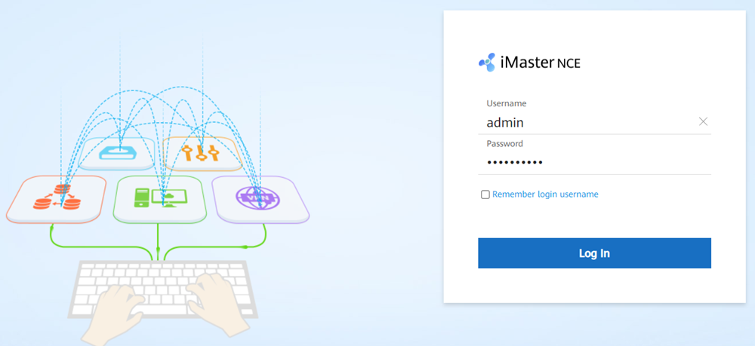
            - On the home page, choose Maintenance > Operation and Maintenance Management > Panoramic Monitoring > Service Monitoring from the main menu. On the Services tab page, search for SDWANAppAnalysis. If the service is found, the source IP address feature patch has been installed.
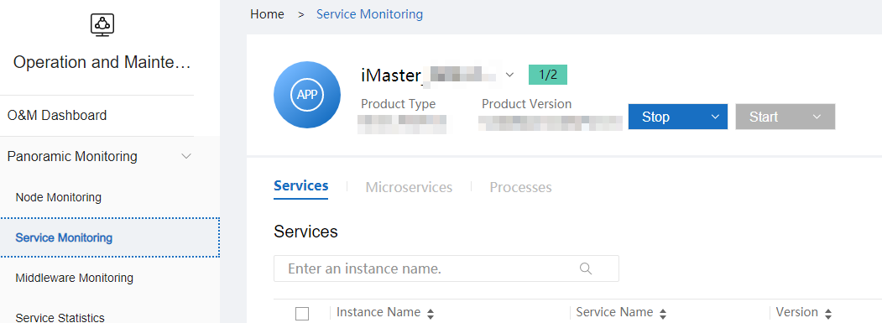
----End

How Do I Check Whether a Wireless Non-operating Plug-in Has Been Installed?
- Access the management plane at https://login IP address of the management plane client:18102.
            - Choose Product > Software Management > Deploy Product Software from the main menu. Click the cluster in the installed state and check whether the component package list contains NCECAMPUSWXFJ. If NCECAMPUSWXFJ exists, the wireless non-operating plug-in has been installed.
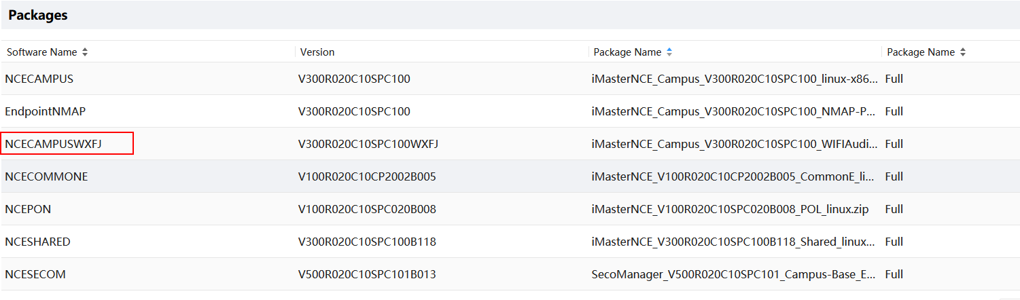
----End

How Do I Check Whether the Nmap Feature Has Been Installed?
- Access the management plane at https://login IP address of the management plane client:18102.
            - Choose Product > Software Management > Deploy Product Software from the main menu. Click the cluster in the installed state and check whether the component package list contains EndpointNMAP. If EndpointNMAP exists, the Nmap feature has been installed.
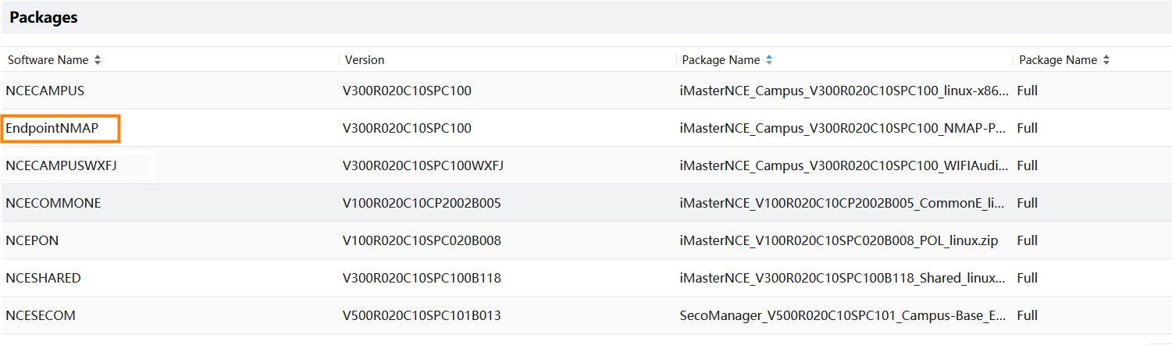
----End

Checking Communication Matrix Changes
                - communication matrix changes
Source Device | Source IP Address | Source Port | Support for NAT | Destination IP Address (Before NAT) | Destination Port (Before NAT) | Destination IP Address (After NAT) | Protocol/Destination Port (After NAT) | Destination Device | Change History | Function | Direction | Usage Scenario
Controller | Local NIC IP address of the controller  (which is reachable to the destination IP address through routing) | 48880~48889 | No | / | / | Device IP address | UDP/Specified by the device (161 by default) | Device | New | This port is used by the controller to send SNMP requests to devices. The destination port number for device access is determined by devices and is port 161 by default.  NOTE  This port is not used in public cloud and HCS scenarios. | Southbound port (outbound) | This port is involved in the traditional device management scenario.
Device | Device IP address | Random port | No | / | / | Floating IP address for southbound load balancing | TCP/179 | Controller | New | This port is the listening port of BGP sessions, which is used to establish sessions with BGP peers.  NOTE  This port is not used in public cloud and HCS scenarios. | Southbound port (inbound) | This port is involved in the SRv6 scenario.
Device | Device IP address | Random port | Yes | Southbound service IP address | 49 | Floating IP address for southbound load balancing | TCP/49 | Controller | New | This port is used by the RadiusServerService process to receive requests from port 30049, as well as requests forwarded by port 49 to this port, to provide the TACACS service. | Southbound port (inbound) | This port is involved in the TACACS authentication scenario.
Device | Device IP address | Random port | Yes | Southbound service IP address | 30049 | Floating IP address for southbound load balancing | TCP/30049 | Controller | New | This port is used by the RadiusServerService process to receive requests from port 30049, as well as requests forwarded by port 49 to this port, to provide the TACACS service. | Southbound port (inbound) | This port is involved in the TACACS authentication scenario.
Device | Device IP address | Random port | No | / | / | Floating IP address for southbound load balancing | TCP/4189 | Controller | New | This port is the listening port of PCEP sessions, which is used to establish sessions with PCCs.  NOTE  This port is not used in public cloud and HCS scenarios. | Southbound port (inbound) | This port is involved in the SRv6 scenario.
Device | Device IP address | Random port | Yes | Southbound service IP address | 10035 | Floating IP address for southbound load balancing | TCP/10035 | Controller | New | This port is used by the data collection service to provide the device performance data collection service. | Southbound port (inbound) | This port is used for performance data collection and is involved only in the scenario where third-party certificates are used.
Device | Device IP address | Random port | Yes | Southbound service IP address | 10034 | Floating IP address for southbound load balancing | TCP/10034 | Controller | New | This port is used by the data collection service to provide the device performance data collection service. | Southbound port (inbound) | This port is used for performance data collection and is involved only in the scenario where V600 devices are managed.
Device | Device IP address | Random port | Yes | Southbound service IP address | 30217 | Floating IP address for southbound load balancing | TCP/30217 | Controller | New | This port is used by the BootstrapProxyService process to listen to TCP connections of southbound devices and receive packets from the devices in TLS mode. | Southbound port (inbound) | This port is used for issuing device certificates during deployment. In the current version, preset certificates are used and therefore this port does not need to be enabled.
Device | Device IP address | Random port | Yes | Southbound service IP address | 50309 | Floating IP address for southbound load balancing | TCP/50309 | Controller | New | This port is used by CampusAccesscfgService to provide the IP-group service and is involved only in the scenario where third-party certificates are used. | Southbound port (inbound) | This port is used by the IP-GROUP service for access authentication. It is involved only in the scenario where third-party certificates are used.
NE | NE IP address | Any | Yes | Southbound service IP address | 30228 | Floating IP address for southbound load balancing | TCP/30228 | Controller | New | This port is used by FIProxyService to provide file upload and download services for IoT devices. The difference between ports 30228 and 18020 is that port 30228 uses the ECC certificate. | Southbound port (inbound) | This port is involved in the IoT device management scenario.
NE | NE IP address | Any | Yes | Southbound service IP address | 30226 | Floating IP address for southbound load balancing | TCP/30226 | Controller | New | This port is used by the IoTMqttService process to receive connection requests from southbound devices. | Southbound port (inbound) | This port is involved in the IoT device management scenario.
NE | NE IP address | Any | Yes | Southbound service IP address | 30225 | Floating IP address for southbound load balancing | TCP/30225 | Controller | New | This port is used by the IoTMqttService process to provide the device registration function. | Southbound port (inbound) | This port is involved in the IoT device management scenario.
NCE server | NCE server IP address | Any | No | / | / | CA server IP address | TCP/26803 | CA server | New | This port is used by LiteCAService to apply for, update, and revoke certificates. Port 26803 is a CMP port used by a client to apply for a certificate from the CA server through CMP over HTTP. HTTP is an insecure protocol. Enabling it has security risks. Therefore, port 26803 is disabled by default. To enable it, choose System > Security Management > Certificate Authority Service from the main menu of the O&M plane. On the displayed page, choose Global Configuration > Port Management from the navigation pane, click Enable on the right of port 26803, and restart the CA service. | Southbound port (outbound) | This port is involved in the scenario where device certificates need to be issued.
NE | NE IP address | Any | Yes | Southbound service IP address | 26803 | Floating IP address for southbound load balancing | TCP/26803 | Controller | New | This port is used by LiteCAService. This service enables ports, initializes TLS channels, and forwards NE certificate application requests to LiteCASignService. Port 26803 is a CMP port used by a client to apply for a certificate from the CA server through CMP over HTTP or CMP over TLS. Port 26803 is disabled by default. To enable it, choose System > Security Management > Certificate Authority Service from the main menu of the O&M plane. On the page that is displayed, choose Global Configuration > Port Management from the navigation pane, click Enable on the right of the port 26803, configure a TLS certificate (a TLS certificate must be configured when the CMP over TLS protocol is used to apply for a certificate from a CA server), and restart the CA service. | Southbound port (inbound) | This port is involved in the scenario where device certificates need to be issued.
NCE server | NCE server IP address | Any | No | / | / | CA server IP address | TCP/26802 | CA server | New | This port is used by LiteCAService to apply for, update, and revoke certificates. Port 26802 is a CMP port used by a client to apply for a certificate from the CA server through CMP over HTTP. HTTP is an insecure protocol. Enabling it has security risks. Therefore, port 26802 is disabled by default. To enable it, choose System > Security Management > Certificate Authority Service from the main menu of the O&M plane. On the displayed page, choose Global Configuration > Port Management from the navigation pane, click Enable on the right of port 26802, and restart the CA service. | Southbound port (outbound) | This port is involved in the scenario where device certificates need to be issued.
NE | NE IP address | Any | Yes | Southbound service IP address | 26802 | Floating IP address for southbound load balancing | TCP | Controller | New | This port is used by LiteCAService (whose process is litecaservice). This service enables ports, initializes TLS channels, and forwards NE certificate application requests to LiteCASignService. Port 26802 is a CMP port used by a client to apply for a certificate from the CA server through CMP over HTTP or CMP over TLS. Port 26802 is disabled by default. To enable it, choose System > Security Management > Certificate Authority Service from the main menu of the O&M plane. On the page that is displayed, choose Global Configuration > Port Management from the navigation pane, click Enable on the right of the port 26802, configure a TLS certificate (a TLS certificate must be configured when the CMP over TLS protocol is used to apply for a certificate from a CA server), and restart the CA service. | Southbound port (inbound) | This port is involved in the scenario where device certificates need to be issued.
NE | NE IP address | Any | Yes | Southbound service IP address | 26801 | Floating IP address for southbound load balancing | TCP/26801 | Controller | New | This port is used by LiteCAService. This service enables ports, initializes TLS channels, and forwards NE certificate application requests to LiteCASignService. Port 26801 is a CMP port used by a client to apply for a certificate from the CA server through CMP over HTTP or CMP over TLS. HTTP is an insecure protocol. Enabling it has security risks. Therefore, port 26801 is disabled by default. To enable it, choose System > Security Management > Certificate Authority Service from the main menu of the O&M plane. On the displayed page, choose Global Configuration > Port Management from the navigation pane, click Enable on the right of port 26801, configure a TLS certificate (a TLS certificate must be configured when the CMP over TLS protocol is used to apply for a certificate from a CA server), and restart the CA service. | Southbound port (inbound) | This port is involved in the scenario where device certificates need to be issued.
NCE server | NCE server IP address | Any | No | / | / | CA server IP address | TCP/26801 | CA server IP address | New | This port is used by LiteCAService to apply for, update, and revoke certificates. Port 26801 is a CMP port used by a client to apply for a certificate from the CA server through CMP over HTTP. HTTP is an insecure protocol. Enabling it has security risks. Therefore, port 26801 is disabled by default. To enable it, choose System > Security Management > Certificate Authority Service from the main menu of the O&M plane. On the displayed page, choose Global Configuration > Port Management from the navigation pane, click Enable on the right of port 26801, and restart the CA service. | Southbound port (outbound) | This port is involved in the scenario where device certificates need to be issued.

                - communication matrix changes
Source Device | Source IP Address | Source Port | Support for NAT | Destination IP Address (Before NAT) | Destination Port (Before NAT) | Destination IP Address (After NAT) | Protocol/Destination Port (After NAT) | Destination Device | Change History | Function | Direction | Usage Scenario
NE | NE IP address | Any | Yes | Southbound service IP address | 30228 | Floating IP address for southbound load balancing | TCP/30228 | Controller | New | This port is used by FIProxyService to provide file upload and download services for IoT devices. The difference between ports 30228 and 18020 is that port 30228 uses the ECC certificate. | Southbound port (inbound) | This port is involved in the IoT device management scenario.
NE | NE IP address | Any | Yes | Southbound service IP address | 30226 | Floating IP address for southbound load balancing | TCP/30226 | Controller | New | This port is used by the IoTMqttService process to receive connection requests from southbound devices. | Southbound port (inbound) | This port is involved in the IoT device management scenario.
NE | NE IP address | Any | Yes | Southbound service IP address | 30225 | Floating IP address for southbound load balancing | TCP/30225 | Controller | New | This port is used by the IoTMqttService process to provide the device registration function. | Southbound port (inbound) | This port is involved in the IoT device management scenario.
NCE server | NCE server IP address | Any | No | / | / | CA server IP address | TCP/26803 | CA server | New | This port is used by LiteCAService to apply for, update, and revoke certificates. Port 26803 is a CMP port used by a client to apply for a certificate from the CA server through CMP over HTTP. HTTP is an insecure protocol. Enabling it has security risks. Therefore, port 26803 is disabled by default. To enable it, choose System > Security Management > Certificate Authority Service from the main menu of the O&M plane. On the displayed page, choose Global Configuration > Port Management from the navigation pane, click Enable on the right of port 26803, and restart the CA service. | Southbound port (outbound) | This port is involved in the scenario where device certificates need to be issued.
NE | NE IP address | Any | Yes | Southbound service IP address | 26803 | Floating IP address for southbound load balancing | TCP/26803 | Controller | New | This port is used by LiteCAService. This service enables ports, initializes TLS channels, and forwards NE certificate application requests to LiteCASignService. Port 26803 is a CMP port used by a client to apply for a certificate from the CA server through CMP over HTTP or CMP over TLS. Port 26803 is disabled by default. To enable it, choose System > Security Management > Certificate Authority Service from the main menu of the O&M plane. On the page that is displayed, choose Global Configuration > Port Management from the navigation pane, click Enable on the right of the port 26803, configure a TLS certificate (a TLS certificate must be configured when the CMP over TLS protocol is used to apply for a certificate from a CA server), and restart the CA service. | Southbound port (inbound) | This port is involved in the scenario where device certificates need to be issued.
NCE server | NCE server IP address | Any | No | / | / | CA server IP address | TCP/26802 | CA server | New | This port is used by LiteCAService to apply for, update, and revoke certificates. Port 26802 is a CMP port used by a client to apply for a certificate from the CA server through CMP over HTTP. HTTP is an insecure protocol. Enabling it has security risks. Therefore, port 26802 is disabled by default. To enable it, choose System > Security Management > Certificate Authority Service from the main menu of the O&M plane. On the displayed page, choose Global Configuration > Port Management from the navigation pane, click Enable on the right of port 26802, and restart the CA service. | Southbound port (outbound) | This port is involved in the scenario where device certificates need to be issued.
NE | NE IP address | Any | Yes | Southbound service IP address | 26802 | Floating IP address for southbound load balancing | TCP | Controller | New | This port is used by LiteCAService (whose process is litecaservice). This service enables ports, initializes TLS channels, and forwards NE certificate application requests to LiteCASignService. Port 26802 is a CMP port used by a client to apply for a certificate from the CA server through CMP over HTTP or CMP over TLS. Port 26802 is disabled by default. To enable it, choose System > Security Management > Certificate Authority Service from the main menu of the O&M plane. On the page that is displayed, choose Global Configuration > Port Management from the navigation pane, click Enable on the right of the port 26802, configure a TLS certificate (a TLS certificate must be configured when the CMP over TLS protocol is used to apply for a certificate from a CA server), and restart the CA service. | Southbound port (inbound) | This port is involved in the scenario where device certificates need to be issued.
NE | NE IP address | Any | Yes | Southbound service IP address | 26801 | Floating IP address for southbound load balancing | TCP/26801 | Controller | New | This port is used by LiteCAService. This service enables ports, initializes TLS channels, and forwards NE certificate application requests to LiteCASignService. Port 26801 is a CMP port used by a client to apply for a certificate from the CA server through CMP over HTTP or CMP over TLS. HTTP is an insecure protocol. Enabling it has security risks. Therefore, port 26801 is disabled by default. To enable it, choose System > Security Management > Certificate Authority Service from the main menu of the O&M plane. On the displayed page, choose Global Configuration > Port Management from the navigation pane, click Enable on the right of port 26801, configure a TLS certificate (a TLS certificate must be configured when the CMP over TLS protocol is used to apply for a certificate from a CA server), and restart the CA service. | Southbound port (inbound) | This port is involved in the scenario where device certificates need to be issued.
NCE server | NCE server IP address | Any | No | / | / | CA server IP address | TCP/26801 | CA server | New | This port is used by LiteCAService to apply for, update, and revoke certificates. Port 26801 is a CMP port used by a client to apply for a certificate from the CA server through CMP over HTTP. HTTP is an insecure protocol. Enabling it has security risks. Therefore, port 26801 is disabled by default. To enable it, choose System > Security Management > Certificate Authority Service from the main menu of the O&M plane. On the displayed page, choose Global Configuration > Port Management from the navigation pane, click Enable on the right of port 26801, and restart the CA service. | Southbound port (outbound) | This port is involved in the scenario where device certificates need to be issued.

                - communication matrix changes
Source Device | Source IP Address | Source Port | Support for NAT | Destination IP Address (Before NAT) | Destination Port (Before NAT) | Destination IP Address (After NAT) | Protocol/Destination Port (After NAT) | Destination Device | Change History | Function | Direction | Usage Scenario
NE | NE IP address | Any | Yes | Southbound service IP address | 30228 | Floating IP address for southbound load balancing | TCP/30228 | Controller | New | This port is used by FIProxyService to provide file upload and download services for IoT devices. The difference between ports 30228 and 18020 is that port 30228 uses the ECC certificate. | Southbound port (inbound) | This port is involved in the IoT device management scenario.
NE | NE IP address | Any | Yes | Southbound service IP address | 30226 | Floating IP address for southbound load balancing | TCP/30226 | Controller | New | This port is used by the IoTMqttService process to receive connection requests from southbound devices. | Southbound port (inbound) | This port is involved in the IoT device management scenario.
NE | NE IP address | Any | Yes | Southbound service IP address | 30225 | Floating IP address for southbound load balancing | TCP/30225 | Controller | New | This port is used by the IoTMqttService process to provide the device registration function. | Southbound port (inbound) | This port is involved in the IoT device management scenario.

How Do I Use FileZilla to Transfer Files by SFTP?
Question
How do I use FileZilla to transfer files by SFTP?
Answer
- Double-click the FileZilla icon on the PC or laptop to launch the tool.
Access https://filezilla-project.org/ and download the latest version of FileZilla.
            - Set up a connection.
- Enter a server IP address in the Host text box.
- Enter the OS username in the User text box.
- Enter the password in Password.
- Enter 22 in the Port text box.
- Click Quickconnect.
The following figure uses the ossadm user as an example.
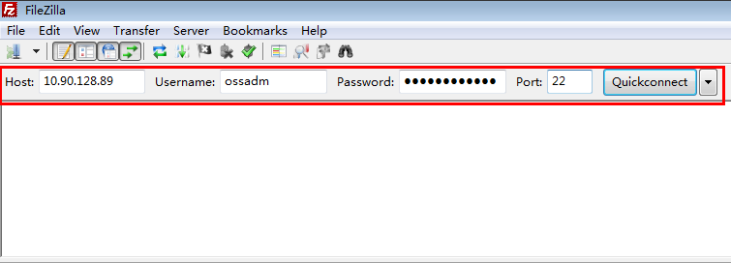
- If "Directory listing successful" is displayed, as shown in the following figure, the SFTP connection is successful.
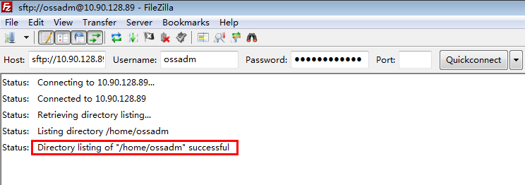
            - Upload files.

The name of the directory with the file to be transferred must not contain any spaces, brackets, or Chinese characters. Only letters, digits, and underscores (_) are allowed. If the directory name contains Chinese characters, garbled characters will appear, but this will not affect the software packages to be uploaded.
- In the Local site directory tree, locate the folder in which the files to be uploaded reside and click it. The folder will be displayed in Filename under Local site.
- In the Remote site directory tree, locate the folder in which the uploaded files are to be stored and click it. All files in the folder will be displayed in Filename under Remote site.
- Select a file in the source folder and drag it to the destination folder.
- Release the button. File uploading starts.
For example, upload the test.txt file in D:\test on a PC to the /opt/upgrade directory on the server, as shown in the following figure.
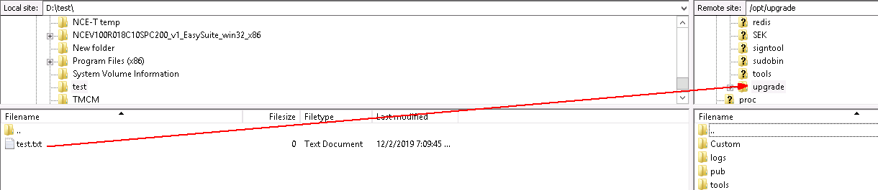
            - After the file is successfully uploaded, a success message is displayed, as shown in the following figure.
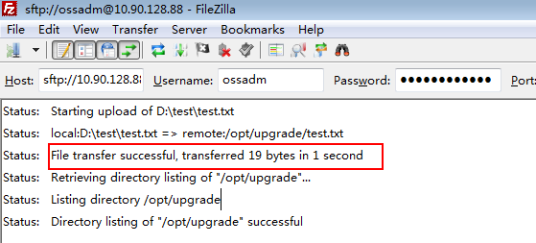
----End

How Do I Use PuTTY to Log In to a Server?
This section describes how to use PuTTY to log in to a server in SSH mode after the operating system is installed. The following uses PuTTY 0.70 as an example.
Prerequisites
You have obtained PuTTY of the latest version from https://www.chiark.greenend.org.uk/~sgtatham/putty/ and have installed it on your local PC.
PuTTY 0.67 or later is required.
Procedure
- Start PuTTY.
            - In the Host Name (or IP address) text box, enter the IP address of the server to which you want to log in.
Log in to the server using its fixed IP address to prevent floating IP address abnormalities from interrupting the SSH connection.
            - Set Connection type to SSH.
            - In the Close window on exit field, select Only on clean exit.
            - In the navigation pane, choose Window > Translation.
            - Set Remote character set to UTF-8.
Set the encoding format to UTF-8 each time you use PuTTY.
            - Click Open.
If this is the first time you are using PuTTY, the PuTTY Security Alert dialog box may be displayed. Click Yes.
            - When the following information is displayed, enter a username and press Enter:
login as:
After security hardening is performed for the OS, only users with the SSH permission (for example, sopuser) are allowed to log in to the server.
            - When the following information is displayed, enter the user password and press Enter.
Username@IP address's password:
For security purposes, keep the password secure and change it regularly.
----End

What Can I Do If the HUAWEI-ROUTER-SYSTEMSND Package Fails to Be Activated?
Question
What can I do if the HUAWEI-ROUTER-SYSTEMSND package fails to be activated?
Answer
- Access the controller service plane at https://floating IP address for northbound load balancing:18008.
            - Enter the administrator's username admin and password and click Log In.
            - Choose System > Service Programming > Package Repo, choose Package Management from the navigation pane, and check whether the 8090_V800R013C00_SYSTEMSND package exists. If so, select the package and click the Uninstall button. On the displayed page, enter the password of the admin user to uninstall the package. If the package does not exist, skip the following operations.
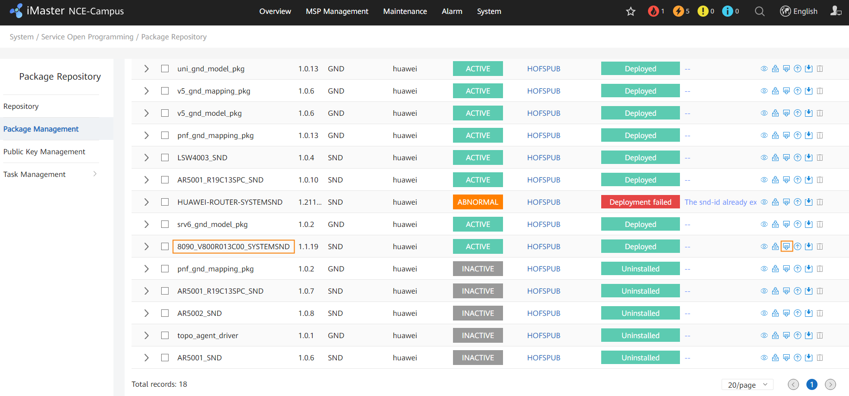
            - If SRv6 is required, select the HUAWEI-ROUTER-SYSTEMSND package and click the Deploy button to activate it. If SRv6 is not required, no action is required.
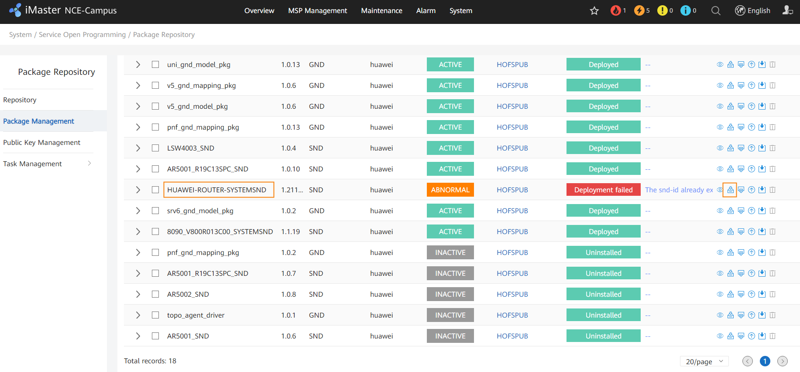
----End

Checking RPM Packages of the SUSE OS
- Log in to each FusionInsight node as the sopuser user, run the su - root command to switch to the root user, and copy and run the following commands to check whether some RPM packages are missing:
ldap_rmp=$(rpm -qa | grep -E 'ldap|libev|krb5|libopenssl|libcap-progs')
check_list="libev4 libevent libopenssl libverto-libev pam_krb5 libcap-progs"
for list in ${check_list} ; do
[ "`echo $ldap_rmp | grep $list`x" == "x" ] && echo "The OpenLDAP RPM package is missing in the current environment,current rpm is: [$list]"
done
If any RPM package is missing, the name of the missing RPM package is displayed in the command output, as shown in the following figure.
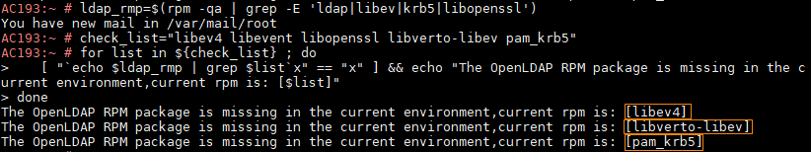
            - Log in to https://www.suse.com/download/sles/, download the SUSE image SLE-12-SP*-Server-DVD-x86_64-GM-DVD1 of the corresponding version, mount the ISO image, and go to the image directory /suse/ to obtain the required RPM packages.
The following RPM packages of the SUSE OS need to be downloaded:
SUSE 12SP2:
- libev4-4.22-1.3.x86_64.rpm
- pam_krb5-2.4.4-4.5.x86_64.rpm
- libverto-libev1-0.2.6-2.4.x86_64.rpm
- libcap-progs-2.22-13.1.x86_64.rpm
SUSE 12SP4:
- libev4-4.22-1.3.x86_64.rpm
- pam_krb5-2.4.4-4.5.x86_64.rpm
- libverto-libev1-0.2.6-3.2.2.x86_64.rpm
- libcap-progs-2.22-13.1.x86_64.rpm
SUSE 12SP5:
- libev4-4.22-3.2.1.x86_64.rpm
- pam_krb5-2.4.4-4.5.x86_64.rpm
- libverto-libev1-0.2.6-3.2.2.x86_64.rpm
- libcap-progs-2.22-13.1.x86_64.rpm
If the RPM package versions in the image are different from those listed above, contact Huawei engineers to check the RPM package versions.
            - Log in to each FusionInsight node as the sopuser user, run the su - root command to switch to the root user, and use FileZilla to upload the obtained RPM packages to any directory, for example, /root/RPM.
If security hardening has been performed on a node, run the sh /opt/SEK/cmd/SetEnv.sh command to disable security hardening on the node.
            - Access the path where RPM packages are stored, such as /root/RPM.
cd /root/RPM
            - Run the following command to install the missing RPM packages (displayed in the command output in Step 1):
rpm -Uvh --force --nodeps RPM package name
After all missing RPM packages are installed, run the following command to perform security hardening on the node:
sh /opt/SEK/cmd/RollBackEnv.sh
----End

How Do I Check the SAC Configuration?
In a DR scenario, perform operations in this section for both the primary and secondary clusters.
- Log in to the service plane as a tenant, choose Policy > Application Management > Application Management from the main menu, and click the SAC Configuration tab.
            - Perform this step only when Configuration is toggled off and Application scope is set to All in the Application Identification Configuration area, and also you want the SAC function to remain enabled on V600 devices after the controller upgrade.
Click in the Operation column of the application identification feature. In the Application Identification Configuration area, toggle on Configuration, set Application scope to Customized, set V600R021C00 and later versions to Yes, and click Search. Select all the sites displayed in the list below, click , and click OK.
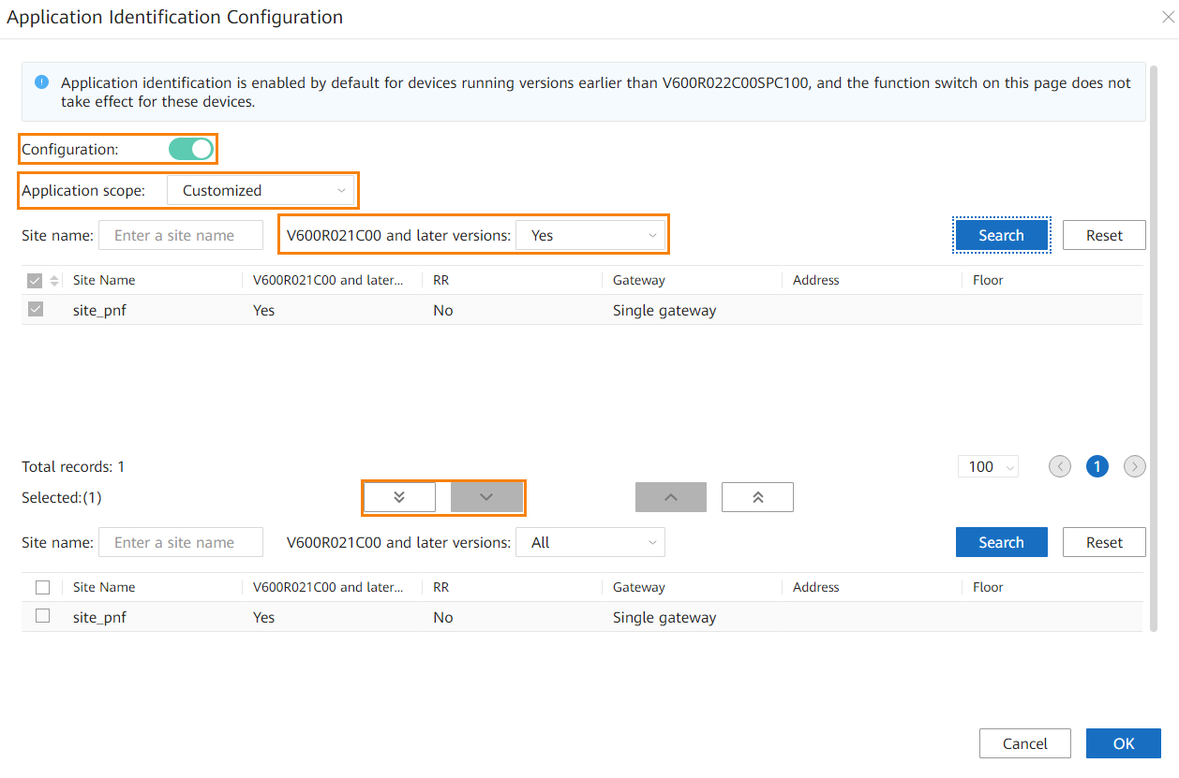
            - Perform this step only when Configuration is toggled on, Application scope is set to Customized, and No is selected for V600R021C00 and later versions in the Application Identification Configuration area (as shown in the following figure), and also you want the SAC function to remain enabled on V600 devices after the controller upgrade. You can click in the Operation column of the application identification feature to check the V600R021C00 and later versions setting.
Select Yes for V600R021C00 and later versions and click Search. Then select all the sites displayed in the list below, click , and click OK.
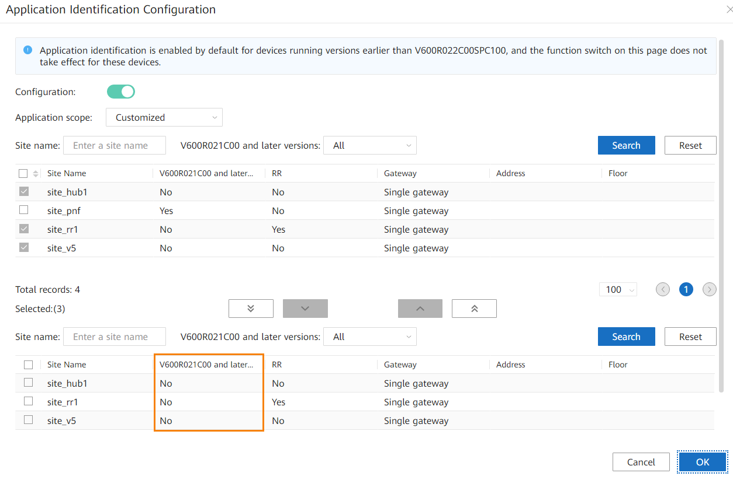
----End

How Do I Delete Consumer Groups L2topoDiscovery and campus_alarm_notification?
- Log in to the management plane and choose Maintenance > Operation and Maintenance Management > Panoramic Monitoring from the main menu. Click and select iMaster_NCE-Campus.
            - Choose Service Monitoring from the navigation pane, click the Microservices tab, enter DmqKafkaService in the search box, and select the DmqKafkaService instance.
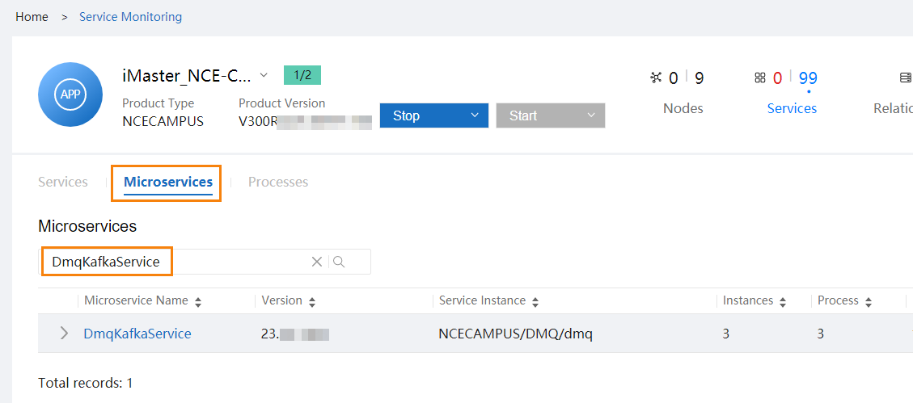
            - Click the node name in the Node Name column to obtain the management IP addresses of the nodes where DmqKafkaService resides.
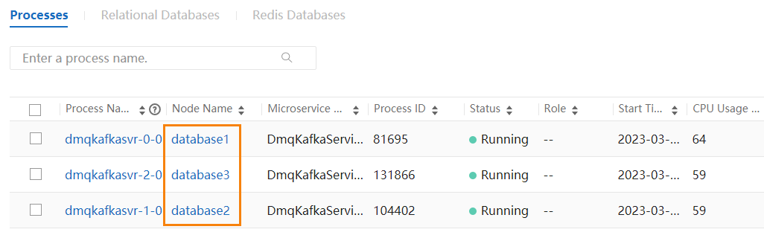
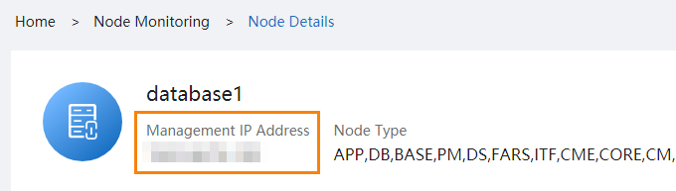
            - Log in to a node where DmqKafkaService resides as the sopuser user, run the su - root command to switch to the root user, and run the following command:
# cd /opt/oss/NCECAMPUS/apps/DmqKafkaService/tools/kafka/bin
            - Run the following commands to delete consumer groups L2topoDiscovery and campus_alarm_notification:
# sh set-env.sh kafka-consumer-groups.sh --boot --command-config ../config/consumer.properties --group L2topoDiscovery --topic topic_ncf_notification:0,1,2,3,4,5,6,7 --delete-offsets
# sh set-env.sh kafka-consumer-groups.sh --boot --command-config ../config/consumer.properties --group campus_alarm_notification --topic topic_ncf_notification:0,1,2,3,4,5,6,7 --delete-offsets
            - Run the following commands to check whether the deletion is successful. If the command output does not contain L2topoDiscovery or campus_alarm_notification, the deletion is successful. If the deletion fails, contact Huawei technical support.
sh set-env.sh kafka-consumer-groups.sh --boot --command-config ../config/consumer.properties --describe --all-groups |grep topic_ncf_notification |grep L2topoDiscovery
sh set-env.sh kafka-consumer-groups.sh --boot --command-config ../config/consumer.properties --describe --all-groups |grep topic_ncf_notification |grep campus_alarm_notification
----End

How Do I Check Whether the Situational Awareness, SRv6, or Remote Attestation Feature Has Been Installed in an Environment?
- Access the management plane as the admin user at https://management plane IP address:18102.
            - Choose Product > Software Management > Deploy Product Software from the main menu, click the cluster in the installed state and check the component package list.
- If the list contains ExtAdvancedSEC, the situational awareness feature has been installed in the environment.
- If the list contains NCESRV6, the SRv6 feature has been installed in the environment.
- If the list contains TrustCenter, the remote attestation feature has been installed in the environment.
----End

How Do I Reset the Passwords of OS Users ossadm, sopuser, and ftpuser?
Log in to each controller node as the root user.

The password must meet the following requirements:
          - The password can contain uppercase letters, lowercase letters, digits, and special characters ~@#^*-_+[{}]:./? %=!
          - The password can contain a maximum of 64 characters.
- To reset the password of the OS user ossadm, run the passwd ossadm command on each controller node.
- To reset the password of the OS user sopuser, run the passwd sopuser command on each controller node.
- To reset the password of the OS user ftpuser, run the passwd ftpuser command on each controller node.

How Do I Reset the Passwords for the ossadm and sopuser Users of the Arbitration Node at the Third-Party Site?
Log in to the arbitration node at the third-party site as the root user.

The password must meet the following requirements:
          - The password can contain uppercase letters, lowercase letters, digits, and special characters ~@#^*-_+[{}]:./? %=!
          - The password can contain a maximum of 64 characters.
- To reset the password for the ossadm user of the arbitration node at the third-party site, run the passwd ossadm command on each controller node.
- To reset the password for the sopuser user of the arbitration node at the third-party site, run the passwd sopuser command on each controller node.

What Do I Do If the OS Is Suspended During the Upgrade?
Symptoms
The OS is suspended during the upgrade. After you check for the IP address of the faulty node on EasySuite, search for the IP address of the faulty node on the FusionCompute web client, and click the VNC login button on the VM page of the faulty node, the login page is suspended and the cursor is not blinking, as shown in the following figure.
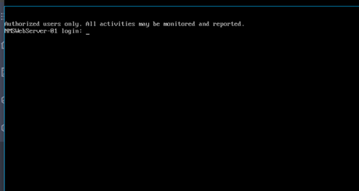
Solution
On the FusionCompute web client, search for the IP address of the faulty node, forcibly restart the faulty node on the VM page of the faulty node, and continue the upgrade.

Deploying EasySuite on the Backend
Procedure
- For details about how to find the OMP_01 node, see 8.2 How Can I Find an OMP Node of the Management Plane?.
- For details about how to upload files using FileZilla, see 8.9 How Do I Use FileZilla to Transfer Files by SFTP?.
- Use FileZilla to upload the EasySuite installation package EasySuite_{version}_OM_linux-***.zip to the /tmp directory on the OMP_01 node of the secondary cluster as the sopuser user.
If you cannot log in to the OMP_01 node using the internal communication IP address, use the service communication plane IP address of the OMP_01 node for login.
            - Log in to the OMP_01 node of the secondary cluster as the sopuser user and run the following commands to install the upgrade tool:
su - root
Enter the password for the root user.
- Run the following command if servers use the x86 architecture:
unzip -qo /tmp/EasySuite_*_OM_linux-x86-64.zip deploy_es_om.sh -d /opt/;bash /opt/deploy_es_om.sh EasySuite_*_OM_linux-x86-64.zip
- Run the following command if servers use the aarch64 architecture:
unzip -qo /tmp/EasySuite_*_OM_linux-aarch64.zip deploy_es_om.sh -d /opt/;bash /opt/deploy_es_om.sh EasySuite_*_OM_linux-aarch64.zip
If the following information is displayed, the upgrade tool is started successfully. You can log in to the upgrade tool using the link displayed in the command output.
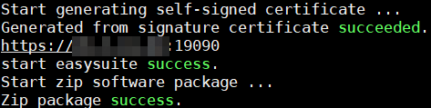
Run the exit command to log out the root user.
            - Open a browser, enter https://IP address in the command output in Step 2:19090 in the address box, and press Enter to access the login page of the upgrade tool.
            - Enter a username and password, and click Log In.
- Username: The preset username is esadmin.
- Password: The preset password is Changeme_123. Change the password upon your first login. For security purposes, change the password periodically and keep it secure.
- If you have used EasySuite to upgrade the system from an earlier version to V300R020C10, enter the password used in the previous upgrade.
- If you forget the password for the esadmin user of EasySuite, see section "Retrieving the EasySuite Login Password During iMaster NCE-Campus Upgrade" under Maintenance and Troubleshooting > NCE&Solution Troubleshooting Guide > Common Troubleshooting Cases > Login Failures in the CloudCampus Solution V100R022C00 & iMaster NCE-Campus V300R022C00 Product Documentation.
----End

What Do I Do If a Message Indicating an Unfinished Upgrade Task Is Displayed When I Set Upgrade Parameters?
- Log in to the management plane as the admin user and choose Product > Project Management > Upgrade Tool from the main menu.
            - Click Roll Back, select the check box in the displayed dialog box, and click Yes to perform a rollback.
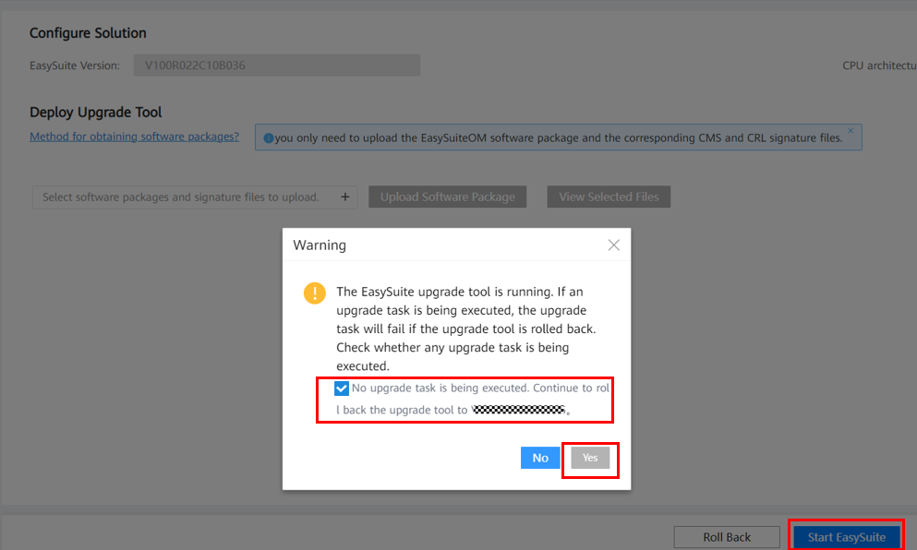
            - After the rollback is complete, click Start EasySuite.
            - After EasySuite is started, find the previous upgrade task and click in the row of upgrade confirm in the lower right corner.
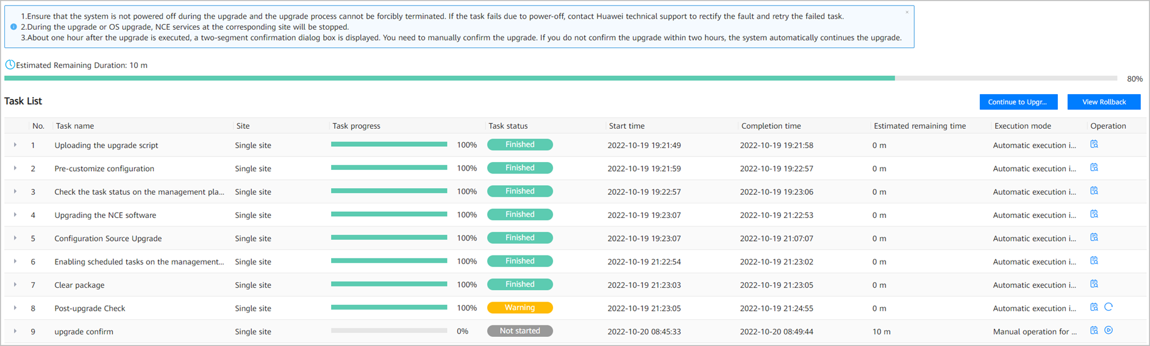
            - After the operation succeeds, click Finish in the lower right corner.
            - Log in to the OMP_01 node as the sopuser user and run the following commands to stop EasySuite.
For details about how to find the OMP_01 node, see 8.2 How Can I Find an OMP Node of the Management Plane?.
su - ossadm
sh /opt/oss/easysuite/easysuite/stop.sh
            - Go to 3.9 Logging In to the Upgrade Tool and upgrade the controller again.
----End

What Do I Do If Software Packages Fail to Be Verified on the Upgrade Tool?
Log in to the OMP_02 node as the sopuser user and run the following command. For details about how to find the OMP_02 node of the management plane, see 8.2 How Can I Find an OMP Node of the Management Plane?.
su -root su - ossadm -c "mkdir -p /opt/oss/easysuite/easysuite/var/software"

How Do I Use a Third-Party Tool to Upload Software Packages to the Server?
Question
How do I use a third-party tool to upload software packages to the server?
Answer
- Use PuTTY to log in to the NMS_ServerOMP_01 node as the sopuser user in SSH mode and run the following commands to create a directory (/opt/upgrade is used as an example) to which the patch package is to be uploaded.
> su - root
Password: password for the root user
# cd /opt/
# mkdir -p upgrade
# chown ossadm:$(id -gn sopuser 2>/dev/null || echo ossgroup) /opt/upgrade
# id sopuser &>/dev/null && setfacl -m u:sopuser:rwx /opt/upgrade
# chmod 770 upgrade/
# exit
            - Upload the software package to the /opt/upgrade directory. For details, see 8.9 How Do I Use FileZilla to Transfer Files by SFTP?.
----End

How Do I Inspect Trust Certificates of Authentication Components and Rectify Problems
Operations in this section are not required in the following scenarios:
- iMaster NCE-Campus is not interconnected with an authentication component.
- iMaster NCE-Campus has been interconnected with an authentication component and their connection is normal.
- You have replaced the certificates related to the authentication component with applied certificates.
Symptom
On the Authentication Component Management page, an authentication component status is displayed as Offline.
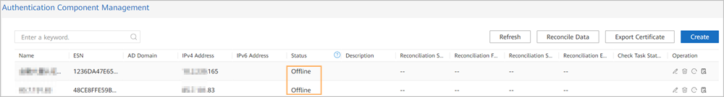
Possible Causes
The trust certificate of the authentication component is lost.
Troubleshooting Procedure
Steps 1 and 2 aim to check whether iMaster NCE-Campus uses default certificates and provide guidance for handling trust certificate loss.
- Check whether a trust certificate exists on the certificate management page.
- Log in to iMaster NCE-Campus as the system administrator, choose System > Security Management > Certificate Management, and click the Service Certificate Management tab.
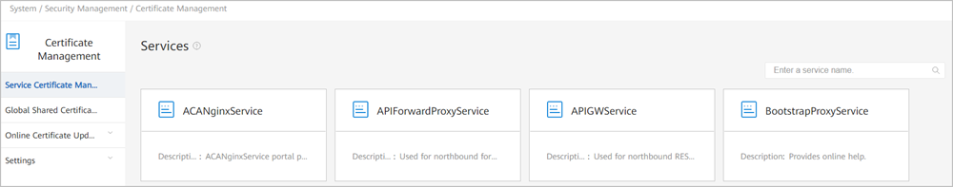
- Select the service card corresponding to IAEService.
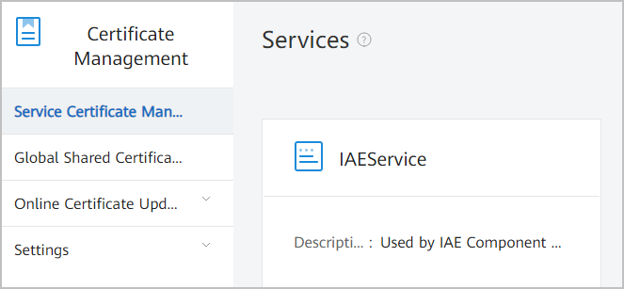
- Click the Trust Certificate tab and check whether a trust certificate exists.
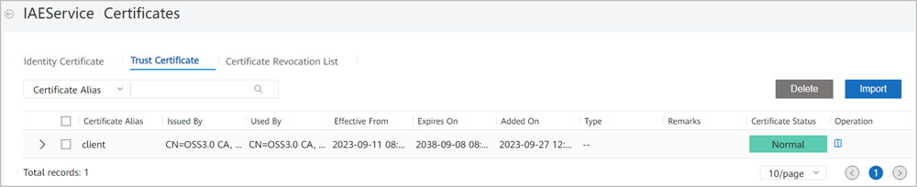
- If a trust certificate exists, no further action is required. If no trust certificate is available, go to the Identity Certificate page, expand the certificate information, and check the identity certificate's issuer.
If the issuer is OSS3.0, go to Step 2 to restore the default certificate.
If the issuer is not OSS3.0, the certificate has been replaced. In this case, you need to replace the certificate by yourself. Otherwise, the authentication component cannot connect to iMaster NCE-Campus at the headquarters. If emergency recovery is required onsite, go to Step 3 to restore all default certificates.
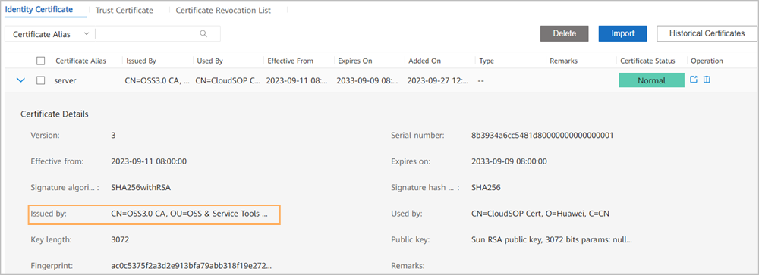
            - Restore the default trust certificate.
- Decrypt the certificate password.
  - View the content of the /opt/oss/NCECAMPUS/etc/ssl/common_cert/cert_pwd file.
Log in to the primary iMaster NCE-Campus node as the sopuser user and run the following commands:
# su - root
Password:
# more /opt/oss/NCECAMPUS/etc/ssl/common_cert/cert_pwd
The command output is as follows.
Then run the following commands:
# su ossadm
# . /opt/oss/manager/bin/engr_profile.sh
# python
# from util import ossext
# ossext.Cipher.decrypt ("output of the more command ")
# exit
- Download the trust certificate file to a local directory.
Use a download tool to download the trust.jks file from the /opt/oss/NCECAMPUS/etc/ssl/common_cert/ folder on the OMP_01 node of iMaster NCE-Campus to a local directory.
- Upload the trust certificate to iMaster NCE-Campus.
Repeat Step 1.1, Step 1.2, and Step 1.3 to access the IAEService certificate card page, click the Trust Certificate tab, and import the certificate file trust.jks downloaded in Step 2.2.
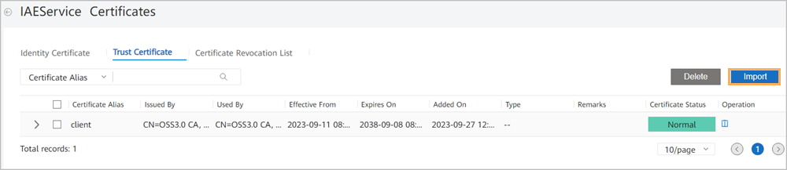
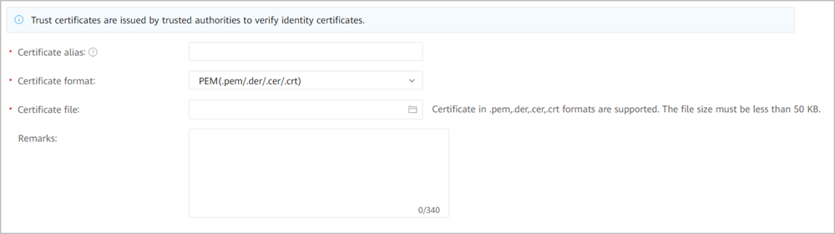
Certificate alias: Set this parameter based on the site requirements. Ensure that the value is unique.
Certificate format: Select JKS (.jks).
Certificate file: Select the certificate file downloaded in Step 2.2.
Certificate password: Enter the decrypted content in Step 2.1.
After filling in the preceding information, click Submit. After the operation is successful, the imported certificate is displayed on the Trust Certificate page.
            - Restore all default certificates.
Step 3 is applicable when you do not have a certificate, iMaster NCE-Campus cannot connect to the authentication component, and certificate restoration is required. In this step, the certificates related to the authentication component are replaced with default certificates of iMaster NCE-Campus.
- Decrypt the certificate password.
  - View the content of the /opt/oss/NCECAMPUS/etc/ssl/common_cert/cert_pwd file.
Log in to the primary iMaster NCE-Campus node as the sopuser user and run the following commands:
# su - root
Password:
# more /opt/oss/NCECAMPUS/etc/ssl/common_cert/cert_pwd
The command output is as follows.
Then run the following commands:
# su ossadm
# . /opt/oss/manager/bin/engr_profile.sh
# python
# from util import ossext
# ossext.Cipher.decrypt ("output of the more command ")
# exit
- Download certificate files to a local directory.
Use a download tool to download the server.jks and trust.jks files from the /opt/oss/NCECAMPUS/etc/ssl/common_cert folder on the OMP_01 node of iMaster NCE-Campus to a local directory.
- Upload the identity certificate to iMaster NCE-Campus.
Repeat Step 1.1, Step 1.2, and Step 1.3 to access the IAEService certificate card page, click the Identity Certificate tab, and import the certificate file server.jks downloaded in Step 3.2.
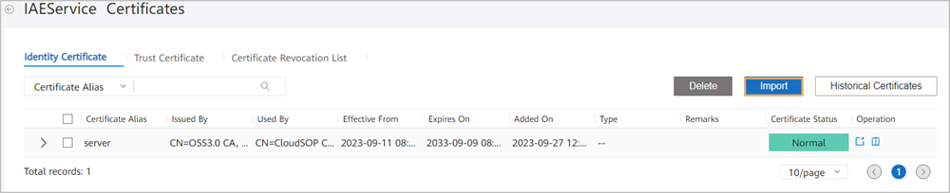
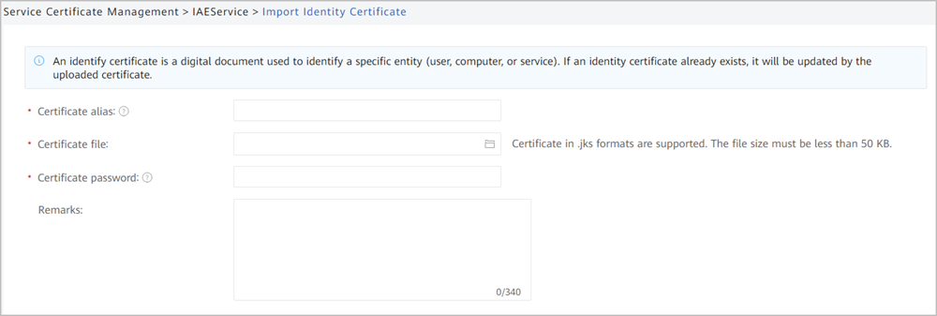
Certificate alias: Enter a name that can identify the certificate based on the site requirements.
Certificate file: Select the server.jks file downloaded in Step 3.2.
Certificate password: Enter the plaintext decoded in Step 3.1.
- Upload the trust certificate to iMaster NCE-Campus.
Repeat Step 1.1, Step 1.2, and Step 1.3 to access the IAEService certificate card page, click the Trust Certificate tab, and import the certificate file trust.jks downloaded in Step 3.2.
Certificate alias: Set this parameter based on the site requirements. Ensure that the value is unique.
Certificate format: Select JKS (.jks).
Certificate file: Select the trust.jks file downloaded in Step 3.2.
Certificate password: Enter the plaintext decoded in Step 3.1.
After filling in the preceding information, click Submit. After the operation is successful, the imported certificate is displayed on the Trust Certificate page.
- Overwrite iMaster NCE-Campus files and restart background services.
Perform this step on each iMaster NCE-Campus node.
In the local directory, rename the server.jks file downloaded in Step 3.2 to sc-kstore.jks and the trust.jks file to sc-tstore.jks.
  - Upload the certificate files.
Upload the sc-kstore.jks and sc-tstore.jks files to the following directory of iMaster NCE-Campus:
/opt/oss/envs/Product-CampusAccountService/{version}/controller/configuration/iae/client
If a node does not have the /opt/oss/envs/Product-CampusAccountService/{version}/controller/configuration/iae/client directory, skip steps Step 3.5.b and Step 3.5.c.
  - Modify the configuration file.
Run the vi command to modify the /opt/oss/envs/Product-CampusAccountService/{version}/controller/configuration/iae/client/sc.properties file on the iMaster NCE-Campus node.
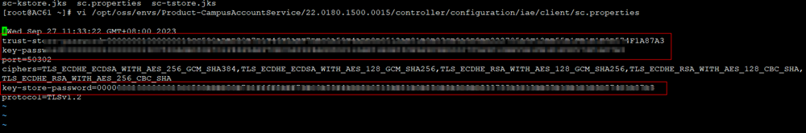
Change the values following the equal signs (=) of the trust-store-password, key-password and key-store-password attributes to the cert_pwd ciphertext obtained in Step 3.1. Save the modification and exit.
  - Restart services.
Run the su - ossadm -c "bash /opt/oss/manager/agent/bin/ipmc_adm -cmd restartapp -app CampusAccountService" command as the root user.
- Export the trust certificate from iMaster NCE-Campus and import the trust certificate to the authentication component.
  - Export the trust certificate from iMaster NCE-Campus.
- Log in to iMaster NCE-Campus as a tenant administrator, choose System > System Management > Authentication Component, go to the Authentication Component Management page, and export the certificate.
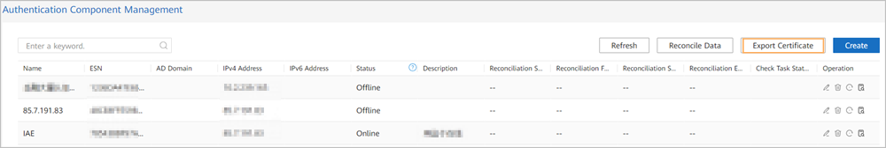
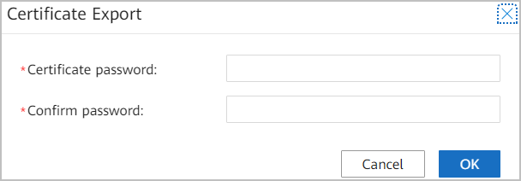
Set the certificate password based on the actual situation.
- Click OK and save the file to the local PC.
  - Import the trust certificate to the authentication component.
- Log in to the management plane of the authentication component as the admin user and choose Commissioning > Service Controller > Connection Management from the main menu.
- Click Import to import the trust certificate.
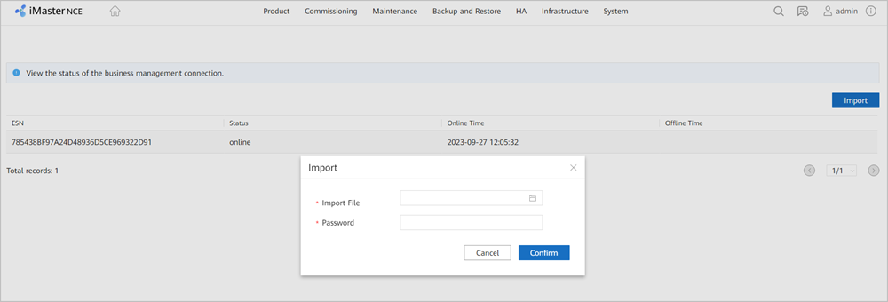
Import File: Select the compressed package exported in Step 3.6.a.
Password: Enter the password you set when exporting the trust certificate in Step 3.6.a.
----End

